
Targets:

Does the use of Outdoor Learning positively impact the engagement of children within a foundation phase class?
The use of researching within a school setting allows teachers to observe their students, providing them with the opportunity to gain a deeper understanding of their own teaching methods, and whether they are successful or not. Benjamin (1994, cited in Childhood observations 2008, p.42) says that: “Systematic observations also help professionals to understand the reasons behind children’s behaviour in certain situations.” When conducting my own research I investigated the use of outdoor learning, looking deeper into the engagement of the students, and how surrounding environments of children can affect their engagement. According to Learning Through Landscapes (2022), outdoor learning can benefit students in multiple ways; these being in areas like: physical skills, confidence, communication and collaborative learning. However, these benefits can only be equipped with appropriate levels of engagement from the students. Therefore, using the Leuven Scale to record multiple students’ levels of engagement through my own observations, I attempted to answer my research question.
Within the Welsh Governments new version of the Welsh curriculum, we can see the creation of the four purposes. One of the four purposes listed by the Welsh Government (2022) is: creative learners who can implement their own knowledge and understanding into their own work and day to day situations. Following this, White (2014, p.108) suggests that the opportunity to be creative in multisensory activities outdoors, works successfully to create more engagement. Her findings, however, suggests that given the opportunity to be creative and messy outdoors, boys were more engaged in their learning. This interestingly follows the gender stereotype that girls are more ‘prim’ and ‘sophisticated’ not wanting to become messy and hands on. This raises questions as to whether the rising pedagogy of outdoor learning is actually successful for all learners. Adventure Ready Girls (2021) stated that around sixteen percent or parents would be less likely to take their daughters to play outside. From this, it could be suggested that later in life, within things like outdoor learning, girls would be a lot less enthused and engaged compared to the engagement of boys. As the use of outdoor learning is becoming more popular around Wales, it is vital that teachers examine their pedagogy when outdoors to ensure they meet the standards of the four purposes to give all of their students the equal opportunities that there are entitled to. The UNCRC rights of a child (2023) would agree with this, stating in Article twenty-eight that every child has the right to learn and attend school. The use of outdoor learning allows children to learn independently. Within activities children learn how to solve problems themselves, this may be through group activities or independent learning. By allowing the children to learn independently they will gain their own knowledge through their own experiences. This means a much greater understanding, than that of a usual lesson. Maria Montessori would agree with this approach. Montessori (1989, cited in Exploring Outdoor Play In Early Years 2014, p.18) was a firm believer in child led learning, allowing the learner to make their own decisions. It was Montessori who cultivated the idea of outdoor learning, referring to the garden as a house in which the children were like masters. However, many could say Montessori’s methods were chaotic and disorganised, and lacking in discipline. Behaviourist Edward Thorndike’s theory of Law and Effect would agree with this. McLeod (2018) summarised Thorndike’s theory saying: his experiment of a cat in a puzzle box suggested that, actions followed by positive outcomes would be adopted, and those with bad outcomes would not. This meaning that, within a classroom setting, a child is more likely to continue to be engaged with their learning if they continue to do well, and the opposite if they perform badly. Some may feel that Thorndike’s theory would have overall negative consequences on children as it leaves no room for error and mistakes, which are crucial for children’s development.
To calculate the level of engagement of students, I used the Leuven Scale. Out of the two forms of Leven Scale, one focusing on well being and the other on involvement, I used the one based on involvement. It consists of five levels of involvement: Extremely Low, Low, Moderate, High and Extremely High. The level of extremely low is that of students who are not mentally involved and physically, the lowest amount of involvement they could reach, and extremely high is the most enthused a student can be, physically and mentally. A child with extremely low engagement would exhibit physical signs of disengagement in the form of crying, screaming and being significantly uncomfortable, whereas a child of extremely high engagement would show signs of extreme happiness and full focus. Despite this tool being useful when conducting research, it does however have so disadvantages. The first of these is that many children may not fit into one of the specific categories mentioned in the Leuven scale, it doesn’t have a broad enough scale. This is very much the case for children with additional learning needs. One of the main additional learning needs it does not cater for is children who are mute (Learning Journals, 2023). Therefore some may say that it is not a reliable source in all classrooms as it does not cater for all. To note the engagement of students I produced an Observation Sheet (see in appendix). This included a table in which I would observe three students for ten minutes every fifteen minutes. This observation would observe their engagement with their environment, tasks, and other students. Although this is an easier way for noting observations, it still leaves opportunity for the researcher to miss something important whilst they write what they have earlier seen. This however could be seen as a weakness of the Observation schedule, rather than one of the Leuven scale itself.
When conducting research in any form, it is vital that the researcher takes an ethical stance. This is extremely relevant when conducting research based on young children’s engagement. Research of this kind “requires sensitivity and planning” (Walker and Solvason 2014, p.33). Sharing a similar view to that of Walker and Solvason, the Bera Ethical Guidelines (2018, p.6) build on their views saying that a researcher should keep in account the child’s age, gender, that all are treated fairly with no bias, and all should be treated with dignity. Keeping this in mind, when conducting my research, I was given consent to take pictures for my research with the inclusion of the students. However, although I had this consent I did lack assent from the students who would have been included in the picture. Therefore, following things like the Bera Guidelines, I decided to just picture the learning environment without the students.
To conduct my research, I was placed in School X. Within school X I was placed in a class with a combination of nursery and reception children. In my first day, I found they spent a majority of their time conducting outdoor learning, especially within their mud kitchen/ forest school. I therefore decided that this would be my topic focus. I firstly chose three children I would follow focusing on their engagement within the tasks, environment and with others. These I labelled as child, A, B and C. Within their lessons outdoors, the children were encouraged to work independently or as a team, rather than going to the teacher for help. If working in a team they would be working to collect ingredients for a mud pie, and if not, they could create their own tasks within the outdoor area. This could be roll play or multiple other options. Child A was a young boy who was shovelling for, in his own words, ‘treasure’. He was using his imagination to create a more fun task for himself than shovelling for the ingredients for the mud pies they were making. His engagement level at this time was four. Whilst shovelling, child A came across a large mound of mud in which he struggled to dig. He became less engaged in his activity and annoyed that he couldn’t continue, bringing his engagement level down to a three. In his struggle, instead of coming up with his own solution, he found another shovel and handed it to me, asking if I could help him. This did cause a bit of obstruction to my observation, as I then wasn’t focused, however it was interesting to see the child approach a more knowledgeable other to find help, instead of forming his own solution. A more knowledgeable other is someone with a ‘higher ability’ than that of the person who needs help (Future Learn 2013). Vygotsky would approve of this child’s method of learning as he feels that the teacher should be involved with the child’s learning. However, Bilton (2010, p.1) argues that when outdoors children are at their most free to feel “settled and capable”. Bilton follows the idea of independent learning in the outdoors, allowing the children to discover things for themselves. However, in Child A’s case, he didn’t feel this capability and sought for help elsewhere. Once he had found this help his engagement level went back up to four, as he knew he could continue with his task.
Child B was a young girl who was mute. The teachers informed me that she can talk but chooses not to. In my first observation of this girl, it was clear that she was very isolated and disengaged. She stood alone just looking around. I labelled her engagement as a level two. In my second observation I found her to be slightly happier, running around and following others sometimes, but still not socialising. Here I labelled her as a level three. In my last observation I found she was very similar to my first observation, alone and sad, not participating in anything. I labelled her as a level two again. Woods (2016, p.48) suggests that children are social beings who learn from each other in unusual circumstances. However, in Child B’s circumstance this is clearly not the case. Child B was completely reluctant to work with others even when others approached her. This could suggest that working outdoors doesn’t work for every child’s way of learning and this child may need a more calm and quiet environment to learn in.
Child C was a young girl who was deaf. She wore a hearing aid and was very skilled at lip reading. Within my first observation of her it was clear that she was really enjoying herself, interacting with others and leading some games. This level of engagement continued during her entire lesson outside. Her hearing did not affect her engagement at all. Child C did happen to run to an out of bounds area, however, using a machine that connects to the child’s hearing aid, the teacher was able to call her straight back. The use of this machine meant that when participating in teacher led activities outside, this girl would always be able to hear what her instructions were. UNCRC rights of a child (2022) would approve of the measures this school has taken to ensure this child can be included, as article two says that every child as a right to non- discrimination.
To conclude, it is clear that outdoor learning can benefit children in many ways. Being presented with the opportunity to be independent in their own learning from early on in their school life, they can gain confidence and more understanding of the world around them. Many children have shown that it is a successful way of teaching, keeping many engaged and enjoying their lesson. However, it can be seen also that outdoor learning is not suited to every child’s needs. Some children may find they are too stimulated outdoors and need a calmer environment to learn in. Within my future practice I hope to include the use of outdoor learning as much as I can. It is something that I feel can really benefit a learner, as the majority of children within the class were highly engaged, and enjoying their time. I would also participate in some form of research inside the classroom to see what pedagogy I should use for those children that I found were not engaged, to ensure that they are also being provided with the learning and care that they deserve.

References:
Adventure Ready Girls, (2021) Available At: https://www.adventurereadygirls.com/ (Accessed: 20/02/2023)
Benjamin, I.P, (2008) Childhood Observations. Published: Learning Matters
Bera Ethical Guidelines, 2018 Available At: https://www.bera.ac.uk/wp-content/uploads/2018/06/BERA-Ethical-Guidelines-for-Educational-Research_4thEdn_2018.pdf (Accessed:20/02/2023)
Bilton, (2010) Outdoor Learning in the Early Years. Published: Routledge
Future Learn, 2023 Available At: https://www.futurelearn.com/info/courses/differentiating-for-learning-stem/0/steps/15505#:~:text=Vygotsky%20defined%20the%20%E2%80%9CMore%20Knowledgeable,is%20not%20always%20the%20case. (Accessed: 20/02/2023)
Learning Journals, (2023) Available At: https://learningjournals.co.uk/what-is-the-leuven-scale-and-how-to-use-it/#:~:text=One%20of%20the%20major%20criticisms,%2C%20especially%20non%2Dverbal%20children. (Accessed:20/02/2023)
Learning Through Landscapes (2022) Five Key Benefits Of Outdoor Learning Available At: https://ltl.org.uk/news/5-key-benefits-of-outdoor-learning/#:~:text=Research%20has%20even%20suggested%20that,and%20positive%20attitude%20to%20learning. (Accessed: 17/02/2023)
McLeod, (2018) Available At: https://www.simplypsychology.org/edward-thorndike.html (Accessed: 20/02/2023)
Montessori (2014), Exploring Outdoor Play In The Early Years. Published: Open University Press
UNCRC Rights Of A Child, (2023) Available At: https://www.childcomwales.org.uk/uncrc-childrens-rights/uncrc/ (Accessed: 20/02/2023)
UNCRC Rights of A Child, 2022 Available At: https://www.gov.wales/childrens-rights-in-wales#:~:text=United%20Nations%20Convention%20on%20the%20Rights%20of%20the%20Child%20(UNCRC),-The%20United%20Nations&text=Children%20and%20young%20people%20aged,non%2Ddiscrimination%20(article%202) (Accessed: 20/02/2023)
Walker and Solvason (2014), Success with your Early Years Research Project. Published: Sage
Welsh Government, (2022) Available At: https://hwb.gov.wales/curriculum-for-wales/designing-your-curriculum/developing-a-vision-for-curriculum-design/#curriculum-design-and-the-four-purposes (Accessed: 20/02/2023)
White, (2014) Playing and Learning Outdoors. Published: Routledge
Woods (2016), Examining Levels of Involvement in the Early Years. Published: Routledge

Appendix:

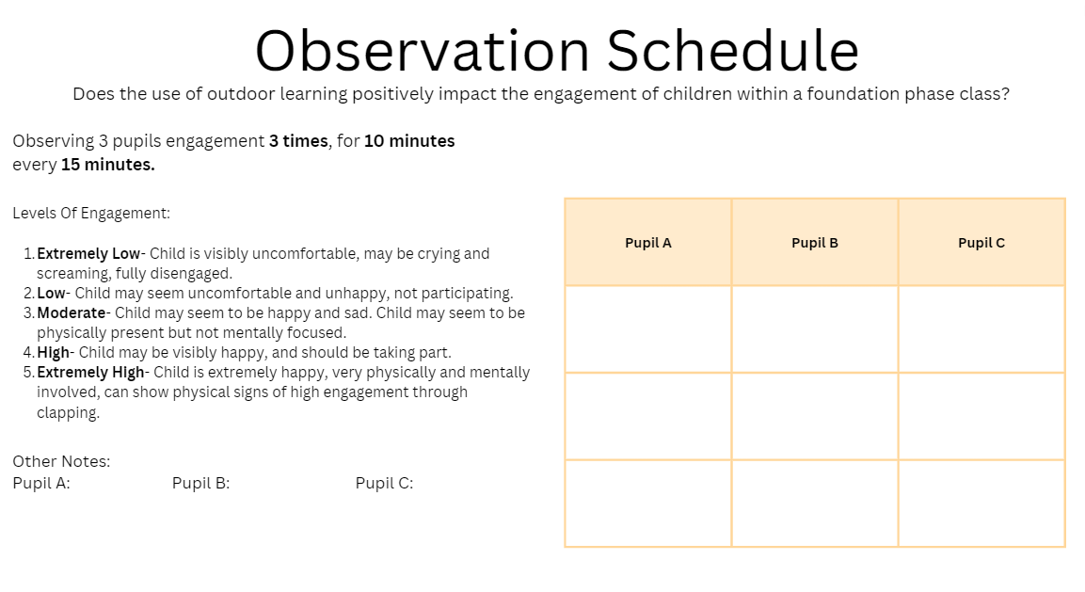
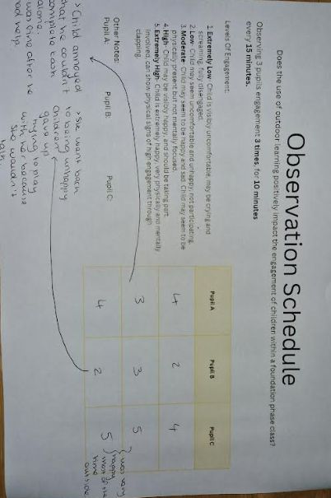

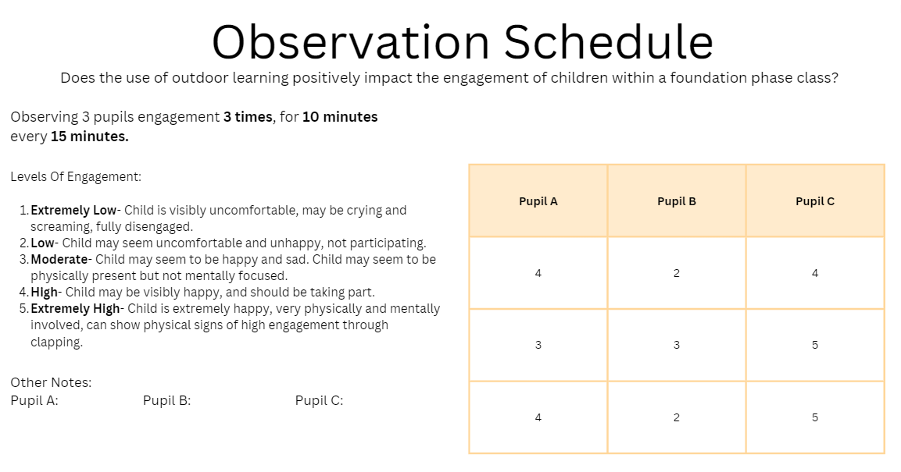





Outdoor Learning Environment:


