TASK DESCRIPTION

Consider each of the following problems and answer all questions.

- Write down the units for the following: [5]

a) Time (seconds(s))
b) Speed (metres per seconds(m/s))
c) Acceleration (metres per seconds squared(m/s²))
d) Weight (newtons(N))
e) Mass (kilograms (kg))

- Given that the equation for density can be written as.

$$density=\frac{mass}{volume}$$

Write down the units of density

Kilograms per cubic metre(kg/mᶟ) [2]

- A body of weight 1200N rests on a rough inclined plane which is at an angle of 25⁰ to the horizontal.

a) Draw a free body diagram in your answer booklet showing the weight, normal reaction, friction and the component of weight that acts down the slope [3]

FN
R
FF

25º

1,200N (FG)

b) Calculate the magnitude of frictional force [4]

63º

25º
90º

90+25=115 180-115= 63º
Friction force= 1200 x Cos65= 507N

c) Calculate the magnitude of the normal reaction to the surface. [4]

Normal Reaction = 1,200 x Cos25= 1087N

- By considering figure 1

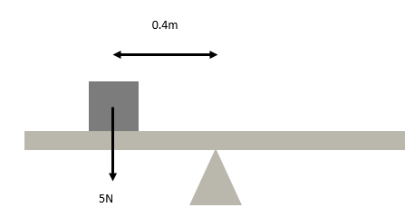

Figure 1

a) Calculate the anticlockwise moment experienced on the see-saw [2]

Moment = 5 x 0.4= 2Nm

b) A 3N weight is placed on the right-hand side of the see-saw to balance it. How far from the pivot should it be placed? [2]

3n x d = 2nm
D = 2 ÷ 3
D = 0.6m

c) Figure 2 consists of a 5m plank that rests on a pivot. A 22.5N weight is added to the right-hand side of the pivot. Determine the distance that the 22.5N weight needs to

be from the centre in order to balance the plank. [4]
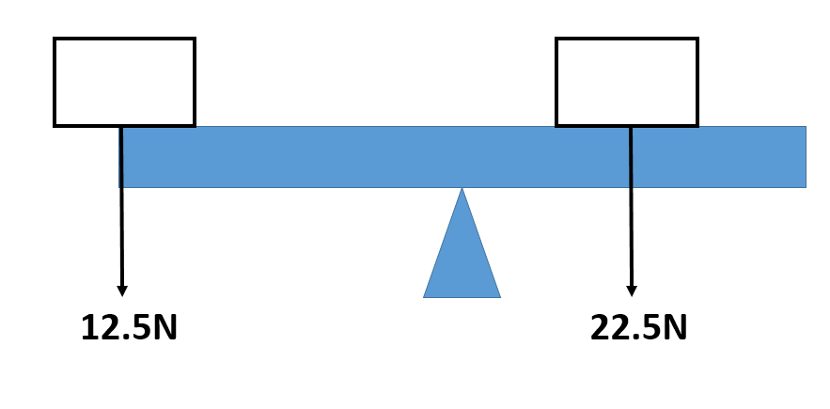

Figure 1

Figure 2

22.5xD= 12.5x2.5
22.5xd=25
D=25/22.5
D=1.1m

- Figure 3 shows a 10m uniform beam of weight 5.5KN which is at rest. The beam is supported by two pillars. Pillar X is positioned 1.2m from the left-hand side of the beam, pillar Y is positioned 2.5m from the right-hand side of the beam.

X
Y
Figure 3

a) Copy this diagram on your answer booklet, showing all forces. [3]


Normal reaction

5.5KN
X
Y

b) Determine both support forces. [6]

6. Solve the following by factorising:

1) $x^{2}+6x+8=0$ [3]

x²+4x+2x+8=0
x²(x+4) +2 (x+8) =0
(x+4) x (x+2)
x+4=0
x+2=0
x=0-4
x=0-2
x= -4,-2
2) $x^{2}+4x+3=0$ [3]

x²+3x+x+3=0
x²(x+3) +x+3=0
(x+3) x(x+1)
x+3=0
x+1=0
x=0-3
x=0-1
x= -3,-1
3)$x^{2}+3x=4$ [3]

x²+3x-4=0
x²+4x-x-4=0
x²(x+4)-(x-4)=0
(x+4)x(x-1)=0
x+4=0
x-1=0
x=0-4
x=0+1
x=-4,1
4) $x^{2}+3x-10=0$ [3]

x²+5x+-2x-10=0
x²(x+5)-2(x+5)=0
(x+5)x(x+2)=0
x+5=0
x-2=0
x=0-5
x=0+2
x= -5,2
5) $x^{2}-5x+6=0$ [3]

x²-5x+6=0
x²(x+1)x(x-6)=0
(x+1)x(x-6)
x+1=0
x-6=0
x=0-6
x=0+6
x=-1,6

7. Solve the following by using the quadratic formula:

(i) $7x^{2}+5x-10=0$ [5]

$$x=\frac{-5±\sqrt{5^{2}-4X7X(-10)}}{2X7}$$

$$x=\frac{-5±\sqrt{{25}^{2}+280}}{14}$$

$$x=\frac{-5±\sqrt{305}}{14}$$

$$x=\frac{-5+\sqrt{305}}{14}$$

$$x2=\frac{-5-\sqrt{305}}{14}$$

(ii) $12x^{2}+5x-4=0$ [5]

$$x=\frac{-5±\sqrt{5^{2}-4X12X(-4)}}{2X12}$$

$$x=\frac{-5±\sqrt{25+192}}{24}$$
$$x=\frac{-5±\sqrt{217}}{14}$$

.
$$x=\frac{-5+\sqrt{217}}{24}$$
$$x2=\frac{-5-\sqrt{217}}{24}$$

x= -0.82, 0.41

8. Solve the following linear equations:

(i) $\frac{5x}{2}=\frac{3x+1}{3}$ [5]

5x×3=2(3x+1)
15x=6x+2
15x-6x=6x-6x+2
9x=2
$$\frac{9x}{9}=\frac{2}{9}$$

$$x=\frac{2}{9}$$

X=0.222…

(ii) $\left(x+5\right)\left(x+1\right)=(x+10)(x+2)$ [5]

x²+x+5x+5=x²+2x+10+20
x+5x+5=2x+10x+20
6x+5=12x+20
6x-12x=20-5
-6x=15
x=-2.5

