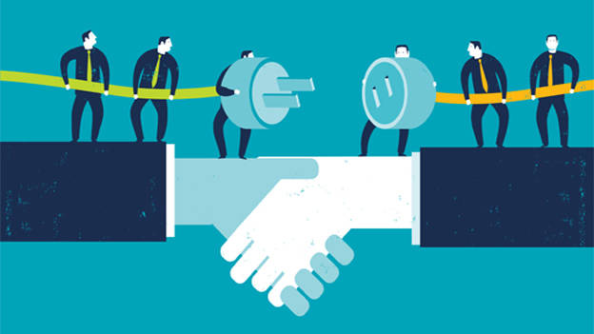  EFFECTIVE TEAM WORKING AND COMMUNICATION(BMSW4002_SWAN) MELANIE SQUIRE | ComMunication within the workplace  VASILICA BETA (1918835) NUMBER OF WORDS:2154

CONTENT

TERMS OF REFERENCE ………………………………………………………………………………………………. 2
INTRODUCTION …………………………………………………………………………………………………………. 3
MAIN FINDINGS …………………………………………………………………………………………………………. 4
CONCLUSION ……………………………………………………………………………………………………………. 10
REFERENCES ……………………………………………………………………………………………………………… 11

TERMS OF REFERENCE

This report was requested by Melanie Squire, Lecturer Skills for the Workplace as part of the assessment for the Effective teamworking and Communication module.
Submission date 01 July 2022.

INTRODUCTION

As part of this assessment, we will discuss the significance of teamwork, as well as the benefits it has for the individuals who form the team. Teamwork makes its members more friendly, open-minded, and ambitious and, as a result, they tend to achieve as a group.
The key to successful teamwork is communication. No matter how it is used, communication must be the main tool used between team members, managers, and subordinate teams.
It will be used a series of theories that must be presented and applied to the case study where Andrea Jones is the new Head of Social Services in the local Council.
Talking about the following:
- The five stages of development by Bruce Tuckman in 1965:

- Forming.
- Storming.
- Norming.
- Performing.
- Adjourning (Tuckman and Jensen, 1977).

- The nine team roles developed by Meredith Belbin in 1981:

- Resource Investigator.
- Team Worker.
- Co-ordinator.
- Plant.
- Evaluator monitor.
- Specialist.
- Shaper.
- Implementer.
- Complete Finisher.

- The importance of communicating in two ways by using the three models learned and which of the three can be used successfully by Andrea in her path to strengthen relationships between members of her teams:

- Berlo's SMCR Model of Communication.
- Shannon and Weaver Model of Communication.
- Schramm's Model of Communication.

- Specific to this case study, why effective communication (verbal and non-verbal) is important for the continuing success of the organization.
MAIN FINDINGS

A very important subject will be a well-known theory that applies to teams from training until they reach the end of the project, namely Stages of Team Development, developed by Bruce W. Tuckman in 1965. For a team to be effective it must be in a continuous evaluation. It must evaluate its decisions, achievements, members, and performance, criteria which are essential to the development of the team.
Since the team’s form, they have to go through the five stages of development made by Tuckman, namely Forming, Storming, Norming, Performing, and Adjourning. Of course, each team develops in different rhythms and ways, but all these stages allow the team to watch and evaluate its evolution (Stein, 2019).
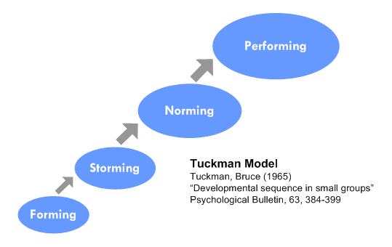
This Photo by Unknown Author is licensed under CC BY-NC-ND
From Andrea's point of view, Tuckman's theory will be a very important tool that she can use in the team she took to lead after accepting the position. It will first have to make an evaluation and find out what the team's problems are. She has to work with great openness to communicate with all members to make them know her better but also between them, which is very important and leads to mutual trust and thus to connections.
When conducting the evaluation, Andrea discovers problems such as:
- Placing teams in different buildings, at considerable distances, makes the team work lose its essence, but also the time lost for moving between them.
- Lack of desire to return to work from the office, as was customary before the pandemic.
- Lack of interest and pleasure in coming to work due to the last Head. By doesn't communicate effectively with the team, they stopped working efficiently which led to a decrease in turnover but also an acute shortage of staff. The remaining team members stopped expressing their ideas because they saw a lack of interest from their manager.
- The need continues for new employees. This means that the teams cannot pass the Forming stage, where the members know each other, develop collegial and even friendly relations, and trust appears which is essential and thus the teams start to work better and have positive results.
- Lack of employees makes old employees face stress, work under pressure, being overloaded with the work of missing employees. Because these employees work as social workers, their decisions can have dangerous repercussions on children.

After deciding to be the new head of social services, Andrea begins to name managers for every team to ensure that each one will be managed properly. Going further with the first stage of development, in which she must be welcomed as a team leader. Then she needs to get to know each member of her team and encourage them to be more open to each other. Once evaluating the teams and their problems, she will decide how they can overcome all these problems (Scully,2020). Then Andrea must find a solution to build a friendly environment that will help her convince her subordinates to return to work physically, to work in the office as they did before the pandemic. She can make them a promise that she will put in place some rewards and recognitions or different team activities that can take place during breaks or even throughout the work schedule (Armstrong,2010).
Returning to office work, rewards and some recognition could help them make friends, connect better with each other, become more confident so they can work better in a team, and ultimately avoid any kind of affection caused by stress, anxiety, etc.
Another very important point that Andrea must keep in mind is to communicate very well with all team members and to be open to accepting ideas from them.
Going from one stage of development to another, the teams will reach the Storming stage where conflicts, divergences of opinion, and ideas will appear. Andrea must have the ability to settle all these divergences and to be able to find solutions to overcome this crisis, have face-to-face meetings with the people in question to see where the whole problem comes from, and calmly communicate to reach a common idea (Veronica,2020).
Once team members perceive Andrea as a colleague and not as a boss and see that their ideas matter and are listened to, they will gain self-esteem and confidence, they start to cooperate better, these elements bringing out what is better from a person. Forming these connections between her and teams, members will no longer want to leave their jobs but will want to stay because they feel wanted and appreciated and thus will try to work as well as possible adding value to the company and successfully solving cases assigned to them (Wallbridge,2021).
Passing from forming to storming, from storming to norming, from norming to performing the teams will become a whole, will work more efficiently, will help each other with ideas and advice, things that will add value to the company will increase their turnover and cases will be solved more responsibly because now they work with pleasure and no stress, being encouraged by the head manager, Andrea. And so following Tuckman's theory, but also using her skills acquired over time, Andrea will succeed in forming and developing an efficient team.

Another theory that needs to be included in this assignment is Dr Meredith Belbin about Teams Roles. In 1981 he developed the theory that the key to a successful team is to have in its component the nine-team roles:
- Resource Investigator.
- Teamworker.
- Co-ordinator.
- Plant.
- Monitor Evaluator
- Specialist.
- Shaper.
- Implementer.
- Complete Finisher.
(Gordon,2022).
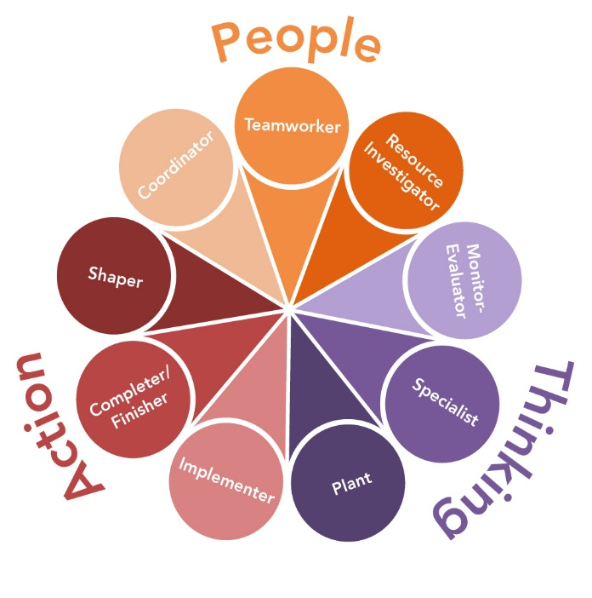
This Photo by Unknown Author is licensed under CC BY

Forward this theory will have to be applied to the given case study. Andrea is in charge of a department that has ninety-six social workers who are divided into eight teams of twelve members each. After putting in place that evaluation and discovering several problems which lead to a lack of staff, a lack of desire to work for the rest, the stress resulting from having a huge amount of work, and the opportunity to put children at risk, she will have to conduct another evaluation and submit each member to a Belbin Questionnaire. After this questionnaire will know what team roles she has in her team and more importantly what team roles are missing. Each team role comes with skills and qualities but also with weaknesses that with the other team roles can form a team that can complete a task or a project (Channell,2021). Once she discovers the missing roles, will have to find solutions to cover them. For this, Andrea will have to communicate the results in a meeting where through communication, involvement, will, and dedication they will discover how they can cover the missing team roles.
By spending time together and communicating they will find close personalities, people with abilities close to those missing roles who in the end in collaboration and with the help of the other team members will be able to fill those roles that they do not have in their composition.

Moving on to the importance of communicating in two ways which of the three can be used successfully by Andrea in her path to strengthen relationships between her team members:

• Berlo's SMCR communication model.
• Shannon and Weaver communication model.
• Schramm's communication model.

In these times when communication is more important than ever, we have these examples that we can follow to understand how communication is put into practice, be it verbal, non-verbal, body language, face to face, or with the help of various forms of technology. In the past by using radio, telegraph, or letters, and due to technological development through text messages, emails, television, and telephone. Some communication models are simple, the message goes from the sender to the receiver through an older form of technology listed above that cannot give the possibility to the receiver to give the sender feedback about the received message.
Andrea having the advantage of the times when the technology is at a very advanced level and her knowledge and abilities in communication are very good, she can use various channels through which she can communicate with the members of her team. Combining her communication skills with different technological ways of communication and also with well-known models developed by various scientists in the past such as Claude Shannon and Warren Weaver (1948), Wilbur Schram (1954), and David Berlo (1960), she will be able to form a cooperative, strong, trust-based team, where members work together to help each other to achieve their common goals. These models are the most commonly used, but in this case study, Andrea can use Schram's communication model as the most appropriate. The advantage of this model is that the sender, after sending the desired message to the receiver through different channels, the receiver can send feedback in which he can communicate that he received the message but through which he can also express his opinions related to the received message (Blythe,2009).
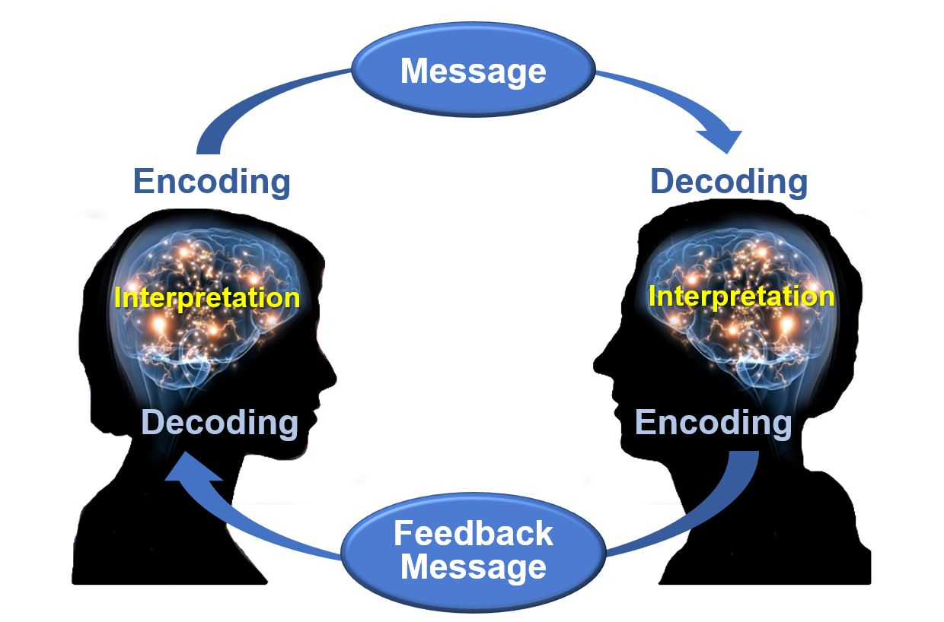
This Photo by Unknown Author is licensed under CC BY

The concept of two-way communication refers to the act of communicating with one another reciprocally between two people or groups (Wiesen,2022).
By sending feedback, the two ways of communication are formed, because after the sender, in this case, Andrea shares his message in different ways with the sender, which is Andrea's team members, the sender can express his opinions in connection with the idea, from the received message. This message from the sender can be done either face to face through a private meeting, it can be done through a brief in which the sender can address several receivers, or by email or text message to each receiver. After each receiver has understood what the sender wants in his message, he can express his doubts, dissatisfaction, or thanks for the message. This type of communication is among the most effective because after the sender receives feedback, be it negative or positive, it will know what to do in the future if what it does is satisfactory or it has to make adjustments, modifications, or improvements that eventually lead to a common point, namely a strong team, eager to work that does everything possible to finish the project successfully.

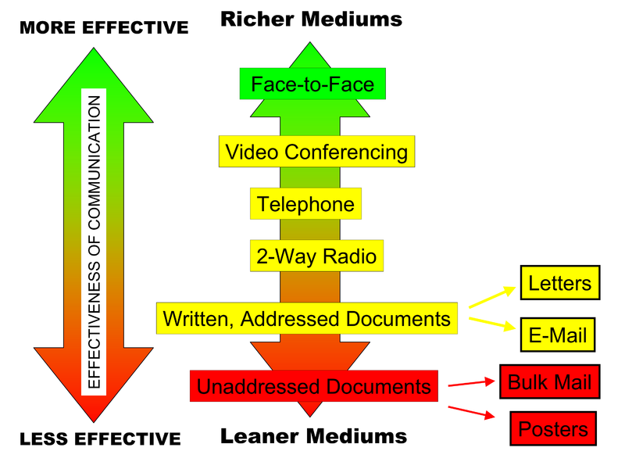
This Photo by Unknown Author is licensed under CC BY
Effective communication
For Andrea to be able to effectively lead the teams, she must have certain skills that will help her to communicate effectively. She needs to know her audience very well, to know whom she is addressing but also how to address them. To be able to express herself showing feelings and empathy for the public, she must have many meetings face to face, avoid the tense environment, be diplomatic, to be calm in expression. Another important thing is that he must know how to listen to ideas, opinions, and thoughts but know how to deal with dissatisfaction or doubts and in the end to offer positive feedback (Effective communication skills,2012).

CONCLUSION

In conclusion, it is observed that carrying out teamwork needs knowledge, theories, personal skills, and previous experiences. Putting all these together form a person who can lead a team to success. Tuckman's stages of development help Andrea on his way to forming a team.
Belbin's theory that each of the nine roles is essential helps Andrea see what characters and mindsets she has to deal with.
Using communication models makes her develop communication skills that will help her develop relationships between herself and team members but will also guide them to become more open with each other.
Effective communication completes the range of skills she has, making her more professional, and diplomatic, transforming her into a good listener, things that will make her accepted and appreciated as a leader.

REFERENCES

Andrew, Wallbridge. (2021), Tuckman’s Model – Forming, Storming, Norming & Performing, Available at: https://tsw.co.uk/blog/leadership-and-management/tuckmans-model/(Accessed:25.06.2022).
Armstrong, M. and Armstrong, M. (2010) Armstrong’s handbook of reward management practice improving performance through reward. 3rd ed. London: Kogan Page.
Deirdre, Scully. (2020), The 5 Stages of Team Development, Available at: https://www.teamwork.com/blog/the-5-stages-of-team-development-what-you-need-to-know/ , (Accessed: 25.06.2022).
Effective communication skills (2012). MTD Training & Ventus Publishing Aps.
Gordon, J. (2022). Belbin Team Roles - Explained. [online] The Business Professor, LLC. Available at: https://thebusinessprofessor.com/en_US/management-leadership-organizational-behavior/belbin-team-roles-definition [Accessed 23 Jun. 2022].
Jim Blythe (2009) ‘The Schramm Model of Communication’, in Key Concepts in Marketing. London: SAGE Publications Ltd. doi:10.4135/9781446221617.n46.
Matthew, Channell. (2021), team roles improve performance in the workplace? Available at: https://www.tsw.co.uk/blog/leadership-and-management/belbins-team-roles/ ,(Accessed: 25.06.2022).
Stein, J. (2019). Using the stages of team development. [online] Mit.edu. Available at: https://hr.mit.edu/learning-topics/teams/articles/stages-development [Accessed 22 Jun. 2022].
Veronica. (2020), Tuckman’s Theory of Group Development, Available at: https://www.eln.co.uk/blog/tuckmans-theory-of-group-development ,(Accessed: 25.06.2022).
Wiesen, G. (2022). What Is Two-Way Communication? (with pictures). [online] Language Humanities. Available at: https://www.languagehumanities.org/what-is-two-way-communication.htm [Accessed 27 Jun. 2022].

