OPTIMISATION OF HIGH SPEED 3 CYLINDER USING RICARDO WAVE
Advanced Computational Methods (M6X00408) – Kyle Cummings (1700852) 12/01/2020

University of Wales Trinity St David: School of Engineering
Motorcycle Engineering

Table of Contents
1. Introduction 4
2. Creating the Excel Document 5
3. Optimising the Ricardo Wave Model 9
3.1 Base Model 9
3.2 Test Run 1 9
3.3 Test Run 2 11
3.4 Test Run 3 14
3.5 Test Run 4 18
4. Comparing Real Data with the Model 20
5. Bibliography 24

Nomenclature

$dn$ Change in Polytropic Index
$dp$ Change in Pressure (Bar)
$dV$ Change in Volume (cc)
$IMEP$ Indicated Mean Effective Pressure (Bar)
$N_{cyl}$ Number of Cylinders
$N_{r}$ Number of Crankshaft Rotations per Cycle
$n$ Polytropic Index
$n_{1}$ Previous Polytropic Index
$n_{2}$ Current Polytropic Index
$P_{I}$ Indicated Power (kW)
$p_{abs}$ Absolute Pressure (Bar)
$p_{cyl}$ Cylinder Pressure (Bar)
$p_{1}$ Previous Pressure (Bar)
$p_{2}$ Current Pressure (Bar)
$RPM$ Engine Speed (RPM)
$T_{1}$ Previous Temperature (K)
$T_{2}$ Current Temperature (K)
$V$ Cylinder Volume (cc)
$V_{D}$ Cylinder Displacement (m³)
$V_{1}$ Previous Volume (cc)
$V_{2}$ Current Volume (cc)
$V_{\%}$ Percentage Volume (m³)

$W_{D}$ Work Done per Degree (J)
$\sum{W_{D}}$ Total Work Done per Cycle (J)
$τ_{I}$ Indicated Torque (Nm)

- Introduction

As part of the Advanced Computational Methods (ACM) third year module there was a requirement to complete a piece of coursework based on the Ricardo Wave software package. Ricardo Wave is a piece of engine performance modelling software used by a large variety of companies in mainstream engineering to predict how an engine would react under test conditions. The software allows the user to build an engine to extremely specific detail and puts it through a series of tests as though it were being run on a dynamometer, this is extremely useful for large companies who want to model their engine performance before putting it into production.

The task as part of the ACM module was to use a previously supplied Ricardo Wave model for a three-cylinder Triumph 675 engine and optimise its performance using various features found in the software. Real experimental data measuring parameters such as cylinder pressure and volume was also provided from the running of the same model of engine on a dynamometer. This could then be used to gain more information and produce graphs using Microsoft Excel, these were then to be compared against the same charts produced in Ricardo Wave via the optimised model. The aim was then to make all these charts as identical as possible to each other through optimisation and hence making the model as accurate as it physically could be.
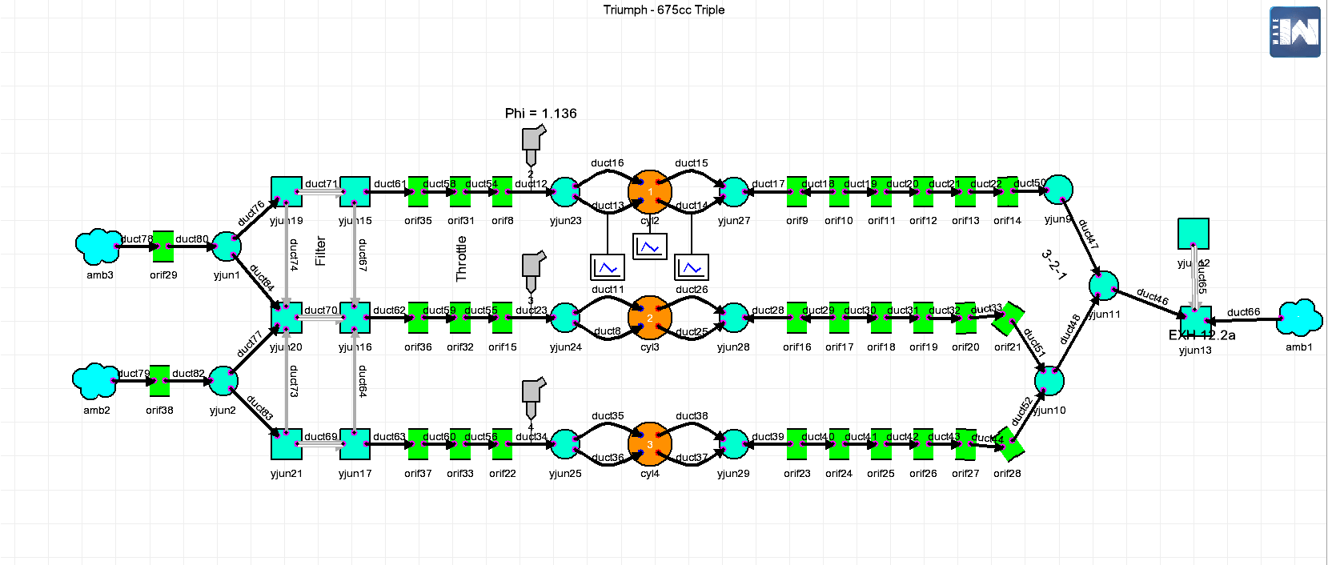

Figure 1 – Originally Supplied Triumph 675 Model

- Creating the Excel Document

Three sets of real data for the Triumph 675 were provided, these were taken from tests at a range of engine speeds – 10250 RPM, 13000 RPM and 14400 RPM. The first step before anything else in this task was to extract the sets of experimental data from its text format and put it into an organised excel format that could be used for graph plotting. The other preparation exercise was transferring some standard provided data for the engine into an excel sheet ready for formula use and as a reference. Once this was all done the already existing columns of data for the full 720-degree cycle could be added to using various formulae from the already gathered data. An example of this data is shown in figure 3 and results shown in figure 2.

The first of these was to change the cylinder pressure in the experimental data to absolute pressure, this was simply done by adding the value of one to all existing pressures as seen in equation 1. The volume also needed to be changed from a percentage to a real value in cc, done using equation 2. Once the new pressure and volume columns have been created the logs of each of those columns are taken to produce two new columns, two more columns can also be formed from pressure and volume – change in pressure (equation 3) and change in volume (equation 4). The log columns are then used to calculate the polytropic index at each degree (equation 5) and change in polytropic index (equation 6) to produce graphs as shown later in section 4. Another column from the original data can be useful when it comes to optimising the Ricardo Wave model without using calculation as the Burn Rate percentage can be used to estimate where combustion starts (1%) and ends (90%). The information that was worked out on where combustion starts and finishes can then be used to show the temperatures at that point (equation 7). The next column over from the temperatures is the work done per degree (equation 8) calculated using the pressure and change in volume at that degree, this value is crucial for the next calculation steps which will ultimately be used to validate the model later on. The first of these values is the indicated power produced over the course of the cycle (equation 9) that uses the total work done per cycle and the number of cylinders in the engine to calculate power throughout the engine. Alongside the indicated power is the indicated torque (equation 10) which will also be used to validate the model along with the Indicative Mean Effective Pressure (IMEP) – equation 11 - using the ‘Wave Post’ program used to evaluate all data from the simulation run.

$$p_{abs}=p_{cyl}+1$$
Equation 1

$$V=\left(\frac{V_{\%}×V_{D}}{100}+V_{C}\right)×1,000,000$$
Equation 2

$$dp=p_{2}-p_{1}$$
Equation 3

$$dV=V_{2}-V_{1}$$
Equation 4

$$n=\frac{\left({Logp}_{2}-{Logp}_{1}\right)}{\left({LogV}_{2}-{LogV}_{1}\right)}$$
Equation 5

$$dn=n_{2}-n_{1}$$
Equation 6

$$T_{2}=\frac{T_{1}×p_{2}×V_{2}}{V_{1}×p_{1}}$$
Equation 7

$$W_{D}=\frac{p_{abs}×100000×dV}{1000000}$$
Equation 8

$$P_{I}=\frac{\left(\frac{\sum{W_{D}}×RPM}{60000}\right)}{2×N_{cyl}}$$
Equation 9

$$τ_{I}=\frac{P_{I}×1000}{\left(\frac{RPM}{60×2×π}\right)}$$
Equation 10

$$IMEP=\frac{\left(\frac{τ_{I}×N_{r}×2×π}{N_{cyl} ×V_{D}}\right)}{1000000}$$
Equation 11

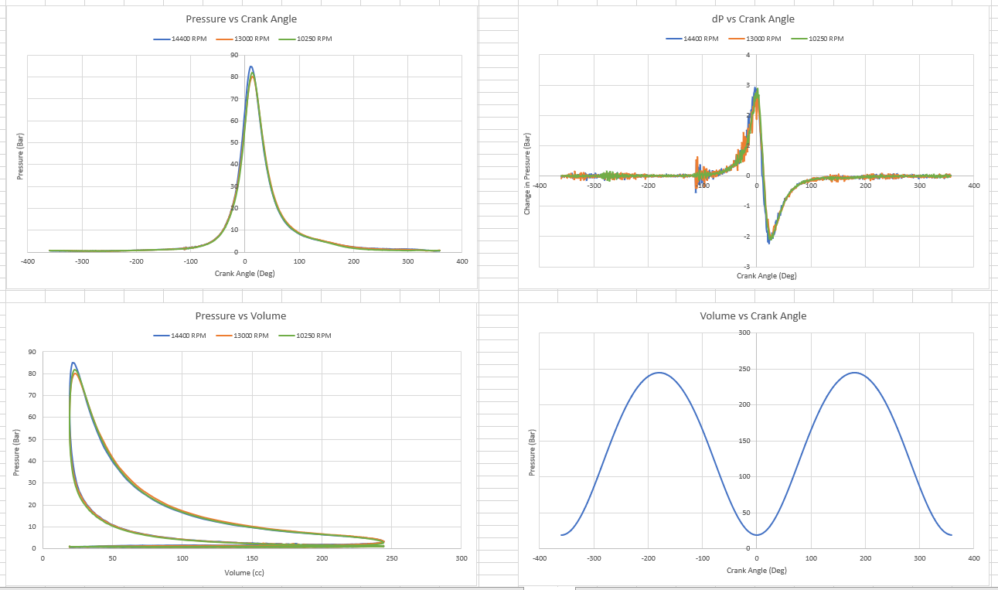

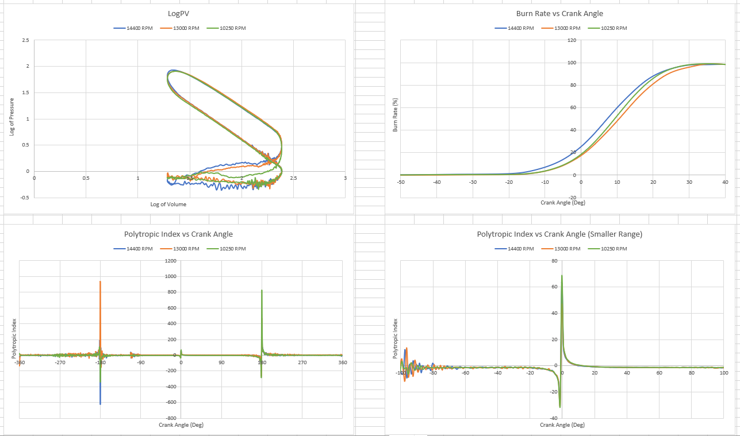

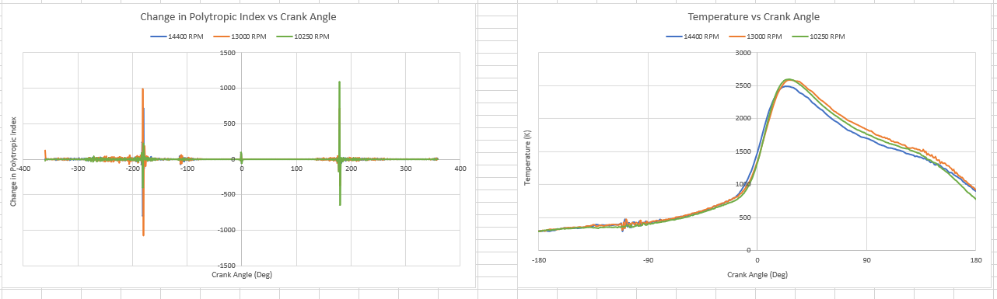

Figure 2 – Original Graphs Created from Excel Data

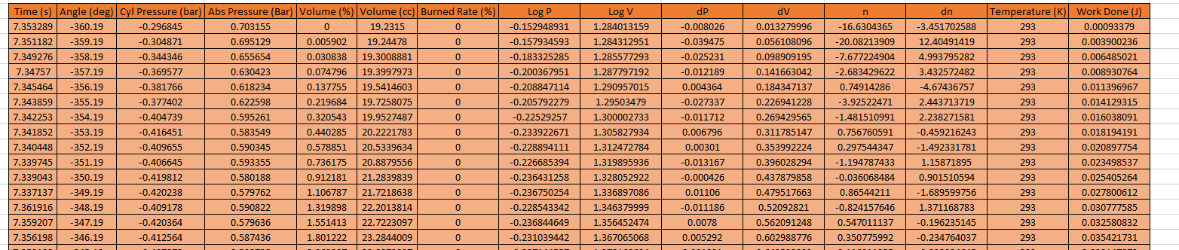

Figure 3
- Optimising the Ricardo Wave Model
3.1 Base Model
The given base model provided for use in the assignment was used for a base in order to reference back to improvements made over the course of the different test runs before finalising the optimised model. The data from these basic runs can be seen below in figure 4.
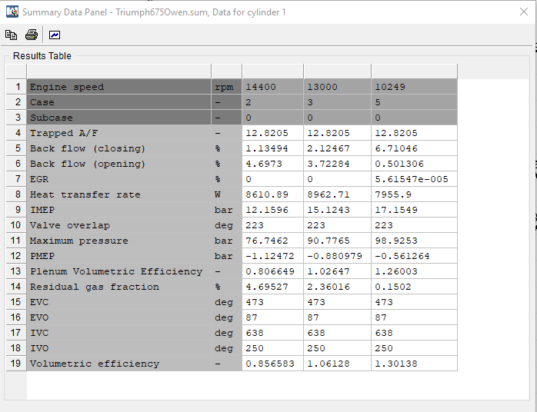

Figure 4

3.2 Test Run 1
The originally provided wave model for the Triumph 675 is extremely basic and has a lot of issues linked to why the original simulation of the given model will produce results that are not very closely linked to the ones in the real excel data. In fact, the model will refuse to run straight from its load up as the valve lift and flow profiles need to be re-added from the model’s files. Once this had been done there were some geometric changes that had to be made in relation to the engine using the engine specification (spec) sheet provided, the first of these were setting the correct conrod length and changing the compression ratio as both of these values were incorrect. Following this, the next change was to set the ambient air pressures and temperatures to those shown in the spec sheet. The biggest changes of all before the first test run however was connected with the previously built excel file. The burn rate column in the excel file was used to determine the burn duration (10%-90%) and the point at which 50% burn rate had been reached in order to create a more accurate combustion profile. This data could then be measured in the simulation by adding new plots set to be measured in the first cylinder. The basic data from these plots are then shown in figure 5. Linking these results back to the original data you can see significant difference just simply by adding the correct geometric and combustion profile data to the model. The pressures have now decreased as have the volumetric efficiencies; this required more changes to be made in order to get the model back to more reasonable values.

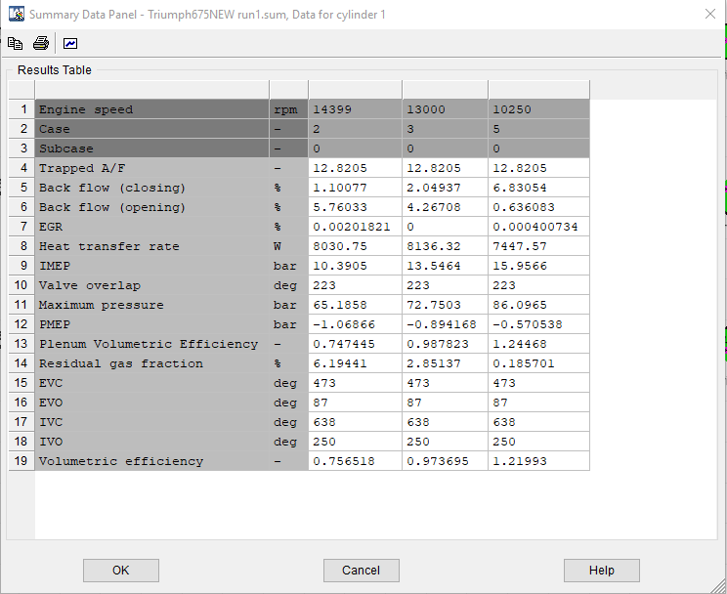

Figure 5

3.3 Test Run 2
The second large change to be made involved correcting the valve timing. This timing changes at what degree the intake and exhaust valves open and close in the engine, this is extremely important as the overlap between the intake valve closing and the exhaust valve opening cannot be too large. The valve timing must also crucially line up with the correct point in the cycle whether that be the exhaust or intake strokes in order to make it work correctly. The initial valve timing from the base model can be seen in figures 6 and 7. To improve this the profile anchor (peak valve lift) is added so that the valve lift cycle can be moved to wherever the desired opening point needs to be. In this case that was at 462 degrees for the intake valve (see figure 8) and 260 degrees in the exhaust valve (see figure 9), this was determined using a different spec sheet for a 2009 Triumph 675 engine (figure 11) which would be considered very similar to the one used in the base model. Both of these opening point values also fall into the correct part of the cycle for each valve and so it is clear this is the required timing point. As the profile uses crank angle against lift the duration of the cycle has been doubled to account for the fact the camshaft would rotate at half the speed of the crankshaft. The results for the second test run following these changes are then seen in figure 10. This change is a significant step forward looking at the results as the pressures and volumetric efficiencies have reduced vastly to numbers that would be close to the expected values. The next problem is the relationship between the pressures and RPM as the pressures get smaller as the RPM increases, this is something unexpected and could be tackled in the next test run as different changes are implemented.
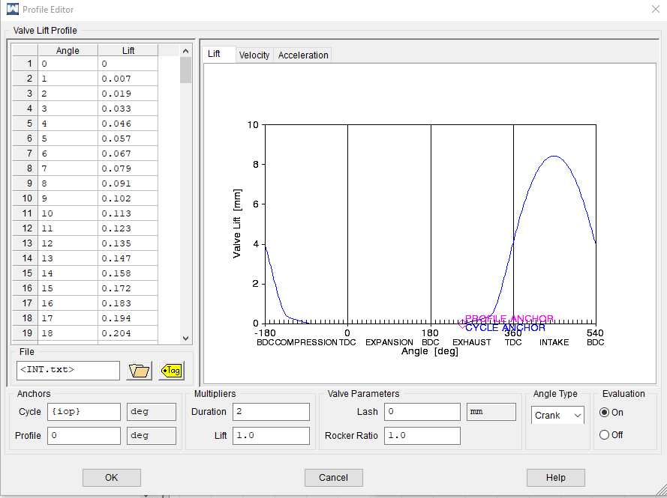

Figure 6

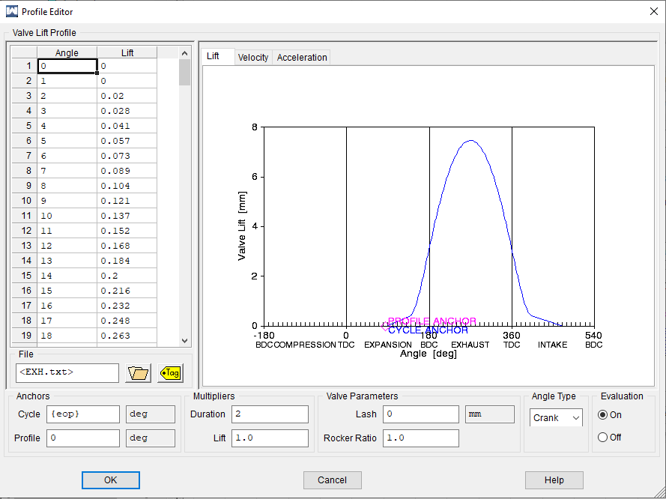

Figure 7

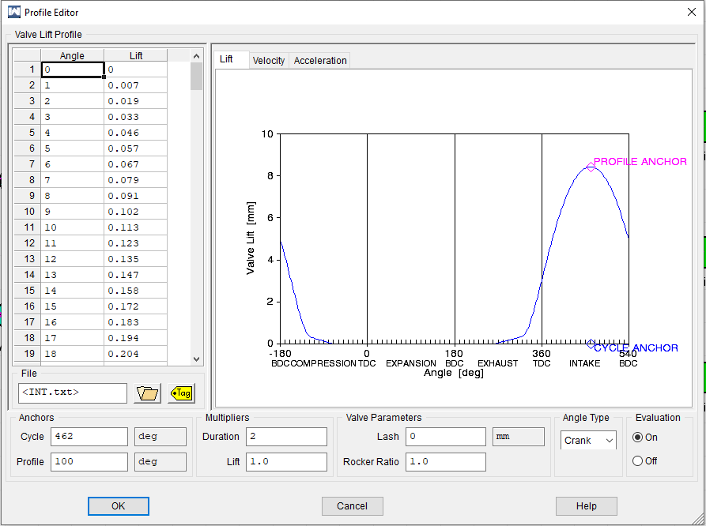

Figure 8

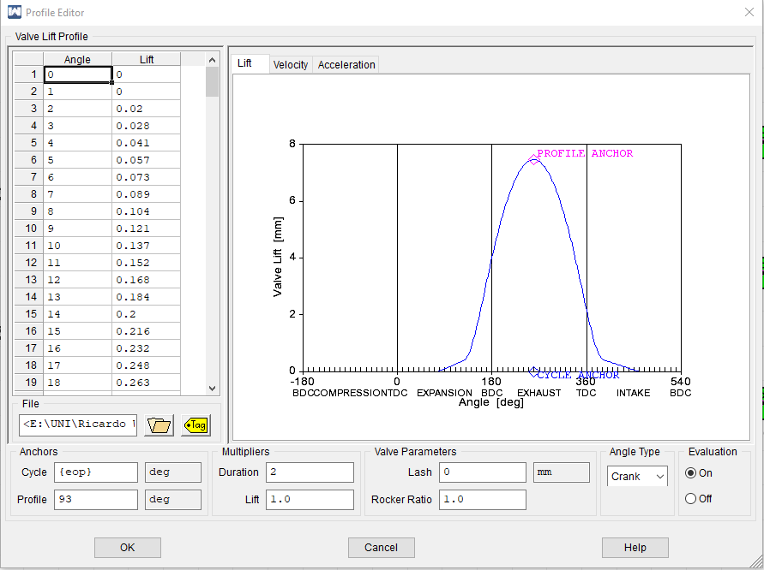

Figure 9

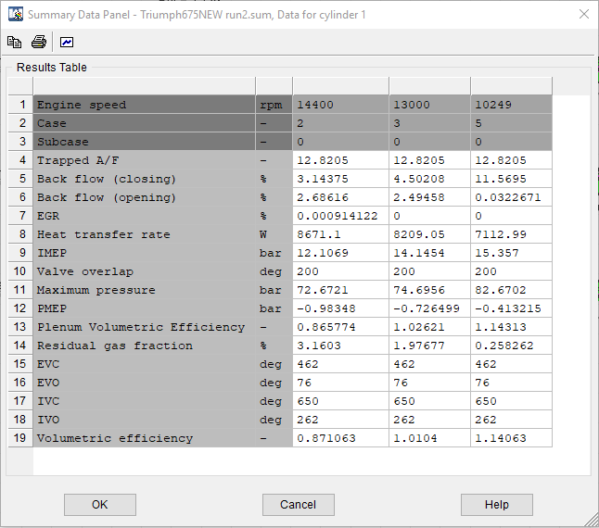

Figure 10

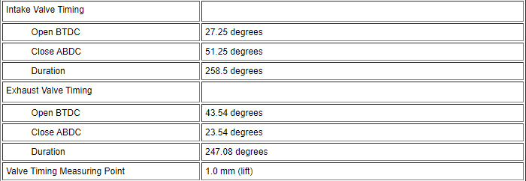

Figure 11

3.4 Test Run 3
To try and improve the relationship between pressures and efficiencies the Wiebe exponent value (Wiebe m) was altered from the default in order to try and give each RPM a more accurate combustion profile. This was done using the Matlab software, previously used in the other coursework piece as part of this module, and the curve fitting toolbox installed as part of that program. Figure 12 shows how the values were determined for the RPM of 10250 while figures 13 and 14 show the results for 13000 and 14400 RPM respectively. The first step in the process was to gather the real combustion data from the excel sheets (crank angle and burn rate) which would be used in the curve fitting process to generate Wiebe a and m values. The data would then be inputted to a curve used to create a fit for the Wiebe values as seen in the top of the results screenshots based on equation 12.

$$y=f\left(x\right)=1^{{\frac{-a(x-\left(-60\right))}{100}}^{m+1}}$$
Equation 12

The Wiebe M values gained from the results were then added into the combustion model via the constants table within the Wave model before the next test run in order to see what effect this could have on bringing the pressures and volumetric efficiencies closer to their expected values. One other tweak made to the model was the increase of the Fuel/Air ratio which was set a little lower than required at 0.078 as opposed to 0.083. As seen in the summary table for this data in figure 15, the pressures have all increased a small amount with the two higher RPM values also seeing decreases in volumetric efficiency whereas this has increased at 10250 RPM. This shows despite the combustion model section of the model being more accurate something else must be wrong as this change has had a more negative effect on the engine at lower RPM even though it had the correct information now inputted.

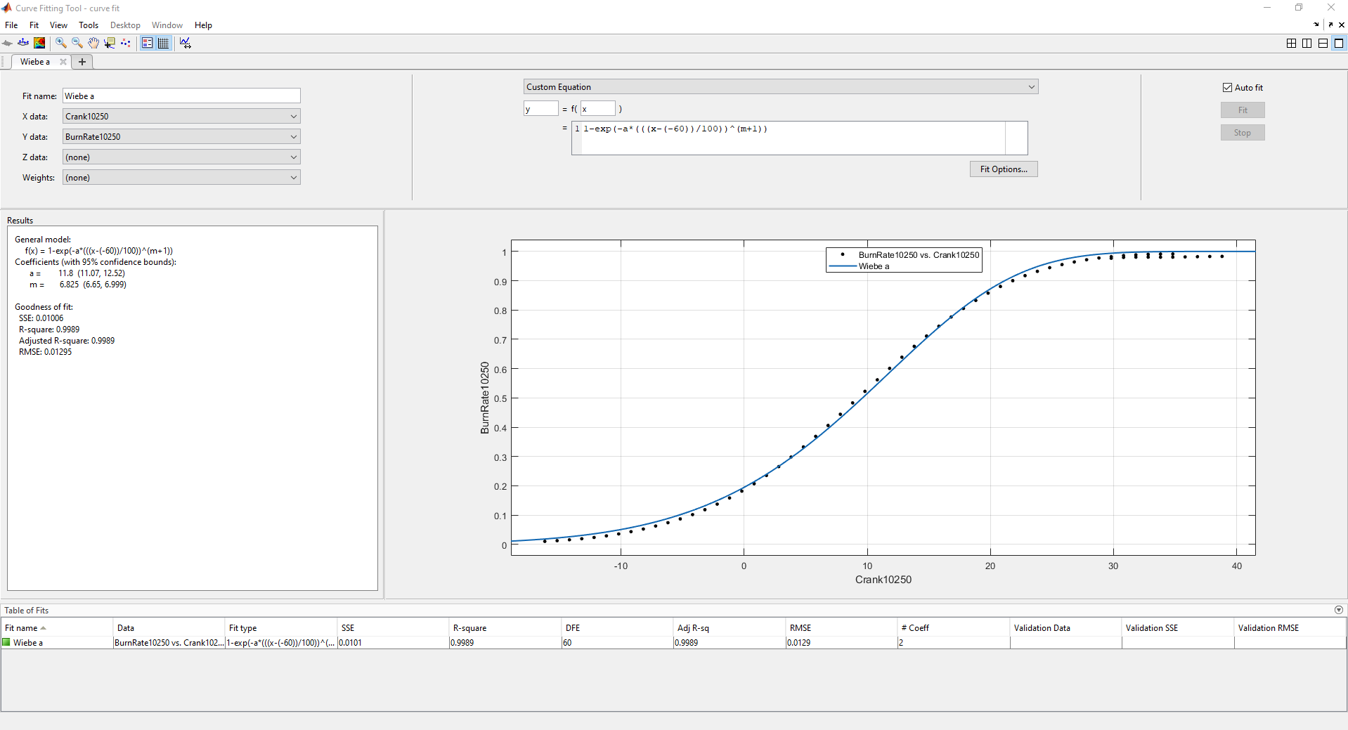

Figure 12
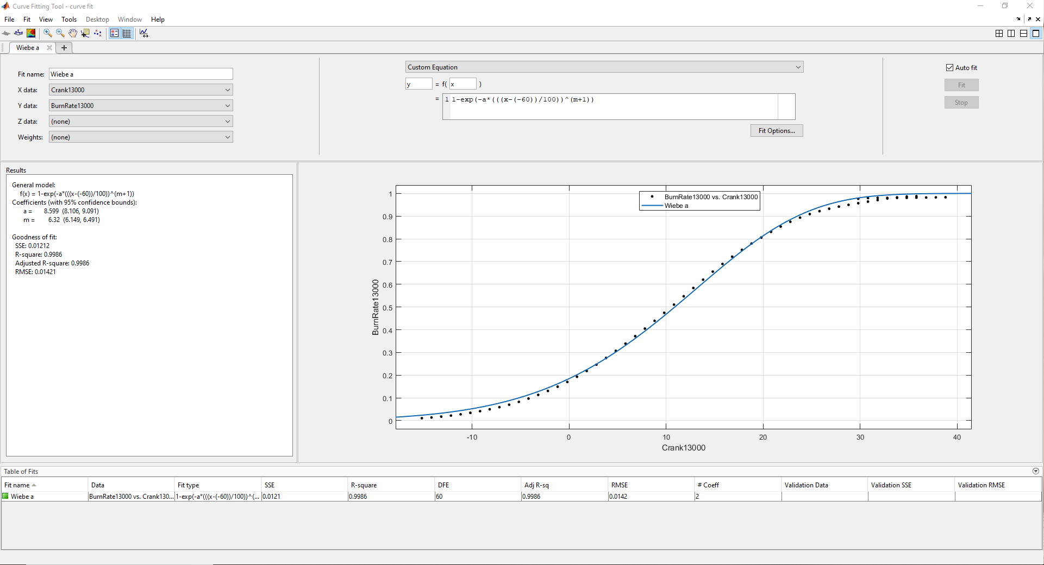

Figure 13

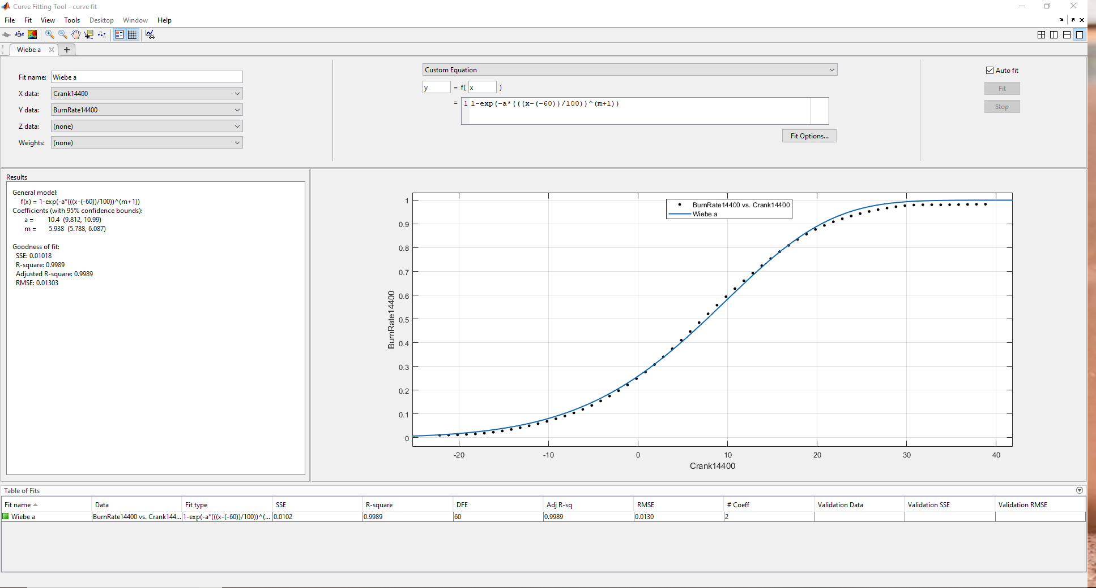

Figure 14
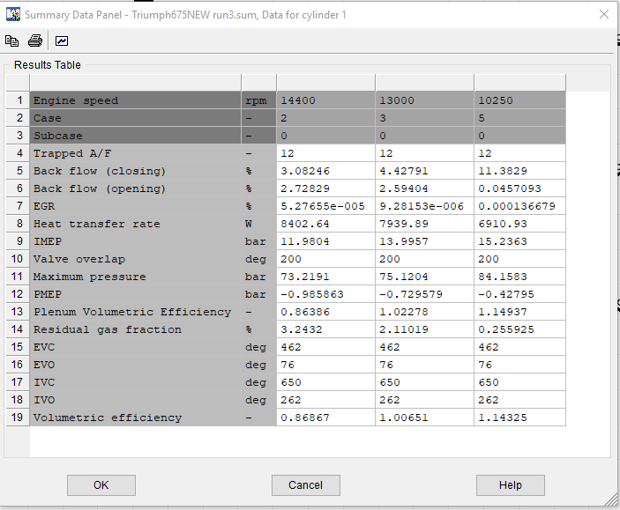

Figure 15

3.5 Test Run 4
The final main test was constructed to see how the volumetric efficiency could be brought down from its inexplicably high state at low RPM. The volumetric efficiency is calculated using mass of air drawn into the cylinder (shown in equation 13), this means the less air drawn into the cylinder the lower the volumetric efficiency. It’s likely that the low efficiency numbers could be having an unwanted effect on decreasing the pressure at highest RPM and this needs to be increased some way in the model. The best way to do that was found via the help files in Ricardo Wave was to change the discharge coefficient within the ambient sections of the model, this would reduce the friction as the air is drawn into the cylinder and hence increasing the previously low volumetric efficiencies.

$$η_{v}=\frac{{\dot{m}}_{air}×n_{r}}{ρ×V_{D}×RPM}$$
Equation 13

The results from this test are shown in figure 16 and give the expected trend, however the improvements are extremely marginal in terms of small decreases in efficiency leading to similarly small increases in pressure. In the 10250 RPM column the pressure was decreased due to the friction being increased here in order to try and bring the efficiency down and hence reduce the peak pressure. These results do however prove that the increase or decrease in friction does affect volumetric efficiency and therefore cylinder pressure meaning this could be the best avenue to look into when trying to make the model even more accurate as it is still unfortunately not close when compared to the real dynamometer data in section 4.

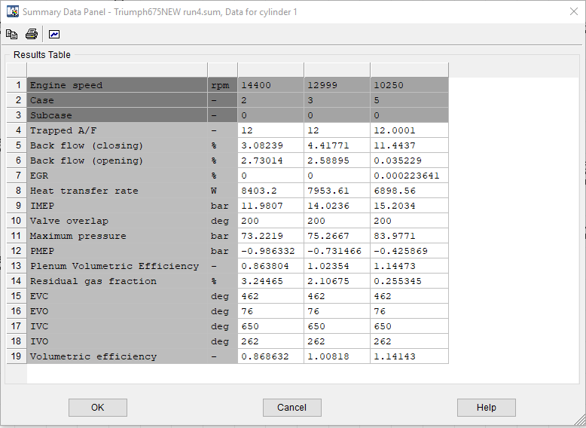

Figure 16

- Comparing Real Data with the Model

As previously mentioned, the aim of the task was to get the model built in Ricardo Wave as accurate as possible in relation to the real measured dynamometer data from the excel file. The only way to really determine how close the model is to the real data is by viewing key parameters graphically as seen below. Figure 18 shows how the PV diagrams compare between the real data and the data calculated after running simulations in the optimised Ricardo Wave model. The main difference is the pressure trend which is known to be incorrect as the lowest pressure according to the real data is found at 13000 RPM however according to the Wave model it is found at 10250 RPM. In terms of the position of the peaks, the peak at 14400 RPM seems to be in around the same place for both the Wave model and the real data meaning the peak pressure is found at around the same position in terms of cylinder volume at that point. Unfortunately this is the only close point to its original graph for the calculated data at 14400 RPM as the low peak offsets the line from its original data making it look like a scaled down version of its original, showing a large differentiation between the two even if the overall trend of the chart is correct. Unlike the 14400 peak however, the other two peaks are offset to a higher volume compared to their real data counterparts and this could be down to the higher volumetric efficiencies seen at these RPMs compared to the peak at 14400. The one overriding positive from this combined graph is that all the lines follow the correct shape throughout the engine’s cycle no matter the RPM, showing the methods followed in the Wave model are not incorrect, it also proves that the valve timing is accurate otherwise the shape of the graphs would be distorted.

The second graph to be combined between real and modelled data is the burn rate during the combustion cycle as seen in figure 19. This graph is used to show the difference between how the fuel burns at different RPMs over the course of the combustion cycle. A large factor in determining this burn rate is the Wiebe values calculated using the curve fitting method in section 3.4 as that could shape or offset the cycle at different crank angles compared to the originally measured data. As in the previous combined graph for pressure against volume the calculated curve for 14400 RPM is the largest difference to its original curve although none of the calculated data from the model is very far away from the original data although this would be expected as the calculated data was partly created using original data. There is no real trend in relation to where the model is not close to the original data other than it starts the main part of combustion either too early or too late in the cycle, however this could likely be fixed with more tweaking as the overall shape and gradients of the graphs are correct.

One other interesting piece of information to look at is the IMEP values for the model found in figure 16. The same parameter was calculated in the excel file from the real data using equation 10 (figure 17) and was found to be similar to the model but just slightly too low on the higher two RPMs and slightly too high at the lower RPM of 10250. Due to it being pressure related however the same issues are found here as in the previous comparisons as the pressure decreases when RPM increases.
These results do show the model is good and close but can definitely still be improved as it is nowhere near close enough to model an engine for an outside organisation such as Triumph themselves. As previously investigated in section 3.5 friction could be a possible reason for pressure loss at the higher RPMs although it is likely to be a larger factor than this at play in order to create such a big differential. If it is indeed volumetric efficiency that is the pre-cursor to the problem involving pressure, then the only real root cause can be the mass of air coming into the cylinder at higher RPMs because all other values in equation 13 are constants and do not change with RPM. Alternatively, this could be a different issue away from solely volumetric efficiency and there could be problems in a different area of the model that have yet to be noticed and the offset in combustion shown in figure 19 may well be connected to these issues. Once the issues with pressure are sorted there is no doubt that this model can be a success making it the obvious place to look when aiming to find areas for improvement, however finding the root cause of these problems are easier said than done. The model in its current state though is by now means terrible and is at least capable of plotting the correct data trends in relation to the graphs shown even if the exact values do not represent that of the measured real data at this point in time. This piece of software can be incredibly accurate once given the time and effort required to make it absolutely perfect and with some finer tuning this model can certainly be much more accurate once its underlying issues are resolved.

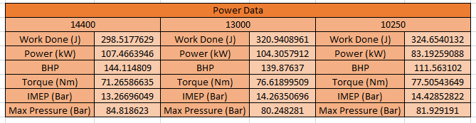

Figure 17

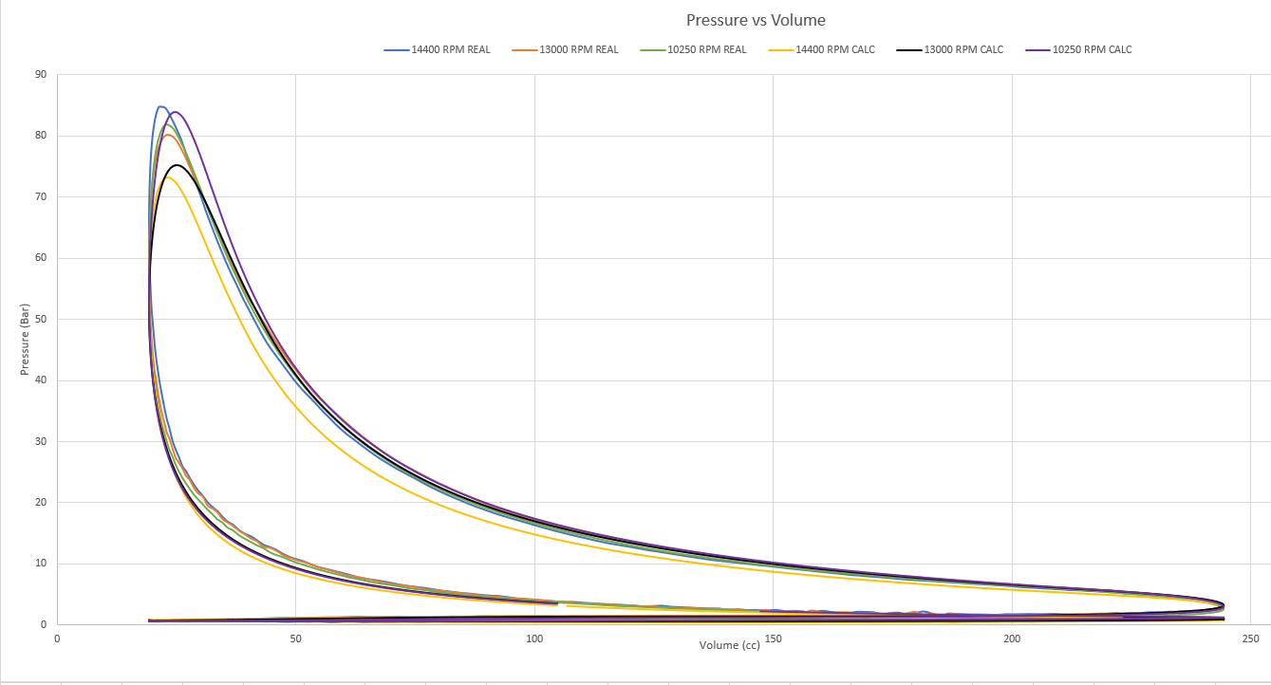

Figure 18

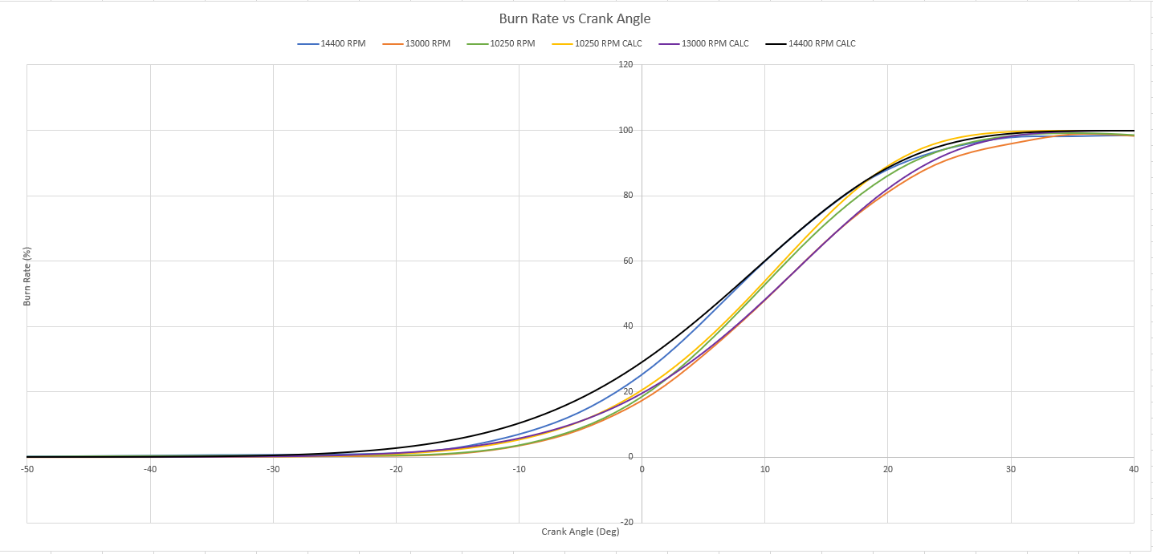

Figure 19

- Bibliography
Gilani, R. (n.d.). Engine Simulation Model for a Formula SAE Race Car. [online] Diva-portal.org. Available at: http://www.diva-portal.org/smash/get/diva2:1025473/FULLTEXT02.pdf [Accessed 20 Jan. 2020].
Triumph (2009). 2009 Triumph Daytona 675. [online] Available at: http://aperaceparts.com/tech/2009%20Triumph%20Daytona%20675.html [Accessed 21 Jan. 2020].
X-engineer.org. (n.d.). What is the Mean Effective Pressure (MEP) of an engine ? – x-engineer.org. [online] Available at: https://x-engineer.org/automotive-engineering/internal-combustion-engines/ice-components-systems/mean-effective-pressure-mep/ [Accessed 22 Jan. 2020].
X-engineer.org. (n.d.). How to calculate the volumetric efficiency of an internal combustion engine – x-engineer.org. [online] Available at: https://x-engineer.org/automotive-engineering/internal-combustion-engines/performance/calculate-volumetric-efficiency/ [Accessed 22 Jan. 2020].

