Homework sheet
1. Practise the key words and phrases on Quizlet
https://quizlet.com/_ahixwa?x=1jqt&i=3xchpx

2. Learn to sing the animal rap:
https://www.youtube.com/watch?v=N2F4mWg0GeY

3. Practise writing the character and the radical
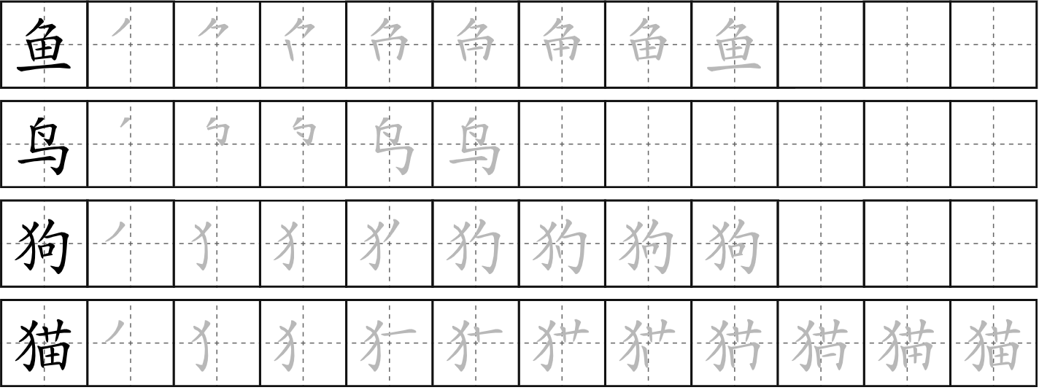
yú
fish
niǎo
bird
ɡǒu
dog
māo
cat

4. Answer the following questions in pinyin or Chinese characters and then translate your answer into English or Welsh
Nia de gǒu kěài ma?
例如：Nia的狗 可爱吗？（✔）
Nia de gǒu hěn kěài。
Nia的狗 很可爱。

Gethin de māo cōngming ma?
Gethin的猫 聪明 吗？（✗）
Gethin de māo bù cōngming.
Gethin的猫 不 聪明。

Caleb de niǎo piàoliang ma?
1. Caleb的鸟 漂亮 吗？（✔）

_______________________
Angharad de mǎ dà ma?
2. Angharad的马 大吗？（✗）

_______________________
Sion de niú pàng ma?
3. Sion的 牛 胖 吗？（✗）

_______________________
Mary de gǒu cōngming ma?
4. Mary 的 狗 聪明 吗？（✔）

_______________________
David de māo kěài ma?
5. David的猫可爱吗？（✔）

_______________________
Peter de yú xiǎo ma?
6. Peter 的鱼 小 吗？（✗）

_______________________
Linsay de shé dà ma?
7. Linsay 的 蛇大吗？（✗）

_______________________

5. Write a sentence in pinyin describing your pets. You can write about the pets you would like to have if you do not have any.
e.g. 我的狗很可爱，我的猫很漂亮。
____________________________________________________________________________________________________________________________________________________________

6. Extensive reading
for KS2:
https://www.youtube.com/watch?v=eVClAj8q_lY
https://www.bbc.co.uk/bitesize/topics/zrd7639/articles/zkgspg8
https://www.bbc.co.uk/teach/school-radio/assemblies-ks1-ks2-chinese-new-year-festivals-lunar-festival/zp993j6

for KS3:
https://chinesenewyear.net/
https://www.bbc.co.uk/bitesize/clips/z49fb9q
https://www.bbc.co.uk/bitesize/articles/zd9nd6f

