

Master of Business Administration
International Marketing: Principles and Practices
LCMB7026

Assessment component 1: Individual report
International marketing mix of KFC in the USA and India
Dakshesh Narendrakumar Patel
2434255
Mustakkima Afrin
Words: 5221
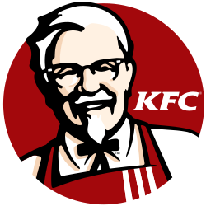
Table of Contents
Section 1: Report 3
1. Introduction 3
1.1 Company overview 3
1.2 Country overview 4
2. Comparative analysis of the market using the PESTLE framework 5
2.1 PESTLE analysis of the USA 5
2.2 PESTLE analysis of India 6
2.3 Comparison of social factors 7
3. Comparative analysis of STP 8
3.1 International Marketing Mix (7Ps) strategies in both countries 9
3.2 Compare and contrast the company’s adaptation of product, price, place, and promotion strategy for both markets, considering cultural and economic factors 13
4. Brand's directional development strategy in India 14
4.1 Competitive strategy 14
4.2 Growth strategy 15
5. Ethical issues 16
5.1 Ethical concerns in India 16
5.2 Ethical concerns in the USA 17
6. Recommendations and conclusions 18
6.1 Recommendations 18
6.2. Conclusion 19
Section 2: 20
Reference List 24

Section 1: Report

1. Introduction
The purpose of the report is to assess the international marketing strategy of one global organisation in two different countries for comparison and contrast. For this report, the chosen brand is KFC, and the brand is operating globally. For better comparison based on social and cultural differences, the chosen two countries are the USA, KFC's home country, and India, where it operates and has expanded significantly. The report is done through macro environmental analysis in both countries, and a comparison between the marketing strategies adopted in both countries. Through this comparison, the brand's directional development strategy and ethical issues are identified, and finally, recommendations are provided.

1.1 Company overview
KFC Corporation is an American multinational fast food restaurant chain which is the second largest fast-food restaurant chain in the world after McDonald's. It was founded in 1930 by Harland Sanders and Pete Harman. Currently, the organisation is operating in 150 countries, and they have 31980 locations all over the world. It is the subsidiary brand of Yum! The brand and its headquarters are in the USA. The current CEO of the organisation is Scott Mezvinsky. They mainly serve fried chicken, chicken burgers, French fries, wraps, soft drinks, desserts, etc.
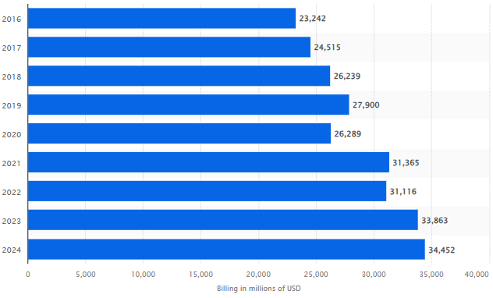
Figure 1: The global revenue of KFC
(Source: Statista, 2026)
According to Figure 1, the revenue growth of KFC has increased from 2016 and in 2021, it was 31365 million USD, and in 2023 and 2024, gradual and slow growth has been recorded (Statista, 2026).

1.2 Country overview
The two chosen countries are the USA and India. The USA is the home country for KFC, and it has 4000 to 4113 locations in the USA and in 2025, approximately $4.9 billion, and it is the largest food chain brand in the USA: however, declining sales by 5% in the first half of 2025 (QSR Magazine, 2025). In comparison, India has approximately 1,200 stores, and growth is also strong (ScrapeHero, 2026).
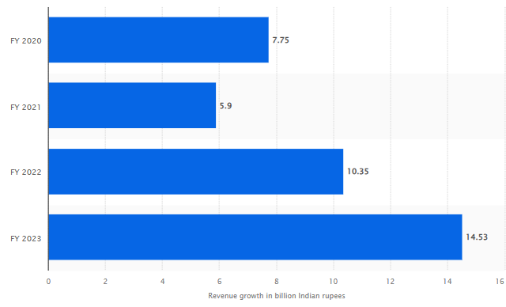
Figure 2: Annual sales of KFC in India
(Source: Statista, 2026)
Figure 2 shows that the growth of annual sales of KFC is good in India, as in 2023, it reached 14.53 billion INR.

2. Comparative analysis of the market using the PESTLE framework

2.1 PESTLE analysis of the USA
Political: The current food safety laws, such as FSMA, the labour laws, and minimum wage laws, impact its operational cost. The USA has diverse global trade agreements, such as USMCA, KORUS, and AUFTA, that can leverage the expansion of KFC (USTR gov, 2026).
Economics: The current inflation rate of nearly 2.4% in 2026 and rising food cost impacts the pricing strategy of the organisation (Trading Economics, 2026). The current global economic downturn also reduces the demand due to lowering the customer spending, which impacts the operation of the brand.
Social: The current consumer behaviour in the USA has shifted towards healthier eating and vegan consumption, which reduces the demand in the region (Heroux et al., 2025). However, the strong brand loyalty and its convenience give it competitive advantages.
Technological: The stores in the USA have fully automated and self-service options, and the use of advanced technologies increases the convenience, so demand is rising. The use of digital ordering apps such as Uber Eats also enhances sales (Shao, 2022).
The tech-based kitchen also improves the quality of food.
Legal: All the food safety standards and employment laws. However, in 2025, the organisation is facing animal welfare-related lawsuits, which were filed by PETA. They even face lawsuits due to false health claims and labour practices impacting their reputation.
Environmental: They are pressured by the environmental agencies in the USA to adopt sustainable packaging and reduce carbon footprint, so they have taken initiatives for sustainable practices (Abdelazim, 2022).

2.2 PESTLE analysis of India
Political: Government regulations on food safety by the FSSAI, as well as taxation policy and FDI regulations, influence KFC's business in India (Khan, 2021). Government policy changes and business rule changes impact its business.
Economics: The current urbanisation and rising disposable income in India increase the demand for fast food consumption. The current economic downturn and price sensitivity among Indian consumers also impact business.
Social: India has a diverse culture, which encourages the brand to localise the menu (Perody and Sudhakara, 2024). The increasing youth population and their lifestyle bring opportunities for KFC.
Technological: The digital technological growth in India and government initiatives towards AI-adoption improve business (Shao, 2022). The usage of social media and the diverse food delivery apps like Swiggy and Zomato brings an opportunity.
Legal: The food safety compliance, labour regulation and environmental regulation increase the operational cost. Strict hygiene and licensing for business impact the brand.
Environmental: The reduction of plastic by government pressure encouraged the adoption of sustainable packaging. Proper waste management and carbon footprint reduction pressure.
An analysis of KFC's business in the United States and India has shown that there are similarities and differences that are critical in the PESTLE environment between the two countries.
Both markets have tough food safety and labour laws, but the regulatory framework, such as FSSAI and GST in India, is more dynamic and complicated, whereas the one in the U.S. is more predictable but expensive because of high wages (Khan, 2021). The U.S. has an advantage in its economic sector due to increased buying capacity among consumers, which allows premium pricing, but in India, the buying power is very high, and KFC must implement value-based pricing and smaller portions pricing. Heroux et al. (2025) identified that differences in social aspects, the U.S. consumers are more convenient and healthier, whereas in India, strong localisation is necessary because of the cultural differences, vegetarian preferences, and religious impact. The two markets are technologically developed, though the U.S. is ahead in terms of automation and innovation, and India is enhanced by the fast adoption of delivery platforms such as Swiggy (Shao, 2022). On the environment, both countries have sustainability pressures which are more regulated and enforced in the U.S. and are emerging in India. So, KFC uses a standardisation strategy in the U.S and a very localised and price-sensitive strategy in India.

2.3 Comparison of social factors
Consumer behaviour
The consumption of fast food in the United States is highly normalised and common. The U.S. is the biggest fast-food economy worldwide, and it produces approximately $799 billion in income, which is an indicator of high reliance on convenience food (Sievert et al., 2025). American consumers also live an individualistic lifestyle that is mostly busy, and this makes them more dependent on fast food restaurants. The consumption of meat is also considerably greater, approximately 80 to 85 kg/person per year, as opposed to significantly lower amounts in India, as per the Business Today (2025) report. This enhances the basic fried chicken model of KFC. Also, according to Boobalan et al. (2022), U.S. consumers are becoming increasingly sensitive to health, sustainability, and functional values, such as organic food, and research indicates that response efficacy, such as health outcomes, is a key influencer in purchase decisions.
Cultural differences
On the other hand, according to The Times of India (2026), the Indian consumer behaviour is influenced by powerful cultural, religious and social values. About 2940 per cent of Indians are vegetarians, one of the highest percentages in the world, owing in part to the Hindu, Jain, and Buddhist beliefs. Meat eating is both low, approximately 4 kg per capita per year and limited even among non-vegetarians, who are restricted by religious or certain days (Business Today, 2025). This makes KFC have to localise its menu deeply, such as vegetarian and non-beef options. Moreover, the Indian food culture is very diverse and socially integrated; food may be a community-based and shared experience and not just convenience-driven. However, according to Ciesla (2025), India is changing at a fast rate. One in every 3 young people in urban areas eats fast food at least twice a week, and online orders of food are on the rise as a result of urbanisation and a change in lifestyle. However, Boobalan et al. (2022) said that, as compared with the U.S., social identity and cultural expression are still important in determining purchasing decisions and not just functional benefits.

3. Comparative analysis of STP
Factors | USA | India
Segmentation | Young adults  Fast-food lovers  Family group | Urban middle-class  Young professionals  Health-conscious  Vegetarian consumers  Students
Targeting | Price-sensitive customer  Heavy use of combo meals and promotions. | Middle and upper-class segments  Veg and non-veg customer group
Positioning | “Finger Lickin’ Good” – tagline used by the company to influence the customer's purchase behaviour | “Taste that unites”- tagline is used specifically for Indian customers.  KFC adopt localised menu and offers an inclusive product range of vegetarian customer group  Modern dining experience influences the customer perception.
Segmentation – The marketing manager of the company takes the decisions to target young adults in USA. It is the home country of the organisation where the popularity of the KFC chicken item is high among the young adults (Business Today, 2025). For India the marketing manager targets urban middle class population. The affordability rate of this group is high compared to rural population.
Targeting – Based on the interest of custosmer, KFC target audiences in USA. Busy lifestyles create high demand for heavy meal and combo offers which target by the company. In India, KFC focus on cultural diversity and target both vegetation and non-vegetarian custosmer group (Shao, 2022).
Positioning – Selecting the right positioning strategy is highly essential for a company. KFC select different tagline to influence the purchase decisions of customer (Shao, 2022).
The above STP analysis provides a clear idea that the organisation has segmented the customer group for different countries, as per the social and economic status of the customer. The marketing manager of the organisation selects the targeting strategy which improves the brand position in the market (BATTILANI, 2023). The company is highly aware that USA customers are highly price sensitive, and their shifting nature is prominent. Due to this erosion, they offer value-based products to the customer, such as combo meals, which have high demand among the young professionals. At the same time, for Indian customers, KFC emphasis on vegetarian food range (Wang, 2022). As there is a mixed cultural group in this country, the marketing manager develops an effective plan to influence the customer group.

3.1 International Marketing Mix (7Ps) strategies in both countries
Product
Selecting the right product strategy is highly essential for an organisation. The marketing manager of KFC select distinguish product strategy for both locations. In the USA, the company emphasis on the heavy meal, which has high demand among the young professionals. During the work break or lunch, young professionals prefer to get an affordable meal option which offered by the KFC (Dukut, 2024, December). The core menu of KFC in the USA is a sandwich, a chicken bucket and a heavy meal combo. The company is mainly following a localisation strategy to develop the product portfolio.
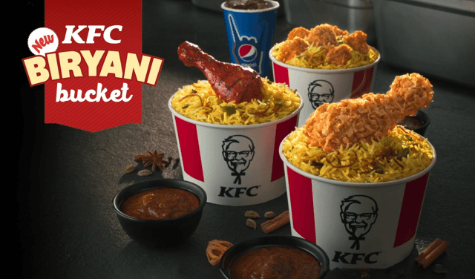
Figure 3: Localized product menu in India
(Source: Brands Pe charocha, 2026)
In India, the company is offering extensive localised food items. The company has both veg and nonveg option to target the audience in India. The veg item of KFC is highly popular in the north and south (Arjun, 2025). The extensive localised food items of the company include spicy chicken variants, rice bowls, regional flavours, vegetarian burgers, etc. The company adopted the menu as per the cultural norms in the market. It ensures that the company avoids any cultural issues or regional issues. Mainly, the company ignored beef and pork in their menu in India to value the customer beliefs.
Price
The pricing strategy of an organisation plays an important role. Selecting the right price for a product is highly essential. It has been found that for the USA, the company take the decision to follow a value-based pricing strategy. Value-added pricing strategies ensure that the company offers a premium product segment at a premium price (Kasian, Zozula and Buniak, 2023). The price range is justified in the USA market to maintain the value of the organisation. Along with this, the company offer several deals and offers to increase customer engagement rate.
In india, the marketing manager selects a competitive pricing strategy to strengthen the position. There are several similar companies operating businesses in this country, which increases the competition level (Brands Pe Charcha, 2026). Dominos, McDonalds, subway etc are the consistent players in this market. KFC offer budget meals to the middle-income customers, which influences the psychological behaviour of customers.
Place
Selecting the right place for the outlets is another important factor which highly emphasised by KFC. KFC target the high traffic areas in the USA, malls and highways. The main reason for targeting this location is that it creates high attractiveness among the customers (Malaysia, 2022). A prominent presence in the crowded location ensures that the company can draw the attention of customers.
In the case of India, KFC targets urban centres, high density area and malls. The company is heavily reliance on the online food delivery platform in India. As per the current data, it has been noticed that Indian customers prefer to order online to get rewards and the best deals (Arjun, 2025). This increases the dependency on this platform.
Promotion
Promotional activity of an organisation determines the brand awareness in the market. The USA is a digitally well-connected market. Due to this reason, the marketing manager uses an influencer marketing strategy to dominate the decision (Dania and Sari, 2023). TV ads and billboards are common channels to promote the product. Nostalgia-driven campaigning allows the organisation to generate steady sales. An omnichannel marketing strategy is a successful strategic decision to create high awareness in the USA.
Digital marketing strategies are currently used by the company to create high awareness in the market. Student discounts and festival promotion through social media campaigns allow the organisation to increase engagement rate (Chea, 2023). Localised ads emphasis on the festivals and systems which develop an emotional connection with customers.
People
The people management strategy of a company is dependent on its social and cultural values. For united states of America, KFC offers training and growth opportunities to its employees (Chea, 2023). A standard working process is followed by the executive across all the outlets.
At the same time, in India, the company offer training programme to the employees to deliver high quality service to the employees. As per the cultural sensitivity, the company determines the organisational culture to restrict the values and beliefs (Dania and Sari, 2023). It helps to get the cooperation from the employees.
Process
The USA process of KFC is designed with a fast service system. Standardised cooking method is followed by the organisation across all the outlets. In the USA, the company follow franchise business model to maintain the same standard and quality (Chea, 2023).
In india KFC's adaptation differentiation strategy values the cultural beliefs (Malaysia, 2022). Vegetarian and non-vegetarian kitchen segmentation develops a loyal customer base in the market.
Service includes in India,
- Standalones dine-in outlets
- Pickup + takeaway combos
- Delivery integrations (Zomato, Swiggy)
- Cloud kitchens for delivery-heavy zones

Physical Evidence
KFC follow iconic red and white branding strategy in the USA to influence customers. All the restaurant in the USA is designed with white colour terms. Colonel Sanders' logo is prominently displayed in all the outlets (Dania and Sari, 2023).
As per, Shyam Future Tech (2026), In India, KFC adopt contemporary model and design for restaurants. Digital menu offered by the company and self-service to target the young customer.

3.2 Compare and contrast the company’s adaptation of product, price, place, and promotion strategy for both markets, considering cultural and economic factors
The overall evaluation of the marketing mix develops a clear understanding that the company value the cultural designs of each market. By considering the cultural values of the USA, KFC adopted a fast delivery service. As the USA customers prefer convenient service and convenient meal option KFC designed the same to maintain the engagement (Kasian, Zozula and Buniak, 2023). The high disposable income of USA customers allows the company to follow different strategies in the USA and India.
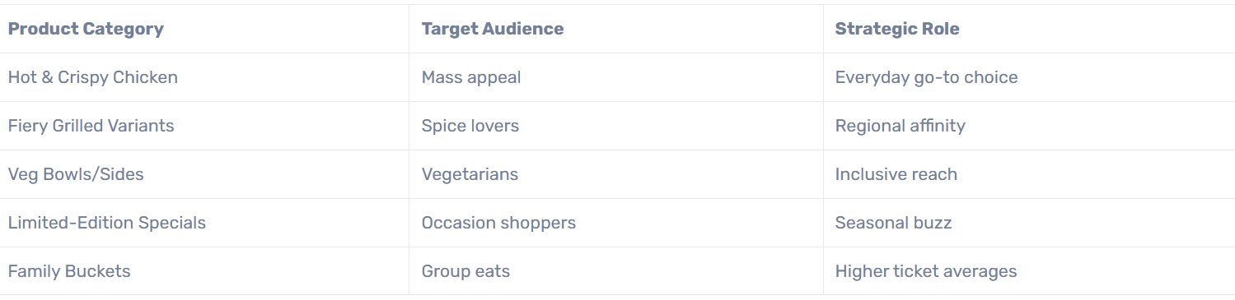
Figure 4: Strategy for Indian customer
(Source: Brands Pe charocha, 2026)
For a middle-income country like india, KFC adopt competitive pricing strategies which determine the price as per customer sensitivities. Cultural restrictions in India influence the design of a vegetarian menu to develop a strong brand position in the market (Dukut, 2024, December). Consideration of economic and cultural factors ensures a stable growth in both regions. In the USA, the company emphasis on convenience and heritage system, while in India, it is focused on localisation, affordability and cultural beliefs (Wang, 2022). This dual approach of KFC highlights how the brand balances the consistency in diverse locations to add highly competitive advantages and growth.

4. Brand's directional development strategy in India

4.1 Competitive strategy
In Porter's generic strategy, there are mainly three strategies which can give competitive advantages. Cost leadership strategy deals with reducing the operational cost for maintaining competitive pricing, whereas differentiation focuses on making unique products or services and focuses on niche markets or products (Bhat et al., 2024).

Figure 5: Porter’s generic model
(Source: Bhat et al., 2024).
KFC uses the cost leadership strategy in the Indian market to align with the local market conditions. Indian consumers are price sensitive, and there are a huge number of global competitors like McDonald's and local competitors such as Wow! Chicken, so they have to offer competitive pricing. Even though most of the population in India is middle-class, the strategy makes the products affordable for Indian consumers, for example, they offer meals at 99 rupees or budget-friendly combos or Wednesday discounts (Business Today, 2024).

4.2 Growth strategy
The Ansoff Matrix would be a good model to examine the directional development strategy of KFC in India, especially through market penetration, product development and market development with the backing of recent evidence.

Figure 6: Ansoff matrix
(Source: Self-developed and idea taken from Zugay and Zakaria, 2023)
Product development (Strongest strategy):
KFC India has a very strong cultural and health-driven consumer behaviour as it tends to adapt heavily to its menu. Indeed, as an example, the recent project, according to Afaqs (2025), article, KFC Smarter Indulgence menu contains grilled chicken, whole wheat buns, and less fat, which indicates the increasing health awareness of Indian consumers. Also, localisation is critical; industry reports by Pardeshi and Samanta (2023) indicate that about 30-40% of Indians are vegetarian, and KFC has to provide paneer-based and veg-based menu items that match the local preferences. This is why product development should be considered one of the fundamental drivers of growth.
Market development:
KFC is also moving out of major urban centres to Tier 2 and Tier 3 markets by accessing the emerging demand (Indian Retailer, 2026). Store network expansion is reported at a rate of about 19% CAGR from 2018 to 2022, and it has been aggressive in expanding to smaller cities where the demand for fast food is increasing (Pardeshi and Samanta, 2023). This is in line with the rising urbanisation and rise in the middle class, hence the market development has become a major directional strategy.

5. Ethical issues

5.1 Ethical concerns in India
The ethical business issues that KFC in India has been portrayed with, especially on animal welfare, quality of food, cultural influence, and consumer health, have been evidenced using cases.
Issues on animal welfare: Among all, the most important moral issue is that of activists like PETA, who claim that KFC is cruel to the chickens (PETA India, 2026). Research and activism have highlighted the issue of ill-treatment of birds in the poultry farms, which brings serious concerns regarding the practice of humane sourcing. This has resulted in protests all over the area.
Issues of food safety and quality: Regulatory inspection showed that KFC products in India supposedly contained too many food additives, such as monosodium glutamate (MSG), and their content sometimes was far beyond the legal level. The issue raises some doubts about ethical adherence to food safety and consumer safety.
Health and nutrition issues: KFC has been accused of marketing junk food, which is high in fat, processed foods and has led to poor eating habits. Surveys have expressed concerns about the high MSG and low nutritional value, which has brought ethical questions of whether there is any responsibility for the health of the people, as per The Hindu (2024) article.
Cultural and social impact: The cultural activists and farmers opposed KFC, claiming that Western fast foods pose a threat to the food culture of India and the local systems of agriculture in India. This creates ethical issues of cultural homogenisation and economic displacement.
Consumer boycott of KFC: Elshaer et al. (2025) demonstrate that KFC faces issues from consumers boycotted with growing ethical and social values, which influence brand trust and performance. This depicts the increase in ethical consciousness of consumers.
Labour practices and working conditions: Low wages, the use of contracts and excessive work pressure have been criticised in the Indian QSR industry by KFC (Hussain, 2023). It has been reported of low job security and welfare of employees, which creates ethical issues regarding fair labour practices and adherence to employment standards.
Sustainability problems of the environment: KFC has been accused of using too much single-use plastics and packaging waste. As environmental awareness is growing in India, sustainability responsibility and environmental impact are concerns in such practices.

5.2 Ethical concerns in the USA
KFC, in the United States, has experienced a number of ethical concerns, especially in the areas of animal welfare, transparency, and corporate responsibility, which have been backed up by verified evidence.
Animal Welfare concerns: Among the most outstanding ethical challenges are claims of inhumane supply chain management by KFC. Studies by PETA showed that chickens contracted by KFC were overcrowded, mis-handled and sliced inhumanely (BATTILANI, 2023). Birds were reported to be crippled by their own weight because they grew fast and were in such bad conditions. Undercover videos also depicted the mishandling of chickens by the workers, including breaking beaks and retaining birds in overcrowded areas.
False advertising and transparency problems: Albarq (2023) said that KFC was alleged on claims about its animal welfare activities. The company had asserted that they treat the chickens humanely, without any pain or injuries, but later withdrew these statements after being sued. This raises ethical issues about integrity and disclosure in marketing by the company.
Failure to use higher welfare standards: according to Flavour 365 (2026) report, the latest criticism argues that KFC has not embraced the Better Chicken Commitment (BCC) in the U.S. as other competitors have. This has given rise to the allegations that the company is lagging behind in terms of enhancing the welfare of the animals in the largest market.
Supplier responsibility issues: Bakery & Snacks (2017) report shows KFC has also been urged to provide bad supervision of suppliers. Investigations revealed that there was unethical conduct in the supplier facilities, which prompted one to question the accountability of its supply chain.

6. Recommendations and conclusions

6.1 Recommendations
- Tiered Pricing Models – The marketing manager of KFC can make the decision to follow a tiered pricing strategy in developed countries like the USA. It maintains premiums brand image in the market and reinforces brand heritage. For emerging markets like India, KFC is required to emphasis on the student-friendly combos for better positioning.
- Digital-First Promotion – To engage young customers in the location, the company required top emphasis on digital-first promotional activity. This activity ensures that young customers are aware of the company's product and service offer by the company. AI-driven personal adaptation strategy enhances customer satisfaction rate. KFC is currently started to use standardised processes, bulk sourcing and economies of scale, which help to maintain lower prices of the products, and they can expand their outlets in the Tier 2 and Tier 3 cities of India by using digital technology. the emerging trend allows the orgagnsitation to utilise the advanced system for expansion. Digital first approach ensures the stable growth and increases purchase retention.
- Sustainability and Health Positioning – KFC required to introduce eco-friendly packaging in Usas and India. As per the macro environment analysis, customers are highly aware of sustainability. In this respect, emphasis on this factor helps the organisation improve the brand value in both regions. A healthier product option can attract the health-conscious customer.
Based on the current environment and considering the cultural values, the recommended plan is proposed. Following these proposed recommendations ensures that there is an opportunity to develop long-term resilience in the target locations.

6.2. Conclusion
This is a comparative study of KFC's marketing mix. KFC is an American brand, and it also operates successfully in India. By evaluating the PESTLE analysis, it is found that in India, the external environment and the current technological advancement and simple regulatory aspects help the company to expand. In the USA, the popularity of KFC is huge, but its growth has declined. Then its marketing strategy using STP and the marketing mix model is compared between the two countries. Then its directional strategic growth is discussed in India, and its ethical issues in India and America both are compared, where it is found that it faces more ethical concerns in India.

Section 2:
Gibbs reflective cycle
Completing an assignment is based on the personal skillset, and knowledge is highly essential. To share my experience, I am going to use Gibbs reflective cycle. Gibbs reflective cycle is consistent with 6 steps – description, feelings, evaluation, analysis, conclusion and action plan. Below, I step-by-step mentioned all the processes which are followed to complete this assignment.
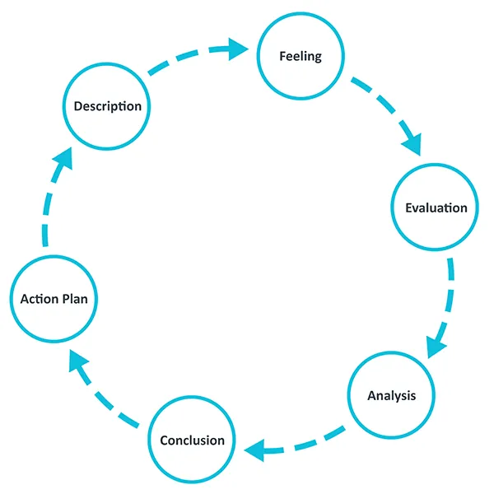
Figure 7: Gibbs reflection
(Source: Ed.ac.UK, 2026)
Description
I have selected a company which is currently operating in multiple regions. Selecting an appropriate company as per the brief is highly essential. I try to maintain relevance with the current time. It helps me to find the best results in the online sources. I have collected all the recently published data of KFC to develop a clear knowledge about the current strategy and policy followed by the organisation (Malaysia, 2022). I have used the recent data and information to know that in which way the company expands its business in multiple regions. I have realised that to evaluate the organisational scenario, it is essential to conduct a macroenvironment analysis. The external business environment provides broad knowledge of how an organisation can change its performance over time. There are several external factors which impact the process differently. I have used PESTLE analysis to evaluate the scenario. I have emphasis on the social features because it helps me to know about the current behaviour of customers, which shapes the marketing strategy of KFC. I have found that, based on the current trend in the market, the managing committee selects the marketing plan which improves the brand engagement rate (Kasian, Zozula and Buniak, 2023). Over time, new segment is developed by the company to add value. PESTLE analysis helps me to identify the directional position which followed by the company follows to remain competitive.
Feelings
I have developed a broad and comprehensive knowledge of marketing strategy after completing this assignment. This assignment helped me to develop the idea that it is essential to have a strong idea about the current trend in the market. It helps to formulate the strategic decisions for the company (Dania and Sari, 2023). I get the opportunity to improve my critical thinking skills from this assignment. Because it helps me to think differently while comparing the business environment, ethical issue and marketing mix. I feel that without the help of strong critical think skills, it is very difficult to analyse a company's business strategy in different locations.

Evaluation
I have used the recently published data of KFC to identify the ethical issue. In different locations, different ethical issue is involved. I have used the keywords to find the most authentic data. I feel that collecting data from the company website, annual report, and newspaper helps me to maintain the overall quality. In this respect, I want to add that I have selected a company which is popular in the market. There are wide sources available to get rich insights. The company has its own website and social sites from which I can get the insights. I have used social media analytics and data to evaluate the feedback in the social site, and ratings help me to develop the perception among the customers regarding KFC (Chea, 2023). Proper knowledge of the research and data analysis helps to complete each section properly on time.
Analysis
I have a learn from this assignment that it is highly essential to have a strong knowledge about the recent preferences of customers. Without knowing the current preference of the customer, it is very difficult to design a plan. I have noticed that currently, the organisational leaders are using advanced tools and techniques to get unique insights into customer behaviour. I have decided that I will develop the knowledge of digital tools and technology to improve performance. Developing knowledge ensures that in future I can work efficiently by using digital tools and technology. There is a particular process and system to collect the data regarding customer preference which I did not know (Arjun, 2025). I have realised that the job market is highly competitive in nature. To get the desired job position, I must improve my technical abilities to propose creative ideas to the organisation. Based on the critical power and data representation ability, the marketing department of an organisation selects a candidate. As in future I want to work as a marketing or sales manager, I must develop this skill for better work proficiency.
Conclusion
Completing a task helps me to develop a clear understanding of my own strengths and weaknesses. Now I am capable enough to conduct an external environment analysis, and I have figured out the important point which is required to consider while conducting a PESTLE analysis. Mainly, I have experienced issues in technical skill development. I have found that KFC, which is a renowned organisation, is using advanced data analytics for market predictions. Limited knowledge does not help me to be a good marketing manager in future. Also, my critical thinking ability is very low. I cannot think in a new or creative way. Making similar decisions or choice influence the decision. Further, it can negatively impact my personal and professional growth. Based on the identified loophole, I have decided that I will develop my critical thinking, decision making and technical abilities.
Action plan
Following a particular action plan is highly essential to avoid any kind of issue in managing the working system.
Action to be taken | Action implementations | Time limitations
To improve my creative thinking ability to propose unique ideas to add value in decisions | I will start to participate in the brainstorming program actively to develop a broader perspective. Also, I have decided that I will follow the decision-making style of the global leader. It helped me to enhance the idea to make relevant decisions about current scenarios. | Within the next 6 months, I will achieve this goal.
To improve my technical skills to work as a technical expert in the marketing segment | I will join an online technical class to enhance my ability to deal with IT solutions. | 8 months’ time will be taken to achieve the goal

Reference List
Abdelazim, Z., (2022). Global Business Environment-Healthy Eating. Available at SSRN 4453748. https://papers.ssrn.com/sol3/Delivery.cfm?abstractid=4453748
Afaqs, (2025). KFC India unveils ‘Smarter Indulgence’ menu for mindful consumers. Available at: https://www.afaqs.com/news/advertising/kfc-india-unveils-smarter-indulgence-menu-for-mindful-consumers-10571286 [Accessed on 18th March 2026]
Albarq, M.F., (2023). Perception of Kentucky Fried Chicken Consumer to the KFC Advertising on Instagram@ naughtybynaturekfc (Doctoral dissertation, Universitas Islam Indonesia). https://papers.ssrn.com/sol3/Delivery.cfm?abstractid=4740983
Arjun. R., (2025). KFC Marketing Strategy: A Case Study. Available at: https://www.simplilearn.com/tutorials/marketing-case-studies-tutorial/kfc-marketing-strategy-case-study [Accessed on: 203.2026]
Bakery & Snacks, (2017). KFC responds to chicken supplier scandal. Available at: https://www.bakeryandsnacks.com/Article/2004/07/23/KFC-responds-to-chicken-supplier-scandal [Accessed on 18th March 2026]
BATTILANI, F., (2023). The impact of consumer behaviors on business strategies. A KFC Case Study. https://unitesi.unive.it/bitstream/20.500.14247/24509/1/FedericaBattilani_Tesi_PDF-A.pdf
Bhat, M., Agrawal, A. and Barmpas, M.V., (2024). Differentiation, cost leadership, or ending up in the middle?: a reflection on the viability of Porter's generic strategies through a case study comparison of McDonalds and Starbucks. Athens journal of business & economics, 10(3), pp.217-238.https://savearchive.zbw.eu/bitstream/11159/653919/1/1892097567_0.pdf
Boobalan, K., Sivakumaran, B. and Susairaj, M., 2022. Organic food preferences: a comparison of American and Indian consumers. Food Quality and Preference, 101, p.104627. https://www.sciencedirect.com/science/article/pii/S0950329322001021
Brands Pe Charcha., (2026). KFC India Marketing Strategy 2025: Localised Menu, Digital Innovation and engagement. Available at: https://brandspecharcha.com/2026/01/13/kfc-india-marketing-strategy-2025/ [Accessed on 21st March 2026]
Business Today, (2024). Fast food woes: Rs 99 combos fail to impress consumers as dining habits change. Available at: https://www.businesstoday.in/latest/corporate/story/fast-food-woes-rs-99-combos-fail-to-impress-consumers-as-dining-habits-change-426861-2024-04-25 [Accessed on 20th March 2026]
Business Today, (2025). Smart Indulgence. Available at: https://www.businesstoday.in/interactive/immersive/smart-indulgence [Accessed on 18th March 2026]
Chea, A.C., (2023). Global marketing: Emerging market economies' challenges, opportunities and effective marketing strategy for success. Business and Economic Research, 13(4), p.103. https://www.academia.edu/download/110124177/16585.pdf
Ciesla. C, (2025). Is India Eating Better? New 2025 Nutrition Data Shows Mixed Results. Claudia’s Concept. Available at: https://claudiasconcept.com/is-india-eating-better-new-2025-nutrition-data-shows-mixed-results/ [Accessed on 18th March 2026]
Dania, R. and Sari, R.K., (2023). A multimodal discourse analysis of KFC fried chicken’s video advertisement. Language Circle: Journal of Language and Literature, 18(1), pp.127-137. https://journal.unnes.ac.id/nju/LC/article/download/48587/15027
Dukut, E.M., (2024, December). Cultural Resilience in Indonesian and USA’s KFC and Starbucks Facilities and Menu: A Cultural Hybridity Study. In 7th Celt International Conference (CIC 2024) (pp. 7-24). Atlantis Press. https://www.atlantis-press.com/article/126007499.pdf
ed.ac.UK., (2026). Gibbs' Reflective Cycle. Available at: https://reflection.ed.ac.uk/reflectors-toolkit/reflecting-on-experience/gibbs-reflective-cycle [Accessed on: 23.3.2026]
Elshaer, I.A., Azazz, A.M., Fayyad, S., Kooli, C., Fouad, A.M., Hamdy, A. and Fathy, E.A., (2025). Consumer boycotts and fast-food chains: economic consequences and reputational damage. Societies, 15(5), p.114. https://www.mdpi.com/2075-4698/15/5/114
Flavor 365, (2026). KFC Chicken Welfare: The Truth Behind The Marketing. Available at: https://eathealthy365.com/kfc-chicken-welfare-the-truth-behind-the-marketing [Accessed on 18th March 2026]
Heroux, L., Gottschall, R. and Gultek, M., (2025). The Role of Consumer Conscientiousness in Marketing Strategies of American and Canadian Vegan Restaurants. Journal of Marketing Management, 13, pp.36-47. https://jmm.thebrpi.org/journals/jmm/Vol_13_2025/4.pdf
Hussain, M.S., (2023). Learning to strike in the gig economy: Mobilization efforts by food delivery workers in Hyderabad, India. Journal of south asian development, 18(3), pp.431-456. https://journals.sagepub.com/doi/abs/10.1177/09731741231182877
Indian Retailer, (2026). KFC Continues Rapid Expansion in India with Panipat Store Launch after Merger Deal. Available at: https://www.indianretailer.com/news/kfc-continues-rapid-expansion-india-panipat-store-launch-after-merger-deal [Accessed on 18th March 2026]
Kasian, S.Y., Zozula, K.Y. and Buniak, V.B., (2023). Analysis of KFC company marketing activities: aspects of sustainable development. Economic Bulletin of the National Mining University scientific journal, 84(84), pp.113-121. https://ev.nmu.org.ua/index.php/en/archive/16-caten?arh_article=1553
Khan, M.A., (2021). Fast Food Preferences and Consumption: A Case Study from Indian Market. Marketing Strategies and Challenges for Emerging, p.59. https://www.researchgate.net/profile/Sangeeta-Chauhan-5/publication/361820759_Global_Supply_Chain_Management_in_Retail_Marketing/links/6350dca38d4484154a190784/Global-Supply-Chain-Management-in-Retail-Marketing.pdf#page=66
Malaysia, I.U.S., (2022). Manpower and service quality of fast-food restaurant: KFC restaurant. Journal of The Community Development in Asia (JCDA) Vol, 5(1), pp.54-66. https://www.researchgate.net/profile/Nikolas-Wuryaningrat/publication/358395310_Manpower_and_Service_Quality_of_Fast-Food_Restaurant_KFC_Restaurant/links/644e75c797449a0e1a6b071a/Manpower-and-Service-Quality-of-Fast-Food-Restaurant-KFC-Restaurant.pdf
Pardeshi. S and Samanta. S, (2023). Back to the future: Margins still matter. Centrum QSR. Available at: https://centrumbroking.com/documents/Thematic_India_QSR_Sector_Centrum_20032023.pdf [Accessed on 18th March 2026]
Perody, S.H. and Sudhakara, A.M., (2024). Strategic analysis of McDonald’s global and Indian market performance. Asian Journal of Managerial Science, 13(2), pp.52-60. https://www.ajmsjournal.org/index.php/ajms/article/download/4255/7598
PETA India, (2021). PETA India Renews Call to Fast-Food Giants to Include Vegan Options, Citing Bird Flu. Available at: https://www.petaindia.com/blog/peta-india-renews-call-to-fast-food-giants-to-include-vegan-options-citing-bird-flu/ [Accessed on 18th March 2026]
QSR Magazine, (2025). The 2025 QSR 50: Fast Food’s Leading Annual Report. Available at: https://www.qsrmagazine.com/story/the-2025-qsr-50-fast-foods-leading-annual-report/ [Accessed on 18th March 2026]
ScrapeHero, (2026). Number of KFC restaurants in India in 2026. Available at: https://www.scrapehero.com/location-reports/KFC-India/#:~:text=How%20many%20KFC%20restaurants%20are,64%20(6%25) [Accessed on 18th March 2026]
Shao, X., (2022). Research on the Related Strategies of a Catering Enterprise based on the Analysis of PEST Multi-dimensional Marketing Means. Scientific Journal of Economics and Management Research Volume, 4(6). http://www.sjemr.org/download/SJEMR-4-6-646-653.pdf
Shyam Future Tech. (2026). KFC’s Marketing Strategy – Actions that Led to KFC’s Success. Available at: https://shyamfuture.com/kfcs-marketing-strategy-actions-that-led-to-kfcs-success/?srsltid=AfmBOoqkpJvDWMhd7ekR_E6s0HWr1remg1_EQ-QFUOMmRaerw46jZm-l [Accessed on: 203.2026]
Sievert, K., Botha, T., Wood, B., Baker, P., Scapin, T. and Sacks, G., (2025). Global market trends and financial performance of the corporate fast-food industry and their potential contributions to diets high in meat and ultra-processed foods. Globalization and Health, 21(1), pp.1-18. https://link.springer.com/content/pdf/10.1186/s12992-025-01158-9.pdf
Statista, (2026). Annual sales revenue of KFC in India from financial year 2020 to 2023. Available at: https://www.statista.com/statistics/818532/india-annual-revenue-of-kfc/ [Accessed on 18th March 2026]
Statista, (2026). Evolution of total sales of the KFC fast food restaurant chain worldwide from 2016 to 2024. Available at: https://www.statista.com/statistics/1636754/kfc-annual-sales-worldwide-20162024/ [Accessed on 18th March 2026]
The Hindu, (2024). KFC India claims chicken safe as per FSSAI norms. Available at: https://www.thehindu.com/news/national/tamil-nadu/kfc-india-claims-chicken-safe-as-per-fssai-norms/article68371793.ece [Accessed on 20th March 2026]
Time of India, (2026). 10 countries with the highest number of vegetarians. Available at: https://timesofindia.indiatimes.com/life-style/travel/destinations/10-countries-with-the-highest-number-of-vegetarians/photostory/126521435. [Accessed on 18th March 2026]
Trading Economics, (2026). United States Inflation Rate. Available at: https://tradingeconomics.com/united-states/inflation-cpi [Accessed on 20th March 2026]
USTR gov, (2026). Trade Agreements. Available at: https://ustr.gov/trade-agreements [Accessed on 20th March 2026]
Wang, C., (2022). Marketing Strategy for KFC. Journal of Global Economy, Business and. https://scholar.archive.org/work/4mxl3eno7fel7j5xtbnx6b3pc4/access/wayback/http://www.bryanhousepub.org/src/static/pdf/JGEBF-2022-4-10_11.pdf
Zugay, B. and Zakaria, R., (2023). Ansoff matrix. SAGE Publications, Inc.. https://sk.sagepub.com/foundations/ansoff-matrix?tab=Theory+In+Practice

