financial performance analasys and investment aprisal : A Case study of vodafone and beard plc
Finance for Business Managers BMMB7005
April 20, 2026
uNIVERSITY OF WALES TRINITY SAINT DAVID

Name: Sayam Ahmed – 2519728

Executive summary
This report assesses the financial performance and investment decision-making based on two business analyses that are interrelated. Part 1 analyses Vodafone Group plc in terms of FY2025 and re-presented FY2024 financial-statement data. The ratio analysis indicates that the gross margin of Vodafone has been generally stable, whereas statutory profitability has declined drastically as operating profit shifted to an operating loss of €411 million, which is primarily due to impairment charges. There was an improvement in liquidity on a continuing-operations basis, as the current ratio increased to 1.26, as compared to 0.92, but this must be viewed with caution since disposals and held-for-sale classifications have an impact on comparability. The outcomes of efficiency indicate fewer debtor days, longer creditor days, and slightly worse stock turnover. The gearing position is mixed: borrowings and net debt decreased, but borrowings in terms of net assets deteriorated, and interest cover became negative (Vodafone Group plc, 2025; Ali Abebe, 2022; Seretidou et al., 2025).
Part 2 analyses three recommended investment options of Beard Plc in terms of NPV, IRR, and capital rationing. The reason why Option A should be rejected is that it has a negative NPV of £3.263k. Option B is also a viable option with an NPV of £73.952k, but the best single option is Option C with an NPV of £91.226k and an approximate IRR of 8.57%, which is above the 5% cost of capital. When there is a constraint in the amount of funds available of £1.5 million and the projects can be divided, then the best policy would be to pursue all of Option C and 55.56% of Option B, giving a total NPV of £132.310k. The two analyses emphasize that numbers must be contextually judged by managers before they can be approved action (Sokolov, 2024; Purnamasari and Adriza, 2024; Hartmann and Weißenberger, 2024).

Contents
01 Introduction 7
1. Part 1 Vodafone Group Plc 8
1.1 Scope, Source Base and Calculation Method 8
1.2 Ratio Results summary 9
1.3 Critical evaluation of the ratios 10
1.3.1 Profitability 10
Vodafone’s gross profit margin was almost unchanged, moving only from 33.39% in FY2024 to 33.43% in FY2025. This suggests that the core relationship between revenue and cost of sales did not materially deteriorate. Therefore, it would be inaccurate to argue that Vodafone’s FY2025 loss was caused mainly by a collapse in gross trading margin. The real deterioration occurred below the gross profit line, where operating profit fell from €3.665bn to an operating loss of €411m, and ROCE declined from 3.56% to -0.39% (Vodafone Group plc, 2025). 10
Vodafone’s consolidated income statement shows an impairment charge of €4.515bn in FY2025, while management states that the operating loss was primarily affected by goodwill impairments in Germany and Romania totalling €4.5bn (Vodafone Group plc, 2025). The impairment is non-cash in the year recognised, so it does not mean the business suddenly stopped generating cash. Vodafone’s FY2025 adjusted EBITDAaL was €10.932bn, close to FY2024’s €11.019bn, and adjusted free cash flow was €2.5bn. However, the impairment reflects a lower expected recoverable value of assets and therefore directly weakens Vodafone’s ability to earn acceptable returns on invested capital (Vodafone Group plc, 2025). 10
Germany is the key concern. Vodafone states that solid growth in other parts of the group was offset by decline in Germany, largely driven by a change in TV regulation (Vodafone Group plc, 2025). The ROCE result is particularly weak. Even before benchmarking against peers, a statutory ROCE of -0.39% is not acceptable for a capital-intensive telecoms group. Telecom companies require heavy investment in network infrastructure, technology and spectrum. If returns on that capital base are not demonstrably above the cost of capital, long-term value destruction becomes a real risk (Yang, Trimi and Lee, 2016; Connect Europe, 2025). Vodafone’s own non-GAAP ROCE methodology is more favourable, but the assignment ratio still highlights a valid concern: statutory profitability is inadequate relative to the asset base. 10
1.3.2 Efficiency 10
1.3.3 Liquidity 12
Using the continuing-operations basis, the current ratio increased to 1.26x from 0.92x and the quick ratio improved to 1.23x from 0.89x. This is a notable improvement because in FY2024 current liabilities exceeded current assets, whereas in FY2025 current assets exceeded current liabilities. Vodafone’s current assets rose to €28.6bn, mainly because of increases in cash and cash equivalents, trade and other receivables, and other investments (Vodafone Group plc, 2025). 12
This improvement should not, however, be overstated. A current ratio above 1.0 is encouraging, but part of the movement reflects disposals and balance-sheet restructuring. In addition, not all current assets are equally liquid or equally available for debt service. The quick ratio of 1.23x looks stronger, but it still includes receivables, other investments and derivative items rather than pure cash. The proper conclusion is that short-term liquidity has improved, but that this does not remove the need for tight cash-flow control in a highly leveraged, capital-intensive business (Khoza, 2025; Vodafone Group plc, 2025). 12
The FY2024 presentation is also sensitive to classification choices. Vodafone Spain and Vodafone Italy were held for sale at 31 March 2024, with assets held for sale of €19.047bn and liabilities held for sale of €6.918bn. If these items were included, FY2024’s current ratio would be 1.35x rather than 0.92x. Excluding them is cleaner because FY2025 does not contain similar held-for-sale balances and the income statement in the main analysis is based on continuing operations. This reinforces an important point: ratio analysis is not purely mechanical and still requires accounting judgement (Vodafone Group plc, 2025; Ali Abebe, 2022). 12
1.3.4 Investment ratios 12
1.3.5 Gearing and interest cover 12
1.3.6 Weaknesses of Ratio analysis 13
2. Part 2 Investment Appraisal of Beard Plc 14
2.1 Basis of appraisal and assumptions 14
2.2 Discussion of the three investments 15
2.3 Approximate IRR of the recommended option 15
2.4 Theoretical case for NPV 16
2.5 Reasons why non-discounting techniques are still popular 17
Non-discounting methods remain popular despite the theoretical strength of NPV because they are simpler to calculate and easier to explain. The payback period, in particular, is straightforward and often appeals to directors who are concerned about liquidity and the speed of cash recovery. This can be especially relevant in smaller businesses where financial flexibility may be limited (Graham and Harvey, 2001; Siziba and Hall, 2021). 17
Payback is not irrational. It provides a rough indication of exposure: the longer the payback period, the longer the company’s money remains at risk. However, it is not a value-maximising measure because it ignores the time value of money and often excludes cash flows occurring after the payback point. It should therefore be treated as a supporting tool rather than the main investment criterion (Siziba and Hall, 2021; Sokolov, 2024). 17
Accounting rate of return also remains popular because it uses accounting profit, which is familiar to managers and aligns with reporting language. However, it is weaker than NPV because accounting profit is affected by depreciation, accruals and accounting policy. It does not directly measure cash generation or wealth creation (Mota and Moreira, 2023; Brunzell, Liljeblom and Vaihekoski, 2013). 17
A longitudinal review by Siziba and Hall (2021) found that NPV, IRR, payback, accounting rate of return, return on investment and real-options valuation all remain widely used in practice, with payback often retained as a supplementary decision aid. This supports a balanced view: NPV should remain the primary decision rule, but simpler methods still have practical value in communication, liquidity screening and risk discussion. 17
2.6 Pre-final investment decision factors 17
2.7 Capital rationing decision 18
2.8 Financing the investment programme 19
2.9 Recommendation 20
2.10 Conclusion 22
3. Reference list 23
4. Appendices 27
4.1 Appendix A 27
4.2 Appendix B: full ratio calculations 31
4.2.1 Appendix B1: Source figures used 31
4.2.2 Appendix B2: profitability ratios 33
4.2.3 Appendix B3: efficiency ratios 34
4.2.4 Appendix B4: liquidity ratios 35
4.2.5 Appendix B5: investment ratios 36
4.2.6 Appendix B6: gearing ratios 36
4.3 Appendix C: Capital allowances and after-tax cash flows 37
4.3.1 C1. Capital allowance calculation 37
1.1.1 C2. Discount factors at 5% 37
4.4 Appendix D: NPV calculations 38
4.4.1 D1. Option A: Expand retail outlet 38
4.4.2 D2. Option B: Develop internet sales 38
4.4.3 D3. Option C: Produce purses and wallets 39
4.5 Appendix E: IRR calculation for Option C 40
4.6 Appendix F: Capital rationing calculation 41

01 Introduction

Part 1 of this report analyses the financial performance and position of Vodafone Group plc using ratio analysis based on published consolidated financial statements for FY2025 and re-presented FY2024 data. Ratio analysis is used to evaluate profitability, efficiency, liquidity, investment performance, and gearing, providing insight into Vodafone’s ability to generate returns, manage resources, and meet its financial obligations. The analysis is conducted using statutory figures prepared under International Financial Reporting Standards, with particular attention paid to the effects of impairment charges, discontinued operations, and balance-sheet restructuring on comparability (Vodafone Group plc, 2025; Ali Abebe, 2022). Given the capital-intensive and highly regulated nature of the telecommunications industry, the report also considers the limitations of ratio analysis when interpreting results (Connect Europe, 2025; Ofcom, 2025. The objective is to provide an informed assessment of Vodafone’s financial health and to support practical recommendations to company directors.

Part 2 of this report evaluates three proposed investment projects for Beard Plc using discounted cash-flow appraisal techniques. The primary method employed is net present value (NPV), supported by internal rate of return (IRR) and profitability index analysis where appropriate. These techniques are applied to assess whether each project is expected to generate returns above the company’s cost of capital and thereby enhance shareholder value (Sokolov, 2024; Purnamasari and Adriza, 2024. The analysis incorporates taxation, capital allowances, and the time value of money to ensure realistic and consistent evaluation. In addition, a capital-rationing scenario is considered to determine the optimal allocation of limited investment funds. The purpose of this section is to recommend the most financially viable investment strategy while acknowledging that final decisions should also reflect strategic, operational, and risk considerations (Hartmann and Weißenberger, 2024; Shaheen et al., 2024).

Part 1 Vodafone Group Plc

Scope, Source Base and Calculation Method
Vodafone Group plc is the company that has been chosen. The analysis is based on Vodafone’s Annual Report 2025, which includes the year ended 31 March 2025 and re-presented the FY2024 comparative figures. A two-year comparison is better based on the 2025 report since Vodafone Spain and Vodafone Italy were considered discontinued operations and prior periods were restated to show the new form of the Group. The restatement of the old FY2024 annual report would yield a poor comparison due to the fact that the numerator and denominator of a number of the ratios would not be based on the same business perimeter (Vodafone Group plc, 2025).
The consolidated financial statements are prepared using UK-adopted International Accounting Standards and IFRS as issued by the IASB. This is important since the ratios are sensitive to accounting outputs: impairment charges, discontinued operations, fair value items, and held-for-sale classifications all influence the numbers that are used in ratio analysis (Ali Abebe, 2022; Vodafone Group plc, 2025).
The attached classroom pattern has been followed. Therefore: Sales = revenue; Stock = inventory; Debtors = current trade receivables plus current trade receivables held at fair value through other comprehensive income; Creditors = current trade payables; TALCL = total assets less current liabilities; Loan = total borrowings; and Interest = financing costs. The Net Profit ratio in the attached sheet uses operating profit / sales × 100, so this report labels it more accurately as operating profit margin while still using the required formula. The TALCL and liquidity denominators are taken from Appendix A2
For FY2024 liquidity and capital-employed ratios, the main calculation excludes Vodafone Spain and Vodafone Italy held-for-sale assets and liabilities, because the income statement ratios use continuing operations. A sensitivity calculation is given in Appendix B to show that including held-for-sale items would change the FY2024 current ratio (Vodafone Group plc, 2025).

Ratio Results summary
The financial-statement inputs come from Vodafone’s FY2025 consolidated income statement, statement of financial position, trade receivables note, trade payables note, EPS/dividend note and funding/net debt reconciliation (Vodafone Group plc, 2025). Full workings are shown in Appendix B.
Ratio category | Ratio | Formula used | FY2025 | FY2024
Profitability | Gross profit margin | Gross profit / Sales × 100 | 33.43% | 33.39%
Profitability | Operating profit margin | Operating profit / Sales × 100 | -1.10% | 9.98%
Profitability | ROCE | Operating profit / TALCL × 100 | -0.39% | 3.56%
Efficiency | Asset turnover | Sales / TALCL | 0.35x | 0.36x
Efficiency | Debtors days | Debtors / Sales × 365 | 35.64 days | 32.63 days
Efficiency | Creditor days | Creditors / COGS × 365 | 90.15 days | 83.76 days
Efficiency | Stock days | Stock / COGS × 365 | 9.03 days | 8.48 days
Efficiency | Stock turnover | COGS / Stock | 40.40x | 43.06x
Liquidity | Current ratio | Current assets / Current liabilities | 1.26x | 0.92x
Liquidity | Quick ratio | Current assets – Stock / Current liabilities | 1.23x | 0.89x
Investment | EPS | Profit after tax attributable to owners / ordinary shares | -15.94c | 4.21c
Investment | Dividend cover | Profit after tax attributable to owners / ordinary dividend | -2.32x | 0.47x
Gearing | Gearing ratio 1 | Loan / TALCL × 100 | 50.25% | 55.35%
Gearing | Gearing ratio 2 | Loan / Net assets × 100 | 98.57% | 93.42%
Gearing | Interest cover | Operating profit / Interest | -0.21x | 1.40x

Critical evaluation of the ratios

Profitability

Vodafone’s gross profit margin was almost unchanged, moving only from 33.39% in FY2024 to 33.43% in FY2025. This suggests that the core relationship between revenue and cost of sales did not materially deteriorate. Therefore, it would be inaccurate to argue that Vodafone’s FY2025 loss was caused mainly by a collapse in gross trading margin. The real deterioration occurred below the gross profit line, where operating profit fell from €3.665bn to an operating loss of €411m, and ROCE declined from 3.56% to -0.39% (Vodafone Group plc, 2025).

Vodafone’s consolidated income statement shows an impairment charge of €4.515bn in FY2025, while management states that the operating loss was primarily affected by goodwill impairments in Germany and Romania totalling €4.5bn (Vodafone Group plc, 2025). The impairment is non-cash in the year recognised, so it does not mean the business suddenly stopped generating cash. Vodafone’s FY2025 adjusted EBITDAaL was €10.932bn, close to FY2024’s €11.019bn, and adjusted free cash flow was €2.5bn. However, the impairment reflects a lower expected recoverable value of assets and therefore directly weakens Vodafone’s ability to earn acceptable returns on invested capital (Vodafone Group plc, 2025).

Germany is the key concern. Vodafone states that solid growth in other parts of the group was offset by decline in Germany, largely driven by a change in TV regulation (Vodafone Group plc, 2025). The ROCE result is particularly weak. Even before benchmarking against peers, a statutory ROCE of -0.39% is not acceptable for a capital-intensive telecoms group. Telecom companies require heavy investment in network infrastructure, technology and spectrum. If returns on that capital base are not demonstrably above the cost of capital, long-term value destruction becomes a real risk (Yang, Trimi and Lee, 2016; Connect Europe, 2025). Vodafone’s own non-GAAP ROCE methodology is more favourable, but the assignment ratio still highlights a valid concern: statutory profitability is inadequate relative to the asset base.

Efficiency
Asset turnover was almost unchanged but slightly weaker, falling from 0.36x to 0.35x. This confirms that Vodafone’s substantial asset base continues to generate relatively low sales per euro of capital employed. In telecoms this is not surprising because the sector is highly capital-intensive, but the result still shows that asset productivity remains structurally low (Yang, Trimi and Lee, 2016; Ofcom, 2025).

Debtor days deteriorated to 35.64 days compared with 32.63 days. The increase is not alarming on its own, but it is directionally negative because it implies that Vodafone is taking longer to convert revenue into cash. At Vodafone’s scale, even a movement of three days is financially meaningful. More broadly, working-capital management is well established in the literature as a factor influencing financial performance and liquidity quality (Deloof, 2003; Aktas, Croci and Petmezas, 2015).
Creditor days increased to 90.15 days from 83.76 days. This helps short-term liquidity because Vodafone is paying suppliers later, but it does not automatically indicate stronger financial management. Stretching suppliers may protect cash temporarily while creating pressure in supplier relationships or concealing working-capital stress. Vodafone also reports supplier-financing arrangements, including a small volume of reverse factoring where payment terms were extended to 90 days instead of 30. This supports the argument that creditor days should not be celebrated mechanically without considering the underlying financing behaviour (Vodafone Group plc, 2025; Huynh and Le, 2025).Creditor days make use of trade payables in Appendix A5.
The stock days increased to 9.03 days as compared to 8.48 days and the stock turnover decreased to 40.40x compared to 43.06x. This is a slight deterioration, but inventory is not the key ratio for Vodafone. Receivables, payables, capex, spectrum, debt, leases and customer churn issues are much more important in a telecoms group than inventory (Vodafone Group plc, 2025; Connect Europe, 2025).

Liquidity

Using the continuing-operations basis, the current ratio increased to 1.26x from 0.92x and the quick ratio improved to 1.23x from 0.89x. This is a notable improvement because in FY2024 current liabilities exceeded current assets, whereas in FY2025 current assets exceeded current liabilities. Vodafone’s current assets rose to €28.6bn, mainly because of increases in cash and cash equivalents, trade and other receivables, and other investments (Vodafone Group plc, 2025).

This improvement should not, however, be overstated. A current ratio above 1.0 is encouraging, but part of the movement reflects disposals and balance-sheet restructuring. In addition, not all current assets are equally liquid or equally available for debt service. The quick ratio of 1.23x looks stronger, but it still includes receivables, other investments and derivative items rather than pure cash. The proper conclusion is that short-term liquidity has improved, but that this does not remove the need for tight cash-flow control in a highly leveraged, capital-intensive business (Khoza, 2025; Vodafone Group plc, 2025).

The FY2024 presentation is also sensitive to classification choices. Vodafone Spain and Vodafone Italy were held for sale at 31 March 2024, with assets held for sale of €19.047bn and liabilities held for sale of €6.918bn. If these items were included, FY2024’s current ratio would be 1.35x rather than 0.92x. Excluding them is cleaner because FY2025 does not contain similar held-for-sale balances and the income statement in the main analysis is based on continuing operations. This reinforces an important point: ratio analysis is not purely mechanical and still requires accounting judgement (Vodafone Group plc, 2025; Ali Abebe, 2022).

Investment ratios
EPS declined drastically to -15.94 eurocents as compared to 4.21 eurocents. This is the outcome of Vodafone’s loss attributable to owners of €4.169bn in FY2025 as opposed to profit attributable to owners of €1.140bn in FY2024. The EPS outcome is drastic; however, once again it must be explained: it is influenced by impairment charges, tax effects, and operating performance. Vodafone’s own adjusted EPS was positive, but the statutory EPS ratio required by the assignment is negative and should not be ignored. EPS and dividend cover are calculated from Appendix A6.
Dividend cover is poor in both years. In FY2024, dividend cover was only 0.47x, meaning dividends declared were not covered by profit attributable to owners. In FY2025, dividend cover was -2.32x, because Vodafone made a statutory loss while still declaring dividends. Vodafone rebased the FY2025 dividend to 4.5 eurocents per share, which is more conservative than the FY2024 dividend of 9.0 eurocents, but the key point remains: statutory profit did not cover shareholder distributions (Vodafone Group plc, 2025).

Gearing and interest cover
The gearing ratio 1 has also improved as it decreased to 50.25% as compared to 55.35% as borrowings have decreased and the capital employed has increased slightly on the continuing basis. This looks positive. Vodafone’s borrowings fell from €56.987bn to €53.143bn, and net debt fell from €33.242bn to €22.397bn. The reduction in net debt was primarily due to disposal proceeds and free cash inflow, which was partially offset by dividends, share buybacks and repayment of borrowings secured against Indian assets (Vodafone Group plc, 2025).
However, gearing ratio 2 worsened from 93.42% to 98.57% because net assets declined from €60.998bn to €53.916bn. This is the harsher balance-sheet view: Vodafone reduced debt, but equity weakened even more. The correct interpretation is therefore mixed. Debt and net debt declined, but debt relative to net assets deteriorated because the equity base weakened. This is important because leverage should be judged not only by borrowings in isolation, but also by the resilience of the equity cushion beneath them (Vodafone Group plc, 2025; Arhinful and Radmehr, 2023).. The cross-checking of borrowings and net debt is done with Appendix A7.
Interest cover is also weak. The FY2024 figure of 1.40x was already thin, and the FY2025 figure of -0.21x is clearly unacceptable under the assignment formula because operating profit turned negative. It is true that the FY2025 operating loss includes non-cash impairment, so cash-based interest cover would be more favourable than the statutory figure suggests. Even so, directors should not use that as an excuse. Finance costs remain substantial and Vodafone’s capital allocation should prioritise creditor confidence, cash generation and balance-sheet resilience (Vodafone Group plc, 2025; Habibniya et al., 2022).

Weaknesses of Ratio analysis
The reason why ratio analysis is a good tool is that it transforms the information contained in financial statements into similar measures of profitability, liquidity, efficiency and solvency. The recent scholarly literature still considers financial ratios as a valuable instrument in evaluating the performance of firms, yet it also demonstrates that their interpretation is strongly reliant on accounting frameworks and contexts. The analysis of IFRS and financial ratios conducted by Ali Abebe (2022), such as the liquidity, leverage and return measures, indicates that IFRS may have a considerable impact.
The first weakness is that ratios are backward-looking. Vodafone’s FY2025 ratios show the position after a major restructuring of the group, but they do not on their own predict whether Germany will recover, whether the UK merger will create value, or whether Africa and Business will continue to grow. Financial analysis therefore requires strategic interpretation and cannot be reduced to arithmetic alone (Vodafone Group plc, 2025; Hartmann and Weißenberger, 2024).
The second weakness is accounting classification. Vodafone’s FY2024 balance sheet included assets and liabilities held for sale in Spain and Italy, while the income statement was re-presented for continuing operations. If an analyst automatically includes all current assets and current liabilities, liquidity ratios change materially. Likewise, impairment charges distort statutory profitability and ROCE even though they may still reflect genuine economic deterioration in recoverable value (Vodafone Group plc, 2025; Ali Abebe, 2022).
The third weakness is that conventional ratios do not fully show cash-flow reality. Seretidou et al. (2025) argue that cash-flow-based ratios are increasingly valued because they provide a more dynamic picture of liquidity and financial health. This matters in Vodafone’s case because statutory operating loss and negative EPS coexist with positive adjusted free cash flow (Seretidou et al., 2025; Vodafone Group plc, 2025).
The fourth weakness is that ratios do not capture sector economics properly. Telecoms is highly capital-intensive and tightly regulated, and operators face large continuing investment requirements. Connect Europe (2025) reports that European telecom revenue fell in real terms despite inflation, while GSMA Intelligence (2025) argues that 5G could generate major economic value in Europe by 2030. This means Vodafone must keep investing to meet future demand while operating under return pressure. Ratio analysis alone cannot fully capture that trade-off (Connect Europe, 2025; GSMA Intelligence, 2025; Ofcom, 2025).

Part 2 Investment Appraisal of Beard Plc

Basis of appraisal and assumptions
This report appraises the three alternatives with discounted cash-flow appraisal. The primary method is net present value, since it quantifies the absolute value of how an investment is likely to boost shareholder wealth. The computations are based on the assumption that the initial investment is done in Year 0, the annual cash flows mentioned are taxable operating cash flows, prior to deduction of capital allowances, and the taxation is done in the same year as the cash flow in question. Capital allowances are not considered as a cash expense, but rather as a tax shield (Sokolov, 2024; Purnamasari and Adriza, 2024).
Another assumption is that taxable profit can be relieved immediately in case of a negative taxable profit. This influences the first year (Year 1) when the annual capital allowance is higher than the operating cash flow (Appendix C1). Without the availability of immediate tax relief, Option A would be a bit worse, but this would not alter the overall recommendation.
The following after-tax cash-flow logic is used to calculate:
- Taxable profit = operating cash flow – capital allowance.
- Tax payable = 25% of the taxable profit.
- After-tax cash flow = operating cash flow – tax payable.
The discount rate is 5%, as stated in the question. However, that assumption should still be challenged. The three projects do not have identical risk profiles. Internet sales may involve technology, marketing and cyber risk, while production of purses and wallets may involve manufacturing, inventory and supplier risk. The use of one discount rate is acceptable for the assignment, but directors should not confuse that with a fully risk-adjusted commercial appraisal (Shaheen et al., 2024; Hartmann and Weißenberger, 2024) (Appendix C2).

Discussion of the three investments
The NPV results show that Option A should not be undertaken. Its NPV is -£3.263k, meaning the present value of its after-tax future cash flows is slightly less than the initial investment. The project is close to break-even, but near break-even is not an adequate investment criterion. A negative NPV means the project does not earn the required 5% return and therefore reduces shareholder value. Unless the Board can identify compelling non-financial reasons such as customer retention, retail presence or brand defence, Option A should be rejected (Sokolov, 2024; Purnamasari and Adriza, 2024).
Option B is financially acceptable. Its NPV is positive at £73.952k, which indicates that it is expected to generate returns above the cost of capital. It may also offer strategic value beyond the base-case NPV because internet sales could widen market reach, improve customer insight, strengthen marketing effectiveness and reduce dependence on physical retail outlets. However, such a move may require additional capabilities in website development, payment security, order fulfilment and online customer support, which are not fully visible in the cash-flow table (Hartmann and Weißenberger, 2024; Shaheen et al., 2024)..
The best single project is Option C. It delivers the highest NPV of the three options at £91.226k. It also has a plausible strategic fit, because purses and wallets are complementary accessories that can extend Beard Plc’s existing handbag offering. Brand-extension literature suggests that extensions tend to perform better when there is a credible fit between the parent brand and the new product category, although success is never automatic and poor execution can damage the parent brand as well as the extension (Peng et al., 2023; Dens and De Pelsmacker, 2010; Milberg et al., 2023). The Board should therefore remain cautious. Purses and wallets may involve different margins, manufacturing processes, quality-control demands and competitive pressures, and the NPV could weaken quickly if market demand or cost assumptions are wrong.
Thus, the suggestion is quite definite yet conditional: choose Option C as the most preferable individual investment, but at the same time, remember that Option B is a good choice and can be a valuable strategy. Option A should be dismissed by the Board because of financial reasons.

Approximate IRR of the recommended option
The IRR of Option C is calculated in Appendix E. Option C has a positive NPV of £13.746k at 8% and a negative NPV of -£10.183k at 9%. Interpolating between the two rates gives an approximate IRR of:
- 8% + [13.746 / (13.746 + 10.183)] × 1% = 8.57% (Appendix E)
The IRR is above the 5% cost of capital, so Option C is acceptable. However, IRR should not be the primary decision rule. It is useful because managers often find a percentage return easy to communicate, but it can be misleading when projects differ in scale, timing or cash-flow pattern. The academic literature continues to recognise IRR as useful, but generally treats NPV as theoretically superior for decision-making because it measures absolute value creation directly (Sokolov, 2024; Mollah, Rouf and Rana, 2023).

For Beard Plc, this matters because Option C requires a larger investment than Option B. A percentage-based measure might overemphasise rate of return and understate total value added. NPV is more appropriate because the Board’s aim is to increase firm value, not merely to select the highest percentage return (Purnamasari and Adriza, 2024)..

Theoretical case for NPV
NPV is theoretically superior because it is based on cash flows, incorporates the time value of money, uses the required return of investors and measures absolute value creation. A positive NPV means the project is expected to generate value above the required return of capital providers. In this case, Option C adds £91.226k of value after discounting at 5% (Sokolov, 2024; Purnamasari and Adriza, 2024).
NPV also uses the whole life of the project. This matters because simpler methods such as payback focus mainly on how quickly the initial investment is recovered. A project may pay back quickly while producing weak long-term value, whereas another project may recover cash more slowly but create more total wealth. NPV avoids that weakness by discounting all expected cash flows over the life of the project (Graham and Harvey, 2001; Brunzell, Liljeblom and Vaihekoski, 2013).
NPV is also better for comparing projects of different sizes. Option B costs £900k, while Option C costs £1,000k. The Board needs to know not only which project gives a good return, but which project creates the most value. Research on capital budgeting continues to distinguish more sophisticated techniques such as NPV, IRR and profitability index from simpler conventional methods such as payback and accounting rate of return; recent evidence suggests that sophisticated capital-budgeting techniques are important in evaluating financial performance (Purnamasari and Adriza, 2024; Mollah et al., 2023).
Another strength is that NPV is additive. If Beard Plc undertakes more than one project, the combined NPV is simply the sum of the NPVs. This is useful in the capital-rationing section, where Option C and a fraction of Option B are combined. Profitability index is used to rank divisible projects, but the final objective remains total NPV maximisation Sokolov, 2024).
The weakness of NPV is not the method itself, but the quality of the inputs. Forecast cash flows, tax timing, capital allowances, working capital and discount rates may all be wrong. Magni and Marchioni (2020) demonstrate that working-capital uncertainty can impact project ranking and the consistency of appraisal measures, which is quite applicable in this case since Beard Plc might require extra inventory and receivables investment in new products or online sales.

Reasons why non-discounting techniques are still popular

Non-discounting methods remain popular despite the theoretical strength of NPV because they are simpler to calculate and easier to explain. The payback period, in particular, is straightforward and often appeals to directors who are concerned about liquidity and the speed of cash recovery. This can be especially relevant in smaller businesses where financial flexibility may be limited (Graham and Harvey, 2001; Siziba and Hall, 2021).

Payback is not irrational. It provides a rough indication of exposure: the longer the payback period, the longer the company’s money remains at risk. However, it is not a value-maximising measure because it ignores the time value of money and often excludes cash flows occurring after the payback point. It should therefore be treated as a supporting tool rather than the main investment criterion (Siziba and Hall, 2021; Sokolov, 2024).

Accounting rate of return also remains popular because it uses accounting profit, which is familiar to managers and aligns with reporting language. However, it is weaker than NPV because accounting profit is affected by depreciation, accruals and accounting policy. It does not directly measure cash generation or wealth creation (Mota and Moreira, 2023; Brunzell, Liljeblom and Vaihekoski, 2013).

A longitudinal review by Siziba and Hall (2021) found that NPV, IRR, payback, accounting rate of return, return on investment and real-options valuation all remain widely used in practice, with payback often retained as a supplementary decision aid. This supports a balanced view: NPV should remain the primary decision rule, but simpler methods still have practical value in communication, liquidity screening and risk discussion.

Pre-final investment decision factors
The Board should not approve Option C solely because it has the highest NPV. Capital budgeting is not just a spreadsheet exercise. It is also a strategic judgement problem involving uncertainty, information quality and managerial capability. Hartmann and Weißenberger (2024) show that decision aids and information load influence capital-budgeting decisions, which is relevant here because the Board needs disciplined scrutiny rather than passive acceptance of model outputs.

First, Beard Plc should test market demand properly. The forecast assumes customers will buy purses and wallets in profitable quantities, but no direct market evidence has been presented. Management should therefore conduct competitor analysis, customer research, price testing and margin analysis before committing investment. Brand-extension research suggests that product-category fit can improve the probability of success, but it does not remove execution risk (Peng et al., 2023; Milberg et al., 2023).

Second, production capacity should be assessed carefully. Purses and wallets may require different materials, supplier relationships, machinery, design capabilities and quality-control processes. Nunden et al. (2022) emphasise the importance of management skills in capital-budgeting practice, especially in SMEs, where planning weaknesses can undermine otherwise promising investments.

Third, working-capital requirements should be estimated realistically. New product lines may increase inventory, trade receivables and storage costs. Internet sales may require fulfilment systems, returns handling and additional customer-service infrastructure. If these effects are excluded, NPV can be overstated materially (Magni and Marchioni, 2020; Aktas, Croci and Petmezas, 2015).

Fourth, the Board should consider ESG and reputational issues. For a business operating in fashion accessories, sourcing practices, labour standards, packaging and environmental impact may affect brand reputation and long-term customer response. Contemporary capital-budgeting literature increasingly recognises sustainability and ESG issues as relevant decision factors rather than purely external considerations (Shaheen et al., 2024).

Finally, strategic fit should be assessed alongside the numbers. Option B has a lower NPV than Option C, but it could build digital capabilities that are not fully captured in a four-year cash-flow forecast. Final approval should therefore combine financial appraisal with strategic analysis, operational readiness and risk evaluation (Hartmann and Weißenberger, 2024; Shaheen et al., 2024).

Capital rationing decision
If Beard Plc has only £1.5m available and the projects are divisible, the correct approach is to use the profitability index. This is because capital should be allocated to the projects that generate the highest present value per pound invested (Sokolov, 2024; Purnamasari and Adriza, 2024).
The profitability index results are shown in Appendix F:
Option | Profitability index | Ranking
C | 1.091 | 1st
B | 1.082 | 2nd
A | 0.995 | Reject
The optimal investment policy is therefore:
- Invest 100% in Option C = £1,000k
Remaining funds:
- £1,500k – £1,000k = £500k
Use the remaining £500k to invest in 55.56% of Option B:
- £500k / £900k = 55.56%
This produces a total NPV of:
- £91.226k + £41.084k = £132.310k
The optimal policy is therefore to invest 100% in Option C, costing £1,000k, and then use the remaining £500k to fund 55.56% of Option B. This produces a total NPV of £132.310k. Under capital rationing, Beard Plc should therefore invest fully in Option C and partially in Option B. Option A should be excluded because it has a negative NPV and a profitability index below 1 (Sokolov, 2024)..

Financing the investment programme
If Beard Plc chooses only Option C, it needs £1.0m. If it follows the capital-rationing policy, it needs £1.5m. The Board should consider a mixture of internal funds, debt, equity and asset finance.
The former is retained earnings. This is normally appealing since it does not require any interest payments and does not dilute ownership. The study by Djabang et al. (2025) in the UK on SMEs revealed that the pecking-order theory is still applicable, and most companies tend to use internally generated funds over external debt or equity. Retained earnings are, however, not free. Excessive cash usage can undermine liquidity and limit financial flexibility.
The second source is bank debt or a medium-term loan. Debt can be appropriate since the projects will have annual cash inflows. Interest can also generate a tax benefit, but Ricca et al. (2021) point out that tax benefits and the costs of bankruptcy or financial distress are trade-offs. Debt is to be used sparingly. An overdraft would not be appropriate, as a four-year or five-year loan would be more appropriate depending on the life of the project.
Asset finance or leasing is the third source. This can be suitable if Option C involves machinery or production equipment. It lessens the amount of cash required at the outset and aligns finance with the asset. The drawback is that the overall cost might be increased, and the company might be limited by the contract.
Fourth is equity finance. Equity does not involve any fixed repayments and enhances the balance sheet, but existing shareholders are diluted and it can be costlier than debt. According to the Equity Tracker published by the British Business Bank (2025b), the amount of equity invested in smaller businesses in the UK decreased slightly, to £10.8bn in 2024, but the number of deals decreased more dramatically, indicating that equity markets are not unavailable, but are selective.
he choice of finance should also reflect external market conditions. OECD evidence indicates that SMEs continue to operate under restrictive financing conditions, including high interest rates and economic uncertainty (OECD, 2025). The Bank of England (2024) and British Business Bank (2025a) also identify high credit costs and risk aversion as barriers to productive investment. UK Finance (2025) reports that gross lending to SMEs by the main retail banks increased in Q1 2025, although lending volumes remain below pre-Covid norms.
The most suitable financing option is therefore likely to be a balanced package, such as using some retained earnings, financing equipment where possible, and covering the remainder with a medium-term loan. Equity should be considered if Beard Plc is already highly geared or wishes to avoid further fixed repayment obligations (Djabang, Shubita and Konstantopoulou, 2025; OECD, 2025; British Business Bank, 2025a).

2.9 Recommendation
he directors of Vodafone Group plc should prioritise restoring profitability and improving returns on capital employed. Although gross margins remain stable, the negative operating margin and ROCE in FY2025 indicate that capital is not being used effectively. Management attention should focus on underperforming regions, particularly Germany, where regulatory change has materially reduced returns and asset values. Capital expenditure should be subjected to tighter appraisal, with approval granted only where expected returns exceed the cost of capital and where post-investment performance can be monitored. While liquidity has improved, reliance on extended creditor terms should be controlled to avoid hidden working-capital strain. Dividend payments and share buybacks should also remain conservative until statutory profitability and interest cover improve, with priority given to balance-sheet resilience and sustainable cash generation (Vodafone Group plc, 2025; Connect Europe, 2025; Huynh and Le, 2025).

The Board of Beard Plc should prioritise Option C, the production of purses and wallets, because it generates the highest NPV and an IRR above the cost of capital, indicating clear value creation. If capital is unconstrained, Option C should be undertaken in full. Under capital rationing, the optimal policy is to invest fully in Option C and allocate the remaining funds to Option B, thereby maximising total NPV. Option A should be rejected because its NPV is negative. Before final approval, the Board should test market demand, confirm production capability, and assess working-capital implications, especially for inventory and receivables. Financing should balance retained earnings and medium-term debt while preserving financial flexibility and avoiding excessive risk (Sokolov, 2024; Nunden et al., 2022; OECD, 2025).

2.10 Conclusion
This analysis demonstrates that Vodafone’s FY2025 financial performance weakened significantly at the operating and statutory levels despite relatively stable revenue and gross margin. Large impairment charges produced an operating loss and negative ROCE, highlighting concerns over asset recoverability and value creation. Although short-term liquidity improved and net debt fell, high leverage and weak interest cover continue to present financial risk. Efficiency ratios deteriorated only marginally, which suggests that the main problem lies less in day-to-day trading and more in capital allocation, asset-value pressure and market conditions. Overall, Vodafone remains operationally substantial but financially strained. Sustainable value creation will depend on disciplined investment, recovery in key markets and a cautious approach to shareholder distributions consistent with long-term financial stability (Vodafone Group plc, 2025; Ali Abebe, 2022; Connect Europe, 2025).

The investment appraisal shows the value of discounted cash-flow techniques, especially NPV, in supporting sound capital-budgeting decisions. Of the three projects, Option C is the strongest financially, creating the greatest increase in shareholder value and offering an IRR comfortably above the 5% cost of capital. Option B is also acceptable, although less strong in absolute-value terms, while Option A fails to meet the required return. Under limited funding, the combination of Option C with a partial investment in Option B maximises overall NPV and therefore represents the best choice. However, financial attractiveness alone is not enough. The Board must also consider strategic fit, operational readiness and execution risk. A disciplined and evidence-based approach to project selection will support Beard Plc’s long-term growth and financial sustainability (Sokolov, 2024; Purnamasari and Adriza, 2024; Hartmann and Weißenberger, 2024).

Reference list
Aktas, N., Croci, E. and Petmezas, D. (2015) ‘Is working capital management value-enhancing? Evidence from firm performance and investments’, Journal of Corporate Finance, 30, pp. 98–113.
Ali Abebe, A., 2022. The effect of IFRS on the financial ratios: Evidence from banking sector in the emerging economy. Cogent Economics & Finance, 10(1), p.2113495.
Alles, L., Jayathilaka, R., Kumari, N., Malalathunga, T., Obeyesekera, H. and Sharmila, S. (2021) ‘An investigation of the usage of capital budgeting techniques by small and medium enterprises’, Quality & Quantity, 55(3), pp. 993–1006.
Andor, G., Mohanty, S.K. and Toth, T. (2015) ‘Capital budgeting practices: A survey of Central and Eastern European firms’, Emerging Markets Review, 23, pp. 148–172.
Arhinful, R. and Radmehr, M. (2023) ‘The effect of financial leverage on financial performance: evidence from non-financial institutions listed on the Tokyo stock market’, Journal of Capital Markets Studies, 7(1), pp. 53–71.
Bank of England (2024) Identifying barriers to productive investment and external finance: a survey of UK SMEs. Bank of England Quarterly Bulletin. https://www.bankofengland.co.uk/quarterly-bulletin/2024/2024/identifying-barriers-to-productive-investment-and-external-finance-a-survey-of-uk-smes
Baños-Caballero, S., García-Teruel, P.J. and Martínez-Solano, P. (2014) ‘Working capital management, corporate performance, and financial constraints’, Journal of Business Research, 67(3), pp. 332–338
British Business Bank (2025a) Small Business Finance Markets Report 2025. British Business Bank. https://www.british-business-bank.co.uk/about/research-and-publications/small-business-finance-markets-report-2025
British Business Bank (2025b) Small Business Equity Tracker 2025. British Business Bank. https://www.british-business-bank.co.uk/about/research-and-publications/small-business-equity-tracker-2025
Brunzell, T., Liljeblom, E. and Vaihekoski, M. (2013) ‘Determinants of capital budgeting methods and hurdle rates in Nordic firms’, Accounting & Finance, 53(1), pp. 85–110.
Chauhan, G.S. (2019) ‘Are working capital decisions truly short-term in nature?’, Journal of Business Research, 99, pp. 238–253
Chit, M.M. and Rizov, M. (2024) ‘SMEs’ diversification of financing sources: Strategy or desperation?’, International Journal of Finance & Economics, 29(3), pp. 3123–3146.
Chivandire, G., Botha, I. and Mouton, M. (2019) ‘The impact of capital structure on mobile telecommunication operators in Africa’, The Journal of Private Equity, 22(4), pp. 96–110.
Connect Europe (2025) State of Digital Communications 2025. https://connecteurope.org/insights/reports/state-digital-communications-2025
Deloof, M. (2003) ‘Does working capital management affect profitability of Belgian firms?’, Journal of Business Finance & Accounting, 30(3–4), pp. 573–588.
Dens, N. and De Pelsmacker, P. (2010) ‘Attitudes toward the extension and parent brand in response to extension advertising’, Journal of Business Research, 63(11), pp. 1237–1244.
Djabang, P., Shubita, M. and Konstantopoulou, A., 2025. Pecking order theory’s impact on the financing of small-and medium-sized enterprises (SMEs) in the UK. International Journal of Organizational Analysis, 33(11), pp.4163-4182.
Enqvist, J., Graham, M. and Nikkinen, J. (2014) ‘The impact of working capital management on firm profitability in different business cycles: Evidence from Finland’, Research in International Business and Finance, 32, pp. 36–49.
Filbeck, G. and Krueger, T.M. (2005) ‘An analysis of working capital management results across industries’, American Journal of Business, 20(2), pp. 11–20.
Francisco, P.M. (2024) ‘A survey of corporate finance practices in micro-enterprises: an exploratory analysis conditional on firm and manager characteristics’, Cogent Business & Management, 11(1), 2429791.
Graham, J.R. and Harvey, C.R. (2001) ‘The theory and practice of corporate finance: Evidence from the field’, Journal of Financial Economics, 60(2–3), pp. 187–243.
GSMA Intelligence (2025) The Mobile Economy Europe 2025. https://www.gsma.com/solutions-and-impact/connectivity-for-good/mobile-economy/europe/
Habibniya, H., Dsouza, S., Rabbani, M.R., Nawaz, N. and Demiraj, R. (2022) ‘Impact of capital structure on profitability: Panel data evidence of the telecom industry in the United States’, Risks, 10(8), 157.
Hartmann, M. and Weißenberger, B.E., 2024. Decision-making in the capital budgeting context: effects of type of decision aid and increases in information load: M. Hartmann, BE Weißenberger. Journal of Business Economics, 94(2), pp.379-411.
Hong, L., Jain, B.A. and Shao, Y. (2024) ‘Family firm governance and working capital management policy’, International Review of Financial Analysis, 95, 103488.
Huynh, N. and Le, Q.N. (2025) ‘From chain to capital: Supply chain risks and working capital management’, Economics Letters, 247, 112100.
Khan, T., Shamim, M. and Khan, M.A. (2022) ‘Leverage strategies of Indian telecom sector: a dynamic panel data approach’, Indian Growth and Development Review, 15(1), pp. 139–164.
Khoza, F., 2025. The impact of liquidity and leverage on the financial performance of the johannesburg stock exchange-listed consumer goods firms. Journal of Risk and Financial Management, 18(9), p.510.
Lomax, W. and McWilliam, G. (2001) ‘Consumer response to line extensions: Trial and cannibalisation effects’, Journal of Marketing Management, 17(3–4), pp. 391–406.
Magni, C.A. and Marchioni, A., 2020. Average rates of return, working capital, and NPV-consistency in project appraisal: A sensitivity analysis approach. International Journal of Production Economics, 229, p.107769.
Martinez-Cillero, M., Lawless, M. and O’Toole, C. (2023) ‘Analysing SME investment, financing constraints and its determinants: A stochastic frontier approach’, International Review of Economics & Finance, 85, pp. 578–588.
McDonald, R.L. (2006) ‘The role of real options in capital budgeting: Theory and practice’, Journal of Applied Corporate Finance, 18(2), pp. 28–39.
Milberg, S.J., Cuneo, A., Silva, M. and Goodstein, R.C. (2023) ‘Parent brand susceptibility to negative feedback effects from brand extensions: A meta-analysis of experimental consumer findings’, Journal of Consumer Psychology, 33(1), pp. 21–44.
Mollah, M.A.S., Rouf, M.A. and Rana, S.S., 2023. A study on capital budgeting practices of some selected companies in Bangladesh. PSU Research Review, 7(2), pp.137-151.
Mota, J. and Moreira, A.C. (2023) ‘Capital budgeting practices: A survey of two industries’, Journal of Risk and Financial Management, 16(3), 191.
Nunden, N., Abbana, S., Marimuthu, F. and Sentoo, N., 2022. An assessment of management skills on capital budgeting planning and practices: evidence from the small and medium enterprise sector. Cogent Business & Management, 9(1), p.2136481.
OECD (2025) Financing SMEs and Entrepreneurs Scoreboard: 2025 Highlights. OECD SME and Entrepreneurship Papers. https://www.oecd.org/en/publications/oecd-financing-smes-and-entrepreneurs-scoreboard-2025-highlights_64c9063c-en.html
Ofcom (2025) The Communications Market 2025. https://www.ofcom.org.uk/phones-and-broadband/service-quality/the-communications-market-2025
Peng, C., Bijmolt, T.H.A., Völckner, F. and Zhao, H. (2023) ‘A meta-analysis of brand extension success: The effects of parent brand equity and extension fit’, Journal of Marketing, 87(6), pp. 906–927.
Purnamasari, P. and Adriza, 2024. Capital budgeting techniques and financial performance: a comparison between SMEs and large listed firms. Cogent Economics & Finance, 12(1), p.2404707.
Ramlan, H. and Wan Hasbollah, W.F. (2021) ‘The impact of capital structure on firms’ performance in telecommunication and media sector listed on Bursa Malaysia’, Global Business and Management Research: An International Journal, 13(4s), pp. 596–603.
Ricca, L.T., Jucá, M.N. and Junior, E.H., 2021. Tax benefit and bankruptcy cost of debt. The Quarterly Review of Economics and Finance, 81, pp.82-92.
Santos, A.M., Cincera, M. and Cerulli, G. (2024) ‘Sources of financing: Which ones are more effective in innovation–growth linkage?’, Economic Systems, 48(2), 101177.
Seretidou, D., Billios, D. and Stavropoulos, A. (2025) Integrative analysis of traditional and cash flow financial ratios: Insights from a systematic comparative review. Risks, 13(4), p.62.
Sezen, B., Pauwels, K. and Ataman, B. (2024) ‘How do line extensions impact brand sales? The role of feature similarity and brand architecture’, Journal of Marketing Analytics, 12(3), pp. 537–550.
Shaheen, W.A., Saleem, T., Shafi, N. and Ullah, U., 2024. Systematic Literature Review on Capital Budgeting Techniques. UCP Journal of Business Perspectives, 2(2), pp.17-29.
Shin, H.H. and Soenen, L. (1998) ‘Efficiency of working capital management and corporate profitability’, Financial Practice and Education, 8(2), pp. 37–45.
Siziba, S. and Hall, J.H., 2021. The evolution of the application of capital budgeting techniques in enterprises. Global finance journal, 47, p.100504.
Sokolov, M.V., 2024. Npv, irr, pi, pp, and dpp: a unified view. Journal of Mathematical Economics, 114, p.102992.
UK Finance (2025) Business Finance Review 2025 Q1. UK Finance. https://www.ukfinance.org.uk/system/files/2025-06/Business%20Finance%20Review%202025%20Q1.pdf
Vodafone Group plc (2025) Annual Report 2025. https://reports.investors.vodafone.com/view/897876789/
Yang, C.-G., Trimi, S. and Lee, S.-G. (2016) ‘Effects of telecom service providers’ strategic investments on business performance: A comparative study of US-Korea’, Industrial Management & Data Systems, 116(5), pp. 960–977.

Appendices

Appendix A
Appendix A1: Revenue and operating profit
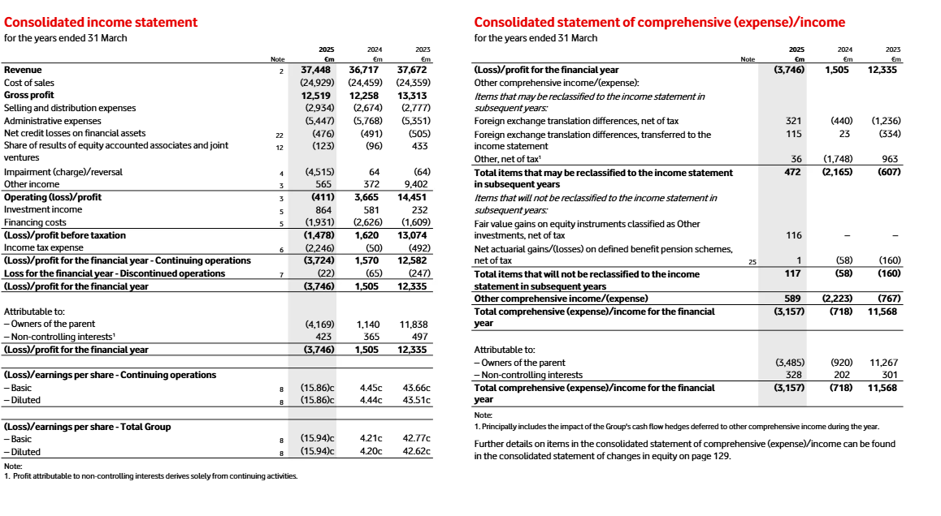
Appendix A2: The TALCL and liquidity denominators
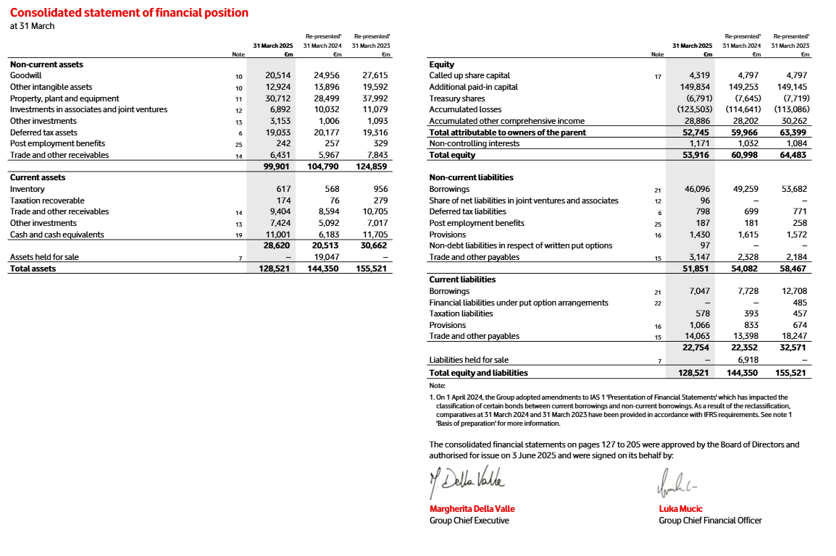
Appendix A3: FY2024 held-for-sale balances
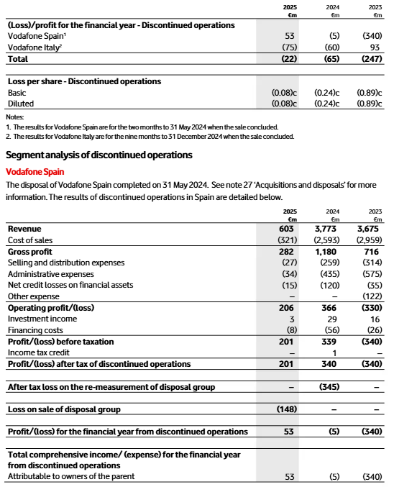
Appendix A4: Debtors days use trade receivables
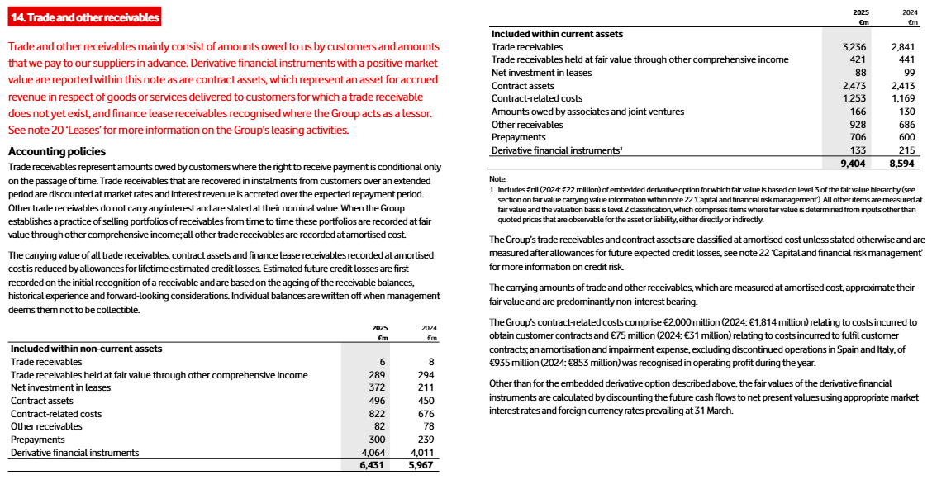
Appendix A5: Creditor days use trade payables
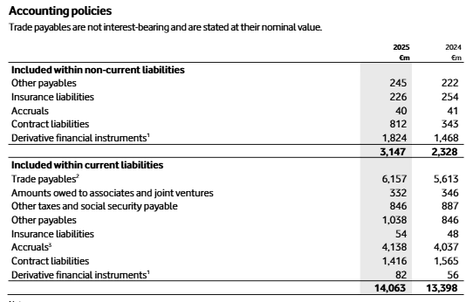
Appendix A6: EPS and dividend cover
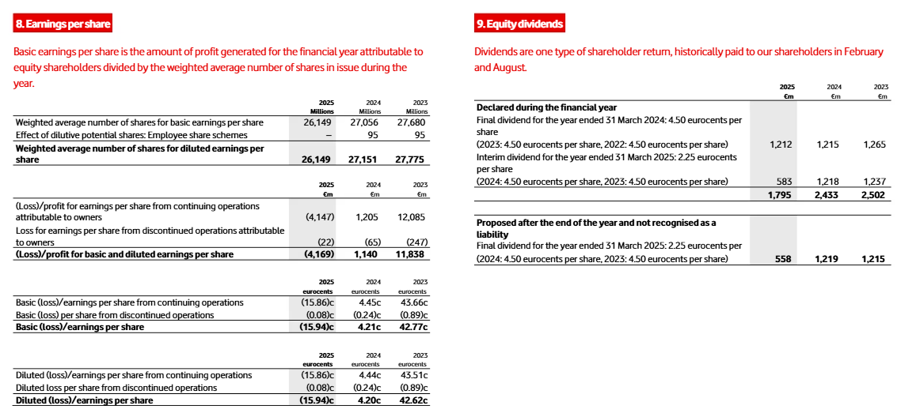
Appendix A7: Borrowings and net debt
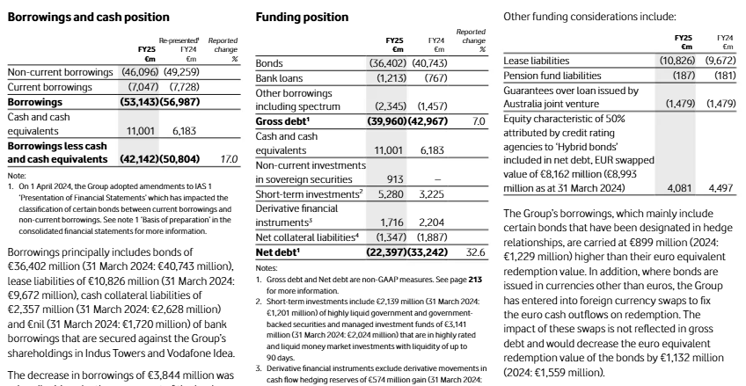

Appendix B: full ratio calculations

Appendix B1: Source figures used
Figure | FY2025 | FY2024
Sales / revenue | 37,448 | 36,717
Cost of sales / COGS | 24,929 | 24,459
Gross profit | 12,519 | 12,258
Operating profit / loss | -411 | 3,665
Finance costs / interest | 1,931 | 2,626
Profit/loss attributable to owners | -4,169 | 1,140
Weighted average ordinary shares, millions | 26,149 | 27,056
Dividends declared | 1,795 | 2,433
Current assets, continuing basis | 28,620 | 20,513
Inventory / stock | 617 | 568
Current liabilities, continuing basis | 22,754 | 22,352
Total assets, continuing basis | 128,521 | 125,303
Debtors | 3,657 | 3,282
Creditors | 6,157 | 5,613
Borrowings / loan | 53,143 | 56,987
Net assets / total equity | 53,916 | 60,998

- FY2024 continuing total assets
= Reported total assets – assets held for sale
= 144,350 – 19,047
= 125,303
- FY2025 TALCL
= Total assets – current liabilities
= 128,521 – 22,754
= 105,767
- FY2024 TALCL
= Continuing total assets – current liabilities
= 125,303 – 22,352
= 102,951
- FY2025 debtors
= Current trade receivables + current trade receivables held at FVOCI
= 3,236 + 421
= 3,657
- FY2024 debtors
= 2,841 + 441
= 3,282

Appendix B2: profitability ratios
1. Gross profit margin
Formula:
Gross profit margin = Gross profit / Sales × 100
- FY2025:
= 12,519 / 37,448 × 100
= 33.43%
- FY2024:
= 12,258 / 36,717 × 100
= 33.39%
2. Operating profit margin
Formula from attached sheet:
Operating profit margin = Operating profit / Sales × 100
- FY2025:
= -411 / 37,448 × 100
= -1.10%
- FY2024:
= 3,665 / 36,717 × 100
= 9.98%
3. Return on capital employed
- Formula:
ROCE = Operating profit / TALCL × 100
- FY2025:
= -411 / 105,767 × 100
= -0.39%
- FY2024:
= 3,665 / 102,951 × 100
= 3.56%

Appendix B3: efficiency ratios
Asset turnover
- Formula:
Asset turnover = Sales / TALCL
- FY2025:
= 37,448 / 105,767
= 0.35 times
- FY2024:
= 36,717 / 102,951
= 0.36 times
Debtors days
- Formula:
Debtors days = Debtors / Sales × 365
- FY2025:
= 3,657 / 37,448 × 365
= 35.64 days
- FY2024:
= 3,282 / 36,717 × 365
= 32.63 days
Creditor days
- Formula:
Creditor days = Creditors / COGS × 365
- FY2025:
= 6,157 / 24,929 × 365
= 90.15 days
- FY2024:
= 5,613 / 24,459 × 365
= 83.76 days
Stock days
- Formula:
Stock days = Stock / COGS × 365
- FY2025:
= 617 / 24,929 × 365
= 9.03 days
- FY2024:
= 568 / 24,459 × 365
= 8.48 days
Stock turnover
- Formula:
Stock turnover = COGS / Stock
- FY2025:
= 24,929 / 617
= 40.40 times
- FY2024:
= 24,459 / 568
= 43.06 times

Appendix B4: liquidity ratios
Current ratio
- Formula:
Current ratio = Current assets / Current liabilities
- FY2025:
= 28,620 / 22,754
= 1.26 times
- FY2024:
= 20,513 / 22,352
= 0.92 times
Quick ratio
- Formula:
Quick ratio = Current assets – Stock / Current liabilities
- FY2025:
= (28,620 – 617) / 22,754
= 28,003 / 22,754
= 1.23 times
- FY2024:
= (20,513 – 568) / 22,352
= 19,945 / 22,352
= 0.89 times
- FY2024 current ratio including held-for-sale items:
= (20,513 + 19,047) / (22,352 + 6,918)
= 39,560 / 29,270
= 1.35 times

Appendix B5: investment ratios
Earnings per share
- Formula:
EPS = Profit after tax attributable to owners / weighted average ordinary shares
- FY2025:
= -4,169 / 26,149
= -€0.1594 per share
= -15.94 eurocents
- FY2024:
= 1,140 / 27,056
= €0.0421 per share
= 4.21 eurocents
Dividend cover
- Formula:
Dividend cover = Profit after tax attributable to owners / ordinary dividend
- FY2025:
= -4,169 / 1,795
= -2.32 times
- FY2024:
= 1,140 / 2,433
= 0.47 times

Appendix B6: gearing ratios
Gearing ratio 1
- Formula:
Gearing ratio 1 = Loan / TALCL × 100
- FY2025:
= 53,143 / 105,767 × 100
= 50.25%
- FY2024:
= 56,987 / 102,951 × 100
= 55.35%
Gearing ratio 2
- Formula:
Gearing ratio 2 = Loan / Net assets × 100
- FY2025:
= 53,143 / 53,916 × 100
= 98.57%
- FY2024:
= 56,987 / 60,998 × 100
= 93.42%
Interest cover
- Formula:
Interest cover = Operating profit / Interest
- FY2025:
= -411 / 1,931
= -0.21 times
- FY2024:
= 3,665 / 2,626
= 1.40 times

Appendix C: Capital allowances and after-tax cash flows

C1. Capital allowance calculation
Option | Initial investment | Capital allowance rate | Annual capital allowance
A | 600 | 20% | 600 × 20% = 120
B | 900 | 20% | 900 × 20% = 180
C | 1,000 | 20% | 1,000 × 20% = 200

C2. Discount factors at 5%
Year | Formula | Discount factor
1 | 1 / 1.05 | 0.9524
2 | 1 / 1.05² | 0.9070
3 | 1 / 1.05³ | 0.8638
4 | 1 / 1.05⁴ | 0.8227

Appendix D: NPV calculations

D1. Option A: Expand retail outlet
Initial investment = £600k
Annual capital allowance = £120k
Year | Cash flow | Capital allowance | Taxable profit | Tax at 25% | After-tax cash flow | DF 5% | Present value
1 | 100 | 120 | 100 − 120 = -20 | -20 × 25% = -5 | 100 − (-5) = 105 | 0.9524 | 105 × 0.9524 = 100.000
2 | 180 | 120 | 180 − 120 = 60 | 60 × 25% = 15 | 180 − 15 = 165 | 0.9070 | 165 × 0.9070 = 149.660
3 | 210 | 120 | 210 − 120 = 90 | 90 × 25% = 22.5 | 210 − 22.5 = 187.5 | 0.8638 | 187.5 × 0.8638 = 161.970
4 | 260 | 120 | 260 − 120 = 140 | 140 × 25% = 35 | 260 − 35 = 225 | 0.8227 | 225 × 0.8227 = 185.108
- Total PV of after-tax cash flows:
= 100.000 + 149.660 + 161.970 + 185.108
= 596.737
- NPV:
= 596.737 − 600
= -3.263

D2. Option B: Develop internet sales
Initial investment = £900k
Annual capital allowance = £180k
Year | Cash flow | Capital allowance | Taxable profit | Tax at 25% | After-tax cash flow | DF 5% | Present value
1 | 220 | 180 | 220 − 180 = 40 | 40 × 25% = 10 | 220 − 10 = 210 | 0.9524 | 210 × 0.9524 = 200.000
2 | 270 | 180 | 270 − 180 = 90 | 90 × 25% = 22.5 | 270 − 22.5 = 247.5 | 0.9070 | 247.5 × 0.9070 = 224.490
3 | 350 | 180 | 350 − 180 = 170 | 170 × 25% = 42.5 | 350 − 42.5 = 307.5 | 0.8638 | 307.5 × 0.8638 = 265.630
4 | 400 | 180 | 400 − 180 = 220 | 220 × 25% = 55 | 400 − 55 = 345 | 0.8227 | 345 × 0.8227 = 283.832
- Total PV of after-tax cash flows:
= 200.000 + 224.490 + 265.630 + 283.832
= 973.952
- NPV:
= 973.952 − 900
= 73.952

D3. Option C: Produce purses and wallets
Initial investment = £1,000k
Annual capital allowance = £200k
Year | Cash flow | Capital allowance | Taxable profit | Tax at 25% | After-tax cash flow | DF 5% | Present value
1 | 250 | 200 | 250 − 200 = 50 | 50 × 25% = 12.5 | 250 − 12.5 = 237.5 | 0.9524 | 237.5 × 0.9524 = 226.190
2 | 310 | 200 | 310 − 200 = 110 | 110 × 25% = 27.5 | 310 − 27.5 = 282.5 | 0.9070 | 282.5 × 0.9070 = 256.236
3 | 400 | 200 | 400 − 200 = 200 | 200 × 25% = 50 | 400 − 50 = 350 | 0.8638 | 350 × 0.8638 = 302.343
4 | 430 | 200 | 430 − 200 = 230 | 230 × 25% = 57.5 | 430 − 57.5 = 372.5 | 0.8227 | 372.5 × 0.8227 = 306.457
- Total PV of after-tax cash flows:
= 226.190 + 256.236 + 302.343 + 306.457
= 1,091.226
- NPV:
= 1,091.226 − 1,000
= 91.226

Appendix E: IRR calculation for Option C
Option C after-tax cash flows:
Year | After-tax cash flow
1 | 237.5
2 | 282.5
3 | 350.0
4 | 372.5
E1. NPV at 8%
Year | Cash flow | DF at 8% | Present value
1 | 237.5 | 0.9259 | 237.5 × 0.9259 = 219.907
2 | 282.5 | 0.8573 | 282.5 × 0.8573 = 242.198
3 | 350.0 | 0.7938 | 350 × 0.7938 = 277.841
4 | 372.5 | 0.7350 | 372.5 × 0.7350 = 273.799
- Total PV at 8%:
= 219.907 + 242.198 + 277.841 + 273.799
= 1,013.746
- NPV at 8%:
= 1,013.746 − 1,000
= 13.746
E2. NPV at 9%
Year | Cash flow | DF at 9% | Present value
1 | 237.5 | 0.9174 | 237.5 × 0.9174 = 217.890
2 | 282.5 | 0.8417 | 282.5 × 0.8417 = 237.775
3 | 350.0 | 0.7722 | 350 × 0.7722 = 270.264
4 | 372.5 | 0.7084 | 372.5 × 0.7084 = 263.888
- Total PV at 9%:
= 217.890 + 237.775 + 270.264 + 263.888
= 989.817
- NPV at 9%:
= 989.817 − 1,000
= -10.183
E3. IRR interpolation
- Formula:
IRR = lower rate + [NPV at lower rate / difference between NPVs] × rate gap
- IRR:
= 8% + [13.746 / (13.746 − -10.183)] × 1%
= 8% + [13.746 / 23.929] × 1%
= 8% + 0.574%
= 8.574%
- Approximate IRR = 8.57%

Appendix F: Capital rationing calculation
Funds available = £1,500k
Projects are divisible, so use the profitability index.
Formula:
Profitability index = PV of cash inflows / Initial investment
Option | PV of cash inflows | Initial investment | Profitability index
A | 596.737 | 600 | 596.737 / 600 = 0.995
B | 973.952 | 900 | 973.952 / 900 = 1.082
C | 1,091.226 | 1,000 | 1,091.226 / 1,000 = 1.091
Ranking
Rank | Option | Profitability index
1 | C | 1.091
2 | B | 1.082
3 | A | 0.995
Optimal investment policy
- Invest fully in Option C:
Cost of C = £1,000k
- Remaining funds:
£1,500k − £1,000k = £500k
- Fraction of Option B possible:
£500k / £900k = 0.5556
- Therefore, Beard Plc should invest in:
100% of Option C + 55.56% of Option B
- Total NPV
- NPV of Option C:
£91.226k
- NPV from 55.56% of Option B:
£73.952k × 55.56% = £41.084k
- Total NPV:
£91.226k + £41.084k = £132.310k
- Final capital-rationing recommendation:
Investment | Amount invested | NPV generated
100% of Option C | 1,000 | 91.226
55.56% of Option B | 500 | 41.084
Total | 1,500 | 132.310

