Securing Quality and Accountability
Accountability in schools has been an area that has changed dramatically over the years moving from an era without accountability to one where the pressure placed on teachers is at an all-time high. In 1944 The Butler Act brought in the biggest changes seen in the education system such as the School leaving age was raised to 15 years, and the tripartite system was implemented where the secondary education was delivered in Grammar Schools (high achievers), Secondary Technical Schools (average students) and Secondary Modern Schools (everyone else). This Act also stated that children who have any ‘disability of the mind or body’ should be provided with an alternative educational provision. This was an improvement from the precious system where pupils with additional needs were excluded from the education system. This new education intended for a segregated education instead of an inclusive one but, it was a provision none the less (learningneverstops.wordpress.com/2013/06/15/historical-and-political-influences-on-inclusive-education-in-the-uk/).
These changes in 1944 were implemented and controlled by local authorities. This is a major difference when comparing this education system to the modern education system where Central Government takes the lead over the Local Education Authority. However the Department for Education at the time was confident in changing the structure of the education system but did not influence the pedagogy being taught within the schools. This is reflected in the conversation between Churchill and the President of the Board of Education, R A Butler where Churchill asked ‘Can’t you ensure that the schools are more patriotic?’, R A Butler replied, ‘I have no say in what is done in schools’ (https://www.atl.org.uk/Images/Teachers%20and%20government.pdf). Questions began to be asked regarding the provision of education to the young people in the system and a system that seemed to be one of segregation and not inclusion.
In the time between the reforms seen in 1944 many teaching professionals saw this time as a time of growth, development and excitement. Teacher autonomy was high and teachers were viewed as professionals alongside lawyers and doctors. They had control over the changes to the system they were working in and were key to providing a system that was more pupil centred. However, in October 1974 Keith Joseph, as Conservative Shadow Home Secretary, made a much publicised speech on a perceived decline in national life which he blamed on the state of the education system:
‘Values were being systematically undermined. Parents were being diverted from their duty as regards education, health, morality, advice and guidance. Delinquency, truancy, vandalism, hooliganism, illiteracy – all these accompanied the decline in educational standards…
Within his speech particular venom was directed at ‘left-wing intellectuals’, motivated primarily ‘by hatred of their own country’. In a powerful climax Joseph claimed that ‘these well-orchestrated sneers’ from their strongholds in the educational system and media ‘have weakened the national will to transmit to future generations those values, standards and aspirations which have made England admired the world over’ (https://www.atl.org.uk/Images/Teachers%20and%20government.pdf). This started an era of questioning the practices seen within the system along with the standard of pupil being produced and the questioning of the use of the money provided by the government. The question of accountability arose in 1976 during what would be known as the William Tyndale affair. The affair was named after a school that displayed left wing liberal practices and an extreme form of child-centred teaching even for that era. Pressure was placed on the government to bring in procedures that would ultimately place a feeling of accountability onto the school system and the teachers within it. The education system was at a time of great unrest which is seen in 1975 with the publication of ‘The crisis in education’ by Rhodes Boyson. This publication had chapters highlighting that the education system was at breaking point, chapters such as ‘truancy,’ and ‘illiteracy’ (https://journals.openedition.org/osb/1771). Ministers were keen at this time to make changes within the education system so to produce young people that would be able to either attend university or be equipped to take up a role in industry. It was around this time that the Prime Minister Jim Callaghan made a famous speech at Ruskin College about the state of the education system questioning if the system was indeed fit for purpose. He acknowledged there may be pockets of good practice but did all of the young people in the country have the same educational experiences? Ruskin asked:
'What do we want from the education of our children and young people?'
'What a wise parent would wish for their children, so the state must wish for all its children.'
(http://www.educationengland.org.uk/documents/speeches/1976ruskin.html).
Callaghan had many concerns and desires that seem to be echoed in our current education system. He had concerns over the quality of the skills the pupils had when leaving the education system that had been highlighted by the complaints from industry that new recruits from the schools sometimes did not have the basic tools to do the job required. We may have the same questions today but the answers would be very different due to the social and cultural differences in both eras and also the vast difference in the skills required in the modern industrial age compared to the industry at this time. The change from a system in 1944 where pupils sat in rows at their desks to a freer more liberal child-centred system may well have been a void too far to travel in that short time. The liberal comprehensive system was seen as a failing system that was not providing the essential skills to the young people that passed through it. Callaghan had been the first Prime Minister to question the pedagogy implemented by teachers within schools in this famous speech which did spark a change in the system. However, this change did not begin here with Callaghan. ‘Procrastination, indecision, delay at all costs – endless consultations’ were endemic and achieved no more than ‘to prepare the soil for a breakthrough by the radical right’ in the next decade (https://www.atl.org.uk/Images/Teachers%20and%20government.pdf). This labour government was defeated in 1979 by the incoming conservative government with Margaret Thatcher as their Prime Minister.

This government put some changes in place such as the 1980 Education Act phased in the Assisted Places Scheme which was, in the words of Margaret Thatcher, “enabling talented children from poorer backgrounds to go to private schools”, this allowed power to shift from the LEA to central government, parents and governing bodies (https://journals.openedition.org/osb/1771). With this system it also created competition between schools that was seen as an opportunity to produce schools that would have to raise their standards to attract pupils and subsequently funding. These changes also started the development of the governing bodies into a powerful collective that would be at the forefront of school accountability. In the second phase (1974-84), the emphasis of “attacks”, was turned into the politicisation of the curriculum and strengthening parents voice in the education, which would link educational quality to consumer accountability (http://epublications.uef.fi/pub/URN_NBN_fi_joy-20070025/URN_NBN_fi_joy-20070025.pdf). As a result of the crisis in the education system, the Secretary of Education, Mr Baker's opening speech in the House of Commons on the 1st of December 1987, can be seen as an attempt to solve this crisis. He said:
‘The education system has operated for more than forty years on the basis of R.A.Butler’s 1944 Act…we need to inject a new vitality into that system. It has become producer- dominated.’ (http://epublications.uef.fi/pub/URN_NBN_fi_joy-20070025/URN_NBN_fi_joy-20070025.pdf)

The Education act of 1988 saw the greatest change of the Education system since 1944. This act had 6 main features namely:
- A national Curriculum
- National tests at 7, 11 and 14.
- Local management of school budgets
- Opting out
- City Technology colleges
- OFSTED- a new inspection regime for schools.
(https://www.slideshare.net/sociologytwynham/1988-education-act-presentation)
These were the biggest changes seen to the education system since 1944 and moved power away from the teachers, schools and local authorities to Central Government. These changes did indeed provide more rigour and a system that was in principle the same for all with an emphasis on testing the pupils and inspecting schools. Both Labour and Conservative governments proceeded to interfere in the pedagogy within schools and how teachers progressed and developed:
- Development of OFSTED to inspect schools.
- Making school performance tables public.
- Performance management for teachers.
- Specialist schools.
- Literacy and Maths hours.
- Reforms in teacher training.
These changes were implemented to improve the educational experience of the students within it and to produce young people with the relevant skills for the future. However, was the tide turning from an era of teacher autonomy to one that took all the power and control away from the professional in the classroom? Other specific examples of Ministers changing the landscape of the education system include:
- Kenneth Clarke’s decision (1991) that contemporary events should not be part of the history curriculum.
- John Major’s decision (1991) that GCSE coursework should be limited to 20 per cent of the total marks.
- David Blunkett’s decision (1998) that all primary school children should do homework (starting with 20 minutes a day for five-year-olds).
- Charles Clarke’s decisions to run as many as one thousand booster classes in the Easter holidays in 2003 for Year 6 children on the borderline of missing targets5 and asking local education authorities to identify by name the children in their schools who needed further support to achieve the expected levels of literacy and numeracy by the age of 11, and to regularly monitor their progress.
(https://www.atl.org.uk/Images/Teachers%20and%20government.pdf)
These examples highlights the interference of government ministers within the education system and how different their roles have become since Butlers quote in 1944 of ‘I have no say in what is done in schools’(https://www.atl.org.uk/Images/Teachers%20and%20government.pdf). Between 1944 and the early 2000’s the involvement of central government has increased dramatically and has attempted to provide a system that is fair and equal to all. Has this happened? With this increase in rigour has the education system produced pupils with a higher standard of skills that are ready for university or industry? Many would argue that in this system we have created pupils that are led and do not lead. Pupils that are tested on recall of facts but are not tested necessarily on creation of new ideas and problem solving skills. As well as pupils that are led we now have a teaching workforce that are happy to follow a prescribed national curriculum but have lost their confidence to create their own courses in their own specialist fields. We have moved away from the Child centred model of the liberals and to a rigid data driven system where pupils have been viewed as statistics and not as individuals. In this model the rigour has improved but this has not produced a blemish free system. The focus moved from one of no accountability to a system that focussed entirely on accountability. The data collected from schools is used to create league tables, this in turn has created an atmosphere of competition but has been publicised without understanding the differences between schools and even different cohorts within a school. This has created a viewpoint that some schools are good and others bad where their unique context have not been considered. There are many successes that occur within many schools that cannot be quantified however it seems that in this new data driven system this has been lost to the detriment of the pupils within the system. There are many variables to consider when analysing data from a particular cohort in a school. Each cohort in the same school can be vastly different as each individual pupil is different. When comparing schools some factors are taken into consideration such as the number of ALN pupils and free school meals however not all factors are taken into consideration such as parental support. Parental support can be one of the biggest influences on the attitudes of the pupils towards their school work and therefore success. Over time these league tables have created schools that are desirable and ones that are oversubscribed versus schools that become sink schools where the morale of both staff and students are eroded by the public advertisement of their poor position on a league table. This education system is indeed vastly different to the one in crisis in 1976 but can we be confident that it is better?
It is now thought that too much interference from central government is harmful to teaching. Before 1988 it was a common idea that educational decisions should be left to the experts however today we are living in an era where the systems within the education system are changed by central government in, what feels like a whim! Michael Bassey points out the perverse consequences of this shift of emphasis. He quotes the National Commission on Education Report which says that ‘central control damages teaching’, thus developing the argument against Central Government being in control as opposed to the Local Authority. It is an argument with which ATL has agreed on numerous occasions, and Mary Bousted, ATL’s general secretary, is quoted as saying that “New Labour needs to curb its ‘control freakery’” (https://www.atl.org.uk/Images/Teachers%20and%20government.pdf) It seems that during this new age in the noughties ministers were happy to have an opinion on the education system and how pupils should be taught within schools. This again seemed a time of discontent for many teachers with record numbers leaving the profession due to stress and pressure placed upon them to deliver the standards required for their school to be placed in the correct band on the League table. In 2004, David Miliband, the then schools minister, sought to redress the balance by a commitment to streamline the accountability framework and to give greater emphasis to more personalised education:

“We set ourselves the task of delivering an intelligent accountability framework, a simplified school improvement process and improved data and information system”. (class notes)

It was acknowledged by David Milliband that something had to change in the current system of data collection, tests and inspections however change did not come swiftly. Even though in the Education act of 2005 School inspections became shorter and more focussed on school’s self-evaluation the ethos of data collection remained. Teachers were becoming increasingly burnt out having to adapt to new ideas but also continuing to carry on with the old system. Changes were made in England to ease the pressure placed on the teachers such as teacher assessment was brought into KS1 however the changes in Wales were more significant with more autonomy given to schools and to teachers. This was an example of the freedom given to Wales and the decision made for the education system following devolution. Devolution has brought many positives to the education system in Wales where decisions can be made independently from the Central Government in Westminster giving Wales the freedom to forge a modern education system. This has seen Wales making their own decisions however, this also creates another level of beaurocracy in Wales slowing the process of change, as new ideas are passed through the Welsh Assembly government, Local Authority, ERW consortium and Estyn.
After David Millibands speech schools were starting to ask the question who are we accountable to? Who are the key stakeholders? This was answered by Earley and Weindling in 2004 where they suggested 4 areas of accountability for schools:
- Pupils, to parents and the local community (moral accountability)
- colleagues (professional accountability)
- employers or government (contractual accountability)
- the market, where clients have a choice of institution (market accountability)
(class notes)
What processes in schools can aid in this accountability framework? It must be a framework that supports staff and not one that provides even more burden that is currently in the system. A culture needs to be fostered of a self-improving school that constantly reflects on its practices with a view to improve for its stakeholders. Testing and inspections will play a part in this process but also we will have to reflect on processes and the quality of the experiences had by the pupils within the school.
“Today’s schools must equip students with the knowledge and skills they’ll need to succeed in an uncertain, constantly changing tomorrow” OECD report 2006)
The first step on the journey of improvement is to carry out a true and honest self-evaluation of the school. Once this is complete then the school development plan can be created to produce actions that will drive forward any improvements that are necessary. In this system of success how would we know that we had been successful? Ultimately the measure of success would be the quality of the pupils leaving the system. If we look back at the Ruskin speech it voices many sentiments that are relevant in this era:
‘To the critics I would say that we must carry the teaching profession with us. They have the expertise and the professional approach. To the teachers I would say that you must satisfy the parents and industry that what you are doing meets their requirements and the needs of our children. For if the public is not convinced then the profession will be laying up trouble for itself in the future.’
To change the education system the change must come from within. It is clear that the Welsh Government are implementing systems to improve the standard and confidence of teachers within the system by changing the teachers training course and also the professional standards of experienced teachers (http://learning.gov.wales/docs/learningwales/publications/140630-revised-professional-standards-en.pdf). The teachers must have the confidence to be able to take risks and try out new techniques in order to improve the system overall. Central government must realise that the teacher in the classroom has the development of the whole child and not necessarily the production of data for a league table. Many positives have developed from the changes seen in our education system namely the collaborative work seen between teachers within a school and between schools can only strengthen the system and skills of the work force. Reporting to parents has strengthened over the years which builds trust and a strong sense of communication between the school and the parents. This is an exciting time in education where we have the opportunity to learn from the successes and the mistakes of the past. What now for the future?
In this time of change we would have to ask how do we change the system from within? With the levels of scrutiny at an all-time high and teachers leaving the profession in droves is it now the time to question the structure of leaders in school and how teachers are managed in their own careers and for the benefit of the pupils in their care. One answer to this is Distributed Leadership which is seen in many countries and in their education systems. This is a system where teachers are provided with leadership roles while still maintaining their teaching responsibilities within the classroom, consequently their classroom responsibilities may be reduced. These teachers could be seen as teacher mentors with specific leadership roles inside the system with the goal of evaluating and improving the system for the pupils within it (http://journals.sagepub.com/doi/full/10.1177/1741143216688469). In the study on Distributed leadership in America by Holloway, Nielsen and Saltmarsh the role of these teacher mentors as distributed leaders was evaluated. It is clear that the teachers that were provided with these opportunities felt they needed more time to be able to complete their roles to a more acceptable standard. I do believe that this method of distributed leadership is a positive one as it provides teachers with control over their own careers and control over the changes within the system. This can be seen in the new system being devised for Wales by Professor Graham Donaldson, Successful Futures. Pioneer schools have been asked to test drive specific aspects of the changes to the curriculum, pedagogy and teacher development before launching it to all schools in Wales. This, as an example of Distributed Leadership has provided the workforce in Wales the opportunity to be involved in these changes. One threat to these changes is the added levels of beaurocracy in the Welsh system with the Department for Education, Welsh Assembly government, ERW, Estyn and the Local Authority there are many more levels of admin compared to England. This can slow down the process of change and development of a new system. With these major changes imminent I reflect on the Ruskin speech:

‘The goals of our education, from nursery school through to adult education, are clear enough. They are to equip children to the best of their ability for a lively, constructive, place in society, and also to fit them to do a job of work’.
This is echoed in the ethos of Professor Donaldson in Successful Futures but hopefully will be implemented in a way that teachers can produce a system that we in Wales will be proud of.

My project and Presentation to The Governing Body.
I have decided to look at the area of Wellbeing within the school (school A). This is an area of growing importance and an area where future inspections will focus upon with dedicated sections on Wellbeing. Pupils wellbeing could be linked to two areas in the new inspection guidance namely inspection areas 2 and 4, ‘Wellbeing and attitudes to learning’ and ‘Care, support and guidance’ (https://www.estyn.gov.wales/inspection). Also in the new curriculum designed by professor Graham Donaldson Wellbeing is seen as its own area of learning highlighting its importance in this new era (Appendix 1). It goes without saying that a happy and emotionally secure pupil will be a pupil that can achieve in school both academically, emotionally and socially. Therefore, we must construct a support structure to support the emotional health of the pupils so that they have every opportunity to achieve their full potential. A country that has consistently scored well in PISA over the last few years is Finland (http://www.oecd.org/pisa/pisa-2015-finland.htm). One area that Finland focusses upon for their pupils is the area of wellbeing, this is seen as an area that is more important than any other with regards to their education system being a success. What can we do to further enhance the Wellbeing of our pupils so that they can achieve their academic potential?
We as a Senior Leadership Team must be clear where our school is at present with regards to the Wellbeing provision highlighting the positives that can be seen in the current system. These positives must be celebrated within the staff, to the governors and the wider community. This provides a natural springboard for the future with how we could strengthen Wellbeing at the school and also the opportunities under the new Successful Futures curriculum that would allow us to produce a more child centred approach to the wellbeing provision within the school. These changes would hopefully highlight how we could gain a more positive persona with parents and members of the local community. The importance of these new strategies need to be explained to staff as they will be essential to not only attract more pupils to the school and ultimately increase funding but the other main benefit to these new strategies is to improve the mental health of the pupils which will have a positive impact on their academic progress strengthening the results achieved (appendix 2 for governor presentation).

From analysis of pupil voice feedback, staff questionnaires, national questionnaires such as The National Healthy Schools Network Questionnaire and a SWOT analysis we as a school have decided to implement changes to certain aspects of the Wellbeing agenda. Firstly, the SWOT analysis was a useful tool of self-evaluation which highlighted both the positive areas of Wellbeing at the school as well as the opportunities for change (Appendix 3). From evaluating the Structure of the Wellbeing implementation within the school the opportunities that were highlighted included:
- To further improve wellbeing at the school such as how to organise PSE lessons.
- To open a wellbeing room to support anxious pupils
- To promote skills on how to handle mental health issues
- To build a positive relationship with parents
- To build a positive persona in the community
- To promote the good work occurring in the school with outside agencies
To begin working on these opportunities we must be clear about the threats to the project and try to plan a way around them (the threats are seen in SWOT analysis in Appendix 2). The first hurdle to overcome would be to gather support from the Senior Leadership Team, governors, staff, pupils and parents with the Wellbeing initiatives. Firstly it would mean convincing SLT and governors that the initiatives would be worth the time and investment. Secondly, convincing staff to support the projects by becoming involved directly or indirectly. Lastly, creating a positivity about the changes with pupils and parents. To improve wellbeing provision at School A will mean changing a culture of ‘This is how we do things around here’ to one that reflects the importance of a pupils emotional and mental health on their overall progress both academically and socially. To do this SLT and governors will have to steer the ship in the right direction and make sure that key members of staff are on board to observe initial, short term successes. Once these are celebrated and promoted, hopefully the new way of doing things will dissipate through to the remaining staff where a shared purpose will help shape the culture of the future within the school (class notes). What would we need to do to overcome these threats and implement these changes?
- In the Senior Leader Secondment interview I would set out my plan for Wellbeing development.
- If the ideas for the Wellbeing development were accepted I would promote the ideas to the staff in a staff meeting.
- During assemblies and through form teachers these initiatives would be promoted to the pupils.
- Allow staff to voice their opinions on the new strategies to feel a part of the changes as this will improve its chances of success (https://www.teachthought.com/the-future-of-learning/5-strategies-for-managing-change-in-schools/).
The first area of Wellbeing to be addressed is the move from having pastoral sessions of 30 minutes on a Thursday morning to dedicated pastoral days to implement the PSE curriculum and also the organise a wellbeing week to promote mental health. This ideas was accepted by the governors, SLT and the staff and were organised for just before the summer holidays in July 2018. On the pastoral day all year groups received lessons ranging from the rights of the child to discussion of mental health issues. The topics chosen for each year group was based on the relevant PSE units that were required to be covered and also the feedback received from the National Healthy Schools Network research informed of areas that we needed to impart for our pupils. On this day years 7, 8 and 9 completed one page profiles with their form teachers to promote individuality and for staff to develop deeper relationships with pupils in their form classes by knowing their wants and needs. The older pupils also had age appropriate lessons of information on the consequences of alcohol and drug use brought to our attention from the answers provided to the National Healthy Schools Network Research Questionnaire. This day was seen as a success within the school where pupils were engaged and participated actively in the lessons. Staff felt that the burden of delivering the lessons were shared across the staff and by the use of outside providers leading to a feeling of positivity with the new system. By moving the pastoral curriculum to one dedicated day we have strengthened one of the threats highlighted in the SWOT analysis namely the threat of the Thursday morning session impacting on the lesson time of Lesson 1. The Thursday morning pastoral session would eat into at least 20 minutes of this lesson each week resulting in a large amount of lesson time lost over the entire year. By organising these PSE/Pastoral days at the end of term that had been viewed previously as ‘dead time’ it was seen as a more constructive use of time by students and by staff.
The organisation of a wellbeing week was an entirely new concept and one where we wanted to promote the positive mental health of the pupils at the school. This was organised for the last week of school before the summer holidays in July 2018. It was organised for the entire school years 7 – 10 (Years 11and 13 had left following their external exams and Year 12 were on work experience) which meant organising activities for around 1000 pupils. Activities included trips out of school to a range of places such as theme parks, local cities, alternative sporting activities such as surfing and a wealth of activities within school including aromatherapy workshop, yoga, dance, healthy eating, mindful art activities as well as many others (Appendix 4). These sessions and trips were intended to provide a wealth of opportunities to the pupils that would not engage with such activities on a normal day to day basis with the intention on boosting self-esteem and promoting a positive state of mind. The school promoted the week and created a video clip of some of the activities to promote the support the school and its staff organised for the pupils. One area to further improve is the image of the school in the community, as a school we need to promote the support provided to pupils within the school. More of the good work that occurs within the school needs to be displayed on the school website, local press and social media as photos, video clips and social media posts. Over time this will only enhance the standing of the school in the community.
On the last day of Wellbeing week pupils were asked to complete an evaluation form to critique the week. Highlighting the positive elements and the areas they would improve for the next wellbeing week. Staff were also asked to provide feedback on the week via email again to suggest ways to further improve the activities and sessions for both staff and pupils. In general both staff and pupils were positive about the week highlighting many positives, for example: learning new skills such as yoga or surfing, trying an activity that they had not attempted before such as language stones and seeing staff in a more informal way by enjoying themselves on the trips such as the muddy assault course. This all accumulated to a feeling of camaraderie and togetherness. There were areas to improve where staff felt there was more pressure on some staff than others. This was where some staff had volunteered to put on sessions but had not realised the time and effort that would be required to do so. This could be alleviated next year by placing each member of staff at an activity to help and support their colleagues throughout the week. Moving forward to the new academic year I think we will proceed with the PSE sessions being delivered on specific days and for a Wellbeing week to finalise the year but implementing the improvements suggested. It is important to enhance staff collaboration to further strengthen Wellbeing provision within the school. The cross departmental collaboration in this area of Wellbeing is essential moving forward due to the unique nature of Wellbeing as it is an area that is seen in all departments across the school (Donaldson, G. Successful Futures. 2005). As a leader in this area I think it is important to continuously monitor and evaluate each aspect to foster an atmosphere of constant evaluation and development.
Another opportunity for improvement in school is to open a Wellbeing room to support anxious pupils. A key member of the pastoral team has been to visit other schools to observe their wellbeing rooms to discover what resources they use and how they are organised. This collaborative working is essential to move the school forwards and also the area we live in as well as the country as a whole. Collaboration on these projects will strengthen the education system in Wales. Collaborative working is more prevalent within schools but needs to be strengthened between schools and with other professionals (https://www.atl.org.uk/Images/Teachers%20as%20collaborative%20professionals.pdf). The major threat to this project in our school is funding and resources. One of the major threats to the project is having the funds to place a member of staff in the room and also to have appropriate resources within the room. We would want the room to be an area to either work in calm and quiet or to be able to cool down from a panic attack. A member of staff located in the room would be able to administer the correct resources and support for the student. To gather funds pupils and parents were asked to support the Wellbeing room by allowing pupils to take part on a sponsored walk within Wellbeing week and also a summer fayre was organised for that week. Both event were a success and a healthy profit was raised across the two events. This will allow us to paint the room, buy appropriate mood lighting, comfortable seating and appropriate resources. This unfortunately is not enough to place a member of staff within the room on a full time basis, however we have planned on rotating this responsibility between key members of staff and sixth form students. The members of staff with pastoral responsibilities could have an allocated time to be in the Wellbeing room where there would be a computer for them to work at so that they can monitor the safety of the pupils within the room. Sixth form student can be used as Wellbeing ambassadors with a responsibility to befriend lonely and anxious pupils. These Wellbeing Ambassadors would also be asked to walk around the school on a break and lunch time to help the younger pupils who may be struggling emotionally. Hopefully this would produce a feeling of support and being cared for within the school. This will be a positive support mechanism that will be seen as one that is in line with the child-centred approach seen in the new Successful Futures era where one of the four purposes is to produce confident individuals that can contribute positively to society.
One area that has been highlighted in the SWOT as an area to improve is the engagement of parents. To engage parents with the wellbeing of their children I suggest that we provide information on Parents evenings. These are evenings where the majority of parents attend to discuss the academic progress of their children and therefore would be ideal to impart other information regarding Wellbeing. Depending on the year group and the time of year we could organise information on internet safety, healthy eating, substance misuse and anxiety/depression and other topical issues for teenagers. At these evenings we could promote the support provided within school and suggest ways parents can support their children at home either independently or by using local services. When needed, outside agencies could be present at these evenings such as the school liaison officer, youth worker, school nurse, Councillor, Education Welfare workers to provide extra support and information to parents. The major threat here would be the willingness of these professional individuals to attend these evenings. Once again to monitor the impact of this intervention we should provide parental questionnaires at these evenings and analyse their responses. We could compare the parental responses to previous responses before these interventions had been implemented to highlight positives and negatives that can be used to further improve the systems put in place. With any new initiatives we should be mindful of the impact on staff and pupils with regards to their workload and morale. It would be important to celebrate the positives and the achievements of even the small ‘wins’ to enhance staff morale. After each area is implemented we should evaluate its impact by use of questionnaires, interviews, pupil voice, staff feedback and correlations of these support mechanisms and changes in attendance to school as well as academic achievement. With these changes there must be a concrete process of evaluation and constant development to ensure the strategies are appropriate for the pupils at that time. This will come from having an immediate evaluation from students and staff after the strategies have been implemented. Once this has been completed an analysis of the feedback will allow us to re-look at the changes and adapt to improve them which would, hopefully benefit both students and staff.
To strengthen the analysis of the benefits to these strategies we could analyse particular groups within school. As we are attempting to improve the support for vulnerable pupils within the school it makes sense to track these pupils before and after these interventions to monitor their impact on the progress of these groups of students. The students we could pay particular attention to could include:
- LAC pupils
- FSM pupils
- Pupils having support from Social Services
- Pupils with poor attendance
- Pupils having support from the councillor/school nurse.
These pupils could be provided a questionnaire before and after the intervention along with an interview/pupils voice session with a key member of the pastoral staff to evaluate and improve the support for all vulnerable pupils and to discuss if they need further support individually.
The evaluation of these strategies must be linked with the SDP/SIP outlining the priorities for the school. One area that has been highlighted in the SDP is safeguarding and continuation of the enrichments programmes for the pupils. This enrichment programme is one that attempts to provide a wide range of experiences to the pupils and in particular to the vulnerable pupils (Appendix 5). The new strategies that have been put in place have provided a range of experiences and activities for the pupils at the school and to provide confident, ambitious, positive members of their communities as described in the four purposes in the Successful futures curriculum.
Good schools have strong systems in place that are robust and support a system of reviewing. As a leader spearheading a new area in school there must be a system of continued evaluation and development. During School inspections Estyn will be looking for a clear link between self-evaluation, the school development plan and how self-evaluation and planning for improvement has had a positive impact on learner outcomes (class notes). To ensure that the process of self-evaluation is fair the Governors should act as a critical friend and question the process and also the new strategies being implemented. This will enhance the self-evaluation process producing a robust system that is essential for any good school. The knowledge gained in these processes will then be seen within the schools policies to provide a strong foundation on which the school can build upon for the future.

Conclusion
The education system in Wales is at the cusp of a major change where the new curriculum will be implemented in 2020. When reviewing the journey of the education system from 1944 to the current day it is clear that there are vast differences in the role of the teacher in the classroom and also the impact that ministers have on that role. We have moved from a system where the Teacher had the authority to deliver the pedagogy they believed in in their classrooms without interference from the political sphere however we seem to have moved into an era of scrutiny and accountability where the power lies with the ministers and not within the teaching workforce. When evaluating this new system are we in a better place now than we were in 1944? There are obvious strengths such as reporting to parents, collaborative working, providing a more inclusive educational system to all pupils regardless of background or academic ability and a system where teaching staff are monitored in order to provide a decent standard within their classrooms. However have we now taken the notion of accountability and rigour too far? Is the interference from the political sphere harming the system rather than enhancing it?
In Wales with the new curriculum on the horizon it is clear that teachers will be given more of a voice in what they will be able to teach in their own classrooms and also schools will be able to mould the provision to the unique culture and demographic of their area. Hopefully this will be built on the knowledge that has been gathered over the vast changes that have been implemented since 1944. As mentioned by Professor Graham Donaldson we must keep the elements of the curriculum that are working while developing on the areas that need to be changed (Donaldson,G. Successful Futures. 2005). Teachers must be confident in their own skills to be able to adapt to this new model of teaching and this could be done through the new professional standards as opposed to the old professional teaching standards. Under the previous model many teachers would have had input in their first year of teaching and could then be set adrift unless they were promoted to middle or senior management. In the new Professional Standards model support will be provided to teachers in order to continually develop throughout their careers. The Leadership standards have also changed to include areas such as: creating a strategic direction, leading learning and teaching, developing working with others, managing the school, securing accountability, and strengthening the community focus (http://learning.gov.wales/docs/learningwales/publications/140630-revised-professional-standards-en.pdf). By including these areas it provides a focus to the Senior Leadership team to create a forward thinking and dynamic school. This enhances the theory that we need vibrant schools within our communities that not only produce engaging and ambitious young people but also improve the communities that they are in. If one of the four purposes in the new curriculum is to create Ambitious students then the workforce leading the changes must also reflect the purposes described in Successful Futures. To produce these ambitious young people we will need a forward thinking and ambitious workforce.

Appendix

1.
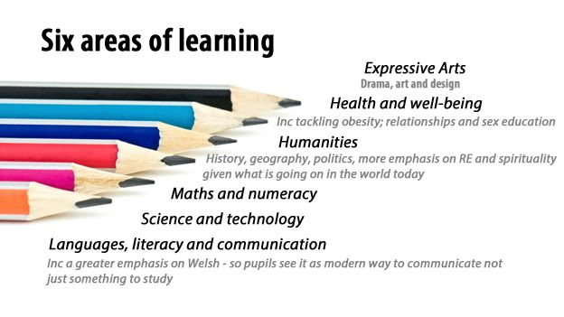

- Presentation to Governors


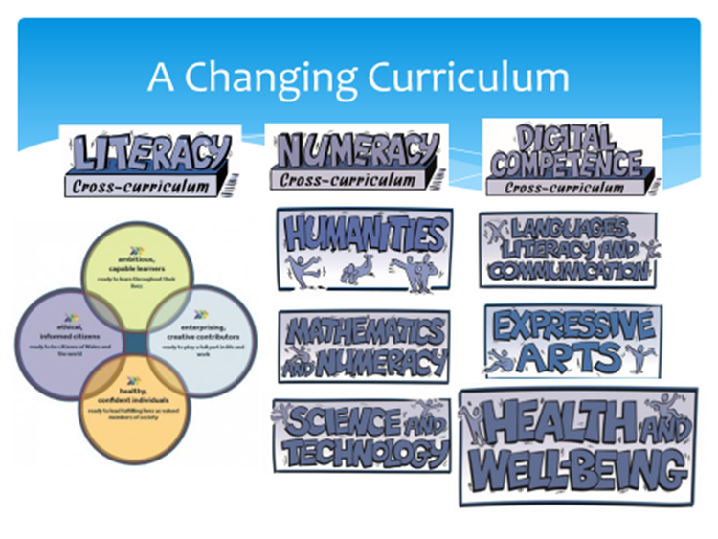

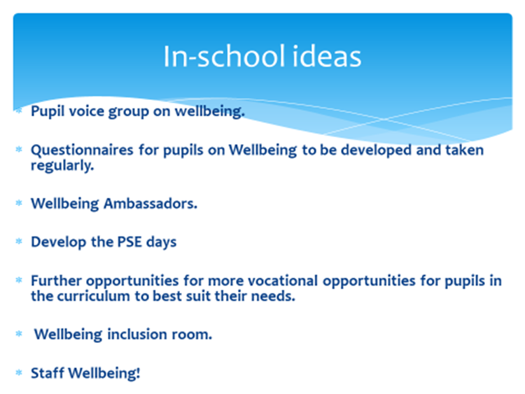

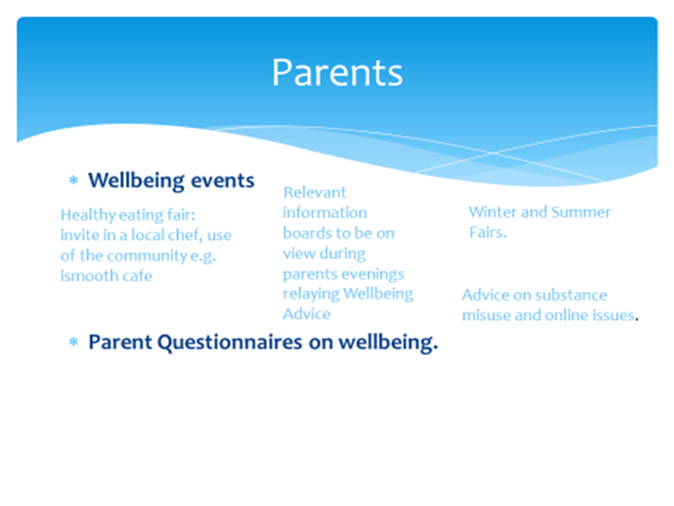

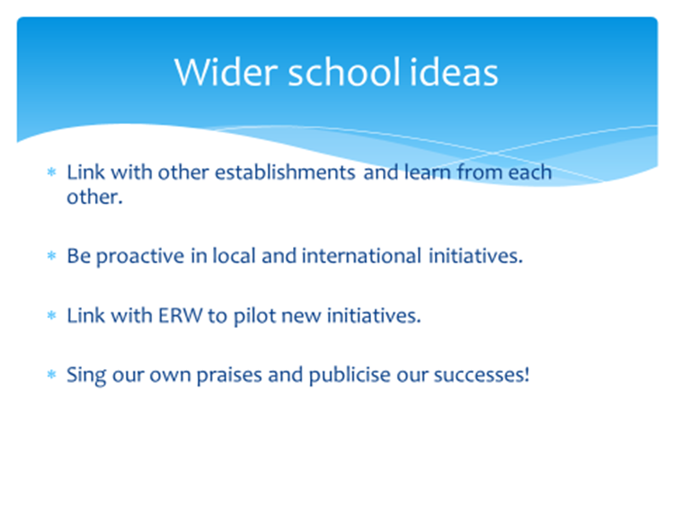

- SWOT analysis of Wellbeing at the school before the project.

Strengths  Small school feel in a large school  Caring staff  Good relationships with pupils | Weaknesses  Communication with parents  Relationship with hard to reach parents  Positive identity in the community  Pastoral lessons on a Thursday morning had a negative impact on the academic lesson on a Thursday morning.
Opportunities  To further improve wellbeing at the school  To open a wellbeing room to support anxious pupils  To promote skills on how to handle mental health issues  To build a positive relationship with parents  To build a positive persona in the community  To promote the good work occurring in the school with outside agencies | Threats  Financial problems to fund the wellbeing room and other wellbeing initiatives.  Support of the SLT and governors.  Support of parents and pupils.  Support of the staff.  By being honest and confronting some of the social issues it may be seen publicly that there is more of a problem here than in other schools.

- Wellbeing activity choices
Years 7 and 8 | Years 9 and 10
Crafts | Yoga
Mindful art | Mindful art and mindful mural
Rugby academy | Rugby academy
Football academy | Football academy
Aromatherapy workshop | Aromatherapy  workshop
Dance workshop | Dance Workshop
Mindful mountain walk | Mindful Mountain walk
Treasure hunt | Treasure hunt
Language stones | Language stones
Mindful music | Mindful music
Mindful Reading | Mindful Reading
 | Martial Arts workshop
1 minute challenge | 1 minute challenge
Lawn games | Lawn games
Reading football club | Reading football club
 | HIIT session
Healthy eating workshop | Healthy eating workshop
Table Tennis | Table Tennis

- Extract from School A SDP
2.3 Safeguarding to keep up to date with recent developments in safeguarding.  Continue Enrichment programme for the pupils | All staff to have regular updates on safeguarding and relevant issues. If necessary updating Safeguarding Policy.  Pupils to have the opportunity to partake in a range of in school activities as well as extra- curricular activities. Increases the engagement of identified under represented pupil groups. Available clubs/ activities on school website. Excursions and trips to be open for all. | ongoing | Lac coordinator  HOY  HOD | All staff aware of changes to safeguarding policy (if relevant) and any relevant issues.  Positive Feedback from parents on the availability of enrichment programme. Primary pupils have a positive learning experience whilst partaking in Transition Programme. | Cost of outside speakers  SEG  PDG  Funds available

