Targets

Targets | How you have worked on this | An example can be found on
Target 1  Continue to include more critical analysis when discussing theories. | To work on this, I have tried to find more than one point of view when discussing key points within my assignment. | Throughout the assignment.
Target 2 Endeavour to use a synthesis of research to support the key discussions. | For this, I have also as above found more than one point of view when discussing key points and have ensured to analyse both points. | Throughout the assignment.
Target 3 Continue to read a wide range of literature and ensure consistent referencing throughout your work. | Throughout the reading part of this assignment I used more journals and articles to achieve a wider breadth of sources. | Throughout the assignment.

What strategies are implemented within the school to support pupils’ wellbeing within the classroom, what are staff's perceptions of these?
Aim, focus and purpose of the research.
My research explored the perspectives of teachers in an effort to comprehend the efficiency of well-being strategies used by staff in specific classes throughout key stage 2 (KS2). The main goal was to understand the elements of well-being strategies that could be effectively implemented throughout a school, creating an atmosphere that would promote students' well-being. The motivation behind this investigation stemmed from my own recognition of a lack of understanding concerning the nature of promoting students' well-being in the classroom and the particular strategies that could support their well-being. Once I was informed about the schools’ non-negotiable strategies, I wanted to know to what extent staff used the schools’ non-negotiable strategies (Appendix 8) to well-being, and how effective staff found them. I choose to focus on well-being as prior to carrying the research out I felt that I lacked understanding of what supporting well-being in the classroom looked like, in addition to lacking awareness of what strategies support the well-being of pupils.

The school that the research took place in was situated in an urban city area. The school is located in a deprived area with 48.4% of pupils eligible for free school meals, which is 25.4% higher than the national average (Estyn, n.d.). This suggests that the well-being of pupils may be worse than a school that is not based in a deprived area. The school has around 370 pupils, of which between 50-70 pupils receive Thrive intervention. Whether in the form of group discussions or one-on-one conversations, these interventions emphasised the seriousness of the issue and demonstrated the widespread need to support and enhance students' well-being across the board in the school community. I knew I would receive a well-rounded experience regarding pupil well-being, as on the Estyn (2023) report it stated that ‘pupils’ emotional well-being is the root of all success at the school.’

Relevant literature
The World Health Organisation (2022) say that well-being encompasses quality of life and the ability of people and societies to contribute to the world with a sense of meaning and purpose. This definition of well-being is about the outcome of well-being, whereas the following definition of well-being describes how well-being is a continued process. Michaelson, Mahony and Schiffers (2012), define well-being as how people feel and how they function, both on a personal and a social level, and how they evaluate their lives as a whole. Collectively, these points of view add to a comprehensive picture of well-being that embraces the complex interactions between social relationships, personal experiences, and the significant contributions people make to the world, in addition to individual enjoyment.

Donaldson (2015) expressed that a challenge that the previous curriculum had was a higher focus on academic outcome rather than an equal focus on academic outcome in addition to the well-being focus. Therefore, it was essential for the 2022 curriculum for Wales to be designed in a way that promotes high expectations for all and can help schools to defeat the circumstances that condemn so many to educational underachievement. According to Donaldson (2015), it is critical that the curriculum be created in a way that will engage each student's interest and help them reach their full potential. Building students' well-being is the focus of the fourth purpose, "healthy, confident individuals who are ready to lead fulfilling lives as valued members of society" (Welsh Government, 2020). According to Donaldson (2015), the four reasons should serve as the foundation for all teaching and learning activities in Wales and serve as a guide for future decisions about educational priorities. Wales' curriculum also includes a health and well-being area of learning and experience (AoLE), which is crucial to fostering learners' well-being by equipping them with knowledge, abilities, and attitudes that support leading healthy and satisfying lives (Welsh Government, 2020). The Welsh government's (2020) emphasis on well-being as a primary educational goal and Donaldson’s (2015) need for an engaging and customised curriculum work together to demonstrate a holistic approach to education. In line with the larger idea of education as a transformational force for people and society at large, the intentional incorporation of health and well-being into the curriculum shows a dedication to prepare students not only intellectually but also socially and emotionally.

A psychological theory called Maslow’s Hierarchy of Needs suggests that human needs can be arranged in a five-tiered pyramid. Moslow’ Hierarchy of Needs relates to wellbeing as the foundation of the pyramid is those of food and shelter, then those of safety, without these needs being met it is implied that a childs’ well-being will be impacted. Physiological demands, such as those for food and shelter, come first, then those for safety. After these are satisfied, people look for esteem, affection, and a sense of belonging before pursuing self-actualization (McLeod, 2023). Self-actualization is the final stage of development in the five-tiered pyramid, as people progress up the pyramid, the need for belongingness, love and esteem becomes more prevalent, while these are referred to as deficiency needs, they become more about personal growth (Aubrey and Riley, 2017). Moslow (1954), described self-actualization as realising one’s potential, being personally fulfilled, seeking personal growth and peak experiences which was seen as one becoming capable of everything that they are capable of. In the definition of well-being by Michaelson, Mahony and Schiffer’s (2012), they describe how well-being is impacted on a social level, building strong bonds between students and teachers is essential in creating an environment where pupils feel that they are able to be themselves, thus, promoting their well-being.

Fostering strong relationships allows pupils to feel cared for and have a sense of belonging, which improves the environment for learning. Teachers have a significant influence on the experiences that children have, and through building strong bonds with their pupils, they may create a foundation of support and trust that extends beyond the classroom. Love and belongingness is the third tier of the five tiered pyramid, this tier entails the need to feel loved and accepted by those around us (Hopper, 2020). Attachment theory explains how having a secure attachment can benefit the child’s well-being by having someone that they trust around to support them when required. Bowlby (1988) described secure attachment as the capacity to connect well and securely in relationships with others while also having the capacity for autonomous action as situationally appropriate.

The adoption of social-emotional learning (SEL) programmes in schools, such as thrive and ELSA, are becoming more widely acknowledged as a beneficial strategy for fostering the overall development of pupils. When these programmes are incorporated into the curriculum, they operate as a preventative step towards giving children the fundamental abilities like empathy, self-regulation, and self-awareness. Students who participate in SEL not only gain a better knowledge of their emotions but also learn how to effectively control and navigate their emotional landscapes. A particular approach to supporting all children that promotes healthy social and emotional development is called Thrive (2019). The thrive approach provides specific strategies and activities to help young people re-engage with life and learning, as well as training for educators on how to be and what to do in response to their diverse range of behaviour. With a trauma-informed approach ingrained in the thrive approach, teachers can better understand how students' behaviours communicate the underlying needs they are experiencing. Thrive helps children accept their past while also providing them with the resources they need to become ready for learning.

Explanation of case study
A case study, according to Crowe et al. (2011), can be defined in many different ways, but all definitions centre on the fact that the research goal is thoroughly examined within its natural setting. A case study, according to Yin (1998), is an empirical investigation that delves deeply into a specific phenomenon and places it in its actual setting. In keeping with this, a case study is defined by Crowe et al. (2011) as a research methodology that produces a comprehensive, multifaceted understanding of anything within its actual environment. It is evident that these definitions support the findings of Crowe et al. (2011), who suggest that case study research has to be comprehensive and conducted within the original setting. The ability of case studies to offer a thorough and in-depth examination of the subject matter is one of its main advantages. Case studies enable a nuanced examination of the complexities present in real-life circumstances, in contrast to quantitative approaches, which frequently place a premium on statistical significance. This level of detail richness provides a comprehensive viewpoint that helps researchers fully comprehend the breadth and complexity of the things they are studying. This is proven through the definition of a case study. Single and group case studies were conducted as part of this research in order to gain a detailed understanding of a particular occurrence (Ayton, 2023). Another significant benefit of case studies is their ability to support contextual understanding of the phenomena being studied. Case studies immerse the researcher in the real-life context of the case, offering a thorough comprehension of the various dynamics and elements that effect the subject matter. Using a variety of research methods allows the researcher to go further into the case study by revealing contextual elements that influence the subject matter's success or failure. However, the unique characteristics of each case may limit the transferability of findings into different contexts. Therefore, when considering implementation of findings in different contexts it will be difficult, as every context will be different. For example the strategies implemented to support wellbeing in school a, may not be able to be implemented in school b due to lack of staff training, which is why the transferability of findings is a limitation of a case study (Ayton, 2023). According to Willis (2014), one drawback of a case study is its construct validity, which relates to the consistency and repeatability of different approaches to analysing a single case study. This suggests that more qualitative and quantitative data should be involved in research rather than just qualitative research. This would allow the findings to be applied in a wider range of contexts and allow more schools to use the research's findings internally. The case study at hand concludes staffs’ perceptions of wellbeing strategies that are implemented within their school, with this research only being taken from one school it does create a concern for transferability whereby other schools may find it difficult to use the information in a practical way to support the students in their school.

Research methods
I used three various methods to gather the research, throughout this case study. I used questionnaires, interviews and observations to gather relevant data on strategies implemented within classrooms across the school to support pupils’ well-being. I believe using these three methods combined allowed me to achieve a wider perspective on the strategies implemented, seeing how they worked during observation, therefore allowing me to have a better understanding of what the strategies entailed when they were discussed in the interviews and questionnaires. On a similar note combining the research methods enables me to view the strategies with an open mind, as I will encounter several thoughts from the participants (Phellas, Bloch and Seale, 2011).

A questionnaire is a set of standard questions that follow a particular pattern in order to collect data (Lavrakas, 2011). Using questionnaires is a very practical technique to get information from many people over the course of a short period of time (Jenn, 2006). In this study, a questionnaire that can be completed online at any time within a set window of time was utilised (Van Selm and Jankowski, 2006). In order to ease the process of gathering data, the questionnaires were distributed electronically to KS2 class teachers. A thorough description of the research goals was included in this correspondence, guaranteeing openness, and understanding regarding the nature and intent of the study. The opportunity for respondents to participate without disclosing their identity was also provided, with information highlighting the confidentiality of their comments. Regmi et al. (2016), stress the importance of ensuring open and clear communication, when providing participants, the online questionnaire to include a disclaimer to emphasise the participants' freedom to leave the study at any time, stressing the importance of ethical issues and honouring their autonomy. To ensure I did this I included this in the information, prior to participants completing the questionnaire, should they wish to participate, this can be seen in Appendix 6. This is also seen as a strength of using questionnaires. The questions asked within the questionnaire were open-ended questions, which enabled me to gather qualitative data, however I also did include one closed question. With all the questions being the same for all participants, helps maintain consistency and comparability of responses, supporting the reliability of the data gathered. In spite of this, participants may differ in their understanding and interpretation of the meaning behind the questions, as indicated by Cleave (2023) given that the questions are consistent throughout all questionnaires. This increases the possibility that the outcomes will become subjective. Furthermore, a biased set of results could result from some respondents not being able to understand questions that the questionnaire's developer thought were clear. Therefore, it's essential to formulate questions that are as easy to respond to as possible.

Easwaramoorthy and Zarinpoush (2006) define an interview as a conversation aimed at gathering information. Both the interviewer and the interviewee engage in conversation and respond to the interviewer's inquiries during a research interview. Interviews are used in research when comprehensive data regarding people's ideas, thoughts, experiences, and feelings must be gathered. Interviews are useful when the topic of the investigation involves issues that necessitate in-depth questioning and thorough digging. According to Stuckey's (2013) description of the various interview formats, this synchronous research project will employ a structured interview format. Other interview formats include semi-structured and narrative interviews. This decision was made due to the way my questions were written, a structured interview is a systematic approach to interviewing where the same predetermined questions to all candidates in the same order (Bika, 2016). I picked my candidates based on their classroom positions, I decided to ask the teachers, who had the last classrooms on both KS2 corridors, I decided to choose my participants like this as it enabled my to be unbiased towards my participants. The process of gathering consent was made simpler due to providing the participants with a consent form, as seen in appendix 2, whereby they were able to see the steps in which I was taking to ensure the confidentiality and anonymity of the data provided, alongside this it was clear how I was going to ensure they were done within an ethical manner. The ability structured interviews have to ensure objectivity, is a strength they hold. Ensuring that all applicants are evaluated using the same criteria is the aim of the interview process. As a result, employing predetermined criteria, or questions in this case, reduces the influence of the interviewer's prejudice or initial thoughts (Harrison, n.d.). However, one pitfall of structured interviews is the complexity of the questions asked, this is due to the questions needing to be broad enough for the participants to respond without probing (Chitra Reddy, 2016). This is a downfall due to participants lacking understanding of what the question is asking of them, this is where the interviewer would require to step in to either re-word the question or probe the participants response.

The final research methods I employed was observation, through participant observation, the researcher aims for immersion in a particular culture, ideally lasting longer, to gain a deep insight of that society as a marginal member (Baker, 2006). The use of observation within this research was to have an insight of the non-negotiable strategies within the different classrooms within the school. This was able to happen through the timetable, as seen in appendix 9, provided to me allowing me to be flexible with how I planned my week. As the timetable highlights there were allotted times where I could observe various classrooms, when going into a classroom to observe a strategy I always asked the class teacher if the time was appropriate to observe, in addition to if it was okay to observe their class for a little while, however all staff were keen to have me observe the strategies employed, therefore had no implications in carrying out my observations. One strength that lays within observation, is the ability that the researcher has to see what is implemented, rather than relying on the participants willingness or ability to provide information (Centres for Disease Control and Prevention, 2018). Morgan et al. (2016), imply that there is a limitation of observation whereby participants may change their behaviour to align in what they think the researcher wants from them.

Data presentation and analysis methods

Data analysis is the process of collecting, modelling, and assessing data using a variety of logical and statistical techniques (Calzon, 2021). I chose to use the five phases of thematic analysis proposed by Braun and Clarke (2006) to analyse my data. This involved abstracting more general concepts from the transcription and making sense of the qualitative data (Fugard and Potts, 2015). I chose to use this strategy since it allowed me to obtain a thorough analysis of my combined research methods.

Following Braun and Clarke's (2006) first phase, I thoroughly engaged myself in my data by transcribing spoken data in order to familiarise myself with it. I listened carefully and took my time turning my tapes into written transcriptions. I also spent my time converting the questionnaire data into tables; I read over each response and transcribed it into the tables, becoming lost in the information. I read the data multiple times after it was transcribed to become familiar with its themes. In order to absorb the data and highlight important themes throughout, I chose to print off digital copies of the transcription during the second phase, "generating initial codes" (Braun and Clarke, 2006). This can be seen in appendix 10, which also coincides with the third phase. Themes were simple to identify because the questions in the questionnaire and interviews were centred around the research topic. I started studying my data and discovered extracts that fit into these themes. I knew in advance where these themes would show up in the transcription since I had framed my interview questions, and my questionnaire questions around them (Braun and Clarke, 2006:89). Phase four was completed at this point. Phase five defines the final stages of thematic analysis. By going back through my data, and examining the coded data a final time, I was able to finalise the themes and ensure all relevant data was included in the themes.

Ethical considerations
To ensure that the research project was ethical I ensured I was following the British Educational Research Association (2018), these guidelines on ethical considerations was a consistent tool when planning the research, using it to understand what was required to ensure that the research was carried out in an ethical manner. Another factor I considered when completing the research was ensuring all data was kept confidential, that all information was kept in strict privacy (Collins dictionary, n.d.). Confidentiality was strictly maintained throughout the research. Understanding that the information gathered was sensitive, I took strict precautions to protect the privacy of the participants. I was the only one with access to my password-protected laptop, which made sure that private data was safe. Furthermore, being aware of the possible hazards connected to audio recordings of interviews, I promptly transcribed up these conversations and made sure the original tapes were destroyed within 24 hours. By doing this, the likelihood of unintentional data breaches was reduced, and participant identity protection was given priority. Participants were made fully aware that their participation in the interview was completely optional and that they could withdraw at any time without facing any consequences before the interview had started. This dedication to openness and participant autonomy was intended to develop a relationship based on trust, which is an essential component of moral research methods. These guarantees were contained in Appendix 4, a crucial component of the research paperwork that gave participants a concrete record of their rights and the voluntary nature of their participation. A crucial component of my study strategy was including ethical issues into the delivery of questionnaires to teachers of KS2 classes. I sent out questionnaires and included a thorough explanation of the research objectives via email correspondence. Teachers were better equipped to decide whether or not to participate after receiving information on the confidentiality safeguards in place and their right to withdraw from the research.

Results

The research showed that the non-negotiable strategies, that are highlighted in appendix 8, were utilised highly across all classrooms throughout the school. One person stated that;

“We place it [well-being] at the forefront of everything because we feel that
the best way to a child can learn is if they are feeling happy within themselves
and confident.”(appendix 5)

Another participant agreed with this statement, by expressing that well-being is a priority within the school, this participant also explained that they do several things to support pupils’ well-being within the school, but they thought it was needed due to the area of which the school is located. The understanding that staff have about well-being is aligned with how the World Health Organisation (2022) define well-being as it includes life quality as well as people's and societies' capacity to make meaningful contributions to the world, this can be seen in appendix 7. Also seen in appendix 7, is the grid on how effective staff found the non-negotiable strategies in promoting students’ well-being, all staff found the majority of the strategies very effective, and others somewhat effective. However, one participant found check in on a Monday morning, and check out on a Friday as very ineffective, the same participant stated in answered another question stating that they find continuous check-ins with restorative discussion is the most effective in their opinion, this suggests that this participant would prefer to check on pupils individually rather than as a whole class. Clemans (2011) say that one challenge that is presented with whole-class check ins is the clock, and keeping check-ins to be within a set time frame. Another participant expressed how they find “whole-class” check-ins to be rushed, and therefore they may not be as useful due to this.

Interestingly, emotion coaching came up several times through the interviews and questionnaires, however didn’t come across the utilization of this through my observations. Emotion coaching is based on the principle that nurturing and emotionally supportive relationships provide optimal contexts for the promotion if children’s outcomes and resilience (Rose, McGuire-Snieckus and Gilbert, 2015). Emotion coaching guides and teaches the child or young person about more appropriate reactions by using moments of heightened emotion and the behaviour that follows. The child's emotional state is vocally addressed and confirmed through sympathetic interaction, which fosters a sense of security (ECUK, 2020). Seven of the eight participants of the questionnaire shared that they found the use of emotion coaches very effective, whereas one said somewhat effective, I noticed that the same participant shared that they found emotion coaching to be the least effective in their opinion because ‘not all staff or pupils are confident’ to carry it out. This leads to thinking is there enough training for all staff and pupils to carry the strategy out effectively. I found out through the interviews that there are emotion coach trained teachers throughout the school, who train one emotion coach per class.

Using the Thrive intervention is one method the school promotes the wellbeing of its students (Thrive, 2019). In addition to offering educators training on how to respond to the wide range of behaviours that young people exhibit, the thrive method offers targeted tactics and activities to assist young people in reengaging with life and education. Despite the use of this intervention not being a school non-negotiable strategy, it was clear from my observation that the heart of well-being throughout the school was delivered through thrive intervention sessions, as well as thrive lessons within every class. One participant in the interviews expressed how beneficial it is to be able to utilise the online tool is to be able to assess the pupils, to see which area of their well-being needs more support within the class. From observing one pupil in a thrive intervention, it was apparent that the intervention does support the child’s needs and is flexible to work on what the child requires on the day they have the intervention.

Conclusion

After finishing the study, I am confident that the research techniques I used were valid inside the school where the study was conducted because I was able to gather information relevant to my research topic. The research methods' strong validity can be attributed to their execution, as demonstrated above. I made sure that my participants understood their rights within the study and that it would be conducted in an ethically sound manner, protecting their anonymity and confidentiality. Some of the research's findings could be generalised to other settings, but not all of them could. This is because every school has a unique context, and strategies used in one setting might not be appropriate in another because of a variety of issues, such as staffing, funding, and resources. Even though the research went well, after giving it some thought, I feel that I could have expanded on some of the tactics used and included additional questions to my questionnaire. In the same vein, I wish my questionnaire had included a greater variety of questions to supplement the questions posed to obtain qualitative data with quantitative data. Another improvement I would make when I do research on other subjects is to simplify the questions within my interviews, which would allow me to probe aspects of what the participant is saying, as I felt that during the interviews I conducted I did not probe for further information from participants, as my questions were detailed enough that they could provide me with a whole answer that covered every aspect of the question asked.

Based on what I have found from this research I think that the daily check ins need to become more engaging for pupils rather than a task that they must do daily, i would suggest that the school adopt another approach which allows pupils to express how they are feeling to a teacher without other pupils being able to see.

Through observing how the school is run and observing various year groups, I noticed that there is always a teaching assistant in the corridor working. Therefore, rather than having the regulation station in every classroom, it might be possible to have one in years 3/4 and 5/6, out in the corridor, which is observed by the teaching assistant which would allow the child in need to use it to feel less embarrassed and would likely allow them to take a few minutes out of the classroom to regulate. Additionally, I think that having a single regulation station with tools that students can use to help them regulate would be beneficial to students when they need to use it. These tools include wordsearches, fidget toys, and colouring pages. Placing this in the corridor would prevent students in the classroom from being distracted by the student using the regulation station, especially if they are upset.

Upon completing this research assignment, I have been provided with insight into what strategies can be implemented to support students’ well-being, alongside colleagues’ thoughts and opinions on them, and their effectiveness. Within this assignment I have been able to work on the Professional Networks and communities professional standard, whereby I have engaged in a small action research project to examine learning in depth and tease out implications of practice (Welsh Government, 2019). This will support me in future practice when I feel that carrying out research on a particular area within education will develop my personal practice.

Word count: 4666

Reference list
Aubrey, K. and Riley, A. (2017). Understanding and Using Challenging Educational Theories. Los Angeles: SAGE, pp.1–24.
Ayton, D. (2023). Chapter 8: Case study. oercollective.caul.edu.au. [online] Available at: https://oercollective.caul.edu.au/qualitative-research/chapter/__unknown__-8/#:~:text=The%20contextual%20conditions%20are%20relevant [Accessed 2 Jan. 2024].
Baker, L. (2006). Observation: A Complex Research Method. Library Trends, [online] 55(1), pp.171–189. doi:https://doi.org/10.1353/lib.2006.0045.
Bika, N. (2016). How to conduct a structured interview | Workable. [online] Recruiting Resources: How to Recruit and Hire Better. Available at: https://resources.workable.com/tutorial/conduct-structured-interview.
Bowlby, J. (1988). A Secure base: Parent-child Attachment and Healthy Human Development. New York: Basic Books.
Braun, V. and Clarke, V. (2006). Using thematic analysis in psychology. Qualitative Research in Psychology, 3(2), pp.77–101. doi:https://doi.org/10.1191/1478088706qp063oa.
British Educational Research Association (2018). Ethical guidelines for educational research. 4th ed. [online] London: British Educational Research Association. Available at: https://www.bera.ac.uk/publication/ethical-guidelines-for-educational-research-2018-online.
Calzon, B. (2021). What Is Data Analysis? Methods, Techniques, Types & How-To. [online] BI Blog | Data Visualization & Analytics Blog | datapine. Available at: https://www.datapine.com/blog/data-analysis-methods-and-techniques/#data-analysis-methods.
Centers for Disease Control and Prevention (2018). Data collection methods for program evaluation: observation. [online] Available at: https://www.cdc.gov/healthyyouth/evaluation/pdf/brief16.pdf.
Chitra Reddy (2016). Structured Interview: Definition, Types, Process, Pros & Cons - WiseStep. [online] WiseStep. Available at: https://content.wisestep.com/structured-interview/.
Cleave, P. (2023). Advantages of Questionnaires in Online Research. [online] SmartSurvey. Available at: https://www.smartsurvey.co.uk/blog/advantages-of-questionnaires-in-online-research.
Clemans, S.E. (2011). The Purpose, Benefits, and Challenges of ‘Check-in’ in a Group-work Class. Social Work With Groups, 34(2), pp.121–140. doi:https://doi.org/10.1080/01609513.2010.549640.
Collins Dictionairy (n.d.). Definition of confidential | Dictionary.com. [online] www.dictionary.com. Available at: https://www.dictionary.com/browse/confidential.
Crowe, S., Cresswell, K., Robertson, A., Huby, G., Avery, A. and Sheikh, A. (2011). The case study approach. BMC Medical Research Methodology, [online] 11(1). doi:https://doi.org/10.1186/1471-2288-11-100.
Donaldson, G. (2015). Successful Futures Independent Review of Curriculum and Assessment Arrangements in Wales. [online] Available at: https://www.gov.wales/sites/default/files/publications/2018-03/successful-futures.pdf.
Easwaramoorthy, M. and Zarinpoush, F. (2006). INTERVIEWING FOR RESEARCH What Is an Interview? [online] Available at: https://sectorsource.ca/sites/default/files/resources/files/tipsheet6_interviewing_for_research_en_0.pdf.
ECUK. (2020). What is Emotion Coaching? [online] Available at: https://www.emotioncoachinguk.com/what-is-emotion-coaching.
ESTYN (n.d.). A report on Cadle Primary School Middle Road Fforestfach SA5 5DU Date of inspection: February 2023 by Estyn, His Majesty’s Inspectorate for Education and Training in Wales. [online] Available at: https://www.estyn.gov.wales/system/files/2023-03/Inspection%20report%20Cadle%20Primary%20School%202023.pdf.
Estyn (2023). A report on Cadle Primary School Middle Road Fforestfach SA5 5DU Date of inspection: February 2023 by Estyn, His Majesty’s Inspectorate for Education and Training in Wales. [online] Available at: https://www.estyn.gov.wales/system/files/2023-03/Inspection%20report%20Cadle%20Primary%20School%202023.pdf.
Fugard, A.J.B. and Potts, H.W.W. (2015). Supporting Thinking on Sample Sizes for Thematic analyses: a Quantitative Tool. International Journal of Social Research Methodology, 18(6), pp.669–684. doi:https://doi.org/10.1080/13645579.2015.1005453.
Harrison, G. (n.d.). WHAT IS A STRUCTURED INTERVIEW? [online] Available at: https://www.sigmaassessmentsystems.com/wp-content/uploads/2015/06/The-Structured-Interview.pdf [Accessed 6 Jan. 2024].
Hopper, E. (2020). Maslow’s Hierarchy of Needs Explained. [online] Thought Co. Available at: https://www.thoughtco.com/maslows-hierarchy-of-needs-4582571.
Jenn, N.C. (2006). Designing A Questionnaire. Malaysian Family Physician : the Official Journal of the Academy of Family Physicians of Malaysia, [online] 1(1), pp.32–35. Available at: https://www.ncbi.nlm.nih.gov/pmc/articles/PMC4797036/#:~:text=A%20questionnaire%20is%20a%20very.
Lavrakas, P. (2011). Questionnaire. [online] Sagepub.com. Available at: https://methods.sagepub.com/reference/encyclopedia-of-survey-research-methods/n424.xml.
Maslow, A.H. (1954). Motivation and Personality. New York: Harper & Row.
McLeod, S. (2023). Maslow’s Hierarchy of Needs. [online] Simply Psychology. Available at: https://www.simplypsychology.org/maslow.html.
Michaelson, J., Mahony, S. and Schifferes, J. (2012). Measuring Well-being a Guide for Practitioners Measuring Well-being 2. [online] Available at: https://neweconomics.org/uploads/files/measuring-wellbeing.pdf.
Morgan, S.J., Pullon, S.R.H., Macdonald, L.M., McKinlay, E.M. and Gray, B.V. (2016). Case Study Observational Research: A Framework for Conducting Case Study Research Where Observation Data Are the Focus. Qualitative Health Research, [online] 27(7), pp.1060–1068. doi:https://doi.org/10.1177/1049732316649160.
Oxford University Press Canada (2019). Chapter Summary.
Phellas, C., Bloch, A. and Seale, C. (2011). STRUCTURED METHODS: INTERVIEWS, QUESTIONNAIRES AND OBSERVATION. [online] Available at: https://courseware.cutm.ac.in/wp-content/uploads/2020/06/interview.pdf.
Regmi, P.R., Waithaka, E., Paudyal, A., Simkhada, P. and Van Teijlingen, E. (2016). Guide to the design and application of online questionnaire surveys. Nepal Journal of Epidemiology, [online] 6(4), pp.640–644. doi:https://doi.org/10.3126/nje.v6i4.17258.
Rose, J., McGuire-Snieckus, R. and Gilbert, L. (2015). Emotion Coaching: A new approach to supporting children’s behaviour in schools. The European Journal of Social and Behavioural Sciences, [online] 13(2), pp.1766–1790. doi:https://doi.org/10.15405/ejsbs.159.
Stuckey, H. (2013). Three types of interviews: Qualitative research methods in social health. Journal of Social Health and Diabetes, 01(02), pp.056–059.
Tardi, S. (2019). Case Study. Advances in higher education and professional development book series, pp.1–19. doi:https://doi.org/10.4018/978-1-5225-9429-1.ch001.
Thrive (2019). Introducing the Thrive Approach. [online] Available at: https://implementingthrive.org/wp-content/uploads/2019/09/Thrive-Approach-Brochure.pdf.
Van Selm, M. and Jankowski, N.W. (2006). Conducting Online Surveys. Quality and Quantity, [online] 40(3), pp.435–456. doi:https://doi.org/10.1007/s11135-005-8081-8.
Welsh Government (2019). Professional Standards for Teaching and Leadership. [online] Available at: https://hwb.gov.wales/api/storage/19bc948b-8a3f-41e0-944a-7bf2cadf7d18/professional-standards-for-teaching-and-leadership-interactive-pdf-for-pc.pdf.
Welsh Government (2020). Health and Well-being: Introduction - Hwb. [online] hwb.gov.wales. Available at: https://hwb.gov.wales/curriculum-for-wales/health-and-well-being/.
Welsh Government (2019). View map | DataMapWales. [online] datamap.gov.wales. Available at: https://datamap.gov.wales/maps/welsh-index-of-multiple-deprivation-wimd-2019/view#/.
Welsh Government (2020). Developing a vision for curriculum design - Hwb. [online] hwb.gov.wales. Available at: https://hwb.gov.wales/curriculum-for-wales/designing-your-curriculum/developing-a-vision-for-curriculum-design.
WIllis, B. (2014). The Advantages and Limitations of Single Case Study Analysis. [online] E-International Relations. Available at: https://www.e-ir.info/2014/07/05/the-advantages-and-limitations-of-single-case-study-analysis/.
World Health Organization (2022). Promoting well-being. [online] World Health Organization. Available at: https://www.who.int/activities/promoting-well-being.
Yin, R.K. (1998). Case Study Research.

Appendix

- Ethics form
- Blank consent form
- Observation transcript
- Interview questions
- Interview transcripts
- Questionnaire questions
- Questionnaire transcript
- Non-negotiable strategies to well-being
- Electives week timetable
- Physical copies of transcriptions

- Ethics form
APPLICATION FOR ETHICAL APPROVAL
RESEARCH STUDENTS
This form is to be completed by the student within SIX months for full-time students and TWELVE months for part time students, after the commencement of the research degree or following progression to Part Two of your course.

Once complete, submit this form via the MyTSD Doctoral College Portal at (https://mytsd.uwtsd.ac.uk).

This document is also available in Welsh.

RESEARCH STAFF ONLY
All communications relating to this application during its processing must be in writing and emailed to pgresearch@uwtsd.ac.uk , with the title ‘Ethical Approval’ followed by your name.

STUDENTS ON UNDERGRADUATE OR TAUGHT MASTERS PROGRAMMES should submit this form (and receive the outcome) via systems explained to you by the supervisor/module leader.

In order for research to result in benefit and minimise risk of harm, it must be conducted ethically. A researcher may not be covered by the University’s insurance if ethical approval has not been obtained prior to commencement.

The University follows the OECD Frascati manual definition of research activity: “creative work undertaken on a systematic basis in order to increase the stock of knowledge, including knowledge of man, culture and society, and the use of this stock of knowledge to devise new applications”. As such this covers activities undertaken by members of staff, postgraduate research students, and both taught postgraduate and undergraduate students working on dissertations/projects.

The individual undertaking the research activity is known as the “principal researcher”.

Ethical approval is not required for routine audits, performance reviews, quality assurance studies, testing within normal educational requirements, and literary or artistic criticism.

Please read the notes for guidance before completing ALL sections of the form.

This form must be completed and approved prior to undertaking any research activity. Please see Checklist for details of process for different categories of application.

SECTION A: About You (Principal Researcher)
1 | Full Name: |  | Cerys Jayne Lucas-Francis
2 | Tick all boxes that apply: |  | Member of staff: | ☐ | Honorary research fellow: | ☐
 | Undergraduate Student | ​​☒​ | Taught Postgraduate Student | ​​☐​ | Postgraduate Research Student | ​​☐​

3 | Institute/Academic Discipline/Centre: | Initial Teacher Education, Yr Athrofa
4 | Campus: | Camarthen
5 | E-mail address: | 2219431@student.uwtsd.ac.uk
6 | Contact Telephone Number:
 | For students:
7 | Student Number: | 2219431
8 | Programme of Study: | BA Primary Education with QTS
9 | Director of Studies/Supervisor: | Julia Holloway

SECTION B: Approval for Research Activity
1 | Has the research activity received approval in principle?  (please check the Guidance Notes as to the appropriate approval process for different levels of research by different categories of individual) |  | YES | ​​☒​ | NO | ​​☐​
 |  |  |  |  | Date
2 | If Yes, please indicate source of approval (and date where known): Approval in principle must be obtained from the relevant source prior to seeking ethical approval | Research Degrees Committee |  | ​​☐​
2 |  | Institute Research Committee |  | ​​☐​
2 |  | Other (write in) ECAD6010 Module lead Julia Holloway |  | ​​☒​ | 16.11.23

SECTION C: Internal and External Ethical Guidance Materials
 | Please list the core ethical guidance documents that have been referred to during the completion of this form (including any discipline-specific codes of research ethics, location-specific codes of research ethics, and also any specific ethical guidance relating to the proposed methodology). Please tick to confirm that your research proposal adheres to these codes and guidelines. You may add rows to this table if needed.
1 | UWTSD Research Ethics & Integrity Code of Practice | ​​☒​
2 | UWTSD Research Data Management Policy | ​​☒​
3 | UWTSD Code of Ethics plus discipline-specific codes of ethical research | ​​☒​

SECTION D: External Collaborative Research Activity
If there are external collaborators then you should gain consent from the contact persons to share their personal data with the university. If there are no external collaborators then leave this section blank and continue to section E.
1 | Institution
2 | Contact person name
3 | Contact person e-mail address
4 | Is your research externally funded? |  | YES | ​​☐​ | NO |  | ​​☒​
5 | Are you in receipt of a KESS scholarship? |  | YES | ​​☐​ | NO |  | ​​☒​
6 | Are you specifically employed to undertake this research in either a paid or voluntary capacity? | Voluntary | YES | ​​☐​ | NO | ​​☒​
7 |  | Employed | YES | ​​☐​ | NO | ​​☒​
8 | Is the research being undertaken within an existing UWTSD Athrofa Professional Learning Partnership (APLP)? | If YES then the permission question below does not need to be answered. | YES | ​​☐​ | NO |  | ​​☒​
9 | Has permission to undertake the research has been provided by the partner organisation? | (If YES attach copy)  If NO the application cannot continue | YES | ​​☐​ | NO |  | ​​☒​

Where research activity is carried out in collaboration with an external organisation
10 | Does this organisation have its own ethics approval system? | YES | ​​☐​ | NO | ​​☒​
 | If Yes, please attach a copy of any final approval (or interim approval) from the organisation (this may be a copy of an email if appropriate).

SECTION E: Details of Research Activity
1 | Indicative title: | Research Project: Case Study based on an Electives Experience  An exploratory case study arising from practice (noticing) and investigated further through identified research tools. The assignment concludes with the identification of an intervention which can be piloted throughout Professional Teaching Experience and evidenced through reflection in the Professional Learning Standards.
2 | Proposed start date: | 27th November 2023 | Proposed end date: | 1st December 2023
Introduction to the Research (maximum 300 words per section)
Ensure that you write for a Non-Specialist Audience when outlining your response to the points below:
- Purpose of Research Activity
- Proposed Research Question
- Aims of Research Activity
- Objectives of Research Activity
Demonstrate, briefly, how Existing Research has informed the proposed activity and explain
- What the research activity will add to the body of knowledge
- How it addresses an area of importance.
3 | Purpose of Research Activity  The purpose of this research is to understand what strategies are implemented within foundation phase to support pupils’ emotional wellbeing. This will be to identify a change in practice and potential intervention to trial in the future, in order to improve learning outcomes. Trialling a range of research methods. The Welsh government policy indicates that a teacher should have a research informed practice.
4 | Research Question  What strategies are implemented within the school to support pupils wellbeing within the classroom, what are staff's perceptions of these?
5 | Aims of Research Activity  The aim of this research activity will be to explore emotional wellbeing strategies that are implemented, and to identify what pupils’ experiences of these are. Also, I will be developing and reflecting upon research methods that I employ.
6 | Objectives of Research Activity  To explore a case study approach.  To explore policy documents.  To explore strategies implemented, and gain an understanding of the impact they have pupils.
Proposed methods (maximum 600 words)
Provide a brief summary of all the methods that may be used in the research activity, making it clear what specific techniques may be used. If methods other than those listed in this section are deemed appropriate later, additional ethical approval for those methods will be needed. You do not need to justify the methods here, but should instead describe how you intend to collect the data necessary for you to complete your project.
7 | For this research I will be adopting a case study approach. This will include conducting interviews with pupils, more specifically semi-structured interviews where pupils will be able to engage with key questions. The interviews will take place in an informal setting, where I will take notes. Pupils will have the opportunity to withdraw from the interview at any point if they wish. Additionally, I will send out questionnaires to members of staff within foundation phase, these questionnaires will be electronic via Microsoft forms, therefore responses will be anonymised to ensure staff are comfortable in being honest with their responses.
Location of research activity
Identify all locations where research activity will take place.
8 | The research will be carried out in a school in South Wales, the school is a medium sized school with around 375 pupils.
Research activity outside of the UK
If research activity will take place overseas, you are responsible for ensuring that local ethical considerations are complied with and that the relevant permissions are sought. Specify any local guidelines (e.g. from local professional associations/learned societies/universities) that exist and whether these involve any ethical stipulations beyond those usual in the UK (provide details of any licenses or permissions required). Also specify whether there are any specific ethical issues raised by the local context in which the research activity is taking place, for example, particular cultural and/or legal sensitivities or vulnerabilities of participants. If you live in the country where you will do the research then please state this.
9 | No

10 | Use of documentation not in the public domain: Are any documents NOT publicly available? | NO | ​​☒​
10 |  | YES | ​​☐​
11 | If Yes, please provide details here of how you will gain access to specific documentation that is not in the public domain and that this is in accordance with the current data protection law of the country in question and that of England and Wales.

 | Does your research relate to one or more of the seven aims of the Well-being of Future Generations (Wales) Act 2015? | YES | NO
12 | A prosperous Wales | ​​☒​ | ​​☐​
13 | A resilient Wales | ​​☒​ | ​​☐​
14 | A healthier Wales | ​​☒​ | ​​☐​
15 | A more equal Wales | ​​☒​ | ​​☐​
16 | A Wales of cohesive communities | ​​☐​ | ​​☒​
17 | A Wales of vibrant culture and thriving Welsh language | ​​☐​ | ​​☒​
18 | A globally responsible Wales | ​​☐​ | ​​☒​
19 | If YES to any of the above, please give details:
This has an impact on Wales' wellbeing outcomes because my research will examine emotional wellbeing and the methods the school employs to foster emotional wellbeing.

(this box should expand as you type)

SECTION F: Scope of Research Activity
 | Will the research activity include: | YES | NO
1 | Use of a questionnaire or similar research instrument? | ​​☒​ | ​​☐​
2 | Use of interviews? | ​​☒​ | ​​☐​
3 | Use of focus groups? | ​​☐​ | ​​☒​
4 | Use of participant diaries? | ​​☐​ | ​​☒​
5 | Use of video or audio recording? | ​​☒​ | ​​☐​
6 | Use of computer-generated log files? | ​​☐​ | ​​☒​
7 | Participant observation with their knowledge? | ​​☒​ | ​​☐​
8 | Participant observation without their knowledge? | ​​☐​ | ​​☒​
9 | Access to personal or confidential information without the participants’ specific consent? | ​​☐​ | ​​☒​
10 | Administration of any questions, test stimuli, presentation that may be experienced as physically, mentally or emotionally harmful / offensive? | ​​☐​ | ​​☒​
11 | Performance of any acts which may cause embarrassment or affect self-esteem? | ​​☐​ | ​​☒​
12 | Investigation of participants involved in illegal activities? | ​​☐​ | ​​☒​
13 | Use of procedures that involve deception? | ​​☐​ | ​​☒​
14 | Administration of any substance, agent or placebo? | ​​☐​ | ​​☒​
15 | Working with live vertebrate animals? | ​​☐​ | ​​☒​
16 | Procedures that may have a negative impact on the environment? | ​​☐​ | ​​☒​
17 | Other primary data collection methods. Please indicate the type of data collection method(s) below. | ​​☐​ | ​​☒​
 | Details of any other primary data collection method:  (this box should expand as you type) | ​​☐​ | ​​☒​
If NO to every question, then the research activity is (ethically) low risk and may be exempt from some of the following sections (please refer to Guidance Notes).

If YES to any question, then no research activity should be undertaken until full ethical approval has been obtained.

SECTION G: Intended Participants
If there are no participants then do not complete this section, but go directly to section H.

 | Who are the intended participants: | YES | NO
1 | Students or staff at the University? | ​​☐​ | ​​☒​
2 | Adults (over the age of 18 and competent to give consent)? | ​​☒​ | ​​☐​
3 | Vulnerable adults? | ​​☐​ | ​​☒​
4 | Children and Young People under the age of 18? (Consent from Parent, Carer or Guardian will be required) | ​​☒​ | ​​☐​
5 | Prisoners? | ​​☐​ | ​​☒​
6 | Young offenders? | ​​☐​ | ​​☒​
7 | Those who could be considered to have a particularly dependent relationship with the investigator or a gatekeeper? | ​​☐​ | ​​☒​
8 | People engaged in illegal activities? | ​​☐​ | ​​☒​
9 | Others. Please indicate the participants below, and specifically any group who may be unable to give consent. | ​​☐​ | ​​☒​
 | Details of any other participant groups:  (this box should expand as you type) | ​​☐​ | ​​☒​

Participant numbers and source
Provide an estimate of the expected number of participants. How will you identify participants and how will they be recruited?
10 | How many participants are expected? | Staff in key stage two – approximately 6  (this box should expand as you type)
11 | Who will the participants be? | Class teachers  (this box should expand as you type)
12 | How will you identify the participants? | To choose participation for interviews I will choose a random classroom within the corridor, and use the same classroom in both year 3/4 and year 5/6. For questionnaires I will ask all key stage 2 staff to complete it.  (this box should expand as you type)

 | Information for participants: | YES | NO | N/A
13 | Will you describe the main research procedures to participants in advance, so that they are informed about what to expect? | ​​☒​ | ​​☐​ | ​​☐​
14 | Will you tell participants that their participation is voluntary? | ​​☒​ | ​​☐​ | ​​☐​
15 | Will you obtain written consent for participation? | ​​☒​ | ​​☐​ | ​​☐​
16 | Will you explain to participants that refusal to participate in the research will not affect their treatment or education (if relevant)? | ​​☒​ | ​​☐​ | ​​☐​
17 | If the research is observational, will you ask participants for their consent to being observed? | ​​☒​ | ​​☐​ | ​​☐​
18 | Will you tell participants that they may withdraw from the research at any time and for any reason? | ​​☒​ | ​​☐​ | ​​☐​
19 | With questionnaires, will you give participants the option of omitting questions they do not want to answer? | ​​☒​ | ​​☐​ | ​​☐​
20 | Will you tell participants that their data will be treated with full confidentiality and that, if published, it will not be identifiable as theirs? | ​​☒​ | ​​☐​ | ​​☐​
21 | Will you debrief participants at the end of their participation, in a way appropriate to the type of research undertaken? | ​​☒​ | ​​☐​ | ​​☐​
22 | If NO to any of above questions, please give an explanation
 | (this box should expand as you type)

 | Information for participants: | YES | NO | N/A
24 | Will participants be paid? | ​​☐​ | ​​☒​ | ​​☐​
25 | Is specialist electrical or other equipment to be used with participants? | ​​☐​ | ​​☒​ | ​​☐​
26 | Are there any financial or other interests to the investigator or University arising from this study? | ​​☐​ | ​​☒​ | ​​☐​
27 | Will the research activity involve deliberately misleading participants in any way, or the partial or full concealment of the specific study aims? | ​​☐​ | ​​☒​ | ​​☐​
28 | If YES to any question, please provide full details
 | (this box should expand as you type)

SECTION H: Anticipated Risks

Outline any anticipated risks that may adversely affect any of the participants, the researchers and/or the University, and the steps that will be taken to address them.

If you have completed a full risk assessment (for example as required by a laboratory, or external research collaborator) you may append that to this form.
1 | Full risk assessment completed and appended? |  | Yes | ​​☐​
1 |  |  | No | ​​☒​
2 | Risks to participants  For example: sector-specific health & safety, emotional distress, financial disclosure, physical harm, transfer of personal data, sensitive organisational information
 | Risk to participants:  - Affecting pupils’ self-esteem through not being chosen as a participant of the research.  - Pupils’ may feel under pressure to give a ‘correct’ answer to a question.  - Safeguarding issues  - Anonymity  - Ongoing consent/ withdrawal | How you will mitigate the risk to participants:  - I will tell pupils that the participants will be selected via a computer generator.  - I will ensure pupils know that they can be honest and will ask non-leading questions.  - I will explain to participants that all the information shared will be kept confidential, unless concerns are presented, whereby safeguarding officers within the school will receive the information also.  - Pupils will be referred to as pupil 1/2/3 etc. to keep anonymity.  - I will ensure I do check-ins with participants to ensure they are comfortable. In addition to this I will remind them that they can continue or they can withdraw at any point.
3 | If research activity may include sensitive, embarrassing or upsetting topics (e.g. sexual activity, drug use) or issues likely to disclose information requiring further action (e.g. criminal activity), give details of the procedures to deal with these issues, including any support/advice (e.g. helpline numbers) to be offered to participants. Note that where applicable, consent procedures should make it clear that if something potentially or actually illegal is discovered in the course of a project, it may need to be disclosed to the proper authorities
4 | Risks to the investigator  For example: personal health & safety, physical harm, emotional distress, risk of accusation of harm/impropriety, conflict of interest
 | Risk to the investigator:  - Allegations from pupils in the classroom whilst completing the research.  - Possibility of being accused of favouritism by pupils who are not part of the research.  - Possible bias in the recording of data due to the teacher's relationship with the pupils. | How you will mitigate the risk to the investigator:  - I will ensure that a door is open whilst carrying out an interview.  - I will tell pupils that participants were chosen via an automated computer generator.  - I will refer to records and notes to reduce bias, while critically engaging with them.
5 | University/institutional risks  For example: adverse publicity, financial loss, data protection
 | Risk to the University:  - The need to uphold the name of the university.  - Falsifying any data which could impact the representing and standards of the university.  (this box should expand as you type) | How you will mitigate the risk to the University:  - I will ensure to present myself at a high level to ensure that I don’t present the university in a negative light.  - I will ensure to refer back to my notes and ensure that I transcribe them accurately.  (this box should expand as you type)
6 | Environmental risks  For example: accidental spillage of pollutants, damage to local ecosystems
 | Risk to the environment:  - General health and safety | How you will mitigate the risk to environment:  (this box should expand as you type)

 | Disclosure and Barring Service
 | If the research activity involves children or vulnerable adults, a Disclosure and Barring Service (DBS) certificate must be obtained before any contact with such participants. | YES | NO | N/A
7 | Does your research require you to hold a current DBS Certificate? | ​​☒​ | ​​☐​ | ​​☐​
8 | If YES, please give the certificate number. If the certificate number is not available please write “Pending”; in this case any ethical approval will be subject to providing the appropriate certificate number. | 001774254189

SECTION I: Feedback, Consent and Confidentiality

1 | Feedback  What de-briefing and feedback will be provided to participants, how will this be done and when?
 | I'll make sure to ask the students once more for their assent before using the information they provided during the interview. I'll express my appreciation to the student or staff member for their time and responses.
2 | Informed consent  Describe the arrangements to inform potential participants, before providing consent, of what is involved in participating. Describe the arrangements for participants to provide full consent before data collection begins. If gaining consent in this way is inappropriate, explain how consent will be obtained and recorded in accordance with prevailing data protection legislation.
 | Prior to my visit, consent forms will be distributed, and I will ask participants for their assent at the start of the interview and to reassure them that they can leave if they are uncomfortable.
3 | Confidentiality / Anonymity  Set out how anonymity of participants and confidentiality will be ensured in any outputs. If anonymity is not being offered, explain why this is the case.
 | I will not identify the school or the students in any of my findings. Furthermore, my research results will be stored on a password-protected laptop, meaning that nobody else can access them.

SECTION J: Data Protection and Storage

 | Does the research activity involve personal data (as defined by the General Data Protection Regulation 2016 “GDPR” and the Data Protection Act 2018 “DPA”)? | YES | NO
1 | “Personal data” means any information relating to an identified or identifiable natural person (‘data subject’). An identifiable natural person is one who can be identified, directly or indirectly, in particular by reference to an identifier such as a name, an identification number, location data, an online identifier or to one or more factors specific to the physical, physiological, genetic, mental, economic, cultural or social identity of that natural person. Any video or audio recordings of participants is considered to be personal data. | ☐ | x
 | If YES, provide a description of the data and explain why this data needs to be collected:
2 | (this box should expand as you type)
 | Does it involve special category data (as defined by the GDPR)? | YES | NO
3 | “Special category data” means sensitive personal data consisting of information as to the data subjects’ –  (a) racial or ethnic origin,  (b) political opinions,  (c ) religious beliefs or other beliefs of a similar nature,  (d) membership of a trade union (within the meaning of the Trade Union and Labour Relations (Consolidation) Act 1992),  (e) physical or mental health or condition,  (f) sexual life,  (g) genetics,  (h) biometric data (as used for ID purposes), | ☐ | x
 | If YES, provide a description of the special category data and explain why this data needs to be collected:
4 | (this box should expand as you type)

 | Will data from the research activity (collected data, drafts of the thesis, or materials for publication) be stored in any of the following ways? | YES | NO
5 | Manual files (i.e. in paper form)? | ​​☒​ | ​​☐​
6 | University computers? | ​​☐​ | ​​☒​
7 | Private company computers? | ​​☐​ | ​​☒​
8 | Home or other personal computers? | ​​☒​ | ​​☐​
9 | Laptop computers/ CDs/ Portable disk-drives/ memory sticks? | ​​☒​ | ​​☐​
10 | “Cloud” storage or websites? | ​​☒​ | ​​☐​
11 | Other – specify: | ​​☐​ | ​​☒​
12 | For all stored data, explain the measures in place to ensure the security of the data collected, data confidentiality, including details of backup procedures, password protection, encryption, anonymisation and pseudonymisation:
 | (this box should expand as you type)

 | Data Protection
 | Will the research activity involve any of the following activities: | YES | NO
13 | Electronic transfer of data in any form? | ​​☐​ | ​​☒​
14 | Sharing of data with others at the University outside of the immediate research team? | ​​☐​ | ​​☒​
15 | Sharing of data with other organisations? | ​​☐​ | ​​☒​
16 | Export of data outside the UK or importing of data from outside the UK? | ​​☐​ | ​​☒​
17 | Use of personal addresses, postcodes, faxes, emails or telephone numbers? | ​​☐​ | ​​☒​
18 | Publication of data that might allow identification of individuals? | ​​☐​ | ​​☒​
19 | Use of data management system? | ​​☐​ | ​​☒​
20 | Data archiving? | ​​☐​ | ​​☒​
21 | If YES to any question, please provide full details, explaining how this will be conducted in accordance with the GDPR and Data Protection Act (2018) (and any international equivalents, where appropriate):
 | (this box should expand as you type)
22 | List all who will have access to the data generated by the research activity:
Myself, as the researcher, and my mentor.

(this box should expand as you type)
23 | List who will have control of, and act as custodian(s) for, data generated by the research activity:
Myself, as the researcher.

(this box should expand as you type)
24 | Give details of data storage arrangements, including security measures in place to protect the data, where data will be stored, how long for, and in what form. Will data be archived – if so how and if not why not.
All digital data will be stored on a password protected computer, and data collected on paper will be stored in a locked cabinet until transcribed, then raw data will be destroyed. Transcribed data will be used for an assignment.

(this box should expand as you type)
25 | Please indicate if your data will be stored in the UWTSD Research Data Repository (see https://researchdata.uwtsd.ac.uk/ ). If so please explain. (Most relevant to academic staff)
N/A

(this box should expand as you type)
26 | Confirm that you have read the UWTSD guidance on data management (see https://www.uwtsd.ac.uk/library/research-data-management/) | YES | ​​☒​
27 | Confirm that you are aware that you need to keep all data until after your research has completed or the end of your funding | YES | ​​☒​

SECTION K: Declaration
The information which I have provided is correct and complete to the best of my knowledge. I have attempted to identify any risks and issues related to the research activity and acknowledge my obligations and the rights of the participants.

In submitting this application I hereby confirm that I undertake to ensure that the above named research activity will meet the University’s Research Ethics and Integrity Code of Practice which is published on the website: https://www.uwtsd.ac.uk/research/research-ethics/
1 | Signature of applicant: | Cerys Lucas-Francis | Date:  16/11/23

For STUDENT Submissions:
2 | Director of Studies/Supervisor: | Dr Julia Holloway | Date:  24/11/23
3 | Signature: | Julia Holloway | Date:  24/11/23

For STAFF Submissions:
4 | Academic Director/ Assistant Dean: |  | Date:
5 | Signature: |  | Date:

Checklist: Please complete the checklist below to ensure that you have completed the form according to the guidelines and attached any required documentation:
​​☒​ | I have read the guidance notes supplied before completing the form.
​​☒​ | I have completed ALL RELEVANT sections of the form in full.
​​☒​ | I confirm that the research activity has received approval in principle
​​☐​ | I have attached a copy of final/interim approval from external organisation (where appropriate)
​​☐​ | I have attached a full risk assessment (where appropriate) ONLY TICK IF YOU HAVE ATTACHED A FULL RISK ASSESSMENT
​​☒​ | I understand that it is my responsibility to ensure that the above named research activity will meet the University’s Research Ethics and Integrity Code of Practice.
​​☒​ | I understand that before commencing data collection all documents aimed at respondents (including information sheets, consent forms, questionnaires, interview schedules etc.) must be confirmed by the DoS/Supervisor, module tutor or Academic Director.

RESEARCH STUDENTS ONLY
Once complete, submit this form via the MyTSD Doctoral College Portal at (https://mytsd.uwtsd.ac.uk).

RESEARCH STAFF ONLY
All communications relating to this application during its processing must be in writing and emailed to pgresearch@uwtsd.ac.uk , with the title ‘Ethical Approval’ followed by your name.

STUDENTS ON UNDERGRADUATE OR TAUGHT MASTERS PROGRAMMES should submit this form (and receive the outcome) via systems explained to you by the supervisor/module leader.

- Blank consent form
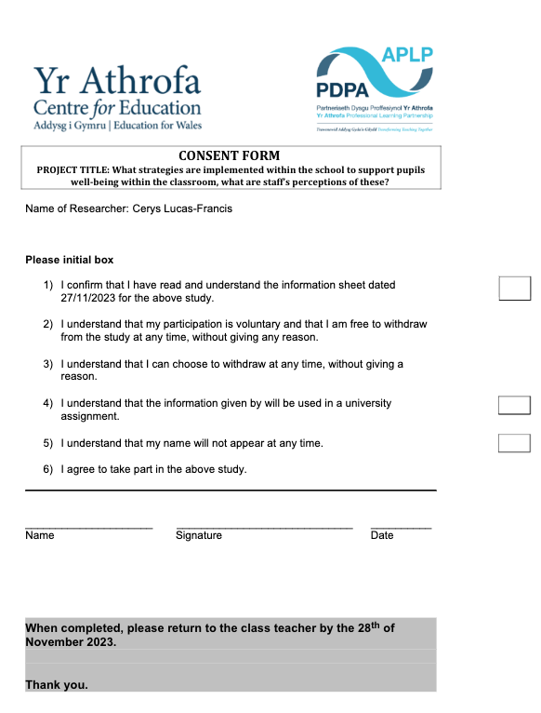
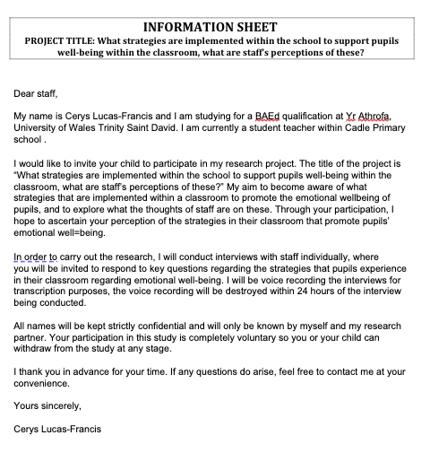

- Observation transcript

Monday morning session 1
- Year 1 and 2
- Observed Christmas concert practice.
- Well-being
- Constant use of positive reinforcement – excellent, well done, amazing, fantastic.
- Referred to pupils as ‘My superstars’.
- Modelling
- BACK IN CLASS – CARPET TIME
- Choice and vote
- Phonics
- Point and leading.
- Reading
- Reading with pupils as a whole class.
- Allowing pupils to contribute
- CHECK IN STATIONS
- Inside out characters – pupils place their name on how they were feeling.
- Calm corner – Pupils free to use whenever they feel like they need to
- Teachers will check in with pupil/pupils after a few minutes.
- Self-affirmation stations
- A mirror with self-affirmations surrounding.
- i.e. I am awesome.

Discussion with headteacher
- Headteacher mantra
- Kindness, stepping up to bullying and acceptance.
- Invisible walls – support ACEs/Thrive
- Children with anger issues – thrive intervention.
- Thrive timetable – proactive, identifies triggers and provide support
- Every child has an assessment, not all children chosen, however these assessments will create whole class targets.
- Meetings with parents about bullying
- Parents will be asked for their child to be removed if their behaviour continues.
- Spectrum project – research
- Different value every month
- Staff
- Trauma informed practice
- TA’s done through inset day training.
- Class teachers done through 3, 2-hour twilight sessions
Monday morning session 2
Reception
- Viewed class display boards and had informal discussions with class teachers.
- Check in station.
- 4 emotions
- Happy
- Sad
- Angry
- Don’t know.
- Choice board
- When pupils are allowed time to choose which activity, they would like to do they can put a photo of their face on the choice board.
- Display boards
- EVERY CHILD IS AN ARTIST
- Behaviour policy displayed.
- Inspirational posters doted around the classroom.
- Feelings displayed in English and in Welsh
- Need someone to talk to posters.
- Included staff,
- Head teacher
- Deputy head teacher
- ALENCo
- Family Liaison officer
- Well-being officer
- Values of the month.

ALN class
- Growing together board
- Information about individual pupils and staff
- 3 faces
- One of the displays had three faces with different colours to describe how they are feeling. Not all pupils can access this yet, so introducing feelings and emotions to these pupils is essential in their development.
- Red - Sad
- Orange – Excited
- Green – Happy
- We are AMAZING board.
- Demonstrated the progress and learning pupils have made since starting in the class.
- Looking to introduce TacPac massaging.
- Book – Once upon a touch
- Visual timetables used to reduce stress.
- Alternative behaviour policy
- Sensory seeking activities are used to support pupils.

Monday afternoon
Trauma informed talk
- What has an impact on pupils’ readiness to learn.
- Relationships
- Self-esteem
- Social
- Behaviour
- The ACE study and protective factors.
- THRIVE
- Thrive assessment will identify who requires support at the beginning of the year.
- Pupils will get support from the well-being officer.
- Pankepp’s emotional system.
- The neuroscience of mental health and mental ill-health.
- Rage
- Fear
- Panic/Grief
- Care
- Seeking and play
- Secure attachment is resilience.
- Self-esteem.
- Capacity to ask for help.
- Development of effective regulatory systems in brain and body.
- Capacity for deeply fulfilling relationships in later life.
- Capacity for empathy.
- Longevity.
- 7 minutes with an emotionally available adult.
- Social rejection
- Words can mean the same as physical rejection.
- Seeking system
- Vital to go enthusiastically into the world.
- Play
- Play with an adult can allow movement from untrust to trust.
- P’s and 3R’s
- Protect
- Regulate
- Reflect
- Relate
- Whole class activity from THRIVE.
- I wish my teacher knew.
- For this session only the wellbeing officer in the class, and pupils have a sheet where they have an opportunity to write anything that they would like their teacher to know, something that may be small to the child, or a big thing to the child.

PET THERAPY
- Which pupils are invited to see the therapy dog.
- Pupils with Speech, Language, and communication difficulties.
- Pupils with low self-esteem and low confidence.

Tuesday Morning
Year 5/6
- Regulation station
- Chairs and beanbags
- Cosmic kids’ yoga
- Massage
- Movement breaks
- Emotion coaching
Year 3/4
- Address pupils’ feelings when pupils are on task.
- Finger breathing – calming music on in background
- Anti-bullying chant
- Musical instruments brought to go along with a beat that the pupils had learnt previously.
- Set rules out prior to giving instruments.
- Allowed all children to make as much noise as possible to ensure no distractions.
- Allow all children to swap instruments to allow every child to have a different instrument.
- Asked Head Teacher to come observe performance!
- Recording performance
- Showing pupils recording afterwards
- Doorbell – as attention grabber
- Learning bodies ready
- Dojos for participation
- Spectrum
- Healthy relationships keychain
- 4 colours
- Yellow – feeling warm inside.
- Heart – feeling loved.
- Star – feeling amazing.
- Smiley face – feeling happy.
- Visual timetable
- Discuss changes within day.
Tuesday afternoon
Meeting with Family Liaison Officer – Safeguarding
- Safeguarding Wales – APP
- Swansea social services – triage service
- My Concern – everything logged on the site.
- Use the child’s words.
- Don’t ask leading questions.
- Confidentiality
- No identifiable features
- No use of names
- EWO – Education welfare officer

Wednesday morning session 1
Outside agencies talk with family liaison officer.
- Child based support.
- The exchange in Swansea
- Counselling service
- 6 sessions
- Can go to 12 if needed.
- Sessions last 30 minutes to an hour.
- Emotional support
- To build emotional resilience
- Talking and paper exercises
- The brighter futures engagement programme
- Faith in families
- Therapeutic play
- From 6 sessions to any amount
- Home sessions/visits
- Support children to manage with emotions/trauma.
- YMCA – Swansea
- Young carers service
- Children who are supporting parents at home
- Give carers support.
- Allow them to lead a more normal childhood.
- CHYPS – Children and young person service
- Organised through women's aid.
- Short term intervention
- Support children who are victims of domestic violence
- Support trauma recovery.
- Family based support.
- Early Help Help
- Supporting parents
- The continuum of needs
- Early social services
- Early help help
- Social services
- Run courses with parents.
- Call in other services to get families back on their feet.
- The help is voluntary.
- Swansea Social Services
- Four hubs across Swansea
- Dependant on the area family lives in
- Home start Cymru
- Not related to social services
- Instead of telling a parent to do something but will help them to do it.
- Must have a child at least under the age of 11.
- SNAP Cymru early help.
- Similar to home start and early help help.
- More for families with a child who has ALN.

- Interview questions

To be read prior to carrying the interview out;
This interview will include questions regarding strategies adopted to promote well-being among pupils. The interview will be voice recorded for transcription purposes and will be destroyed immediately after it has been transcribed. This interview should take approximately 5-10 minutes. Your participation is completely voluntary, and you can withdraw at any time. All information shared will be kept confidential and in accordance with the Data Protection Act 2018.

- How would you describe the school’s approach to supporting the well-being of pupils’ within the classroom?
- Do you find any challenges using the well-being strategies?
- How do you ensure that you adopt the schools’ non-negotiable well-being strategies?
- Do you have opportunities as staff to have continued professional development to enhance your understanding and implementation of strategies for supporting student well-being?
- Do you find that the well-being strategies have impacted student engagement?
- How do the wellbeing strategies implemented relate to the curriculum?
- Is there anything else that you would like to add?

- Interview transcript
Interview 1
Speaker 1
- How would you describe the school's approach to support the well-being of pupils in the classroom?
Speaker 2
- Health and well-being is as part of the six AoLEs, it's plays as much importance as all the other AoLEs. So has as much importance as literacy and numeracy. Your art, your expressive arts, your science, technology and humanities. We place it [Well-being] at the forefront of everything because we feel that the best way a child can learn is if they are feeling happy within themselves and confident. So obviously healthy, confident individuals, we use four purposes quite a lot. At the beginning of each term we always have a PSC fortnight, so at the beginning of the year in September, it's like to get to know the children. We formulate their one page profiles, we get to know where their strengths and maybe their difficulties lie and they can tell us what's important to them. Where they need more help, we also get to know who's important to them, families, what their interests are. Yeah, just to build relationships. Really.
Speaker 1
- How would you ensure that you adopt the schools non negotiable well-being strategies?
Speaker 2
- Well I have the non negotiables for all the AoLEs as I said, which I keep on my desk and through the week we use things like the check in on the Monday. Yeah, where all the children are asked to put their lollipop stick in an emotions part. I've got an area which is bilingual, where the children can talk in Welsh about their feelings and maybe what they've been up to on the weekend. The children can change their lollipop sticks into different pots throughout the day. So if I feel there's any issues or anything I need to address, then I'm able to do that. We use the finger breathing techniques, so if the children need to be settled then I've got my emotion coaches who have been trained up in in emotion coaching. They will come out to the front and they will do finger breathing and play calm music during lessons. Yeah. So there's quite a lot always going on.
Speaker 1
- You mentioned that the emotion coaches have been trained, who are they trained by?
Speaker 2
- Yes, they're trained by Miss John and Miss Guernsey, who also trained emotion coach teachers. We've also got the Thrive room, the well-being room. Each class has got, like, a regulation stations, so the children can go into those to calm down. They've got, like, techniques for the children to follow. How do you regulate my emotions in my class I've got the emotion coach posters up. To make sure that they know the routines and the points that they need to go through to calm and regulate.
Speaker 1
- Do you find any challenges using the well-being strategies?
Speaker 2
- Sometimes I feel frustrated because if you know something happens on the yard, it's not been dealt with by other members of staff, or maybe there's been too much going on it can spill back into class, and sometimes they feel pressurised. They don't always have time to deal with it before a lesson begins. Also if there are any situations that have to be dealt with behaviour or pupils falling out it does. It is quite time consuming cause we got to fill in a class concern [My concern] message online and that goes through. It's a very good system, goes through to our safeguarding officer and to the SLT, so everybody knows what's going on. Everything else I think seems to run effectively.
Speaker 1
- Do you find that the well-being strategies implemented have an impact on student engagement?
Speaker 2
- Yes, absolutely. I think that, if a child is happy and they're feeling settled, then they're more likely to complete the work to, you know and you know, settle into class.
Speaker 1
- Do you have opportunities as a staff to have continued professional development to enhance your understanding and implementation of strategies for supporting student well-being?
Speaker 2
- Yeah, we have constant recapping of the emotion coaching strategies. We appoint new motion coaches every year. They have like a checklist to make sure that we've got the emotion coach information up on the wall, regulation strategies. We constantly update thrive profiles to make sure that you know we want to show that the children are put in groups or worked with on an individual basis with our thrive practitioners to help them and support them with their well-being.
Speaker 1
- Is there anything else that you'd like to add about well-being?
Speaker 2
- No, I think it's important in this type of school that well-being is at the heart of everything. Also that we've got time to listen to pupils, make sure that we are dealing with their feelings and their emotions because sometimes the emotions can be too big for them to cope with themselves, and then it gives us the chance then to step in and support them.

Interview 2
Speaker 1
- How would you describe the schools approach to supporting the well-being of pupils in the classroom?
Speaker 2
- We do lots of different things and so we would do things like at the end of every play they would do finger breathing to regulate them so that they're ready to learn if they're a bit fidgety then they might do a go noodle or something. On a Monday we have a big check in and on a Friday we have a big check out and then they will tell us then you know things that they've enjoyed or what they're looking forward to. And sometimes in those conversations things might come up, but they can speak to you quietly about later. They have a check in chart every day as well, where they peg their picture onto one of the inside out characters, and then we'll tend to go over. They can change them during the day and we'll go over and check why they're feeling sad or angry or something like that. We do an awful lot in the school to support it [well-being]. But I think it's needed especially in this kind of area, they do need.
Speaker 1
- Do you find any challenges when approaching and carrying out the well-being strategies?
Speaker 2
- Not challenges, necessarily in carrying them out, I suppose knowing which strategies work for certain pupils. I suppose the challenge is trying to ensure that you're doing it for all the pupils you might have. You may have different challenges during the day and you've got to use different approaches for different types of children. Or you might have someone who's dysregulated and maybe disrupting a group's learning so, that’s the only challenge is really.
Speaker 1
- Do you find that the well-being strategies have impacted student engagement?
Speaker 2
- OK, so it definitely does impact them. You know, if they if they come in, some will maybe arrive at school and they're really dysregulated. So obviously they're definitely not going to have any good learning experiences at all. So you need to prioritise that, you know, regulating them and getting them back down to a level where they can sit alongside other children and learn and participate in the class. So it does definitely impact it and things like, if you know if you're in the middle of a group and somebody becomes upset or something, and then instead of trying to brush it off, you know, deal with it, empathise with them and validate their feelings and just take that time because they're, they're not going to carry on working, if they're really upset about them. Similarly, if they're really fidgety, if you do go noodle and just get their fidgets out and give them a bit of a shake, then that works as well. So it definitely does impact it, because if we didn't have any strategies and just try to plod on, well then; I don't think they'd learn anything.
Speaker 1
- Do you have opportunities as a staff to have continued professional development to enhance your understanding and implementation of strategies for supporting student well-being?
Speaker 2
- Yeah, we do. We have a lot of training on specifically on well-being. You know, we're a thrive school, so we use the Thrive port. We've been trained in that as well. Not all staff to a really deep level, but we've all had some form of basic training on it and then we would use the Thrive online tool to be able to assess really where the children are at and what they are struggling with in your class and where they need to go. So we do that we've, you know, we do emotion coaching. We've had training on that as well and then there's emotion coach training staff in the school. We're having trauma informed training at the minute in our twilight sessions. I think well-being always is always one of those things which is I'd say a priority for the school because I think we recognise that if a child's well-being isn't positive or where it should be. It's not going to help them learn at all if they, you know, they are really going to struggle to get any further and get their mind in a space where they can, you know, learn maths, English or whatever. Yeah. So it's things like that really that we do have a lot of different opportunities of how we can deal with children and different strategies we can use and examples.
Speaker 1
- Is there anything else that you'd like to add?
Speaker 2
- I'd just say really that this well-being is really a priority because, yeah, if they if they don't have a good well-being, then you don't care about their well-being well, you're not then the trusted adult that they're coming to school with, you know, they might not have that at home and they really need somebody in school to be that for them so. Yeah, if you can be that person for them and empathise with them, then they can get on board with you. Really and they are more likely to participate in things and learn, I guess. So it is really important and I think the challenge is really which one works for which pupil. You know you do and especially with some children it might be there's a particular adult in the school that they really bonded with and you know, although they might be in a different class. Unfortunately, if that is their trusted adult and you just got to go with it. Even you know, if it disrupts things. Now that is that is your priority. So being able to help any children you see rather than just ones in your own class.

- Blank questionnaire
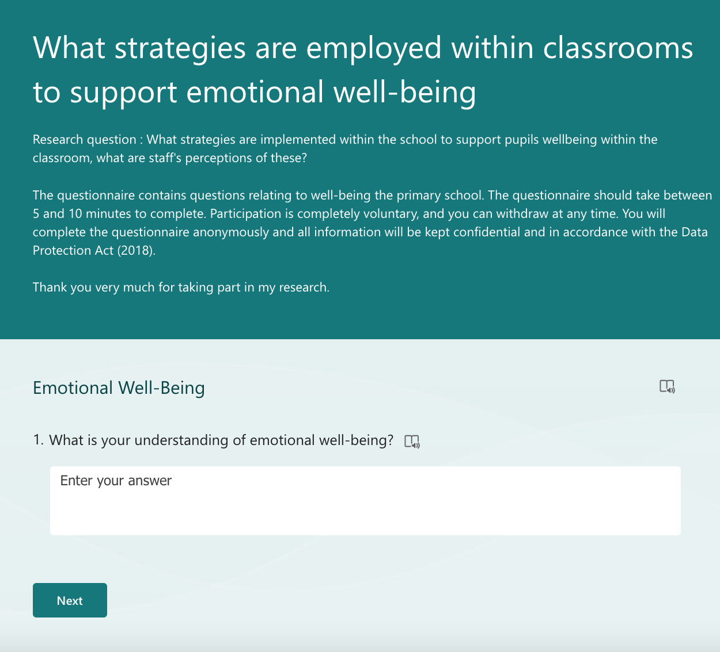

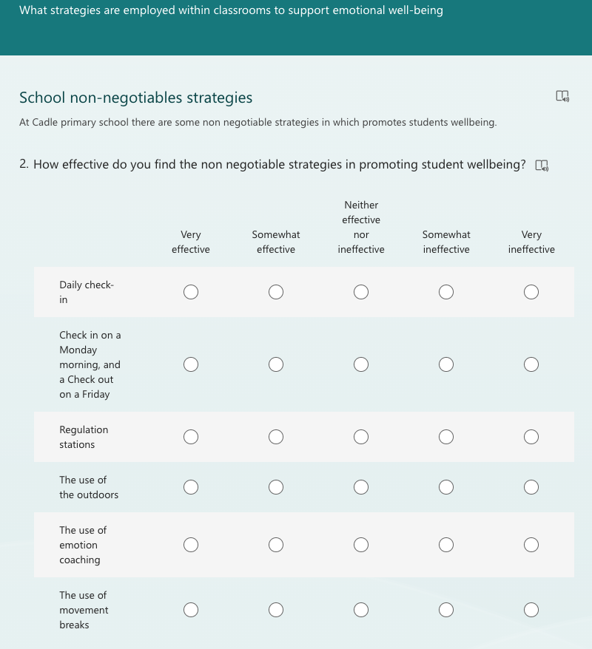

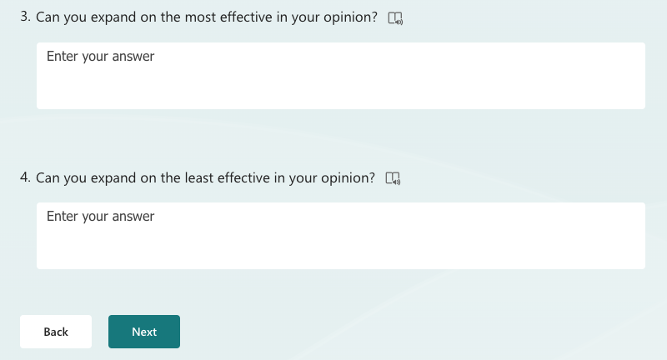

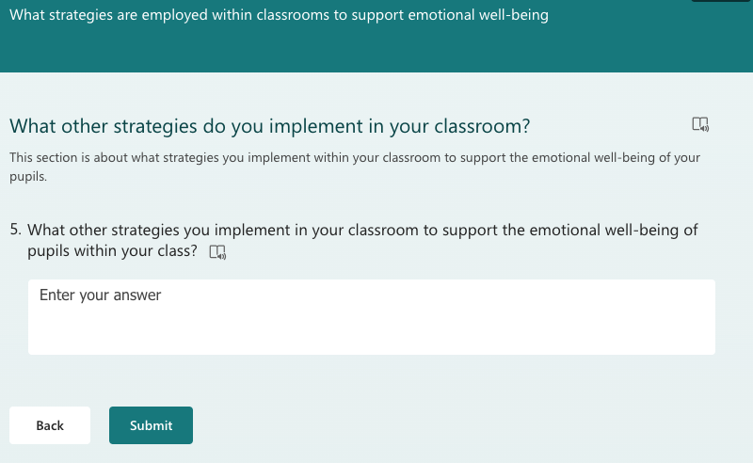

- Questionnaire transcripts

Question 1 – What is your understanding of emotional well-being?

1 | Emotional well-being is the ability to produce positive emotions, moods, thoughts, and feelings, and adapt when confronted with adversity and stressful situations. One of its foundations is resilience, which allows you to navigate challenging school and life events.
2 | The ability to regulate your emotions whether negative or positive and adapt to any changes that may impact those emotions.
3 | My understanding of emotional well-being is that it can affect how we think, feel and relate to ourselves in a positive or negative way. Our emotional health affects our capacity to manage, communicate, and form and sustain social relationships.
4 | The children are able to manage their emotions. That they are aware of the emotions they feel, can name it and have strategies to support them and manage them.
5 | Very good, we have received lots of training through the years. We are a relationships first school and trauma informed. Trauma informed is also part of our school development plan this year.
6 | Pupils are emotionally regulated and ready for learning. Emotional well-being is something that needs to be taught explicitly and be at the centre of a teacher’s pedagogy.
7 | Looking after yourself, your happiness and well-being.
8 | Looking after pupils mental health.

Question 2 – How effective do you find the non-negotiable strategies in promoting student wellbeing?

 | Daily check-in | Check in on a Monday morning, and check out on a Friday | Regulation stations | The use of the outdoors | The use of emotion coaching | The use of movement breaks
1 | Somewhat effective | Very effective | Somewhat effective | Very effective | Somewhat effective | Somewhat effective
2 | Very effective | Very effective | Very effective | Very effective | Very effective | Very effective
3 | Somewhat effective | Somewhat effective | Very effective | Very effective | Very effective | Somewhat effective
4 | Very effective | Very ineffective | Very effective | Very effective | Very effective | Very effective
5 | Very effective | Very effective | Very effective | Very effective | Very effective | Very effective
6 | Somewhat effective | Very effective | Very effective | Very effective | Very effective | Very effective
7 | Somewhat effective | Very effective | Somewhat effective | Very effective | Very effective | Very effective
8 | Somewhat effective | Somewhat effective | Somewhat effective | Neither effective nor ineffective | Very effective | Very effective

Very effective | Somewhat effective | Neither effective nor ineffective | Somewhat ineffective | Very ineffective

Question 3 – Can you expand on the most effective in your opinion?

1 | I feel check ins enable teachers to gauge how pupils are feeling and also deal with any safeguarding issues.
2 | A combination of all strategies particularly help many of our pupils who may become more easily dysregulated.
3 | The steps taken by emotion coaches are extremely relevant and effective within our environment in school. Particularly ‘naming and taming it’.
4 | Check ins all the time with restorative discussions.
5 | Finger breathing and mindfulness in general.
6 | Regulation stations – as long as pupils are taught how and when to access these. De-regulation strategies have to be modelled and taught to the pupils.  Check ins – Very important. As a teacher these enable you to gauge the emotional well-being of your pupils and to know when to provide support where necessary.
7 | Use of the outdoors is extremely beneficial as it allows children to move freely and supports physical movement, health and well-being.
8 | Building good trusting relationships.  Understanding a young persons’ life.

Question 4 – Can you expand on the least effective in your opinion?

1 | Emotion coaching as not all staff or pupils are confident with this strategy.
2
3 | The daily check ins can be difficult due to children not wanting to open up on difficult days/or wanting to share with a teacher.
4
5 | Regulation station. Some children do not use it effectively.
6 | Daily ‘whole class’ check-ins can be rushed. Pupils need to be made aware and feel confident to identify their different feelings throughout the day and be able to identify adults that they can seek help from.
7 | Regulation stations aren’t used as purposefully as they should. The aim of them is fantastic but children do not use them as they are intended.
8 | I am not sure utilising the outdoors as much as I would like presently but will in future months.

Question 5 – What other strategies do you implement in your classroom to support the emotional well-being of pupils within your class?

1 | One to one chats. Pairing pupils in friendship groups to carry out tasks.
2 | Massage partners, finger breathing, compliment circles, therapy dog, role play scenarios, mindfulness colouring.
3
4 | All of the above.
5 | Mindful colouring. Games and activities.
6 | A focus on each of our monthly values facilitates discussion around how we should treat each other, hence promoting class well-being. A health and well-being focus at the beginning of each term helps to remind pupils of the behaviours, values and ethics that contribute to the emotional well-being of our class.
7 | Informal check in, always observing children’s moods and engagement and asking if they are okay.
8 | Emotion coaching  Regulation  Relationship building

- Non-negotiable strategies to well-being

- Accurate up-to-date record Keeping on My Concern.
- Weekly Safeguarding Meetings between SLT and Wellbeing Officer.
- Open communication between staff and wellbeing team to discuss initial/ongoing concerns.
- Check in daily – use class appropriate strategies (flowerpots/ pebbles)
- Check in – Monday morning – every child shares their feelings with an adult
- Check out Friday – A discussion about the week – weekend’s activities
- Regulation Stations
- Calming music in classes ( especially after transition times )
- Calming activities after transition from break
- Use of the outdoors – as much as possible
- Behaviour policy – displayed ( discussed) followed and adhered to
- Use of emotion coaching
- Use of movement breaks
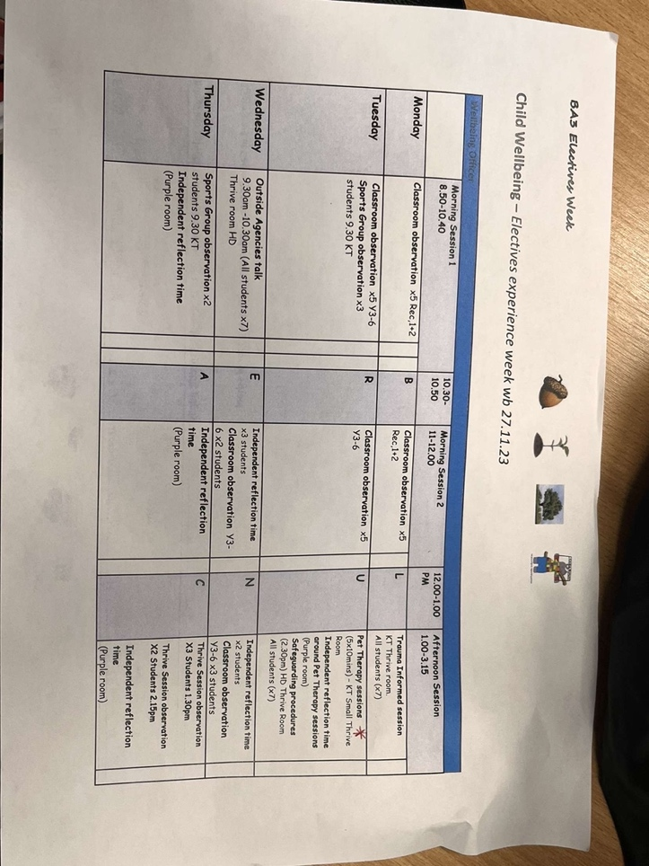
- Discussion of values at the beginning of each month – dojos awarded and certificates given

- Electives week timetable

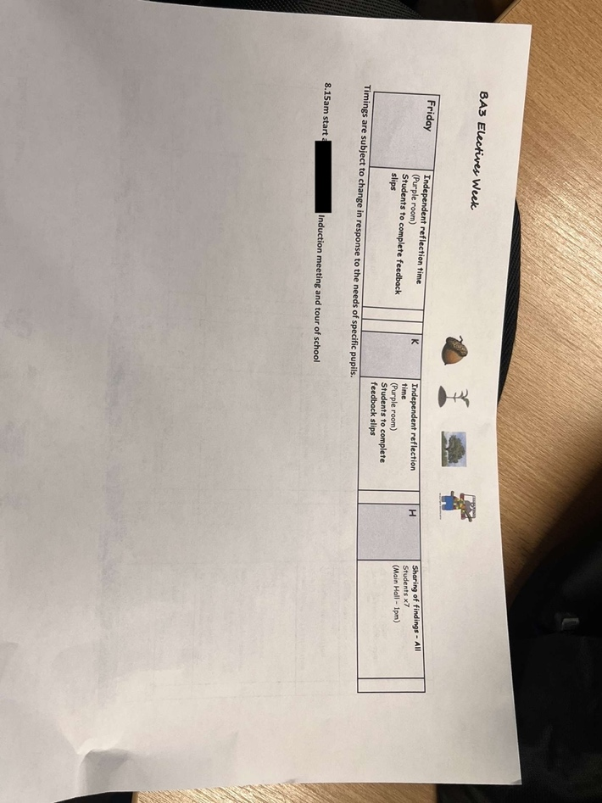

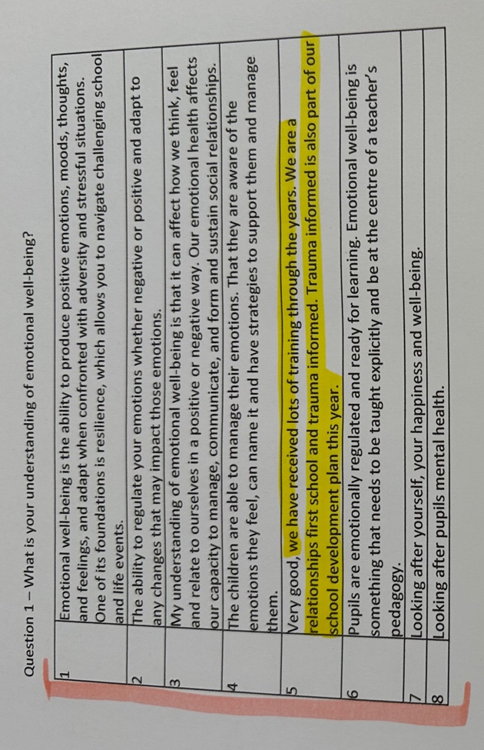
- Physical transcription



