Worksheet 2

Network Operating Systems ACCA5023
Neil O’Mahoney 0351709
Part Time Cyber Security Networks

Contents
Task 1 - Pre-requisite tasks 3
Task 2 - Deploying Active Directory as a role or feature based installation. 4
Task 3 - Creating user account objects using Active Directory Users and Computers snap-in console 6
Task 4 - Object attributes of interest 7
Task 5 - Adjoining the domain and testing user logins 9
Task 6 11
References 17

Task 1 - Pre-requisite tasks

Figure 1 - Server 1 IP is statically defined, no DNS
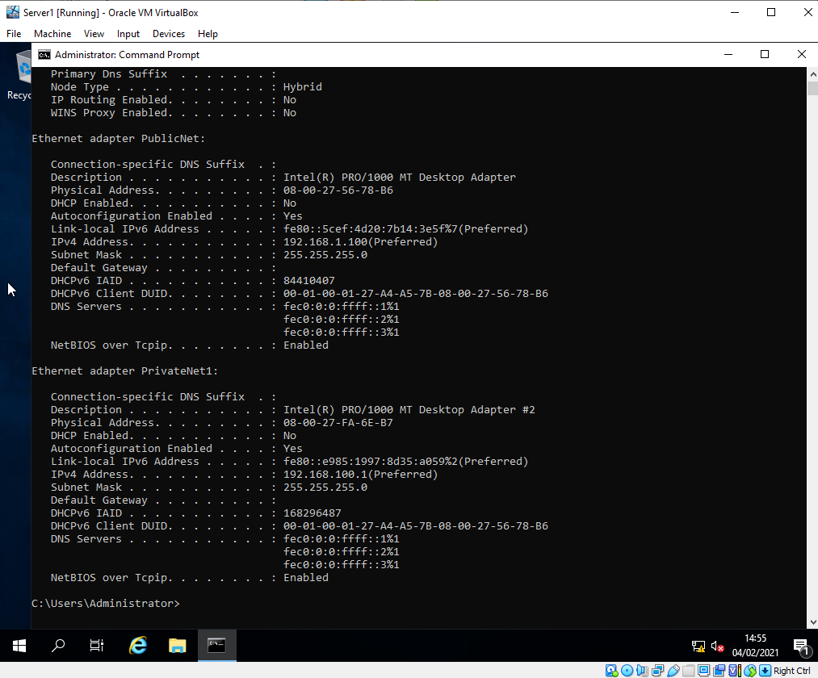

Figure 2 - Server 1 Name has had its name changed
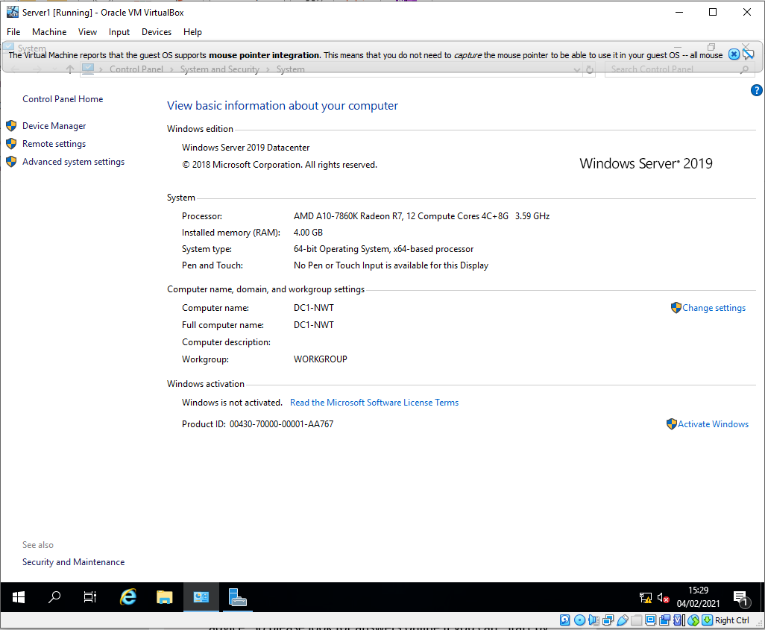

Task 2 - Deploying Active Directory as a role or feature based installation.
Figure 3 - Server 1 deployment and installation of Active Directory as a Role. Verification that this has happened on Server 1
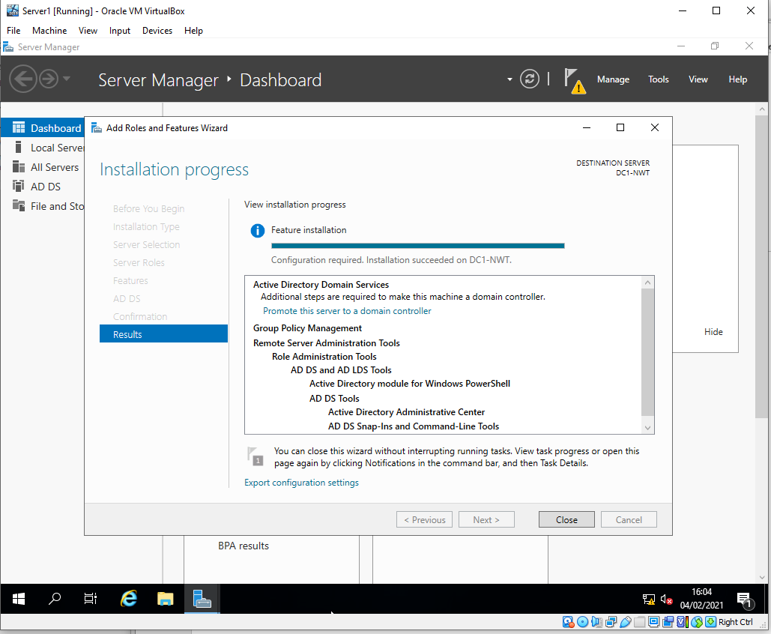
Figure 4 - Server 1 added to a new forest, domain name ‘nwtraders.msft’
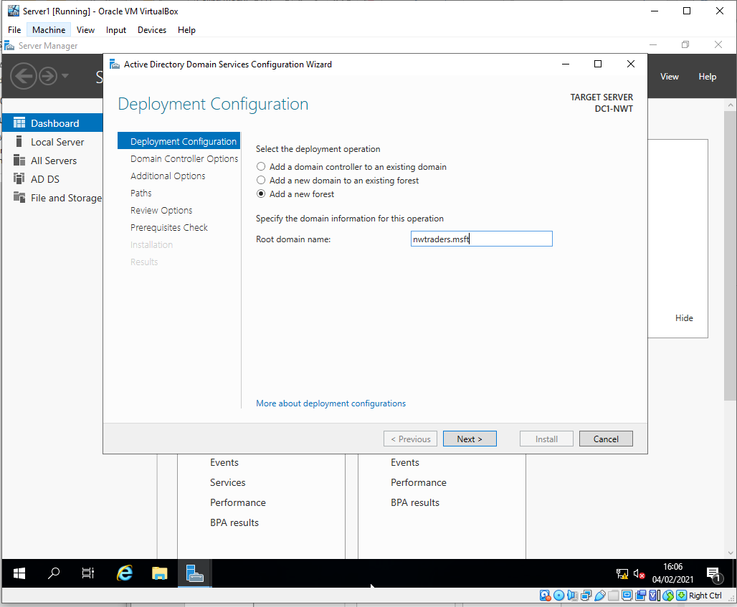

Figure 5 - Domain functional level set to 2016 and pre Server 1 pre-requisite checks performed, no errors just cautions > install
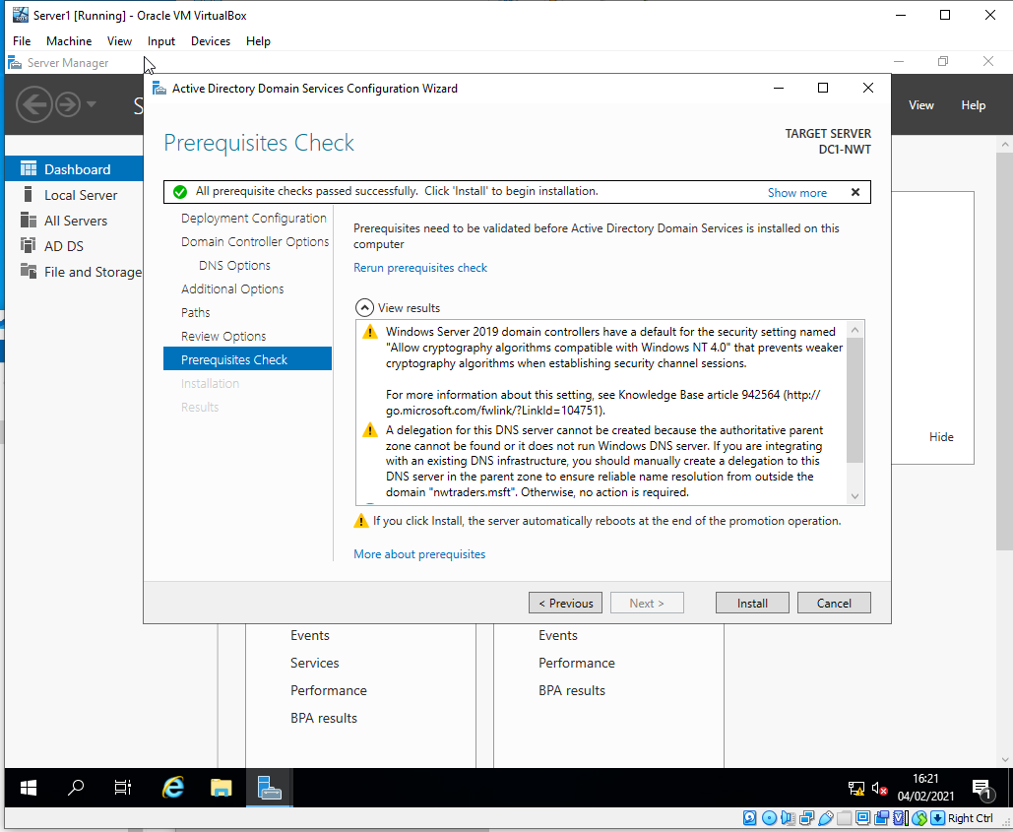

Figure 6 - Server 1 machine has rebooted successfully after domain controller configuration install admin@ nwtraders enter password
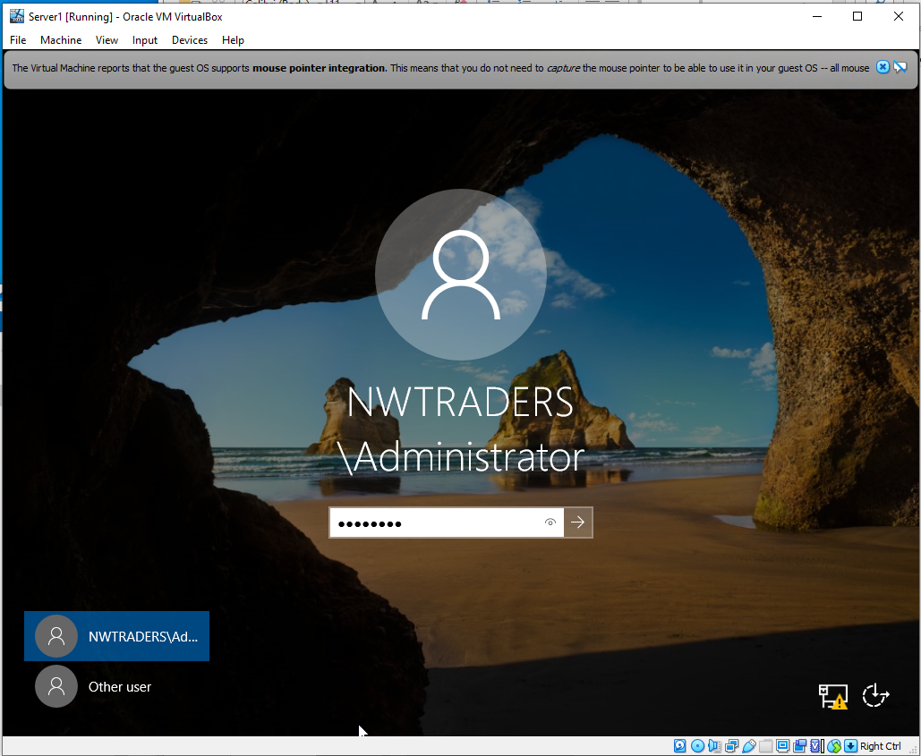

Task 3 - Creating user account objects using Active Directory Users and Computers snap-in console
Figure 7 - Server 1 verifying that DC1-NWT is listed as the nwtraders.msft domain
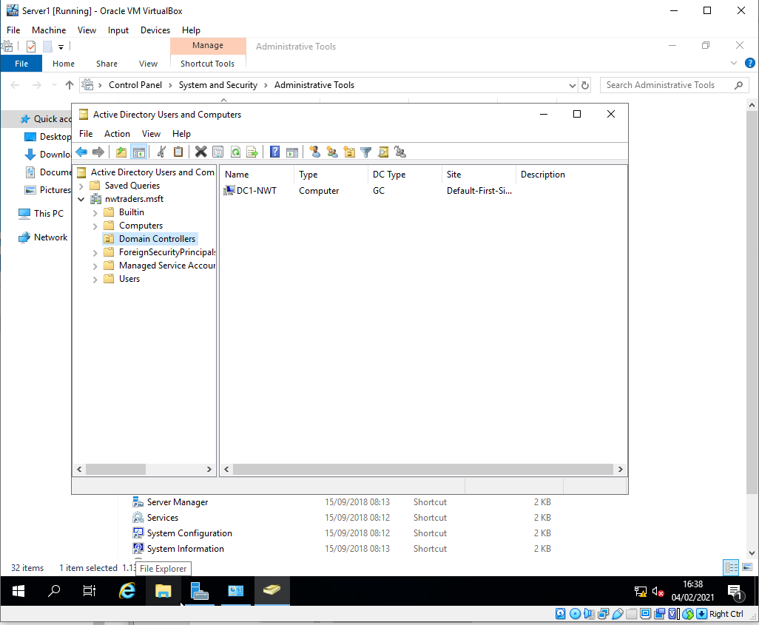

Figure 8 - Accounts created and added to relevant groups. Server 1 account now added to domain admins confirmed
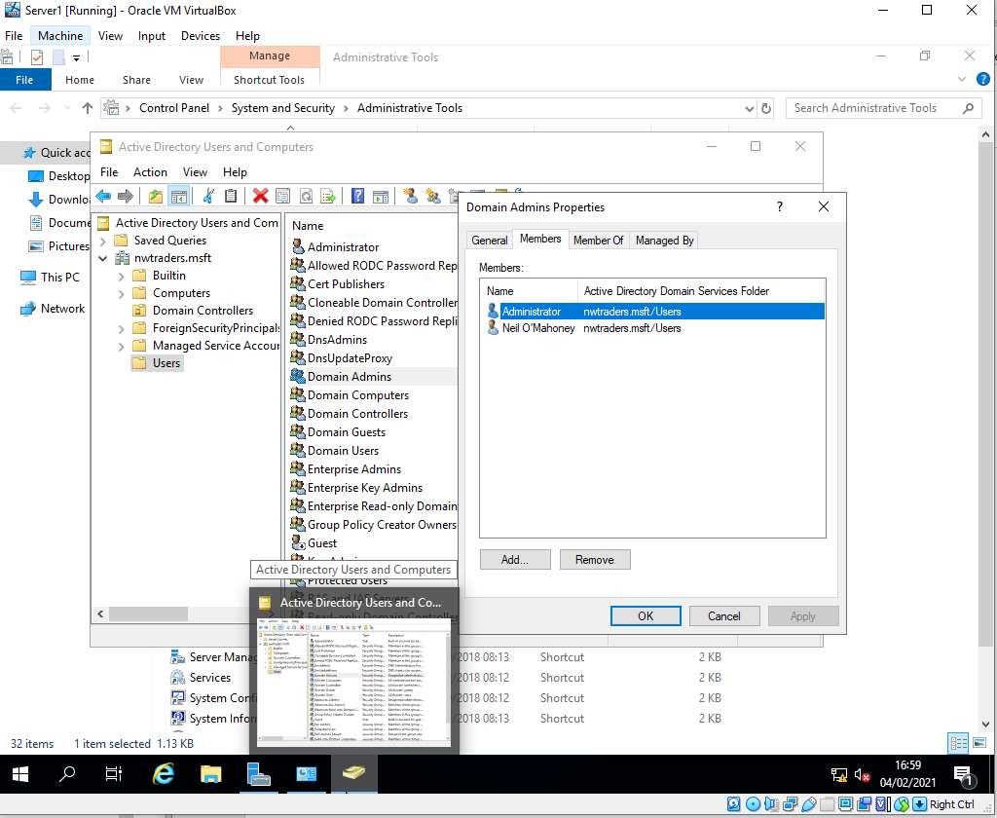

Task 4 - Object attributes of interest

Figure 9 - Verification that Server 1 ‘test user’ created verified in members tab (password P@ssw0rd)
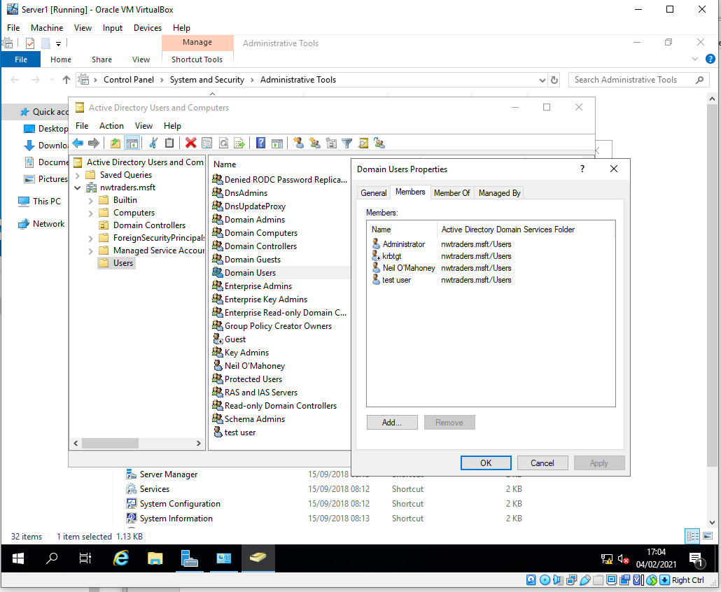

Figure 10 - Server 1 restricting test users account logon times 8-5 Monday – Friday.
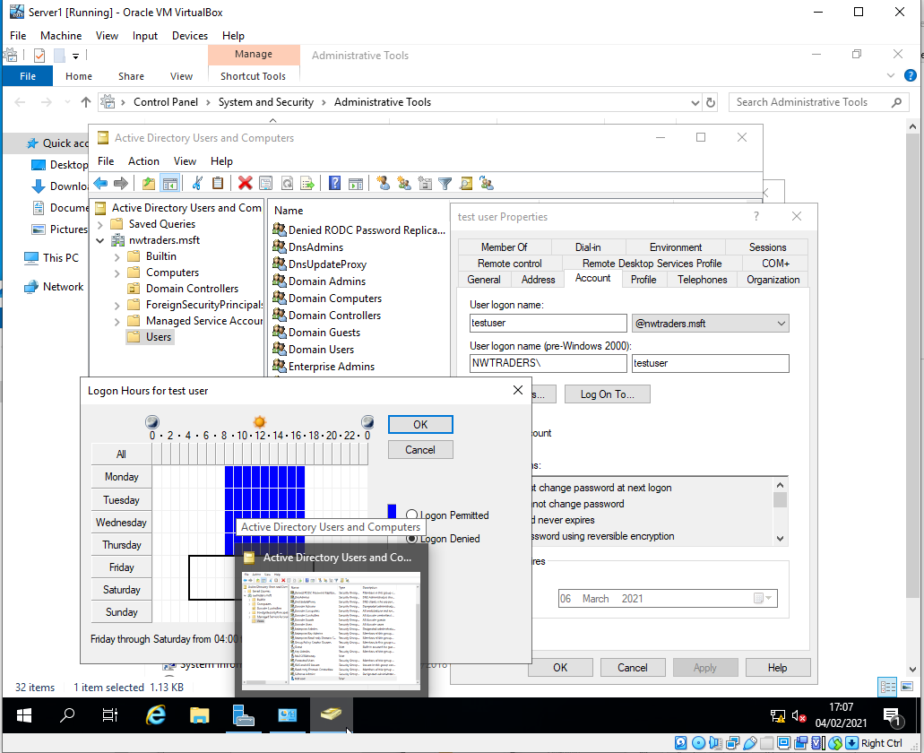

Figure 11 - Server 1 stop user changing password > ok
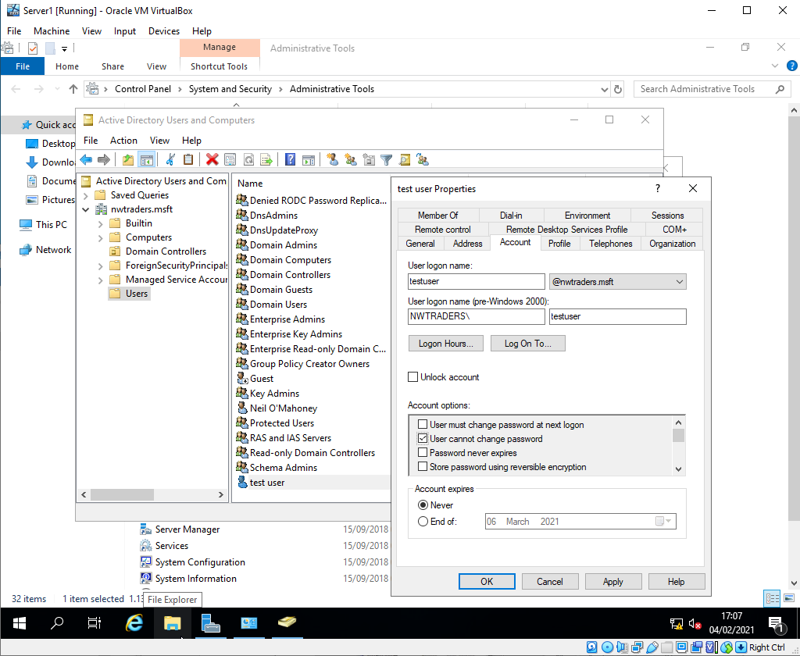

Task 5 - Adjoining the domain and testing user logins
Figure 12 - Client 1 (WS1-NWT) joined to NWTRADERS.MSFT domain. Client 1 username Administrator password ‘N3tW0rk1’ > successful.
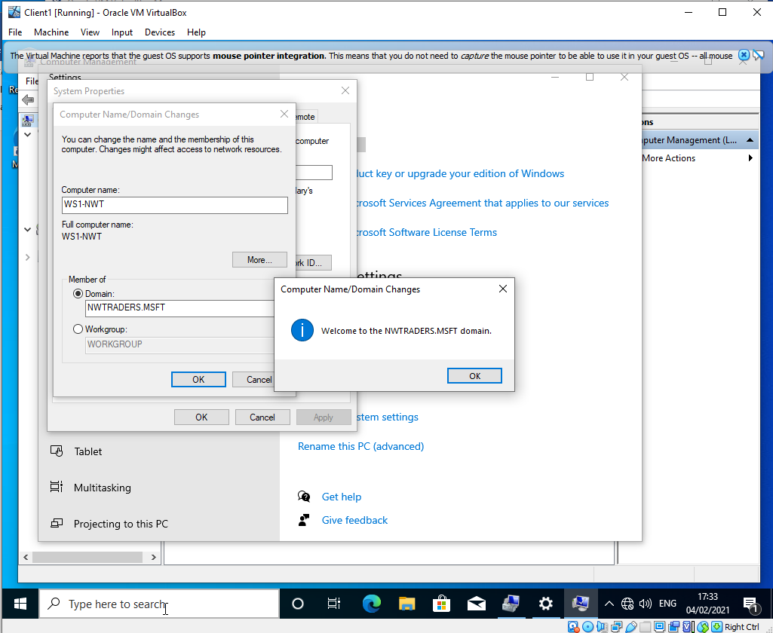
Figure 13 - Testing domain joined computer with Client 1 denies access to members account (due to time restrictions – 17:39)
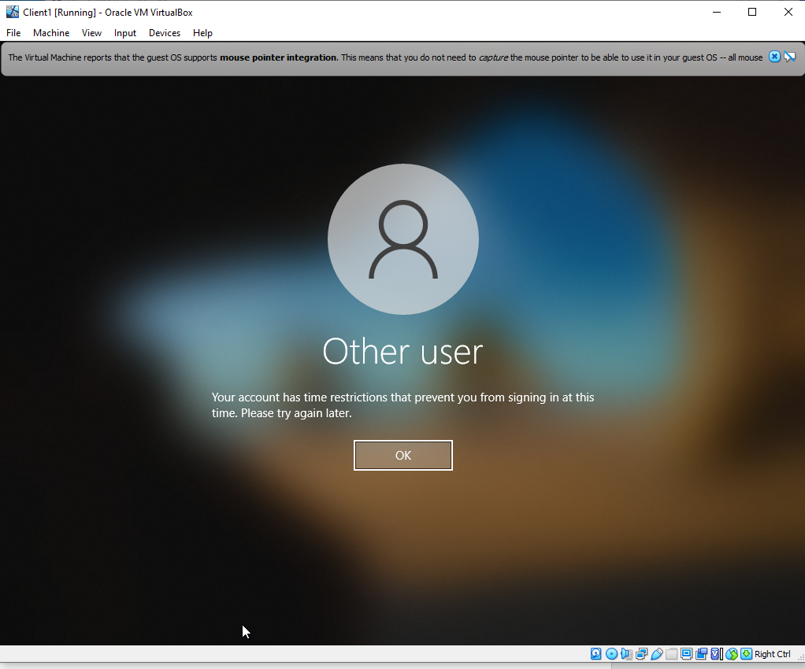

Figure 14 - Server 1 trying to login with non-admin user account (test user) unsuccessful login
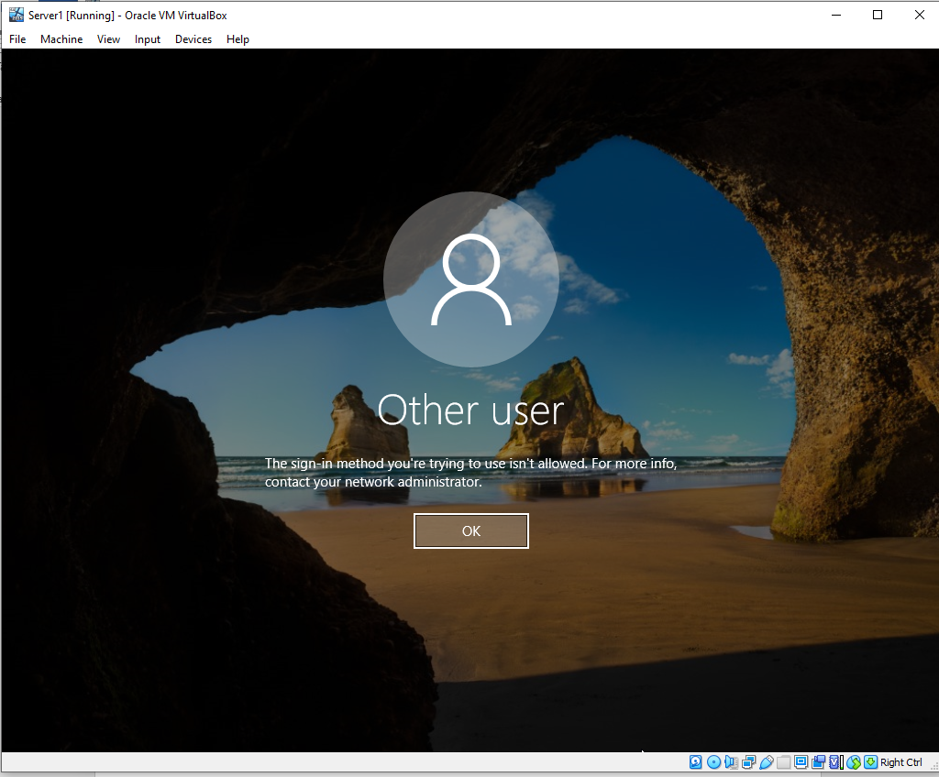

Task 6
6 a)
Domain Name System (or DNS) is used for translation between IP addresses and domain names and vice versa. ‘Domain Name System (DNS) protocol is an essential part of the Internet. It maps tough-to remember Internet Protocol (IP) addresses to easy memorable domain names’. [1]
A DNS query (or DNS request) is a request for information from a DNS client (PC) to get IP information relating to a domain. There are two types of request; recursive and non-recursive query. A recursive query is whereby a client gets the IP of a domain by asking the DNS server to do a complete translation or put another way ‘…The machines that receive a client’s query for a domain name and resolve it to a corresponding IP address’ [2]. A non-recursive query is where a DNS client contacts DNS servers sequentially until it finds the server with the required information.

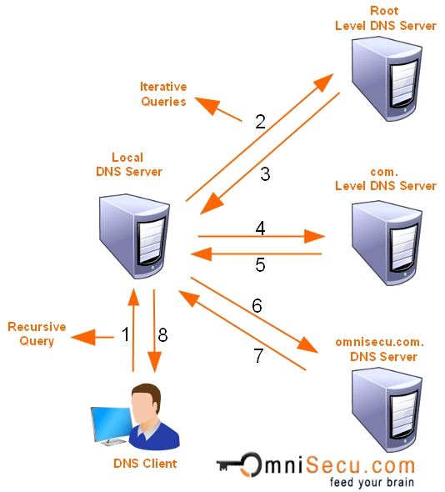
Figure 15 - DNS Recursive and iterative processes [3]
DNS also has a critical role within the Domain Controller (a server that manages network ID security for authentication and authorisation access into the domain. Active directory uses DNS as a location hub so that when searches such as authentication etc are performed, the computers with use the DNS service to locate its domain controller. 'When any of the principal Active Directory operations is performed...computers use DNS to locate Active Directory domain controllers'. [4] DC’s also use DNS to locate one another. This feature was enabled after windows NT to reduce a reliance on the NetBIOS broadcast.
The process involves the host and SRV records host records map the DNS name (FQDN) SERV records map specific computers at a specific site that offer a service. Client computers locates a DC by going to the DNS server, the DNS server returns a list of weighted records that can allow a DC login a second query is then sent that requests a specific IP address for the top DC, this is returned by the DNS server and the client computer contacts the DC if available (or the next in line if it is not). Finding a DC in the same site as the client is important as sites are often linked by a slow connection, traffic schedule and unnecessary traffic can be reduced.

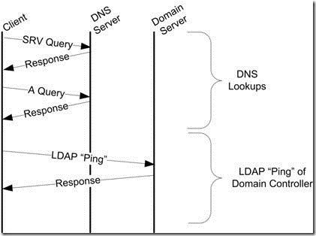
Figure 16 - DC Locator Process [5]
6 b)
Installed by default on a Windows Server, the File and Storage Services allows you to setup and manage single or multiple servers. Basic installed functionality allows you to use the GUI in Server Manager or the command line driven ‘PowerShell’ to manage storage on your servers. A focal point for any organisation Files and storage is a centralised repository.
In addition to the above-mentioned File and Storage services allows management of work folders (for users personal PC’s), offline files, folder redirection and roaming profiles to increase speed of access and portability of users. Resilient in storage spaces by using industry standard disks, ISCSI Target Server to centralise SW based and hardware Storage Area Networks (SAN’s), finally the file and storage services eliminates the need for data duplication by users creating profiles on multiple machines. ‘File and Storage Services includes technologies that help you set up and manage one or more file servers, which are servers that provide central locations on your network where you can store files and share them with users.’ [6]
Dynamic Host Configuration Protocol (DHCP) is a Windows Server critical role that is responsible for the centralisation and automation of the IP configuration. Rather than statically assigning IP addresses to each host that comes onto a network it is far easier the administrate them all from a central location. It is possible to do this on a router however DHCP on a Windows server is far easier. It can maintain a database of IP addresses, set lease times, reservations, upper and lower limits and deploy or close down scopes. It is also effective in the logging and reporting of issues with a scope. ‘DHCP removes the need for manual configuration of these parameters on every device and provides a convenient method for them to share a limited pool of IP addresses.’ [7]
Using the Discover, Offer, Request Acknowledge (DORA) method, a computer can request and be responded to, to gain an IP address on a network.
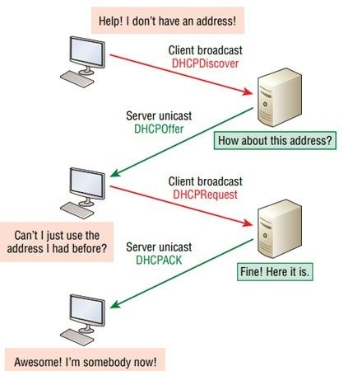
Figure 17 - Illustration of the DORA process [8]

6 c)
To powerful Admin accounts on a server open to all is a dangerous thing and it is much preferred to have a layered approach when administrating a Windows server after the initial setup. This means that no-one computer account can have overall authority on a network (with the exception of emergency use only accounts). It is important for logging purposes also that if there are mistakes made then a shared Admin account is a bad idea when trying to pinpoint an error in procedure.
Should there be only one Admin account on a server then a user who might not necessarily ever use all of the functions, be given access to it. Also, if the account was ever compromised, then this could be a very dangerous situation, there needs to be a layered approach to prevent against this.
Privileged Access Management (PAM) strategy is a method of exerting control over privileged access accounts. Typically, users will have a single account and permissions to complete their work. For IT administrators of a system however there is a requirement to have multiple accounts and varying privileges associated for each. There are Local admin accounts (to provide admin access at a local level), Domain Admin Accounts (to provide admin access at the domain level), Break Glass Admin accounts (to be used in an emergency), Active Directory Accounts (password changes etc) to name but a few. In short to complete a task there should be an account(s) associated for the role.
Within Windows Server there are built-in accounts and groups preconfigured to complete the setup and running of a new server. These fall into two categories: Service Admin and Data Admin. Service admins are responsible for Active Directory Domain Services and Domain Controllers whereas the Data Admins are responsible for data stores on AD DS, servers and Workstations.
Security Accounts Manager (SAM) or Active Directory is used to validate the Windows credentials that have been inputted on a domain joined device. Users’ passwords are stored in a hashed format file in the Windows Registry and authenticates local user logons.
6 d)
Microsoft has an administrative policy which guides domain admins when creating accounts stating that ‘..All users should log on with a user account that has the absolute minimum permissions necessary to complete the current task and nothing more. Doing so provides protection against malicious code, among other attacks’. [9] It would be too easy to add every user to the domain admin group, but very quickly chaos would ensue and issues would arise.
Account, Global, Domain Local and Permission (AGDLP) is a Microsoft recommendation for implementation Role-Based Access Controls (RBAC) within Active Directory (AD). Designed to maximize flexibility whilst reducing the administrative burden. ‘Microsoft recommends that you apply a nesting and role-based access control (RBAC), specifically the AGDLP for single-domain environments and AGUDLP for multi-domain/multi-forest environments.’ [10]
Another method of interoperating the ‘Least-Privilege’ policy would be adding all employees to individual resources. This would be very time consuming and complex business (not to mention removing them again). Although initially a company might be small in start-up stages, it is not scalable to add contractors, additional employees and temporary users to all the same files that a single department require. Not only that but it is easy to forget files they might need access to as well as Token Bloat (users in excess of a predefined SID token size which leads to login errors). ‘…A user being a member of thousands of groups by the time they are granted access to all of the resources they need…could…result in issues like token bloat.’ [11]
Within AGDLP users accounts go into Global Groups which represent their standing or role within the entity or company they represent. These Global Groups are then made members of Domain Local groups and some permissions are applied to them. An example of this could be a resource such as a Marketing Documents a domain local is applied to this device to allow access. User groups (such as Marketing) are added to the domain local Marketing Documents group. We can say with certainty that only Marketing is allowed to access the folder. This can only be used from users from this domain and not from another domain giving us confidence who has used the Marketing Folder. The domain local group has not been used in another domain. ‘Groups with domain local scope help you define and manage access to resources within a single domain.’ [12]
If using a global group instead of a local group to a resource it will limit administration later on as if another forest is added to the domain it would not be allowed to be added to the global group.
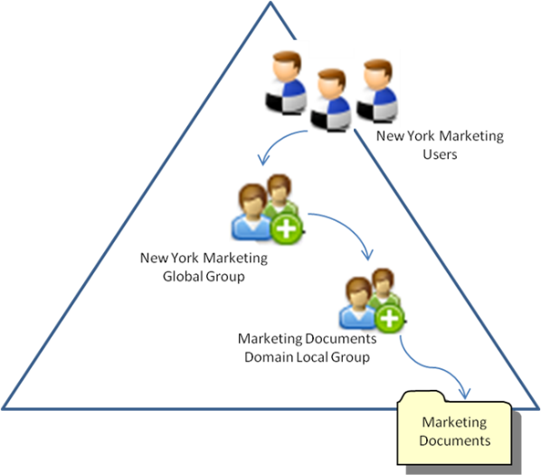
Figure 18 – how permissions interact with a single domain [11]
AGUDLP stands for Account Global Universal Domain Local Permission and is the multi-domain version of AGDLP. The addition this time of the Universal group. This means that users can be added into the Universal group which are members of other domains.

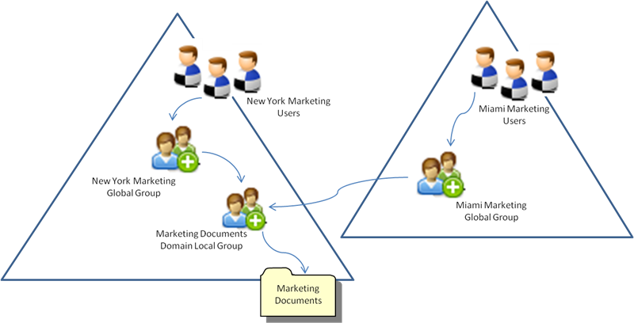
Figure 19 - How permissions interact within two domains [11]

Microsoft’s bests practices however would not be the best fit for larger organisations. Just having Domain Local managing resources could lead to a big number of groups. Again, this could lead to ‘Token Bloat’ which means that the token size has reached over 64k (approx. 125 groups). This will lead to an authentication box and denied access to a folder. Other recommendations are regarding migrations from one domain to another. Thinking about SID history & nesting of groups that users may previously have been a member of. To pre-empt this, it would be good practice to reduce the number of groups when implementing a solution or increase the token size -although this may just delay the problem.
‘User permissions often evolve over time, and changes are often made in an ad hoc manner and do not follow any rigorous process. This is largely due to the fact that the structure of the implemented permissions are often determined by experts during initial system configuration and documentation is rarely created.’ [13]
To keep on top of this it is important to address the problems that exist as well as future problems that may occur. There are several types of groups that should be avoid:
Stale groups are users of a particular group have not authenticated to the domain in a significant period of time. Although the accounts contained within should be fully understood by those that are cleaning up the system.
Empty/ Duplicate/ Single member groups are groups that are not adding value to the system. They should be avoided and removed.
Circular nesting is an example of groups being added to groups for the sake of it going around and around, this can cause issues for users especially if they are added to lower grade groups and has an effect on higher privilege access ones.
When implementing the best practice to also use a naming convention. Something that does not have whitespaces (replace with underscores) and perhaps the role or department alongside the type of permission that it is allowed to have i.e. ‘HR_Managers_Miami_Read_Only’. This strategy should be propagated through the rest of the administration staff who are assigning permission alongside consultation with HR to identify the roles what people will need.
The below image from Microsoft explains the types and uses of each kind of group.
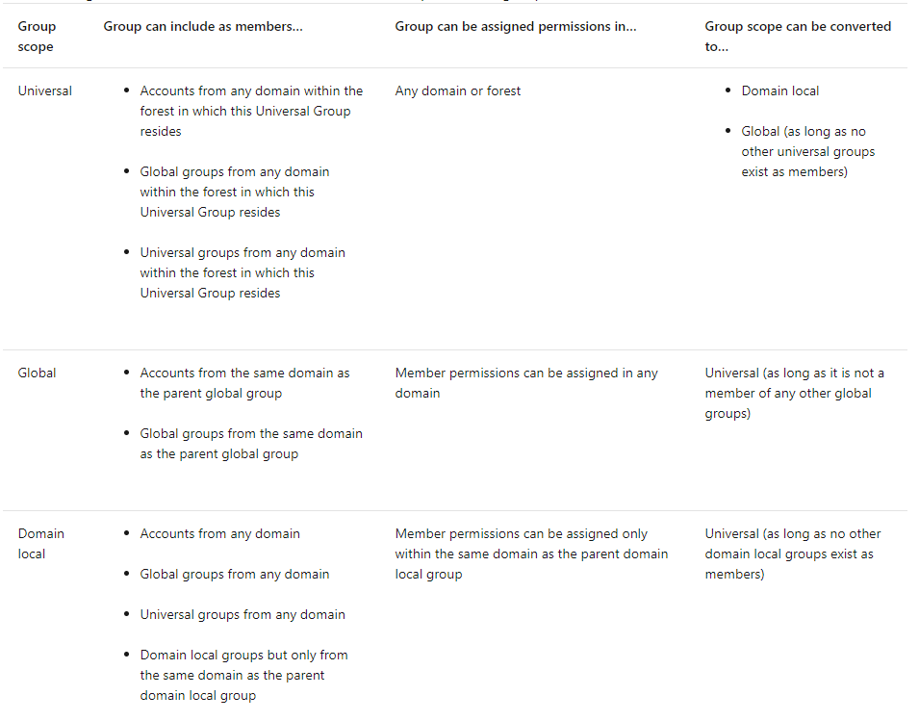
Figure 20 – Microsoft definition of AD groups [12]

References

[1] | I. K. a. T. Y. YURY ZHAUNIAROVICH, “A Survey on Malicious Domains Detection through DNS,” ACM computing surveys, vol. 51, no. 4, p. 67:2, 2018.
[2] | P. Schmitt, A. Edmundson, A. Mankin and N. S. Feamster, “Oblivious DNS: Practical Privacy for DNS Queries,” Proceedings on Privacy Enhancing Technologies, vol. 2019, no. 2, pp. 228-244, 2019.
[3] | “Recursive and Iterative DNS Queries,” OmniSec, 11 Feb 2021. [Online]. Available: https://www.omnisecu.com/tcpip/recursive-and-iterative-dns-queries.php. [Accessed 11 Feb 2021].
[4] | Microsoft Corp, “Domain Name System,” Microsoft, 07 Aug 2020. [Online]. Available: https://docs.microsoft.com/en-us/windows-server/networking/dns/dns-top. [Accessed 06 Feb 2021].
[5] | “ServerGuruNow,” 14 Oct 2017. [Online]. Available: https://servergurunow.wordpress.com/2017/10/14/dc-locator-process-2/. [Accessed 01 March 2021].
[6] | Microsoft Corp., “File and Storage Services Overview,” 29 Dec 2016. [Online]. Available: https://docs.microsoft.com/en-us/previous-versions/windows/it-pro/windows-server-2012-r2-and-2012/hh831487(v=ws.11). [Accessed 05 Feb 2021].
[7] | G. E. N. a. A. K. Andrew Butterfield, A Dictionary of Computer Science (8 ed.), Oxford: 7 Oxford University Press, 2019.
[8] | “DHCP DORA--> Broadcasts or Unicasts?,” Cisco, [Online]. Available: https://community.cisco.com/t5/switching/dhcp-dora-gt-broadcasts-or-unicasts/td-p/3369441. [Accessed 11 Feb 2021].
[9] | Microsoft, “Implementing Least-Privilege Administrative Models,” Microsoft, 08 09 2018. [Online]. Available: https://docs.microsoft.com/en-us/windows-server/identity/ad-ds/plan/security-best-practices/implementing-least-privilege-administrative-models. [Accessed 05 Feb 2021].
[10] | A. Bertram, “Active Directory nesting groups strategy and implementation,” Tech Target, 08 Apr 2020. [Online]. Available: https://searchwindowsserver.techtarget.com/tip/Active-Directory-nesting-groups-strategy-and-implementation. [Accessed 05 Feb 2021].
[11] | A. Berger, “All About AGDLP Group Scope for Active Directory – Account, Global, Domain Local, Permissions,” infoSecInstitute, 13 Nov 2015. [Online]. Available: https://resources.infosecinstitute.com/topic/agdlp-group-scope-active-directory-account-global-domain-local-permissions/ . [Accessed 29 Dec 2020].
[12] | Microsoft, “Group Scope,” Microsoft, 10 July 2014. [Online]. Available: https://docs.microsoft.com/en-us/previous-versions/windows/it-pro/windows-server-2003/cc755692(v=ws.10). [Accessed 01 Mar 2021].
[13] | S. Parkinson, S. Khan, J. Bray and D. Shreef, “Creeper: a tool for detecting permission creep in file system access controls,” Cybersecurity, vol. 2, no. 1, pp. 1-14, 2019.

