Referencing practice activity
In the following Activity you will find 9 different credible sources, comprising of books, journal articles and websites.

The actual websites are connected to the website image with a link, so you can access the original source to look around for information if needs be. To access this please right click on the image and open the link.

For each source, please provide the citation (both variations – eg (Cottrell, 2019) or Cottrell (2019)) and the full reference.

Once complete, make sure you are happy and confident with your answers before submitting to the Turn-It-In link.

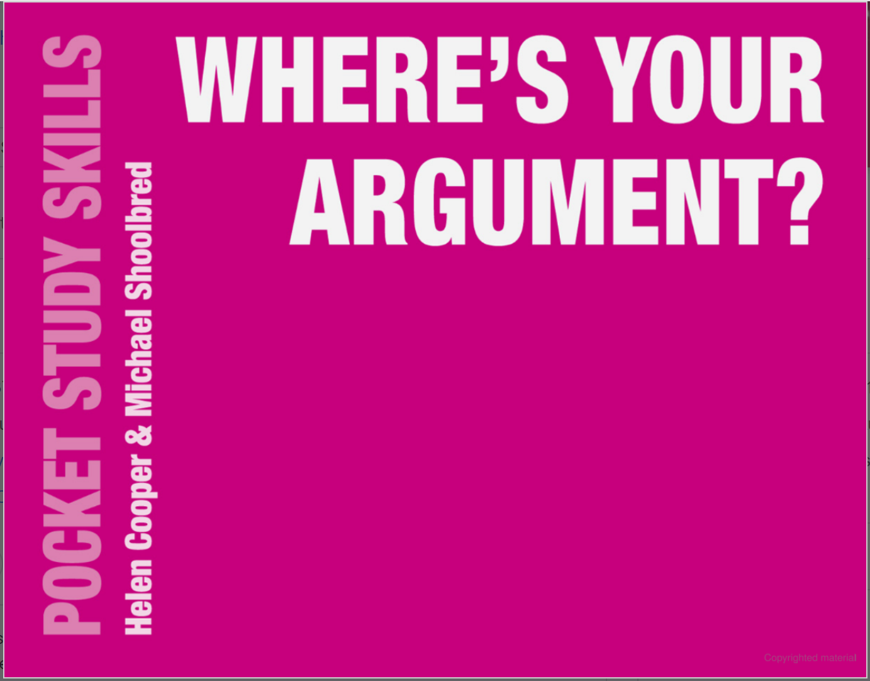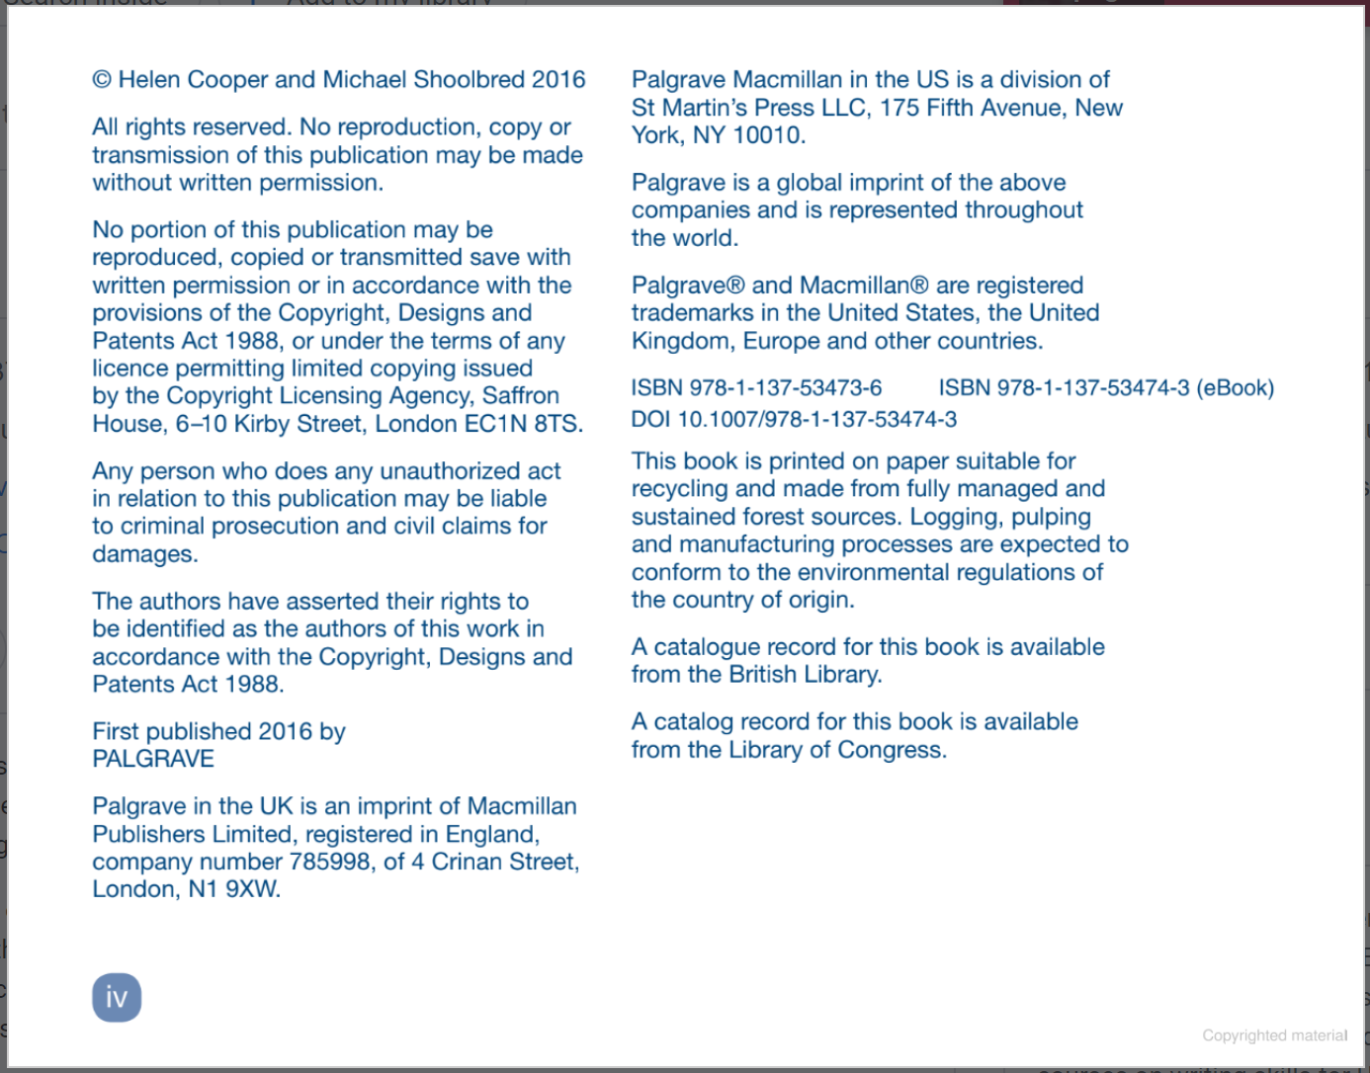

Citation:
Reference:
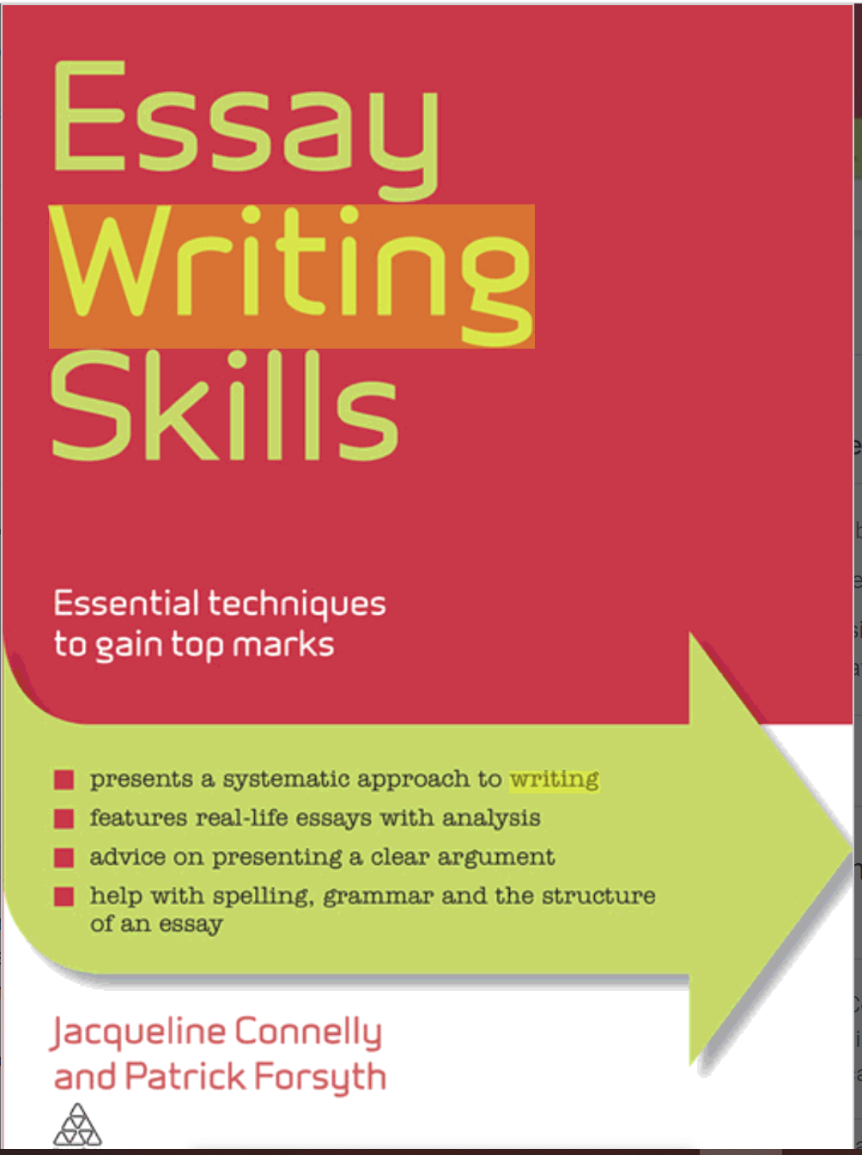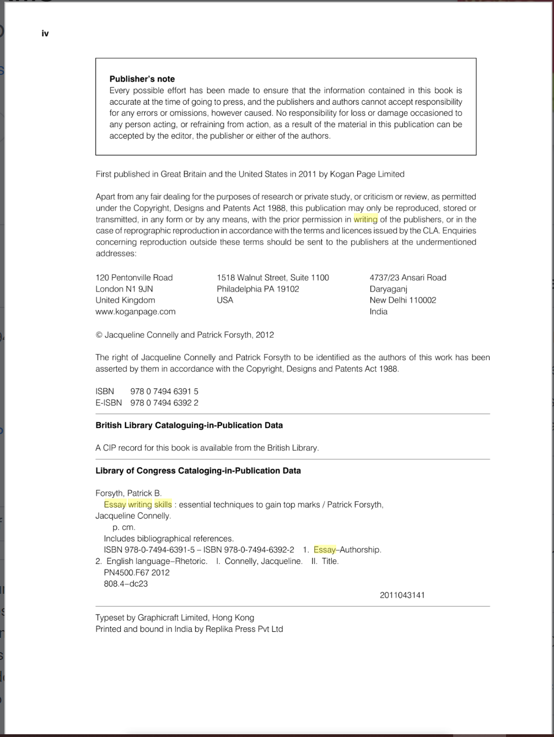
Citation:
Reference:

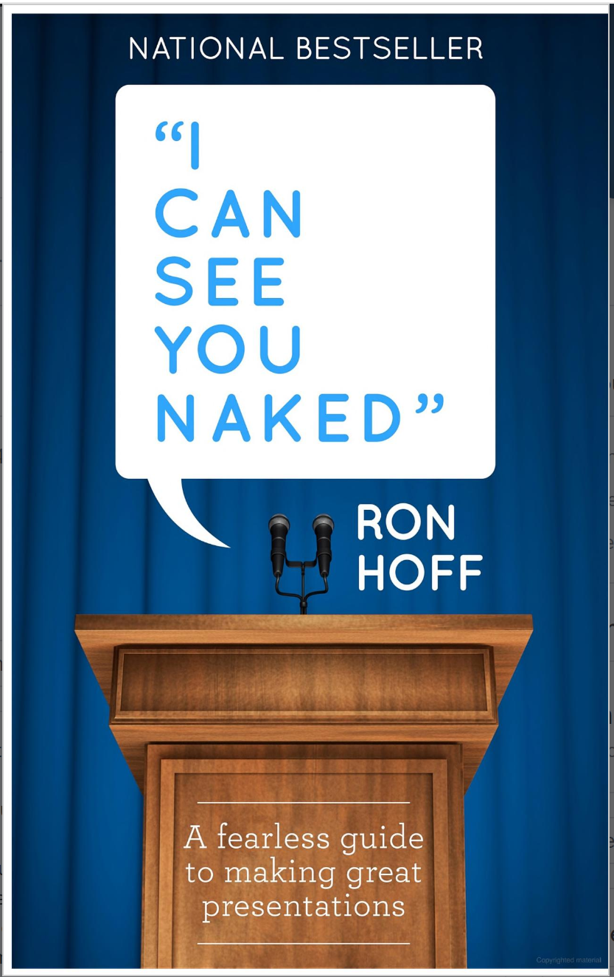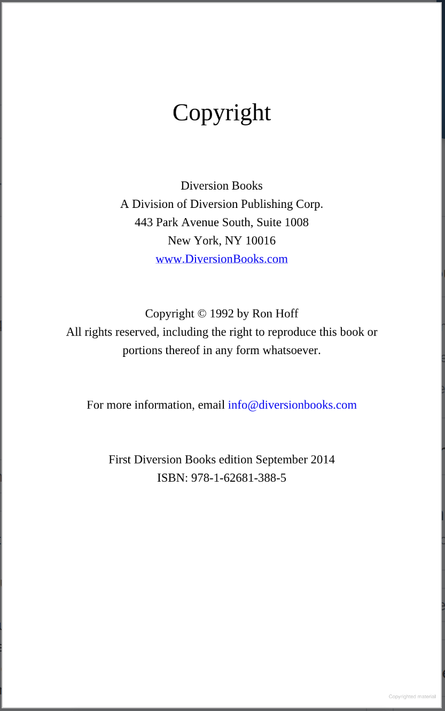
Citation:
Reference:
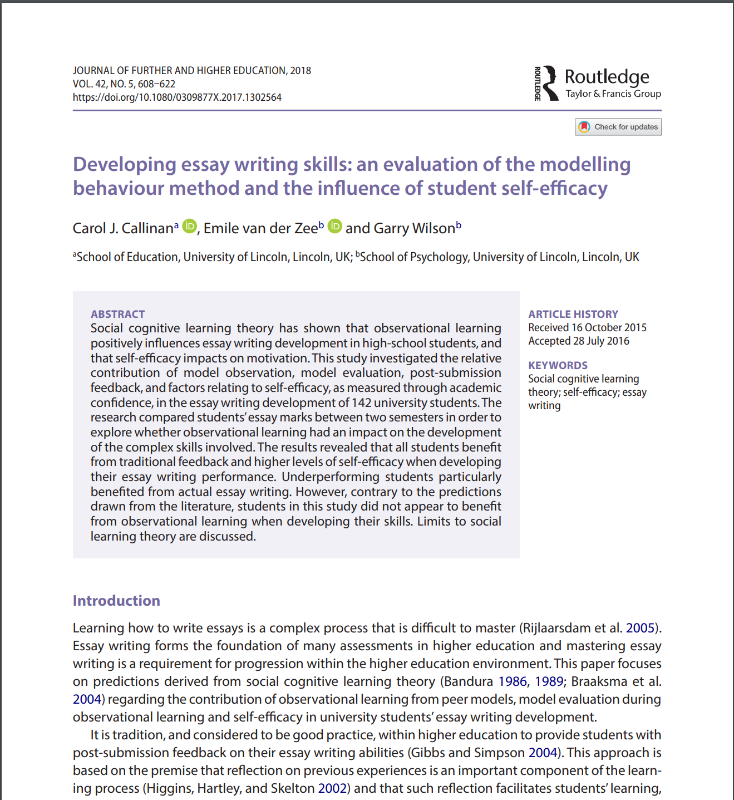
Citation:
Reference:

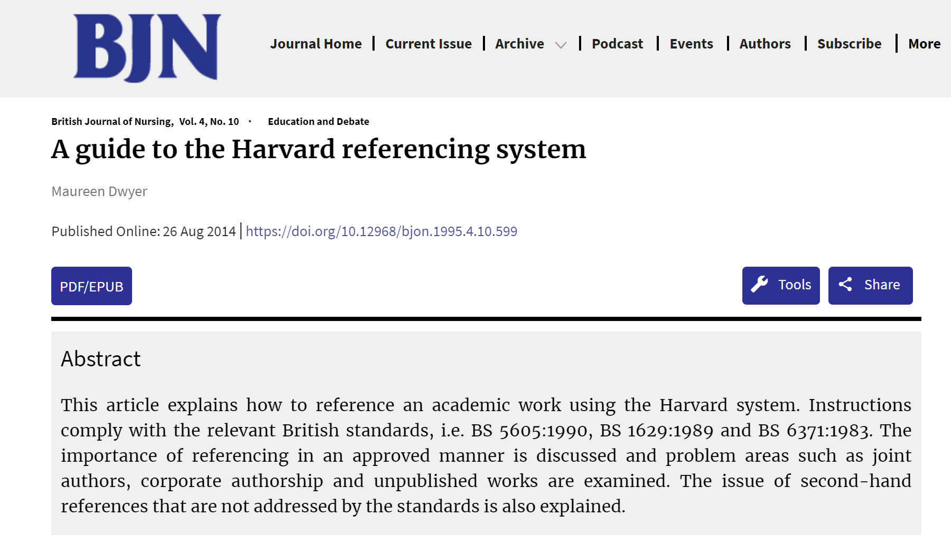
Citation:
Reference:
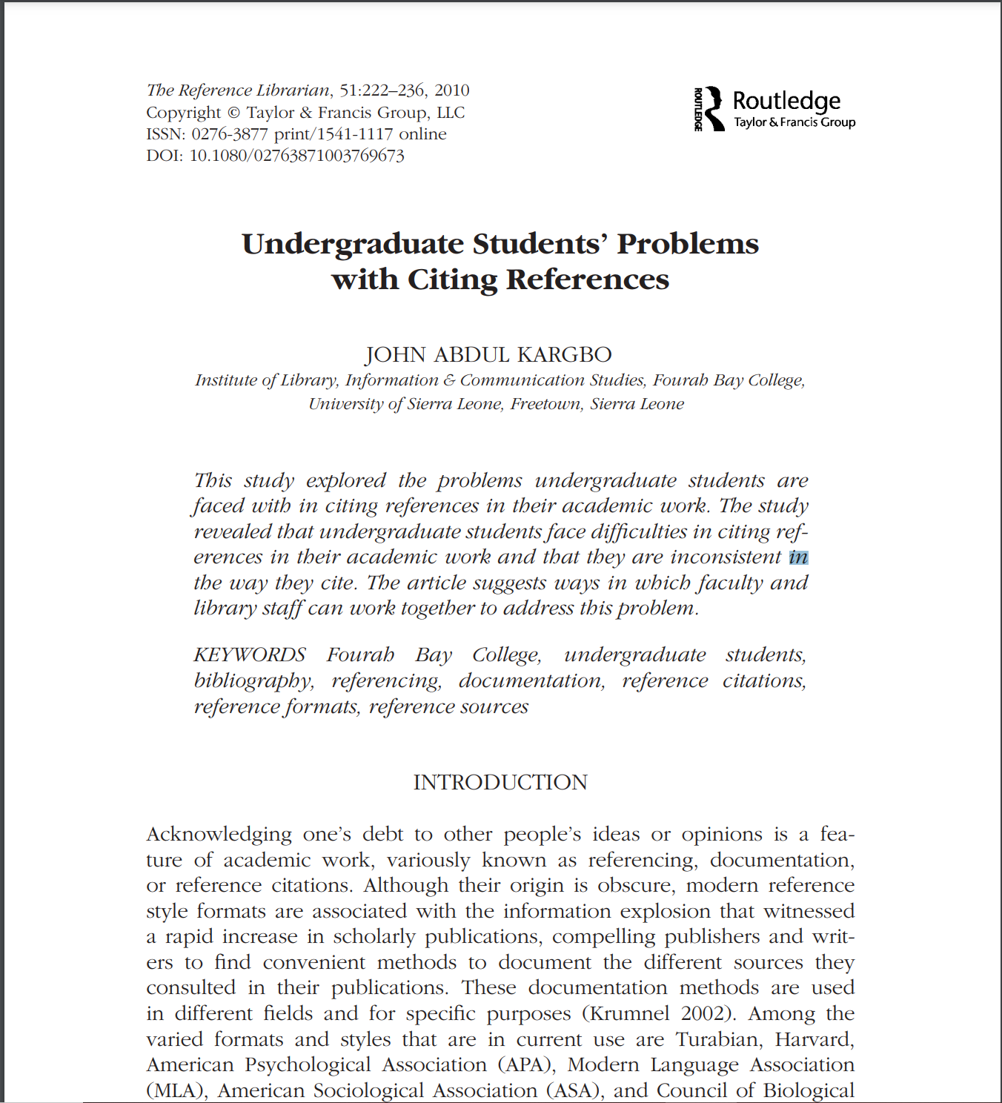
Citation:
Reference:

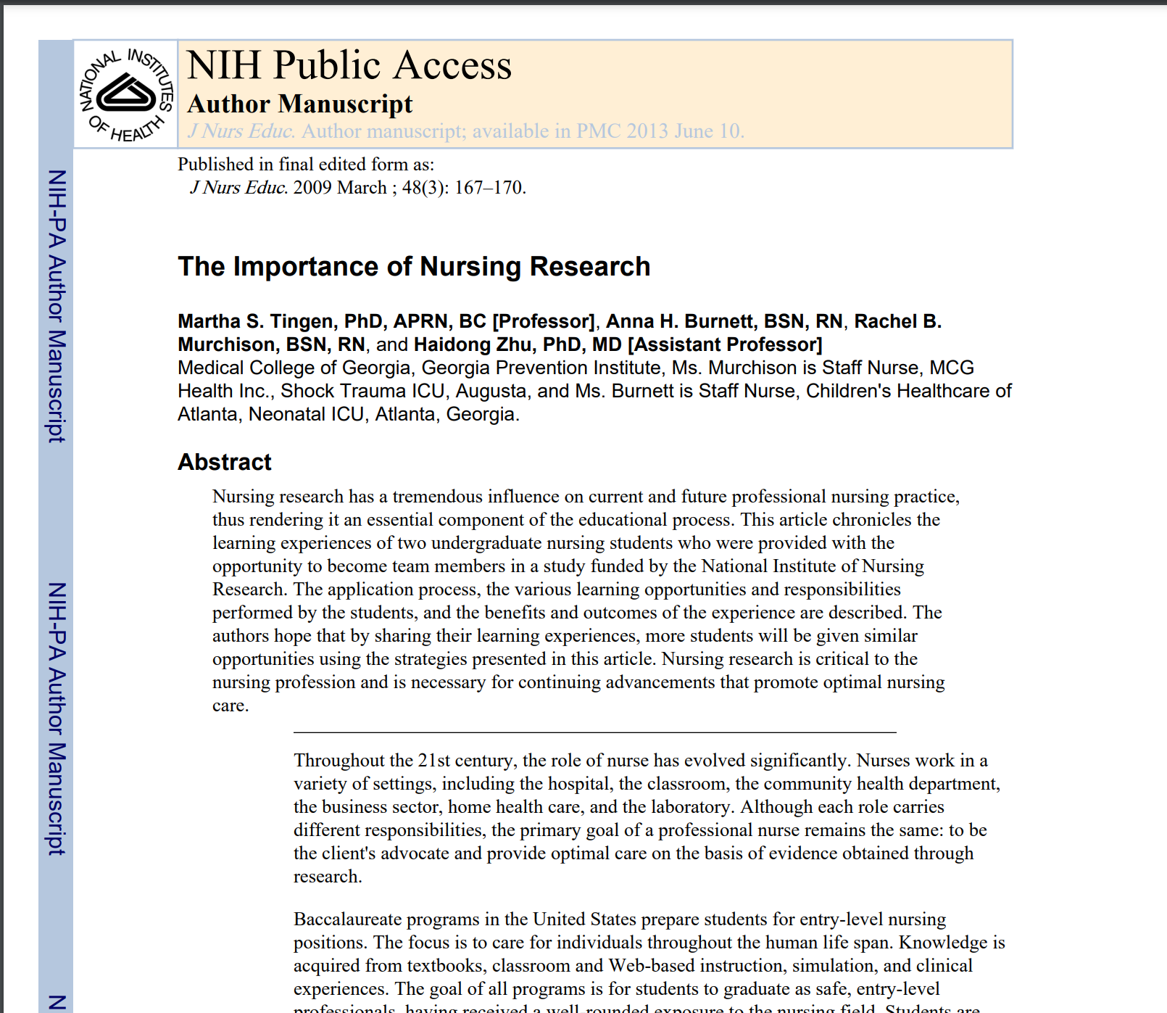
Citation:
Reference:
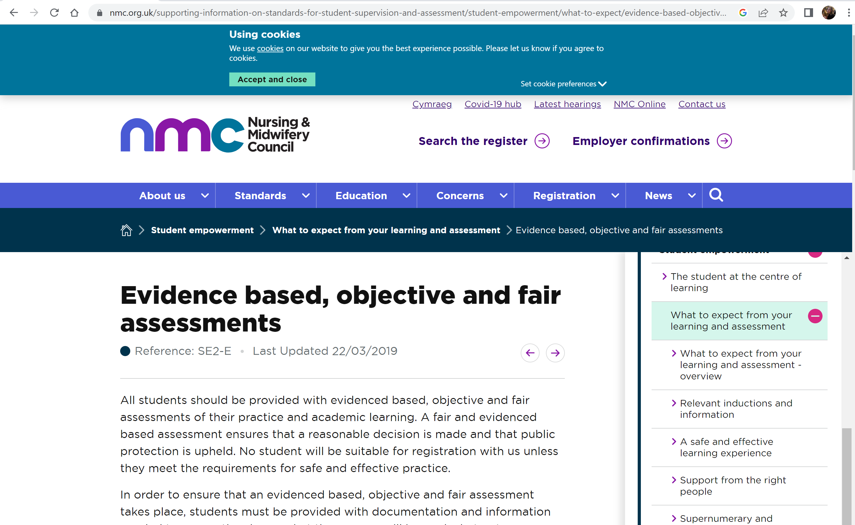
Citation:
Reference:
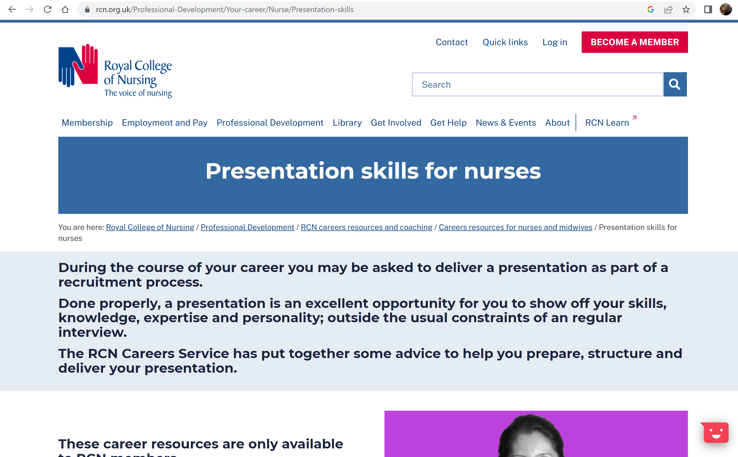
Citation:
Reference:

