Student ID:2008309 |
BSc Cloud Computing
University of Wales Trinity Saint David
Mariana Angelova
ACCB4017 Software Development- Assessment 1
Lecturer: Renuga Jayakumar
2021
Table of Contents
Introduction 2
Variables 2
If/else statement 3
Loops 6
Exercise 1 9
Exercise 2 9
Exercise 3 10
Exercise 4 12
Conclusion 14
References 15
Appendices 15

Introduction
In this assessment paper I will analyse and explain various concepts of software development. First, I will explain what is variable and why variables are important when we write programs. Second, I will describe what an If/else statement is, how and why they are used, and I will give a code example. Third, I will clarify about loops and why we need them when writing programs, when we might use for and while loop. I will give examples, using the Python programming language.
Variables
According to Allen B Downey [1] “A variable is a name that refers to a value”. He also said that one of the most powerful features of programming languages is ability to manipulate variables.
Variables can contain letters and numbers, but they must begin with a letter. When writing the name of the variables, we can use capital letters too, but the name always must start with lower case letters. We can use underscore characters (_) too. Many programmers when writing variable names use camel casing- capital letters in the middle of the name, for example:” myName”, “firstNumber”, that make variable names more readable.
When programmers write programs, they use keywords. The interpreter recognizes the structure of the program with this keyword. They cannot be used as variable names.
Corresponding to Allen B Downey [1] book keywords are:
and, as, assert, break, class, continue, def, del, elif, else, except, exec, finally, for, from, global, if, important, in, is, lambda, not, or, pass, print, return, raise, try, while, with, yield.
When we write programs, we use special symbols as +, -, *, / and ** , which represent addition, subtraction, multiplication, division and exponentiation. They are named operators. The values the operator is applied to are called operands.

According to John Whitington [2]computer programs in Python are built from statements and expressions. Each statement performs some action. Example for statement is print statement- allow us to write to the screen. Each expression performs some calculation. We can calculate because of mathematical expression using whole numbers (or integers).
In his book John Whitington mentioned that in Python we have three types of data: strings, integers, and Booleans:
- ‘str’- indicates strings. A single or double quotation marks in our print statement that what we are printing a string- a sequence of letters or symbols.
- ‘Bool’- indicates Booleans.
- ‘Int’- indicate integers.

If/else statement
Computer make decisions built on comparison operands. We can use If... elif... else statement for decision making. This helps us to compare two things so that the computer can make decisions about what to do next. The if … else statement we use to evaluate the text expression and it will be executed only if statement is true. If the condition is False, then else statement will be executed. This is syntax statement for If…else:
If test expression:
Body of if
Else:
Body of else

The if... elif...else statement we use when we want to check for multiple expressions. If the condition for If is false, we can check for next condition with elif. We can use elif many times, but else we can use only one time.
If statement means, that if the user does something, then will be executed one part of the program. In addition, elif statement is used when we want to give the program more choices. On another side else statement uses to catch something else that the user does, and it is not in the program. Else statement is a signal of the end of possible choices in the program.
Syntax of if…elif…else statement:
If test expression:
Body of if
Elif test expression:
Body of elif
Else:
Body of else
To explain better this I will give this example:
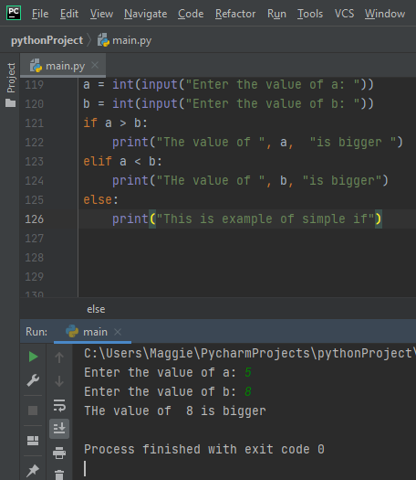
Screenshot 1: Example for if, elif and else
In this example I used two variables “a” and “b” and I want to compare them. Then I used an if statement to ask the program if a>b to execute print statemen saying that a is bigger. Then I used elif statement to ask program if a<b to execute another condition and print statement saying that ”b” is bigger. and else statement as last condition (in this case a=b). The program executed different outputs depending on the value of variables which I used.
Keywords and and or are logical operators used to combine conditional statements. This is an example for using and keyword in conditional statement.
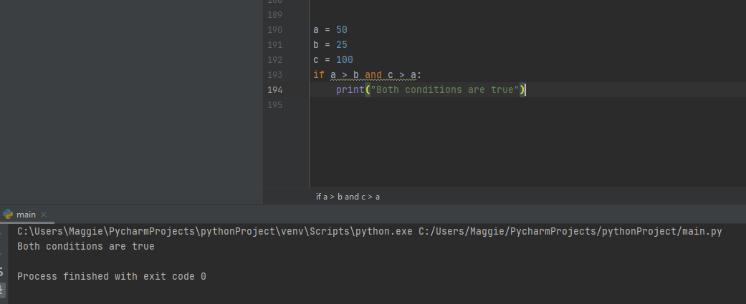
Screen shot 2: Example with keyword and
In this example I used if statement and and keyword to make conditional statement.
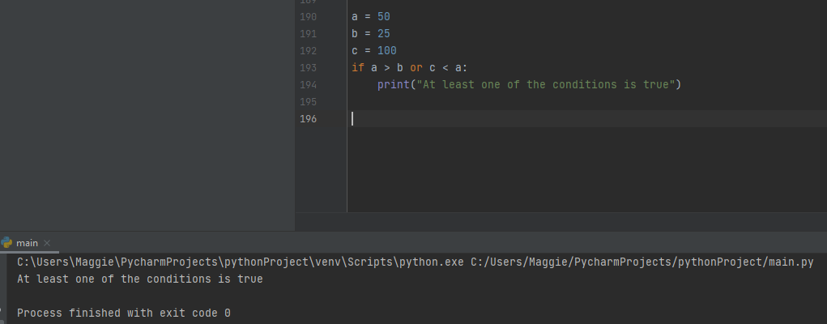
Screen shoot 3: Example with keyword or
In this example I used or keyword in if statement. Or keywork say that if one of the conditions is true the program will be executed.
Loops
Loops is when the same block of code rerun repeatedly until something else tells the loop to stop repeating itself. There are three kinds of loops: for and while and nested loops. According to John Whitington [2] the difference between them is that:
· The for loop is used when a programmer knows how many times, he needs the loop to repeat.
· The while loop is used when the programmer does not know when the user will be done with calculation. The while loop is flexible. It also repeats a statement when a provided condition is true – it tests the condition before executing the loop. (Figure 1)
· Nested loop is when we use one or more loops inside any other while or for loop.
Srart

False
END
Condition

True

Statement

Figure 2: Flowchart explain while loop.
When we apply for loop, we use range () function. This function allows us to specify a range of numbers instead of writing them all out.
Syntax statemen for for loop is:
For variable in sentence:
Body of for
Syntax statement for while loop is:
While test expression:
Body of while

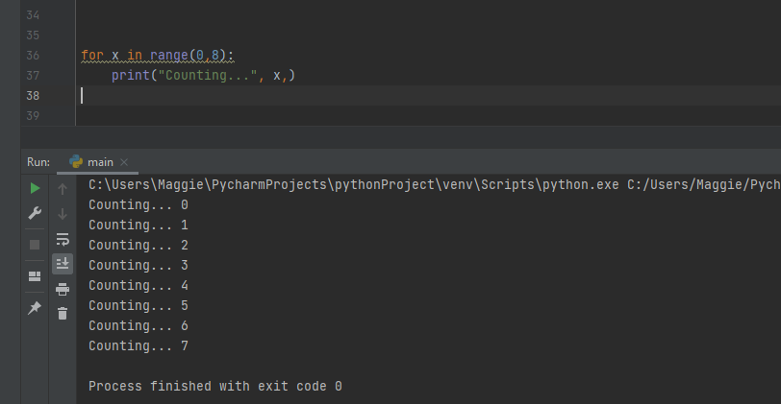
Screenshot 4: Code example with for loop
In this example I can see two arguments to the range function, specify where to start, at 0 and where to stop at 7. It is important to remember that ranges begin at the first given number but stop before the second given number. This is one of often met mistakes from beginners. It is important also when use for loop to remember range function, or our output will look like this:

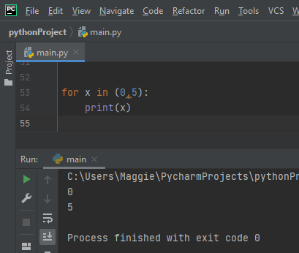
Screenshot 5: Example for mistake with for loop
With for function, we said to program how many times we want to repeat something. The difference is that when we use a while loop, we do not know how many times to repeat an action until we begin. This is my example for a while loop. I used a print statement, give name for variable- “myNumber”, and argument that number must be less than 10 and allow the user to input his number. If the number is bigger than 10, one statement will appear. If the number is less than 10, the program ends.
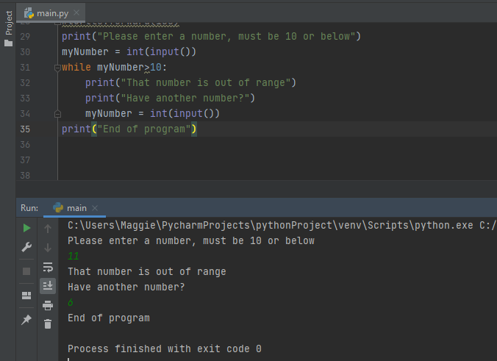
Screenshot 6: Code example for while loop
Exercise 1
In this task I must write program, which must include four variables – car make, model, mileage, and number of doors. The program allows the user to input values for variables. I used print statement, strings, and input function.
Input () function allow user to type in a line of output from the keyboard. When user press Enter key everything which was typed are returned as a string. If the user needs to type numbers to convert into strings, appropriate type is with Int () for integers numbers, float () for decimals numbers and str () for words.
This is my code:

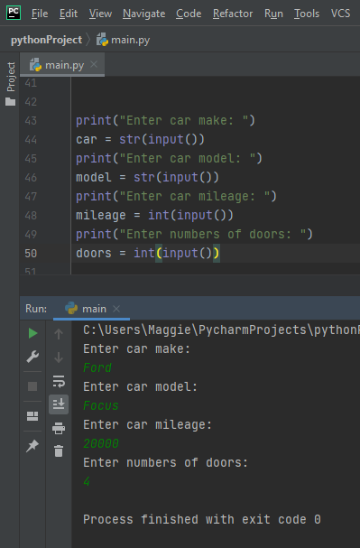
print("Enter car make: ")
car = str(input())
print("Enter car model: ")
model = str(input())
print("Enter car mileage: ")
mileage = int(input())
print("Enter numbers of doors: ")
doors = int(input())
Screenshot 7: Exercise 1
Exercise 2
In this task a person wants to grow carrots in a vegetable bed. He knows that carrots require 64 square cm. soil area. I made a program that allow a person to input dimension of his area as width and height.
This is my code:

print("Hello please enter the width of your vegetable bed in centimetres")
width = int(input())
print("Hello, please enter the height of your vegetable bed in centimetres")
height = int(input())
total = width * height
print("The total area of your vegetable bed is", total, "cm squared")
carrots = total // 64
print("The carrot of your vegetable bed is: ", carrots)

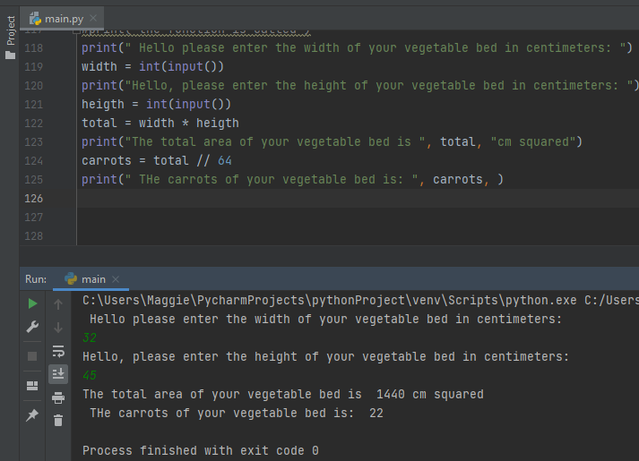
Screenshot 8: Exercise 2
I found the perimeter of the area. The person wants to know how many carrots he can grow in his area. To found this as I divided perimeter of the area with 64. I used floor division, because I want the result to be whole number (because the person does not want a half carrot). I used for that input () function and print statement.
Exercise 3

In this task I made a program with list products and list of prices of products. I used for loop, input function, append method, sum function. This is my code:
myProduct = []
myPrice = []
n = int(input("Insert how many item do you want: "))
for i in range(n):
n1 = input("Enter the product ")
ext = float(input("Enter the price "))
myProduct.append(n1)
myPrice.append(ext)
print("Product entered: ")
for counter in range(n):
print(myProduct[counter], " ", myPrice[counter])
print("Total price is:", "£", sum(myPrice))
per = sum(myPrice) * (15/100)
total = (sum(myPrice) - per)
print("Total with staff discount is :", "£", total)

First, I add my variables – my Product and myPrice and add an empty list. Then I use a variable with name n to allow the user to choose the number of products. After that I used for loop with a range function of the number of products. I named other variables and with input () function and allow the user to choose the products and prices. In the next two lines I used the append method to add new products and prices to the lists. One more for loop allows the user to see products and prices together. I used the sum () function to calculate all prices together. At the end I found a staff discount of 15 % as I multiplied the total sum of products by 15/100. Total sum I received as subtracted sum of products by staff discount.
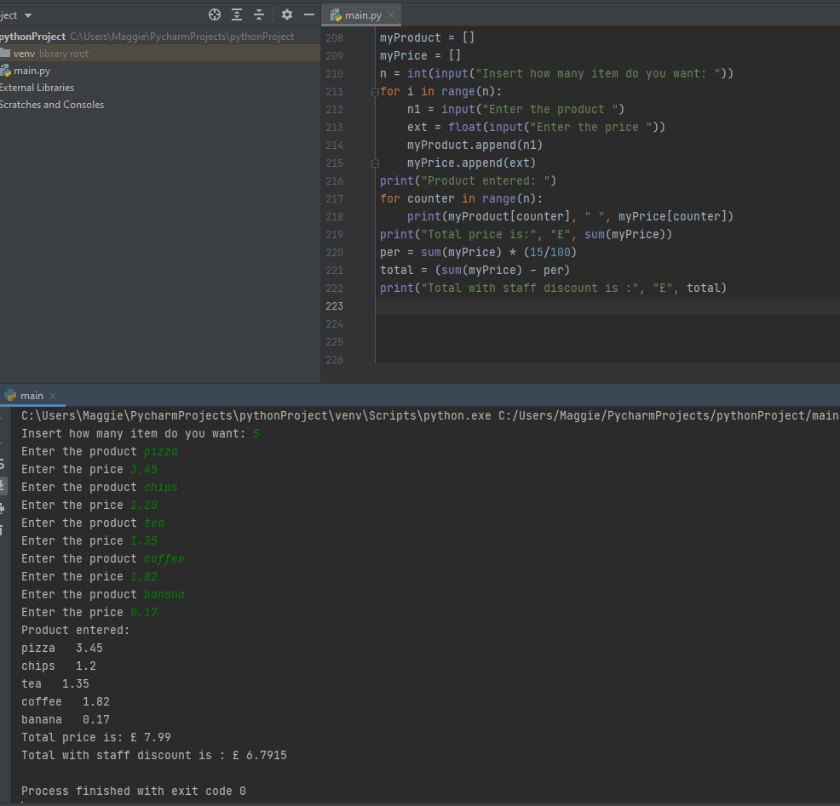
Screenshot 9: Exercise 3

Exercise 4:
In this task I must do board game. I do this as I generate a random number using import random module, random randint function and if…else statement. The program asks the user to choose a number, then the program accumulate a random number. If the number is equal with random number, then the program prints one statement, if not another statement. I allow the user to have 3 turns of the game.

This is my code:
import random
choose = input("Choose position (0- 15)")
n = random.randint(0, 15)
print(" The number is ", n)
if choose == n:
print("WIN! Well done!")
else:
print("Miss! Unlucky")
choose = input("Choose position(0-15)")
n = random.randint(1, 15)
print(" The number is ", n)
if choose != n:
print("Keep trying")
else:
print("Win")
choose = input("Choose position(0-15)")
n = random.randint(1, 15)
print(" The number is ", n)
print("You took 3 turns")

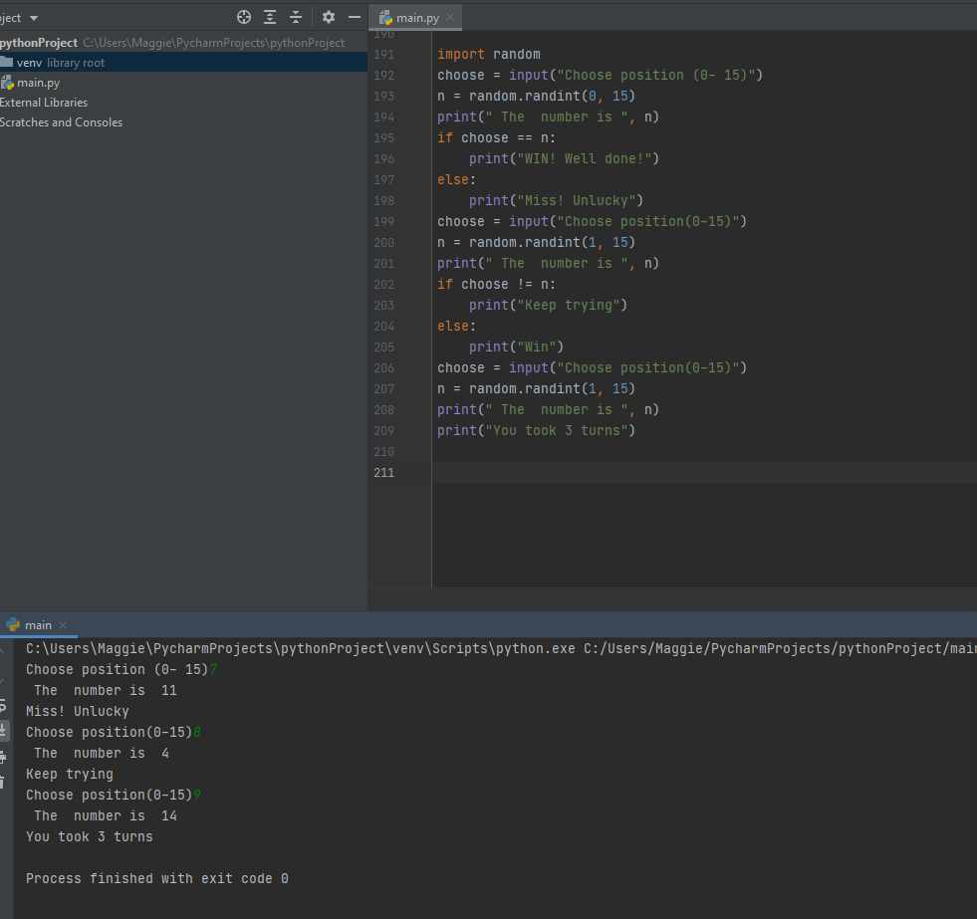
Screenshot 10: Exercise 4 solution

Conclusion
Learning a program language is like learning a new language. Technology is a growing fast industry and software engineering is a massive part of this industry. Python is the perfect program language for beginners in this sphere.
According to Ewan McBride [3] Python is perfect programming language because:
· It is a high-level language – that means easy to understand and similar to English.
· The syntax is simple.
· It is used by many people.
· There are many books, courses and forums which help the student when they start with it.
For me was pleasure to learn this new language.

References

[1] | J. Whitington, in Python from the very begining, Coherent Press, October 2020, p. 238.
[2] | A. B. Downey, in Think Python, Sebastopol, USA, O'Reilly Media,Inc, 2012.
[3] | E. McBride, “Why I Think Python Is the Perfect Programming Language for Beginners,” 24 Nov 2020. [Online]. Available: https://medium.com/swlh/why-i-think-python-is-the-perfect-programming-language-for-beginners-159330cb2a70. [Accessed 22 April 2021].

Appendices:
Screenshots of testing my programs for exercise 1, 2 ,3 and 4
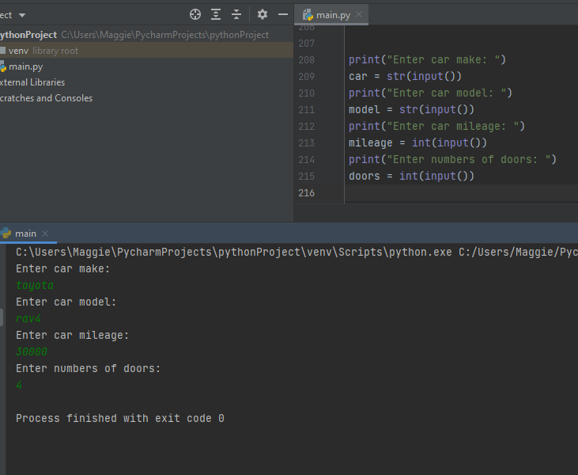
Screenshot of test of my program for exercise 1
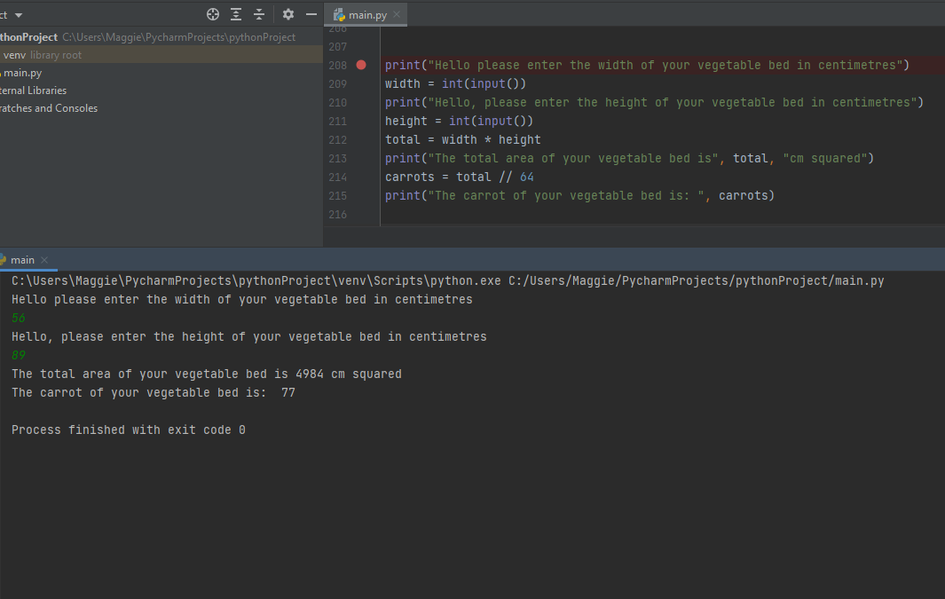
Screenshot from test of program for exercise 2
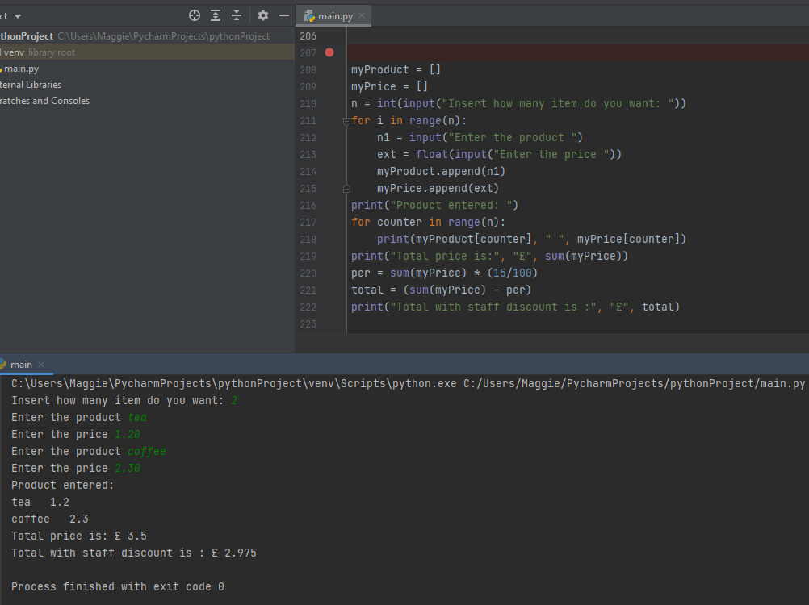
Screenshot test my program for exercise 3
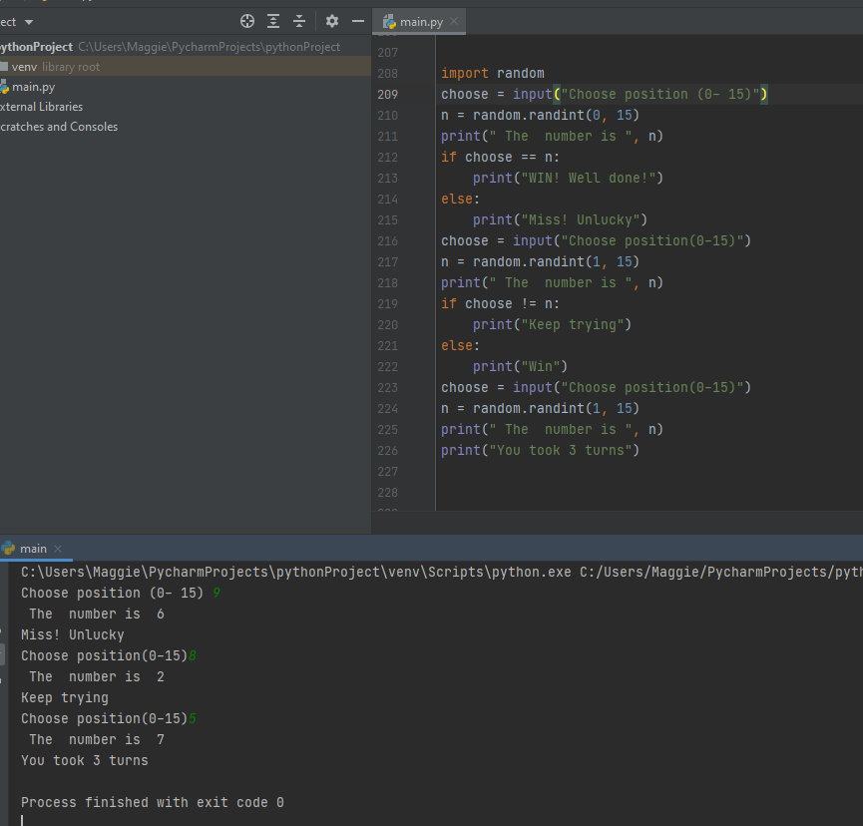
Screenshot from test of the program for exercise 4

