

SUSTAINABLE BRAND EXTENSION STRATEGY FOR PATAGONIA: REFIBER 3D

Programme name: Master of Business Administration
Module name: Marketing Management
Module code: LCMB7024
Lecturer’s name: Laila Maazouz, Taonga Kaonga Sobere-
Snithers
Student name: Arshi Parveen
Student ID: 2545115
Word count: 2551

Table of Contents

Element 1: Sustainable brand extension poster presentation 3
Element 2: Segmentation, Targeting, Differentiation, and Positioning (STDP) 4
2.1 Segmentation 4
2.2 Targeting 5
2.3 Differentiation 5
2.4 Positioning 6
Element 3: Marketing mix (7Ps) 7
3.1 Product 7
3.2 Price 8
3.3 Place 9
3.4 Promotion 10
3.5 People 10
3.6 Process 11
3.7 Physical evidence 12
Element 4: Reflection 12
4.1 Experience developing the strategy 12
4.2 Experience with the poster presentation 12
4.3 Skills and knowledge gained 13
4.4 Future development 13
References 14

Element 1: Sustainable brand extension poster presentation
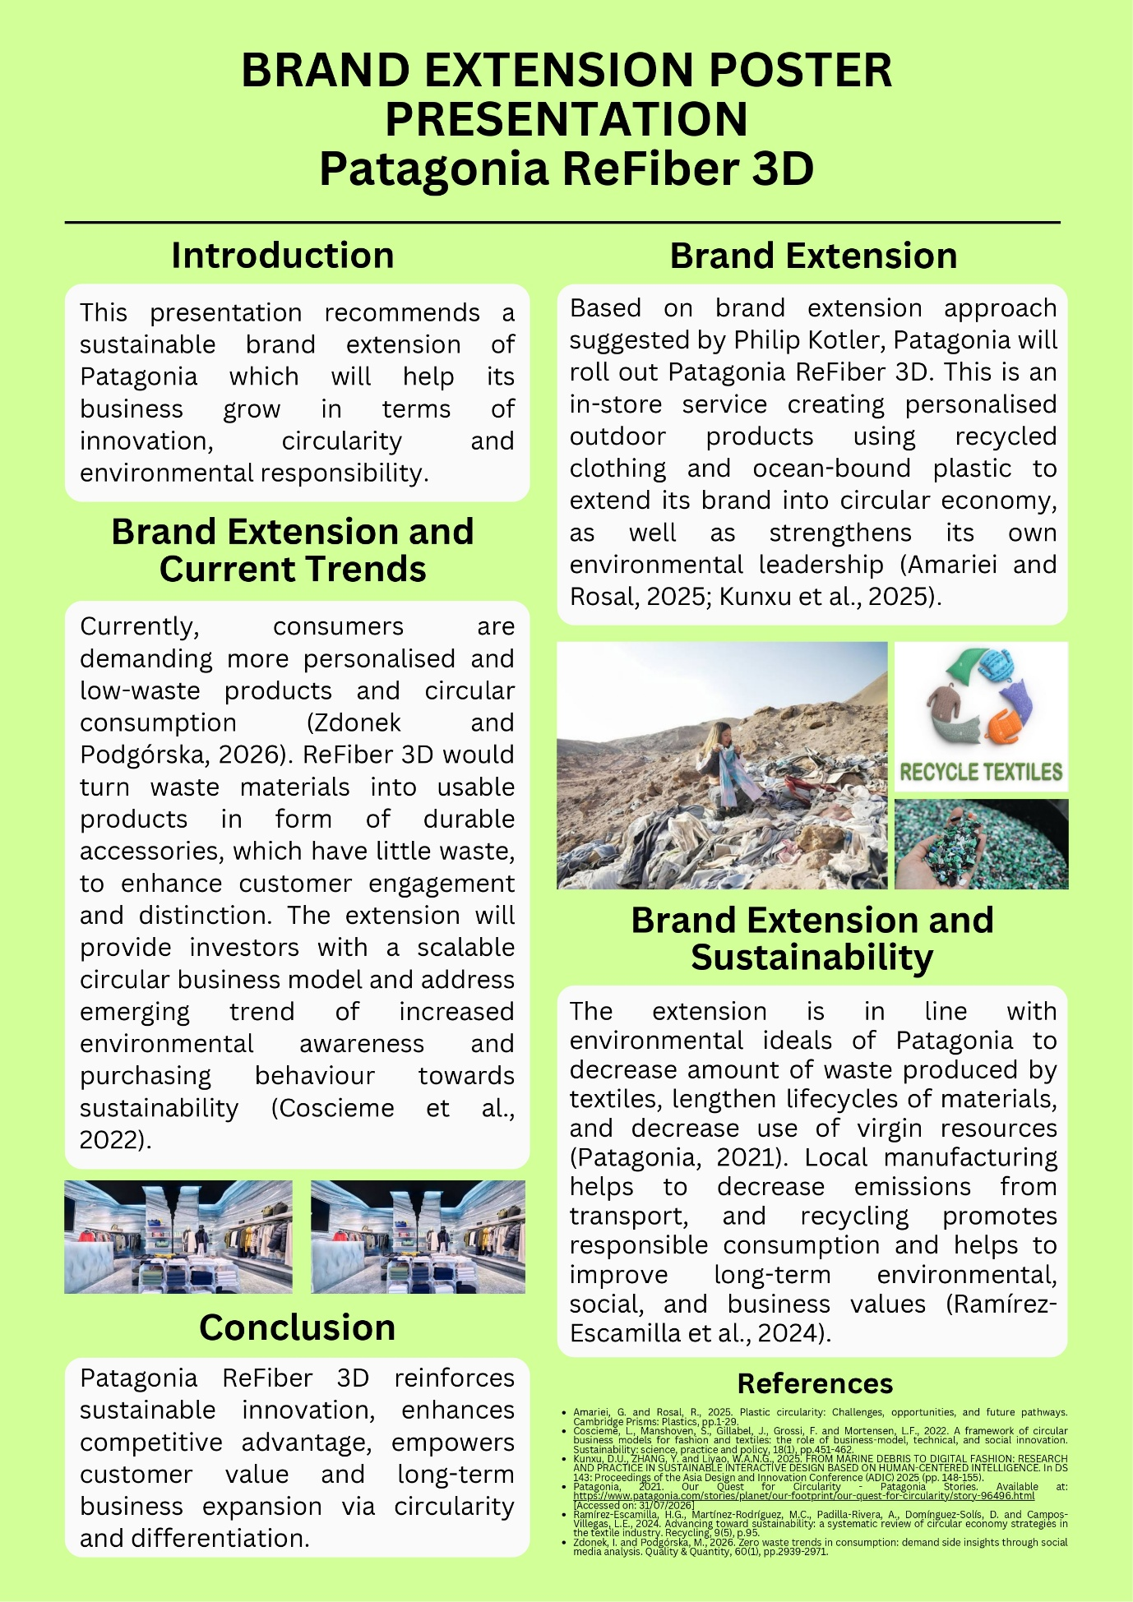

Element 2: Segmentation, Targeting, Differentiation, and Positioning (STDP)
Analysis

2.1 Segmentation
Patagonia currently operates in more than 45 nations and has more than 160 retail outlets all over the world, with most of them being located in North America, Japan, and Europe (Patagonia, 2026). Patagonia generated revenues of $1.47 billion during its fiscal year ending April 1, 2025, with 61% of revenues generated in US as compared to 39% revenues generated in international markets (SGB media, 2025). This provides ReFiber 3D with several physical stores already in place from which they can launch their retail strategy.
Variable | Description
Geographic | Urban and suburban areas in the US, Western Europe, and Japan. Regions with strong outdoor culture and green regulation.
Demographic | Age 25–45 core group, plus Gen Z (18–26). Mid-to-upper income. Higher education level.
Psychographic | Environmentally conscious buyers. LOHAS lifestyle group. People who value personal expression.
Behavioural | Repeat buyers. High brand loyalty. Already use repair services like Worn Wear. Follow sustainability content online.
Table 1: Market segmentation for ReFiber 3D
(Source: Self-created in Ms-Word)
Approximately, 62% of Generation Z consumers like eco-friendly brands, while 73% of them are ready to pay extra for such products (Lopes et al. 2024). In addition, Forrester, (2023) in-depth study shows that 76% of Generation Z people are ready to spend 15% more on products that have been proven sustainable compared with much smaller price premiums paid by other generations. This proves that predictions for a market with a rising demand for personalized and low-waste goods has been increased day-by-day.

2.2 Targeting
ReFiber 3D needs to focus on concentrated targeting. This will mean concentrating efforts on one specific market segment rather than reaching out to all customers. These segments are loyal customer of Patagonia and young design-oriented consumer, who prefers customization.
Criterion | Assessment
Segment size | Large enough. Gen Z alone is a fast-growing share of retail spend.
Accessibility | Easy to reach. Existing store network and online channels already exist.
Profitability | Strong. Patagonia holds 50–55% gross margins, supporting premium pricing for a service extension (Patagonia, 2026).
Fit with brand | Excellent. Matches Patagonia's existing repair and reuse culture.
Table 2: Targeting evaluation
(Source: Self-created in Ms-Word)
This segment is considered as brand believer. They are more likely to take the chance of trying a costly new circular service than a cold audience would.

2.3 Differentiation
It is important that ReFiber 3D differentiates itself from two types of competitors: fast-fashion upcycling ranges and other circular clothing brands, like Eileen Fisher Renew and The North Face Renewed (Choudhry et al. 2026). Most of the competitors provide products that are recycled. However, very few competitors offer an in-store, personalised, made-with-you experience.
Type | Element
Point of Parity (POP) | Use of recycled materials and ocean-bound plastic. Circular economy claims. Now expected by most outdoor brands (Moubarak et al. 2025).
Point of Difference (POD) | In-store personalisation. 3D-produced, one-of-a-kind items. Customer co-creates the product.
Point of Difference (POD) | Local, small-batch production, cutting transport emissions
Table 3: Points of parity vs Points of difference
(Source: Self-created in Ms-Word)
It is evident from the above table that circular business models work, when they integrate business, technology, and societal innovations in addition to recycling of materials.

2.4 Positioning
Positioning Statement:
“Patagonia ReFiber 3D is offering a personalized circular product for environmentally concerned outdoor customers who seek products that express their uniqueness. It is an in-store solution to turning waste into wearable identity; unlike competitors’ recycled products, it has craft and collaboration.”
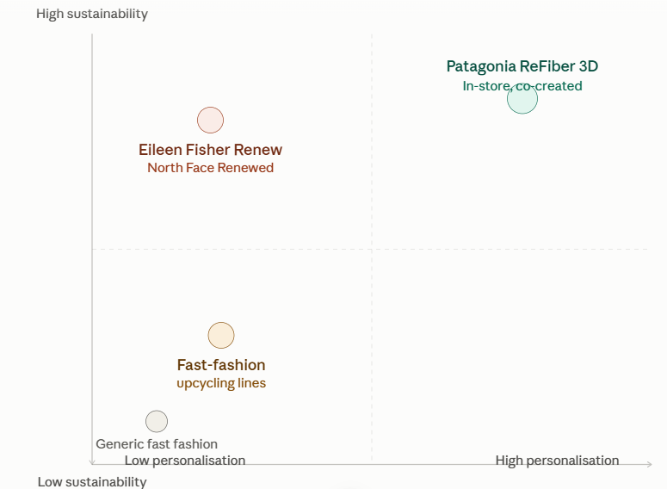
Figure 1: Perceptual map
(Source: Created by learner in Ms-Word)
Perceptual map would help to clarify this concept. One axis defines low personalization to high personalization, while the other dictates about low sustainability to high sustainability (Gigauri, 2019). Most fast-fashion recyclers fall under low personalization, medium sustainability. Most circular apparel competitors fall under high sustainability, low personalization. However, ReFiber 3D occupies high personalization, high sustainability. This is because of Kotler’s brand extension strategy that says leverage existing brand equity and reputation, when introducing an additional product without compromising reputation of parent company (Kumar et al. 2026). As Patagonia has good reputation and sustainability credibility, this would enhance rather than harm its reputation.
However, STDP approach reveals certain limitations. Segmentation strategy is based mainly on Willingness-to-pay measures among Generation Z that may overestimate real purchasing behaviour because there is a difference between stated attitude and actual behaviour (the attitude-behaviour gap) (Gagliardi, 2026). Targeting strategy is effective but narrow, because the strategy considers loyal clients only, which may limit future potential and prevent market expansion. Differentiation strategy is strong concerning personalized approach; however, premium pricing strategy of Patagonia may reduce appeal to price-conscious but sustainable-oriented consumers. In summation, proposed STDP strategy is effective; however, needs further investigation related to competitors’ performance and possible risks associated with premium pricing and execution.

Element 3: Marketing mix (7Ps)
The 7Ps include the additional 3Ps to the traditional 4Ps. The relevance of this model lies in the fact that Refiber 3D is considered as both a product and a service experience.

3.1 Product
ReFiber 3D can be described from three product perspectives.
Level | Description
Core benefit | Sustainable self-expression through a personal, low-impact product
Actual product | A physical accessory made from recycled clothing and ocean-bound plastic
Augmented product | The in-store personalisation service and design experience
Table 4: Product levels
(Source: Self-created in Ms-Word)
Apart from price and design, the core feature is considered as beneficial for products to stand out. The customer is purchasing an item and a way of identifying oneself, while protecting the environment (Kumar et al. 2023). The best circular economy strategies increase the time a product spends in hands of consumer and at the same time, use less new material.
The extension is related to Worn Wear program that Patagonia currently has in place. The Worn Wear program is based on principle of repair rather than replacing things. The ReFiber 3D product line adds value to this trust. It does not bring something new to the brand; however, extends the concept that consumers have already trusted and believed in. With this brand consistency, level of risk is greatly reduced; since, 84% of all fabrications and trims utilized by the company are derived from the company’s preferred and certified material during their most recent fiscal year. It indicates that the company possesses genuine supply-chain capabilities that can support a recycled-material product range.

3.2 Price
ReFiber 3D should adopt value-based pricing rather than cost-based pricing. Price will be determined based on the worth of personalisation and sustainability to the consumer rather than the cost of the recycled raw materials (Enable, 2020). This is consistent with the current business model of Patagonia. The business operates using high margin rates of about 50% to 55% gross profit margins (Hellström, and Olsson, 2024). Premium pricing is realistic because consumers have demonstrated a willingness to pay for sustainable products.
Group | Willing to pay more | Source detail
Gen Z | 73–77% | First Insight; PDI Technologies
Gen Z (specific premium) | Up to 15% more | Forrester Research, 2025
Millennials | 67–72% | PDI Technologies
General population (US) | 68% (Deloitte, 2026) | PDI Technologies (BOSI survey)
Table 5: Willingness to pay more for sustainable products
(Source: Self-created in Ms-Word)
Tiered pricing approach is suggested:
- Base tier: Readymade recycled accessory, less expensive.
- Premium tier: Fully customized, 3D designed item, more expensive.
Thus, Patagonia can attract both price-sensitive eco-conscious consumers and high-spending customers interested in design without losing image of their premium brand.

3.3 Place
ReFiber 3D should be available for sale only in stores. This preserves the element of exclusivity as well as keeps the hands-on, experience-driven nature of the offering intact. Patagonia has a strong network of stores that it can leverage.
Region | Stores
North America | 40
Japan | 23
Chile and Argentina | 14
Europe | 13
Australia and New Zealand | 10
South Korea | 6
Total owned stores | 106
Table 6: Patagonia store footprint (FY2025)
(Source: SGB media, 2025)
A staged rollout strategy is preferable, where the campaign is launched in flagship stores located in cities that value sustainability, and from there, expansion will take place through mobile "ReFiber stations" at festivals and other outdoor venues (De Simone, and Pezoa, 2021). In addition, this mobile model illustrates that local manufacturing will reduce amount of transport emissions because the making of goods is not carried out far away from the retail.

3.4 Promotion
Promotion should be about storytelling, not about discounting. Voice of Patagonia brand is one of activism, not just commerce. The promotional campaign will have to maintain authenticity of the brand. Suggested tools for the promotion campaign are-
- User-generated content: Customers post pictures of their customised piece of clothing along with the story (Lariba, 2023).
- Sustainability campaign: Related to the "1% for the Planet" pledge of Patagonia (Patagonia, 2026).
- Environmental ambassador partnership: Skip the celebrity endorsement. Bring in outdoor and environmental voices that people actually trust.
It aligns closely with consumer data. According to research, 78% of consumers consider sustainability an important aspect in their purchase decision, and that percentage is higher among Gen Z (88%) and Millennials (86%). That is why promotion should be based on environmental arguments, rather than product attributes. In addition, as 68% of Gen Z consumers investigate a company’s production processes prior to making a purchase worth more than $75, promotional content must reveal all information about materials sources. It will help to avoid accusations of greenwashing. This helps to prevent the company from being accused of greenwashing, a common claim that Gen Z consumers are swift to notice that.

3.5 People
Employees become important because the product will be developed together with the customer. Store employees will have to combine two different skill sets:
- Design and crafting skills, for making personalization decisions.
- Sustainability story telling skills, for explaining origins and impact of materials used.
This needs investment in training. This is because Patagonia has already established an organizational culture where there is a high degree of employee alignment with the brand’s mission (Carreno, 2024). Employees should be considered brand ambassadors rather than mere sales representatives because services marketing research has shown that employee behaviour determines the quality of the customer experience.

3.6 Process
The customer journey should involve four distinct steps.
Step | Action
1 | Customer brings in old garment or material
2 | In-store consultation on design and material use
3 | In-store 3D production of the personalised item
4 | Collection, with impact summary provided
Table 7: ReFiber 3D customer journey
(Source: Self-created in Ms-Word)
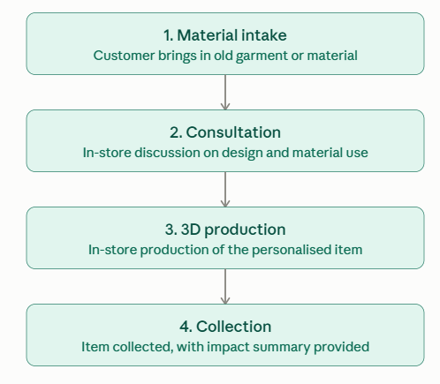
Figure 2: Customer journey
(Source: Created by learner in Ms-Word)
Transparency should saturate the entire process. The transparency provided by making customers witness production makes circularity an observable and trustworthy process rather than marketing (Lyu et al. 2025). The circularity of plastics requires observable and verifiable systems to foster trust from consumers.

3.7 Physical evidence
Physical evidence provides concrete evidence that backs the claims made for sustainability. Recommended components:
- Design of the store: Evidence of the use of recycled material as decoration, thus highlighting the concept of being circular (Münster et al. 2022).
- Minimal, recycled packaging, preventing wastage from occurring even at the end.
- Certificates of material impact, letting customers know precisely which waste has been used and to what extent (Regueiro et al. 2024).
This is important; since, the claims about sustainability have become something that needs verification rather than belief. It ensures trust for the brand through giving customers verifiable proof of what it is claiming about sustainability.

Element 4: Reflection

4.1 Experience developing the strategy
ReFiber 3D strategy development was a valuable as well as challenging process. One of the difficulties was striking a balance between innovation and sustainability. I wished to introduce concept of innovative and attractive with realistic and eco-friendly gesture for the services. Another difficulty was to attract attention of two different audiences simultaneously: investors were interested in growth and profitability; consumers were interested in authenticity and low ecological footprint (Jacubavicius et al. 2026). Yet another difficulty was making the service concept specific enough. Initially, "personalised outdoor products" was an unclear term. I needed to develop a more specific concept through applying Kotler's brand extension theory to make the connection between idea and brand (Patagonia and its Worn Wear program).

4.2 Experience with the poster presentation
Preparation of the poster gave me some insights into how to effectively convey complicated concepts in a confined space. Condensing the entire concept in limited words was difficult; since, I had to leave out many details and include only those that would carry the most persuasion. The process helped me understand what it takes to connect with an audience within a few moments. Being able to present the entire presentation in 3 to 5 minutes was another important practice exercise. It enhanced my communication skills, making sure that I speak clearly and do not exceed the time limit, which is defined as great business skill.

4.3 Skills and knowledge gained
In this project, I had an opportunity to put marketing theories into practice. For example, I applied the framework by Kotler to assess whether ReFiber 3D is suitable for Patagonia. I also learned how to create a complete STDP analysis that includes Segmentation, Targeting, Differentiation, and Positioning. Creating STP and POD/POP frameworks along with the perceptual map helped me to better understand the principles of competitive positioning. Working with the 7Ps made me aware of differences between product marketing and services marketing, in particular, the aspects of People, Process, and Physical Evidence (Išoraitė, 2021). Another aspect that I have developed is critical analysis of sources instead of providing factual-information. Reflection through writing limitations for the STDP section prompted critical self-evaluation of my strategy.

4.4 Future development
Next time, I would undertake some primary research through carrying out a short survey rather than only using secondary data. Additionally, I would have made clear earlier what the "3D" technology is all about, because this was one of the flaws in the concept. Incorporating competitor benchmarking figures would make my point of differentiation even better (Neilson, 2025). Lastly, I would have undertaken basic financial feasibility analysis to find out whether the business is financially feasible or not. Through adoption of these approaches, it would transform the strategy in a convincing way for real investors.

References
Carreno, A.M., 2024. Purpose-driven transformation: Aligning organizational culture with values and mission. White Paper, pp.1-13.
Choudhry, N., Islam, S., Van Amber, R., Rodriguez, C.Q., Underwood, J. and Panwar, T., 2026. Regenerative fashion systems: redefining circularity in the fashion and textiles industry. Circular Economy and Sustainability, 6(2), p.129.
De Simone, L. and Pezoa, M., 2021. Urban shopping malls and sustainability approaches in Chilean cities: Relations between environmental impacts of buildings and greenwashing branding discourses. Sustainability, 13(13), p.7228.
Deloitte, 2026. 2026 Gen Z and Millennial Survey. Available at: https://www.deloitte.com/global/en/issues/work/genz-millennial-survey.html [Accessed: 11.08.2026]
Enable, D.M.C., 2020. Sustainability in the Fashion Industry?. Fashion Industry: An itinerary between feelings and technology, p.21.
Forrester, 2023. Beware The Stereotype: Gen Z Isn’t The Most Actively Green Generation. Available at: https://www.forrester.com/blogs/beware-the-stereotype-gen-z-isnt-the-most-actively-green-generation/ [Accessed: 11.08.2026]
Gagliardi, G., 2026. A Cross-Country Analysis of Gen Z Consumers’ Perceptions towards Sustainable Luxury in Italy and Finland.
Gigauri, I., 2019. Perceptual mapping as a marketing research tool for brand positioning. International Journal of Economics and Management Studies, 6(4), pp.73-79.
Hellström, D. and Olsson, J., 2024. Let's go thrift shopping: exploring circular business model innovation in fashion retail. Technological Forecasting and Social Change, 198, p.123000.
Išoraitė, M., 2021. 7 P marketing mix literature review. International Journal of Trend in Scientific Research and Development (IJTSRD)., 5(6), pp.1586-1591.
Jacubavicius, C., Pereira, G.M., Vendrametto, O., Borchardt, M. and Milan, G.S., 2026. Purpose and Profit: Social and Environmental Marketing for Large Companies in Adverse Scenarios. Corporate Social Responsibility and Environmental Management, 33(2), pp.1656-1670.
Kumar, R., Kumar, K., Singh, R., Sá, J.C., Carvalho, S. and Santos, G., 2023. Modeling environmentally conscious purchase behavior: Examining the role of ethical obligation and green self-identity. Sustainability, 15(8), p.6426.
Kumar, V., Kotler, P. and Rajan, B., 2026. Whether, when and how to brand: a framework for strategic branding decisions for new-age technologies. European Journal of Marketing, 60(02), pp.337-368.
Lariba, C., 2023. The role of user-generated content in shaping brand perceptions. International Journal of Public Relation and Communication, 1(1), pp.25-37.
Lopes, J.M., Gomes, S., Suchek, N. and Nogueira, S., 2024. The hidden reasons behind generation Z's green choices. Discover Sustainability, 5(1), p.520.
Lyu, W., van den Berg, M., Schraven, D. and Wang, T., 2025. From potential to reality: Advocating for an evidence-based circularity assessment framework. In 2nd International Conference on Circularity in the Built Environment (CiBEn), pp. 245-251.
Moubarak, M., Schlummer, M., Loos, H.M., Ragaert, K., Van Geem, K.M. and Buettner, A., 2025. Recycling of Marine Plastic Waste. In Springer Handbook of Circular Plastics Economy, pp. 705-722.
Münster, M.B., Sönnichsen, S.D. and Clement, J., 2022. Retail design in the transition to circular economy: A study of barriers and drivers. Journal of Cleaner Production, 362, p.132310.
Neilson, C.A., 2025. Targeted vouchers, competition among schools and the academic achievement of poor students. Econometrica.
Patagonia, 2026. 1% for the Planet. Available at: https://www.patagonia.com/one-percent-for-the-planet.html [Accessed: 11.08.2026]
Patagonia, 2026. A History of Our Environmental and Social Responsibility. Available at: https://www.patagonia.com/our-footprint/corporate-social-responsibility-history.html [Accessed: 11.08.2026]
Patagonia, 2026. Owned and Operated. Available at: https://www.patagonia.com/where-we-do-business/owned-and-operated.html [Accessed: 11.08.2026]
Regueiro, C., Gómez-Goiri, A., Pedrosa, N., Semertzidis, C., Iturbe, E. and Mansell, J., 2024. Blockchain-based refurbishment certification system for enhancing the circular economy. Blockchain: Research and Applications, 5(1), p.100172.
SGB media, 2025. EXEC: Patagonia Publishes Fiscal 2025 Sales Figures, Spot Checks Business Against Key Goals. Available at: https://sgbonline.com/exec-patagonia-publishes-fiscal-2025-sales-figures-spot-checks-business-against-key-goals/ [Accessed: 11.08.2026]

