8/11/2026

DR. KWAME ASSA-AGEI
UNIVERSITY OF WALES TRINITY SAINT DAVIDS-LONDON
CERTIFICATE IN HIGHER EDUCATION

SOFTWARE SOLUTIONS FOR BUSINESS

ACCA4026

KOFI DENNIS ADORSOO
2540934

Table of Contents
Introduction 2
Task 1. e-Commerce Website builders/software solutions 3
1.1 Wix 3
1.2 Shopify 3
Task 2. Mind-map of contemporary software applications 3
2.1 Describe mind mapping and explain the benefits of using mind mapping 3
2.2 Create a mind map of contemporary software applications 4
Task 3. Office Applications 5
3.1 Four office software solutions for business operations 5
Ms Word 5
Ms Excel 6
Ms PowerPoint 6
Ms Access 6
3.2 Test any two features 6
Mail Merge 6
IF Statement 9
Task 4. Communication and Collaboration applications 10
4.1 One contemporary Communication and one Online Collaboration 10
Gmail 10
Zoom 10
4.2 Test one feature of a freely available Communication (1) and one feature of a Collaboration (1) application 10
Microsoft outlook 10
MS Teams 14
Conclusion 21
References 21

Introduction
Software solutions are digital tools businesses and companies use to help them perform task, solve problems and improve efficiency in the business. They can be used for accounting, customer management, inventory, communication, e-commerce and project monitoring. Software helps businesses to save time, run smoothly, increase productivity and support decision making. Its helps with the growth of the business.

Task 1. e-Commerce Website builders/software solutions

Wix
 Wix is well known cloud-based website development platform that helps organizations, businesses and an individual to create and manage websites without needing any advance coding skills. Wix is very simple to use by drag -and -drop editor, it helps you to design a professional looking website from scratch or by using already made templates and it was founded in the year 2006.
Wix has got over hundreds of already made templates that you can choose from for different purposes for example Restaurants, Business websites, online stores, blogs, portfolios and personal websites. It gives you the opportunity to customize the layout colour fonts, images, and other elements to match brand or personal style. It also provides tools for adding videos, booking, forms galleries, blogs and online system of payments.
For more flexibility to the users Wix supports custom code and advance development through its development tools has an artificial -intelligence features that can help generate websites design and content.
In some cases. Wix can be relatively expensive because users need an advanced features, storage or business capabilities. Websites created on Wix are also closely connected to its platforms therefore moving it to another website builder can be more difficult.
Wix has many advantages, but one main advantage is its all-in-one approach. Users can buy domains ,host their website, improve search -engines visibility through SEO(search engine optimisation)tools, and manage website content from one platform also provides e-commerce features that enables businesses to sell products and services on line, manage inventory, accept payments and track orders, is a user-friendly and a convenient website building solution is suitable for beginners ,small businesses, freelancers and entrepreneurs who want to establish an online presence quickly without having to learn complex web-development languages[1][2].

Shopify
 Shopify is a very popular e-commerce platform allow individuals and businesses to create, operate and manage their online stores. Shopify is one of the leading platforms for selling products and services online. Shopify is designed to make online selling very easy and user-friendly that even those with or without technical knowledge can use it. Shopify was founded in the year 2006. One of the main features of Shopify is its Easy-To-Use store builder. Shopify allows its users to select from different professional themes and customize their websites by changing colours, images, fonts, products information and layouts. Shopify also has tools that allow you to add products, managing inventory, processing orders and tracking sales.
Shopify allows businesses to sell physical products, digital ones, subscriptions, and services. Shopify supports various payment methods. Customers can pay securely using their cards and any other available options. Shopify provides tax managing features and shipping helping businesses to deliver products and calculate cost.
One of the advantages of Shopify is its App store, this allows the users to install applications that add extra features to their store. These extra features can email marketing, customer review, accounting, analytics and social media integration. This helps to provide reports and analytics that helps business owners to monitor customer behaviour and business performance.
Shopify supports selling through social media, websites and other sales channels. Its mobile friendly and allows store owners to manage their businesses using a smart phone. Shopify can be used by large companies or a very small business.
Shopify is a flexible and convenient e-commerce platform. It is designed simple and it has a wide range of features, powerful business tools, secure payment options that makes it useful choice for anyone who wants to start online business[3][4].

Task 2. Mind-map of contemporary software applications

2.1 Describe mind mapping and explain the benefits of using mind mapping

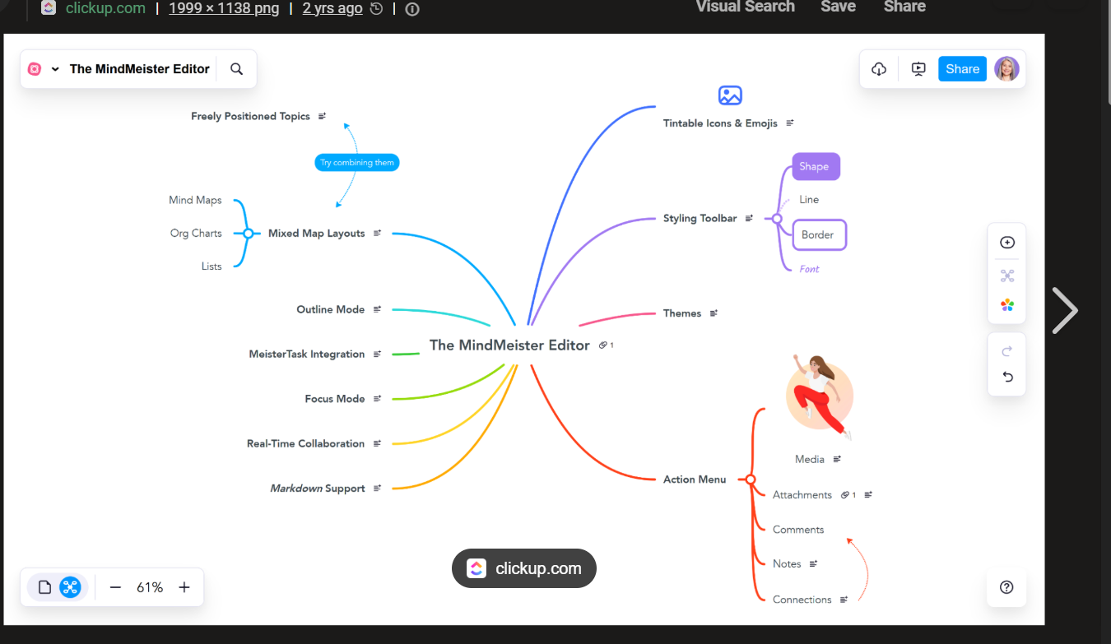

Mind Mapping
Mind mapping is a visual technique used to organize and represent information around a central idea. The main topic is placed at the canter, with related ideas branching out from it. These branches can contain keywords, concepts, facts, images, or examples. Mind maps show relationships between ideas and make complex information easier to understand.
For example, if the central topic is “Healthy Lifestyle,” branches might include Exercise, Diet, Sleep, Mental Health, and Daily Habits, with further details branching from each.
Benefits of Mind Mapping
- Improves understanding – It presents information visually, making complex topics easier to grasp.
- Enhances memory – The use of keywords, colours, images, and connections helps people remember information.
- Encourages creativity – It allows ideas to flow freely and helps generate new connections.
- Organizes information – Related ideas can be grouped logically, giving a clear overview of a topic.
- Helps with problem-solving – Seeing different aspects of a problem can make it easier to identify solutions.
- Supports planning – Mind maps can be used to plan projects, essays, presentations, or daily tasks.
- Saves time – Key information can be summarized using short words and visual connections rather than lengthy notes.
- Encourages active learning – Creating a mind map requires learners to process, connect, and organize information rather than simply copy it.

Mind Mapping
Mind mapping is a visual technique used to organize and represent information around a central idea. The main topic is placed at the center, with related ideas branching out from it. These branches can contain keywords, concepts, facts, images, or examples. Mind maps show relationships between ideas and make complex information easier to understand.
For example, if the central topic is “Healthy Lifestyle,” branches might include Exercise, Diet, Sleep, Mental Health, and Daily Habits, with further details branching from each.
Benefits of Mind Mapping
- Understanding improvement – It presents information visually, making complex topics easier to grasp.
- Optimizes memory – The use of keywords, colours, images, and connections helps people remember information.
- Promotes creativity – It allows ideas to flow freely and helps generate new connections.
- Schedules information – Related ideas can be grouped logically, giving a clear overview of a topic.
- Aids with problem-solving – Seeing different aspects of a problem can make it easier to identify solutions.
- Facilitate planning – Mind maps can be used to plan projects, essays, presentations, or daily tasks.
- Reduces time spent – Key information can be summarized using short words and visual connections rather than lengthy notes.
- Motivates active learning – Creating a mind map requires learners to process, connect, and organize information rather than simply copy it[5][6].

2.2 Create a mind map of contemporary software applications
A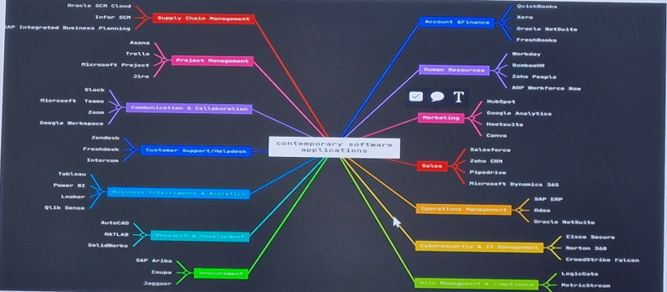

Task 3. Office Applications

3.1 Four office software solutions for business operations

Ms Word


Description
Microsoft PowerPoint is the industry-standard presentation software developed by Microsoft, part of the Microsoft 365 (Office) suite. It enables users to create, edit, and deliver slide-based presentations combining text, images, charts, animations, audio, video, and interactive elements. Originally released in 1987, it runs on Windows, macOS, iOS, Android, and web browsers, and dominates the global presentation market with approximately 95% share.

BENEFITS
Ease of Use — Intuitive ribbon interface, drag-and-drop, minimal learning curve; accessible to beginners yet powerful for experts.
Universal Compatibility — De facto standard; files open reliably across devices; widely accepted in business, education, government.
Rich Content Support — Combine text, graphics, charts, animation, audio, and video in one file without external tools.
Seamless Microsoft 365 Integration — Direct linking with Excel data, Word content, Outlook, Teams, OneDrive.
Collaboration & Cloud — Work simultaneously with others; auto-save, version tracking, easy sharing with permission controls.
Professional Quality Fast — Designer + AI tools produce polished layouts in minutes; consistent branding via slide masters.
Flexible Output — Present live, record video, export PDF/handouts, print, or publish online.
Accessibility — Built-in checker for contrast, alt-text, reading order; supports screen readers.

Limitations
Subscription Cost — Full features require a paid Microsoft 365 subscription; free/web version is significantly limited.
Over-Simplification Risk — Default bullet-point layouts encourage "text-heavy" slides; can reduce comprehension if overused.
Design Inflexibility — Freeform graphic design is weaker than Adobe Canva, Illustrator, or Keynote; precise layout control is clumsy.
Large Data / Complex Charts — Not built for advanced analytics; embedding large datasets causes lag; limited chart types vs Excel.
Compatibility Issues — Formatting may shift when opening .pptx files in older versions or non-Microsoft tools.
File Bloat — Embedded media (especially high-res video/images) creates very large files; slower performance on older computers.
AI Features Restricted — Copilot and advanced tools require premium subscriptions; not available to all users.
Animation Overuse — Easy to abuse transitions/effects, leading to distraction rather than clarity.

Aspect | Details
Developer | Microsoft
First Released | 1987
Platforms | Windows, macOS, iOS, Android, Web
File Format | .pptx (primary), .ppt, .ppsx, .potx
Pricing | Free (basic web/mobile); Paid via Microsoft 365 Personal/Family/Business
Best For | Business, education, conferences, training, pitches
Strength | Ecosystem, collaboration, reliability, broad adoption
Weakness | Cost, design limits, file size, data visualization

Would you like me to turn this into a concise one-page comparison table vs alternatives like Google Slides, Keynote, and Canva?
ms word description and features and benefits and limitation
Searched for 3 keywords · 18 sources

Description
Microsoft Word is the world's leading professional word processor, developed by Microsoft and part of the Microsoft 365 (Office) suite. First released in 1983, it creates, edits, formats, and shares professional-quality documents using a WYSIWYG (What You See Is What You Get) interface. It runs on Windows, macOS, iOS, Android, and web browsers, and is the global standard for letters, reports, essays, resumes, contracts, books, and academic papers. Primary file formats: .docx (modern), .doc (legacy), .pdf, .rtf, .txt.

Key Features
Table
Category | Features
Editing & Formatting | Rich text formatting, paragraph styles, themes, columns, headers/footers, page numbering, line spacing, section breaks
Structure & References | Automatic Table of Contents, footnotes/endnotes, citations, bibliography, indexes, cross-references
Templates & Styles | Thousands of built-in templates; Styles system for consistent, document-wide formatting changes
Review & Collaboration | Track Changes, inline comments, compare/merge documents, real-time co-authoring, version history
AI & Writing Tools | Copilot — generate drafts, summarize, rewrite, adjust tone; Editor — grammar, spelling, clarity, style checker; Dictate (speech-to-text)
Graphics & Layout | Insert images, shapes, SmartArt, charts, text boxes, tables, equations, watermarks
Productivity | Mail Merge, auto-correct, auto-format, find/replace, macros, custom keyboard shortcuts
Export & Compatibility | Save/export to PDF, HTML, EPUB, TXT; robust DOC/DOCX compatibility; password encryption

BENEFITS
Industry Standard — Universally accepted in business, education, government; nearly every device can open .docx files.
Professional Layout Control — Precise page formatting, styles, referencing, and multi-level numbering far beyond simpler editors.
Powerful Review Workflow — Track Changes + Comments = the gold standard for editing, legal review, and academic peer review.
Consistent Branding — Styles and templates ensure uniform formatting across hundreds of pages; update all headings in one click.
Microsoft 365 Ecosystem — Embed Excel charts, share via OneDrive, co-author in Teams, sync across all devices.
AI-Assisted Writing — Copilot drafts, summarizes, and polishes; Editor improves grammar, clarity, and tone.
Offline & Cross-Platform — Full desktop app works without internet; mobile/web versions for anywhere access.
Advanced Automation — Mail Merge for bulk correspondence; macros for repetitive tasks.
Security & Privacy — Password protection, file encryption, permission,
Print-Perfect Output — Layouts stay faithful when printed or saved to PDF; professional publishing quality.

Limitations
Subscription Cost — Full features require paid Microsoft 365 subscription; free/web version is heavily restricted.
Formatting Fragility — Layout can shift when opening files in older versions or non-Microsoft tools; floating objects often misalign.
Image & Graphic Handling — Clunky image placement; poor text-wrap behaviour; weaker design tools than desktop publishing software.
Complexity Overwhelm — Ribbon interface is crowded; advanced features are hard to find; steep learning curve for power tools.
Large Document Performance — Slows down significantly on long, media-heavy files; can lag or crash on older hardware.
Collaboration Lag — Real-time co-authoring is less responsive and smoother than Google Docs; requires OneDrive/SharePoint.
Limited Version Control — No native line-by-line diff or Git-style history; poor for technical/text-based collaborative workflows.
Equations & Technical Content — Weak native math; awkward for scientific, technical, or highly mathematical documents.
Proprietary Format — .docx is closed specification; less future-proof than open formats like .dot or Markdown.

Quick Summary Table

Aspect | Details
Developer | Microsoft
First Released | 1983
Platforms | Windows, macOS, iOS, Android, Web
Primary Format | .docx
Pricing | Free (basic web/mobile); Paid via Microsoft 365
Best For | Reports, essays, contracts, resumes, academic papers, books, legal docs
Strength | Layout fidelity, styles, references, review workflow, ecosystem
Weakness | Cost, image layout, collaboration lag, complexity, file bloat

Ms Excel
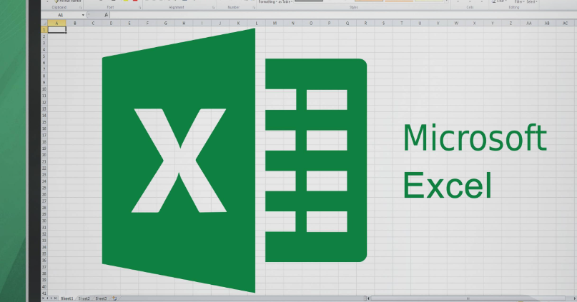
Description
Microsoft Excel is a powerful spreadsheet application developed by Microsoft, part of the Microsoft 365 / Office suite, available for Windows, macOS, Android, and iOS. It organises information in a grid of cells arranged in rows (numbered) and columns (lettered), enabling users to store, organise, calculate, analyse, and visualise data numerically and textually. First released in 1985, it has become the global industry standard for spreadsheets.
Key Features

Category | Features
Data Organisation | Grid-based worksheets; multiple sheets per file; sorting, filtering, formatting, conditional formatting, data validation
Formulas & Functions | 500+ built-in functions — mathematical, statistical, financial, date/time, text, logical; custom formulas
Data Analysis | PivotTables (summarise & reshape large datasets); Power Query (import & clean external data); Power Pivot (advanced modelling); What-If Analysis, Solver, Scenario Manager
Visualisation | Charts (bar, line, pie, area, scatter, histogram, etc.); sparklines, conditional formatting, data bars, icon sets
Automation | Macros & VBA (Visual Basic for Applications) — record or write scripts to automate repetitive tasks
Collaboration & Cloud | Share workbooks; co-authoring in real time (Microsoft 365); online version via Excel for the web; version history & comments
AI & Intelligence | Copilot — natural language assistance to create formulas, analyse data, generate charts, and write explanations
Data Connectivity | Connect to SQL databases, CSV, web data, APIs, and other sources; refresh automatically

Key Benefits
Versatility — Suitable for finance, accounting, sales, engineering, education, HR, project management, and personal use.
Powerful Calculation Engine — Handles everything from simple sums to advanced statistical, financial, and engineering computations with precision.
Scalability — Manages very large datasets (up to ~1 million rows per worksheet) efficiently on capable hardware.
Data Visualisation — Turn raw numbers into professional, customisable charts and dashboards for clear communication.
Automate Work — Use macros and VBA to eliminate repetition; Copilot reduces formula/analysis effort further.
Universal Compatibility — .xlsx is the global business standard; nearly every organisation supports Excel files.
Ecosystem Integration — Seamlessly works with Word, PowerPoint, Outlook, Power BI, and cloud services.
Decision Support — PivotTables, forecasting, and scenario tools help spot trends and make data-driven decisions.

Limitations
Steep Learning Curve — Basic use is easy, but advanced features (PivotTables, complex formulas, VBA, Power Query) require significant time to master.
Data Integrity Risks — No built-in database-style validation rules; accidental overwrites, typos, or hidden formula errors can corrupt results silently.
Performance Limits — Very large datasets .
May slow down or crash; web version is slower than desktop.
Collaboration Gaps — Real-time co-authoring works best in Excel for the web; desktop collaboration has limitations; version conflicts can occur.
Cost — Full desktop version requires a paid Microsoft 365 subscription or one-time purchase; free version is feature-limited.
Security & Audit — Lack of built-in row-level permissions and clear audit trails; macros can carry malicious code.
Not a Database — Poor choice for relational data, multi-user apps, or transactional systems; it is a spreadsheet, not a database engine.
Summary Table

Aspect | Details
Developer | Microsoft
File Format | .xlsx (modern), .axles (legacy)
Platforms | Windows, macOS, Android, iOS, Web
Primary Use | Data organisation, calculation, analysis, visualisation
Strengths | Industry standard, powerful functions, PivotTables, VBA, broad compatibility
Weaknesses | Complexity, error-prone, not a database, cost, performance at sca

Ms PowerPoint
Description
Microsoft PowerPoint is the industry-standard presentation software developed by Microsoft, part of the Microsoft 365 (Office) suite. It enables users to create, edit, and deliver slide-based presentations combining text, images, charts, animations, audio, video, and interactive elements. Originally released in 1987, it runs on Windows, macOS, iOS, Android, and web browsers, and dominates the global presentation market with approximately 95% share.

 | Features
Slides & Layout | Multiple slide layouts, master slides, custom slide sizes, portrait/landscape support
Templates & Design | Thousands of free/premium customizable templates, AI-powered Designer auto-layout, themes, colour palettes, font schemes
Multimedia | Insert images, audio, video, 3D models, icons, stock photos, screen recordings, Cameo (live video overlay)
Animation & Transitions | Object animations, slide transitions, motion paths, timing control, morph transition
Data & Visuals | Built-in charts, SmartArt diagrams, Excel data linking, tables, equations
AI Tools | Copilot — generates outlines, slides, summaries; Speaker Coach — AI rehearsal feedback; Accessibility Assistant
Collaboration | Real-time co-authoring, comments, version history, cloud sharing via OneDrive/SharePoint
Delivery | Presenter View, slide show modes, recording with timings/ink, export to PDF/MP4/HTML
Cross-Platform | Desktop (Windows/Mac), web browser, iOS & Android apps

BENEFITS
Ease of Use — Intuitive ribbon interface, drag-and-drop, minimal learning curve; accessible to beginners yet powerful for experts.
Universal Compatibility — De facto standard; files open reliably across devices; widely accepted in business, education, government.
Rich Content Support — Combine text, graphics, charts, animation, audio, and video in one file without external tools.
Seamless Microsoft 365 Integration — Direct linking with Excel data, Word content, Outlook, Teams, OneDrive.
Collaboration & Cloud — Work simultaneously with others; auto-save, version tracking, easy sharing with permission controls.
Professional Quality Fast — Designer + AI tools produce polished layouts in minutes; consistent branding via slide masters.
Flexible Output — Present live, record video, export PDF/handouts, print, or publish online.
Accessibility — Built-in checker for contrast, alt-text, reading order; supports screen readers.

Limitations
Subscription Cost — Full features require a paid Microsoft 365 subscription; free/web version is significantly limited.
Over-Simplification Risk — Default bullet-point layouts encourage "text-heavy" slides; can reduce comprehension if overused.
Design Inflexibility — Freeform graphic design is weaker than Adobe Canva, Illustrator, or Keynote; precise layout control is clumsy.
Large Data / Complex Charts — Not built for advanced analytics; embedding large datasets causes lag; limited chart types vs Excel.
Compatibility Issues — Formatting may shift when opening .pptx files in older versions or non-Microsoft tools.
File Bloat — Embedded media (especially high-res video/images) creates very large files; slower performance on older computers.
AI Features Restricted — Copilot and advanced tools require premium subscriptions; not available to all users.
Animation Overuse — Easy to abuse transitions/effects, leading to distraction rather than clarity.

Summary Table

Aspect | Details
Developer | Microsoft
First Released | 1987
Platforms | Windows, macOS, iOS, Android, Web
File Format | .pptx (primary), .ppt, .pops, .pot
Pricing | Free (basic web/mobile); Paid via Microsoft 365 Personal/Family/Business
Best For | Business, education, conferences, training, pitches
Strength | Ecosystem, collaboration, reliability, broad adoption
Weakness | Cost, design limits, file size, data visualization
PowerPoint information here>

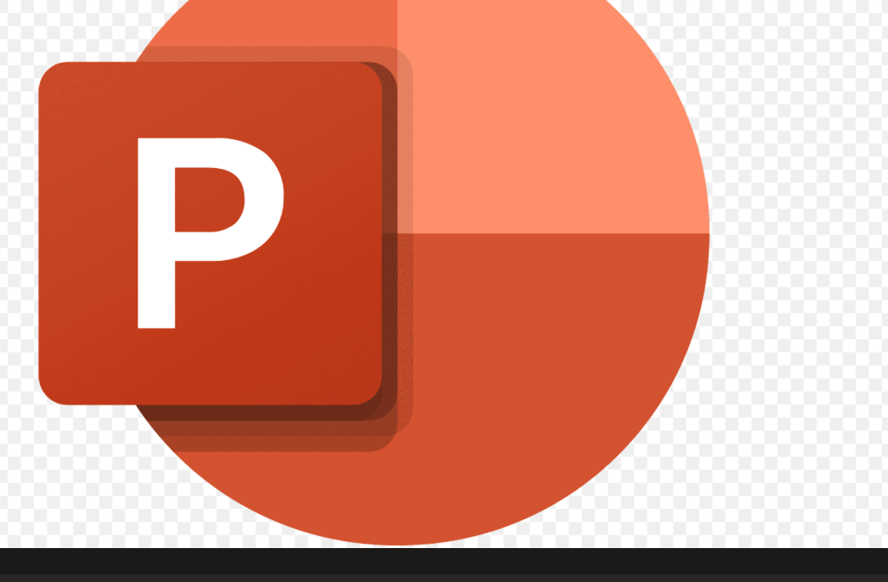
Description
Microsoft PowerPoint is the industry-standard presentation software developed by Microsoft, part of the Microsoft 365 / Office suite, available for Windows, macOS, Android, iOS, and the web. It enables users to create, edit, and deliver visual presentations arranged in sequential slides combining text, images, graphics, charts, animations, and multimedia. First released in 1990, it is the most widely used presentation tool across business, education, and government worldwide.

Key Features

Category | Features
Slides & Layout | Slide-based structure; built-in layouts, Master Slides for consistency; thousands of customizable templates & themes
Design & AI | Designer — auto-generates professional layouts; Copilot — creates content & designs from prompts; Microsoft Designer integration; colou,brand themes
Multimedia & Visuals | Insert images, icons, shapes, 3D models, audio, video; Cameo — live camera feed directly on slides; charts, SmartArt, diagrams
Animation & Motion | Object animations (appear, fade, fly-in); slide transitions; morph transition for smooth movement; timings & trigger effects
Presentation Tools | Presenter View (speaker notes, timer, slide preview); Speaker Coach — AI rehearsal feedback; ink/drawing tools; teleprompter
Collaboration | Real-time co-authoring; comments & @mentions; version history; cloud sharing via OneDrive/SharePoint; Excel/Word integration
Accessibility & Export | Accessibility Checker; export to PDF, video, images; embed fonts; password protection
Data Connectivity | Linked charts & tables from Excel; automatically updateable data; PowerPoint embedded in Word/Excel

Key Benefits
Intuitive & Accessible — Easy-to-learn interface; beginners can create professional slides quickly; ribbon UI is consistent across Microsoft apps.
Professional Quality Fast — Templates, Designer, and themes ensure polished, consistent branding without being a graphic designer.
Rich Communication — Combine text, visuals, charts, animation, and video to make complex ideas clear and engaging.
Seamless Microsoft Ecosystem — One-click Excel charts; paste from Word; embed in Outlook; work across desktop & web.
Present with Confidence — Presenter View, notes, timings, and rehearsal tools help you deliver smoothly; Morph & animations keep attention.
Universal Compatibility — .pptx is the global standard; opens everywhere; works offline or via cloud sharing.
Powerful Automation — Copilot drafts content; Designer suggests layouts; Speaker Coach improves delivery.

Limitations
Cost — Full desktop version requires a paid Microsoft 365 subscription; free web/mobile versions are feature-limited.
Performance with Heavy Media — Large files with high-res images, videos, or complex animations can lag, crash, or become slow to share.
Design Inflexibility — Less free-form than tools like Canva; precise custom positioning can be frustrating; vector graphics support is limited.
Version Compatibility Issues — Animations, fonts, and advanced features may break or display differently on older versions or non-Microsoft viewers.
Not for Advanced Graphics — Built-in image editing is basic; needs Photoshop/Illustrator-quality work requires external tools.
Overused / Generic — Default templates are widely recognised; "Death by PowerPoint" risk — text-heavy slides can bore audiences.
Limited Non-Linear Flow — Designed for linear slide order; branching/interactive navigation is possible but cumbersome.
Collaboration Best in Web Version — Real-time co-editing works smoothly online; desktop collaboration has delays and version conflicts.
Summary Table
Table
Aspect | Details
Developer | Microsoft
File Format | .pptx (modern), .ppt (legacy)
Platforms | Windows, macOS, Android, iOS, Web
Primary Use | Create & deliver slide presentations
Strengths | Industry standard, easy to use, templates, Excel integration, animation, AI tools
Weaknesses | Cost, performance at scale, limited graphic design, version compatibility, linear structure

Ms Access

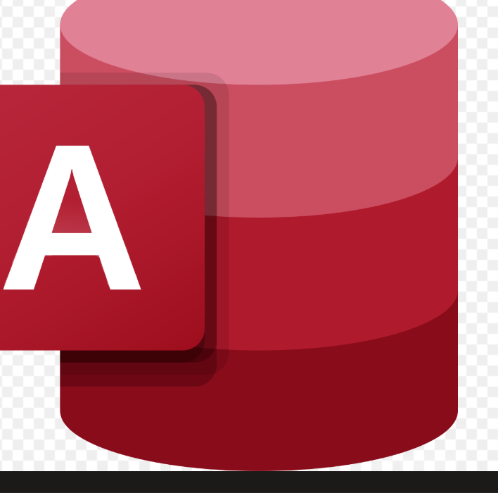

Microsoft Access (MS Access) is a relational database management system developed by Microsoft. It allows users to store, organize, retrieve, analyse, and report structured data. An Access database can contain tables, relationships, queries, forms, reports, macros, and VBA modules, usually within a single .accede file.
Access is best suited to individuals, departments, and small or medium-sized organizations that need a desktop database without the complexity of an enterprise database platform.
Main features
- Relational tables
Data is stored in related tables made up of fields and records. Primary and foreign keys help connect tables while reducing duplicate data.
- Queries
Queries retrieve, filter, sort, calculate, summarize, or modify data. Access supports a version of SQL as well as a graphical query designer.
- Forms
Forms provide user-friendly screens for entering, viewing, and editing records. Controls and validation rules can improve accuracy.
- Reports
Reports present data in organized, printable layouts. They support grouping, sorting, totals, charts, and sub reports.
- Macros and VBA
Macros automate routine operations without extensive coding, while Visual Basic for Applications supports more advanced business logic and automation.
- Import, export, and linking
Access can exchange or link data with sources such as Excel, text files, Outlook, SharePoint, ODBC databases, and SQL Server.
- Templates and wizards
Built-in templates and step-by-step wizards make it faster to create tables, queries, forms, and reports.
- Multi-user operation
Several users can work with the same database. A split design can keep tables in a shared back-end file while each user has a local front-end.
Benefits
Easy application development: Its visual designers and wizards allow useful database applications to be created relatively quickly.
Improved data integrity: Relationships, validation rules, required fields, and data types help maintain consistent information.
Better than spreadsheets for related data: Access can manage relationships among customers, orders, products, employees, and other entities.
Office integration: It works well with Excel, Word, Outlook, and other Microsoft products.
Automation: Macros and VBA reduce repetitive work and support customized workflows.
Flexible reporting: Users can produce detailed, grouped, summarized, and printable reports.
Cost-effective for smaller systems: Organizations may already have Access through an eligible Microsoft 365 or Office license.
- Migration path: Access can serve as a front-end for SQL Server when more database capacity or reliability is required. software-matters.co.uk
Limitations
Limitation | Practical effect
2 GB database-file limit | Unsuitable for large databases, especially when files and images are stored as attachments.
Limited scalability | Performance may decline with many simultaneous users or complex workloads.
Windows-focused | The full desktop application does not run natively on macOS, Linux, or mobile devices.
Limited web support | Access is mainly designed for desktop applications rather than modern browser-based systems.
File-corruption risk | Shared database files can become damaged because of network interruptions, hardware failures, or improper shutdowns.
Basic enterprise security | It lacks some of the advanced auditing, access control, resilience, and administration found in server databases.
Maintenance challenges | Poor table design, excessive VBA, and missing documentation can make an application difficult to support.
Performance constraints | It is not ideal for very large datasets, high transaction volumes, or business-critical systems requiring continuous availability.
The often-mentioned number of supported users should not be treated as a practical guarantee: actual performance depends on the database design, network, workload, and record-locking behavior.
Conclusion
MS Access is a strong choice for small inventory systems, customer records, project tracking, departmental applications, and reporting tools. It offers a useful combination of database storage, interface design, reporting, and automation. For large-scale, internet-facing, highly secure, or heavily concurrent applications, a server platform such as SQL Server, PostgreSQL, or Oracle is generally more appropriate.

3.2 Test any two features

Mail Merge

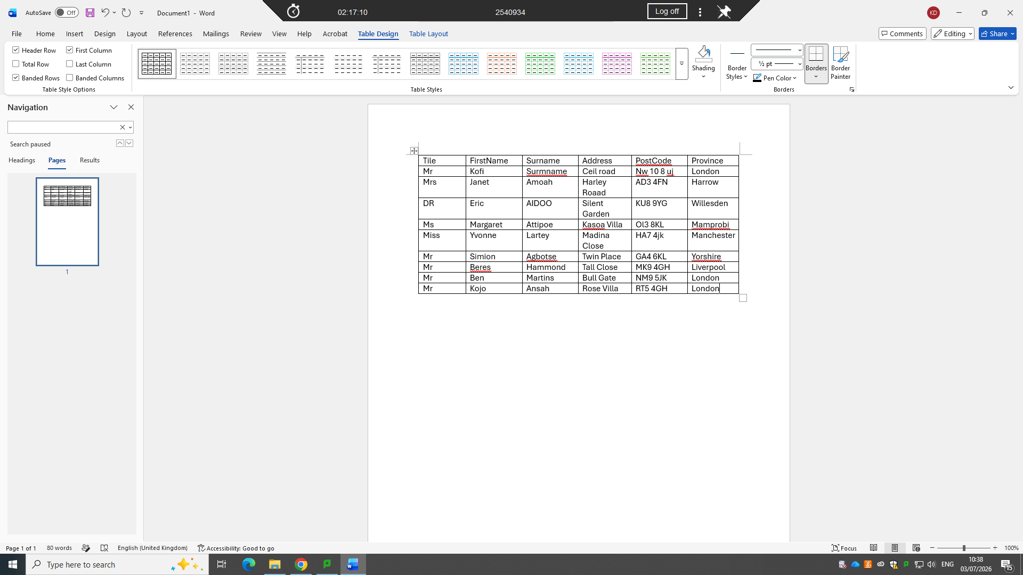

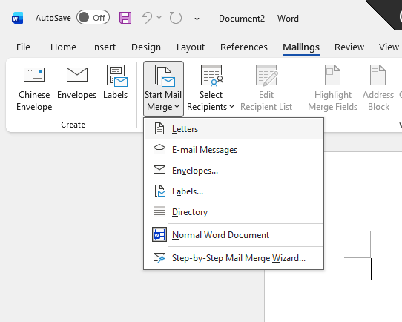

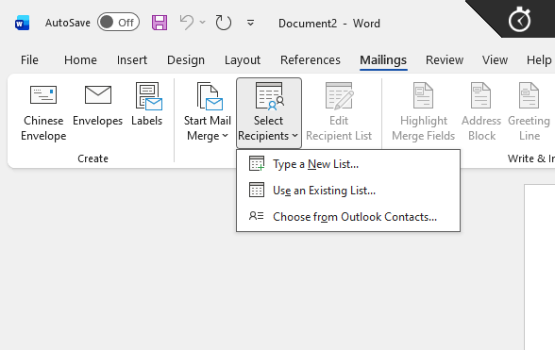

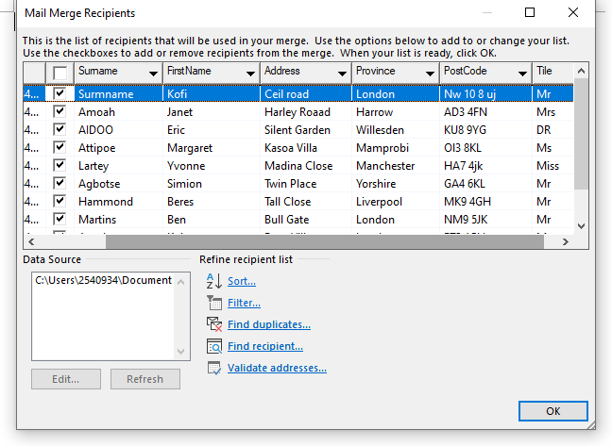

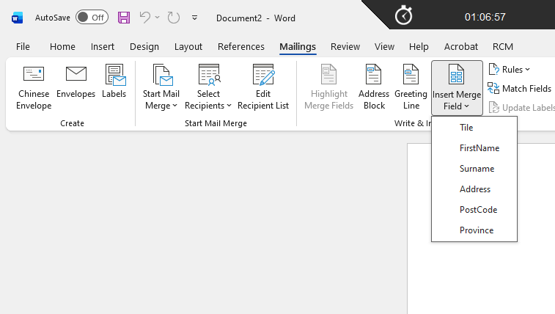

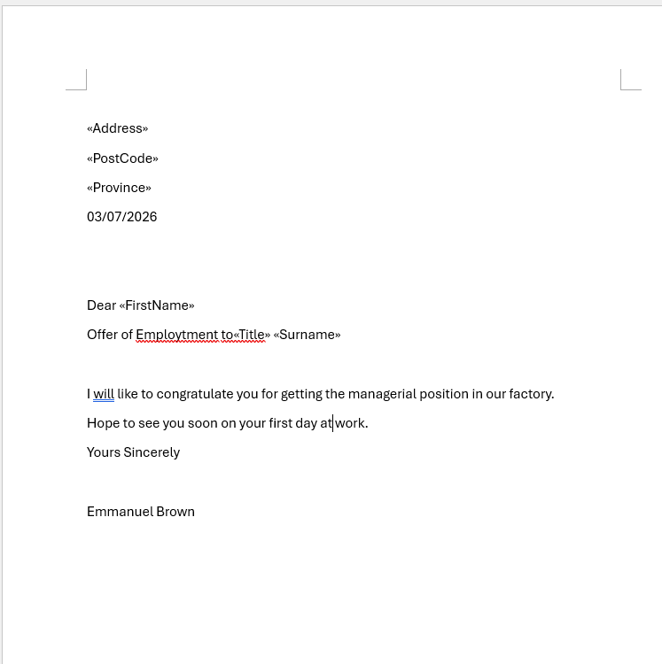

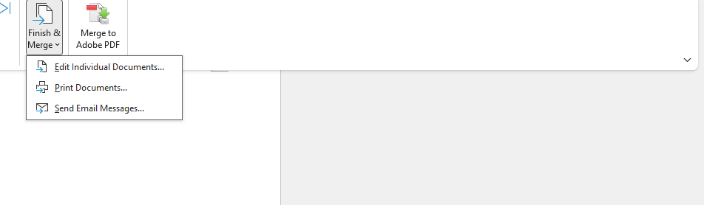

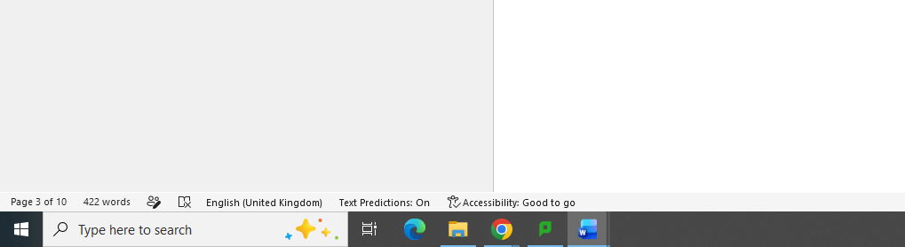

IF Statement

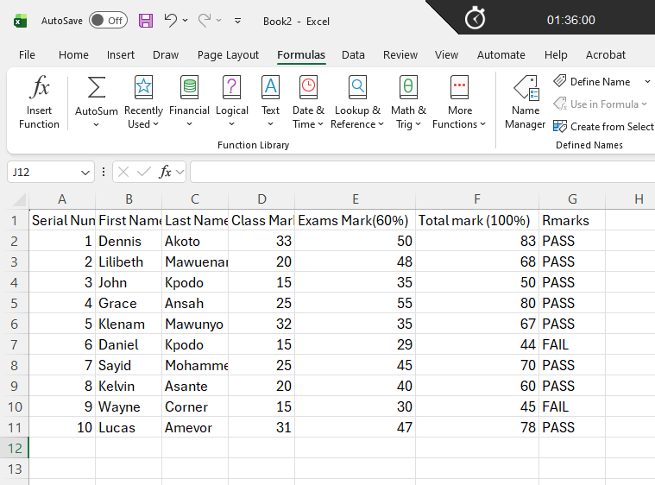

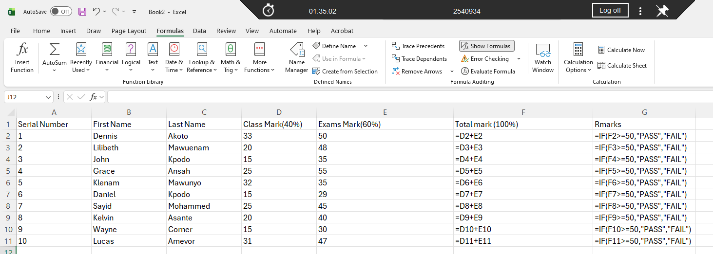

Task 4. Communication and Collaboration applications

4.1 One contemporary Communication and one Online Collaboration

Gmail
Gmail is a free email service developed by google that allows users to send, receive, and organise electronic mail over the internet. It has features such as spam filtering, large storage capacity, such functionality, labels, and integration with other google services. Users can access Gmail through web browsers or mobile applications, making it convenient for personal and professional communication[7][8].

Zoom
ZOOM is an online video-conferencing platform that allows people to communicate through video and audio over the internet. It can also be used for online meetings, classes, weasands group discussions. Users can also share their screens, send messages, and record meetings[9][10].

4.2 Test one feature of a freely available Communication (1) and one feature of a

Collaboration (1) application

Microsoft outlook

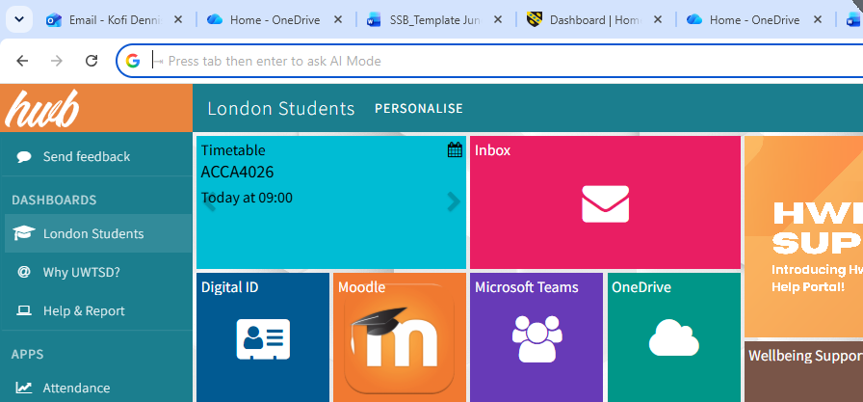

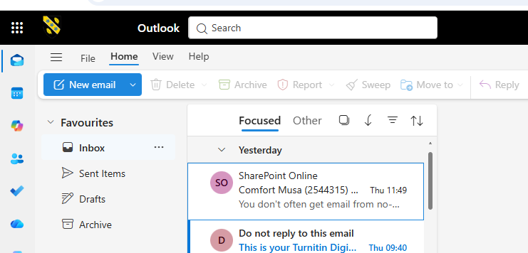

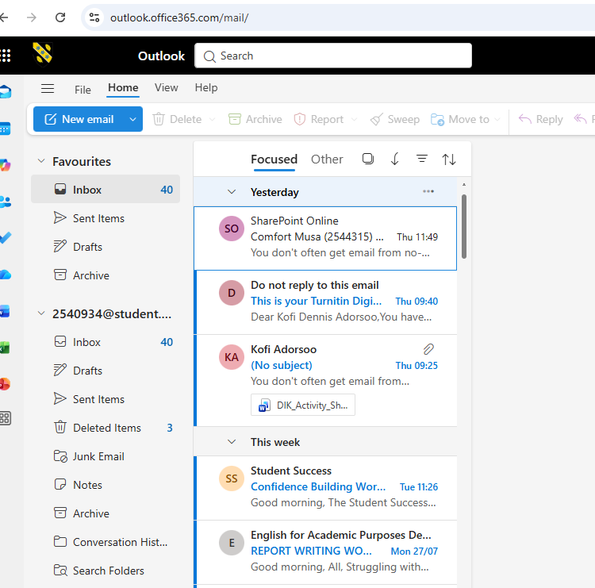

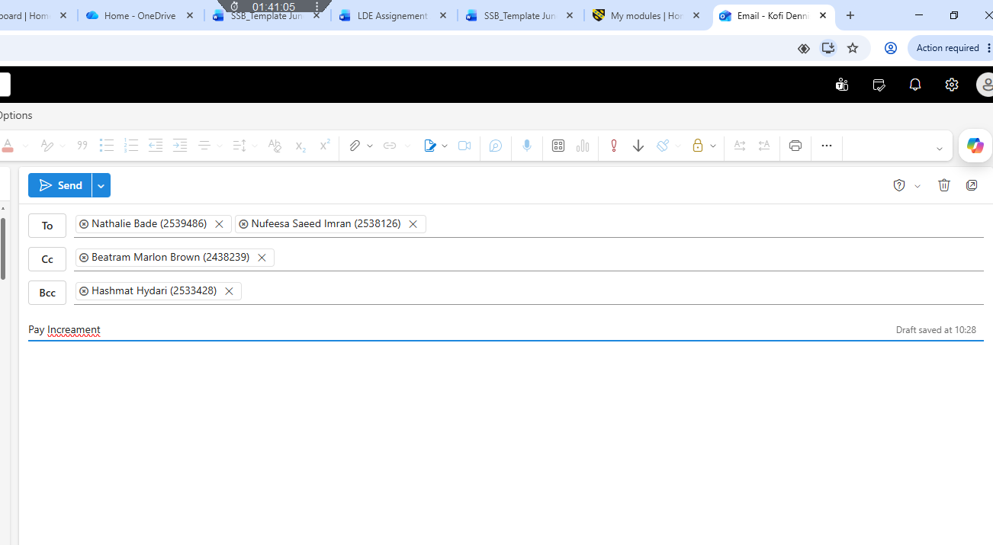

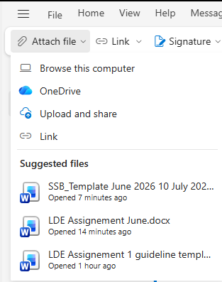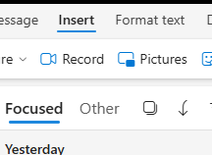

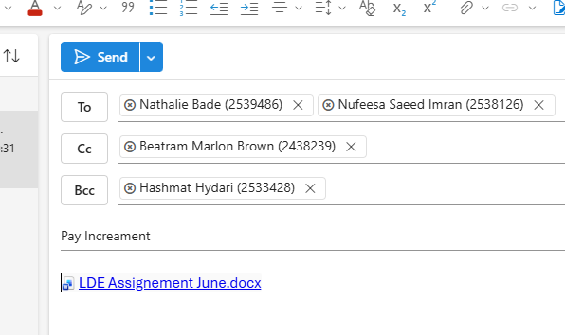

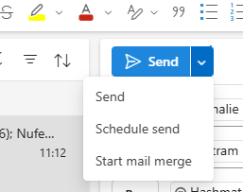

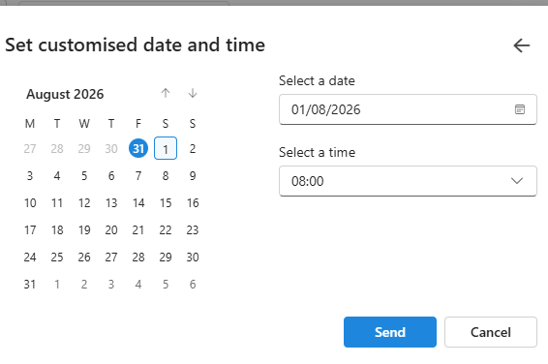

MS Teams

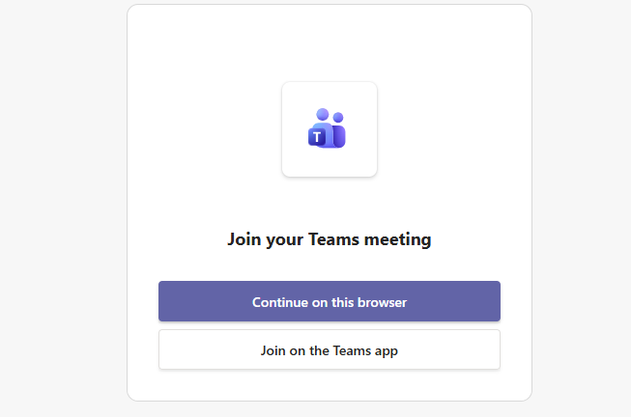

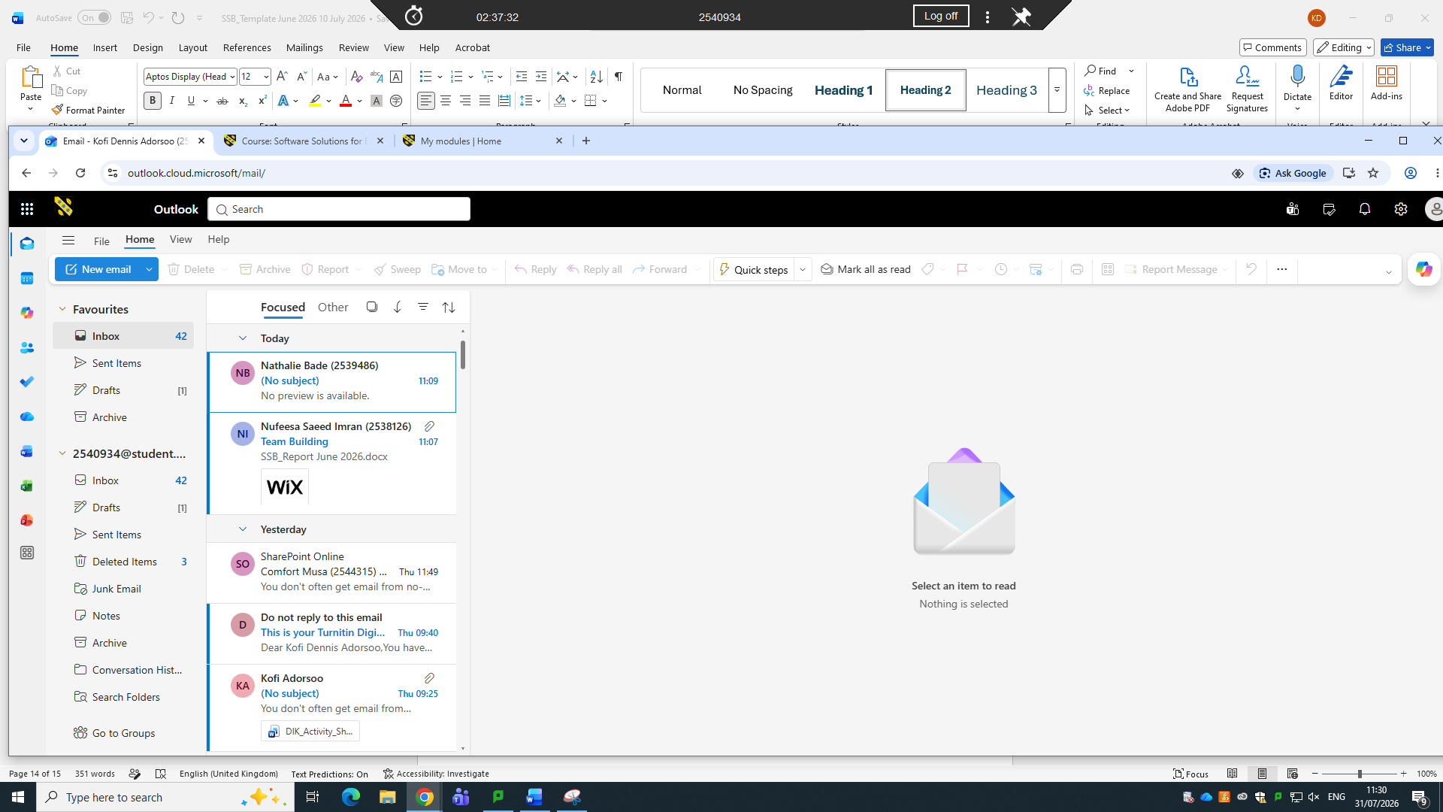
<Practical demonstration here>
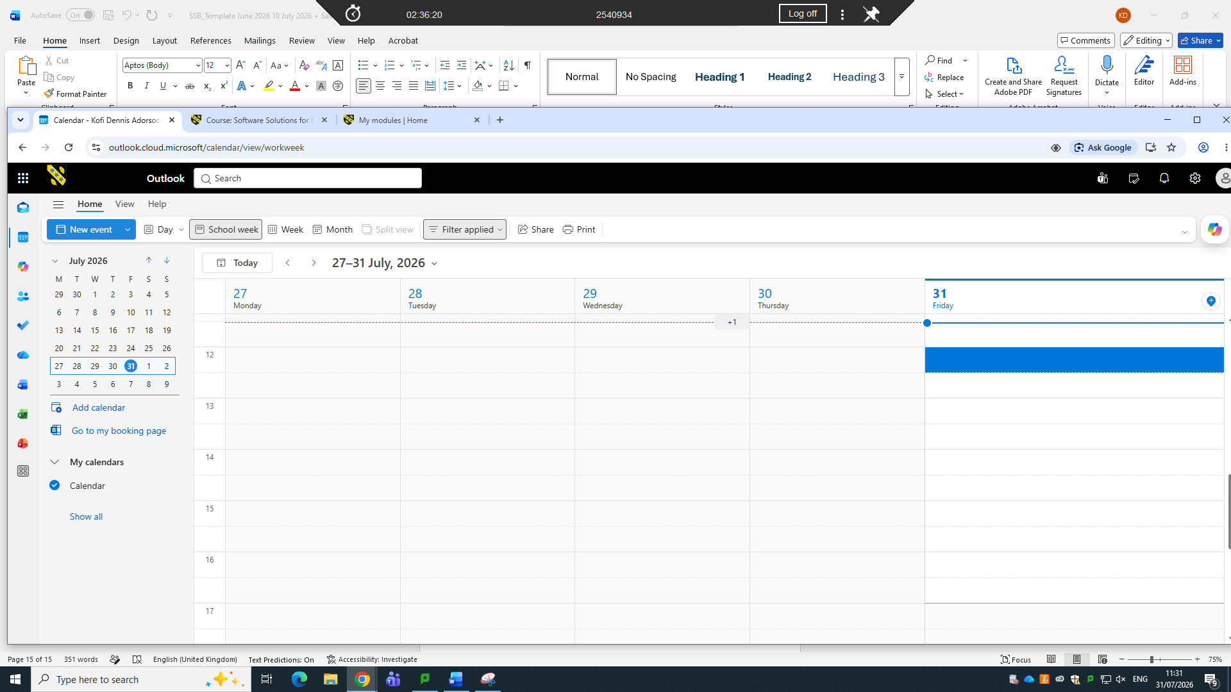

[2]
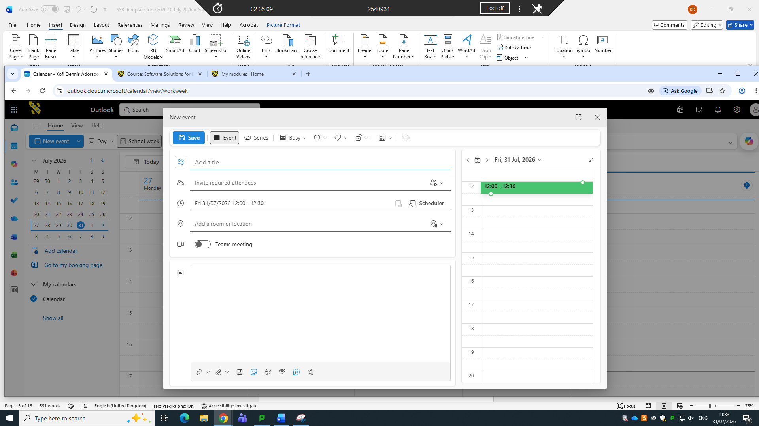

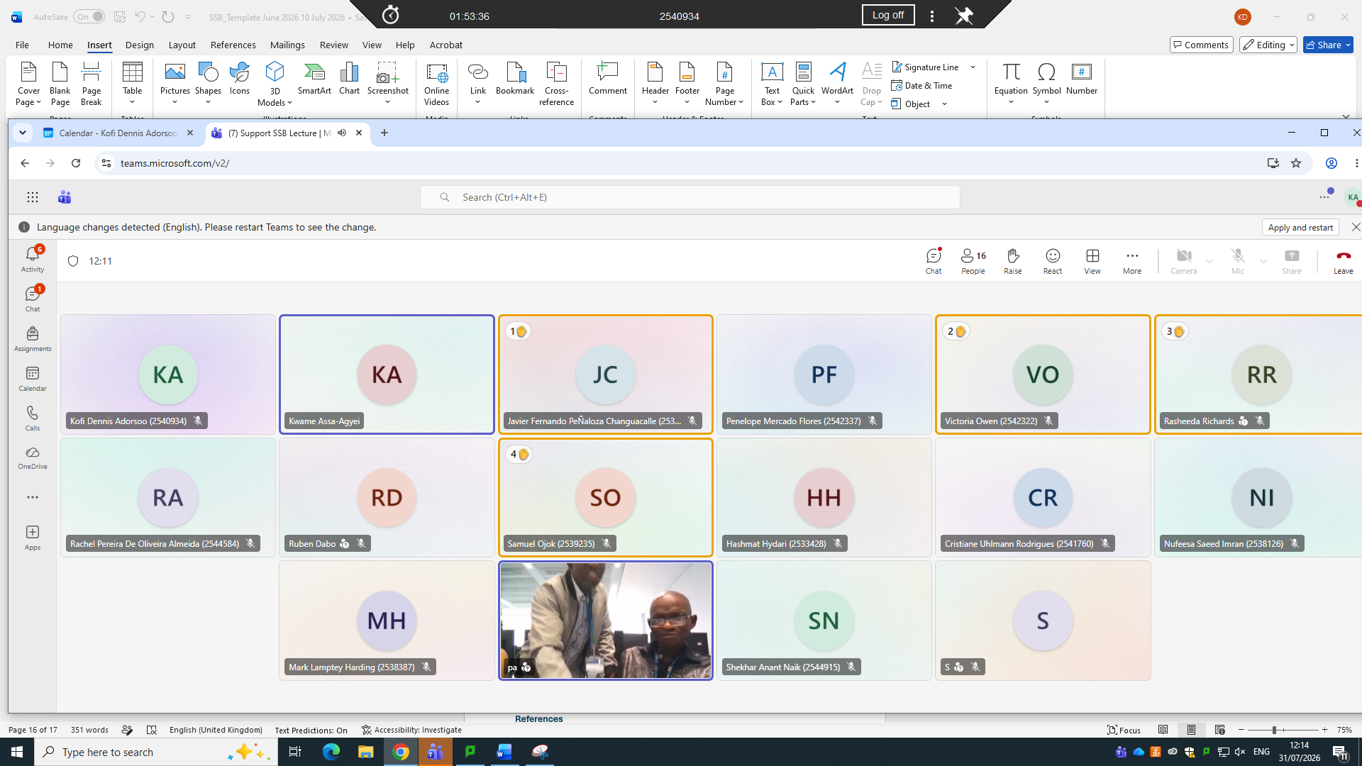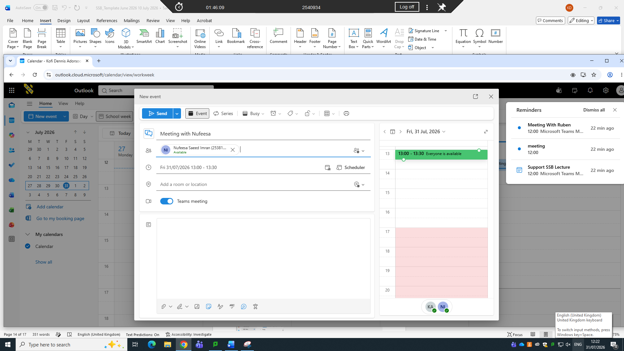

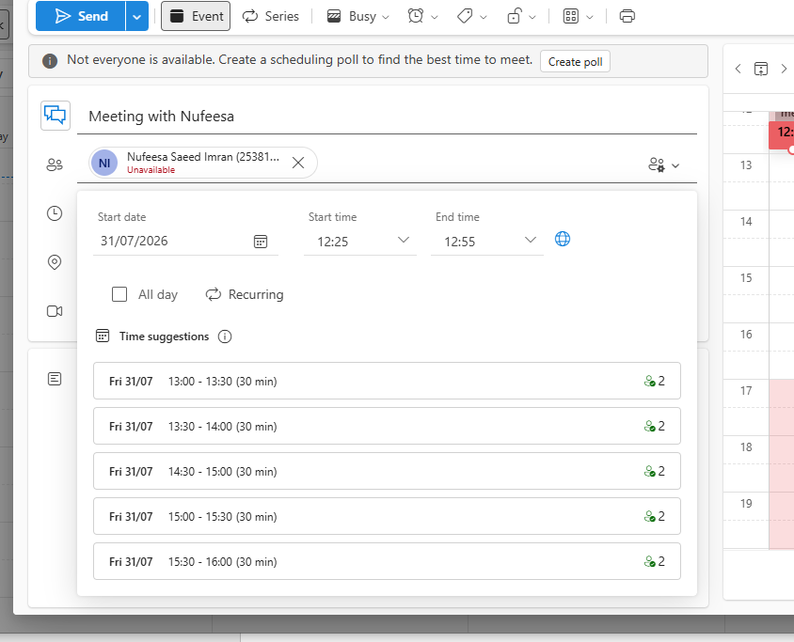

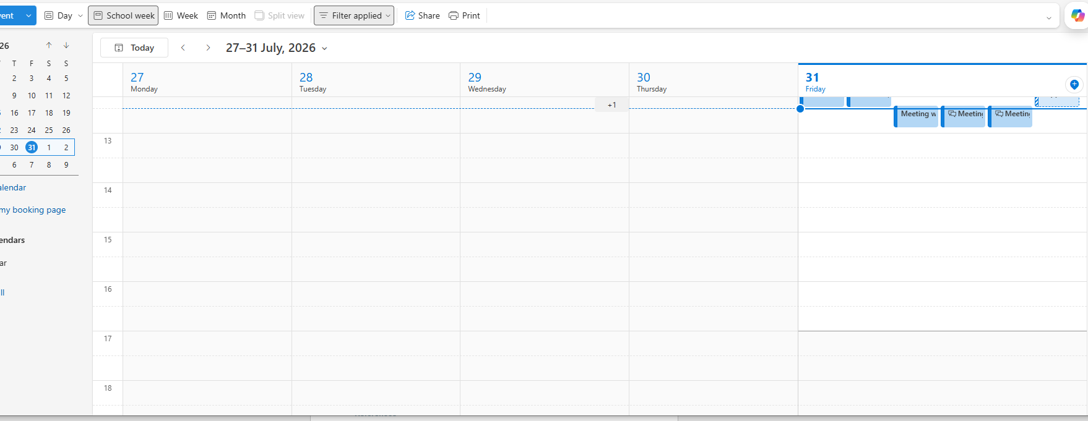
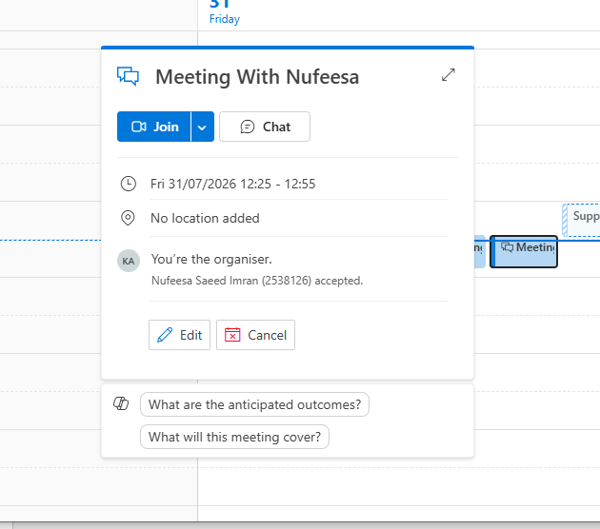



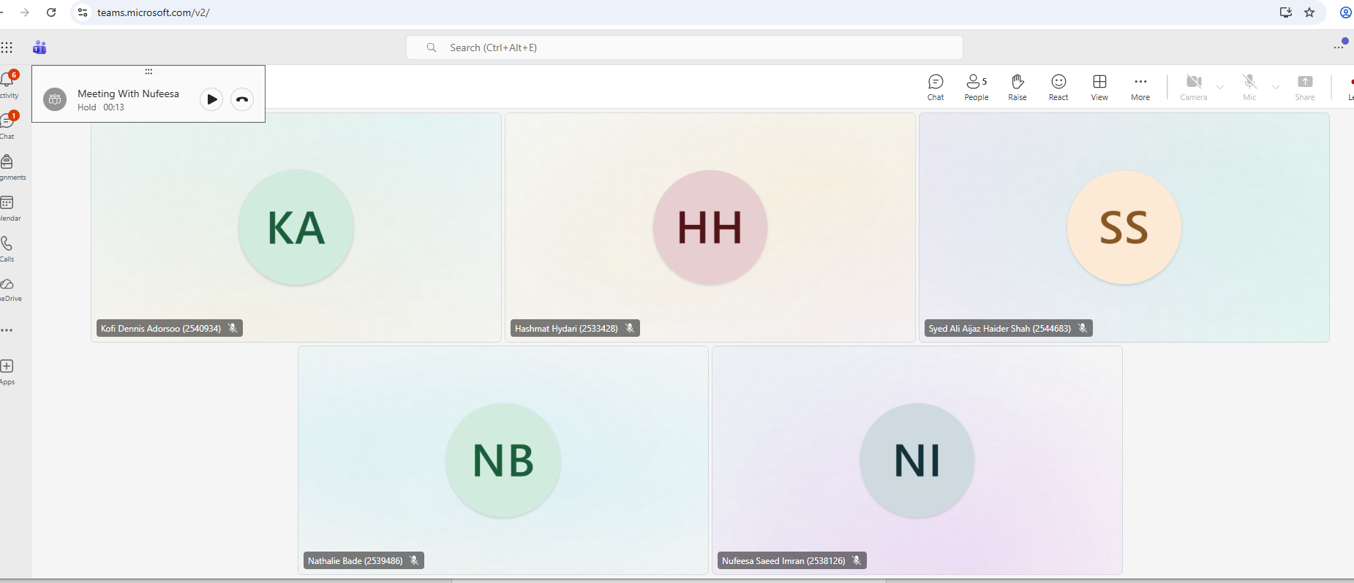

Conclusion
In conclusion software solutions plays an important role in helping businesses to improve efficiency, reduce costs and achieve their goals. It also gives the businesses effective management of information, auto mating task improvements improving communication and decision making. Software gives businesses competitive advantage .When the right software is chosen business growth is certain, improvement of productivity and meeting the changing needs of the organisation and the customers.

References
References
[1] A. d. R. Rueda Villa, "Wix, a free website builder as a teaching tool for the enhancement of extensive reading skills to students of first year bachillerato at unidad educativa PCEI Manuela Saenz, province of Santa Elena, 2015-2016," 2015,
[2] N. M. Ramirez, WiX 3.6: A Developer's Guide to Windows Installer XML: An all-in-one introduction to Windows Installer XML from the installer and beyond, Packt Publishing Ltd, 2012.
[3] M. Larkin, Shopify Application Development: Build highly effective Shopify apps using the powerful Ruby on Rails framework, Packt Publishing Ltd, 2014.
[4] S. Bhattacharjee, N. Singh and N. Prasath, "Shopify-Shop Augmentation and Recommendation System", in 2023 International Conference on Computer Communication and Informatics (ICCCI), pp. 1–6.
[5] A. Buran and A. Filyukov, "Mind mapping technique in language learning," vol. 206, pp.215–218, 2015,
[6] J. W. Budd, "Mind maps as classroom exercises," vol. 35, no. 1, pp.35–46, 2004,
[7] J. Mbuya and A. Mphahlele, "Livashan Naick Livashann@ gmail. com", in CONFERENCE PROCEEDINGS OF THE INTERNATIONAL CONFERENCE ON BUSINESS RESILIENCE, CONTINUITY AND REGENERATION, pp. 152.
[8] M. Paknahad, "Maryam Paknahad 1 Email maryampaknahad37@ gmail. com Hossein Daneste 2 Email hd80_2003@ yahoo. com Reza Daryani 3 Email rezadaryani@ gmail. com Azita Sadeghzade 4✉ Phone 98-71-36263193 Email a_sadeghzade@ sums. ac. ir,"
[9] S. Lindsay, "A comparative analysis of data quality in online zoom versus phone interviews: An example of youth with and without disabilities," vol. 12, no. 4, pp.21582440221140098, 2022,
[10] A. Miks and J. Novak, "Paraxial analysis of four-component zoom lens with fixed distance between focal points," Appl.Opt., vol. 51, no. 21, pp.5231–5235, 2012,

