  Component One:  What are the key skills required when working in the housekeeping team? 750 words (+/- 10%)  Contribution to Overall Module Assessment: 25% | Student No: | 2215574
 | Module Title: | Operating Hotel Facilities
 | Module Code: | BMIH4006
 | Lecturer: | Kathryn Flynn
Introduction
Housekeeping skills are necessary skills that give a housekeeper to be super-efficient in their jobs. These skills vary from customer service to paying close attention to the small details. Housekeeping should know about the best products they need to use. Housekeepers in the hotel industry need to be punctual and active in their job.
Skills required for housekeeping team.
A housekeeper is responsible for their duties of maintaining the hotel rooms and cleaning them. Their main job is to wash bedsheets and organise rooms, and discard waste. Skills that are required for housekeeping need work on managing their own time. They have a certain task of cleaning every day and completing it within the shift hours (Clark, 2019). Being able to complete all tasks on time. Housekeeping should pay attention to each and every small detail by managing all the items of households and making sure that all the floors are clean. Housekeepers surely communicate with clients about their expectations of the workers. Interpersonal skills are required for housekeepers to perform well in their respective jobs. Most of the time, housekeepers have to work different shifts according to the client's demands and needs. Housekeepers should provide excellent customer service, making sure that client is satisfied to be successful in their career. Housekeepers need to develop several hard skills like control over infections. Being organised is another skill housekeepers should have, been familiar with tools (Hasnat, 2021). Remain constant in doing your work and plan every task according to the requirement of clients. Housekeeping staff of a hotel need to make a lot of new changes when needed. Mu's experience with housekeeping staff has been weird due to communication issues faced. After my checking in the room, it was not clean and required attention; upon calling the staff, they claimed that they had cleaned the room and it was what it has supposed to be.
Theoretical knowledge
Housekeeping requires a lot of skills to operate a department; housekeeping is a running department in a hotel responsible for services like cleaning, maintaining the machines, and maintaining the public areas (Tra, 2020). Hotels in the UK provide top-notch housekeeping services, ensuring the cleanliness, and aesthetic feel of the walking areas, making rooms feel like their own house. This department not only cleans the rooms but maintains everything in the hotel, as it opens the doors to success for the business. "Four Seasons Hotel London at Ten Trinity Square" has been providing amazing quality housekeeping services; the rooms are super clean and set according to the customer's demand, and highly trained housekeepers' communication skills show how perfect they are at doing their job.
Importance of hotel housekeeping skills in the hotel industry
The housekeeping department is one of the key departments that play a prominent role in making the hotel's reputation strong in the market. The top skills that are required for a hotel's housekeeper are the ability to work in a team (Andrade, 2021). The bigger the hotel is, the larger the team will be. There are different levels of housekeeper in a hotel, trainee level and experienced. Housekeepers should be trustworthy as working in top hotels, customer baggage is expensive, and they have to keep it very safely in the room. While entering a customer's personal space, a housekeeper should never overhear it. Elite Hotel UK has been providing their housekeeping services very promisingly. Their housekeeping service is very dedicated and tends to maintain high standards of cleanliness. They are aware of the needs of their guests. The housekeeping department takes immediate action and pays attention to every little detail of customers. “London Hilton Hotel" on park lane provides outstanding services; their housekeeping department has experienced employees, keeping the privacy of customers their top priority, and housekeepers are very aware of not crossing it. Their housekeepers know how to set up a room according to the customers (Reidhead, 2020).
Conclusion
Housekeeping is important for hotels; it manages the image and takes care of customers’ demands regarding cleanliness and other matters. A team of housekeepers are available to keep on checking the guest's needs and services for their room. Maintaining the floor of the hotels and other areas. Hotels in the UK keep their department well-trained to fulfilling the demands of guests.

Word Count | 710

Component Two:
Contribution to Overall Module Assessment: 25%
In this scenario – You have just been promoted to the team leader for a floor within the hotel. A guest complained that on their arrival, their room had not been properly cleaned. Create an action plan and answer the following questions.

Problem | Why did it happen? | What are you going to do? | How will you prevent this from happening in the future? | What measures would you introduce to improve team effectiveness?
Staff not quickly responding to the provision of facilities and queries. | Poor guest communication was the root cause of the issue because it caused delays in meeting demands on time. | I will organise a training session for the entire staff on my floor that emphasises the benefits of communication and active listening. By doing this, they will refine their capacity to be patient with guests and their queries. | I will ask the management of the hotel to schedule such training sessions or seminars each month, specifically highlighting the weak areas as per customers' feedback so that staff members can learn about different issues and their solutions. | I'll suggest new rules to ensure that visitors receive timely responses. At all costs, everyone will be expected to comply with those rules or otherwise face the consequences.
Cleanliness in room | It was the newly hired staff's obligation to clean that floor. Additionally, the required tasks were not properly taught to them. | I will ask the management to arrange a training session for them. They will get the inspiration they need and, as a result, work well. | Putting together a team with both new hires and seasoned professionals will be my first objective. I will consider it necessary that the staff people in charge of cleaning have knowledge or, at the very least, training. | In addition to an incentive plan to recognise employees who obtain the highest professional ratings, I will also ask hotel customers to rate services and respective housekeeping personnel that cater to their needs.
Requested amenities not available in rooms and bathrooms | The incident happened when The floor personnel was unable to guarantee efficient resource management. It was actually at the time when the hotel was busy with hundreds of guests. | I will ask the employees to compile a list of all potential resources at the end of the day. | Establishing the habit of asking guests if anything is needed when cleaning will be my main concern. | I will consider that my team is fully instructed on all kinds of protocols that should be fulfilled when catering to guests’ needs.
Issues with electronic equipment in the room | When the AC in a room stopped working, and guests were extremely unhappy, they reported the problem. | I will ask the management to report to the maintenance department. In the meantime, I will arrange another room for the guest. | I will establish strict protocols for performing routine maintenance checks on equipment. | I will ask the management to make sure there are people from the maintenance department on the floor who have the necessary abilities so that problems can be handled quickly.
No proper Wi-Fi connection in the room | The problem was reported when the room's Wi-Fi stopped working. The guests were businessmen staying for the meeting. | I will request that the IT and maintenance division examine all Wi-Fi connections on the floor. | I will concentrate on calling the IT division once a week to check all of the floor's connections. | By holding a brief workshop for staff members to tackle minor issues independently, such as changing gadgets.

Component Three:
Contribution to Overall Module Assessment: 50%
Your task is to create and prepare a presentation following the detailed scenario provided below.

As the floor housekeeping manager and given the recent guest complaints, you need to put together a basic training presentation for your colleagues within the housekeeping team to get the best out of them, ensure that brand standard is being achieved and that Health and Safety procedures are also being followed.

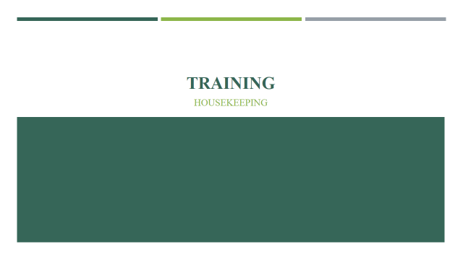

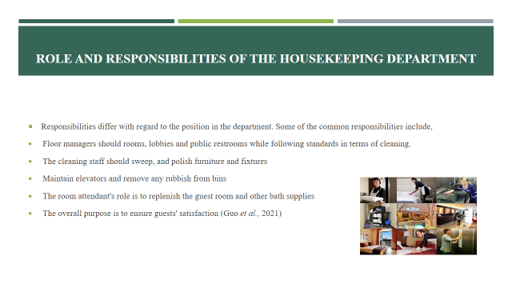

Training Notes:
The management in charge must be informed of any safety issues. Efficient cleaning must be done, which includes sweeping, hovering, emptying trash cans, dusting bookcases, washing windows and mop floors, among other tasks. Some housekeepers perform mild dishwashing, light ironing, laundry, and linen changes. Responsibilities differ with regard to the position in the department (Guo et al., 2021).

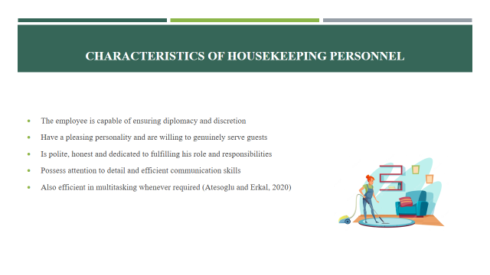

Training Notes:
In order to promote appropriate housekeeping practices in workplaces, the management concept known as "5S" can be considered. The concept stands for "Organisation," "Neatness," "Cleanliness," "Standardisation," and "Discipline" is promoted. Other characteristics can be considered in terms of skills, such as politeness, honesty, communication and multitasking skills (Atesoglu and Erkal, 2020).

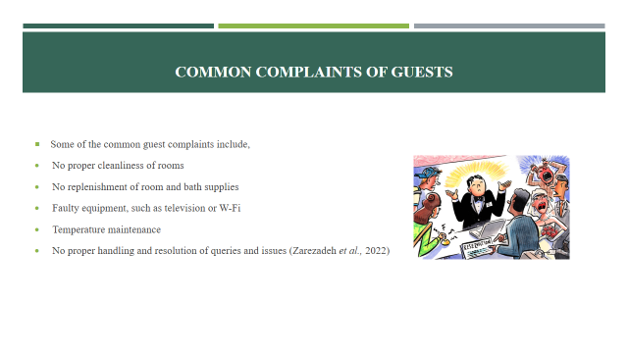

Training Notes:
Handling customer complaints is a common issue for those working in the hospitality sector, and a lot of effort is required to ensure that the issues do not have a negative impact on the brand. Some of the common complaints are associated with cleanliness, faulty equipment, ineffective handling of issues by the management and others (Zarezadeh et al., 2022).

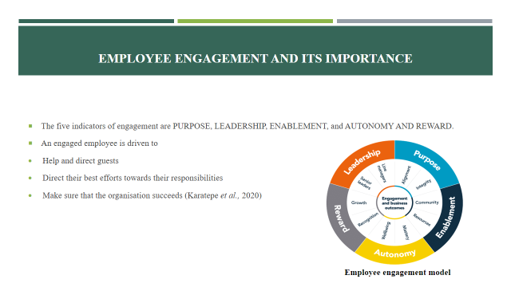

Training Notes:
Offering exceptional customer service is the hospitality industry's top priority; the housekeeping team is the sole brand protector. One error could mean the difference between a satisfied and unsatisfied customer. The best strategy to keep experienced as well as skilled personnel in the team satisfied with their role is to ensure efficient engagement. In this manner, these personnel will be more interested in providing guests with an exceptional experience (Karatepe et al., 2020).

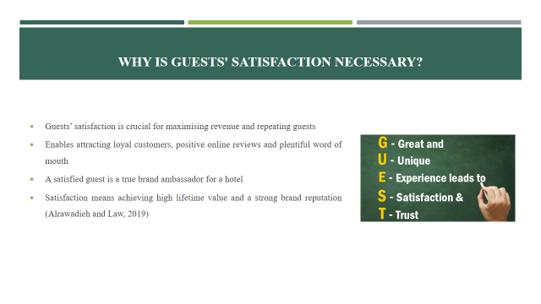

Training Notes:
Customer satisfaction is a critical metric that employees in the housekeeping department may use to boost earnings and promote business. High guest satisfaction ratings can help a hotel attract respective customers, generate positive online reviews, and a lot of word-of-mouth advertising, all of which can boost revenue. In addition, guest satisfaction is important since it indicates whether employees are performing their roles efficiently. In this manner, satisfaction boosts lifetime value, brand reputation, and customer retention (Alrawadieh and Law, 2019).

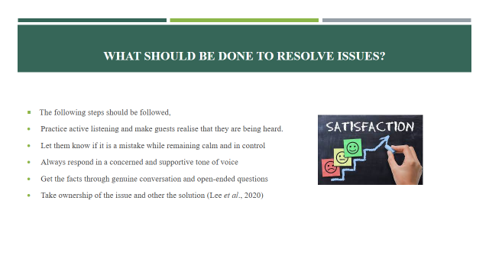
Training Notes:
Handling customers efficiently could be rewarding and build loyalty. The process should start with careful listening and making notes of key facts. Let them know that the hotel actually cares about the issue. Start with significantly changing the tone of the conversation by sincerely thanking them for bringing the matter to your attention. When offering a solution, be courteous and considerate at the same time. Show that the management is willing to take responsibility for the issue (Lee et al., 2020).

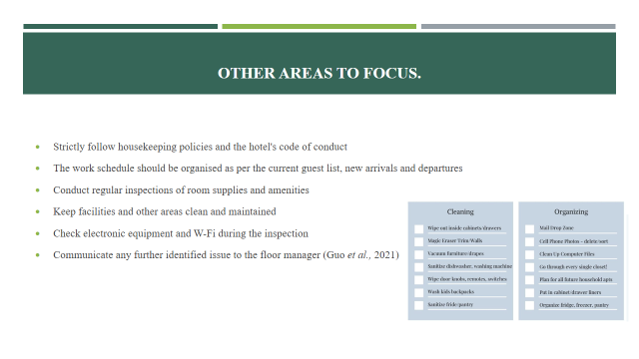

Training Notes:
It is crucial to ensure that all of the housekeeping functions are carried out in accordance with the hotel's code of conduct. In this regard, the major priority should remain to deal with already identified guest complaints, which include regular inspection of room amenities and keeping facilities clean (Guo et al., 2021).

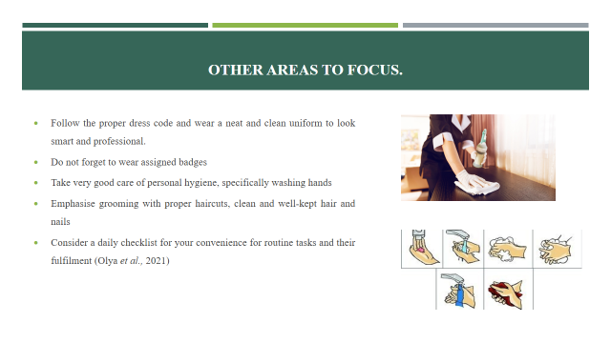
Training Notes:
The importance of personal hygiene and grooming cannot be ignored. In this regard, the focus should be on following the proper dress code with badges. The emphasis should also be on taking care of personal hygiene. A well-dressed and well-groomed individual is able to efficiently interact with guests (Olya et al., 2021).

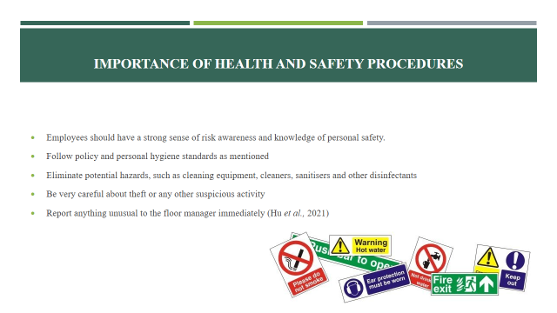

Training Notes:
It is undeniable that numerous incidents are frequently caused by poor housekeeping procedures. Effective housekeeping can reduce risks if proper health and safety procedures are followed. Besides following hygiene standards, it is also crucial to emphasise safety from theft or other such activities (Hu et al., 2021).

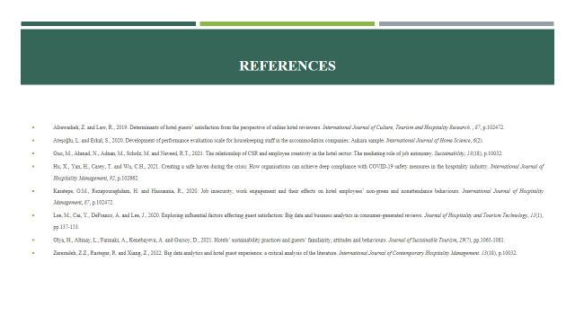

References
Alrawadieh, Z. and Law, R., 2019. Determinants of hotel guests’ satisfaction from the perspective of online hotel reviewers. International Journal of Culture, Tourism and Hospitality Research. , 87, p.102472.
Andrade, M.S., Miller, D. and Westover, J.H., 2021. Job satisfaction factors for housekeepers in the hotel industry: a global comparative analysis. International Hospitality Review, 35(1), pp.90-108.
Ateşoğlu, L. and Erkal, S., 2020. Development of performance evaluation scale for housekeeping staff in the accommodation companies: Ankara sample. International Journal of Home Science, 6(2).
Clark, S.J., Halter, M., Porter, A., Smith, H.C., Brand, M., Fothergill, R., Lindridge, S.J., McTigue, M. and Snooks, H., 2019. Using deterministic record linkage to link ambulance and emergency department data: is it possible without patient identifiers? A case study from the UK. International Journal of Population Data Science, 4(1).
Guo, M., Ahmad, N., Adnan, M., Scholz, M. and Naveed, R.T., 2021. The relationship of CSR and employee creativity in the hotel sector: The mediating role of job autonomy. Sustainability, 13(18), p.10032.
Hasnat, Q., 2021. An Exploration of Employee Engagement and Employee Commitment in the London Hotel Sector: The Perspectives of Migrant Housekeeping Workers and Their Managers (Doctoral dissertation, University of Brighton).
Hu, X., Yan, H., Casey, T. and Wu, C.H., 2021. Creating a safe haven during the crisis: How organisations can achieve deep compliance with COVID-19 safety measures in the hospitality industry. International Journal of Hospitality Management, 92, p.102662.
Karatepe, O.M., Rezapouraghdam, H. and Hassannia, R., 2020. Job insecurity, work engagement and their effects on hotel employees’ non-green and nonattendance behaviours. International Journal of Hospitality Management, 87, p.102472.
Lee, M., Cai, Y., DeFranco, A. and Lee, J., 2020. Exploring influential factors affecting guest satisfaction: Big data and business analytics in consumer-generated reviews. Journal of Hospitality and Tourism Technology, 11(1), pp.137-153.
Olya, H., Altinay, L., Farmaki, A., Kenebayeva, A. and Gursoy, D., 2021. Hotels’ sustainability practices and guests’ familiarity, attitudes and behaviours. Journal of Sustainable Tourism, 29(7), pp.1063-1081.
Reidhead, C., 2020. Impact of organisational culture on employee satisfaction: A case of Hilton hotel, United Kingdom. Journal of Economics and Business, 3(1).
Tra, T., 2020. Action plan for training new Housekeeping Employee: case: Hotel Indigo Helsinki.
Zarezadeh, Z.Z., Rastegar, R. and Xiang, Z., 2022. Big data analytics and hotel guest experience: a critical analysis of the literature. International Journal of Contemporary Hospitality Management. 13(18), p.10032.

