

International Business LCMB7014

Toyota International Business in China

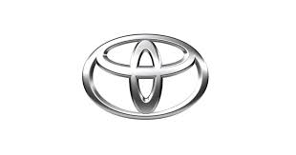

Name : Sanjay Avulareddy
Student Number : 2213727
Lecturer : Dr Hossein Shokri
Submission Date : 21/08/2023
Table of Contents
Introduction 2
Company Background 2
Company’s Objectives and Strategies 4
Countries’ Specifications 5
Home Country 6
Host Country 7
External Analysis 8
A Comparative PESTEL Analysis 9
Industry Five Forces 10
Market Analysis 11
Host Country Analysis 12
Country’s National Diamond 12
Country Business Risks 13
Internal Analysis 14
Global value chain 14
SWOT analysis 15
International Strategies 16
Entry Modes 17
Corporate Social Responsibility 18
Conclusion 19
References 20
Appendix 22
Appendix 1: 22
Appendix 2: 23

Introduction
In this report it includes cretically analysed the toyota international business in china this report toyota background like when it started ,who started company , toyotas objectives and stratagies for its succession and why toyota is operation in china rather than its home country japan ,and critical annalysis of external factors like PESTEL analysis ,five fource model , market analysis, countries business risk like political risk, economical, legal risk. And also included internal analysis and internal stratagies ( SWOT analysis) and entry modes of toyato into automobile industey.
WHAT IS INTERNATIONAL BUSINESS
International business refers to commercial activity and transactions that take place between people, businesses, and organisations from various nations. It entails the cross-border interchange of goods, services, information, and resources with the goal of growing market presence, optimising profitability, and capitalising on global opportunities. (Daniels, 2018)
Companies participate in a variety of activities in international commerce, including exporting and importing commodities, establishing overseas subsidiaries or joint ventures, licencing intellectual property, undertaking cross-border investments, and engaging in international marketing and distribution. These activities frequently necessitate firms navigating various legal, economic, political, cultural, and logistical environments, each with its own set of problems and opportunities. (Daniels, 2018)

Company Background
Toyota's incredible success is founded on a tradition of invention and adaptation. The voyage began in 1918, when Sakichi Toyoda invented the mechanical loom, which revolutionised the weaving industry. The profits from this breakthrough cleared the path for Toyota's entry into the automobile industry, which resulted in the production of the first prototype car, the Toyoda AA, in 1936. Sakichi Toyoda was inspired by Ford's production lines and adapted their methods to match the scale of automobile manufacturing in their own facility. Following the creation of the Toyota Motor Corporation, the name was changed to Toyota due of its fortunate eight-stroke composition in Japanese writing. Despite competition from strong American imports and the upheavals of World War II, Toyota persevered and accomplished key milestones . (Toyota Motor Corporation plc, 2020)
In 1947, the company produced its 100,000th automobile. Toyota established the groundbreaking Toyota Production System in the 1950s, a highly efficient manufacturing strategy that changed the worldwide automobile industry. With sales offices in Taiwan and Saudi Arabia, as well as a foray into international production in Brazil in 1959, the company's global influence grew. Toyota's international footprint grew further with its debut into the European market in the 1960s, which was characterised by shipments to Denmark and the introduction of the Corona saloon in the United Kingdom in 1965. The debut of the original Corolla in 1966 marked a watershed moment, paving the way for one of the world's most successful model lines, with over 46 million global sales as of 2019. Through creativity, strategic adaptability, and dedication (Toyota Motor Corporation plc, 2020)

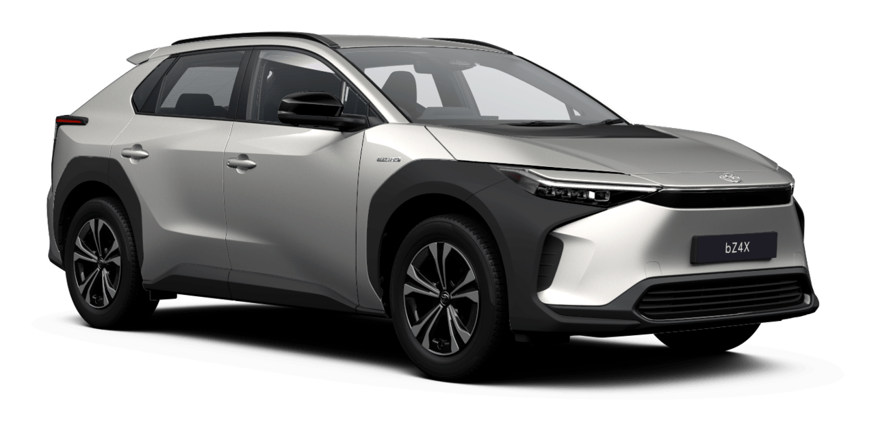
Source: Toyota official website
Toyota expanded its product selection and established manufacturing sites outside of Japan throughout the following decades, resulting in fast expansion. Toyota introduced the legendary Corolla in the 1960s, which went on to become the world's best-selling automobile model. The Corolla's popularity increased Toyota's global reach and earned its reputation for dependability.
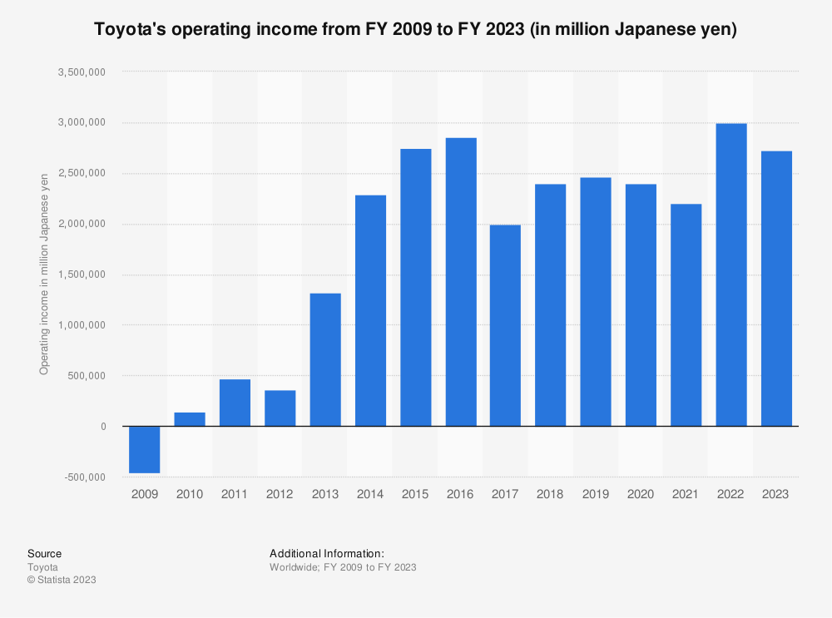 Source:Toyota statista.com
Toyota entered the luxury vehicle industry in the 1980s with the launch of the Lexus brand, aimed at the high-end automobile market. Lexus swiftly established a reputation for superb craftsmanship, cutting-edge technology, and exceptional customer service. Toyota's commitment to innovation was clear with the introduction of the Prius, the world's first mass-produced hybrid vehicle, in 1997. The Prius not only changed the car industry, but it also established Toyota as a leader in environmentally friendly mobility solutions (Toyota Global, 2023).

Company’s Objectives and Strategies
Continual Improvement
Toyota adheres to the Kaizen principle of continual improvement in all parts of their business. They encourage their employees to find and implement small changes that will improve efficiency, quality, and customer pleasure.
Lean Manufacturing and Just-In-Time Production:
Toyota is well-known for its lean manufacturing approach, which attempts to minimise waste and maximise efficiency. They use a just-in-time production method, which means that parts and components are delivered exactly when they are needed, minimising inventory and expenses (Liker, 2003).
Toyota pursues a global market expansion strategy :
in order to reach a larger client base. They build manufacturing sites, R&D centres, and sales networks in many countries across the world, tailoring their products to local market demands (Liker, 2003).
Partnerships and Collaborations:
Toyota works with a variety of stakeholders, including suppliers, research institutes, and other businesses, to promote innovation and address industry concerns. They actively seek collaborations to create new technology and enter new industries.
Toyota recently established a list of environmental objectives that would serve as the foundation for a second 5-year "environmental action plan" for its North American operations.
Among other goals, the business intends to lower the total energy usage of its North American production facilities by 27 percent each vehicle manufactured, as well as drastically reduce the amount of garbage generated by its sales and distribution centres (BNPMedia, 2007,).
Toyota cut energy consumption at its manufacturing plants by 30% as part of its first 5-year action plan.
"Global corporations, with their enormous technical resources, must assume a leadership role in environmental stewardship," says Jim Press, president of Toyota Motor North America Inc. "We can't talk about the environment as if it's someone else's problem." It is everyone's responsibility to actively collaborate in order to preserve our world for future generations." (BNPMedia, 2007,).

Countries’ Specifications
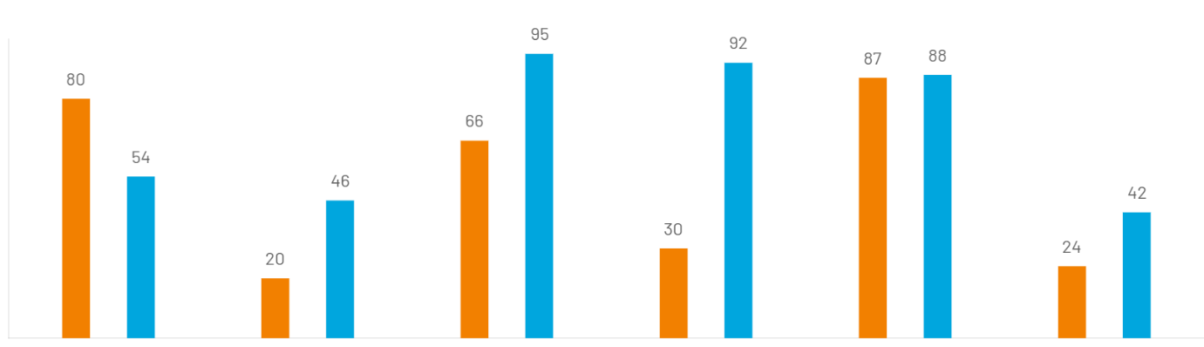
Source :hofstede insights.com
Power distance :
China
China has a PDI score of 80, placing it in the upper echelons of societies that accept social inequality. There is no safeguard against superiors abusing their power, and the subordinate-superior relationship is often polarised. People are generally positive about people's aptitude for leadership and initiative and are impacted by formal authority and sanctions. People shouldn't aim higher than their position (Michael, n.d.).
JAPAN
Japan is on the verge of being a hierarchical society with an intermediate score of 54. Yes, Japanese people are always aware of their social hierarchy and behave appropriately. It is less hierarchical than the majority of other Asian cultures, nevertheless. Due to their commercial experiences with painfully slow decision-making, several foreigners perceive Japan as being excessively hierarchical (Hofstede, 1984).
Individualism
China
China has a PDI score of 80, placing it in the upper echelons of societies that accept social inequality. There is no safeguard against superiors abusing their power, and the subordinate-superior relationship is often polarised. People are generally positive about people's aptitude for leadership and initiative and are impacted by formal authority and sanctions. People shouldn't aim higher than their position (Hofstede, 1984).
JAPAN
Japan is on the verge of being a hierarchical society with an intermediate score of 54. Yes, Japanese people are always aware of their social hierarchy and behave appropriately. It is less hierarchical than the majority of other Asian cultures, nevertheless. Due to their commercial experiences with painfully slow decision-making, several foreigners perceive Japan as being excessively hierarchical.
Masculinity
China
China is a patriarchal society that values achievement. The fact that many Chinese will put work before family and leisure is an example of the necessity to assure success. Service providers, including hairdressers, often work well into the night. The importance of downtime is minimal. The migrant farm labourers will abandon their family in distant locations in search of better employment and money in the cities.
japan
One of the world's most patriarchal societies is that of Japan. They do not exhibit the strong and competitive individual behaviours that typically identify with masculine culture, despite their slight collectivism. we can tell that there is fierce competition between the groups. Children learn to read at kindergartens from a very young age. On sports day, participants compete for their respective groups (often, red team vs. white team) (Hofstede, 1984).

Home Country (Jepan)
Toyota Motor Corporation (Toyota or "the company") develops, produces, and markets sedans, minivans, small cars, sports utility vehicles, trucks, and associated components and accessories globally. In order to assist the sales of Toyota vehicles and other items, it also offers financing, leasing for vehicles and other equipment, and a few other financial services, mostly to its dealers and their clients (market line , 2023).
Toyota designs, produces, assembles, and sells passenger cars, minivans, and commercial vehicles including trucks, along with related components and accessories, under the automotive segment. Toyota also produces auto parts, accessories, and parts for both internal usage and external sale. Toyota offers a variety of automobiles, including subcompact and compact cars, minivans, midsize cars, and luxury cars. sport utility vehicles (SUVs), sports and specialised automobiles, minivans, lorries and buses. Three categories—hybrids, conventional engines, and fuel cells—can be used to group the automobiles produced by Toyota, Daihatsu, and Hino. Toyota sells hybrid vehicles under the Prius nameplate (market line , 2023)
Toyota Production technique (TPS):
Toyota is well-known for its lean manufacturing technique, known as the Toyota Production System (TPS). This strategy focuses on reducing waste, increasing efficiency, and ensuring high-quality output. It incorporates principles like Just-In-Time manufacturing and Jidoka, which emphasise efficiency and quality control (Liker, 2003).
Toyota maintains tight links with its suppliers through the keiretsu system, a type of Japanese company grouping. These long-term collaborations assure a consistent supply of high-quality components while also encouraging collaboration in research, development, and manufacture.
Toyota has a client-centric approach, focusing on understanding customer wants and preferences in the Japanese market. They undertake market research, collect client input, and adjust their products and services to Japanese consumers' specific needs. Toyota understands the value of understanding local markets and adapting products and services to individual client preferences. They prioritise localization efforts by performing market research, partnering with regional partners, and interacting with local suppliers. This strategy guarantees that Toyota's offers resonate with local consumers and that the company gains a competitive advantage (Liker., 2003).
Host Country (China)
WHY CHINA
Toyota, one of the biggest automakers in the world, has found China to be a desirable host nation for a number of reasons. China has a sizable middle class and a huge consumer market, which has enormous growth possibilities for businesses looking to broaden their reach. In addition, China has developed into a key hub for global manufacturing, providing access to efficient manufacturing, a qualified workforce, and a solid supply chain infrastructure. Through tax breaks and other incentives, the Chinese government has encouraged international investment, luring businesses like Toyota to establish operations there. Additionally, businesses can target the home market in China and expand regionally by taking advantage of the country's proximity to other Asian countries. (sustainability report , 2022)
Market Size and Potential:
China is the world's largest automobile market, with significant growth and sales volume prospects. Toyota can tap into a large consumer base and capitalise on the country's strong demand for autos by expanding in China. Toyota understands the significance of localising products and operations to fit Chinese customer preferences and market conditions. Toyota can produce automobiles adapted to Chinese consumer needs by building production units and research and development centres in China, which is critical for success in the highly competitive Chinese market (Rugman, 2012).
Government Support and Incentives:
The Chinese government has provided a range of incentives and supports to foreign businesses looking to invest and establish operations in the nation. Tax advantages, financial aid, and reduced administrative procedures are a few examples of these incentives.
Geographical Advantage:
Companies with a focus on both domestic and regional markets might benefit from China's strategic position. It is a suitable base for companies looking to expand in the Asia-Pacific area due to its close proximity to other Asian nations.
Opportunities for Joint Ventures:
In the past, China required foreign businesses to enter specific industries through joint ventures with local partners. As a result, businesses like Toyota were able to enter the market and take advantage of local resources and knowledge (Rugman, 2012).

External Analysis
An organization's performance and decision-making are impacted by external events and effects, which are strategically assessed in external analysis. Analysis of the macroenvironment, market dynamics, competitive environment, industry trends, technical developments, legislative shifts, and societal impacts are all part of this process. Businesses may identify opportunities and risks, adjust their strategies, and make wise decisions to stay competitive and accomplish their goals by recognising these external influences (Hitt, 2019).

A Comparative PESTEL Analysis ( compare with home and host countries )
Political Factors: JAPAN
As a constitutional monarchy with a stable political system, Japan is a political factor. Government actions and policies have an impact on corporate regulations, global ties, and economic growth.
Political Aspects: CHINA
China is a one-party communist state. Business operations and international trade are impacted by government policy, political stability, and relations with other nations. (MarketLine, 2023).
Economic Factors: JAPAN
The economy of Japan is sizable and well developed. Ageing populations, deflationary pressures, and high levels of state debt are problems, but technological advancement and opportunities for international trade also offer room for growth (MarketLine, 2023).
Economic factors: CHINA
China's economy is one of the largest in the world and is expanding quickly. Trade policy, wealth inequality, and economic growth all have an impact on company potential (Horjus, 2019)
Social factors : JAPAN
shifting demographics, and cultural factors that influence consumer choices and market trends define Japan's society.
Social Factors: CHINA
China's sizable population, urbanisation, and shifting consumer habits offer a variety of businesses enormous market prospects.
Technological factors : JAPAN
Japan is renowned for its technological innovations and breakthroughs in sectors including electronics, robotics, and automotive. Different areas are impacted by technological advancements, which also help the economy grow (MarketLine, 2023).
Technological factors : CHINA
China is investing extensively in R&D and technical innovation, which is advancing a variety of industries and supporting a vibrant tech sector.
Environmental factors : JAPAN
Japan has a number of environmental issues, such as pollution, natural disasters, and initiatives for sustainable development and green technologies. (MarketLine, 2023).
Environmental factors : CHINA
China faces issues with pollution, climate change, and resource preservation. Initiatives by the government are meant to advance green practises and clean technologies (MarketLine, 2023).
Legal factors : JAPAN
Japan's legal system has an impact on business operations, including corporate governance, the protection of intellectual property, and labour laws.
Legal Aspects: CHINA
China's legal system has an impact on corporate operations, including labour rules, restrictions on foreign investment, and intellectual property protection (MarketLine, 2023).

Industry Five Forces
Michael Porter created the porter's Five Forces model, a strategic framework for examining the forces of competition within an industry. The threat of new entrants, the bargaining power of customers, the bargaining power of suppliers, the threat of substitute goods and services, and the ferocity of competitive rivalry are the five main elements that are identified as having an impact on the attractiveness and profitability of an industry. Companies can develop successful strategies to acquire a competitive edge in the market, identify potential risks and opportunities, and better comprehend the broader competitive landscape by evaluating these factors (Porter, 1979).
Buying power : low
A number of reasons contribute to the weak purchasing power in the auto manufacturing sector. Due to their scale, car dealerships have a relative advantage in power when serving as a middleman between producers and consumers, but this advantage is offset by exclusive contractual arrangements that place an increased reliance on particular producers. Due to the uniformity of the market's products, there is less room for buyer difference, which encourages price-focused competition. However, the popularity of hybrid and electric vehicles, which is being fueled by environmental concerns, has created a market for greater consumer input. Customer dissatisfaction sharpens the focus on features and costs, further increasing buyer power. Through bulk purchases and long-term contracts, partnerships with big organisations can give businesses some negotiating power. Although industry participants may be able to forward integrate, the reliance on the goods of producers limits buyer power (market line , 2023).

Supplier Power Assessment: Moderate
Supplier influence in the auto manufacturing sector is seen as moderate. Both common materials like metals and highly specialised components made outside the factory are considered important inputs for manufacturers. Due of different business structures, raw materials suppliers are unlikely to merge upstream. Contract manufacturing is also common, and it has an impact on OEMs and component makers by allowing enterprises to produce parts anonymously. While some car components are handled by huge manufacturers, specialised parts are provided by businesses like Bosch, Denso, and Bridgestone. The manufacturing stage is highlighted by operational excellence, accurate technology, and testing, favouring established businesses. Supplier margins are impacted by fluctuating raw material prices, which prompts adjustments to increase turnover. Labour unions can affect labor-intensive processes, but automation boosts productivity. Due to a combination of factors, supplier power is viewed as moderate overall. (market line , 2023)

Assessment of the Threat of New Entrants: Low
It is believed that there is little threat from new competitors in the auto manufacturing sector. For new players, barriers are created by high fixed costs, economies of scale, and the importance of brand reputation. Market dominance is dominated by long-standing incumbents like Volkswagen and General Motors. Although the transition to electric and driverless vehicles brings about innovations, it also necessitates significant funding for R&D. Strong intellectual property protection and consolidation in China further reduce entry opportunities for new players. Additionally, the low danger level makes it difficult for new players to establish themselves due to disruptions brought on by the COVID-19 epidemic and strict business standards. (market line , 2023).

Threat of Substitutes Assessment: Low
In the vehicle manufacturing sector, the threat of alternatives is viewed as minimal. Even though they are an alternative, used cars have limitations because of contracts, switching prices, and manufacturer requirements. Increased sales of used automobiles might result from economic downturns and uncertain times, especially for dealerships that sell both new and used cars. By lowering the demand for new cars, the rise of car sharing poses an indirect danger. Car-sharing businesses like Feezu and Mobike are becoming more well-known in China. By encouraging client loyalty, finance packages like PCP arrangements provide an alternative, although the efficiency of this replacement is constrained by restrictions on vehicle ownership and re-leasing practises. Even while fuel price rises sometimes surpass the convenience of personal vehicles, a continuous shift towards public transit could (market line , 2023).

Degree of Rivalry : High
The level of competition in the automobile manufacturing sector is considered to be strong. International rivals ratchet up the rivalry, forcing businesses to fight on price and non-price factors while also providing unique incentives to draw in customers. Major companies including Volkswagen, Geely, General Motors, and Toyota control a substantial percentage of the market. Strong cultural linkages between domestic companies like SAIC, Geely, and FAW and China minimise the number of prospective competitors, which limits competition. Product differentiation includes brand and attribute discrimination and affects profit margins and competitive strategies. High exit barriers brought on by initial investment and industrial complexity fuel increased competition. Service agreements and extended warranties also affect costs and competition. Increased buyer switching costs and the historically low performance of the Chinese industry (market line , 2023).

Market Analysis
Market analysis of toyota involves their stratagies, compotitors and stratagic initatives here are some market analysis of toyota.
stratagies of Toyota
Toyota's efforts revolve on minimising their global footprint and negative effects on the environment. They do this by releasing new products that are manufactured using robotics and electric vehicle technologies. Toyota is also reorganising its operations to improve efficiency and save operating expenses. Sales have increased, and profit margins have improved as a result of these initiatives (Nkomo, 2019).
Stratagic initiatives
To meet the rising demand for environmentally friendly transportation, Toyota is investing in the development of hybrid and electric vehicle technology.to improve client experience, the corporation is concentrating on connectivity and autonomous driving technology. Toyota's competitive edge is a result of its extensive global production and distribution network (Report, 2021).
competitors
Toyota is up against intense competition from businesses all over the world in the fiercely competitive automobile sector. Customers' demand has been influenced by competitors' abilities to differentiate themselves by providing new features, higher quality, competitive pricing, fuel efficiency, and reliability. As a result, compared to its past market domination, Toyota's annual unit sales have declined. Honda, Chrysler, Ford Motor Company, Volkswagen, and Chevrolet are significant rivals. Competitors like Chrysler and Ford provide purchasing incentives, including price reductions, to entice current Toyota consumers, hoping to threaten Toyota's market dominance. This strategy lowers Toyota's market share while increasing their own sales. Competitors also employ clever marketing techniques to draw Toyota owners to rival brands.
Ford Motor, the second-largest automaker worldwide, is one of Toyota's main rivals. Ford owns a controlling stake in Mazda and runs a credit organisation, just like Toyota. In terms of brand and valuation, Toyota and Ford are comparable industry rivals (Jothi, 2015).

Host Country Analysis
Country’s National Diamond (host country)
The National Diamond framework offers a comprehensive look at the elements affecting a country's competitiveness in particular industries. It offers insights for researchers, firms, and governments to comprehend and promote competitive advantages. It also aids in the explanation of why specific industries flourish in particular nations (Porter, 1998).
Demand condition
The size and makeup of the domestic market have an impact on how competitively different industries are. China's home market is enormous, and its middle class is expanding along with its middle class's purchasing power. Numerous industries in the nation have grown as a result of the need for a wide variety of goods and services (Cheng, 2019).
Factor condition
These are the nation's current natural and human resources that are pertinent to a specific sector. In China's example, a sizable labour force is provided by the country's sizeable population, and a variety of businesses are supported by its wealth of natural resources. Factor circumstances in China are also influenced by its well-developed infrastructure, which includes its transit systems and manufacturing facilities (Ahlstrom, 2020).
Related and supporting industrries
plastic components are cheap in china for car manufacturer The existence of related and supporting industries can increase competitiveness. Strong interlinkages have been established in China as a result of the existence of a wide variety of industries, enabling effective supply chains and access to essential inputs and services.

Firm strategy, structure and rivalry
Firm Strategy, Structure, and Competition: Domestic enterprises' strategies, structures, and level of competition all have a big impact. China has seen the emergence of multiple strong local firms in a variety of industries, which has sparked creativity, cost effectiveness, and ongoing development (Li, 2021).
Country Business Risks (china)
Business operations, financial performance, and overall success of companies operating in a particular country are all potentially vulnerable to threats and uncertainties, which are referred to as "country business risk." It includes a range of elements and situations that can produce unfavourable circumstances, obstruct business operations, or hinder the accomplishment of corporate goals. These dangers may be brought on by domestic economic, political, social, legal, environmental, and technical reasons (Kim, 2019).
Political risk
The need for positive government relations and productive collaboration with local partners, as well as geopolitical factors like trade conflicts or diplomatic disputes, are all political risks for Toyota in China. These risks include potential changes in government policies and regulations, political instability, nationalistic sentiments impacting consumer preferences, challenges related to intellectual property protection, and potential changes in government policies and regulations. Toyota's operations, market share, brand reputation, and competitiveness in China may all be impacted by these dangers. As a result, Toyota needs constant surveillance, proactive engagement, and risk-reduction techniques to successfully manage the complex political environment and maintain a strong presence in the Chinese market. (Li, 2021).
Economical risk
Economic Slowdown: China's economy is susceptible to swings, just like any other. Toyota's sales and profitability in China could be impacted by an economic slowdown or slump that results in decreased consumer spending and auto demand.
Fluctuations in Currency currency Rates: When conducting commercial operations with the Chinese Yuan, Toyota is susceptible to currency rate risks due to its status as an international corporation. Toyota's sales, expenditures, and overall financial performance may be impacted by changes in currency (Li, 2021).
Legal risk
Protection of Intellectual Property Foreign businesses doing business in China have been concerned about the protection of intellectual property rights. Like other international firms, Toyota is subject to hazards of intellectual property infringement, unauthorised technology usage, and potential difficulties with IP enforcement.
Compliance with local rules and regulations is essential for businesses operating in China due to the country's extensive legal and regulatory framework, which might apply to employment practises, imports and exports, commercial operations, and environmental standards (Yu, 2019).

Internal Analysis
An organization's internal resources, competencies, and strengths are assessed as part of the strategic management process known as internal analysis in order to determine its competitive advantage and possible growth opportunities. It tries to evaluate the organization's distinctive assets and how well they are applied to its objectives. Internal analysis aids in strategic decision-making by shedding light on the organization's key competencies (David, 2016).

Global value chain
Toyota's remarkable production and supply chain skills, along with a solid customer base, serve as the foundation for the company's stellar reputation as a vehicle manufacturer. The brand has successfully managed every step of its extensive value chain, from the conception of the product to the after-sales service. Toyota distinguishes out for its manufacturing management expertise. The value chain analysis goes into further detail on important facets of Toyota's strategy. (market line , 2023)
Primary and support activities are the two different types of activities that make up the value chain.
primary Activities :
Toyota successfully manages its broad supply chain through the effective sourcing of parts from a worldwide supplier network. These vendors effectively deliver parts to the company's warehouses and distribution centres around the world.
Outbound Logistics: Toyota runs parts and logistics facilities in numerous countries across the world, delivering a sizable number of orders and parts each day from its distribution network. The Belgian-based Toyota Parts Centre Europe functions as a regional distribution centre for regional depots all throughout the region.

Operations: Toyota has a worldwide presence and its corporate headquarters are in Japan. The company serves customers worldwide with its broad distribution network. Toyota operates a number of parts distribution facilities around the world in addition to its manufacturing and R&D facilities. (market line , 2023)
Marketing & Sales: Toyota invests much in marketing and promotions to maintain market share and client loyalty in a fiercely competitive business. Toyota's marketing initiatives include activities like racing and auto fairs, combining conventional and contemporary advertising channels. The company's advertising expenditures, which totaled over $4 billion in 2015 and 2016, demonstrate its dedication.
Supporting operations
Technology: Toyota is well known for its aptitude in both engineering and technology. The company makes significant investments in technology innovation and research and development (R&D), frequently working with prestigious organisations like MIT and Stanford. The emphasis on AI and robotics innovation highlights Toyota's dedication.
Infrastructure: With a presence in important areas like North and South Americas, Asia, and Europe, Toyota maintains a vast worldwide infrastructure. The brand is well-known worldwide thanks in large part to Akio Toyoda and its extensive presence.
Human Resources Management (HRM): Through its "Monozukuri" methodology, Toyota bases its HRM concept on the creation of value that is centred on people. Toyota's emphasis on creating competent human capital is consistent with its competitive strategy and it has over 364,500 employees as of 2017. (sustainibility report , June 2023)
Purchasing: Toyota follows the "Toyota way of purchasing," a policy that was developed in 2009. Toyota buys raw materials from a variety of sources throughout the world. This strategy supports regional economies and sustainability while being governed by specific policies and ideals.
. Global HRM
Teamwork and Collaboration: Toyota actively encourages collaboration and teamwork among all of its employees worldwide. Workers are urged to cooperate with one another to find solutions and advance the business.
Continuous Improvement (Kaizen):
Toyota's HRM procedures are profoundly ingrained with the Kaizen philosophy. Employees are encouraged to pinpoint problem areas and implement small adjustments to improve effectiveness and quality.
Employee Development:
Toyota places a high priority on personnel development through programmes for skill development. To ensure that employees have the abilities they need to flourish in their positions, the organisation makes investments in both technical and soft skill training.
Cross-Functional Training:
Employees frequently participate in cross-functional training to obtain a deeper grasp of the business' operations. With this strategy, teamwork is improved and workers are better equipped to make valuable contributions to many parts of the company. (sustainibility report , June 2023)

Employee Empowerment:
All employees are given the freedom to offer suggestions and solutions. Employees are given the freedom to own their job and make a positive impact on the performance of the organisation as a result.
Global Mobility:
Toyota gives employees the chance to work in various locations across the world, fostering cross-cultural dialogue and broadening the company's perspective.

SWOT analysis
An organization's internal strengths and weaknesses (SW) and external opportunities and threats (OT) are evaluated using the SWOT analysis, a strategic planning technique. It entails identifying and assessing variables that support or undermine the organization's goals and initiatives. While opportunities and threats are tied to the external market, competition, and macro-environmental factors, strengths and weaknesses are related to the organization's internal resources, capabilities, and constraints. Businesses can learn more about their current situation, pinpoint areas for development, and develop plans to build on their strengths, solve their weaknesses, seize opportunities, and counteract potential threats by performing a SWOT analysis (Kotler, 2019).
Strengths:
Toyota has a strong brand image because it is widely recognised for its quality, dependability, and new technology. Toyota has a varied product line, including hybrid and electric models, to suit to various client preferences and market niches. Toyota invests extensively in research and development, allowing them to offer sophisticated technology, improve fuel efficiency, and improve vehicle safety (Porter, (2008)).
Weaknesses:
Product Recalls: Toyota has had various high-profile recalls in the past, which have harmed their brand and cost them a lot of money. Toyota's revenue is primarily dependent on specific areas, such as North America and Japan, exposing them to regional economic changes and market dangers. Toyota confronts difficulty in attaining considerable market share in certain emerging areas where it competes against well-established local competitors.
Toyota has a well-established manufacturing system (Toyota Production System) and a solid supply chain network, which ensures efficient production and prompt delivery.

Opportunities:
Electric Vehicle Growth: As worldwide demand for electric vehicles grows, Toyota has a potential to expand its electric vehicle lineup and capitalise on the burgeoning market segment. Advances in autonomous driving, connectivity, and mobility services provide opportunities for Toyota to develop unique solutions and remain at the forefront of automotive technology. Toyota may increase its footprint in emerging regions such as China and India by customising goods and strategies to fit the specific demands and preferences of these markets (Porter, 1998).

Threats:
Intense Competition: The automobile business is very competitive, with many global and local players, which can put Toyota's market share and profitability at risk. Economic Uncertainty: Economic downturns and currency exchange rate fluctuations can have an impact on customer purchasing power, affecting Toyota's sales and profitability. Stricter laws governing emissions, safety standards, and trade policies can raise compliance costs and complicate Toyota's operations and profitability (Porter, 1980).

International Strategies
The plans and actions that companies use to grow their operations and compete in global marketplaces are referred to as international strategy. These tactics include expanding into worldwide markets, creating global supply chains, partnering with foreign businesses, and customising goods and services to meet the demands of other markets. Depending on their objectives and resources, businesses may choose from a variety of foreign strategies, including exporting, licencing, joint ventures, strategic alliances, direct investment, and franchising (Hill, 2021).
Global Standardisation Strategy:
Toyota places a strong emphasis on maintaining uniformity across markets in its branding, operations, and products.to achieve economies of scale and cost effectiveness, standardised components and platforms are utilised (Hitt, 2019)

Localization Strategy
Toyota customises its goods and marketing tactics to adhere to regional standards and laws. In a variety of markets, customization assures relevance and competitiveness.
Transnational Strategies:
Toyota maintains basic principles while balancing international standardisation with local customization. across all of its operations, the corporation makes use of global resources and knowledge exchange (Hitt, 2019)
.Export Strategy:
Toyota exports vehicles and components to a variety of countries. this technique enables the organisation to enter areas where local production may not be feasible at first.
Joint Ventures and Alliances:
Toyota enters overseas markets through partnerships and joint ventures with local enterprises. access to local experience, distribution networks, and regulatory knowledge is made possible through collaborative partnerships (Makino, 1996).
Global Supply Chain Integration:
Toyota connects its worldwide supply chain to maximise efficiency and minimise costs. Sourcing components, parts, and materials from several countries helps you get a competitive advantage.
Collaboration in Research and Development:
Toyota works with research organisations and universities all around the world to create technology. this strategy allows the organisation to benefit from global knowledge and innovation (Makino, 1996).

Entry Modes
Entry mode describes the tactical course of action a business takes to enter and make a name for itself in a foreign market. It entails choices about how the business will run, distribute its goods and services, and interact with the target market. Exporting, obtaining licences, forming joint ventures, franchising businesses, making acquisitions, and establishing wholly-owned subsidiaries are just a few examples of entry modes (Czinkota, 2013).
Toyota has employed various entry modes to expand its international presence. These entry modes include joint ventures, subsidiaries, acquisitions, and strategic alliances and so on.
1. Joint Ventures:
Toyota has entered overseas markets through joint ventures with local partners. Toyota, for example, developed joint ventures with local companies in China and other regions to harness local expertise, distribution networks, and regulatory understanding (e.g., Guangzhou Toyota, Sichuan FAW Toyota).
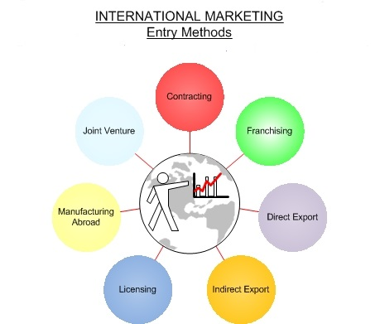
Source: Theintactone.com

2. Subsidiaries that are wholly owned by the parent company:
Toyota has formed wholly-owned companies in various markets to maintain complete control over operations and decision-making. Toyota, for example, developed wholly-owned subsidiaries in countries such as the United States and the United Kingdom (Hitt, 2019).
3. Strategic Alliances:
Toyota has developed strategic agreements with other corporations in order to expand its global reach and capabilities. One significant example is Toyota and Mazda's collaboration on electric vehicle technology and other activities.
4. Acquisitions:
Toyota has purchased interests or ownership in other firms in order to gain access to new markets and technology. Toyota's participation in Uber to provide vehicle leasing to Uber drivers is one example (Hitt, 2019).
ENTRY MODE USED BY TOYOTA IN CHINA
Toyota established manufacturing and production facilities in China through joint ventures with regional Chinese businesses. Toyota was able to navigate China's regulatory landscape due to these joint ventures, which also gave it access to local market knowledge and established distribution networks. The cooperation between Toyota and Guangzhou Automobile Group (GAC), which resulted in the establishment of Toyota Motor (China) Investment Co., Ltd., which manufactures and distributes Toyota vehicles in China, is one prominent joint venture. (sustainability report , 2022).

Corporate Social Responsibility
Toyota's Corporate Social Responsibility (CSR):
Toyota has established a strong commitment to Corporate Social Responsibility (CSR) as a worldwide automotive leader through different projects targeted at environmental sustainability, community participation, and ethical business practises.
Environmental Sustainability:
Toyota has always been at the forefront of ecologically friendly practises in the car sector. The company was a pioneer in the development of hybrid and fuel-efficient vehicles, particularly the Prius, which has become synonymous with environmentally friendly driving. Toyota's Environmental Challenge 2050 sets ambitious goals, including achieving zero CO2 emissions from vehicles and plants, promoting recycling, and using sustainable materials (Toyota, n.d.).
Community Engagement:
Toyota actively participates in communities through charity endeavours and social programmes. The Toyota Foundation provides funding for initiatives that advance societal advancement, culture, and education. Toyota has donated money and resources to help communities recover from disasters, demonstrating its dedication to social well-being (Toyota, n.d.).
Ethical Business Practices:
High ethical standards are upheld by Toyota in all aspects of its company activities. The company's Global Code of Conduct, which places an emphasis on honesty, openness, and respect for human rights, serves as a behavioural guide for employees. Relationships with partners and stakeholders show Toyota's commitment to ethical business practises (Toyota, n.d.).

Conclusion
In conclusion, a detailed investigation of Toyota Corporation's several facets reveals a conglomerate with a strong historical foundation and a dynamic position in the current global corporate scene. The thorough analysis of the company's history, strategic goals, and operating procedures reveals Toyota's unwavering commitment to innovation, quality, and sustainability. The corporation's skill at managing outside influences and influencing market trends is made clear through an insightful comparative PESTEL analysis, a thorough Industry Five Forces review, and an in-depth examination of market dynamics. The thorough analysis of Toyota's operations in both its home and its host nations highlights its skillful ability to adapt to various national situations while streamlining its global value chain for operational effectiveness. Interplay between internal strength, as shown by the SWOT analysis, and globally wise plans for company's foray into the sector emphasises its dominance in the automotive industry even more. Toyota is an example of responsible leadership by embracing corporate social responsibility as a compass for moral actions. In conclusion, Toyota's experience with this variety of assessments serves as an engrossing case study for a successful global company, highlighting its resiliency, agility, and dedication to long-lasting excellence.

References
Ahlstrom, D. &. G. G., 2020. Toyota and the Hybrid Car Market in China.. American Business Review, Cambridge, Volume 5(1), pp. 57-63..
BNPMedia, T., 2007,. Toyota outlines U.S. environmental objectives. Vol.50 (2),(Assembly,), p. p.8.
Cheng, J. L. Z. Y. &. L. L., 2019. Factors Affecting the Internationalization of Chinese Automobile Manufacturers.. Sustainability report , Volume 11(19), p. 5311.
Czinkota, M. &. R. I., 2013. International Marketing. (10th ed.). ed. s.l.:Cengage Learning.
Daniels, J. D. R. L. H. &. S. D. P., 2018. International Business:, Environments and Operations. (16th ed.) ed. s.l.:Pearson.
David, F. R. &. D. F. R., 2016. competitive advantage approach, concepts and cases., s.l.: s.n.
Doyle, P. & Stern, P., 2006. Marketing Management and Strategy. 4 ed. Essex: Pearson Education Limited.
Hill, C. W. L. H. G. T. M. &. W.-P. F., 2021. Competing in the Global Marketplace.. Issue McGraw-Hill Education..
Hitt, M. A. &. H., 2019. Strategic Management: Concepts and Cases: Competitiveness and Globalization. 13th ed. ed. s.l.:Cengage.
Hitt, M. A. R. D. &. H. R. E., 2019. Strategic management: competitiveness and globalization..
Hitt, M. A. R. D. &. H. R. E., 2019. Strategic management: concepts and cases: competitiveness and globalization.. 4th ed. Ireland,: s.n.
Hofstede, G., 1984. Country hofstede. s.l.:sage.
Horjus, J. S. A. V. A. &. G. J. W. E., 2019. A PESTLE Analysis of the European Biofuels Energy Sector., s.l.: s.n.
https://hbr.org/2008/06/the-contradictions-that-drive-toyotas-success, n.d. s.l.:s.n.
J. K. Liker, J. E. E. a. J. C. C., 1995. Japanese technology management techniques, engineered in Japan.. 3 ed. s.l.:s.n.
Jothi, K. &. K. P., 2015. financial performance of Honda and Toyota automobile company. Progressive Research in Social Sciences,, Volume 2(1), pp. 33-35.
Kim, S., 2019. Impact of Country Risk on International Business Strategy.. Asian Finance, Economics, and Business,, Volume 6(2), , pp. 151-160..
Kotler, P. K. K. L. &. B. M., 2019. Marketing Management. 15th ed ed. s.l.: Pearson..
Li, D. a. Y. J., 2021. "China's Currency Regime and Its Impact on Global Financial Markets.", s.l.: s.n.
Liker., J. K., 2003. The Toyota Way: 14 Management Principles from the World's Greatest Manufacturer, s.l.: McGraw Hill Professional.
Liker, J. K., 2003. The Toyota Way. techniquest of toyota , Volume 3, pp. 50-62.
line, m., 2023. taiwan province of china in depth PESTEL insight. s.l.:s.n.
Li, W. &. W. C. L., 2021. Analysis on the Competitive Strategy of Toyota in China.. Open Journal of Social Sciences, Volume 9(3), pp. 291-299..
Makino, S. &. D. A., 1996. Journal of International Business Studies,. Local knowledge transfer and performance: Implications for alliance formation in Asia. , Volume 27(5), pp. 905-927..
market line , 2023. Car Manufacturing Industry Data Global, s.l.: s.n.
market line , 2023. marketline.com. [Online]
Available at: https://advantage-marketline-com.ezproxy.uwtsd.ac.uk/Company/Summary/toyota_motor_corporation
[Accessed 06 july 2023 ].
market line , 2023. toyota motor corporation. [Online]
Available at: https://advantage-marketline-com.ezproxy.uwtsd.ac.uk/Company/ResearchReports/toyota_motor_corporation
[Accessed 18 07 2023].
MarketLine, 2023. [Online]
[Accessed 18 july 2023].
Michael, M., n.d. 3 ed. 2010: culture and organizations.
Nkomo, T., 2019. Analysis of Toyota Motor Corporation. , s.l.: s.n.
Porter, M. E., 1980. Competitive Strategy: Techniques for Analyzing Industries and Competitors, s.l.: s.n.
Porter, M. E., 1998. Clusters and the New Economics of Competition.. Harvard Business Review,, Volume 76(6), pp. 77-90.
Porter, M. E. .., (2008). The Five Competitive Forces That Shape Strategy.. competitive stratagy, Volume ,86(1), pp. 78-93..
Porter, M. E. H. B. R., 1979. . How competitive forces shape strategy., s.l.: s.n.
Report, A., 2021. Toyota Motor Corporation, 2021., s.l.: s.n.
Rugman, a., 2012. international business. 6th ed. s.l.:Mc graw-hill.
Schaede., U. & Huo Jiazhen , n.d. The Chinese Automotive Industry: Opportunities and Risks. s.l.:s.n.
sustainability report , 2022. global.toyota. [Online]
Available at: https://global.toyota/pages/global_toyota/sustainability/report/sdb/sdb22_en.pdf
[Accessed 15 july 2023 ].
sustainibility report , June 2023. sustainability data book , s.l.: Sustainability Management Dept..
Taki, H., 1977. Japanese Business and Economy. 2nd ed. s.l.:s.n.
Toyota Motor Corporation plc, 2020. https://media.toyota.co.uk/. [Online]
[Accessed 14 july 2023].
Wood, M. B., 2013. Essential Guide to Marketing Planning. 3 ed. Harlow: Pearson Education Limited.
Yu, P. K. a. A. P. Z., 2019. "Intellectual Property in China.", s.l.: s.n.

Appendix (if any)

Appendix 1:

Appendix 2:

