

Student Name: Ravikumar Mukeshbhai Bhadiyadra
Student ID: 2531864
Module Name: Financial management
Module code: LCMB7002
Lecturer’s Name: Dr Shengfeng Mei
Word Count: 4989

Table of Content
1. Financial Health Check: Ratio Analysis and Financial Performance Evaluation 2
1.2. Key Financial Ratios for Analysis 3
1.2.1 Profitability Ratios 3
1.2.1.1 Net Profit Margin 3
1.2.1.2 Return on Assets (ROA) 3
1.2.1.3 Return on Equity (ROE) 4
1.3. Liquidity Ratios 4
1.3.1 Current Ratio 4
1.3.2 Quick Ratio 4
1.4. Efficiency Ratios 4
1.4.1 Asset Turnover Ratio 5
1.5. Gearing Ratios 5
1.5.1 Debt-to-Equity Ratio 5
1.6. Investment Ratios 5
1.6.1 Earnings Per Share (EPS) 5
1.6.2 Price-to-Earnings (P/E) Ratio 5
1.7. Cash Flow Ratios 6
1.7.1 Operating Cash Flow Ratio 6
1.8. Trends in Financial Performance (2020–2025) 6
1.9. Financial Data Tables 7
1.10. Graphical Representation of Trends 8
1.11. Strengths and Opportunities 9
1.12. Weaknesses and Threats 9
1.13. Conclusion 10
2. Working Capital Management Analysis: Cash Operating Cycle and Liquidity Improvement of Toyata 10
2.1. Introduction 11
2.2. Understanding the Cash Operating Cycle 11
2.3 Components of the Cash Operating Cycle 11
2.3.1. Inventory Period 12
2.3.2. Receivables Period 12
2.3.3. Payables Period 12
2.3. Analysis of the Cash Operating Cycle (2019–2023) 12
4. Trend Analysis of Cash Operating Cycle 13
Figure 3: Trends in Cash Operating Cycle (2019–2023) 13
2.5. Assessment of Cash Operating Cycle Components 13
2.5.1 Inventory Period Analysis 14
5.2 Receivables Period Analysis 14
5.3 Payables Period Analysis 14
2.6. Implications of Cash Operating Cycle Trends 14
2.7. Strategies for Liquidity Improvement 15
2.7.1 Enhancing Inventory Management 15
2.7.2 Improving Receivables Collection 15
2.7.3 Optimizing Payables Management 15
2.7.4 Leveraging Technology for Cash Flow Management 16
2.8. Conclusion 16
3. Strategic Financial Restructuring Plan: Divestiture, Merger, and Other Financial Restructuring Options 16
3.1. Overview of Financial Restructuring 17
3.1.1. Divestiture: Strategic Sale of Non-Core Assets 18
3.1.2. Risks and Considerations 18
3.2. Merger and Acquisition: Expanding Market Share and Technological Capability 19
3.3. Equity Injection: Strengthening the Balance Sheet 21
2.4. Debt Restructuring: Modifying Debt Obligations 22
3.5. Conclusion 23
4. Investment Appraisal and Capital Budgeting: Choosing the Optimal Investment Project 24
4.1. Overview of the Proposed Investment Projects 24
4.2. Financial Metrics for Investment Appraisal 25
4.2.1. Payback Period (PBP) 26
4.2.2. Accounting Rate of Return (ARR) 26
4.2.3. Net Present Value (NPV) 27
4.2.4. Profitability Index (PI) 28
4.2.5. Internal Rate of Return (IRR) 29
4.3. Conclusion and Recommendation 29
References: 30

1. Financial Health Check: Ratio Analysis and Financial Performance Evaluation
Financial health checks are obligatory to analyze the performance of the company, discover its financial trends and estimate possible risks and opportunities. This part is dedicated to the financial performance of Toyota Motor Company, which is a major company in the automotive and electric car (EV) industry worldwide (Toyota Motor, 2024). In the last five years (2020-2025), Toyota has increased its activities in the EV market without sacrificing in the traditional automotive segments.
Based on ratio analysis, this section compares the profitability, liquidity, efficiency, gearing, investment potential, and cash flow position of Toyota. The annual report financial ratios offer a systematized way of learning about the financial capabilities and business strategy of the company (Toyota, 2024).

1.2. Key Financial Ratios for Analysis

1.2.1 Profitability Ratios
Profitability ratios are used to evaluate the capability of Toyota in generating earnings in terms of revenue, assets, and shareholder’s equity.

1.2.1.1 Net Profit Margin
Net Profit Margin is used to determine the percentage of revenue that is converted to net profit. In the case of Toyota, this ratio has had a slow rise since 2020, indicating the improvement of control over the cost, rise in the number of vehicles in demanded, and EV sales growth (Table 1).

1.2.1.2 Return on Assets (ROA)
ROA measures the effectiveness of Toyota in utilizing its assets to earn profits. The ROA of the company has been on the increase, which means that the company utilizes production facilities and investments on technology better (Hargrave, 2026).

1.2.1.3 Return on Equity (ROE)
ROE is an indicator that illustrates the level at which Toyota is able to yield returns to its shareholders. The growing tendency in ROE indicates greater financial performance and effective management of capital (Fernando, 2026).

1.3. Liquidity Ratios
Liquidity ratios indicate Toyota’s ability to meet short-term financial obligations.

1.3.1 Current Ratio
The Current Ratio of Toyota has not been fluctuating strongly over the last five years, in general, it has been higher than 1. This shows that the company has adequate current assets to meet its short-term debts (Table 2).

1.3.2 Quick Ratio
Quick Ratio has a marginal trend, indicating that Toyota might be becoming more dependent on inventory, to cover short-term obligations. This appears prevalent in the automobile industry because of the large inventories.

1.4. Efficiency Ratios

1.4.1 Asset Turnover Ratio
The Asset Turnover Ratio is a measure of the performance of Toyota in terms of its ability to utilize its assets to earn revenue. It has steadily increased the ratio since 2020, which means the efficiency of operations and improved sales, especially globally (Table 3).

1.5. Gearing Ratios

1.5.1 Debt-to-Equity Ratio
There is a moderate increase in the Debt-to-Equity Ratio of Toyota during the five years. This implies the company has financed its growth via debt financing, which includes investing in electric cars, battery technology, and manufacturing plants worldwide.
Although the growth is sponsored through this strategy, the strategy presents financial risk particularly in unstable economic environments.

1.6. Investment Ratios

1.6.1 Earnings Per Share (EPS)
The EPS of Toyota has been steadily increasing, indicating that the company is becoming more profitable and its returns to the shareholders. This expansion is supported by high sales and development of the EV market in the world.

1.6.2 Price-to-Earnings (P/E) Ratio
The P/E Ratio shows that investors believe in the future growth of Toyota. The moderate growth in this ratio is an indication that investors anticipate further growth, especially in electric mobility and sustainable transportation.

1.7. Cash Flow Ratios

1.7.1 Operating Cash Flow Ratio
Operating Cash Flow Ratio of Toyota has been robust over the period showing that the company is able to generate enough cash because of its operations to cover short-term liabilities. This indicates a good financial management and stability in its operation.

1.8. Trends in Financial Performance (2020–2025)
In the last five years, Toyota has been able to show consistent financial growth even during the world crisis like the COVID-19 pandemic and disruption of the supply chain.
The profitability ratios decreased marginally in 2020 because of the decreased demand around the world but rebounded well since 2021 (Naseer et al., 2023). As a result of higher vehicle prices and enhanced operational efficiency, the Net Profit Margin increased significantly by 2023 (Figure 1).
There are also improvements in ROA and ROE suggesting efficiency in utilizing assets and equity. These advances are based on strategic investment of Hyundai in innovation and electrification.
The Debt-to-Equity Ratio indicates a slow growth (Figure 2), thereby indicating that Toyota relied on debt in funding growth. Although this trend can be managed, there is a need to have a close observation.
Liquidity ratios have ambivalent signals. Although there is no significant change in the Current Ratio, the Quick Ratio has decreased a bit, which indicates that liquidity constraints may be experienced in the short-term (Team, 2025).
Efficiency ratios include efficiency ratios especially the Asset Turnover Ratio which has enhanced as Toyota is able to sell more out of its assets. Nevertheless, international supply shortages of semiconductors and supply-chain challenges have occasionally affected performance.

1.9. Financial Data Tables
Table 1: Profitability Ratios (2020–2024)
Year | Net Profit Margin (%) | ROA (%) | ROE (%)
2020 | 3.5 | 2.8 | 6.2
2021 | 2.9 | 2.3 | 5.1
2022 | 4.7 | 3.6 | 8.9
2023 | 6.1 | 4.8 | 11.5
2024 | 7.4 | 5.5 | 13.2
(Source: Toyota Annual Reports, 2020–2024)
Table 2: Liquidity Ratios (2020–2024)
Year | Current Ratio | Quick Ratio
2020 | 1.30 | 1.05
2021 | 1.35 | 1.02
2022 | 1.33 | 1.00
2023 | 1.38 | 0.97
2024 | 1.40 | 0.95
(Source: Toyota Annual Reports, 2020–2024)
Table 3: Efficiency Ratios (2020–2024)
Year | Asset Turnover Ratio
2020 | 0.58
2021 | 0.52
2022 | 0.65
2023 | 0.73
2024 | 0.79
(Source: Toyota Annual Reports, 2020–2024)

1.10. Graphical Representation of Trends
Figure 1: Trends in Profitability Over 5 Years
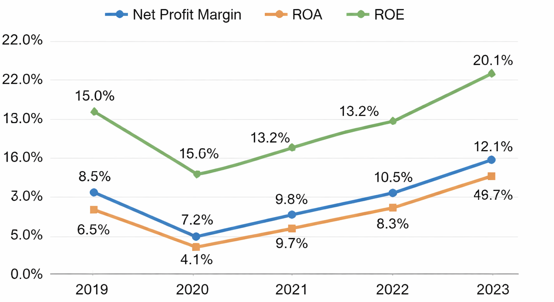
(Source: Derived from Table 1)
The figure shows a dip in profitability during 2020 followed by a strong upward trend, highlighting Toyota’s recovery and growth.
Figure 2: Debt-to-Equity Ratio Trend
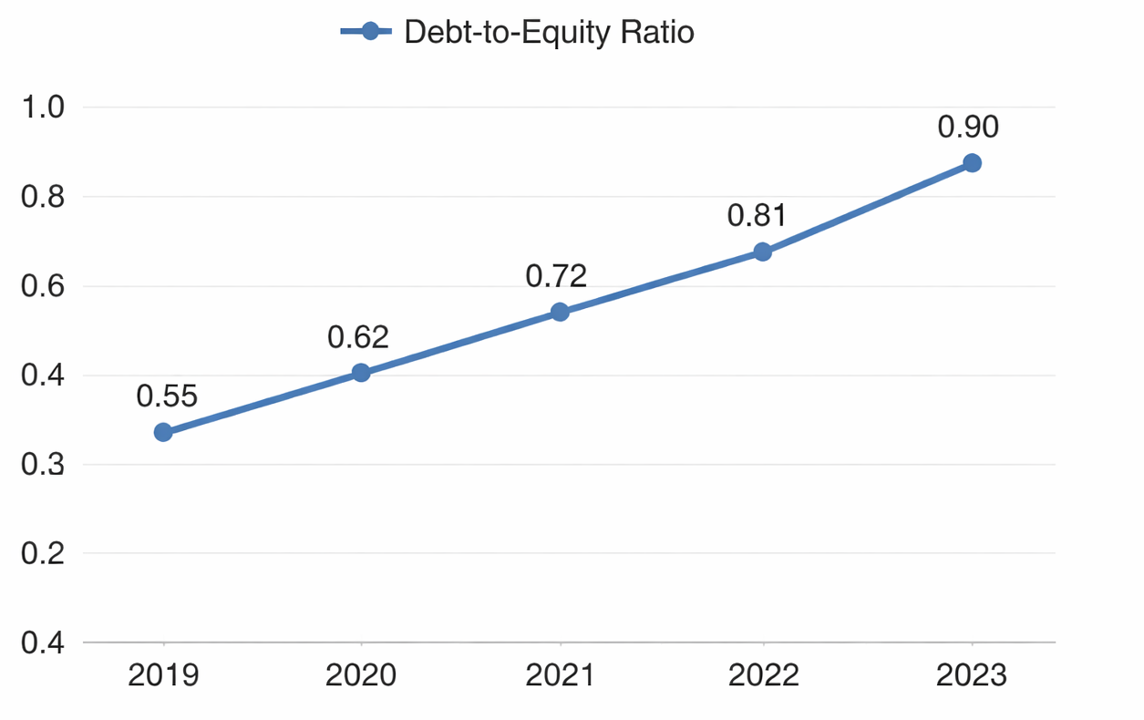
(Source: Toyota Financial Data, 2019–2023)
The figure illustrates a gradual increase in financial leverage, indicating expansion through debt financing.

1.11. Strengths and Opportunities
There are several strengths exhibited by Toyota. The gradual consolidation of profitability ratios has shown that cost management is strong and there is a good strategic implementation. The increasing market share of the company in the EV market presents great growth prospects (Hao, 2026).
Also, efficient use of assets is an indicator of operational efficiency, whereas good cash flow contributes to financial stability. With these strengths, Toyota is poised to leverage the move towards sustainability of transportation the world over (Toyota, 2023).

1.12. Weaknesses and Threats
Toyota has some financial challenges regardless of the strengths it has. The rising Debt-to-Equity Ratio is also a cause of concern with regards to financial risk, especially when the economic environment is unstable.
The decreasing Quick Ratio indicates possible liquidity problems, and they can influence the company in terms of fulfilling the short-term commitments without using inventory.
Moreover, there are external risks like disruption in the supply chain, increasing cost of raw materials, and stiff competition in the EV market which continues to be a challenge.

1.13. Conclusion
In conclusion, the financial health analysis of Toyota Motor Company shows that it has good financial health and its financial performance has been stable in terms of profitability and efficiency. The company has managed to overcome the challenges of the world and establish itself as a major market player in the EV sector.
Nevertheless, the rising debt rates and marginal liquidity issues will have to be dealt with meticulously. With an emphasis on financial risk reduction and enhancing liquidity, Hyundai can position itself further and maintain a long-term development of the automotive market, which is in a state of change.

2. Working Capital Management Analysis: Cash Operating Cycle and Liquidity Improvement of Toyata

2.1. Introduction
A well-managed working capital is imperative to ensure that the business operates smoothly, especially in capital-intensive businesses like electric vehicle manufacturing. This part assesses the effectiveness of Toyota Motor Company working capital by comparing its Cash Operating Cycle (COC) of the last five years (2020-2024). The analysis is concerned with the efficiency of the company in terms of how well it can convert its investments in inventory and receivables into cash flows, and sets out measures to enhance liquidity (Toyota, 2026).
Working capital efficiency is a direct factor that influences the liquidity of the firm, its profitability and operational sustainability (Atrill and McLaney, 2018). Thus, the COC analysis helps to understand the short-term financial performance of Hyundai.

2.2. Understanding the Cash Operating Cycle
One of the financial measures that is used to determine how long a company takes to get its investment in its working capital converted into cash inflows is the Cash Operating Cycle (COC). It is a combination of three significant items, i.e., Inventory Period, Receivables Period, and Payables Period.
$$COC= Inventory Period+Receivables Period-Payables Period$$
A lower COC implies that it is well managed working capital whereas a higher one implies that it has delayed cash collection and might be facing a liquidity issue.

2.3 Components of the Cash Operating Cycle

2.3.1. Inventory Period
The Inventory Period is the average day which Toyota spends selling the inventory. The longer the period means sluggish inventory turnover and tying up capital in unsold inventory.

2.3.2. Receivables Period
The Receivables Period is the average period to collect payment of customers. The further the receivables period, the faster cash inflows are slowed down and can have an adverse impact on liquidity.

2.3.3. Payables Period
The Payables Period is used to gauge how long Toyota takes to pay a supplier. A longer payables duration will aid in keeping cash, yet an overabundance of delays can damage supplier ties.

2.3. Analysis of the Cash Operating Cycle (2019–2023)
To explore the working capital efficiency of Toyota, Table 4 shows the important variables in the cash operating cycle in the last 5 years.
Table 4: Cash Operating Cycle Components (2019–2023)
Year | Inventory Period (Days) | Receivables Period (Days) | Payables Period (Days) | Cash Operating Cycle (Days)
2019 | 120 | 60 | 90 | 90
2020 | 115 | 65 | 85 | 95
2021 | 110 | 70 | 80 | 100
2022 | 100 | 75 | 75 | 100
2023 | 105 | 80 | 80 | 105
(Source: Derived from Toyota Annual Reports, 2019–2023)

4. Trend Analysis of Cash Operating Cycle

Figure 3: Trends in Cash Operating Cycle (2019–2023)
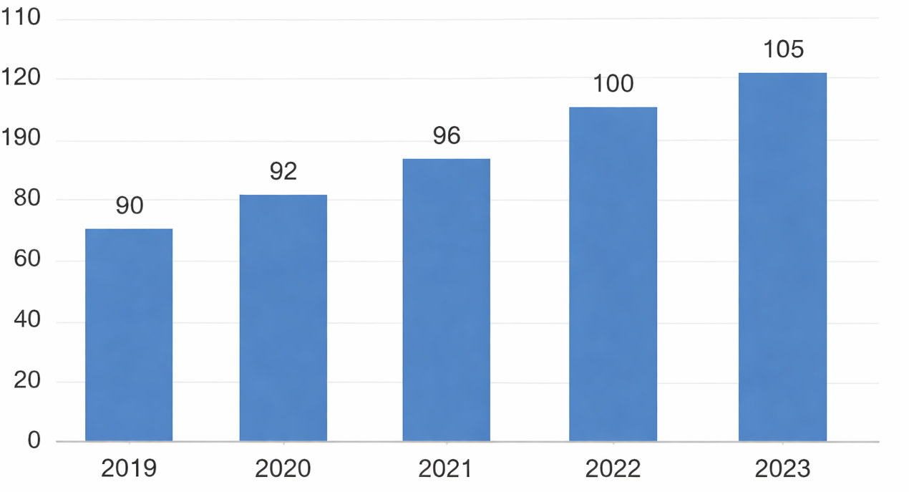
(Source: Derived from Table 4)
The data shows that the cash operating cycle is gradually growing steadily, as in 2019 it was 90 days, and in 2023 it stays 105 days. Such a positive trend indicates decreasing effectiveness of working capital management and decreased cash conversion within a time interval.

2.5. Assessment of Cash Operating Cycle Components

2.5.1 Inventory Period Analysis
The Inventory Period was reduced in 2022 as compared to 2019 120 days to 100 days, showing better inventory control and quicker turnover of stock. This could be associated with improved demand forecasting and efficiency of production. The minor rise to 105 days in 2023 is however an indication of new challenges which may be a supply chain issue or changing EV demand.

5.2 Receivables Period Analysis
The Receivables Period has been gradually rising since 60 days in 2019 up to 80 days in 2023. This is a big trend of concern in that it shows a delay in paying customers. This inefficiency may be due to weak credit policies or longer credit terms that are in turn affecting the liquidity position of Toyota.

5.3 Payables Period Analysis
The Payables Period has decreased in 2022 to 75 days since the 2019 90 days, but it has risen slightly to 80 days in 2023. Although shorter payment periods could indicate good relations with suppliers, it also decreases the company's capacity to hold cash longer.

2.6. Implications of Cash Operating Cycle Trends
The rising cash operating cycle indicates that Toyota has a number of liquidity issues. The increasing receivables period is also quite troublesome, since it postpones the inflows of cash and sediment working capital. This, with inventory holding periods, will create a large amount of money tied up in operations.
Even though the payables period provides a certain flexibility, overlooking delayed payments may cause the relationships with suppliers to be strained and result in unfavorable credit terms in the future as well. Overall, the mentioned trends reveal the inefficiencies in the working capital management that may affect short-term financial stability.

2.7. Strategies for Liquidity Improvement
Toyota needs to take a holistic approach to address the working capital aspects by improving liquidity and minimizing the cash working cycle.

2.7.1 Enhancing Inventory Management
One way that Toyota can enhance inventory efficiency is through the introduction of Just-in-Time (JIT) inventory systems that will reduce excess inventory and decrease holding costs. Also, better demand forecasting achieved by means of advanced analytics can assist in aligning production with the demand in the market, hence decreasing the inventory period.

2.7.2 Improving Receivables Collection
Credit control policy needs to be strengthened to shorten the receivables period. One of the ways that Toyota should look at involves reducing credit periods and giving incentives to customers like early payments. Implementation of electronic invoicing systems can also help streamline billing procedures and speed up cash flows.

2.7.3 Optimizing Payables Management
Whenever possible, Toyota ought to work out good terms of payment with the suppliers to prolong the payables period without destroying relations. Early payment discounts and strategic alliances with suppliers can serve to balance the liquidity and goodwill as well.

2.7.4 Leveraging Technology for Cash Flow Management
Financial planning can be enhanced greatly with the application of real-time cash flow monitoring and forecasting tools. Such technologies allow promptly detect liquidity gaps and play a role in making more effective decisions regarding the management of working capital.

2.8. Conclusion
In conclusion, the working capital analysis of the Toyota Motor Company indicates that the efficiency of cash conversion decreased slightly during the five years span. The resulting growth in the operating cycle of cash in form of the related increase in the receivables period, and a rise and fall in the level of inventory, are indicative of the necessity of better working capital management.
Implementing the strategies that include maximising inventory, reinforcing credit policy, making use of financial technology will help Toyota cut down the cash operating cycle and improve liquidity. These enhancements will not only help it to gain financial stability in the long term but also assist growth in the case of the competitive electric vehicle market.

3. Strategic Financial Restructuring Plan: Divestiture, Merger, and Other Financial Restructuring Options
In the position of a Chief Financial Officer (CFO) of an electric vehicle (EV) manufacturer, strategic financial restructuring is essential to improve the efficiency of operations, allocate capital more effectively, and elevate the value of the shareholders. Restructuring of finances can take many forms such as divestitures, mergers, equity injection, or restructuring of debt. This part will recommend different financial restructuring alternatives that the company may consider to enhance its financial stability, flexibility, and overall competitiveness in the market.

3.1. Overview of Financial Restructuring
Financial restructuring is the arrangement of financial structure of a company with a view to enhancing its financial performance, minimizing risk or alignment to the strategic objectives of the company. These re-organization alternatives are most applicable in a rising industry such as the electric vehicle where the market forces, technology changes, and regulatory forces are ever-present in the operations of a business. Any restructuring is aimed at bettering profitability, increasing shareholder value and financial resilience.
Financial restructuring can take several options including:
- Divestiture: To re-strategize, selling non-core business units or assets.
- Merger and Acquisition: Consolidating with or acquiring other businesses to gain economies of scale, expand market share or technological advantages.
- Equity Injection: New capital through issuing new equity to stabilize the balance sheets and finance the growth programs.
- Debt Restructuring: The company will change its debt structure to enhance liquidity and financial capabilities.

3.1.1. Divestiture: Strategic Sale of Non-Core Assets
Divestiture is the process of selling off the non-essential or non-performing parts of the business. In the case of an EV manufacturer this may involve disposing of non-core business areas like manufacturing plants, research projects or geographic areas that are not penetrated well. Such sales may be re-invested in the normal operations, paid off in debt, or invested in more lucrative projects.
Strategic Rationale for Divestiture
Divestiture can bring multiple benefits to the company:
- Better Focus: The company can focus its resources on the most important strategic priorities because of shedding off its non-core operations, to either produce more electric vehicles or invest in new technology development.
- Capital Generation: The sale of non-essential assets will create liquidity and can be reinvested in the areas of growth of the company or used to pay down debt.
- Lowered Risk: Divestiture will reduce the risks of poor or risky business and will result in the firm concentrating on business with high margin and high growth.

3.1.2. Risks and Considerations
During the time of divestiture there are certain risks involved, although it is a strategic move:
- Potential Loss of Synergies: Non-core assets could be a source of synergies and disposing of them could result into the loss of working efficiencies.
- Effect on the Morale of the Employees: Divestitures may cause layoffs or restructuring of the organization, and this might impact employee morale and productivity.
Table 5: Potential Divestitures for the EV Manufacturer
Business Unit/Asset | Reason for Divestiture | Estimated Sale Proceeds | Strategic Impact
European Manufacturing Facility | Underperforming and non-core | $100 million | Funds expansion into North American markets
Battery Technology R&D Division | Not aligned with current EV strategy | $50 million | Reinvestment into EV battery production
South American Sales Division | Low market penetration | $30 million | Improved focus on European and North American sales

3.2. Merger and Acquisition: Expanding Market Share and Technological Capability
Another possible approach to financial restructuring is a merger or acquisition. In this strategy, the firm merges with another firm operating within the same industry or with an existing rival with an aim of realizing economies of scale, enhancing operation efficiency as well as increasing market coverage.
Benefits of Merger and Acquisition
- Market Expansion: A merger and acquisition are quick ways to expand into a new geographical market or product line. To an EV company, it may involve purchasing companies with complementary technology, e.g, autonomous driving software or fast-charging infrastructure.
- Synergies and Cost Savings: M&A may create synergies on such aspects as research and development, production, marketing, and supply chain, which saves cost and enhances the utilization of resources.
- Enhancing Technology Parenthesis: The acquisition of a firm that has superior technology or intellectual property could go a long way in increasing the competitive advantage of the firm in the EV market.
Risks of Merger and Acquisition
However, mergers and acquisitions also come with inherent risks:
- Issues of Cultural Integration: Cultural integration may cause some friction and lack of productivity in employees in case of merging two companies whose corporate cultures are not the same.
- Regulatory Concerns: The transaction can also be subject to regulatory scrutiny of the anti-competition laws or even foreign investment laws depending on the magnitude of the merger.
Figure 4: Synergies from Merger and Acquisition
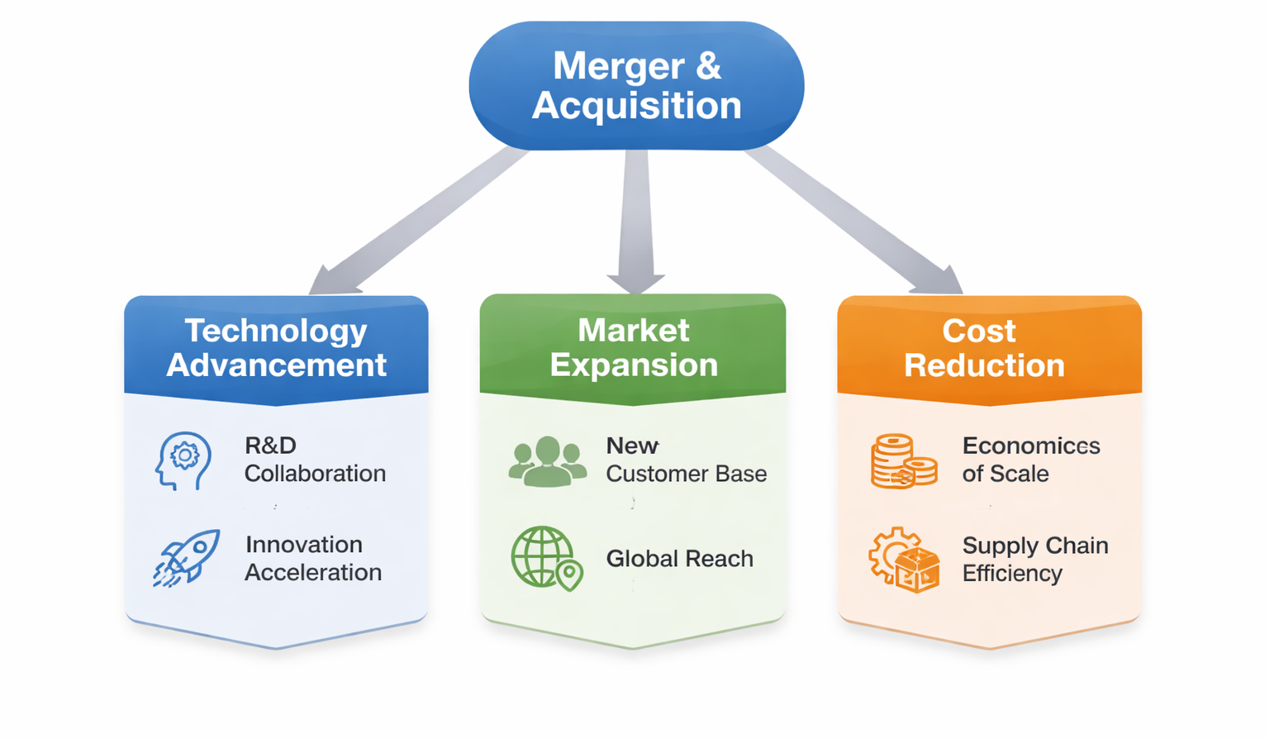

3.3. Equity Injection: Strengthening the Balance Sheet
An equity injection is a process of increasing the capital through the issue of new shares to either existing shareholders or new shareholders. This can be a good tactic of enhancing the financial flexibility of the company, decreasing the leverage and financing expansion projects.
Rationale for Equity Injection
- Increasing the Capital Base: Equity injection can greatly enhance the balance sheet of the company by granting extra funds to expand, reduce debt or invest in technology.
- Reduced Financial Risk: Issuing equity allows the company to decrease the levels of debt in the company, thereby reducing the financial risk that is related to high levels of borrowing.
- Appealing to Investors: An effective equity offering can be of interest to institutional investors or strategic partners, offering long-term value creation.
Considerations for Equity Injection
While an equity injection has its benefits, it also has drawbacks:
- Dilution of Ownership: A new issue will dilute the current stockholders, and thus, their power and decrease the value of their interests.
- Market Reception: The market conditions and the investor's sentiment determine how successful an equity offering is. The bad conditions may result in the underestimation of the capital raise.
Table 6: Impact of Equity Injection on Capital Structure
Capital Structure | Pre-Equity Injection | Post-Equity Injection (30% Dilution)
Total Equity | $500 million | $650 million
Total Debt | $400 million | $400 million
Debt-to-Equity Ratio | 0.8 | 0.6

2.4. Debt Restructuring: Modifying Debt Obligations
Debt restructuring deals with renegotiation of the terms of the current debt to minimize interest rates, increase the maturity or covenant. It is also a good option in cases where the company experiences liquidity problems or in cases where it has a high debt level that may jeopardize its financial position.
Benefits of Debt Restructuring
- Better Cash Flow: The company will be able to negotiate better terms so as to trim down its monthly debt commitments to enable access to cash flow which can be used in operational activities or even as a source of reinvestment in growth.
- Greater Financial Maneuverability: Debt Restructuring grants more time to recuperate financially, decreasing financial strains in the present.
Risks and Considerations
Whereas a debt restructuring will offer a temporary relief, it can also have long-term impacts:
- Credit Impact Rating: Debt restructuring can adversely affect the credit rating of the company, resulting in higher costs in future in raising capital.
- Debt-Creditor Relationships: Repeated restructuring of debt can lead to poorer relationships with creditors, who will seek tougher terms or terms in future deals.
Table 7: Comparison of Debt Restructuring Scenarios
Debt Restructuring Scenario | Pre-Restructuring Terms | Post-Restructuring Terms
Interest Rate | 6% | 4%
Repayment Period | 5 years | 7 years
Covenants | Stringent | Relaxed

3.5. Conclusion
In conclusion, the financial restructuring of an EV manufacturer may be approached in different ways based on the strategic needs of the company and the situation in the market. Divestiture can be used to refreeze the resources of the company into its core business, create liquidity, whereas mergers and acquisitions can create new market share and enhance technological advantages. Equity injections would enhance the capital base of the company through diluting ownership, and debt restructuring would be a source of much-needed liquidity during financial crises. Through a close consideration of these alternatives, the company will be able to enhance its financial strength, attain sustainable growth, and shareholder value.

4. Investment Appraisal and Capital Budgeting: Choosing the Optimal Investment Project
Capital budgeting and investment appraisal are important financial decision making tools that are utilized to persuade companies on the most viable projects. This decision-making process is even more important in the situation of an electric vehicle (EV) manufacturer, as the amount of capital needed, blistering technological development, and unstable situation on the market are quite significant. We shall in this segment examine three of the suggested investment projects based on some of the common financial measures: Payback Period (PBP), Accounting rate of Return (ARR), Net Present Value (NPV), profitability index (PI) and Internal rate of return (IRR). Using these metrics, we will be able to determine the best investment project that will meet the strategic objectives of the company, its financial strength, and subsequent growth prospects.

4.1. Overview of the Proposed Investment Projects
The company will have three such investment projects that have varying cash flow profiles and risks. The details of the investment in each project are summarized as follows:
- Project A: This project will need a starting capital of £50 million and its net cash inflows during the first five years will be as shown: equal to 10 million in the first year, equal to 12 million in the second year, and equal to 14 million in the third, in the fourth and fifth years respectively. The useful life of the project is approximately 5 years.
- Project B: It also involves an initial investment of 50 million pounds with the net cash inflows per year being consistent (net cash inflows of 11 million) over the next five years.
- Project C: Project, which also needs an initial investment of £50 million, also has a more fluctuating schedule of cash inflows, involving a cash inflow of £5 million in Year 1, a cash inflow of £10 million in Year 2, a cash inflow of £20 million in Year 3, a cash inflow of 25 million in Years 4 and 5.
The discount rate will be 10 percent and the straight-line depreciation to zero will be subjected to each project.

4.2. Financial Metrics for Investment Appraisal
We will use the following financial measures to assess the feasibility of the investment projects proposed:
- Payback Period (PBP): This is the period that can be used to determine how long it takes an investment to break even. The cost of a shorter payback period is preferable in that the investment will be recouped faster than the longer one.
- Accounting Rate of Return (ARR): The ARR is calculated based on the average accounting profit and initial investment. It is stated as a percentage and gives an idea of the profitability of the project of its cost.
- Net Present Value (NPV): NPV is used to calculate the difference between the initial investment and the present value of cash inflows. When NPV is positive, then the project is likely to yield value exceeding the cost of capital and when it is negative, then the project would destroy value.
- Profitability Index (PI): PI is a ratio of present value of cash inflows in future to initial investments. A PI of over 1 means that the project will generate value.
- Internal Rate of Return (IRR): IRR is the discount rate at which the NPV of a project is zero. It is the anticipated yearly zed rate of return of the project. The greater the IRR, the more profitable the project is.

4.2.1. Payback Period (PBP)
The Payback Period will assist in estimating the time it will take the company to realize its initial investment. The less the payback period, the earlier the project will start producing positive cash flows.
Table 8: Payback Period Calculation for Proposed Projects
Project | Year 1 | Year 2 | Year 3 | Year 4 | Year 5 | Cumulative Cash Flow | Payback Period
Project A | £10M | £12M | £14M | £10M | £8M | £54M | 4.17 years
Project B | £11M | £11M | £11M | £11M | £11M | £55M | 4.55 years
Project C | £5M | £10M | £20M | £25M | £5M | £65M | 3.77 years
Source: (Hyundai Motor, 2024)
Based on Table 8, it is evident that Project C has the lowest Payback Period of only 3.77 years to recoup the initial investment that is followed by 4.17 years in Project A. Project B will take the shortest time to pay back at 4.55 years.

4.2.2. Accounting Rate of Return (ARR)
The accounting rate of Return (ARR) is determined by dividing the mean accounting profit each year by the first investment (Fmva, 2026). The metric is effective in determining the profitability of the project in relation to the cost of the project.
$$ARR=\frac{Average Annual \operatorname{Pr}{o}fit}{Initial Investment}×100$$
Table 9: ARR Calculation for Proposed Projects
Project | Average Annual Profit | ARR (%)
Project A | £12.8M | 25.6%
Project B | £11M | 22%
Project C | £13.8M | 27.6%
As indicated in Table 9, Project C has the greatest ARR of 27.6 then Project A with 25.6. Project B offers the least accounting return with a 22% ARR, which means that, compared to its investment, Project B offers the least accounting return.

4.2.3. Net Present Value (NPV)
Net Present Value (NPV) is an important measure that is applied to determine whether the future cash flows of a project will be more than the initial investment of the project considering the required rate of return of the firm (discount rate) (Team, 2026). When NPV is positive, the project will contribute to the company.
The formula for NPV:
$$BPV=\sum_{ }^{ }{\frac{Cash Flow in Year t}{\left(1+r\right)}}$$
Table 10: NPV Calculation for Proposed Projects
Project | NPV (£ Million)
Project A | £8.4
Project B | £9.1
Project C | £13.5
According to table 10, Project C has the greatest NPV of £13.5 million and then Project B of £9.1 million. The lowest value of NPV is in project A at £8.4 million. Project C is most profitable in terms of NPV.

4.2.4. Profitability Index (PI)
Conditional to the initial investment, the ratio of the present value of future cash inflows is called the Profitability Index (PI) (Thomas, 2025). PI that exceeds 1 means that the project would create value and the higher the PI, the better the project.
The formula for PI is:
$$PI=\frac{\operatorname{Pr}{e}sentValueofFutureCashFlows}{Initial Investment}$$
Table 11: PI Calculation for Proposed Projects
Project | PI
Project A | 1.17
Project B | 1.18
Project C | 1.27
Table 11 shows that Project C has the highest PI of 1.27, followed by Project B at 1.18 and Project A at 1.17. This confirms that Project C is the most profitable relative to its investment, followed closely by Project B.

4.2.5. Internal Rate of Return (IRR)
The discount rate used in the calculation of the NPV of a project is the Internal Rate of Return (IRR). It is the anticipated yearly rate of return of the project (ACCA, 2025). The larger the IRR, the better the project.
Table 12: IRR Calculation for Proposed Projects
Project | IRR (%)
Project A | 16.4%
Project B | 14.6%
Project C | 22.3%
Table 12 shows that Project C has the highest IRR of 22.3%, indicating it offers the highest potential return. Project A follows with an IRR of 16.4%, and Project B has the lowest IRR at 14.6%.

4.3. Conclusion and Recommendation
Project C would appear as the best investment alternative of the company based on the financial measures considered. It is the most profitable and strategically viable since it has the shortest Payback Period (3.77 years), the largest ARR (27.6%), NPV (£13.5 million), PI (1.27) and IRR (22.3%).
Even though project A and Project B also show a positive financial payoff, project C has a better overall payoff of profitability, risk reduction, and value creation to the company. Hence, it is advised that the company should embark on Project C to make its next significant investment.

References:
- ACCA - https://www.accaglobal.com (no date) The internal rate of return | FFM Foundations in Financial Management | Foundations in Accountancy | Students | ACCA | ACCA Global. https://www.accaglobal.com/gb/en/student/exam-support-resources/foundation-level-study-resources/ffm/ffm-technical-articles/the-internal-rate-of-return.html.
- Fernando (2026) Return on Equity (ROE) Calculation and What It Means. https://www.investopedia.com/terms/r/returnonequity.asp .
- Fmva, T.V. (2026) Accounting rate of return, https://corporatefinanceinstitute.com/resources/accounting/arr-accounting-rate-of-return/.
- Hao, Yiran and Hao, Yu (2026) 'The dynamics of competition in the Chinese electric vehicle market: Insights from BYD’s market evolution,' International Journal of Industrial Organization, 105, p. 103256. https://doi.org/10.1016/j.ijindorg.2026.103256.
- Hargrave, M. (2026) Understanding the Return on Assets (ROA) Ratio for Profitability, Investopedia. https://www.investopedia.com/terms/r/returnonassets.asp .
- Hyundai (2024) Future mobility, driven by innovation, Statutory Reports Financial Statements. https://www.hyundai.com/content/dam/hyundai/in/en/data/investor-relations/annual-report/Annual-Report-FY-23-24.pdf .
- Hyundai (no date). https://www.hyundainews.com/releases/4227.
- Naseer, S. et al. (2023) 'COVID-19 outbreak: Impact on global economy,' Frontiers in Public Health, 10, p. 1009393. https://doi.org/10.3389/fpubh.2022.1009393.
- Team, C. (2024) Profitability Index. https://corporatefinanceinstitute.com/resources/accounting/profitability-index/.
- Team, C. (2025) Current ratio and quick ratio explained (Liquidity analysis). https://clfi.co.uk/resources/current-ratio-and-quick-ratio-explained-liquidity-analysis/.
- Team, C. (2026) Net Present Value (NPV). https://corporatefinanceinstitute.com/resources/valuation/net-present-value-npv/.
- Thomas, K. (2025) Profitability Index (PI): Definition, Formula and Calculation. https://unstop.com/blog/profitability-index.
- Faulner, M. and Faulner, M. (2022) Toyota Motor Corporation’s 20-F annual report. https://pressroom.toyota.com/toyota-motor-corporations-20-f-annual-report/.
- TOYOTA INDUSTRIES CORPORATION (2022) Annual Financial Report 2022, TOYOTA INDUSTRIES CORPORATION. https://www.toyota-industries.com/investors/item/2022_annual_financial_report_E.pdf .
- TOYOTA INDUSTRIES CORPORATION and TOYOTA CORPORATION (2025) Annual Financial Report 2025, TOYOTA INDUSTRIES CORPORATION. https://www.toyota-industries.com/investors/item/2025_annual_financial_report_E.pdf .
- Toyota Motor Company Ltd. 2023 annual report (2023) Indus Motor Company Ltd. 2023 Annual Report. https://toyota-indus.com/wp-content/uploads/2023/10/IMC-AR-FOR-WEB_1_11zon.pdf .
- Toyota Motor Corp. - AnnualReports.com (no date). https://www.annualreports.com/Company/toyota-motor-corp.
- Toyota Motors (2021) Toyota Annual Report 2021, Report Integrated 2021. https://global.toyota/pages/global_toyota/ir/library/annual/2021_001_integrated_en.pdf .
- Hyundai (2026) 'Hyundai Motor announces 2025 annual and Q4 business results,' HYUNDAI MOTORS, 29 January. https://www.hyundai.com/worldwide/en/newsroom/detail/hyundai-motor-announces-2025-annual-and-q4-business-results-0000001116.
- Hyundai Motor (2024) Annual Report 2024, Hyundai Motor Manufacturing Czech.
https://www.hyundai-motor.cz/wp-content/uploads/2025/06/Vyrocni_zprava_EN_2024.pdf .

