

Master of Business Administration

Module: International Marketing: Principles and Practices

Module Code: LCMB7026

Assessment component 1: Individual report

International Market Entry Strategy and Marketing Mix of Cadbury in the United Kingdom and India

Name: Riyaben Jayrushnabhai Prajapati
Student ID: 2529556
Lecturer: Tushara Balendran / Dian Mayasari
Word Count: 5321
Submission Date: 13th August 2026

AI Acknowledgement
Generative AI, specifically ChatGPT (OpenAI), was used as a supporting tool during the research and proofreading stages of this assessment. Its use included identifying areas for further research, summarising and comparing information, and checking the grammar and clarity of independently written content. All information used in the assessment was verified against original academic, organisational, and industry sources. The analysis, evaluation, conclusions, and final submitted content were independently produced.
Contents
1. Introduction 7
2. Company Background: Cadbury 7
3. Comparative Macro-Environmental Analysis 9
3.1 Political Factors 9
3.2 Economic Factors 10
3.3 Social Factors 10
3.4 Technological Factors 10
3.5 Environmental Factors 11
3.6 Legal Factors 11
4. Comparative Cultural Analysis Using Hofstede’s Culture Dimensions 11
4.1 Power distance 12
4.2 Individualism and collectivism 12
4.3 Motivation Towards Achievement and Success (Masculinity) 13
4.4 Uncertainty avoidance 13
4.5 Long-term orientation 13
4.6 Indulgence and restraint 13
4.7 Advantages and Limitations of Hofstede’s Cultural Model 14
4.8 Marketing implications for Cadbury 14
5. Comparative Segmentation, Targeting and Positioning Analysis 15
5.1 Segmentation 15
5.2 Targeting 15
5.3 Positioning 16
6. Comparative International Marketing Mix 16
6.1 Product 17
6.2 Price 17
6.3 Place 17
6.4 Promotion 18
6.5 People 18
6.6 Process 19
6.7 Physical evidence 19
7. Cadbury’s Market-Entry Strategy in India 20
7.1 Historical Development in India 20
7.2 Market-Entry Method 20
7.3 Reasons for Selecting the Entry Method 20
7.4 Advantages of the Entry Method 20
7.5 Disadvantages, Risks and Overall Evaluation 21
8. Ethical Evaluation of Cadbury’s Marketing Mix in India 21
8.1 Ethical Marketing Practice One: Sustainable Cocoa Sourcing 21
8.2 Ethical marketing practice two: Community Development 22
8.3 Ethical concern one: Health and Promotional Responsibility 22
8.4 Ethical concern two: Packaging Waste 22
9. Recommendations 23
9.1 Recommended Target Market 23
9.2 Recommended Brand-Image Development 23
9.3 Product Recommendation 23
9.4 Promotion Recommendation 24
9.5 Implementation Considerations 24
10. Conclusion 25
Section 2: Reflective Account 25
11. Reflective Account Using Gibbs’ Reflective Cycle 25
11.1 Description 26
11.2 Feelings 26
11.3 Evaluation 27
11.4 Analysis 27
11.5 Conclusion 28
11.6 Action Plan 28
Reference List 30

Table of Figures
Figure 1 (history of cadbury (Kale, 2015)) 8
Figure 2 (Political Stability and Absence of Violence/Terrorism – Selected Countries 9
Figure 3 (Comparison of Hofstede’s Cultural Dimensions – United Kingdom and India 12
Figure 4 Own-developed, based on Hofstede, Hofstede and Minkov (2010), The Culture Factor Group (2023), Cadbury UK (2026) and Mondelēz International (2026). 14
Figure 5 (source: Gibbs (1988)) 25

List of Abbreviations

Abbreviation |  |  |  | Meaning
FDI |  |  |  | Foreign Direct Investment
FSSAI |  |  |  | Food Safety and Standards Authority of India
GDP |  |  |  | Gross Domestic Product
IMC |  |  |  | Integrated Marketing Communications
PESTEL |  |  |  | Political, Economic, Social, Technological, Environmental and Legal
STP |  |  |  | Segmentation, Targeting and Positioning
UK |  |  |  | United Kingdom
US |  |  |  | United States

1. Introduction
International marketing requires multinational organisations to understand and respond to differences in consumer behaviour, cultural values, economic conditions and regulatory systems across national markets. Effective international strategies must balance global consistency with local responsiveness when developing market-entry decisions, customer targeting and the marketing mix (Hollensen, 2020; Kotler, Keller and Chernev, 2022).
This report critically evaluates Cadbury’s international marketing strategy in the United Kingdom and India. The UK represents Cadbury’s heritage market, as the brand originated in Birmingham in 1824 and subsequently became closely associated with British confectionery culture (Cadbury UK, n.d.). India provides a contrasting international market in which Mondelēz has operated for more than seven decades through brands including Cadbury, Cadbury Dairy Milk, 5 Star and Bournvita (Mondelēz International, n.d.).
The report applies PESTEL and Hofstede’s cultural dimensions before comparing Cadbury’s segmentation, targeting and positioning and its international marketing mix through the 7Ps framework. It also evaluates Cadbury’s market-entry strategy in India, associated ethical issues and future strategic recommendations. The central argument is that Cadbury’s international effectiveness depends on protecting its global identity while adapting its marketing decisions to local market conditions.

2. Company Background: Cadbury
Cadbury is a long-established British confectionery brand founded in Birmingham in 1824, when John Cadbury began selling cocoa and drinking chocolate. From these origins, the business developed into one of the UK’s most recognised chocolate brands, supported by product innovation, distinctive branding and strong associations with generosity, community and shared enjoyment. Cadbury Dairy Milk subsequently became a central product within the portfolio and continues to reinforce the brand’s heritage and recognition in the UK confectionery market (Cadbury UK, n.d.).
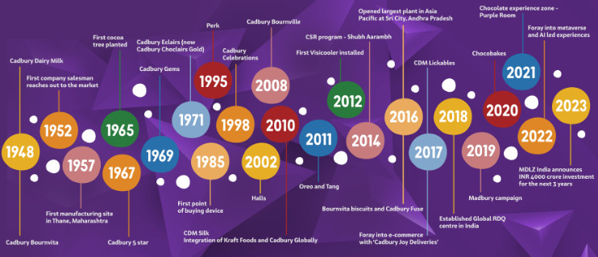
Figure 1 (history of cadbury (Kale, 2015))
Cadbury currently operates as part of Mondelēz International, a multinational snacking company with operations in more than 150 countries. Mondelēz defines its corporate purpose as empowering people to “snack right”, linking consumer enjoyment with responsible and sustainable approaches to snacking (Mondelēz International, n.d.). This purpose is relevant to Cadbury because it connects product innovation and consumer satisfaction with wider expectations concerning responsible sourcing, mindful consumption and sustainability. Despite multinational ownership, Cadbury continues to maintain its distinctive British heritage, purple visual identity and emotionally focused brand positioning (Mondelēz International, 2025).
India represents one of Cadbury’s longest-established international markets. Mondelēz India Foods Private Limited, formerly Cadbury India Limited, has operated in the country for more than 75 years, with Cadbury Dairy Milk and Bournvita introduced in 1948. Its portfolio has since expanded across mass-market, premium and gifting occasions, demonstrating the adaptation of a global brand to local consumer needs (Mondelēz International, 2026).
Overall, Cadbury benefits from strong brand heritage, global organizational resources and an established presence in both markets. However, mature-market pressures in the UK and greater differences in purchasing power, culture and distribution in India require continued adaptation of its international marketing strategy.

3. Comparative Macro-Environmental Analysis
PESTEL evaluates the political, economic, social, technological, environmental and legal forces affecting international marketing. For Cadbury, the UK and India present contrasting opportunities and constraints, supporting selective adaptation rather than complete standardisation (Hollensen, 2020).

3.1 Political Factors
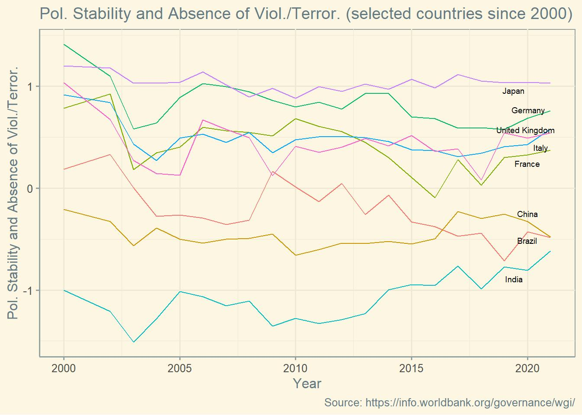
The UK is politically stable, but public-health policy increasingly restricts confectionery promotion. From January 2026, qualifying less-healthy food and drink became subject to a 9 p.m. television watershed and restrictions on paid online advertising, reducing promotional flexibility for Cadbury (Department of Health and Social Care, 2026). India offers greater expansion potential through its large consumer market, although firms operate within an evolving regulatory system overseen by the Food Safety and Standards Authority of India. The UK is therefore stable but restrictive, while India combines growth potential with greater administrative complexity.
Figure 2 (Political Stability and Absence of Violence/Terrorism – Selected Countries
Source: Henrique Martins (2022), based on World Bank Worldwide Governance Indicators. https://data360.worldbank.org/en/dataset/WB_WGI

3.2 Economic Factors
India recorded GDP growth of approximately 7.6% in 2025, compared with 1.4% in the UK, while GDP per capita was about US$2,703 in India and US$57,602 in the UK (World Bank, 2026). India therefore offers stronger growth potential but lower purchasing power, requiring affordable prices, smaller packs and selective premiumisation. The UK supports premium and seasonal products but slower growth and cost-of-living pressures constrain demand. Cocoa-price inflation affects both markets: Mondelēz reported that significant price increases contributed to a 3.7% decline in full-year volume/mix in 2025, illustrating consumer sensitivity to higher prices (Mondelēz International, 2026c). Overall, India is more attractive for volume growth, whereas the UK remains commercially attractive but mature and price sensitive.

3.3 Social Factors
In both markets, chocolate is associated with emotional experiences, family occasions and celebrations, supporting Cadbury’s emotional branding (Kotler, Keller and Chernev, 2022). However, consumption meanings differ. In the UK, Cadbury draws on heritage, nostalgia, everyday treats and seasonal occasions. In India, greater emphasis is placed on “meetha” moments, family relationships, festivals and gifting, enabling chocolate to complement traditional sweets (Mondelēz International, 2026b). Health awareness is also increasing in both countries, creating pressure for clearer nutrition information and responsible promotion. UK marketing can rely more on established familiarity, whereas India requires stronger cultural localisation because of regional and social diversity.

3.4 Technological Factors
The UK’s developed digital-retail infrastructure supports online grocery distribution, targeted communication and data-driven promotion. Online sales represented 27.4% of UK retail sales in 2025, while internet use reached about 95% of the UK population compared with 70% in India (Office for National Statistics, 2026; World Bank, 2026). India therefore offers digital-growth opportunities through mobile commerce and social media, but Cadbury must also support traditional distributors and neighbourhood retailers, making a hybrid online–offline strategy essential.

3.5 Environmental Factors
Packaging waste and responsible cocoa sourcing create pressures in both markets. The UK’s extended producer responsibility system requires affected organisations to report packaging data and contribute to waste-management costs (Department for Environment, Food and Rural Affairs and PackUK, 2026). India also imposes extended producer responsibility obligations on plastic packaging. This is particularly challenging because small, affordable packs improve accessibility but can increase waste. Mondelēz reported that approximately 100% of cocoa used by its chocolate business was sourced through Cocoa Life in 2025, although progress on emissions and sustainable packaging remains necessary (Mondelēz International, 2026c).

3.6 Legal Factors
UK law restricts advertising and placement of qualifying less-healthy products, particularly where children may be exposed. In India, FSSAI regulations require packaged-food labelling and mandatory consumer information, with a further amendment issued in 2026 (FSSAI, 2026). Non-compliance could create financial, operational and reputational consequences. The UK therefore imposes stronger promotional constraints, while India presents broader labelling and operational-compliance requirements.
Overall, the UK offers higher purchasing power, developed retail infrastructure and strong Cadbury heritage but is mature and increasingly regulated. India offers faster growth and culturally significant gifting opportunities but requires greater adaptation to affordability, retail fragmentation and regulatory complexity. Cadbury should preserve its global identity while adapting pricing, pack sizes, distribution and communication to each market.

4. Comparative Cultural Analysis Using Hofstede’s Culture Dimensions
Hofstede’s six-dimensional model provides a structured basis for comparing national cultural tendencies and their potential influence on consumer behaviour and international marketing. It examines power distance, individualism, achievement and success, uncertainty avoidance, long-term orientation and indulgence. However, national scores represent broad tendencies rather than individual behaviour and should therefore be interpreted alongside contemporary consumer evidence (Hofstede, Hofstede and Minkov, 2010; The Culture Factor Group, 2023).
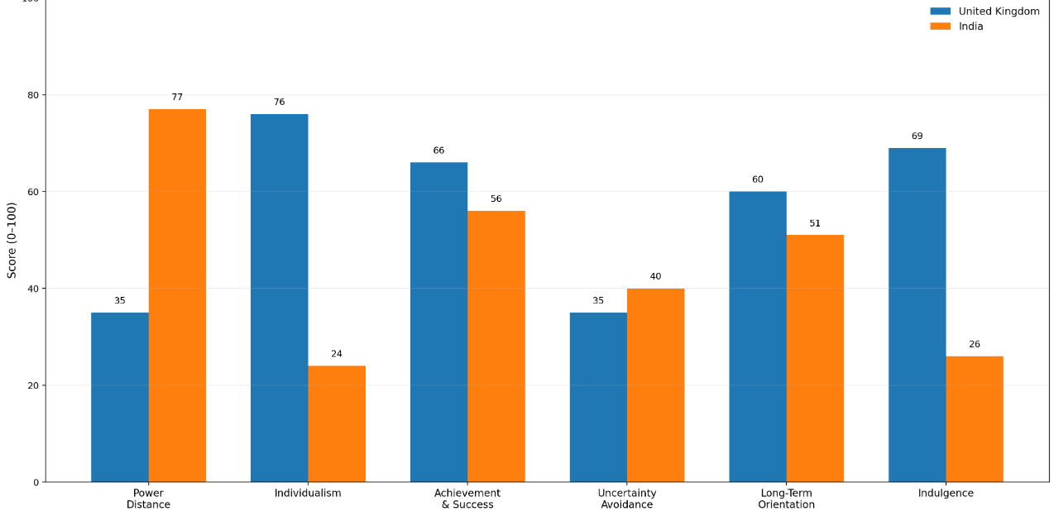
Figure 3 (Comparison of Hofstede’s Cultural Dimensions – United Kingdom and India

4.1 Power distance
India has substantially higher power distance than the UK, indicating greater acceptance of hierarchy and status differences. This may increase the relevance of respected family roles and intergenerational relationships in Indian communication. In contrast, the UK’s lower power distance supports more informal, egalitarian and relatable messaging (The Culture Factor Group, 2023). Cadbury should therefore adapt how relationships are represented rather than changing its underlying emotional positioning.

4.2 Individualism and collectivism
The UK is considerably more individualistic, supporting positioning around personal enjoyment, self-reward and nostalgia. India’s stronger collectivist characteristics make family, sharing and collective celebration more relevant. Cadbury Celebrations campaigns around Raksha Bandhan illustrate relationship-based gifting and shared emotional experiences (Mondelēz International, 2026a). Thus, the brand’s emotional foundation can remain consistent while the social context of consumption is localised.

4.3 Motivation Towards Achievement and Success (Masculinity)
Both markets demonstrate achievement-oriented characteristics, although the UK scores somewhat higher. Themes of aspiration and reward can therefore be relevant in both countries (Hofstede, Hofstede and Minkov, 2010; The Culture Factor Group, 2023). However, UK communication may emphasise personal achievement and reward, whereas Indian communication can associate milestones with family pride and shared celebration.

4.4 Uncertainty avoidance
Both countries demonstrate comparatively moderate-to-low uncertainty avoidance, creating scope for new products, flavours and limited editions (The Culture Factor Group, 2023). Nevertheless, innovation should retain recognisable Cadbury brand cues. Novelty can stimulate interest, but excessive change could weaken consumer expectations concerning taste, quality and familiarity.

4.5 Long-term orientation
Tradition remains important in both markets but operates differently. In the UK, Cadbury’s long heritage contributes to familiarity and trust, whereas in India the brand has developed relevance by integrating chocolate into established festivals and social occasions. The strategic opportunity therefore lies in preserving heritage in the UK while embedding the brand within culturally meaningful occasions in India.

4.6 Indulgence and restraint
The UK demonstrates considerably higher indulgence than India, supporting chocolate positioning around everyday enjoyment, comfort and personal treats (The Culture Factor Group, 2023). India’s more restrained orientation suggests that indulgence may be particularly effective when connected with gifting, festivals and relationships. This does not imply lower demand for indulgence, but rather that its cultural framing requires adaptation.

4.7 Advantages and Limitations of Hofstede’s Cultural Model
Hofstede provides a consistent framework for identifying cultural differences and translating them into potential marketing implications. More recent research has also supported revised dimensions of national culture (Minkov and Kaasa, 2022). However, the model can oversimplify societies by treating national populations as relatively homogeneous. McSweeney (2002) argues that national-level assumptions may inadequately explain individual behaviour, particularly where regional, religious, generational and socioeconomic differences are substantial. Hofstede’s scores should therefore guide investigation rather than determine marketing decisions.

4.8 Marketing implications for Cadbury
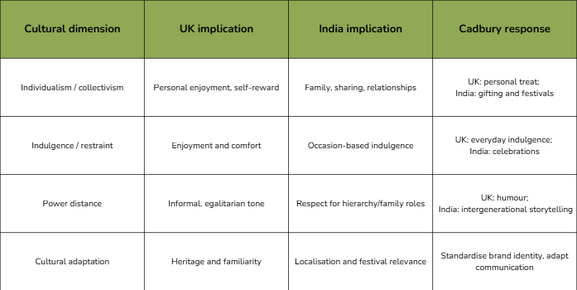
The comparison supports selective adaptation rather than complete standardisation or localisation. Cadbury can retain core assets such as its name, purple identity, product quality and emotional positioning while adapting their cultural meaning. In the UK, marketing can emphasise heritage, personal enjoyment and informal generosity. In India, stronger emphasis should be placed on family relationships, festivals, gifting and shared experiences.
Figure 4 Own-developed, based on Hofstede, Hofstede and Minkov (2010), The Culture Factor Group (2023), Cadbury UK (2026) and Mondelēz International (2026).
Figure 4 demonstrates how Cadbury can maintain a consistent global emotional identity while adapting communication and consumption occasions to local expectations. Overall, Hofstede is useful for explaining broad cultural differences, but strategic decisions should also incorporate current regional, demographic and behavioural consumer research.

5. Comparative Segmentation, Targeting and Positioning Analysis
Segmentation, targeting and positioning enable organisations to identify groups with different needs, select commercially attractive customers and establish a distinctive value proposition (Kotler, Keller and Chernev, 2022). Cadbury maintains a broadly consistent emotional identity across the UK and India but adapts its STP strategy to differences in purchasing power, culture and consumption occasions.

5.1 Segmentation
In the UK, Cadbury applies demographic, behavioural, lifestyle and occasion-based segmentation. Its portfolio serves children, younger adults, families and older consumers, while products such as Dairy Milk and Twirl support individual snacking and Heroes, Roses and Milk Tray address sharing and gifting occasions. Seasonal products associated with Easter, Christmas and other celebrations further segment consumers according to purchase occasion. Vegetarian and under-100-calorie categories also respond to dietary and health-related preferences (Cadbury UK, 2026).
Segmentation in India is more strongly influenced by income, age, consumption occasion and cultural behaviour. Cadbury Dairy Milk and 5 Star serve the mass market, whereas Dairy Milk Silk targets consumers seeking premium indulgence and gifting. Products including Celebrations, Gems, Perk and Bournville allow Mondelēz to address children, younger consumers, families and higher-income urban customers through differentiated product propositions (Mondelēz International, 2026a).

5.2 Targeting
Cadbury follows differentiated mass targeting in the UK. Individual bars target routine snack purchasers, sharing formats appeal to families, and boxed products serve seasonal and gift buyers. This broad approach benefits from established awareness but may limit growth unless Cadbury responds more effectively to health-conscious consumers.
In India, targeting places greater emphasis on young consumers, families, festival shoppers and aspirational urban groups. Cadbury also uses culturally relevant interests to reach specific audiences. For example, its 2026 #TheKhaasSeat campaign connected Dairy Milk with first-time cricket experiences and shared emotional moments, demonstrating how targeting extends beyond demographic characteristics to passions and culturally meaningful occasions (Mondelēz International, 2026b).

5.3 Positioning
In the UK, Cadbury is positioned as a familiar, trusted and emotionally comforting British brand. Its heritage, purple identity and “glass and a half” association reinforce generosity, nostalgia and everyday enjoyment. In India, the emotional foundation remains, but its meaning is adapted through the “Kuch Meetha Ho Jaaye” philosophy, which connects chocolate with special moments, relationships and celebration. Dairy Milk Silk additionally occupies a premium position based on indulgence, gifting and self-reward (Mondelēz International, 2026a; Mondelēz International, 2026b).
Cadbury standardises its central emotional identity but localises the reasons for consumption. UK positioning relies principally on heritage, familiarity and personal enjoyment, whereas Indian positioning depends more on cultural integration, shared happiness and accessible-to-premium product differentiation. This selective adaptation strengthens relevance in both countries. However, Cadbury should use continuing local consumer research because broad national segments may overlook regional, generational and health-related differences.

6. Comparative International Marketing Mix
The extended marketing mix considers product, price, place, promotion, people, process and physical evidence. International brands must coordinate these elements while deciding which activities should remain standardised and which require local adaptation (Booms and Bitner, 1981; Kotler, Keller and Chernev, 2022).

6.1 Product
In the UK, Cadbury offers a broad portfolio including Dairy Milk, Twirl, Creme Egg, Heroes, Roses and Milk Tray, alongside seasonal, gifting and lower-calorie options. This range supports individual snacking, sharing and celebration occasions while reinforcing Cadbury’s established brand heritage. Product familiarity is particularly important in this mature market, where recognised products help sustain customer loyalty and differentiate the brand through emotional associations and tradition (Cadbury UK, n.d.-b).
In India, Cadbury’s portfolio is adapted more strongly to different income levels and consumption occasions. Dairy Milk, 5 Star, Perk and Gems support mass-market consumption, while Silk, Bournville and Celebrations address premium indulgence and gifting. The 2026 limited-edition Dairy Milk Silk Dubai Chocolate illustrates adaptation to emerging consumer preferences (Mondelēz International, 2026f). However, premium innovation should remain balanced with accessible formats for price-sensitive consumers.

6.2 Price
In the UK, Cadbury primarily operates within mass- and mid-market confectionery, while seasonal, sharing and limited-edition products permit selective premium pricing. Higher purchasing power supports these formats, but supermarket competition, cost-of-living pressures and cocoa inflation increase price sensitivity. Mondelēz reported that price increases during 2025 were accompanied by a 3.7% decline in full-year volume/mix, demonstrating the risk that excessive pricing can weaken demand (Mondelēz International, 2026c).
In India, lower average purchasing power and greater income differences require a broader pricing architecture. Small, affordable packs help maintain mass-market penetration, while Dairy Milk Silk and limited editions target more affluent urban consumers. For example, Silk Dubai Chocolate was introduced at ₹550, illustrating premiumisation at the upper end of the portfolio (Mondelēz International, 2026f). Cadbury should therefore protect affordability while using selective premium pricing where consumer willingness to pay is stronger.

6.3 Place
In the UK, Cadbury benefits from an established distribution infrastructure comprising supermarkets, convenience stores, online grocery platforms and other organised retail channels. This extensive availability supports impulse purchases, routine consumption and planned seasonal buying. Developed digital retail also enables Cadbury products to remain easily accessible across both physical and online consumer touchpoints.
In India, distribution is more complex because traditional retail, modern trade and e-commerce must operate simultaneously. Mondelēz’s network reaches approximately three million traditional stores, while digitised sales, direct-store delivery and branded coolers support product availability and quality (Mondelēz International, n.d.-c). This extensive network improves market penetration but increases logistical and cold-chain complexity across India’s large and geographically diverse market.

6.4 Promotion
In the UK, Cadbury’s promotional communication emphasises heritage, generosity, kindness and everyday shared moments, supported by its established “glass and a half” identity. Integrated Marketing Communications (IMC) allows these themes to remain consistent across advertising, digital platforms, packaging and other consumer touchpoints (Mogaji, 2025). The emphasis is therefore primarily on maintaining familiarity and emotional attachment in an established market.
In India, promotion is more strongly localised around festivals, relationships, romance, gifting and popular culture. The 2026 “Say It With Silk” campaign combined digital film, refreshed packaging and a 360-degree communication strategy (Mondelēz International, 2026d), while the #TheKhaasSeat campaign connected Dairy Milk with culturally important cricket experiences (Mondelēz International, 2026e). These examples demonstrate how Cadbury retains emotional positioning while adapting promotional meaning to Indian consumer interests.

6.5 People
In the UK, Cadbury benefits from Mondelēz’s global organisational capabilities and an established network of retailers, digital platforms and customer-service channels. Mondelēz employed approximately 91,000 people worldwide at the end of 2025, including around 79,000 outside the United States (Mondelēz International, 2026a). Consumer interactions in the UK are comparatively standardised because organised retail and established service systems facilitate consistent brand delivery.
In India, people have a more complex role because sales teams, distributors, traditional retailers and modern retailers directly influence product availability, merchandising and consumer access. Mondelēz reports approximately 300 employees at its Mumbai head office alongside its wider manufacturing and operational network (Mondelēz International, n.d.-e). Strong employee capabilities and retailer relationships are therefore particularly important, although reliance on numerous intermediaries can make consistency more challenging.

6.6 Process
In the UK, Cadbury benefits from established supply chains, online grocery services and planned seasonal distribution, making purchasing comparatively straightforward. Post-purchase support is also structured through FAQs, a virtual assistant, online forms, telephone Careline and WhatsApp. Product details can be collected to investigate complaints systematically, strengthening consumer trust and quality management (Cadbury UK, n.d.-d).
In India, processes must coordinate domestic manufacturing, traditional retailers, modern supermarkets, e-commerce and direct-store delivery. Cold-chain systems and branded coolers are particularly important because high temperatures can affect chocolate quality, while festival-related peaks increase forecasting requirements. Mondelēz also provides a dedicated consumer-contact route for enquiries and feedback (Mondelēz International, n.d.-f). Indian processes therefore require greater operational flexibility than those in the UK.

6.7 Physical Evidence
In the UK, Cadbury’s purple identity, logo, distinctive wrappers and “glass and a half” symbolism provide recognisable physical evidence. Products such as Roses, Heroes and Milk Tray also reinforce associations with heritage, sharing and seasonal gifting. Consistent packaging and visual identity strengthen familiarity and make Cadbury readily identifiable within a highly competitive confectionery market.
In India, the same core brand elements are maintained, but packaging is adapted more strongly to consumption occasions. Silk packaging supports premium indulgence and romance, while Cadbury Celebrations is positioned around festivals and gifting. Localised designs therefore communicate culturally relevant occasions while preserving global brand recognition. Sustainability is also becoming increasingly visible, with Mondelēz reporting that approximately 100% of cocoa used by its chocolate business was sourced through Cocoa Life in 2025 (Mondelēz International, 2026b).
Overall, Cadbury follows selective adaptation. Its name, purple identity, quality and emotional positioning remain broadly standardised, while product emphasis, pricing, distribution, communication and packaging are adapted. India requires deeper localisation because of purchasing-power differences, fragmented retail and occasion-led demand; the UK permits greater reliance on heritage and established distribution. This balance protects brand recognition while improving local relevance.

7. Cadbury’s Market-Entry Strategy in India

7.1 Historical Development in India
Cadbury entered India in 1948, with Cadbury-Fry (India) Private Limited incorporated on 19 July 1948. The company subsequently developed domestic manufacturing and invested in cocoa-development services, nurseries and research facilities, demonstrating long-term commitment to an Indian supply base (The Economic Times, 2026). The business now operates as Mondelēz India Foods Private Limited and has maintained an Indian presence for more than seven decades (Mondelēz International, 2026a).

7.2 Market-Entry Method
Cadbury entered India through foreign direct investment using a locally incorporated subsidiary, followed by investment in manufacturing and distribution. This high-control approach differs from lower-commitment alternatives such as exporting or licensing. Although requiring greater resources, high-control modes provide stronger authority over product quality, branding and strategic decisions (Hollensen, 2020).

7.3 Reasons for Selecting the Entry Method
This approach was appropriate because product quality, pricing and availability required local operational control. Domestic production reduced dependence on imported finished products and enabled Cadbury to adapt products, pack sizes, prices and promotion to Indian consumers. Local operations also supported retailer relationships and responses to India's climate, cultural diversity and fragmented distribution system.

7.4 Advantages of the Entry Method
The subsidiary model provided control over manufacturing, product quality, intellectual property and brand positioning while developing local market knowledge, cocoa sourcing and distribution capabilities. Cadbury's Indian infrastructure now includes manufacturing operations, regional sales offices, cocoa operations and research and development facilities, illustrating the capabilities created through sustained local investment (Mondelēz International, 2018; Mondelēz International, 2026a).

7.5 Disadvantages, Risks and Overall Evaluation
Direct investment requires substantial capital and increases exposure to regulatory, operational, supply-chain and reputational risks. India's regional diversity, traditional retail network and climatic conditions further increase distribution and product-quality challenges. These risks differ from the UK, Cadbury's heritage market, where established consumer familiarity and mature distribution reduce foreign-market uncertainty.
Overall, direct investment was an appropriate strategy for India. Although riskier than exporting or licensing, it enabled greater control, localisation and development of local capabilities. Cadbury's long-term presence suggests that these benefits have outweighed the higher financial and operational commitment.

8. Ethical Evaluation of Cadbury’s Marketing Mix in India
Ethical marketing requires businesses to consider the effects of their product, promotion, packaging and supply-chain decisions on consumers, employees, communities and the environment. Cadbury demonstrates several responsible practices in India; however, tensions remain between commercial growth, public health and environmental sustainability.

8.1 Ethical Marketing Practice One: Sustainable Cocoa Sourcing
Cadbury’s Cocoa Life programme represents an ethical application of the product, people and process elements of the marketing mix. The programme supports cocoa farmers through agricultural training, subsidised seedlings, productivity improvements and more sustainable farming practices. Mondelēz states that Cocoa Life has reached approximately 100,000 farmers in India and distributed more than 12 million cocoa seedlings through nurseries across four states (Mondelēz International, 2026a). This approach can improve supply-chain resilience while supporting farmer livelihoods and environmental responsibility. However, because these outcomes are primarily company-reported, independent impact assessment remains important.

8.2 Ethical marketing practice two: Community Development
Mondelēz India’s Shubh Aarambh programme supports children and young people through nutrition, education and physical-activity initiatives. The programme operates across several Indian states and illustrates how the people and process elements can generate social value beyond product sales (Mondelēz International, 2026b). Community programmes can strengthen stakeholder relationships and corporate reputation, although they should complement rather than replace responsible practices within Cadbury’s core products and marketing activities.

8.3 Ethical concern one: Health and Promotional Responsibility
Cadbury’s products are marketed around indulgence, celebration and emotional connection. While this positioning is culturally effective, an ethical concern arises where persuasive promotion encourages frequent consumption of products containing substantial sugar, particularly among children and younger audiences. Indian regulations prohibit misleading food advertising, unsupported health claims and advertisements that undermine healthy lifestyles (FSSAI, 2018). Cadbury should therefore ensure that promotional communication is transparent, avoids presenting chocolate as nutritionally necessary and gives appropriate visibility to portion guidance.

8.4 Ethical concern two: Packaging Waste
Affordable single-serve packs increase Cadbury’s accessibility in India but can contribute to flexible-plastic waste. Mondelēz reports collecting and processing plastic equivalent to its Indian packaging footprint and supporting recycling initiatives; nevertheless, recovering waste does not completely eliminate the environmental impact of producing disposable packaging (Mondelēz International, 2026c). This creates a tension between the price, product and physical-evidence elements: small packs support affordability but may weaken sustainability objectives.
Overall, Cadbury’s Indian marketing approach demonstrates meaningful ethical progress through farmer support, community investment and plastic-recovery initiatives. However, health-related promotion and reliance on disposable packaging remain significant concerns. Cadbury should strengthen transparent nutrition communication, responsible audience targeting and recyclable packaging while publishing independently verified evidence of its social and environmental impact.

9. Recommendations

9.1 Recommended Target Market
Cadbury should prioritise digitally connected urban consumers aged 18–35, particularly young professionals, students and young families seeking affordable indulgence, convenient gifting and greater nutritional transparency. This segment offers strong potential because it combines increasing digital engagement with aspirational consumption and demand for both accessible and premium products. Targeting should therefore extend beyond festival-based purchasing towards everyday sharing, gifting and responsible indulgence, while maintaining affordable price points for wider accessibility.

9.2 Recommended Brand-Image Development
Cadbury should evolve its Indian positioning from primarily celebration-focused indulgence towards “responsible enjoyment and meaningful sharing.” This proposed positioning would preserve the brand's established emotional identity while strengthening associations with moderation, sustainable sourcing and transparent communication. Rather than replacing Cadbury's existing celebration-based positioning, responsible enjoyment should complement it. Sustainability claims should also be supported by measurable evidence to reduce the risk of perceived greenwashing and strengthen consumer trust.

9.3 Product Recommendation
The highest product priority should be the development of portion-controlled formats offering smaller servings, clearer front-of-pack nutritional information and reduced or more recyclable packaging. Reduced-sugar variants could also be tested, provided taste, affordability and consumer acceptance are maintained. This recommendation integrates the product, price and physical-evidence elements of the marketing mix by responding simultaneously to health concerns, packaging waste and price sensitivity. Consumer testing should precede large-scale introduction to minimise the risk of weakening Cadbury's established taste proposition.

9.4 Promotion Recommendation
Promotion should retain culturally relevant themes of festivals, relationships, sharing and personal milestones while incorporating responsible-consumption messaging and visible portion guidance. Digital channels are particularly appropriate because approximately 70% of India's population used the internet in 2025 (World Bank, 2026). However, audience targeting should avoid encouraging excessive consumption or disproportionately appealing to children. This approach would maintain Cadbury's emotional relevance while responding to FSSAI requirements for truthful and non-misleading food communication (FSSAI, 2018).

9.5 Implementation Considerations
Implementation should follow a phased approach. First, Cadbury should pilot the proposed product and communication strategy in selected metropolitan markets through supermarkets, neighbourhood retailers and e-commerce platforms. Second, performance should be assessed using trial purchases, repeat-purchase rates, profitability, consumer perceptions, packaging reduction and advertising compliance. Third, product, pricing and communication should be refined using the pilot evidence before wider expansion. National rollout should proceed only where predetermined commercial, consumer and sustainability indicators demonstrate satisfactory performance.
Overall, priority should be given to portion and packaging innovation first, responsible digital communication second, and brand-positioning development third, supported by phased implementation. This would allow Cadbury to strengthen its relevance in India while balancing commercial growth with affordability, health responsibility and environmental sustainability.

10. Conclusion
This report demonstrates that Cadbury’s international marketing effectiveness depends on balancing global brand consistency with selective local adaptation. The UK provides strong brand heritage, high purchasing power and developed retail infrastructure, but growth is constrained by market maturity, tighter health regulation and sustainability pressures. India offers stronger long-term growth opportunities through its large consumer base, digital expansion and culturally significant gifting occasions, although lower purchasing power, regional diversity and fragmented distribution require deeper adaptation.
Cadbury’s direct investment in India has enabled greater control over manufacturing, distribution and local market responsiveness. Across STP and the 7Ps, the brand retains core assets such as its name, purple identity and emotional positioning while adapting pricing, packaging, promotion and distribution.
Overall, selective adaptation is the most appropriate international strategy. Future competitiveness will depend on maintaining affordability and cultural relevance while strengthening responsible promotion, nutritional transparency, portion control and sustainable packaging.

Section 2: Reflective Account

11. Reflective Account Using Gibbs’ Reflective Cycle
Gibbs’ Reflective Cycle provides a structured approach to reflection through description, feelings, evaluation, analysis, conclusion and action planning (Gibbs, 1988). It is used here to evaluate the process of researching and preparing the comparative international marketing report on Cadbury in the UK and India.
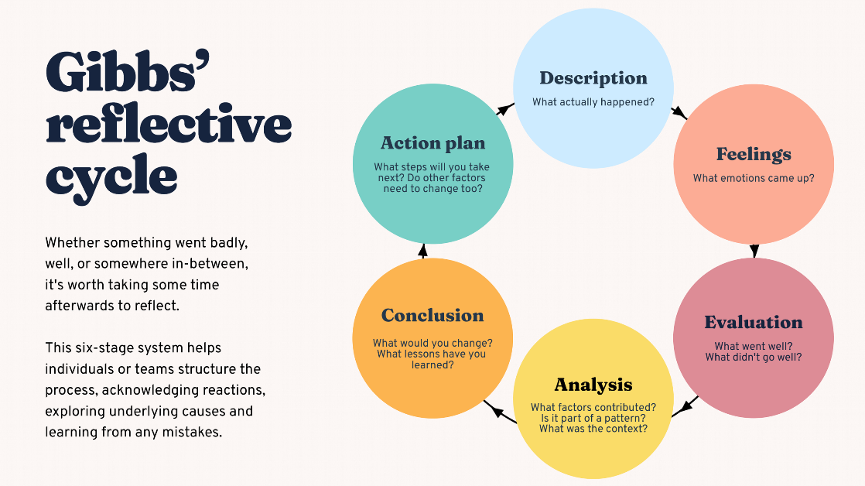
Figure 5 (source: Gibbs (1988))

11.1 Description
The assignment involved comparing Cadbury’s international marketing strategy in the UK and India. The UK represented Cadbury’s heritage market, while India provided a contrasting context characterised by cultural diversity, lower purchasing power, regional variation and festival-based consumption.
PESTEL and Hofstede’s dimensions were used to assess environmental and cultural differences, while STP and the 7Ps examined customer targeting and marketing decisions. Market entry, ethical practices and recommendations were also evaluated. Research drew on academic literature, government publications, regulatory documents, company reports and industry evidence.

11.2 Feelings
Initial confidence arose from familiarity with Cadbury in both markets, but uncertainty developed around the level of critical evaluation required at postgraduate level. The task required more than describing products and campaigns; evidence-based comparison and strategic judgement were necessary.
Researching the UK was relatively straightforward because official information was widely available, while India-specific research was more challenging because many sources emphasised corporate achievements rather than independent criticism. Word-count pressure also emerged because early drafts repeated themes such as heritage, gifting and festivals. Confidence improved as evidence became more organised and the links between culture, market conditions and marketing strategy became clearer.

11.3 Evaluation
The UK–India comparison was effective because the markets differ significantly in culture, purchasing power, regulation and retail structure. The combination of PESTEL, Hofstede, STP and the 7Ps also helped connect environmental analysis with practical marketing decisions.
Academic literature provided theoretical foundations, while government and regulatory sources strengthened analysis of advertising, labelling and environmental requirements. Company sources were useful for products, campaigns and sustainability initiatives.
However, early drafts were too descriptive and contained repeated arguments. Reliance on corporate publications also risked presenting favourable organisational claims without sufficient independent evaluation. Quantitative evidence was introduced relatively late, increasing editing requirements and pressure on the word limit.

11.4 Analysis
A key learning point concerned the balance between standardisation and adaptation. International brands benefit from consistent identity and quality, but cultural, economic and regulatory differences often require local modification (Hollensen, 2020). Cadbury demonstrates this through consistent branding alongside adapted pricing, packaging, communication and distribution.
PESTEL showed that environmental information becomes useful only when its strategic implications are evaluated. The UK offers high purchasing power and established retail infrastructure but faces market maturity and promotional restrictions, whereas India offers stronger growth potential but greater price sensitivity and distribution complexity.
Hofstede’s framework helped interpret cultural differences, particularly stronger individualism and indulgence in the UK and greater collectivist characteristics in India (Hofstede, Hofstede and Minkov, 2010). However, national scores cannot fully represent regional, religious, generational or income differences, demonstrating the need to combine cultural models with current consumer evidence.
The STP and 7Ps analysis also demonstrated that international marketing decisions are interconnected. Target selection influences product formats, pricing, promotion and distribution. Similarly, the market-entry analysis showed that greater local control can improve quality and adaptation but also increases financial, regulatory and operational exposure.
Ethical analysis further demonstrated that commercial performance alone does not define marketing success. Sustainable sourcing and community programmes may create social value, while sugar consumption, persuasive promotion and packaging waste create wider stakeholder concerns.

11.5 Conclusion
The assignment strengthened the ability to connect international marketing theory with practical business decisions. The most significant development was moving from descriptive discussion towards evidence-based comparison, evaluation and judgement. Greater awareness of source credibility also developed.
Weaknesses remained in research planning, quantitative evidence collection and word-count control. Earlier use of independent evidence and clearer word allocation would have improved efficiency and strengthened the final analysis.

11.6 Action Plan
Future assignments should begin with a structured schedule covering research, drafting, editing and proofreading, with a clear word allocation for each section. A source matrix should record source credibility, key evidence and Harvard referencing information, with academic and independent sources prioritised over unsupported corporate claims.
Analytical paragraphs should consistently move from evidence to comparison, evaluation and judgement. Quantitative evidence should be collected during initial research rather than added during final editing, and sufficient time should be reserved for proofreading, citation checking and word-count reduction. These actions should strengthen critical analysis, academic writing and independent research in future work.

Reference List
Booms, B.H. and Bitner, M.J. (1981) ‘Marketing strategies and organisation structures for service firms’, in Donnelly, J.H. and George, W.R. (eds.) Marketing of services. Chicago: American Marketing Association, pp. 47–51.
Cadbury UK (n.d.-a) 200 years of Cadbury. Available at: https://www.cadbury.co.uk/about/history/200-years-of-cadbury/ (Accessed: 19 July 2026).
Cadbury UK (n.d.-b) Our products. Available at: https://www.cadbury.co.uk/products/discover-cadbury-products/ (Accessed: 20 July 2026).
Cadbury UK (n.d.-c) Our story. Available at: https://www.cadbury.co.uk/about/history/our-story/ (Accessed: 19 July 2026).
Cadbury UK (n.d.-d) Contact us. Available at: https://www.cadbury.co.uk/contact/index.html (Accessed: 7 August 2026).
Department for Environment, Food and Rural Affairs and PackUK (2026) Extended producer responsibility for packaging. Available at: https://www.gov.uk/government/collections/extended-producer-responsibility-for-packaging (Accessed: 25 July 2026).
Department of Health and Social Care and Department for Culture, Media and Sport (2026) Less healthy food or drink: Advertising and promotions restrictions. Available at: https://www.gov.uk/government/collections/less-healthy-food-or-drink-advertising-and-promotions-restrictions (Accessed: 8 August 2026).
Food Safety and Standards Authority of India (2018) Food Safety and Standards (Advertising and Claims) Regulations, 2018. New Delhi: FSSAI. Available at: https://fssai.gov.in/docs/business/import/Gazette_Notification_Advertising_Claims_27_11_2018.pdf (Accessed: 3 August 2026).
Food Safety and Standards Authority of India (2026) Food Safety and Standards (Labelling and Display) First Amendment Regulations, 2026. New Delhi: FSSAI. Available at: https://fssai.gov.in/docs/food-law/regulations/amendments/labelling-display/Notification%20dt%2024_03_2026_NRC.pdf (Accessed: 24 July 2026).
Gibbs, G. (1988) Learning by doing: A guide to teaching and learning methods. Oxford: Further Education Unit, Oxford Polytechnic.
Hofstede, G., Hofstede, G.J. and Minkov, M. (2010) Cultures and organizations: Software of the mind. 3rd edn. New York: McGraw-Hill.
Hollensen, S. (2020) Global marketing. 8th edn. Harlow: Pearson Education.
Kotler, P., Keller, K.L. and Chernev, A. (2022) Marketing management. 16th global edn. Harlow: Pearson Education.
McSweeney, B. (2002) ‘Hofstede’s model of national cultural differences and their consequences: A triumph of faith—a failure of analysis’, Human Relations, 55(1), pp. 89–118. doi: 10.1177/0018726702551004.
Minkov, M. and Kaasa, A. (2022) ‘Do dimensions of culture exist objectively? A validation of the revised Minkov–Hofstede model of culture with World Values Survey items and scores for 102 countries’, Journal of International Management, 28(4), article 100971. doi: 10.1016/j.intman.2022.100971.
Mogaji, E. (2025) ‘Integrated Marketing Communications’, in Strategic Marketing Management: Principles and Practice. Cham: Palgrave Macmillan, pp. 175–209. doi: 10.1007/978-3-031-99367-1_7.
Mondelēz International (2018) Mondelēz International unveils new global technical center in India. Available at: https://ir.mondelezinternational.com/news-releases/news-release-details/mondelez-international-unveils-new-global-technical-center-india/ (Accessed: 2 August 2026).
Mondelēz International (2024) Cheers to Cadbury’s 200 years in the UK. Available at: https://www.mondelezinternational.com/news/cadbury-200-years-uk/ (Accessed: 21 July 2026).
Mondelēz International (2026a) Annual Report 2025. Chicago, IL: Mondelēz International, Inc. Available at: https://ir.mondelezinternational.com/static-files/01542e43-4c7b-4410-9b7e-820b24804e2f (Accessed: 5 August 2026).
Mondelēz International (2026b) Mondelēz International announces 2025 sustainability milestones. Available at: https://ir.mondelezinternational.com/news-releases/news-release-details/mondelez-international-announces-2025-sustainability-milestones1 (Accessed: 4 August 2026).
Mondelēz International (2026c) Mondelēz International reports Q4 and FY 2025 results. Available at: https://ir.mondelezinternational.com/news-releases/news-release-details/mondelez-international-reports-q4-and-fy-2025-results (Accessed: 24 July 2026).
Mondelēz International (2026d) Cadbury Dairy Milk Silk continues its iconic ‘Say It With Silk’ Valentine’s campaign, encouraging meaningful expressions of love. Available at: https://www.mondelezinternational.com/assets/Country/India/Press-Releases/2026/Cadbury-DairyMilk-Silk-Continues-Its-Iconic-%E2%80%98Say-It-With-Silk%E2%80%99-Valentine%E2%80%99s-Campaign-Encouraging-Meaningful-Expressions-of-Love.pdf (Accessed: 8 August 2026).
Mondelēz International (2026e) Cadbury Dairy Milk celebrates the magic of every fan’s Pehla Match this IPL season. Available at: https://www.mondelezinternational.com/assets/Country/India/Press-Releases/2026/Cadbury-Dairy-Milk-Celebrates-the-Magic-of-Every-Fans-Pehla-Match-This-IPL-Season.pdf (Accessed: 8 August 2026).
Mondelēz International (2026f) Cadbury Dairy Milk Silk introduces limited-edition Dubai Chocolate, bringing a global dessert sensation to Indian consumers. Available at: https://www.mondelezinternational.com/assets/Country/India/Press-Releases/2026/Cadbury-Dairy-Milk-Silk-Introduces-Limited-Edition-Dubai-Chocolate.pdf (Accessed: 8 August 2026).
Mondelēz International (2026g) Cadbury Celebrations elevates Raksha Bandhan gifting with a refreshed portfolio and a new campaign #ThisTakraarIsSweet – celebrating the uniqueness of sibling bonds. Available at: https://www.mondelezinternational.com/assets/Country/India/Press-Releases/2026/Cadbury-Celebrations-Elevates-Raksha-Bandhan-Gifting-with-a-Refreshed-Portfolio-and-a-New%20Campaign-ThisTakraarIsSweet.pdf (Accessed:3 August 2026).
Mondelēz International (n.d.-a) Cocoa Life: Cocoa Made Right—India. Available at: https://www.mondelezinternational.com/india/india-business/cocoa-life/ (Accessed: 3 August 2026).
Mondelēz International (n.d.-b) Community initiatives. Available at: https://www.mondelezinternational.com/india/india-business/community-initiatives/ (Accessed: 4 August 2026).
Mondelēz International (n.d.-c) Our business in India. Available at: https://www.mondelezinternational.com/india/india-business/ (Accessed: 28 July 2026).
Mondelēz International (n.d.-d) Snacking Made Right: India. Available at: https://www.mondelezinternational.com/india/india-business/snacking-made-right/ (Accessed: 5 August 2026).
Mondelēz International (n.d.-e) Our locations: India. Available at: https://www.mondelezinternational.com/india/our-locations/ (Accessed: 6 August 2026).
Mondelēz International (n.d.-f) Consumer contacts. Available at: https://www.mondelezinternational.com/contact-us/consumers/ (Accessed: 7 August 2026).
Office for National Statistics (2026) Internet sales as a percentage of total retail sales (ratio). Available at: https://www.ons.gov.uk/businessindustryandtrade/retailindustry/timeseries/j4mc/drsi (Accessed: 23 July 2026).
The Culture Factor Group (2023) Country comparison tool. Available at: https://www.theculturefactor.com/country-comparison-tool (Accessed: 26 July 2026).
The Economic Times (n.d.) Mondelez India Foods Ltd: Company history. Available at: https://economictimes.indiatimes.com/mondelez-india-foods-ltd/infocompanyhistory/companyid-13926.cms (Accessed: 2 August 2026).
World Bank (2026) Data for India and the United Kingdom. Available at: https://data.worldbank.org/?locations=IN-GB (Accessed: 22 July 2026).

