

Kinetic Energy Recovery
Alternative Propulsion Systems
Level 5 ACHA5010
Joseph Howard
Motorsport Engineering
2100922

Contents

- Introduction – Page 3
- Vehicle Selection – Page 4
  - Dynamic Characteristics – Page5
  - WLTP Selection – Page6
3.0 Energy Recovery Analysis – Page8
4.0 KER System and Calculations – Page9
5.0 Motor Deceleration – Page13
6.0 System Operation – Page 14
6.1 Total system Efficiency – Page 15
7.0 Conclusion – Page16
8.0 References – Page17

1.0 Introduction –
Kinetic Energy Recovery Systems (KERS) play a critical role in reducing fuel consumption. The function of a KERS system is to harvest kinetic energy from rotating parts and turn the kinetic energy into chemical energy stored in a battery. The energy can be collected through the braking system, the transmission, the driveshaft and the turbocharger. The stored energy can then be redeployed in a few different ways. The motors can drive the car forward without the assistance from the engine, or the motors can give a boost in power, assisting the engine. This can help reduce flat spots in the engine acceleration, keeping forward propulsion more linear. It can also be deployed at low speeds, when the engine is not in the power band. This will also assist with overall acceleration. In this report, the chosen vehicle will be subject to various tests to calculate overall resistance and efficiency. Using the assistance of a WLTP, research will be carried out to determine which KERS systems will benefit the motor vehicle the most.

2.0 Vehicle Selection:
The chosen vehicle for this project is a 2002 Volkswagen Golf GTI 1.8 Turbo. This vehicle was chosen due to the lightweight chassis, fuel efficiency and engine performance. The Volkswagen Golf is one of the most popular car models ever created. Due to their popularity, this vehicle would hugely benefit from a KER system. The Mk4 Golf is a commuter car for the public, so increasing efficiency and energy recovery would have huge benefits to the environment. According to Volkswagen- ‘Nearly 5 million Golf MK4s had been produced and it had won several awards including Top Gear’s Best Family Car and What Car’s Best Small Hatchback.’ (The Golf MK4: A new era | VW Life Magazine | Volkswagen UK, 2024)

The popularity of the Mk4 Golf GTI is due to the safety rating of the vehicle. The price that the Golfs were sold for also had a big impact. The Golf GTI has a Euro NCAP score of 25 (4 Stars) for an adult occupant. This is shown in figure 1 below. With information found from Honest John Classics (Volkswagen Golf MK4 (1998 – 2004), no date), it was discovered that the price when new was ‘£18,045’. This was a reasonable price in 2002 for a safe hatchback with good economy.
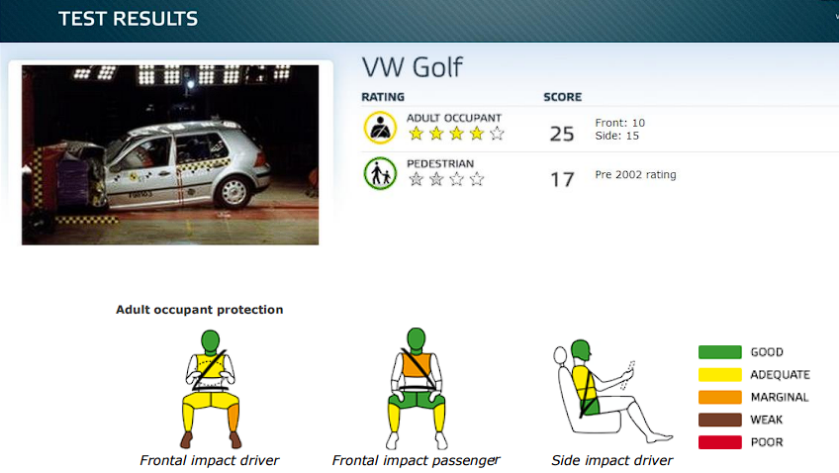
Figure 1, (Adult occupant protection, 1998)



Figure 2, Golf GTI, Joe Howard, 2023

2.1 Dynamic Characteristics of the vehicle

Test Mass (Kerb + driver + Equipment + luggage) | 1213+75+20+20 = 1328kg₄
Coefficient of drag | 0.31₁
Frontal Area | 2.34 M₃
Tyre size | 225/40/18
Tyre rolling resistance | 0.874 N₂
Coefficient of rolling resistance | 237.99 N₃
1-(UKMKIV.net)
Figure 3, Vehicle data
2- Barker (2023)
3-Calculated in CAD/excel
4- WLTP document 2021
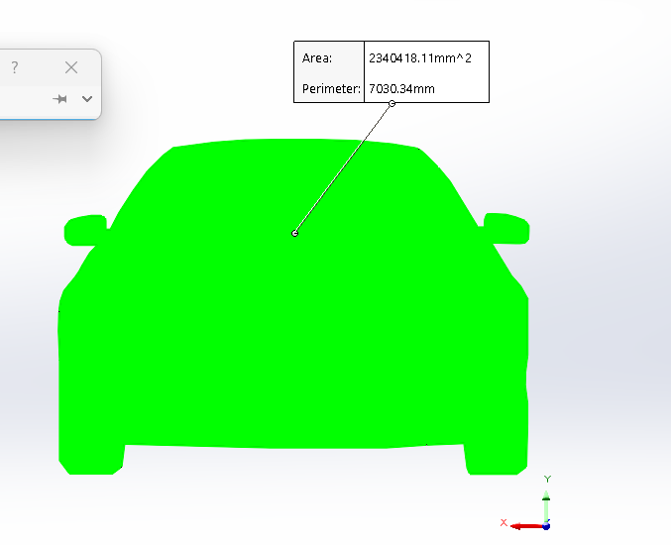

The image on the left shows how the frontal area of the VW Golf was measured in SolidWorks. An outline of the front profile was drawn on a front facing image of the car. The image was then sized mirror to mirror, and the frontal area was calculated after that.

Figure 4, Frontal area

2.2 WLTP Selection
Class 3 was chosen for this vehicle due to its performance characteristics. The golf has a power : weight ratio greater than 34.
167782/1213 = 138.31
The Worldwide Harmonized Light Vehicles Test Procedure (WLTP) is a testing procedure used to measure fuel consumption, energy consumption, range, and emissions of cars and light commercial vehicles. Introduced in 2017, it replaced the NEDC (New European Driving Cycle) test, providing more accurate data by simulating real-world driving. The WLTP includes a more varied driving test, higher speeds, and stricter temperature ranges. It ensures more accurate analysis between vehicles and is essential for environmental considerations. The graphs below show the calculations for this vehicle.
Figure 6, WLTP calculations

Figure 5, WLTP calculations

Figure 7, WLTP calculations

Figure 8, WLTP calculations

Figure 9, WLTP calculations

3.0 Energy recovery analysis

A Kinetic energy recovery system can be used to harvest braking energy from the vehicle. A total braking energy of just over 300,000 Joules can be harvested. 300,000 Joules in 1800 seconds is required. This is equivalent to 300KJ / 300 Kilowatt Seconds.
Figure 10, WLTP calculations

Using E = P x T and J = W x S it is possible to figure out Kilowatt Hours. 300 KWS/3600 = 0.083 Kilowatt Hours of energy that is used to slow the vehicle down. This is the energy that can be harvested by regenerative braking.

4.0 KER system analysis and calculations

Electric motor onto the flywheel –
Using an electric motor on the flywheel is a reliable and efficient way of harvesting kinetic energy from a motor vehicle. In this instance, an electric motor would be fixed to the flywheel of the Internal combustion engine. The motor would be able to recover kinetic energy by decelerating the car, and it will also have the capabilities to add power to the powertrain system. Either working individually, or assisting the engine, the motor will be able to assist in the forward motion of the vehicle. In this theoretical design, the motor will send power to the wheels through the manual transmission. A clutch will be used to disconnect the engine from the drivetrain, so that the motor will not lose as much efficiency turning the engine as well as the drivetrain.

System Components:
Electric motor – The electric motor that will be used in this instance is a 150KW Permanent synchronous magnet powertrain. The PSM motor was selected because of the small footprint, lighter mass and simplicity compared to a ASM motor. Research was found to prove this ‘For the ASM on the other hand, there are higher costs due to its additional size and higher cooling requirements. It needs more case material like Aluminum, a larger stator, and more copper for the windings. The extra costs for the stator exceed the additional costs for the magnets of a PSM with comparable power.’ (Lindvai-Soos and Kaimer, 2021).
The PSM motor has an output power of 150KW (201BHP), a weight of 77kg and an efficiency of >95% (150kW Motor | Electrofit, no date)

Standard manual transmission – According to ( Stephan Lacock , Armand André du Plessis and Marthinus Johannes Booysen, World Electric Vehicle Journal, 2023) ‘The efficiency of an MT ranges from 92 to 97% depending on the load and speed input’. Using this data, the worst-case scenario will be assumed. That being the efficiency is 92%, which gives 8% loses through heat and friction
Other drivetrain components – A pair of driveshafts and a differential are needed to deliver power to the wheels. Being a front wheel drive car, the differential is built into the gearbox. There are two driveshafts that come out of the differential to power the wheels. Using research from (x-engineer.org, no date), the efficiencies of these components can be calculated, which will further help the calculations of recoverable energy and electrical propulsion.

Driveshafts- The article states ‘The inner CVJ (on differential side) usually is a Tripod type joint, while the outer CVJ is a Rzeppa type joint. The efficiency of these joints is around 0.99’ (x-engineer.org, no date). The efficiency of these joints can be calculated as follows:
- Efficiency of one shaft = 0.99 * 0.99 = 0.98. This gives a loss of 2%. For two driveshafts, the loses would be 4%.

Differential – The article also states that ‘There are 3 bearings (one on the input pinion, one on the left output shaft and one on the right output shaft) and 1 spiral bevel gear. The efficiency of a ball-bearing is around 0.99 and of a spiral bevel gear mesh around 0.96. With these numbers, we can calculate the overall efficiency of the differential.’ (x-engineer.org, no date)
- Differential efficiency = 0.99^3 * 0.96 = 0.931. This gives an efficiency of 93.1% and a value of 6.9% in loses.

Calculating Complete drivetrain efficiency
Efficiency = 0.95 (motor) * 0.92 (Transmission) * 0.96 (driveshafts) * 0.931 (differential)
Total efficiency of drivetrain = 0.7811 or 78.11%

Battery Storage cell –
An efficient storage device is needed to hold all the electricity that is generated through regenerative braking. The battery must also be able to discharge the power at a constant rate that is suitable for the rating of the motor. Therefore, the battery must be able to be charged and discharged thousands of times without the need for regular maintenance. This will make the vehicle reliable and more appealing to consumers.
A research paper (By Yunus Emre Ekici , Nusret Tan) named ‘Charge and discharge characteristics of different types of batteries on a hybrid electric vehicle model and selection of suitable battery type for electric vehicles’ Goes into detail comparing LiFePO4, Nickel Metal Hydride, Lead Acid and Nickel Cadmium batteries. Their research will be summarised, and then an informed decision can be made for a suitable battery type. A 30kwh battery will be used in this vehicle. This should be sufficient to store lots of energy from regenerative braking and can power the vehicle for a long distance.

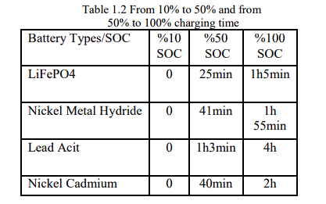

In this test, the time taken for each battery type to charge to 100% is recorded. It was discovered that LiFePo4 was the fastest. This is ideal for either charging at home, or when recovering energy.
Figure 11, (Yunus Emre Ekici, 2019)

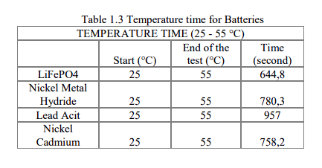
In this test, the time for each battery to heat up from room temperature to 55 Degrees Celsius. This test is critical in situation where the battery inside the vehicle must heat up to optimal operating temperatures quickly so that the vehicle can drive, and that everything is operating efficiently. The Lithium Iron Phosphate battery is the best in class.
Figure 12, (Yunus Emre Ekici, 2019)

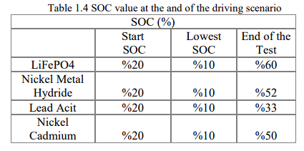
In the final test, the batteries were put into a simulation of charging and discharging. This was to represent the real-world situation of the cells being charged and discharged for whatever the BMS requires. All batteries started at 20% capacity. After being discharged equally and being given the same constant charge rate, the Lithium Iron Phosphate battery had the highest state of charge.
Figure 13, (Yunus Emre Ekici, 2019)

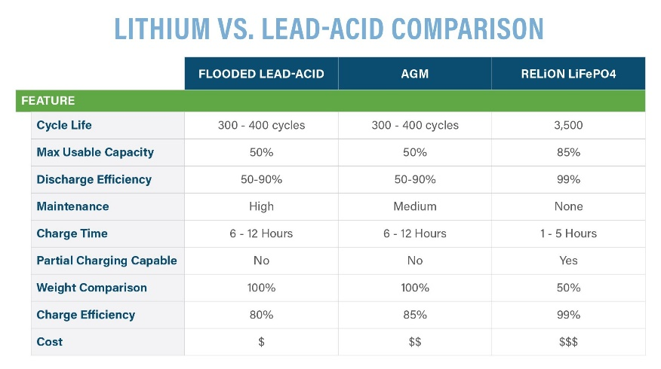

A different source, found on Relion batteries, further reinforces the evidence that Lithium Iron Phosphate batteries outperform other types of batteries. Using this data, the efficiency of the battery and the maximum usable capacity will be used in further calculations.

Figure 14, (Relion, 2024)

Inverter – with information found from EVEngineeringOnline,(Heney, 2024), the following quote was found that describes efficiency of EV inverters: ‘EVs are moving from inverters with silicon-based semiconductors to those based on silicon carbide (SiC). This is primarily due to an increase in efficiency from 97 to 98% for silicon to 99% for SiC.’ With this quote, it is assumed in this case that the inverter in this system will have an efficiency of 99%

5.0 Electric motor deceleration –
According to a regenerative braking test on The Brake Report, ‘The vehicle is able to brake up to ~0.2g without any hydraulic pressure applied’ (The Brake Report, 2023) This quote is discussing the regenerative braking deceleration force of an electric vehicle, which will be used in the assumption for this paper.
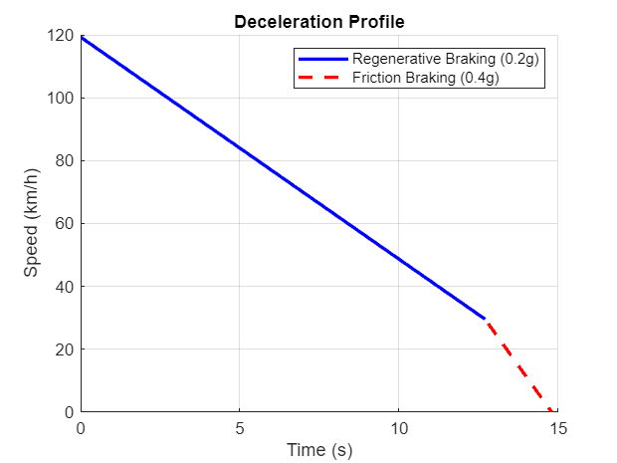

Figure 15 shows a MATLAB graph that shows the theoretical regenerative braking of the vehicle, with the transition to friction braking at low speeds.

Figure 15, MATLAB drive cycle assumptions

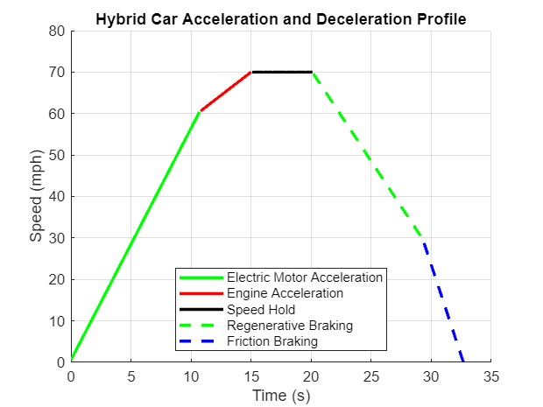
Figure 16 is another MATLAB produced graph, which represents the theoretical drive cycle of the hybrid vehicle. The motor accelerates the vehicle at 2.5 m/s^2, the engine then takes over and accelerates the vehicle from 60 to 70 mph, at a speed of 1m/s^2. The engine then maintains the current velocity until the regenerative braking takes over, slowing the vehicle at 0.2g. The friction brakes take over at 30mph and slows the car at a rate of 0.4g until the vehicle hits rest.
Figure 16, MATLAB drive cycle assumptions

6.0 System Operation
This vehicle will operate in a similar way to a regular car with a manual gearbox. As the motor is attached to the flywheel, the manual gearbox will have to be operated when accelerating with the engine or the motor. An automatic clutch will engage and disengage the motor when required. For the driver, the experience of operating the vehicle will remain mostly unchanged. As the driver will operate a clutch and gear selector even when in full electric mode. This design was chosen to keep the principal as simple as possible, and to reduce the extra weight of a more complex motor on wheel system. The image below demonstrates how the motor will be integrated with the engine. The motor is fitted inside the bell housing, with the 3 phase cables visible in orange at the top.
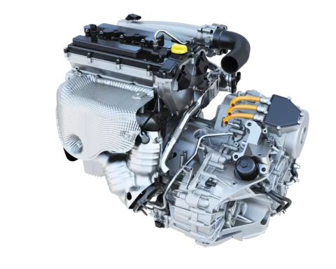

Figure 17 , (Electrified Internal Combustion Engines | AVL, no date)

6.1 Total system efficiencies

According to the figure below, 23.26km is travelled during the wltp test.

0.083 KWh of electricity can be recovered in 23.26km.
0.083/23.26*100= 0.35kwh per 100km.
Using Total efficiency of drivetrain = 0.7811 or 78.11%,
0.35kw * 0.78 = 0.27 kwh (drivetrain loses)
With battery loses, 0.27 * 0.98 (battery and inverter) = 0.2646KWH into the battery, per 100km.
Convert back to the wltp cycle: 0.2646/100*23.26 =0.061kwh.
Back to the road – 0.061kwh * 0.7644 ( total system efficiency) = 0.046kwh

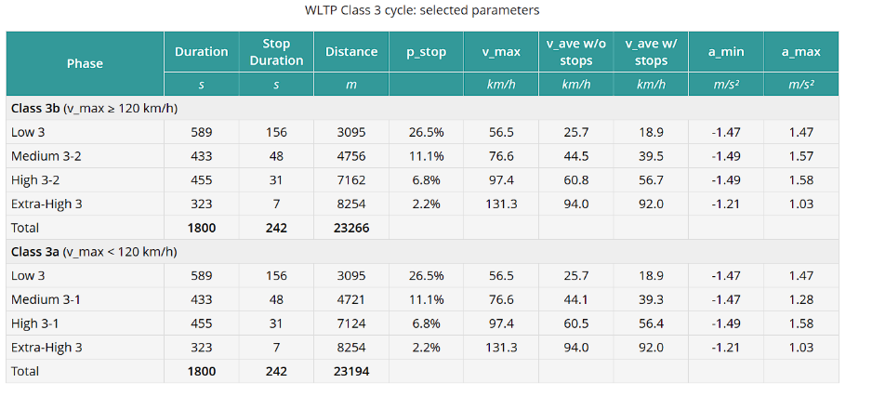

Figure 18 , (Emission Test Cycles: WLTC, no date)

Figure 19 , WLTP calculations

The figure above shows the energy transferred back to the wheels from the battery. With the total system efficiency in mind, just under 250,000 joules is used from the battery, until the system is empty. At the beginning of the paper, it was observed that just over 300,000 joules could be harvested.

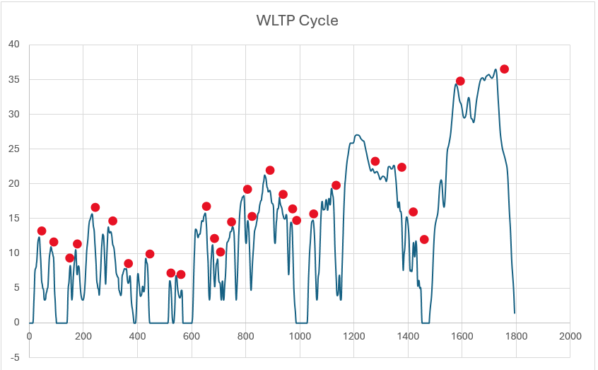

Figure 20, WLTP Calculations
The graph above represents every moment where the car is decelerating. This will either be using friction braking or coasting down. The braking is less frequent on the high and extra high sections of the WLTP, where velocity is higher.
7.0 Conclusion
During the WLTP cycle, it is possible to harvest energy from the braking of the vehicle. It is also possible to store that energy and then redeploy it to power the vehicle. This will reduce the emissions of the ICE, as it will not be used as frequently. However, the quantity of energy recovered is not a large amount. The energy recovery will assist in slowing the discharge rate of the battery but will not suddenly give the battery charge. Over a long drive of a few hours, the recovered energy will be much greater and will have a larger impact. But over the 30 minutes of the WLTP cycle, it is an insignificant amount. The efficiency of the car is also worse than expected. With 76.44% efficiency, that is 23.56% of electricity lost in the system as heat and friction. This does significantly reduce the energy harvested.
Overall, the theory is possible. There will have to be a more efficient way of collecting energy, or another system to aid the regenerative braking system. The goal of the paper has been completed. A solution to reduce emissions in a motor vehicle has been demonstrated. There have been no considerations to the added weight that the vehicle from the motor, battery and inverter. This added weight will add extra load on the engine, which will result in higher fuel burning. It must be observed as to how long the extra fuel burned will be a leading factor in this proposal. As it may take years for the hybrid system to reduce emissions that were produced carrying the system.

8.0 References –

Mk4 gti weight https://fastestlaps.com/models/vw-golf-gti-mk-iv

https://www.carsized.com/en/cars/volkswagen-golf-1997-5-door-hatchback/front/
for width

https://www.carfolio.com/volkswagen-golf-gti-16995
for drag coefficient

The Golf MK4: A new era | VW Life Magazine | Volkswagen UK (2024). https://www.volkswagen.co.uk/en/yourwagen/magazine/vw-golf-evolution/mk-4-a-new-era.html.
Golf NCAP Adult occupant protection (1998) VW Golf 1.4. report. https://cdn.euroncap.com/media/9743/euroncap_vw_golf_1998_4stars.pdf.

Goingslow? (no date) VOLKSWAGEN GOLF 1.8T AUM 150 STAGE 1 REMAP 210 HP 06A906032HJ IMMO OFF. https://goingslow.co.uk/products/vw-golf-1-8t-aum-150-stage-1-210-hp-06a906032hj-immo-off.
https://thebrakereport.com/regenerative-braking-characterization-4-of-4/
Ellmore, J. (2024) What is Miles per kilowatt-hour mi/kWh? | Electric Car Guide. https://electriccarguide.co.uk/what-is-miles-per-kwh-mi-kwh/#:~:text=Tesla%20Model%203%2C%20Standard%20Range,500e%3A%204.57%20miles%20per%20kWh.

Electric Vehicle Drivetrain Efficiency and the Multi-Speed
Transmission Question
Stephan Lacock 1 , Armand André du Plessis 1 and Marthinus Johannes Booysen 2,* 2023
x-engineer.org (no date) Drivetrain losses (efficiency) – x-engineer.org. https://x-engineer.org/drivetrain-losses-efficiency/.
Lindvai-Soos, D. and Kaimer, S. (2021) 'Electric drives for all-wheel functions - a system comparison of ASM and PSM,' ATZ Worldwide, 124(1), pp. 48–51. https://doi.org/10.1007/s38311-021-0754-y.
150kW Motor | Electrofit (no date). https://www.electrofit.com/product/150kw-electric-motor-oem/.

Charge and discharge characteristics of different types of batteries on a hybrid electric vehicle model and selection of suitable battery type for electric vehicles, Yunus Emre Ekici, Nusret Tan, 2019

https://www.relionbattery.com/resource-center/technology/lithium-vs-lead-acid
Heney, P. (2024) EV inverters: Key to motor control. https://www.evengineeringonline.com/what-is-driving-development-of-ev-inverters/#:~:text=Reduced%20weight%20further%20increases%20range,silicon%20to%2099%25%20for%20SiC.

Emission Test Cycles: WLTC (no date). https://dieselnet.com/standards/cycles/wltp.php.
Barker, J. (2023) 'Best 18-inch tyres - R18 225/40 performance tyre test,' Evo, 1 December. https://www.evo.co.uk/tyre-reviews/18309/best-18-inch-tyres-r18-22540-performance-tyre-test.
Is a bora more aerodynamic than a MK4 Golf? (2009). https://www.uk-mkivs.net/threads/is-a-bora-more-aerodynamic-than-a-mk4-golf.190291/.
Wltp 2021 United nations document
Electrified Internal Combustion Engines | AVL (no date). https://www.avl.com/en/engineering/hybrid-propulsion-engineering/electrified-internal-combustion-engines.

