Llyanllyr landscape characterisation

Key words
Llanllyr, dendrochronology, dig-site, dendrochronology, neolithic

Llanllyr is currently a free-range livestock farm that is located In the greater Ceredigion area. It was a nunnery in the Cistercian period (Murphy,2015 p.3) the area itself is a such green collection of fields that are there for sheep and cattle to graze in. like in many fields in rural farmland it is segmented by fences made of various types of shrubbery and flora. The botanical archaeology of the area is of key interest as it can reveal a significant portion of history, as the neolithic era is primarily known as the time period when humanity began farming, although, britain did begin farming later as it took a little longer for the climate change enough for farming(Prehistoric Wales | Cadw).
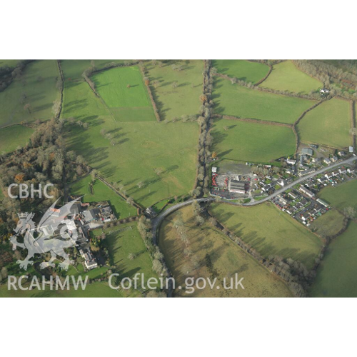
figure 1/6456665/Toby G Driver/2007/coflien

In 2015 there was an archaeological dig in Llanlyr that was primarily about the Cistercian settlement(Murphy, 2015) which, unfortunately is not the focus of this landscape characteristic but it tells us a large deal about what significant changes that happened in the intervening years. Changes in the environment such as the water being diverted in order to make living in that area significantly easier(Murphy,1025 p.6). the neolithic period was known primarily for the introduction of agriculture into human society and living(Prehistoric Wales | Cadw,). This led to the rapid introduction of cereals in Britain and Ireland, cereals including wild fruits and berries, cereal grain, cereal chaff and Celtic beans, among more(Bradley and Edmonds, 2005 p.200). this means that in the general area the flora in Llanlyr shows evidence of at least an attempt in neolithic styles of farming .

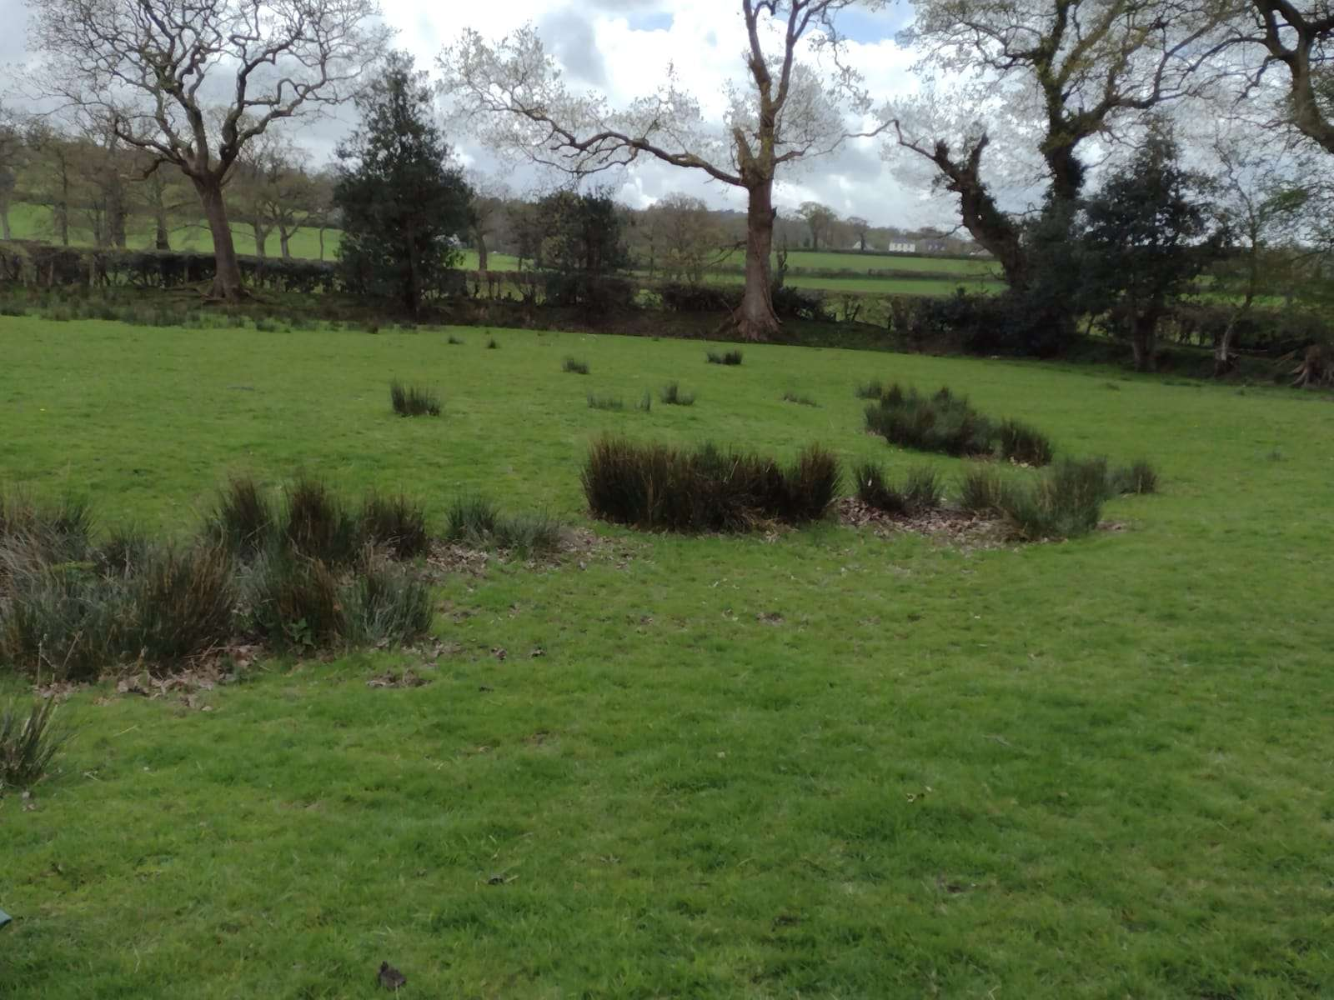
figure 2/Llyanllyr field/caleb rees/2024/Llyanllyr
the area of Llanllyr has a storied history as there is evidence of people settling there for thousands of years, so the area actually has physical evidence of people crafting tools in the area of Llanllyr as mentioned by Martin Bates in the archaeological dig that took place in Llanllyr in 2024. These tools show evidence that there was human activity in the area of Ceredigion (see table 1) (Treasure et al., 2019 p.196) the table below shows that there is settlements of farming in Ceredigion but few and far between ,but it actually shows that there is a concentration of settlements in the north-eastern part of Wales as well as the eastern and the south-western parts of Wales so it is possible that the areas in Ceredigion (25) are stopping points that people would stop at and remake tools as well as restock on food, as there has been no settlements found in the recent 2024 dig as well as having found a nunnery in Cistercian buildings found in the area (Murphy,2015 p.3)as well shows that there is no long term settlements in the Llanllyr. In order to date the area in a specific time methods such as carbon and radio dating is used but more specifically in Llanllyr is dendrochronology is primarily used for gathering an eco-fact file, such as the dig site in Llanllyr that took place in 2015 as well as the most recent dig that happened in 2024.

Table 1

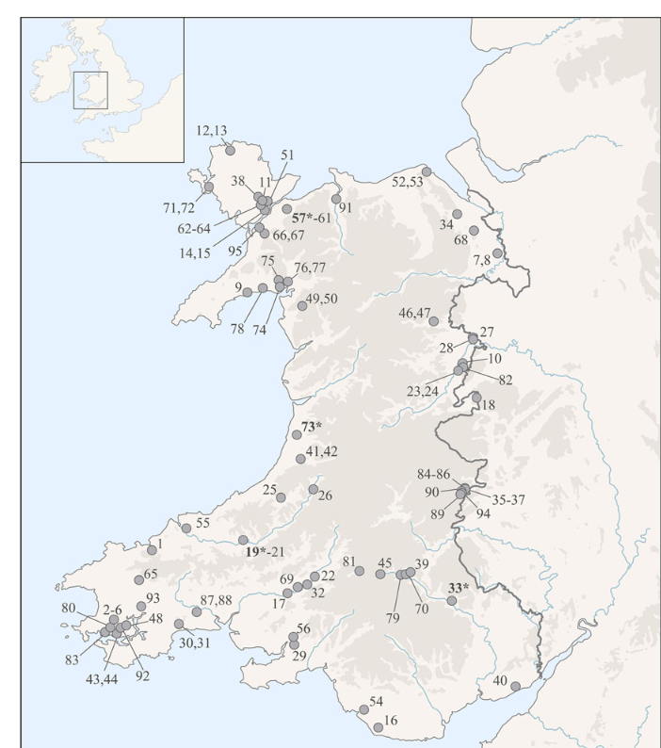
figure 3/distribution of sites/Treasure et al/2017
The lack of evidence can actually tell us a good deal of information, specifically the distinct lack of structures and megaliths in the surrounding the greater Ceredigion area and by extension, Llanllyr. this lack of buildings and megaliths shows that there was no reason for the creation of them or that there was no importance Llanllyr that was worth creating something significantly large, or inversely there was no available materials in the surrounding area to build these sorts of megaliths(Whittle, 2017). But as treasure said “the neolithic period is defined by a dramatic change in the archaeological record”, this is essentially saying that the neolithic period is so different to all that came before so there is a thought that there was such a dramatic shift in the times that it caused people to adopt new ways and new societal norms. This leads on to the previous idea that the area of Llanllyr was transit point in the context of the nomadic neolithic period that people eventually became the societies we know now. Since the climate dramatically shifted in the neolithic period it allowed for the European part of the world start being able to farming and agricultural practices such as farming or just planting certain plants in the area such as breakfast grain(Treasure et al., 2019 p.194), all of these factors caused a shift in life stye that would necessitate a re work of everything that happened in the world.
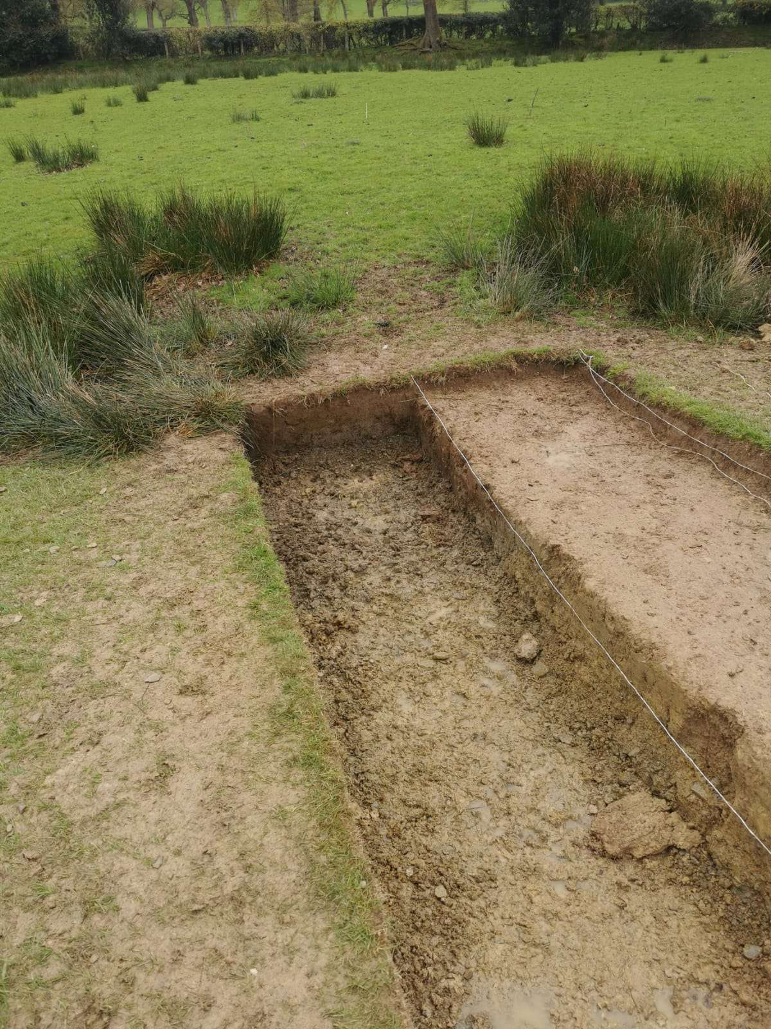
figure 4/trench 14/caradoc ewing/2024/Llyanlllyr

During the neolithic period there was a significant social factor that took place in Europe and the rest of the mid neolithic period (Castleden, 2014 p.3) this means that there is a social factor that eisted in Llanllyr and that possibility of it being a trade hub or meeting point in the neolithic period in the Wales. This is also further linked to the neolithic axe trade that took place in the eastern part of Britain that eventually made its way towards Wales and resulted in a few stone axes being found in Wales of considerable size(Bradley and Edmonds, 2005). Since there is evidence of bladelets in Llanllyr and Ceredigion it is possible that Llanllyr was a place where people would knap flint tools in order to survive on their journeys across prehistoric Wales. The water sources that exist in Llanllyr. Water, is used when knapping and by looking at the evidence of lakes and streams existing in different point, provides evidence that there were good conditions for knapping stone and flint into tools, aswell as there bing solid conditions for berries and other cereal foods to grow within the area. Evidence of this can be seen currently as there is lush forestry and rolling hills in the Talsarn area making it a prime location to grow small bush based foods aswell as to raise herd animals on a farm, which is exactly what is being done in modern times now.

“Trails, paths and roads are essential structures of the human landscape”(Snead, Erickson and Darling, 2011 p.1) the paths that animals and humans walk is aimportant as even birds are known to have strict migration patterns, these patterns manifest in humans much the same as humanity will create desired paths in nature and in modern society and although there is little evidence of a desired roads being made all the way from the neolithic era. There is evidence of travel and of movement of humans as there was no structures or evidence of permanent structures in Llanllyr. Roads in the neolithic era is not a stretch but there is documented evidence of there being a trade route that the Welsh would take in order to export goods across the mountains of North Wales which as table one recalls North Wales is a cluster of berry farms and settlements within Wales.whether or not these trade routes existed later is irellevant but it is clear evidence that there was a form of trade within wales and routes across the country did exit in the neolithic time period.

Llyanllyr is an area that has had a lot of history such as the cistertion nunnery. And potentially even further back. The entire area is blanketed in the rich cultural history of wales, which only compliments the cant emeral hills that cover the area. The neolithic period mustve been that such time as it is evident thay people did come to this location regulary for thousands of years in order to collect food or even craft tool out of flint and stone, while now it is a farm used for raising sheep and lamb aswell and calf and cow. There is a significant amount of evidence to sacn through that this are has been marked by human activity and it seems it will continue too for decades to come.

Bradley, R. and Edmonds, M. (2005) Interpreting the Axe Trade: Production and Exchange in Neolithic Britain. Cambridge University Press.
Castleden, R. (2014) Neolithic Britain: New Stone Age sites of England, Scotland and Wales. Routledge.
Murphy, F. (no date) ‘SURVEY AND EXCAVATION AT LLANLLYR MEDIEVAL NUNNERY AND POST-MEDIEVAL MANSION, CEREDIGION, 2014-2015’.
Prehistoric Wales | Cadw (no date). Available at: https://cadw.gov.wales/learn/sites-through-centuries/prehistoric-wales (Accessed: 16 May 2024).
Snead, J.E., Erickson, C.L. and Darling, J.A. (2011) Landscapes of Movement: Trails, Paths, and Roads in Anthropological Perspective. University of Pennsylvania Press.
Treasure, E.R. et al. (2019) ‘Neolithic Farming and Wild Plant Exploitation in Western Britain: Archaeobotanical and Crop Stable Isotope Evidence from Wales (c. 4000–2200 cal bc)’, Proceedings of the Prehistoric Society, 85, pp. 193–222. Available at: https://doi.org/10.1017/ppr.2019.12.
Whittle, A. (2017) ‘Places of Special Virtue : Megaliths in the Neolithic landscapes of Wales’, pp. 1–224.
figure 5/trench 14/caradoc ewing/2024/Llyanlllyr
figure 3/distribution of sites/Treasure et al/2017
figure 2/Llyanllyr field/caleb rees/2024/Llyanllyr
figure 1/6456665/Toby G Driver/2007/coflien

