Data Security, Governance And compliance Report

Name: Ao Liu
Student Number: 2106322
Finish Date: 2/January/2022

Contents
Abstract
- Introduction 4
2.Security Frameworks and Models 6
2.1 Information Technology Infrastructure Library 6
2.2 International Organization for Standardization 27000 11
2.3 Control Objectives for Information and related Technology 13
3.Information Security System design. 15
3.1 Server Management 16
3.2 Check Management 17
3.3 Data Resource Management 17
4.Conclusion 18
5.references 19

Abstract
With the continuous improvement of infrastructure and the popularization of network terminal devices such as computers and mobile phones, more and more companies choose to provide customers with their own services and products through Information Technology (IT) and manage their own employees. This means that a large number of important information such as employee information, customer information, and the company intellectual property rights may be attacked by other netizens. Therefore, how to design a safe and reliable information system has become a major problem for enterprises.
This paper studies the advantages and disadvantages of three different network security models, including Information Technology Infrastructure Library (ITIL), Information Standardization Organization 27000 (ISO 27000) and Control Objectives for Information and related Technology (COBIT). Then, based on the improved ITIL model, a perfect information system is designed for CoffeeBlue Company to ensure that the company can provide customers with high-quality IT services and a more effective staff management system. The most important thing is to ensure that employees and customers of enterprises can enjoy convenient IT services and protect their information security from threats.

Keyward: IT service, ITIL , ISO 27000, COBIT.

- Introduction
With the rapid development of IT, more and more enterprises have increased their investment in IT to enhance the competitiveness of enterprises and meet the needs of customers. Different from the traditional model, enterprises should not only innovate products to meet customers' preferences, but also combine products and IT to adapt to the development of the times. Therefore, enterprises need to purchase related equipment, introduce network technology professionals, build network platforms and servers, and provide reliable network services to customers. At the same time, with the increasing demand for equipment and network platforms, more professionals are required for daily operation and maintenance.
With the rapid development of cloud computing technology, enterprises have solved some problems. Its advantage is that enterprises can quickly deliver the required infrastructure services through virtualization technology, but the shortcomings of cloud computing technology are also obvious. Many key information of enterprises, such as customer information, core intellectual property rights, employee information, etc., are likely to be exposed to the public cloud platform and attacked by others at any time. Once this critical information is leaked, it will cause immeasurable losses to the enterprise. Therefore, many enterprises will adopt the hybrid cloud platform made of public cloud platform and private cloud platform to provide cloud services to customers and employees.
Under this mode, the core technical system of the enterprise will remain in the local server, and some customer-oriented systems will be migrated to the public cloud platform. While enabling enterprises to provide cloud services to customers, it is more convenient to protect the security of a large amount of data, reducing the cost and pressure of some enterprises on IT service operation and maintenance.
IT can provide stable, efficient and safe services for corporate customers and employees. But the most important thing is that we need a comprehensive and reliable enterprise information security system. The development of cloud computing provides more reliable and efficient solutions for enterprise IT deployment, helps traditional enterprises transform to digital enterprises, and provides better cloud services for customers and employees. At the same time, it also brings significant data security problems to enterprises. First, within the enterprise, employees' own private information and related intellectual property rights of the company are likely to be attacked by external hackers, leading to data leakage and great losses to the company; Secondly, when customers are enjoying the cloud services provided by the company, their dynamic information will be exposed to the public network. If the customer's information is not effectively protected, the rights and interests of customers will probably be infringed.
In order to prevent the above situation from happening, in addition to enhancing personal safety awareness, it is more important for the company to design a complete and reliable information security system to protect the data security of the company and customer. In the first part of this paper, the advantages and disadvantages of three network information security frameworks (ITIL, ISO 27000, COBIT) will be analyzed; the next second part will design an information security system for CoffeeBlue Company according to the ITIL protocol, which can protect the personal data of employees and customers while providing online services for customers. Finally, the third part summarizes the three different information security frameworks mentioned in the article and the shortcomings of the information management system designed for CoffeeBlue Company, and puts forward the improvement direction and future prospects.

- Security Frameworks and Models
  - Information Technology Infrastructure Library
Information Technology Infrastructure Library (ITIL) is a guiding framework for continuously improving IT services. The purpose of the design is to guide enterprises to strengthen the connection between IT and products, and to improve the IT service quality. ITIL is a result of repeated practice. And it is developed by experts all over the world and can be provided to any organization in the world for free. Therefore, ITIL is also a classic framework which is constantly updated and improved.
Since its birth, ITIL has gone through three versions. First of all, from 1986 to 1999, ITIL gradually formed ITIL 1.0, which consists of two parts, service providing and service supporting version. Secondly, during the period of 1999-2006, professionals paid attention to ITIL 1.0, and after further supplement and improvement. ITIL 2.0 includes six modules, namely, business management, service management, IT infrastructure, application management, security management and IT service management. Finally, from 2007 to the present, on the basis of ITIL 1.0 and ITIL 2.0, ITIL 3.0 is to introduce the practical experience in IT service management. The composition of the three versions of ITIL is complex, including the necessary resources for it service management, and clarifying the specific roles of objectives, input and output, activities in each process.
Nowadays, ITIL is being used by thousands of enterprises in all walks of life around the world. These enterprises also brought many successful cases of ITIL practice, which not only succeeded, but also greatly enriched ITIL. ITIL has received the full support of many Internet giants and has been widely used in Europe, North America, Australia and other regions.
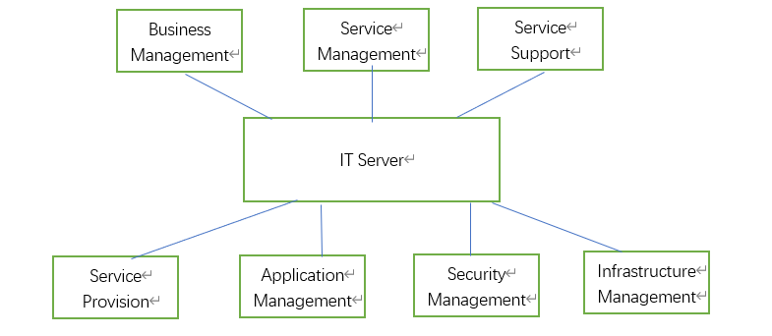
Fig1. The frameworks of ITIL 2.0
The security module is responsible for defining the service security requirements, formulating relevant security policies, and handling methods after various security incidents, so as to protect the entire IT architecture and user data security. The main tasks of security management are to maintain the normal operation of the system, repair system anomalies, data backup and firewall management. During operation, the security management module formulates different permissions to restrict some unauthorized operations, which leads to serious security problems in the system.
Information service management module is the core of ITIL framework. It consists of two core processes: service support and service provision. The core function of this module is to integrate all IT infrastructures for centralized management, thus ensuring the stability and reliability of the whole IT service, and finally stably supporting business execution and provide high-quality services to customers.
The application module is an extension of IT service management, including the development, testing and implementation of the application system. Its core purpose is to ensure that the application system can meet the needs of customers, facilitate the real-time maintenance and development of the application system by managers, and enable the system to respond and deal with the problems in actual operation more quickly, thus giving customers a better experience.
The business management module is to better understand the business requirements and determine the requirements of IT services through business requirements. The business module provides a new idea for managers, that is, taking business as the center to solve information service problems, knowing the supporting ability of it infrastructure to business processes, and then clarify the role of IT service management in providing IT services, so that managers can understand the relationship between IT services and business.
The focus of information technology service module is implementation. The module establishes reasonable goals, and then analyzes the gap. It is also possible to establish long-term goals and realize the analysis and evaluation of the present situation.
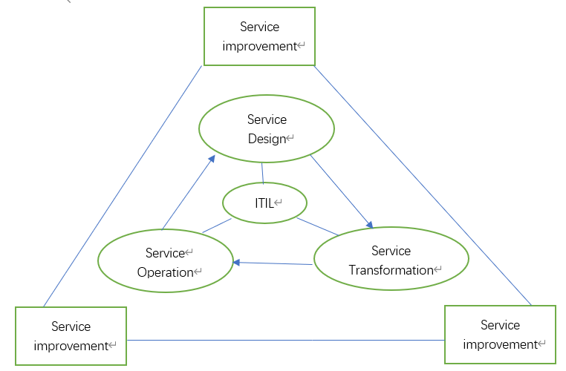
Fig. The frameworks of ITIL 3.0
The core of ITIL 3.0 is the service life cycle, including five service life cycles: service strategy, design, transformation, implementation and improvement.
Service strategy can provide process and guidance throughout the service life cycle, and guide the implementation process of design, development and service management.
The purpose of service design is to guide the development and design of service and service management processes. Service design is based on service strategy to achieve the strategic goal of specific services. The main processes include service catalog management, service level management, availability management, capacity management, service continuity management, information security management and so on.
The goal of service transformation is to provide guidance in the process of the transformation from new service to operation. It is in the second of three real-time phases. Service transformation depends on service design, providing conditions for service realization.
The purpose of service operation is to deliver the determined service levels to customers and users, and to manage the delivered applications, technologies and frameworks. This stage is the stage of realizing the service value, which enables the service strategy, service design and service transformation to become routine and reach the service level expected by users. The business scope includes technology, services, personnel and management processes.
The purpose of service operation is to deliver services to customers, and to manage the applications, technologies and frameworks in the delivery process. This stage is the concrete implementation stage of services, which enables the service strategy, design and transformation to be put into practice and delivered to customers who meet their needs. There are two modes of service operation: active and passive. Its value lies on optimizing the design and planning, maintaining the stability of the system and adapting to changes in external demand.

Service improvement first evaluates the whole stages of service quality and service management life cycle, and then puts forward practical and effective suggestions for each stage of the service life cycle, thus improving service quality. Service improvement should not only improve service quality and efficiency, but also optimize processes, reduce service cost and improve service efficiency on the premise of not affecting user experience.
  - International Organization for standardization 27000
ISO/IEC 27000 (ISO 27000) series of standards is a set of standards designated by the International Standards Organization for the information security management system. They are composed of iso 27001 and iso 27002 standards, modified by bs 7799-1 and bs 7799-2 standards issued by the British Standards Institute (BSI) in 1995, respectively, forming a general framework, which is convenient for establishing information security management.
Risk management is the core of information management. By identifying, evaluating and analyzing information security risks, the probability of risk occurrence will be reduced to a very low level, and some measures will be taken to ensure that the business will not be interrupted and cause losses due to security incidents. ISO 27001 standard requires risk assessment, making information security strategy, determining the scope of management system, defining management responsibilities, determining control objectives, selecting control measures, etc. Once the system is established, the organization shall continuously maintain and improve the information security management system in order to keep the system effective. Similar to the ISO 9001 quality management standard in ISO 9000 series, ISO 27001 standard puts forward a PDCA reference model for the establishment, implementation, operation, monitoring, evaluation and improvement of information security system, emphasizing the continuous cyclic improvement based on the PDCA model. The construction and operation mechanism of information security system based on PDCA cycle model can effectively improve the initiative of information security management in enterprises.
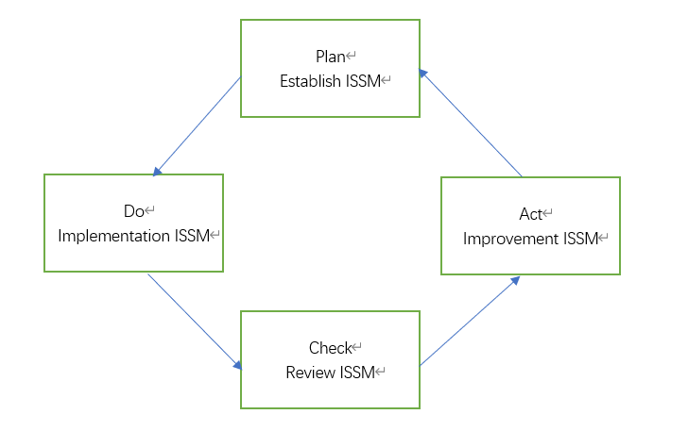
Fig3. PDCA cycle model
Plan, establish information security management policies, objectives, processes and specifications consistent with the overall strategy, objectives and policies of the organization to manage information security risks.
Do, policies, control measures, processes and specifications for implementing and operating the information security management system.
Check, evaluate the effectiveness of information security management according to the policies and objectives of the information security management system, and report the results to the manager for review.
Act, based on the results of internal audit and management evaluation of the system, take corrective and preventive measures to continuously improve the organization's information security management system.
ISO 27001 standard divides the activities in the field of information security management into 114 specific security management and control measures, and the management system based on the standard ensures the all-round security of important information assets of enterprises. The business demand-oriented information security management system construction method is the biggest feature of ISO 27001 standard, which can ensure that the management activities in the system meet the needs of enterprise business management and control to the greatest extent. Carry out information security construction around information assets, and protect the confidentiality, integrity and availability of information assets by identifying assets and threats, making up loopholes and controlling risks.
  - Control Objectives for Information and related Technology
COBIT framework is based on the following main characteristics: business-centered, process-oriented, driven by control and performance evaluation.
The core of COBIT framework with business as the center is the business requirements of enterprises. It provides a comprehensive guide for it related internal and external stakeholders and business process participants such as it managers, it users and it auditors.
COBIT framework supports enterprises to determine it resources according to business needs, use it resources to determine IT processes, generate enterprise information based on IT processes, and finally meet business needs through enterprise information.
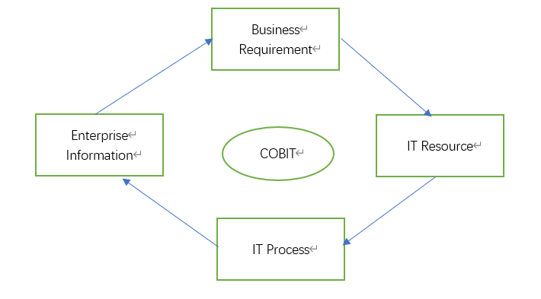
Fig4. The frameworks of COBIT
Driven by the actual business needs, enterprises should adopt a sound and standardized framework to guide their investment, management and control of it resources, and generate the information needed by enterprises through reasonable and standardized IT processes to meet the business needs. Managing and controlling information that can meet the business requirements of enterprises is the core of the COBIT framework. Information must meet certain control standards to meet business requirements.

- Information Security System design
CoffeeBlue mainly sells Jamaican Blue Mountain Coffee, which is a very popular coffee. Besides offline sales, the company provides IT services to customers and employees through cloud services. Therefore, the company has to deal with a lot of online businesses every day. A large number of online businesses that need to be processed in real time have brought great pressure to the company. Every day, a large number of customers and employees need access to the company's servers. And the personal information security of employees and customers has a huge potential safety hazard. Once the data is missing or leaked, the company will suffer huge economic losses.
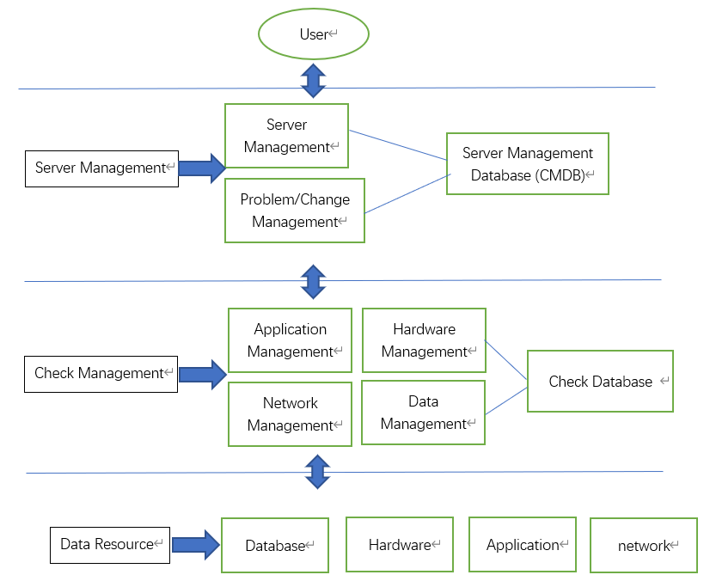
Fig5. The Security system for CoffeeBlue

Aiming at the problems existing in Coffee Blue Company, based on ITIL network security architecture, this paper analyzes the business and security requirements of the company, and builds a complete network security architecture, including service management, check management and data source management.
3.1 Server Management
Server Management includes project management, problem management and demand management. First of all, project management refers to providing coffee ordering service for customers online. Customers and employees of enterprises can access the company's network through their own terminal devices and buy coffee online; Secondly, problem management means that when a large number of customers enter the company network to order coffee, if there is an abnormality in the server, first determine the type of abnormality and decide whether to deliver it to the background according to the severity of the abnormality; Finally, demand management means that when customers have questions about online order service, they are divided into different grades according to the customer 'questions and delivered to different employees to solve the problems according to the grades. IT service management is located at the top level of the system, directly facing the needs of customers, and constantly searching for relevant queries about the system. The data generated from the three parts of project management, problem management and demand management are stored in the service management database, waiting for retrieval or delivery to the administrator in case of abnormality.
3.2 Check Management
Check Management includes application management, hardware management, network management and data management. The purpose of Check Management is to monitor the application, hardware, network and data for abnormalities, and to add permissions to all access. Whenever there is an external inquiry operation, it is necessary to check whether the inquiry has corresponding authority to prevent the external malicious attacks on personal data of employees and customers. Application management is responsible for managing all kinds of applications developed by the company, including online coffee sales, offline shop inquiry, etc. Hardware management is responsible for managing various tools of the company, including servers, employee 'computers, coffee machines and so on.
Network manager is responsible for maintaining the company's servers and websites, ensuring that external customers and employees can access the company's network through personal terminals and protecting the access information from external malicious attacks. Data management is responsible for integrating the data generated by the other three parts, transferring the data to the patrol database, and transferring the abnormal data and abnormal query operations to the administrator, so as to ensure that the data of employee and customer are protected from external attacks.
3.3 Data Resource Management
Data Resource Management includes four parts: database, hardware, application and network. These four parts of data will be encrypted in different forms, and the data of each part will eventually flow to different technicians. Without corresponding authority, data cannot be allocated and queried. The purpose of data source management is to comprehensively manage the data generated by various departments within the company, strengthen the protection of data through encryption, use different encryption methods and set access rights for each part of the data, which can effectively prevent internal employees from destroying or stealing the company's core data, and further strengthen the company's protection of customers, employees, intellectual property rights and other core data.

- Conclusion
Firstly, this paper analyzes the current network security environment, and studies three network security architectures with a wide range of applications, including ITIL, COBIT and ISO 27000. We have a deep understanding of the importance of network security and network security architecture. Secondly, this paper adopts itil 3 0 architecture to design a complete network information security architecture for Coffee Blue Company, which enables the company to provide high-quality services for employees and customers while ensuring data security. In the future, we can study more network security-related technologies and security architecture, constantly improve the IT service system, enhance the management level of the company and ensure the information security of customers and employees.

