UNIVERSITY WALES TRINITY SAINT DAVID
Ryan Williams 1908507
MECHANICAL AND MANUFACTING PART TIME
analysis and simulation of a centrifugal clutch

Contents
Introduction 2
Task A 3
What is a clutch? 3
Centrifugal clutch 3
Electromagnetic clutches 5
Task B 7
B1 What is the diameter of the outer drum? 7
B2 Determine the engagement speed of the centrifugal clutch. You should provide your answer in RPM (revolutions per minute) and rounded to the nearest whole value of RPM. 7
B3 Calculate the radial force acting on the clutch face when the driving shaft is rotating at a speed of 550 RPM. 8
B4 At the driving shaft speed of 550 RPM, what will be the value of torque transmitted to the driven shaft? 8
B5 Using either MatLab or MS Excel, calculate and plot on a suitable graph the transmitted torque at the driven shaft against driving shaft speed, from 450 RPM to 700 RPM in increments of 25 RPM. 9
B6 Undertake the same analysis as in point 5 above but adopt a coefficient of friction of 0.3 and 0.4. Discuss the effect of changing the coefficient of friction of the shoe material on the torque transmitted when comparing the three values of coefficient of friction. 10
B7 For the maximum possible transmitted torque determined from either point 5 or 6 above, and given that the mass of the drum is 750 grams and can be considered as a solid disc, what is the angular acceleration of the drum to achieve the maximum possible torque? 11
Works Cited 12

Introduction

The basis of this report is centripetal and centrifugal forces, centripetal is the force required to make something move in a circle or change direction. A constant magnitude force that is always perpendicular to the direction of motion whereas Centrifugal force can be described as the outward force acting on a mass when it is rotated.
The first part of this report will focus on clutches, discuss different types and their applications, advantages/disadvantages. The second part of the report will investigate some of these forces in effect on a centrifugal clutch with 4 shoes.

Task A

Although now generally superseded by fluid mechanical clutches, centrifugal clutches applied in small motor equipment have only been utilised within the last century. Discuss the development of the centrifugal friction clutch including suitable diagrams, choice of materials and typical applications and operating conditions. Also consider the advantages of centrifugal clutches. Finally, discuss the current application of electromagnetic clutches in modern automation of manufacturing processes.

What is a clutch?

A clutch is a mechanical device that transmits power and motion from one component (the driving member) to another (the driven member) and is the exact opposite to a brake. (Guguloth ravi, n.d.)
The main functions of a clutch are to allow power interruption/disconnection between said driving member and driven member. To perform a progressive power introduction and keep the two components connected without loss in power by slipping. (engineer, 2021) the clutch helps an engine run when the vehicle or equipment is in a stationary position.
The power supply from a clutch is usually transmitted through friction.
Different types of clutches include the following:
- Single plate clutch
- Multiplate clutch
- Cone clutch
- Centrifugal clutch
- Electromagnetic clutch
- Hydraulic clutch.

Centrifugal clutch

It is reported that a man called Thomas Fogarty is often credited with inventing the centrifugal clutch in the 1940’s however it is also reported that they were used on railway locomotive’s previous to this and referred to in a patent in 1898 and featured on Armstrong Siddeley cars at the beginning of 1936. (Anon., 2020)
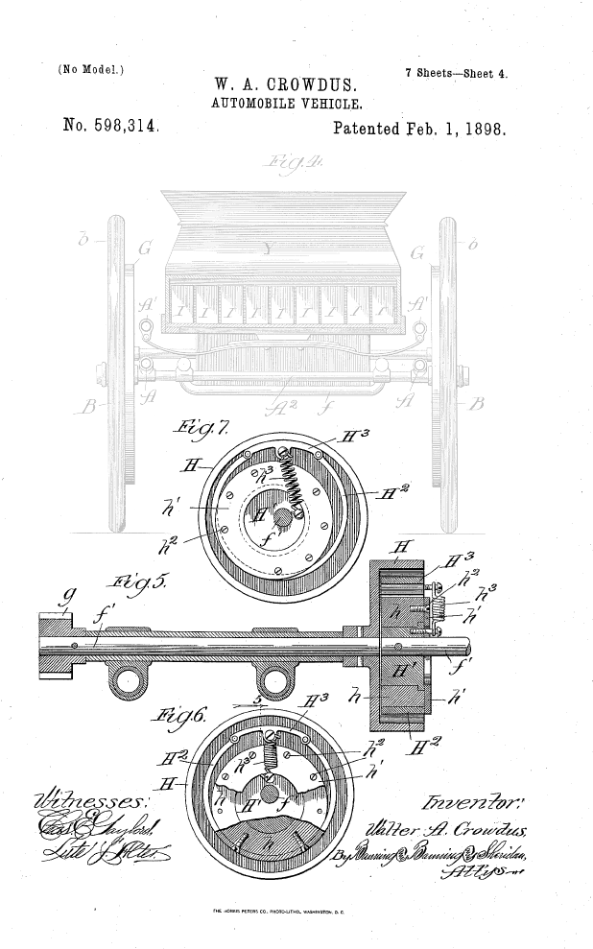
Figure 1 showing centrifugal clutch in 1898 patent
A centrifugal clutch can be useful for a range of engine driven equipment with a high starting inertia and are commonly found on mobile equipment featuring rotating components driven by relatively small petrol or diesel engines such as:
- Rammers
- Vibratory plate compactors/rollers
- Trowel and concrete finishers
- Ground care equipment – grass/turf cutters
- Compact road/street cleaners
- Mobile water pumps
- Go-karts
- Woodchippers/stump grinders
- Transport refrigeration units
- Compressors/vacuum/fan drives (unknown, 2019)
Torque transmitted by using centrifugal force is the main characteristic of a centrifugal clutch. The input of the clutch is connected to a rotating shaft, often a crankshaft and at least one part of centrifugal clutch is driven in a rotational motion. These parts under centrifugal force participate directly or indirectly with in the transmission of torque. The centrifugal force creates a pressing force between the friction components of the clutch and the surface of the driven components. This pressing force produces friction and therefore the torque is transmitted. (Budala & Savescu, 2016)
Using a centrifugal clutch on engine driven equipment with high starting inertia provides the added benefit of being able to start the engine under a no-load situation. An engine featuring a centrifugal clutch should be disengaged from the clutch at idle speed and it is only when the RPM of the engine is increased to the engagement speed of the clutch or above will the drive be fully connected. This often results in smooth engagement. An added benefit of using a centrifugal clutch is also the protection it provides from transmitting high levels of torque back through the flywheel of the engine. When rotating equipment jams extremely high levels of torque are created and this torque can cause irreparable damage to an engine and could be very costly. By using a centrifugal clutch this can be avoided as the wearing parts of the centrifugal clutch will take the excessive torque and can be replaced easily and cost effectively. (unknown, 2019)
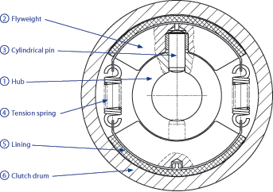
Figure 2 typical pin guided centrifugal clutch diagram
See figure 2 (scheuffele, n.d.) for a typical layout of a centrifugal clutch. The cylindrical hub (1) carriers two flyweights (2) which are located by and can slide on the cylindrical pins (3). The tension springs restrain the flyweights until centrifugal force overcomes the spring force then the flyweights lift from their seats and the linings contact the inside diameter of the clutch drum (6). Friction between these linings and the clutch drum allows the torque to be transmitted.
The engagement speed of a centrifugal clutch is the speed at which the centrifugal force acting on the mass of the fly weights overcomes the force of the retaining springs. Full torque is only transmitted at a higher speed at which the friction surfaces are fully in contact with the clutch drum. The engagement speed is determined by the strength of the springs that retain the flyweights – the stronger the spring tension of the retaining spring the longer the friction lining is held back. Wear of the friction linings can be minimised by passing quickly through the engagement speed band. (scheuffele, n.d.)
An important part of the centrifugal clutch is the friction created between the linings and the clutch drum therefore consideration should be taken to choose suitable friction material of which the linings are made of. Since heat energy is a by-product of friction manufactures typically use materials that are resistant to heat. The most popular choice of friction materials used to be fibres of asbestos but due to increased health concerns associated with exposure to asbestos manufacturers have resorted to using different materials, with ceramic becoming a popular replacement. Ceramic is highly durable and heat resistant. Semi-metallic materials using brass, copper and steel wool bonded by resin are also used, these elements are like ceramics in terms of durability.
Due to the nature of the linings and their role within a centrifugal clutch they can wear down quickly and little can be done to prolong their life span therefore it is important that these components are inspected and replaced routinely to prolong the life of your clutch. (Anon., 2018)

Electromagnetic clutches

Electromagnetic clutches are electrically activated but transmit torque mechanically and are often referred to as electromechanical clutches. One of the most common type utilizes a single friction plate surface to engage the input and output components of the clutch. Electromagnetic clutches are today commonly used in a wide range of machinery, equipment, and industries such as
- Copy machines
- Printing machines
- Food processing equipment
- Packaging machinery
- Factory automation
- Pumps and compressors
- Medical equipment

Electromagnet clutches require a DC power supply. They generally operate on 24v DC but can be supplied to suit other voltages such as 6, 12 and 48v DC.
When current is applied to the low current coil this creates an electromagnetic field which attracts the inner rotor toward the outer rotor thus allowing torque to be transmitted between the input shaft and the output shaft via friction. When the current is terminated to the coil and the electromagnetic field stops the inner rotor is sprung return to its original position and therefore the output shaft stops rotating. Please see figure 3 (Anon., 2013)
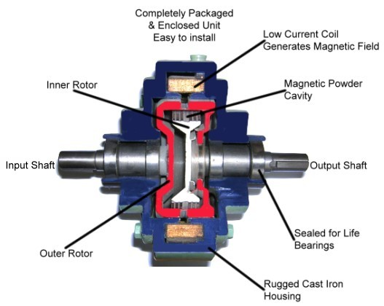
Figure 3 sealed electromagnet clutch

An example of how they can be used in automation and manufacturing applications is shown below in figure 4 (Anon., 2021) we see three separate conveyors being operated by one motor and shaft, but all coupled via separate electromechanical clutches. The output from theses clutches can be controlled independently and based on business requirements to provide drive to the conveyors without stopping the power and turning off the motor.

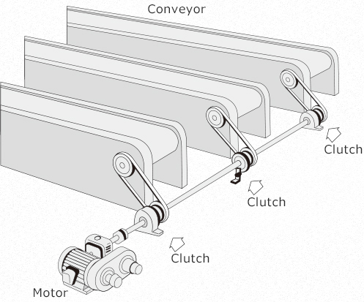
Figure 4 seperate conveyors being operated by electromagnet clutches

Task B

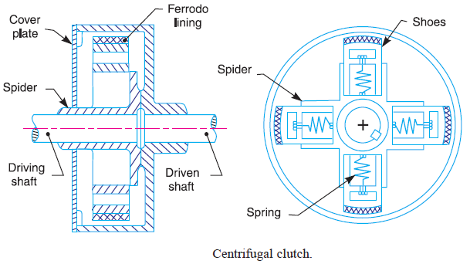

Consider the centrifugal clutch above that comprises of four ‘shoes’ symmetrically attached to the ‘spider’. Each shoe with its friction lining has a mass of 275 grams and is attached by means of a linear mechanical spring with a stiffness value of 7.5 kN/m. The coefficient of friction of the material attached to the shoes is 0.35. The centre of mass of each of the shoes is at a radius of 95 mm from the shaft centres in the rest position shown above and has a clearance distance of 9 mm to the outer drum. The outer drum has a wall thickness of 4 mm.

B1 What is the diameter of the outer drum?

The diameters of the drum are as follows:
$$r=\left(0.095+0.009\right)*2=0.104 metres (to the mating face)$$
$$r=\left(0.104+0.004\right)*2=0.216 metres \left(to the outside of the drum\right)$$

B2 Determine the engagement speed of the centrifugal clutch. You should provide your answer in RPM (revolutions per minute) and rounded to the nearest whole value of RPM.

- m = 0.275kg
- spring stiffness = 7500 n/m
- r = 0.104 m
from our research we know that for the shoes to engage the centrifugal force must at least equal the spring stiffness therefore we shall first work that out:
$$total spring stiffness(Sf)=7500 x spring extension \\ Sf=7500 x 0.009 \\ Sf=67.5 N$$

Using the following equation and the spring stiffness we can work out the engagement speed:
$$Fc=mrω^{2} \\ 67.5=0.275 x 0.104 x ω^{2} \\ \frac{67.5}{0.275 x 0.104}= ω^{2} \\ \frac{\sqrt{}67.5}{0.275 x 0.104}= ω \\ ω=48.59 rads per second \\ ω=48.59 x 60\frac{}{2π} \\ ω=464 RPM$$

B3 Calculate the radial force acting on the clutch face when the driving shaft is rotating at a speed of 550 RPM.

Firstly convert 550 RPM to rads/s:
$$2π x\frac{550}{60}=57.6 rads per second$$
$$Fc=mrω^{2} \\ Fc= 0.275 x 0.104 x {57.6}^{2} \\ Fc=94.89 Nm$$
$$Fc-Sf=94.89-67.5 \\ Fc-Sf=27.39 per shoe \\ Fc-Sf=27.39 x 4 \\ Fc-Sf=109.56 Nm for 4 shoes$$

B4 At the driving shaft speed of 550 RPM, what will be the value of torque transmitted to the driven shaft?

$$T= μ x \left(Fc-Sf\right) x r \\ T=0.35 x 109.56 x 0.104 \\ T=3.99 Nm$$

B5 Using either MatLab or MS Excel, calculate and plot on a suitable graph the transmitted torque at the driven shaft against driving shaft speed, from 450 RPM to 700 RPM in increments of 25 RPM.

For this question I decided to use the opportunity to try and expand on my limited experience of MATLAB. Firstly, I had to assign the variable’s as follows:
m=0.275; m = the mass
u=[0.3,0.35,0.4]; u = the friction
sf=67.5; sf = the spring force
r=0.104; r = the radius
a=450:25:700; a = the RPM from 450 to 700 in. steps of 25
n=4; n = the number of shoes
w=(a.*2.*pi./60); w = RPM to rads/s

to work out Fc I used this piece of code:
fc=m.*r.*w.^2 Centrifugal force fc = M x r x w^2
tfc=(fc-sf).*n Total centrifugal force fc -sf times 4 shoes
T2=u(2).*(tfc-sf).*r Torque T = friction x (centrifugal force - spring force) x radius @ 0.35

to plot the graph RPM vs Torque at 0.35 coefficient of friction I used:
plot(a,T2,'b','LineWidth',1.5,'Marker','*')
title('Torque at driven shaft vs RPM''at 0.35\mu')
xlabel('RPM')
ylabel('Torque')
figure(1)

the above code produced the following results, as you can see from the table the torque produced at 550 RPM corresponds to the Torque worked out for B4

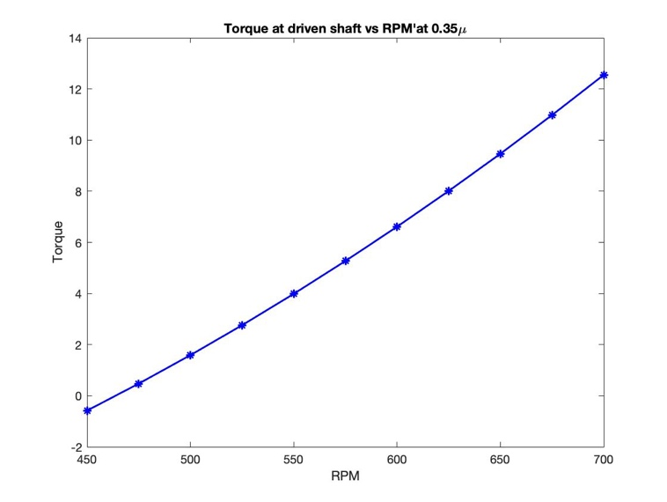
Figure 5 torque on driven shaft at 0.35

B6 Undertake the same analysis as in point 5 above but adopt a coefficient of friction of 0.3 and 0.4. Discuss the effect of changing the coefficient of friction of the shoe material on the torque transmitted when comparing the three values of coefficient of friction.

For this question I used the following piece of code using the same formulas, and over-laying all three graphs for comparison:

T1=u(1).*tfc.*r Torque T = friction x (centrifugal force - spring force) x radius @ 0.3
T2=u(2).*tfc.*r Torque T = friction x (centrifugal force - spring force) x radius @ 0.35
T3=u(3).*tfc.*r Torque T = friction x (centrifugal force - spring force) x radius @ 0.4

figure(2)
plot(a,T1,'r','LineWidth',1.5,'Marker','*')
hold on
plot(a,T2,'b','LineWidth',1.5,'Marker','*')
hold on
plot(a,T3,'g','LineWidth',1.5,'Marker','*')
title('Torque at driven shaft vs RPM''at 0.3 0.35 0.4\mu')
xlabel('RPM')
ylabel('Torque')

Figure 6 table of results produced

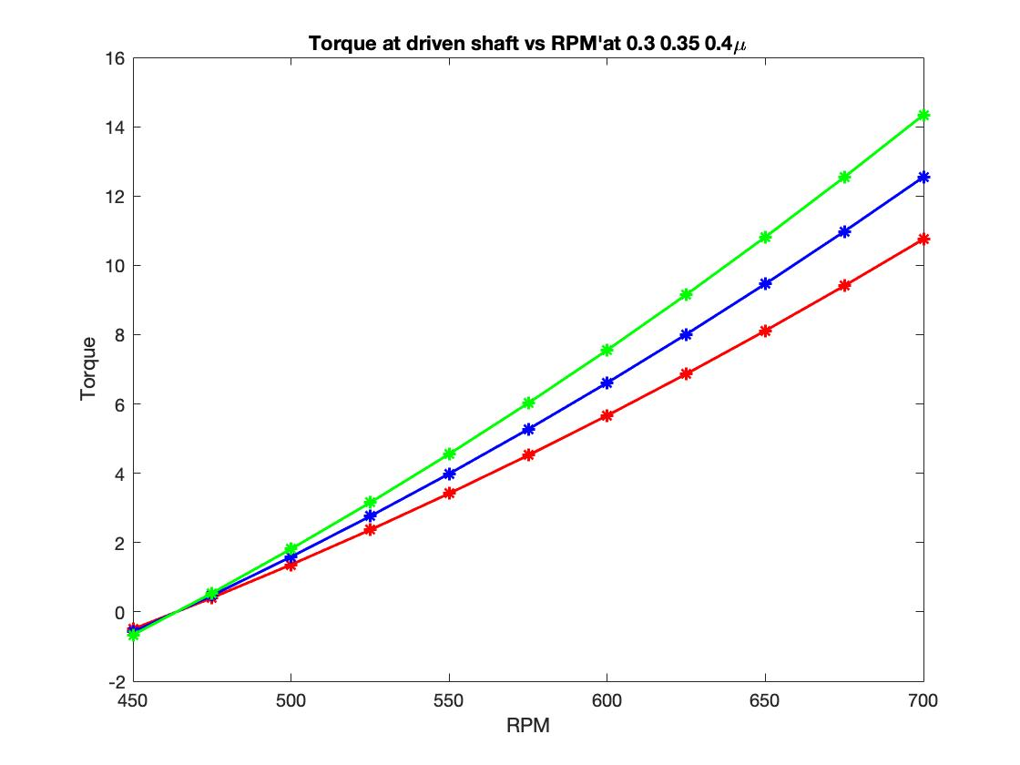
Figure 7 graph showing torque on driven sahft for all 3 friction fiqures

The red line represents 0.3µ, the blue 0.35µ and red 0.4µ as you can see from the graph increasing the friction increases the torque produced.
Increasing the friction from 0.3µ to 0.35µ resulted in an increase of torque of 16.7% whereas increasing the friction from 0.35µ to 0.4µ resulted in a 14.3 % increase

B7 For the maximum possible transmitted torque determined from either point 5 or 6 above, and given that the mass of the drum is 750 grams and can be considered as a solid disc, what is the angular acceleration of the drum to achieve the maximum possible torque?

Firstly, we need to find the radius of gyration:
$$k^{2}=\frac{d^{2}}{8} \\ k^{2}=\frac{{\left(r x 2\right)}^{2}}{8} \\ k^{2}=\frac{{\left(0.104x2\right)}^{2}}{8} \\ k^{2}=\frac{{0.208}^{2}}{8} \\ k^{2}=5.408 x {10}^{-3}$$
Next moment of inertia:
$$I=mk^{2} \\ I=0.750 x 5.408 x {10}^{-3} \\ I=4.056 x {10}^{-3}$$
Now that we have acquired Inertia we can work out angular acceleration.
$$T=Iα \\ α=\frac{T}{I} \\ α=\frac{14.34}{4.056}x {10}^{-3} \\ α=3535.50 rads per second$$
I also attempted to work this out with MATLAB, the code looked like this:
k=((r.*2)^2)/8; k = radius of gyration - k^2= d^/8 in metres
m2=0.750; mass of solid disc = 750 g
I=m2.*k I = moment of inertia - I = m x k^2
T4 = max(T3); T4 = max torque
aa=T4/I aa = Angular acceleration at max torque at 0.4 friction

Results from the code: aa = 3.5356e+03

Works Cited
Anon., 2013. Mechanical Rocks. [Online]
Available at: http://meroock.blogspot.com/2013/02/electromagnetic-clutches.html
[Accessed 10 october 2021].
Anon., 2018. friction materials. [Online]
Available at: https://www.frictionmaterials.com/tag/centrifugal-clutch/
[Accessed 13 october 2021].
Anon., 2020. wikipedia. [Online]
Available at: https://en.wikipedia.org/wiki/Centrifugal_clutch
[Accessed 12 october 2021].
Anon., 2021. Mikipulley. [Online]
Available at: https://www.mikipulley.co.jp/EN/Products/ElectoromagneticClutchesAndBrakes/about.html
[Accessed 11 october 2021].
Anon., n.d. normal Clark. [Online]
Available at: https://www.ngclark.com.au/brands/suco/w-type-pin-guided-centrifugal-clutch/
Budala, A. & Savescu, D., 2016. Applied Mechanics and materials. Volume 823.
engineer, x., 2021. x-engineer. [Online]
Available at: https://x-engineer.org/automotive-engineering/drivetrain/coupling-devices/how-a-clutch-works/
[Accessed 10 october 2021].
Guguloth ravi, T. S. M. H., n.d. Design evaluation of a multi plate clutch. , s.l.: s.n.
Meuller, J. S. &. J. P., 2015. MATLAB for dummies. first ed. New Jersey: John wiley and sons.
Ross, J. B. &. C., 2015. Mechanical Engineering principles. third ed. London : Routledge.
scheuffele, R., n.d. SUCO transmition technology. [Online]
Available at: https://www.bibus.cz/fileadmin/product_data/suco/documents/suco_transmission_technology_catalogue_en.pdf
[Accessed 13 october 2021].
unknown, 2019. Lancereal - an engineers guide. [Online]
Available at: https://www.lancereal.com/centrifugal-clutch-explained/
[Accessed 10 october 2021].

Appendices


