

GLOBAL BUSINESS ENVIRONMENT
ASSESSMENT 1

Programme: BA Business and Management
Module: Global Business Environment
Module code: LCBB4005
Student: Marieta Marinova
Student ID: 2217644
Lecturer: Rexon Nting
Table of contents Page

Title page………………………………………………………………………………………………...1

Content page……………………………………………………………………………………………..2

Introduction……………………………………………………………………………………………...3

A Brief Introduction of Angola as a selected country…………………………………………………...4

Application of theories of the business environment in Angola (PESTEL)…...………………………...5

PESTEL Analysis………………………………………………………………………………………..6

Porter Five Forces……………………………………………………………………………………….7

Critical evaluation of opportunities and challenges faced by Tesco in Angola (SWOT).………..……..8

Examples of different barriers experienced by foreign businesses in Angola…………………………..9

Strategies and recommendations to enable Tesco to succeed in Angola……………………………….9

Conclusion……………………………………………………………………………………………..10

Reference list…………………………………………………………………………………………..11

Appendix………………………………………………………………………………………………12

INTRODUCTION

The Definition of International Business is relationships that cross boundaries into another country with the intention of selling, buying, or trade is an international business. These international transactions could be between governments, organisations, people, and private companies. Examples: services, technology, shareholding capital and properties. Skills in International Business: Language and communications, you may speak with business experts from all over the world in person, over the phone, or in writing E-mails when you work with them. Being able to communicate effectively and appropriately is one of the most crucial business talents in the world. For example, foreign languages such as Spanish, Mandarin Chinese, and Arabic are highly valued in the International Business Industry. Cultural awareness: You must be cross-culturally competent in an international company. You must be able to approach your task with an understanding of people's varied backgrounds and regard for alternative opinions. Leadership Abilities: To inspire employees and follow their activities by giving advice, solving problems, and speaking out about your efforts. Data Analysis and Technologies: In addition to conventional stocks, bonds, and securities, the usage of bitcoin and other forms of digital currency is on the rise throughout the world economy. Fundamental marketing and data analytics knowledge may help you identify growing markets and the best ways to meet their demands as technology becomes more ingrained in corporate operations. Budgeting and Finances: Specialists in this business sector must have availabilities to operate with the constraints in the budgets of the organisation’s financial resources. Therefore, understanding costs are crucial. Sales: Any business that distributes or sells its goods and services across national boundaries or seas must prioritise promotions. International companies depend on the team’s productivity to increase sales, promote brand awareness, find potential consumers and encourage purchases. (Pathways, 2022)
This Report will be focused on Tesco PLC. The company is a British multinational retailer of groceries and other goods, with its headquarters in England. The business wants to take its operation global by analysing several aspects that must be considered before the admittance of this expansion. Therefore, the author of this report will examine the external elements that influence the company’s performance in the market and the opportunities and challenges to gain an advantage over the competitors in this sector.

A Brief Introduction of Angola as a selected developing country

The Republic of Angola is in southwestern Africa, with a population of (2022 est.) 33,013,000, Official Language of Portuguese. And a territory size of 1,246,700 km². The capital Luanda is an economic hub. Angola’s heritage combines Portuguese colonies and African culture. According to Britannica, Angola was devastated by war and the impacts of minefields and starvation from began of the 21st century (Britannica, 2022).
It frequently relied on the international community for the necessities of life. Despite this, the nation has a wealth of natural resources, including petroleum, gold, zinc, precious metals, gemstones etc. It is one of sub-Saharan Africa's primary oil producers. Although Angola just obtained its current borders in 1891. It’s a great African republic with a population that speaks Portuguese as the primary language. In 1975, the anticolonial fight that had started in 1961 resulted in independence. Even though many unsuccessful communist ventures were dismantled by economic reforms in 1988 and foreign investors were given more freedom to invest, the conflict constantly inhibited such investment. It made it difficult for much of the nation's essential infrastructure to be rebuilt. Since the war's end in 2002, the Angolan government has prioritised rehabilitation, nonetheless. Since that day, economic growth and overall health have also improved, primarily because of the money the nation's petroleum industry has brought in. (Britannica, 2022).

Theories of the business environment in Angola (PESTEL)

Tesco Plc has a chance to increase activities and expand its business in Angola. However, a few external elements, referred to as the business climate, will determine if this development is booming. These elements will have an impact on business operations in various ways. As a result, all aspects that must be evaluated before committing to an investment business environment in Angola will be analysed using a variety of methodologies and perspectives in the sections below.

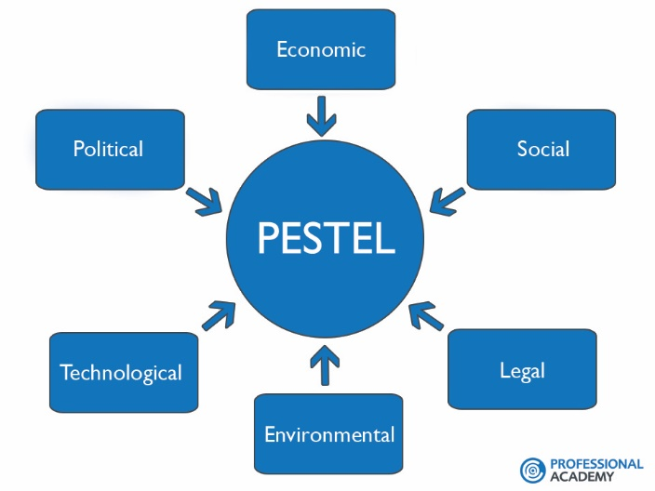

Political: Governmental interference in businesses if the companies do not follow specific policies in government regulations. Law regulations should be established by the state and local governments while investing money in countries. Nevertheless, Tesco pls. should be aware that a change in the Government could result in those rules changing. A country with a stable Politic system has positive development for business entry because of indicating possible growth.
Economical: The Economic factors engaged with the retail industry are the cost of living, labour costs, employment, and consumer interests. According to The World Bank (2022). The economy of Angola grew by 2.6% year over year in the first quarter of 2022 as the solid economic momentum persisted. The primary factors were increased oil production levels and the non-oil industries' robust growth. Angola now has excellent macroeconomic factors, including high net international reserves, exports, and fiscal revenues, a rising exchange, and a reduced public debt to GDP, mainly due to high oil prices. Taking advantage of this trend, public expenditure increased in the first quarter of 2022 compared to the first quarter of 2021, especially on investments and goods and services. This increase in central spending helped the areas of housing, agriculture, communication, education, social protection, security, and defence.

Social and Demographic: Angola’s population is closer as a culture to Latino Americans. Due to Portuguese colonies having mixed with the African culture. Numerous facets of Angolan culture are influenced by Portuguese, African, and ethnic elements. Language, music, cuisine, and arts are all diverse among different groups.
Technological: Angola also made significant investments in developing into a substitute hub for southern and central Africa by constructing data centres, satellites, and fibre optic projects to connect the nation to itself, to the rest of Africa, and the rest of the globe. People now have access to cell phones and the internet thanks to the government's liberalisation of the telecommunications industry. Although just 26% of people access the internet, most do so via cellular operators.
Environmental: Angola has nearly 58 million hectares of land accessible for the agriculture sector, including 35 million hectares of arable land, according to the Department of Agriculture. The country is also rich in natural resources such as oil, gas, petroleum, precious metals, gold, gemstones etc. Angola has good environmental conditions for certain businesses there. The country has potential in the agriculture business. Rich in soils, a good water supply and the atmospheric weather conditions are favourable.
Legal: Any individual or legal entity may do export and import business in Angola. To export and import goods from and into Angola for business reasons require a registered trade with the appropriate licence (if needed) for the business and to be included in the nation's Trade and Company Register. The process for obtaining a licence to import products into a country is essentially the same.

(World Bank, 2022)

Porter Five Forces
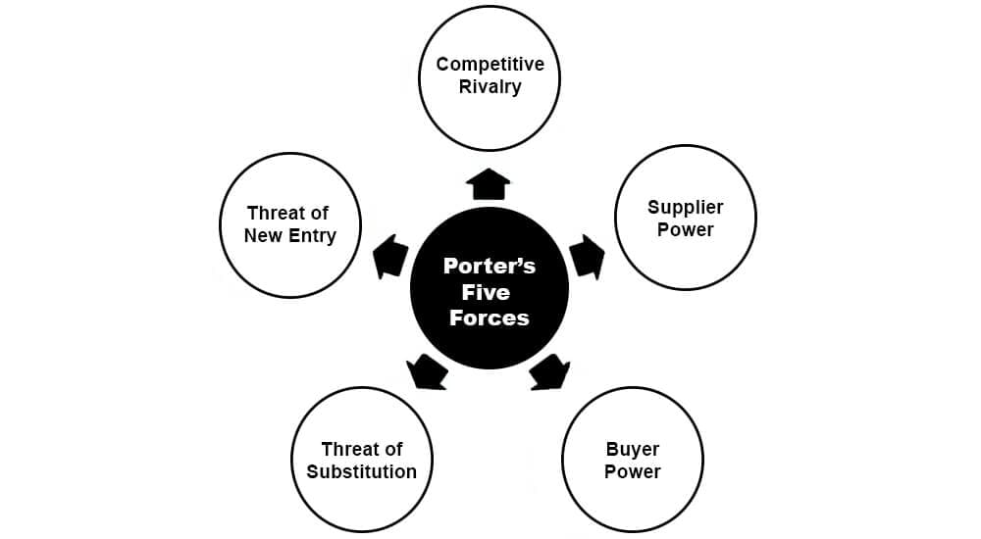
Porter’s Five Forces to examine Tesco’s competitive environment.
Competition in retailer business: There are ten supermarket industry brands in Angola, including the government-owned and privately managed retail companies and the Swiss Webcor Group, which runs the import and distribution firm in smaller stores. Since employment, consumer spending, and middle-class growth are strongly correlated with economic success and rely on the oil and gas industry. The downturn has significantly impacted the grocery industry. Due to Angola's dependence on food imports, threats from industry participants are made worse since currency shortages and exchange rate volatility may significantly affect food inflation, input costs, and renting space prices. Many big merchants have struggled to keep their whole product line in stock and have been forced to subsidise food costs, hurting their bottom lines. Store development outside of major cities is restricted by poor infrastructure, which also affects supply chains. (Business Wire, 2020)
New entry and threads: If the company analyses the best options to enter a developing country and begin a business, key factors are documents, requirements and pricing. So, if Tesco finds a faster and more cost-effective strategy to enter Angola and start a business there, the big chances are to succeed.
Power of suppliers: Suppliers have a crucial role; the business depends on them. Pricing and the variety of products also is a factor that the supplier can impact. Several suppliers that are even in competition with each other could use a strategy that can help with a lower price on products and supplements and the variety.
Power of Customers: Consumers can negotiate. They usually look for lower prices and switch quickly between choosing the option that provides a large amount and better quality for the same or lower pricing. By providing a variety of products with different ranges of pricing, Tesco would have a successful business in Angola, satisfying consumer’s needs.
Threats of Substitutes: Competitions in the retail business often look at price matching and providing lower prices to attract customers. So, working on a strategy for finding the right price for the consumers and making offers and discounts can increase interest and keep the loyal existing customers.
Critical evaluation of opportunities and challenges faced by Tesco in Angola

(Robles, 2021) The Angolan Central Bank has also authorised several announcements to gradually ease significant foreign exchange restrictions to encourage more outstanding international investment. These entry regulation rules welcome foreign business in Angola. The “Angolanisation Principle” is the most critical legislation in Angola's employment legislation: (Pete Oversby, 2021). According to the policy, every firm with more than five workers must employ at least 70% Angolans and 30% foreign non-residents. As a result, the Angolanisation Principle is also known as the 70/30 rule.
Opportunities for Tesco to expand the business, find new suppliers, and attract potential new customers. Likewise, boost brand awareness worldwide, ideas to patent new products to satisfy consumer’s needs according to demographic segmentation in the foreign country.

SWOT Analysis on Tesco)

STRENGTHS:
- Diversified stores
- Effective supplying
- Variety of products
- Online shopping
- Excellent technological innovations

WEAKNESSES:
- Negative feedback
- Exploitation of workers

OPPORTUNITIES:
- Emerging market
- Expanding the business
- Pricing comparison
- Brand awareness
- New customers

THREATS:
- The competition
- Rising costs

Examples of different barriers experienced by foreign businesses in Angola

Angola’s vast market size and future economic possibilities, Angola is regarded as one of the world's most challenging business environments. A lot of effort and money for investment is necessary for success, and a competent, qualified partner is strongly recommended. (International Trade Administration, 2022) Angolan executive wages are equivalent to those in the United States. Although wages must be paid at an exchange rate, many worldwide corporations connect compensation rates to an international currency. Organisations have experienced difficulties due to the scarcity of foreign currency. With the increased price of oil bringing in more money, the situation has transformed, and more foreign cash is available locally.

Recommendations to enable Tesco to succeed in Angola

With much promise in the retail business. Tesco can raise sales and beat the competition. Using the right strategies, clever decisions and marketing techniques to promote the company’s strengths. Recommendations for Tesco:

- Discover developing markets and expand business in Asia, Africa, ca and other developing countries.
- The company should pay more attention to feedback and customer services to make sure to receive positive feedback and use negative feedback as key to improvements.
- Increase the advertising to attract new people more than the competition.
- Providing a variety of products.
- Supply the stores with products appropriate to the environment and local needs.
- Be aware of the local legal rights, permits and requirements before expanding your business in a foreign country.
- Providing training to the employees can improve the quality of customer service.

Tesco Mobile also could be beneficial in expanding in Angola, knowing that only 26% of the population of Angola has access to the network. One of the main reasons in Local mobile networks in Angola created monopole and have high charges. Tesco can use that as an advantage and offer reduced prices (Britannica, 2022).

Conclusion:

It can be concluded that the Republic of Angola is a very fertile, vast production of natural resources with good opportunities. With positive Economic growth for the last couple of years, there are no specific requirements for business entry in the country. Therefore, Angola is convenient and encourages foreign businesses to enter and open and expand. Nevertheless, some necessary analyses such as PESTEL, Porter’s Five Forces and SWOT, external and internal factors show the opportunities, challenges and risks during moving business to develop the country. The author of this report recommended that the company be aware of the legal permit and requirements before expanding. Price matching and differentiation from the competition can help form customer retention. Promotion and marketing segmentation can help find the appropriate product for consumer needs.

Reference list:
Smith, W. (2022) Britannica, Angola/Place. Available at: https://www.britannica.com/place/Angola (Accessed: 17 November 2022).
Pathways, J. (2022) Pearson Pathways, International business. Available at: https://www.pearson.com/pathways/areas-work-study/international-business.html (Accessed: 26 November 2022).
Smith, W. (2022) Britannica, Angola/Economy. Available at: https://www.britannica.com/place/Angola/Economy (Accessed: 20 November 2022).
Smith, W. (2022) Britannica, Angola/Independence. Available at: https://www.britannica.com/place/Angola/Independence-and-civil-war (Accessed: 27 November 2022).
The World Bank.org (2022) Angola/overview. Available at: https://www.worldbank.org/en/country/angola/overview (Accessed: 26 November 2022).
Thorton, J. (2022) Britannica, Angola in the 21st century. Available at: https://www.britannica.com/place/Angola/Angola-in-the-21st-century (Accessed: 26 November 2022).
Matthee, H (2022) Britannica, Angola/ Political risk analysis. Available at: https://www.britannica.com/topic/political-risk-analysis (Accessed: 26 November 2022).
International Trade Administration (2022) Angola/Information. Available at: https://www.trade.gov/market-intelligence/angola-information-and-communications-technology (Accessed: 27 November 2022).
International Trade Administration (2022) Licensing requirements and professional services. Available at: https://www.trade.gov/country-commercial-guides/angola-licensing-requirements-professional-services (Accessed: 27 November 2022).
Business Wire (2022) Wholesale and retail of food in Angola. Available at: https://www.businesswire.com/news/home/20200207005306/en/Angola-Wholesale-Retail-of-Food-2020---Grocery-Market-is-Still-Far-from-Mature-Represents-a-Significant-Growth-Opportunity---ResearchAndMarkets.com (Accessed: 27 November 2022).
Robles, J (2021) Tomson Reuters Practical Law. Doing business in Angola/ Overview. Available at: https://uk.practicallaw.thomsonreuters.com/9-517-9446?transitionType=Default&contextData=(sc.Default)&firstPage=true (Accessed: 26 November 2022).
Oversby, P (2021) Airswift A guide to employment law in Angola. Available at: https://www.airswift.com/blog/a-guide-to-employment-law-in-angola (Accessed: 27 November 2022).

Appendix :

