

International Business LCMB7014

Toyota International Business in China

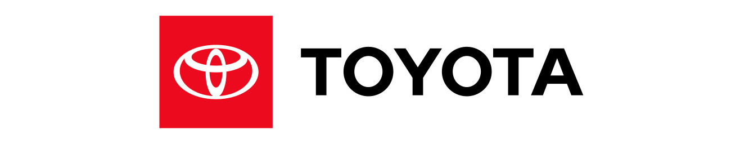

Student name: Apurva Parmar
Student Number: 2211066
Lecturer: Dr Hossein Shokri
Submission Date: 03/05/2023
Table of Contents
Introduction 2
Company Background 2
Company’s Objectives and Strategies 3
Countries’ Specifications 4
Home Country 4
Host Country 5
External Analysis 6
A Comparative PESTEL Analysis 6
Industry Five Forces 8
Market Analysis 10
Host Country Analysis 12
Country’s National Diamond 12
Country Business Risks 13
Internal Analysis 14
Global value chain 14
SWOT analysis 15
International Strategies 16
Entry Modes 16
Corporate Social Responsibility 16
Conclusion 17
References 19

Introduction
A business uses an overseas strategy to sell its products or services outside of its own country. Global marketplaces provide many fresh prospects for business growth. Many firms' worldwide strategies, which involve importing and exporting goods and services while maintaining corporate offices or headquarters in respective home nations, serve as the first step in their international developmental projects (Potter, 2022). Multinational corporations (MNEs) use the local consolidation and integration of their foreign direct investments as a crucial component of their internationalisation. In reference to the context of Tortorella et al. (2020) it has been analysed that the internationalization options are incorporated at the regional level, but further research is needed to fully grasp the extent of this greater integration. This paper has analysed Toyota, one of the top multinational car corporations, and its internationalisation approach.

Company Background
Generally, the Toyota Group's primary organisation is the Japanese Toyota Jidsha KK, also known as Toyota Motor Corporation (TOYOTA, 2023). It surpassed General Motors in 2008 to become the largest automaker and manufacturer globally. Its over 1,000 subsidiary businesses and affiliations manufacture cars, trucks, and other business and agricultural vehicles, as well as auto parts as inferred from the article of Saabye and Powell, (2022). The headquarters of Toyota are located in Toyota City, an important commercial hub east of Nagoya, Japan. Even though to its scale and the reality that the majority of its production is exported, Toyota is a key player in the UK's industrial sector and export marketplace (Coetzee et al. 2019).
Toyota continually invests in its UK business activities to bolster and improve its manufacturing capacities and performance in order to maintain the viability of its factories. As of right now, more than £2.75 billion has been allocated (Netland et al. 2020). Toyota (GB) PLC is indeed the corporation in charge of sales, marketing, after-sales support, and relationship management for Lexus and Toyota in the UK. Additionally, because to its sales volume success, the UK has continued to be one of Toyota's strongest European markets. It has consistently appeared on the Financial Express' ranking of the "100 Best Companies to Working For," moving up to 15th position in the rankings in 2020 (Coetzee et al. 2019)

Company’s Objectives and Strategies
Toyota is a corporation with a worldwide influence and a Tokyo headquarters. Its goals and objectives are focused on innovation, sustainability, and constant progress. The following are Toyota's goals:
Customer satisfaction: Toyota strives to exceed customer expectations by offering high-quality products and services.
Sustinable growth: Toyota typically focuses on environmentally friendly methods, boosting social responsibility, and enhancing safety in order to achieve sustainable growth.
Global leadership: In order to keep its position as the industry leader in the automotive industry, Toyota plans to continuously improve both its services and its products.
Employee development: It appears that Toyota makes an effort to promote employee growth in the workplace (Potter, 2022).
Toyota's tactics include the following:
Lean manufacturing: Toyota uses a lean manufacturing strategy to reduce waste and boost productivity across its whole manufacturing process
Kaizen: Toyota's Kaizen concept promotes continuous cycle, production, and service improvement.
Innovation: Toyota invests much in research and development to create innovative products that satisfy the needs of its customers and the changing market
Sustainable business methods: Toyota is dedicated to minimising the environmental impact of its operations. These procedures entail lowering CO2 emissions, supporting resource conservation, and promoting recycling.
Localization: Toyota strives to localise its operations in order to effectively serve local markets and meet client demands. Toyota has a global network of production and sales locations.
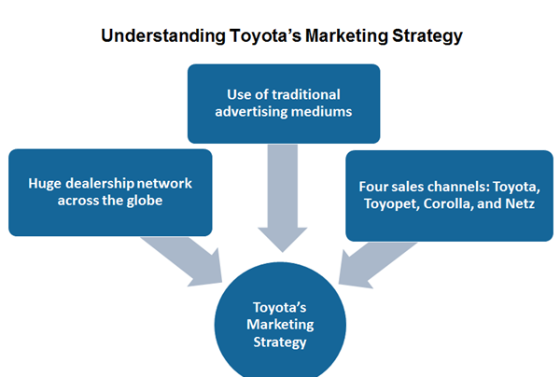
Figure 1: Marketing strategies of Toyota
(Source: Self created)

Countries’ Specifications
Considering China is regarded as a growing market for the automotive industry, it is preferable for Toyota to internationalise in that country. However, these are the requirements for the home country and the host country:
Home Country (Jepan)
Japan, where Toyota is headquartered, has the following laws and criteria that Toyota must go by in order to manufacture and market its vehicles:
Emission requirements: To sell its automobiles in Japan, where there are some of the highest pollution levels on the world, Toyota should indeed abide by these regulations. This includes rules for CO2 emissions as well as other harmful pollutants.
Safety rules: In Japan, Toyota is subject to a number of security laws, such as those governing road tests, automotive traction control, and passenger safety. According to the idea of Magnani et al. (2019), it has been analysed that Japan places a great importance on quality assurance, thus for Toyota to market its vehicles there, they must adhere to exacting requirements.
Consumer protection laws: Toyota is subject to a number of consumer protection rules in Japan, including those that govern advertising, guarantees, and product liability.
Manufacturing standards: Toyota should adhere to Japanese manufacturing standards in order to operate their production plants there, especially those that deal with employee security and ecological impact.
Host Country (China)
China can indeed be regarded as Toyota's home nation for a variety of reasons, including the following:
Growing and large market: It has been analysed from the findings of Leksic et al. (2020) that China is expected to generate over 28 million automobiles in 2021, making it the largest auto marketplace on earth. The Chinese market is anticipated to expand in the future, providing Toyota with substantial potential.
Increasing middle class consumers: Consumers from the middle class are becoming more numerous, which is driving up demand for premium cars as inferred from the article of Netland et al. (2020). Toyota, a well-known company in every country, can take home a sizable chunk of this expanding market.
Government incentives: To entice international businesses to invest in China, the Chinese government provides tax exemptions, subsidies, and other benefits. In reference to the context of Magnani et al. (2019) it has been analysed that the Chinese marketplace, Toyota might be able to lower its costs and increase its profitability.
Localization strategy: Toyota employs a successful localization strategy that comprises customising its products and operations to meet the particular requirements of regional markets. Therefore, it can be mentioned that this strategy has been effective in other nations and could be highly effective in China.
Competitiveness: It has been evaluated that there is penty of Toyota's rivals have made significant inroads in the Chinese market, including Volkswagen as well as General Motors (Tortorella et al. 2020). Toyota may also be required to expand internationally in China in order to keep up with competitors

External Analysis
The external analysis of Toyota is as follows with the help of PESTLE Analysis.

A Comparative PESTEL Analysis
The capital of Japan, a nation in East Asia, is Tokyo. In addition to having 6852 islands, the majority of Japan's territory is surrounded by the Pacific Ocean. Japan's economy ranks third globally, behind those of the United States and the People's Republic of China. In addition, and over ninety percent of people in Japan speak Japanese (Saabye and Powell, 2022). It is the tenth most populous nation in the world, with 127 million people living there. While Koreans, Chinese, and other nationalities make up 0.5%, 0.4%, and respectively 0.6% of the total population, Japanese make up 98.5% of the population as inferred from the article of Carvalho et al. (2019). In addition to this, it has been analysed that Japanese companies are well-known worldwide; Toyota, Hitachi, Honda, Nissan, Panasonic, Sony, Toshiba, and others are among the Fortune 100 companies.
PESTLE Analysis
Political | Japan's central government has experienced significant transformation recently. For the previous three years, the nation has had three distinct prime ministers in charge. Companies who want to operate ought to become cautious of the government since this would mean frequent law changes and possibly unpredictable outcomes. According to a latest announcement, all cars sold in the nation will be environmentally beneficial by 2035 as inferred from the article of Leksic et al. (2020). The government has recently taken a number of initiatives for multiple industries. In the automotive industry, for example, the administration has been pushing for more ecologically responsible alternatives like electric and hydrogen-powered cars.
Economic | One of the most powerful economies worldwide is that of Japan. The commercial relationships that exist between Japan and other countries must be considered by businesses wishing to operate in Japan. Organizations that want to start exporting must engage in manufacturing, electrical components, and vehicles because they are the main exports from Japan. Thus according data on investment from abroad, or FDI, a sizeable portion of income departs the nation; in 2021, the nation lost $222.5 billion, but still only $14.5 billion in FDI came in (Carvalho et al. 2019).
Social | The two societal trends that are more widespread in Japan are playing video games and watching anime. The notion that each individual in Japan will have spent $300 and play video games an equivalent of 16.9 hours per week in 2021 lends credence to this claim as founded from the notion of Evans et al. (2021). Moreover, Japan has one of the highest percentages of the senior individuals, with 36.4 million people aged 65 or older as of today. Further, it can be mentioned from the findings of Opute (2020), that businesses may struggle to recruit high-performing individuals with a strong body given the significant percentage of elderly people. To get over this issue, the companies can hire individuals from abroad, although this could prove pricey.
Technological | The alternate method is to use technology like robots to complete the tasks. Another technique that has become rather popular in Japan's corporate environment is the recruitment of personnel for life or having them stay with a company till retirement. Small firms entering Japan need to start paying attention to this since if they regularly replace their employees, it can be considered as going against convention and the enterprises might not be able to thrive and grow there. The younger generation in Japan is very materialistic, and buyers prefer to use time to save money rather than money to save time, which suggests that companies who sell inexpensive goods have a good chance of succeeding in the country.
Legal | In 2020, the Japanese administration would spend more than 19.50 billion yen on R&D. The world's fastest railroads, known as bullet trains, were initially introduced in Japan, opening the door to a novel technological age. Another important Japanese creation was the blue LED light, which is currently among the most cutting-edge commercial products.
Environmental | In Japan, businesses can anticipate that experimenting with a variety of technologies will be simple and that their research will be protected by patents. Japan allows for a registration period of 25 years, whereas copyrights worldwide typically last 20 years (Haque et al. 2019). As an outcome, the organizations can bring in cash for a further five years without being worried about competition. However, in light of the nation's expanding economy, management enacted the Fair Trade Maintenance Act to ensure that every business has an equal chance of success.

Industry Five Forces
The threat of new entrants
In areas like marketing and innovation, automobile manufacturers engage in fierce cross-border competition. Toyota faces competition from a number of companies that differ from one another in a variety of ways, including affordability, technologies, fuel economy, style, and brand recognition (Potter, 2022). Despite the fact that there are numerous small automobile manufacturers, Toyota competes primarily with a small number of extremely large businesses.
The bargaining power of suppliers
Since exchanging costs are low, clients can undoubtedly change from Toyota to different organizations without paying any extra charges. When purchasing a new car, customers frequently go through this transition. In addition to this, according to the notion of Vilkas et al. (2021) it has been analysed that Toyota customers have easy access to trustworthy information and such product characteristics from business websites, allowing them to easily choose the best option. Automobiles produced by manufacturers like Toyota are even more valuable than other options.
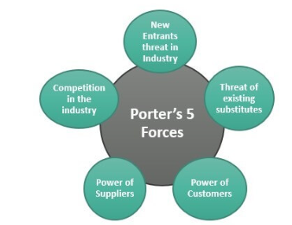
Figure 2: Porters 5 forces analysis
(Source: Self-created)
The bargaining power of buyers
The small number of global suppliers has little effect on Toyota. It is said that as the number of suppliers decreases, this power to negotiate increases. However, it has been analysed that the high availability of supplies utilized in the production of Toyota products reduces the significance of suppliers.
The threat of substitute products or services
The threat posed by competing goods or services prompts customers to choose other options over Toyota. Alternatives to Toyota products include bicycles, public transportation, and other means of transportation. Unfortunately, these options are only available occasionally (Leksic et al. 2020). In specific rural regions with restricted admittance to public transportation, Toyota advances are not generally promptly accessible as options. These options are less practical when taken as a whole than shopping at companies like Toyota.
Intensity of competition
The emergence of new competitors poses a threat to Toyota. Due to the high costs of starting, running, and developing a brand-new business in the region, there are significant barriers to entry. In addition to this, because of these obstacles, companies like Toyota are less likely to be affected by new competitors (Saabye and Powell, 2022). Toyota's organizations are less impacted by this element than by the opposition or customer bartering power. As a result, Toyota's concerns about expanding its customer base and maintaining its position as a global leader are among the least significant of the Five Forces.
Market Analysis
Competitors in the market
Toyota is a well known automaker that contends savagely with Passage, Hyundai, and VW. It is a well-known global manufacturer of SUVs, electric vehicles, and automobiles. The production of environmentally friendly electric vehicles and sustainable development are Toyota's current priorities. North America is by a long shot Toyota's biggest market, trailed by Japan and Asia. North American Toyota vehicle sales made up 32% of the total 8,970,860 sold in 2017. There are 364,445 Toyota employees as inferred from the article of Evans et al. (2021). In 2017, it had 69 businesses and production facilities worldwide. It had a net income of 27,597 as comprehended from the notion of Vilkas et al. (2021).1 trillion Japanese yen in 2017, which was down 2.8% from the year before.
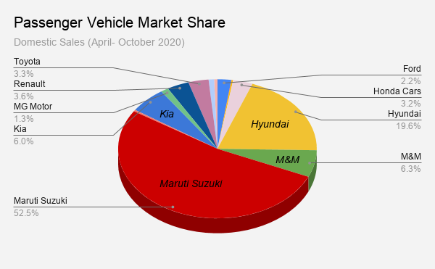
Figure 3: Vehicle market share
(Source: Evans et al. 2021)
Market size
Toyota was the largest carmaker in 2022, with a share of the market of roughly 11.5 percent (Vilkas et al. 2021). The VW Group will indeed lose market share to Toyota Motor Corporation, a Japanese carmaker that also owns the Toyota brand. The market size of automotive sector is facing new difficulties as a result of rising initiatives to connect cars and increasing worries about the environment. According to the idea of Marodin et al. (2019) it has been analysed that the industry will undergo a metamorphosis even though of consumer trends like the shift towards lighter materials in addition to the movement onto self-driving and electrified cars. Tesla Motors, with its headquarters in Palo Alto, is currently driving the electrified movement, with similar California firms like Google and Apple perhaps following.
The company made a net profit of 1831.1 trillion Japanese yen in 2017. In 1997, the company debuted the Toyota Prius, that the very first hybrids vehicle to be mass-produced. It intends to introduce updated Prius models and step up its investment in the creation of electric vehicles. It has also introduced some high-end vehicles to the industry, including the hybrid Camry. Volkswagen Group sold and over six times quite so many vehicles as Tesla did in 2022, when it delivered just under 1.3 million vehicles as inferred from the article of Marodin et al. (2019). According to estimates, Tesla holds close to 2% of the U.S. automotive market.
Key success factors
Toyota has modern production facilities all over the world that gather and create vehicles for both domestic and foreign marketplaces. The company's primary success element is JIT Production, which, along with lean manufacturing, enables it to keep a monopoly on the global vehicle market. Toyota launched its Innovative International Multi-purpose Vehicle Plan in order to streamline its production as well as supply methods for automobiles around the world (IMV). This is done to satisfy the market's expanding demand across more than 142 nations on the planet (van Assen, 2021). The key sucess factors are Modern production facilities and cutting-edge techniques. Toyota's research and development procedures are governed by ideals including excellence, sturdiness, dependability, kindness to the environment, and speed (van Assen, 2021). One of the main cars made by Toyota using innovative technology is the mass-produced hybrid gasoline-electric vehicle. It displayed the enormous two million sales made worldwide in 2010. The Advanced Parking Guidance system and eight-speed automatic transmission are two more technological features offered by Toyota.

Host Country Analysis
Country’s National Diamond (host country)
Firm strategy, structure and rivalry
The company made 1831.1 billion Japanese yen in net profits in 2017. The primary efficiently manufactured half breed vehicle, the Toyota Prius, was disclosed by the firm in 1997. Toyota intends to offer superior Prius models and increment its interests in the advancement of controlled portability. Other than that, it has introduced high-end automobiles to the market, including the hybrid Camry. In 2022, Volkswagen Group delivered just under 1.3 million vehicles, which was more than six times as many as Tesla sold. In addition to this, it can be mentioned that the estimates suggest that Tesla controls close to 2% of the automobile market in the United States.
Demand conditions
Japanese companies are focusing on sectors with strong growth potential. The construction of production facilities, research centers, and interior designers necessitated significant expenditures on the part of the European automotive industry. Owing to the demand conditions, it can be mentioned that in order to create cutting-edge equipment and cutting-edge innovations that enhance living conditions, Toyota architects from three continents are examining concepts, objectives, and aspirations.
Related and supporting industries
The experts at the company quickly realized that, especially in terms of marketing, installing automobiles is a more profitable business than making them locally and exporting them to other countries. In reference to the context of Magnani et al. (2019) it has been analysed that the quick infringement of a sizable piece of the pie in the EU is straightforwardly owing to the capacity to answer really to the one of a kind qualities of every district and consistence with regulation without attempting to change or get around them. Therefore, it can be mentioned that the extension of its organization of plan and advancement offices contiguous its assembling destinations is one more significant part of Toyota's technique. Therefore, it can be said that Toyota bring specific characteristics and design cues from the places. European-built automobiles were exported to other global markets as a result of the Japanese manufacturers' enormous success.
Factor conditions
The majority of Toyota's strategies for establishing corporate success and market dominance in particular markets were developed by experts from Japan. In reference to the context of Dahlgaard and Anninos (2022), it has been analysed that the KAIZEN strategy, which stands for "continuous improvement and the impact it has on the quality of the products," is the general guiding philosophy for the majority of Japanese businesses as well as the Toyota Company. In addition to this, it can be mentioned further that the integrative strategy known as "KAIZEN" requires ongoing management, improvement, and business operations and specifies the standards for quality, output, and profitability with the direct involvement of all employees. It is also sometimes referred to as a "cross-functional plan."
Country Business Risks (host country)
The automobile sector is undergoing unprecedented change. The rapid movement in consumer preferences forward into more sustainable solutions, the ongoing growth of EVs and AVs, the confluence of sectors, the transformation of supply chains, and all of these factors helped to define this timeframe (Ramori et al. 2021). Due to these shifts, companies now have to concurrently plan for mobility's growth while negotiating the constantly shifting environment of today in China. The global community of PwC problem solvers offers market expertise, financial commitment to cutting-edge digital technology, and familiarity with regional markets. helping you produce solid and long-lasting outcomes so that your organisation is prepared for the future in every way. Further, it can be mentioned that giving customers insightful information to address important global risk, tax, audit, assurance, strategy consulting, and ESG concerns.
Toyota has present day creation offices all around the world that assemble and make vehicles for both homegrown and unfamiliar commercial centers. Lean manufacturing and JIT Production, the company's primary success factors, enable it to maintain a monopoly on the global automobile market. Toyota introduced its Innovative International Multi-Purpose Vehicle Plan (IMV) to streamline its global vehicle production and supply processes. This is done to meet the growing demand in more than 142 countries around the world (van Assen, 2021). Modern production facilities and cutting-edge methods are essential to success. The ideals of excellence, durability, dependability, environmental stewardship, and speed guide Toyota's research and development processes (van Assen, 2021). The mass-produced hybrid gasoline-electric vehicle is one of Toyota's most important automobiles made with cutting-edge technology. It demonstrated the staggering two million global sales in 2010. The High level Stopping Direction framework and eight-speed programmed transmission are two additional innovative elements presented by Toyota.

Internal Analysis
Toyota's innovation culture is well known. The company has managed to stay one step ahead of its rivals by delivering some of the most cutting-edge vehicles now on the market. According to the viewpoint of Beraldin et al. (2022) it has been analysed that Toyota enjoys some of the strong strategic advantages as a result of its R&D activities, particularly in producing ecologically responsible automotive technology, safety inspections, and systems integration

Global value chain
- Global Production
Toyota is a multinational automotive manufacturer with a global presence in over 170 countries. The company has manufacturing facilities in several countries, including low-cost countries like India, Mexico, and Brazil. Toyota has established lean manufacturing techniques to produce high-quality vehicles at a low cost. The company has been investing in its R&D capabilities around the world, including in Japan, the United States, and Europe, to develop new technologies and products that meet customers’ evolving needs worldwide. Toyota’s expansion in low-cost countries allows it to meet growing demand in these markets while maintaining its reputation for high-quality products.

- Global Marketing
Toyota’s global marketing strategy is focused on building a strong brand image through effective promotion and advertising campaigns. The company has a reputation for producing high-quality, reliable vehicles, and it aims to maintain this image through its marketing efforts. Toyota has a strong online presence and actively engages with customers through social media platforms such as Twitter, Facebook, and Instagram. The company’s social media profiles are tailored to meet the preferences of local customers in different countries. Toyota also uses traditional marketing methods, such as TV commercials and print ads, to reach its target audience. The company has consistently emphasized on product quality and innovation, which has contributed to its global brand recognition and customer loyalty.

- Global HRM
Toyota’s Global HRM strategy is centered on developing and retaining a talented and diverse workforce. The company places a strong emphasis on employee development and engagement through various training programs and career advancement opportunities. Toyota’s HR policies are guided by the principle of respect for people, which aims to create a positive and inclusive work environment for all employees. The company has also implemented measures to promote diversity and inclusion in the workplace, such as establishing a Diversity & Inclusion Committee and providing equal employment opportunities regardless of race, gender, age, or nationality. As of March 2022, Toyota had a global workforce of approximately 398,000 employees (Toyota, 2022).

SWOT analysis
Strenght
Toyota is prestigious for its way of life of development. In order to stay ahead of its rivals, the company launched some of the most cutting-edge automobiles on the market (). This strategy has been successful.
Weakness
Despite the fact that Toyota's manufacturing and design are not flawless, it sets the standard for quality control. For instance, Toyota issued 700,000 vehicles at the beginning of this year due to a malfunctioning fuel pump (Ufua et al. 2022). Events like these can end years of enthusiasm and reduce customer confidence in the brand.
Opportunities
The monetary circumstance in arising nations has decisively improved during the most recent couple of many years (Vanichchinchai, 2022). Toyota may benefit from the growing middle class's ongoing demand for automobiles by increasing its investments in emerging markets like China.
Threaths
Due to the high capital requirements, the automobile industry faces little threat from new competitors (Muniz Jr et al. 2022). The organization faces a serious threat from large corporations, like those from China. Chinese organizations could begin showcasing their items in nations where Toyota has proactively been laid out.

International Strategies
A company's marketing strategy outlines the measures it plans to take to implement a certain marketing strategy. Toyota's marketing approach differs depending on the state of the regional supermarket (Antony et al. 2022). It also has a huge sales and distribution network to promote its products internationally, and each vehicle is kept up to a high quality attributable to an inventive company culture. Toyota has long considered the demands of its customers to be the most crucial aspect of its marketing plan. This might hold the key to the business's long sustainability.

Entry Modes
Toyota had introduced its automobiles to North America, particularly the United States of America, following the expansion of its products into South America. Toyota carried out the second phase of their development strategies here. Toyota built five assembly plants during this phase to implement its Cross-Continent Space Program. Deplorably, Toyota's endeavors to advance its vehicles were hampered by the climate in the USA. As a result, Toyota began shipping the brand-new Corolla and Corona to Canada (Vanichchinchai, 2022). The availability of large port towns on the West Coast, which were crucial for Toyota in delivering its goods to the United States, was another important factor that pushed Toyota to increase the number of cars it sold in the United States. The entry mode employed by Toyota is Strategic Acquisitions in China.

Corporate Social Responsibility
Before the Toyota People group Care Board was laid out and local area care rules were created, social obligation support tasks had been done by evaluating and going with choices in view of financing demands made by different associations. However, Toyota started laying out unions in 1998, utilizing them to course subsidizing to associations that had some expertise in addressing specific requirements, like natural safeguarding, instructive grant, and lessen mishaps (Muniz Jr et al. 2022). Currently, communities and civilizations all over the world are deeply ingrained in the Toyota social responsibility program. In all of the nations where Toyota conducts business, a number of these programs aim to improve traffic safety, support the arts, provide financial assistance for education, and protect the environment.
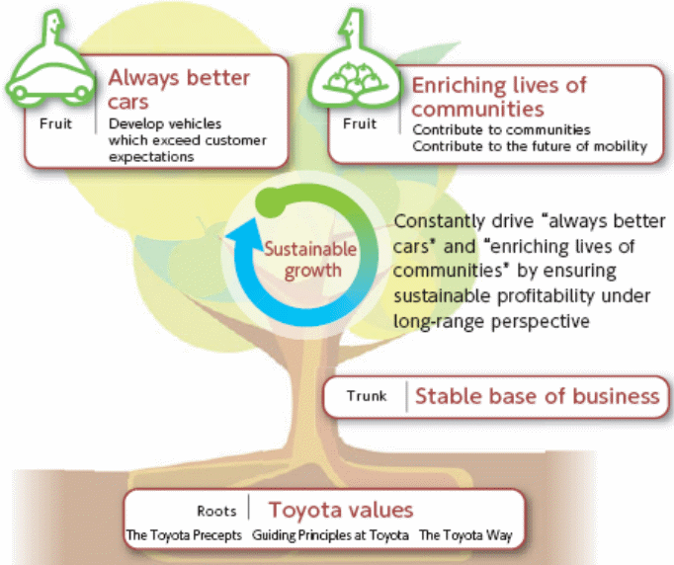
Figure 4: CSR of Toyota
(Source: Muniz Jr et al. 2022)

Conclusion
A business utilizes an abroad procedure to sell its items or administrations beyond its own country. There are numerous fresh opportunities for business expansion in global markets. Many firms' overall methodologies, which include bringing in and trading labor and products while keeping up with corporate workplaces or central command in separate home countries, act as the most vital phase in their worldwide formative undertakings. As a crucial part of their internationalization, multinational corporations (MNEs) consolidate and integrate their foreign direct investments locally. Options for internationalization are incorporated at the regional level, but it is necessary to conduct additional research to fully comprehend the extent of this greater integration. The internationalization strategy of Toyota, one of the largest automobile manufacturers worldwide, has been the subject of this study.

References
Adler, P.S., Goldoftas, B. and Levine, D.I., 1999. Flexibility versus efficiency? A case study of model changeovers in the Toyota production system. Organization science, 10(1), pp.43-68.
Antony, J., Swarnakar, V., Cudney, E. and Pepper, M., 2022. A meta-analytic investigation of lean practices and their impact on organisational performance. Total Quality Management & Business Excellence, 33(15-16), pp.1799-1825.
Beraldin, A.R., Danese, P. and Romano, P., 2022. Employee involvement for continuous improvement and production repetitiveness: a contingency perspective for achieving organisational outcomes. Production Planning & Control, 33(4), pp.323-339.
Bryce, C., Ring, P., Ashby, S. and Wardman, J.K., 2020. Resilience in the face of uncertainty: Early lessons from the COVID-19 pandemic. Journal of Risk Research, 23(7-8), pp.880-887.
Carvalho, A.M., Sampaio, P., Rebentisch, E., Carvalho, J.Á. and Saraiva, P., 2019. Operational excellence, organisational culture and agility: the missing link?. Total Quality Management & Business Excellence, 30(13-14), pp.1495-1514.
Coetzee, R., Van Dyk, L. and Van der Merwe, K.R., 2019. Towards addressing respect for people during lean implementation. International Journal of Lean Six Sigma, 10(3), pp.830-854.
Dahlgaard, J.J. and Anninos, L.N., 2022. Quality, resilience, sustainability and excellence: Understanding LEGO’s journey towards organisational excellence. International Journal of Quality and Service Sciences.
Evans, M., Farrell, P., Elbeltagi, E. and Dion, H., 2021. Barriers to integrating lean construction and integrated project delivery (IPD) on construction megaprojects towards the global integrated delivery (GID) in multinational organisations: lean IPD&GID transformative initiatives. Journal of Engineering, Design and Technology, (ahead-of-print).
Haque, A., Fernando, M. and Caputi, P., 2019. The relationship between responsible leadership and organisational commitment and the mediating effect of employee turnover intentions: An empirical study with Australian employees. Journal of Business Ethics, 156, pp.759-774.
Leksic, I., Stefanic, N. and Veza, I., 2020. The impact of using different lean manufacturing tools on waste reduction. Advances in Production Engineering & Management, 15(1).
Liker, J.K., 2021. Toyota way: 14 management principles from the world's greatest manufacturer. McGraw-Hill Education.
Magnani, F., Carbone, V. and Moatti, V., 2019, April. The human dimension of lean: a literature review. In Supply Chain Forum: An International Journal (Vol. 20, No. 2, pp. 132-144). Taylor & Francis.
Marodin, G.A., Frank, A.G., Tortorella, G.L. and Fetterman, D.C., 2019. Lean production and operational performance in the Brazilian automotive supply chain. Total Quality Management & Business Excellence, 30(3-4), pp.370-385.
Marodin, G.A., Frank, A.G., Tortorella, G.L. and Fetterman, D.C., 2019. Lean production and operational performance in the Brazilian automotive supply chain. Total Quality Management & Business Excellence, 30(3-4), pp.370-385.
Muniz Jr, J., Popadiuk, S., Batistela, G.C., Nakanishi, F.K. and Rodriguez, I.A., 2022. Toyota’s knowledge-sharing intention in Brazil and Japan: does organisational cross-culture matter?. Knowledge Management Research & Practice, pp.1-15.
Netland, T.H., Powell, D.J. and Hines, P., 2020. Demystifying lean leadership. International Journal of Lean Six Sigma, 11(3), pp.543-554.
Opute, A.P., 2020. Small and medium enterprises marketing: Innovation and sustainable economic growth perspective. In Entrepreneurship marketing (pp. 13-30). Routledge.
Potter, A., 2022. Exploring the role of lean managers within the Toyota supply network: evidence from a social media platform. Production Planning & Control, 33(8), pp.723-740.
Ramori, K.A., Cudney, E.A., Elrod, C.C. and Antony, J., 2021. Lean business models in healthcare: a systematic review. Total Quality Management & Business Excellence, 32(5-6), pp.558-573.
Saabye, H. and Powell, D.J., 2022. Fostering insights and improvements from IIoT systems at the shop floor: a case of industry 4.0 and lean complementarity enabled by action learning. International Journal of Lean Six Sigma, (ahead-of-print).
Tortorella, G.L., Fettermann, D., Cauchick Miguel, P.A. and Sawhney, R., 2020. Learning organisation and lean production: an empirical research on their relationship. International Journal of Production Research, 58(12), pp.3650-3666.
Toyota, 2022. Number of employees at Toyota from FY 2009 to FY 2022 (in 1,000s). Statista. Retrieved from https://www.statista.com/statistics/269015/number-of-employees-at-toyota/
TOYOTA, (2023) https://global.toyota/en/, Toyota Motor Corporation Official Global Website. Available at: https://global.toyota/en/ (Accessed: April 2, 2023).
Ufua, D.E., Ibidunni, A.S., Papadopoulos, T., Matthew, O.A., Khatoon, R. and Agboola, M.G., 2022. Implementing just-in-time inventory management to address contextual operational issues: a case study of a commercial livestock farm in southern Nigeria. The TQM Journal, 34(6), pp.1752-1771.
van Assen, M.F., 2021. Lean, process improvement and customer-focused performance. The moderating effect of perceived organisational context. Total Quality Management & Business Excellence, 32(1-2), pp.57-75.
Vanichchinchai, A., 2022. The effects of the Toyota Way on agile manufacturing: an empirical analysis. Journal of Manufacturing Technology Management, (ahead-of-print).
Vilkas, M., Rauleckas, R., Šeinauskienė, B. and Rutelionė, A., 2021. Lean, agile and service-oriented performers: templates of organising in a global production field. Total Quality Management & Business Excellence, 32(9-10), pp.1122-1146.

