

Student Name: Arnob Talukder
Student ID: 251910
Module Name: Marketing Mangement
Module Code: LCMB7024
Lecturer’s Name: Dr Laila Maazouz
Term 2
Words Count: 2457

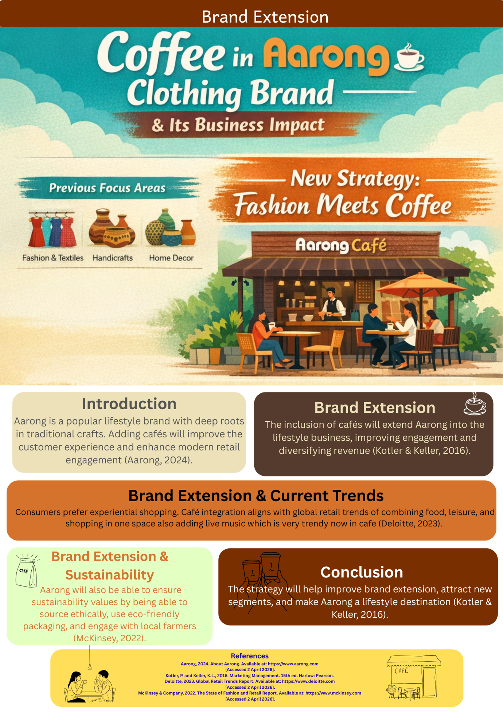

STDP Analysis of the Brand Extension Strategy

As a marketing manager, this study concentrates on the extension strategy of Aarong, where the café concept will be incorporated into the retail stores of Aarong. The objective here is to conduct an analysis of STDP which will help in growing the business.

The term 'segmentation' refers to the method that involves breaking up a wide market by dividing it into small segments having similar characteristics (Kotler and Keller, 2016). Segmentation of the Aarong Café extension can be conducted considering four variables: geographical, demographic, psychographic, and behavioral.

With regards to geography, it can be said that Aarong’s operations revolve around the urban area. This is mainly because Aarong targets the urban consumers as the buying power of consumers is quite high in urban cities. In addition, the café extension can be located in cities where consumers prefer premium retail and premium cafes.

Some of the major demographic segments in consideration include the youth (18-35), professional, and middle/upper-middle class. This means that these segments have disposable income and would prefer buying things related to their lifestyle. In addition, students and professionals make another key segment in which they usually visit cafes to relax.

When it comes to psychographics, the targeted consumers should be the ones who care about their lifestyle, culture, and experience. Aarong already has such consumers that are interested in traditional, craft, and ethical consumption. Similarly, consumers with modern and traditional cultures will be attracted to the café extension as well
(Deloitte, 2023).
When we talk about behavioral segmentation, convenience-seeking, experiential, and quality-conscious customers are of major concern. Such type of consumers do not only look forward to buying goods but are equally concerned with enjoying themselves in a convenient and comfortable setting. They are bound to make frequent visits if some additional services are offered, such as cafés.

Coming to Targeting, a differentiated approach towards targeting will be adopted by Aarong, where urban, youth, and experience-oriented consumers will be targeted. Youthful professionals as well as students from universities will comprise the main target segment of this organization. These consumers use a lot of social networking sites and prefer the experience that brands provide. Families and tourists who are drawn to the culture of Aarong can also be regarded as secondary targets.
Finally, the Differentiation strategy is crucial in terms of guaranteeing that the Aarong’s café will be able to distinguish itself from competitors within the market environment. It can differentiate itself in several ways: first of all, due to the rich cultural heritage associated with the Aarong brand, it can use such opportunities as interior design and traditional food and drinks served in their cafe. In addition, Aarong can distinguish itself from other brands thanks to the ethical sourcing approach. Thus, it will be able to offer coffee which is not only of premium quality but also organic and/or produced in Bangladesh. Therefore, the combination of culture, ethics, and experience gives rise to the competitive advantage.

The Positioning strategy concerns the perception of the brand by the consumer. The positioning strategy refers to positioning Aarong’s café as a “premium cultural lifestyle experience”. As a result, the positioning strategy should focus on promoting comfort and authenticity associated with the brand as well as a connection between the traditional aspects and modern lifestyle in terms of the café.
STDP analysis demonstrates that Aarong’s café extension has a strong match with prevailing market trends and customer preferences. Through proper segmentation of the market, Identification of the target customer base, differentiation based on cultural and ethical values, and effective positioning of the café as an experience-oriented venture, Aarong can easily increase brand equity and sustain growth in the long run.

Element 3: Marketing Mix (7Ps) for the Brand Extension
In my role as a marketing manager, I provide the description below on how the 7Ps marketing mix will be used in the brand extension of Aarong, particularly the development of a café in their stores. The aim here is to demonstrate how each element plays a part in achieving the brand extension strategy and contributing to business growth. As pointed out by Booms and Bitner (1981), the 7Ps include Product, Price, Place, Promotion, People, Process, and Physical Evidence.

Product: In this case, the product refers to the café experience which would be developed in the Aarong store. It includes the different beverages like coffee, tea, and drinks inspired from the culture of Bangladesh. In addition, some light food could also be included. However, the café goes beyond being a functional product; it becomes an augmented experience that offers customers a chance to relax while shopping. This is consistent with experiential marketing which aims at creating memorable
Experiences for customers (Pine and Gilmore, 1999).
Price: A pricing strategy should be implemented in light of the premium yet affordable positioning strategy adopted by Aarong. In this case, value-based pricing would come into use, where the prices would be determined on the basis of perceived customer value instead of the traditional cost-based pricing model (Kotler and Keller, 2016). Given the unique experience offered at the café, it is fair enough to expect that prices will be a bit high, but they need to be competitive enough. Discount packages such as discounts on purchase of café products could further drive sales.

Place: The café will operate inside the existing retail outlets of Aarong in urban locations. Such a business decision would bring benefits of convenience and would also help sell more by means of cross-selling strategy. The physical positioning in terms of store design plays a pivotal role in customer behavior according to retail strategy theory (Deloitte, 2023). Hence, it is important that the café is strategically
Positioned inside the store.
Promotion: Promotion will be done through multiple channels, including social media promotion, digital marketing, etc., both online and offline, for customer attraction and awareness. Storytelling can also be an effective method of promotion, where the culture of Aarong is highlighted in the café to make customers aware of their heritage. The integrated marketing communication technique will be applied here to ensure consistency in messages on different channels (Kotler and Keller, 2016).

People: People are one of the main components of service-based firms. For a successful café, the employees of the firm must be competent, friendly, and hospitable, and they must represent the values of Aarong. Proper customer service is critical for the success of any business because it not only makes the customers happy but also helps build long-term relationships. Based on service marketing theories, employees’ behavior influences customer satisfaction (Booms and Bitner, 1981).
Process: From a process perspective, it refers to the way the service is delivered in the café. Aarong needs to have efficient processes where there are quick and easy order-making and payment processes, and also minimal waiting time for customers. This can be achieved through the application of technology, such as online payment and mobile phone order-making. An efficient process will lead to higher customer satisfaction and operational efficiency (McKinsey & Company, 2022). It is important to note the need for consistency in delivering the service.

Physical Evidence: Physical evidence consists of the material features of the service. These include the interior design of the space, furniture, lighting, and general ambiance. For Aarong’s café, the design should include traditional décor elements, colour schemes, and material choices, making the space unique and identifiable. Physical evidence serves as an indicator of quality and helps to establish the firm’s
market position (Pine and Gilmore, 1999).
Critically Evaluate: The application of the marketing mix framework of 7 Ps for Aarong’s cafe extension reveals that the company’s decision of launching the brand extension aligns with the brand’s core values and trends of the marketplace. Each factor plays a significant role in developing an effective marketing strategy for the company. There are certain issues in operating the business, including higher operational expenses, ensuring quality services, and consistency of brand among others. Aarong needs to regularly evaluate the customer reactions and make necessary changes in its strategy to succeed.

the use of 7Ps marketing mix in the application of the marketing strategy helps in implementing the brand extension of Aarong successfully. With experience, quality, and cultural identity, the company can enhance its position in the marketplace and secure success in the future.
For further improvement of the marketing mix strategy of Aarong's café, it is necessary to consider critically the relationship between these components and their contribution to the overall development of the brand.
There is an essential role played by the combination of Product and Physical Evidence in ensuring consistency in brand delivery. The café will not only include offerings in terms of foods and drinks, but it should also provide customers with the kind of experience that makes them feel good. By incorporating traditional elements of Bangladesh design into the café, including furniture and décor, one can create the kind of unique ambience that can contribute to sensory marketing, according to Krishna (2012).
Price and Positioning need to be handled with care. Although premium pricing can boost the quality perception of products, it can make the product less accessible to certain customers. The company should use a combination of premium and affordable pricing strategies to reach out to a more significant number of people. In addition, the application of psychological pricing strategies, such as value meals or combos, can increase perceived value and spending (Kotler and Keller, 2016).

Promotion is another element whose significance must be mentioned with reference to storytelling for brands. Aarong has good culture, which may be reflected through storytelling in promotion. The promotion efforts made by the firm can include the use of promotional material that highlights the story of the supply of coffee beans from local people or design ideas behind the creation of cafes. Thus, it will not only promote the product offered but also the values associated with it. According to the marketing approach of today, storytelling makes the consumers more emotionally attached and loyal to the brand (Lundqvist et al., 2013).

On the part of People and Process, consistency is vital. If staff members are well-trained, then customers will receive uniform service regardless of the facility visited. Standardized operating procedures can be utilized to facilitate this process. Channels for customer feedback may be used to achieve higher levels of service delivery. This consideration becomes important while adopting the customer orientation principle in marketing.

In regard to Place, there are more opportunities for growth in the online space. In order to meet the needs of the consumer base that has become interested in digital shopping options, Aarong can use online platforms to sell their café products as well as to deliver their orders. Indeed, the era of digital consumption has arrived and, in such conditions, brands should think about taking an omnichannel approach (Deloitte, 2023).

In addition to that, sustainability needs to become the focus of attention of the entire marketing mix from procuring raw materials until disposing of any waste material. Thus, Aarong would be able to incorporate this aspect into the new venture that they plan to undertake – launching their own cafes. Sustainability is important because it adds to their brand value and reputation among socially responsible consumers. Indeed, sustainable practices are now recognized as one of the main competitive advantages (McKinsey & Company, 2022).

Finally, the last potential problem that arises in connection with the implementation of the 7Ps approach is the risk of losing consistency in terms of brand. As Aarong begins to run cafes, they may forget about what made their brand popular – cultural heritage, craftsmanship, and environmental sustainability. Thus, all elements of the marketing mix must consistently support and promote Aarong's brand identity.
Element 4: Reflection
The discussion in this section focuses on the reflection of experiences associated with developing the strategy for brand extension for Aarong, specifically adding the concept of a café in its retail store. The reflection will also focus on the experiences gained in preparing and presenting the poster presentation and will discuss the main learnings from the whole activity.

By developing the idea of brand extension, I was able to appreciate the practical application of marketing concepts in actual business cases. Marketing concepts such as brand extension, STDP, and marketing mix became more relevant and understandable after this activity. For instance, through this activity, I was able to learn how Aarong can create a brand image extension from a retail business to a lifestyle
Brand by having a café experience.
Furthermore, I developed analytical skills through the assessment of the current market trend and consumer behavior. I discovered that contemporary customers look for more experiential shopping experience that allows them to obtain not only goods but also additional services. Such realization helped me to prove that the implementation of the café will be considered a reasonable strategy because it may result in increased customer involvement and brand valuation (Deloitte, 2023). Moreover, I developed my research skills since I could use academic literature and reports in order to back up my arguments, which is crucial in the marketing domain.

Creating the poster presentation contributed greatly to developing my creative and communicative skills. I found out how to simplify complicated thoughts and make them understandable to other people through the use of visual material. Making the poster implied that I needed to emphasize important information, speak clearly, and organize content properly. At the same time, making a poster presentation made me learn how to communicate with people, feel confident, and express my ideas effectively. Indeed, learning is considered the most effective when learners get engaged in practical
Activities and reflect on the outcomes (Kolb, 1984).
In addition, it was a learning process for me as an individual and professionally. Time management was achieved by doing different sections of the task in the appropriate deadline. On the other hand, my analytical skills were sharpened when analyzing the advantages and disadvantages of brand extension as a marketing tool. Both these skills will be necessary in my future marketing career as an employee in this field.

On the contrary, there is room for improvement when it comes to future assignments. Firstly, I can improve on my project by incorporating current data into my work and analyzing more cases. Presentation skills can be improved through practice and using more sophisticated presentation software that can make better presentations. Getting criticism from peers and teachers will enable me to know my weaknesses and improve
on them.
Conclude: To conclude, this project was an extremely informative experience for me. On one hand, I gained knowledge about the process of developing and implementing the marketing strategy. On the other hand, my skills of conducting research and analysis, as well as communicating the results to others, were significantly improved.

References
Aarong, 2024. About Aarong. Available at: https://www.aarong.com [Accessed 2 April 2026].
Kotler, P. and Keller, K.L., 2016. Marketing Management. 15th ed. Harlow: Pearson.
McKinsey & Company, 2022. The State of Fashion and Retail Report. Available at: https://www.mckinsey.com [Accessed 2 April 2026].
Booms, B.H. and Bitner, M.J., 1981. Marketing Strategies and Organization Structures for Service Firms. Chicago: American Marketing Association.
Deloitte, 2023. Global Retail Trends Report. Available at: https://www.deloitte.com [Accessed 2 April 2026].
Pine, B.J. and Gilmore, J.H., 1999. The Experience Economy. Boston: Harvard Business School Press.
Kolb, D.A., 1984. Experiential Learning: Experience as the Source of Learning and Development. New Jersey: Prentice Hall.
Krishna, A., 2012. An integrative review of sensory marketing. Journal of Consumer Psychology, 22(3), pp.332–351.
Lundqvist, A., Liljander, V., Gummerus, J. and van Riel, A., 2013. The impact of storytelling on brand equity. Journal of Brand Management, 20(4), pp.283–297.

