Soap box report

Sam Williams

Michael Heys

Nicholas Jones

Joshua Lewis

[1/5/18]

Integrating Project

M4X01506



Contents

Design process

Suitability of design

chassis

Calculations

1)Design process
The design process took a while to decide upon as we ended up going though through multiple design possibilities to figure out what would be the best solution for the soapbox racer. We started off by figuring out what would be the best dimensions for the soapbox racer which we ended up deciding on XYZ. We mapped out these dimensions on the flour (shown in figure X and figure Y) and it seemed like a suitable size to fit the driver while also being a decent enough size for the soapbox. These dimensions were also influenced by using the British average height as a reference (which is 5ft 10). The first material we considered using for the design was carbon fibre as its lightweight a strong material, but we ended up changing our minds as it would end up being too expensive to use. We then thought about using aluminium as it’s cheaper than carbon fibre but decided to go against it as it it’s still too expensive to use and it isn’t as strong as steel; and when relying on gravity to propel us downhill we want something with a bit more mass to build up momentum. So this ended up giving us our clear choice of mild steel as it’s a durable enough material to use as well as being cheaper than the alternative choices.
The CAD drawings shown are a basic idea of our concept to show what the basis of our racer would look like. We had some minor difficulties while using CAD so our design can seem quite basic but it would still be a functional idea.
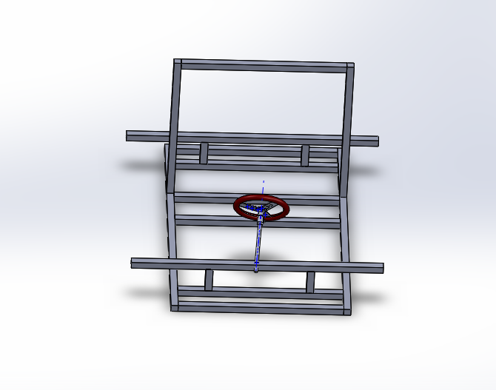
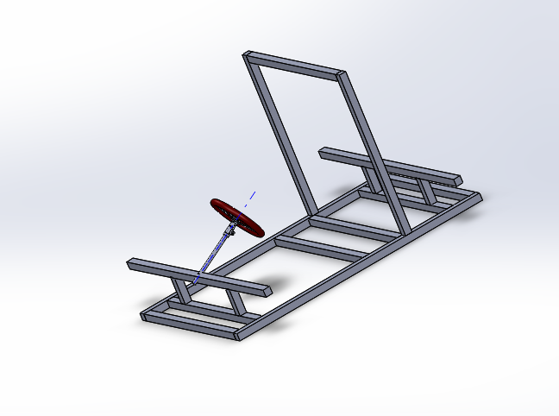
Figure Y(soap box chassis)
Figure X(soap box chassis)

Suitability of the design
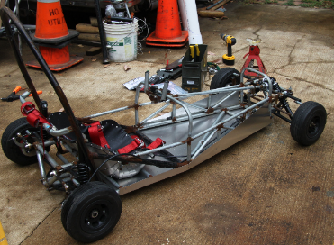
The design is simple but effective for its purpose and not an expensive project. Having looked at the Richards castle hill climb I believe that our simple design will be strong and rigid and with rose jointed steering it will have a competitive time. Due to its mild steel chassis and roll bar it will be able to build up momentum quickly and then apply the rear disk brake for when you come into the bends. This design can be done economically but effectively by using old parts like our rear axle off a go kart. All the steel that’s been used can be recycled and you could even use old unwanted go kart wheels. Overall I like the design as a naked soapbox racer and we believe it will perform well at the derby.
Jeremy Ashinghurst. (2012). Adult Soapbox Kart . Available: https://makezine.com/projects/adult-soapbox-kart/. Last accessed 1/05/18.

3) Chassis

The chassis that we had previously designed used 42.4mm by 3mm steel pipe as it is relatively inexpensive but also simple to construct and strong. We decided to change a variety of things on our design because of complications that we hadn’t thought of. The first complication was that we wanted to have the axle running through the chassis. This was a difficult because we had chosen tubular steel, if we had drilled a hole through to receive the axle then the chassis would have become weak at that point which could lead to a catastrophic failure. To overcome this issue we decided to do two things that would benefit the overall racer project. One; we changed tubular steel to 40mm x 40mm x 3mm box section. This is a strong alternative which is also a cost effective option as it is only £35.26 (excl. vat) for 3m lengths and the flat surfaces make constructing the chassis much easier (Mild Steel Box Section, n.d.). Two; we decided to raise the height of the axles so they aren’t going through the chassis itself. We accomplished this by mounting the axle 150mm above the chassis on bearings. This would lower the centre of mass of the racer, allowing the driver to take corners harder and faster without the worry of toppling to racer. This is because the centre of mass would remain within the wheelbase, and a vehicle only topples when the centre of mass is outside of the wheelbase because it becomes off balance.
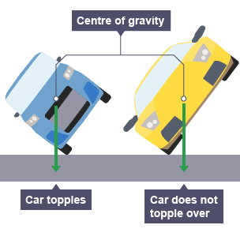 (Centre of Mass, 2014)
We will also weld in a support bar to the roll bar, this is to add additional support and ensure the driver’s safety should the racer roll. Apart from these minor changes the design shall remain the same. The chassis design is a seasoned and tested design that has been used in production cars and race cars alike, granted this was a few years ago.

4) Calculations Analysis

As a team, we aim to create our soap box/gravity racer to be of an estimated un-laden mass of between 80-100kg. This is considering the mass of each component and that the chassis would be made of mild steel as confirmed in the first report. The team approximates that the weight of the driver would be 80kg so coupled with the mass of the gravity racer, we estimate a combined mass to be 160-180kg. Due to this being an estimation and the calculations being purely hypothetical, for the purpose of working out maximums, we took the weight as being 180kg.
Firstly, we used data given to us in the 2018 Rules and Regulations (RCSB, 2018) to determine the race length and descent. ‘The course is 550m long with a descent of 50m’. We are also told that this is not a true reflection of the full course however. Obviously, there are parts of the course that are steeper or flatter than others, as well as corners to manoeuvre. However, using the information given to us, we can construct a right-angle triangle as shown in figure 1 to work out a theoretical angle of descent, labelled as ‘A’.

550
50
A

We used the sine function to determine that angle A is equal to 5.22°. Obviously, the angle of descent varies throughout the course, but we can use angle A as an average assumption to base further calculations from.
Utilizing the 2017 results of the Richards Castle Soapbox Derby which are published online (RCSB, 2018), we took a random sample of 5 teams. We used the teams’ data to determine an average time for the complete course as well as sector 1 and sector 2 individually. A speedtrap recorded racers velocity at the end of sector 1. We took a sample of this also to determine an average, as well as the maximum velocity recorded. This data can be seen in table 1.
From the information given to us, we can also decipher the change in potential energy from the start of the course to the end. We are told that the course has a descent of 50m therefore using the equation for potential energy we can determine the change in potential energy.

$$PE=mg∆h=180× 9.81×50=88290J (drop from start to finish)$$

The maximum speed recorded by the speedtrap in 2017 was 65.8km/h. To work out the speed in m/s we divided by 3.6 in order to covert our speed from km/h to m/s.

V(max) = 65.8km/h ÷ 3.6 = 18.28m/s

Table 1
 | Sector 1 Time (s) | Sector 2 Time (s) | Combined time (s) | Speedtrap  (m/s)
 | 23.850 | 15.006 | 38.856 | 18.28
 | 26.752 | 16.323 | 43.075 | 15.22
 | 27.224 | 19.144 | 46.368 | 13.71
 | 29.602 | 21.096 | 50.698 | 12.91
 | 40.626 | 32.943 | 73.569 | 6.44
Average | 29.611 | 20.902 | 50.513 | 13.31

We used the maximum recorded velocity along with our maximum estimated mass in order to calculate the theoretical maximum kinetic energy of our gravity racer. We then used our maximum estimated mass and the average recorded speed to record an average kinetic energy.

$$KE(max)=\frac{1}{2}mv^{2}=\frac{1}{2}×180×{18.28}^{2}=30074.26J$$

$$KE(avg)=\frac{1}{2}mv^{2}=\frac{1}{2}×180×{13.31}^{2}=15944.05J$$

Although the runs are clearly not linear motion, we can use linear motion equations to work out a theoretical value for acceleration in sector 1. We know that we start from rest and we have an average and maximum velocity value for the end of sector 1, courtesy of the speedtrap. Therefore, by rearranging the linear motion equation, we can calculate;

$a\left(max\right)=\frac{v-u}{t}=\frac{(18.28-0)}{23.850 }$ = 0.766m/s²

$a\left(avg\right)=\frac{v-u}{t}=\frac{(13.31-0)}{29.611 }$ = 0.449m/s²

Utilizing the values calculated, the team used Newton’s second law of motion to calculate the forces that could be exerted on the gravity racer through sector 1. Again, the team calculated an average and maximum value.
$$F\left(max\right)=ma=180×0.766=137.88N$$
$$F\left(avg\right)=ma=180×0.449=80.82N$$

References
Centre of Mass. (2014). Retrieved from BBC GCSE Bitesize: http://www.bbc.co.uk/schools/gcsebitesize/science/triple_aqa/using_physics_make_things_work/centre_of_mass/revision/3/
Mild Steel Box Section. (n.d.). Retrieved from Metals4u: https://www.metals4u.co.uk/mild-steel/c6/box-section/c49/40mm-x-40mm-x-3mm/p2301
RCSB. (2018, April 20). 2017 results. Retrieved from Richards Castle Soap Box: http://www.richardscastlesoapbox.co.uk/cms/images/PDF/FullResults2017.pdf
RCSB. (2018, April 20). Rules and Regulations 2018. Retrieved from Richards Castle Soap Box: http://www.richardscastlesoapbox.co.uk/cms/images/PDF/RulesandRegulations2018.pdf

