May Davies (1902699)
Computer Games Development
L5 – CHANGE MAKERS:
Creativity and Value Creation
Assignment 2: Project Outcomes

Contents
Video link 2
Link to source code mentioned in video 3
Link to built standalone of prototype mentioned in the video 3

Video link
Link to video presentation: https://www.youtube.com/watch?v=xKk3KvNuhbQ&feature=youtu.be
Note: As I did include a link to view source code or the actual build (should you desire to see these), I have included links to both further down this document for ease of access. This video link above is the link for this assignment’s video presentation.
Screenshot of uploaded video:
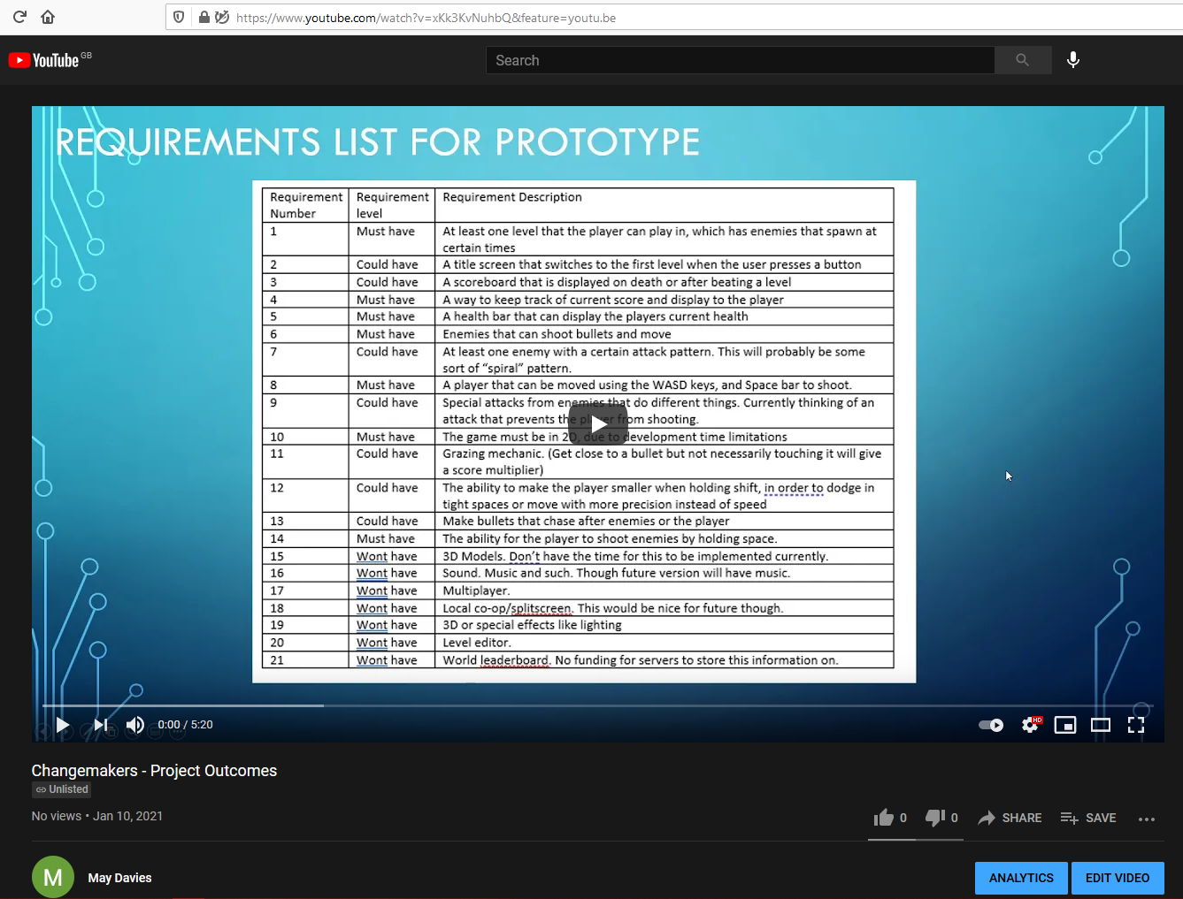
Download/Google Drive mirror (Should the video for some reason not be available on youtube): https://drive.google.com/file/d/1u7jsHC1-7ZhwWU0hJ8yk3TKvIUY7aJxD/view?usp=sharing
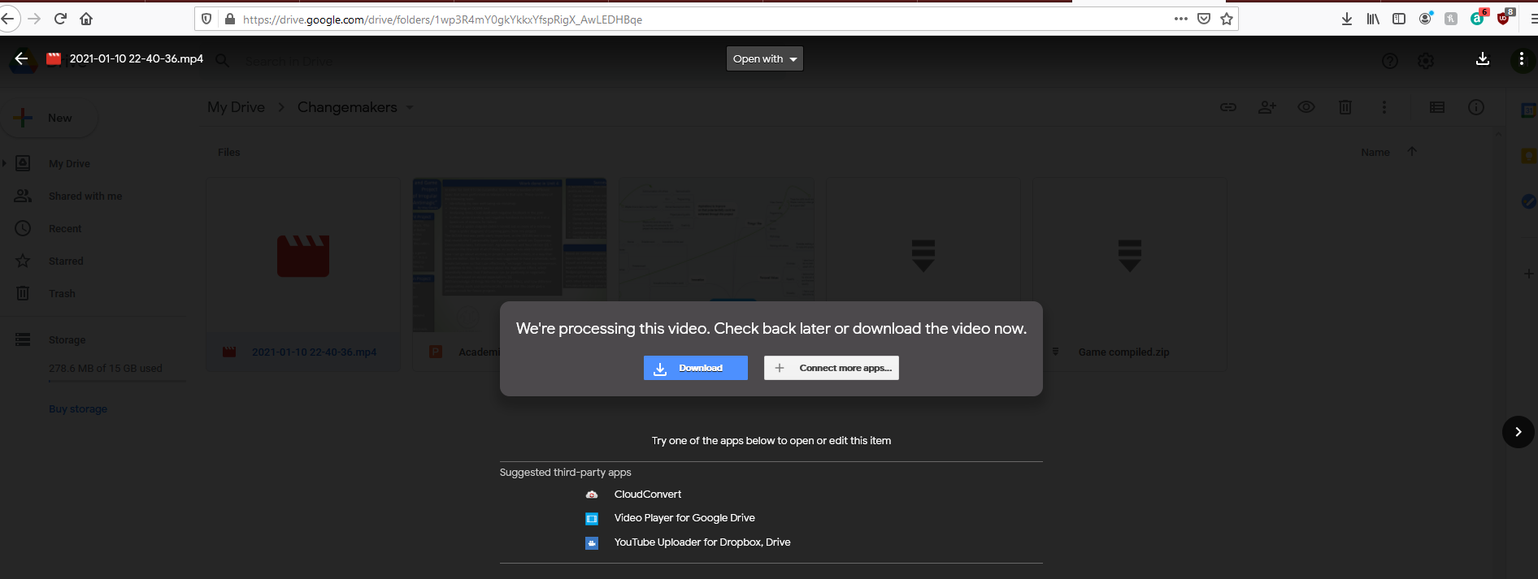

Link to source code mentioned in video
Short URL: shorturl.at/isxyF
Unshortened, original URL: https://drive.google.com/file/d/12EfIHXfghDzsr53Cv9y2zzPnRAxC1sSy/view


Link to built standalone of prototype mentioned in the video
Short URL: shorturl.at/bilE7
Unshortened, Original URL: https://drive.google.com/file/d/1Qd13uWoduHijmR4s9i4Cg2FQoqB09JI6/view


