Baker, Michael J. Marketing Strategy and Management. 4th. Palgrave Macmillan, 2007.
Ana Diana Rosca
Student ID:2020311
Module: LCBB6002

Strategies for Managing Foreign Exchange Risks
A Case Study of Apple Inc.

University of Wales Trinity Saint David
Assessment 1

Introduction
International Financial Management (IFM) plays a crucial role in multinational corporations' strategic decision-making process, especially when it comes to managing exposure to foreign exchange risks. In this report, we will evaluate the different strategies that Apple Inc., a global technology giant, adopts to effectively manage its foreign exchange risks. By examining relevant literature, analysing empirical evidence, and critically evaluating the points made, we aim to provide insights into Apple's approach to IFM and its impact on the company's financial performance.
In today's globalized economy, businesses like Apple are expanding their operations beyond domestic borders to tap into new markets, access resources, and gain a competitive edge. However, operating in international markets brings forth a myriad of challenges, particularly in terms of financial management. Factors such as currency fluctuations, foreign exchange risks, diverse regulatory frameworks, and varying tax systems can significantly impact a company's financial performance (Eiteman et al., 2016).

Apple Inc. is a renowned global leader in the technology industry, known for its innovative products and services. With a diverse product portfolio including iPhones, iPads, Macs, and services like Apple Music and iCloud, Apple generates substantial revenue from international markets. In the fiscal year 2021, Apple reported total revenue of $365.7 billion, with international sales accounting for a significant portion (Apple Inc, 2022).

For Apple, efficient international financial management is crucial for maintaining profitability, optimizing cash flows, and mitigating risks. By implementing robust strategies in international financial management, Apple can make informed decisions regarding currency hedging, investment allocation, financing options, and capital structure across its global operations (Madura, 2017). Moreover, international financial management enables Apple to identify and evaluate potential markets, assess the feasibility of investments, and allocate resources effectively, thereby enhancing its competitive position and driving sustainable growth in revenue and market share. (Rugman & Verbeke, 2004).

Apple Inc. benefits from international financial management by optimizing its global supply chain, which involves a network of 166,000 direct suppliers (Apple Inc., 2023). Through efficient management of cross-border transactions and foreign exchange risks, Apple ensures the seamless and cost-effective operation of its international network (Cavusgil et al., 2014). This approach enhances customer satisfaction, strengthens relationships with suppliers and partners, and improves overall operational efficiency.
In this report, we will delve into the various aspects of international financial management for Apple, including the management of foreign exchange risks, financial planning and risk assessment for international operations, and the utilization of financial instruments to optimize financial outcomes. By examining Apple's international financial management practices, we aim to provide valuable insights into the strategies employed by the company to navigate the challenges of international markets, enhance financial performance, and sustain its position as a global leader in the technology industry.

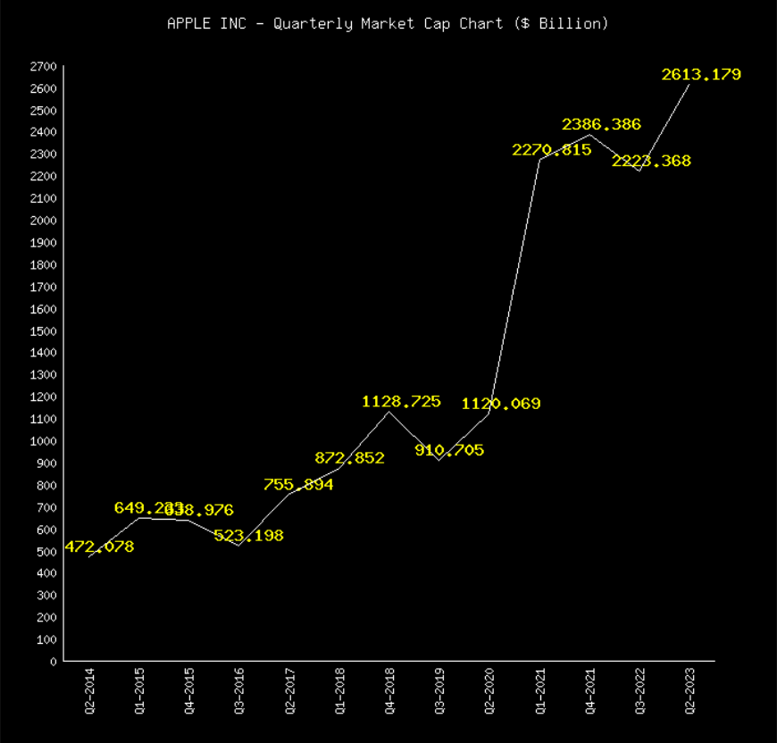
Figure 1 Apple Inc-Quarterly market Cap Chart 2014-2023 (Netcials,2023)

International financial management practices employed by Apple Inc.
International financial management plays a pivotal role in Apple's success in the global marketplace. The company effectively manages currency risks, engages in strategic financial planning, and optimizes its supply chain operations. These practices enable Apple to navigate the complexities of international markets, drive growth, and maintain its position as a leader in the technology industry.
- Mitigating foreign Exchange Risk
To manage the risk associated with foreign exchange fluctuations, Apple has the option to utilize various hedging techniques including forward contracts, options, and swaps (Madura, 2017). These strategies allow Apple to minimize the potential negative effects of currency movements on its financial performance. For example, by entering into forward contracts, Apple can secure exchange rates for future transactions, thereby reducing uncertainty and safeguarding profitability. Implementing these hedging techniques enables Apple to proactively protect its financial interests and make informed decisions when engaging in international transactions.

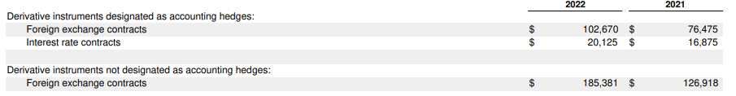
Figure 2- Apple Inc, 2022- Foreign Exchange Risk-Derivative Instruments
- Accessing Global Financial Markets
As a multinational corporation, Apple requires access to global financial markets for capital raising to support its operations and investments. Leveraging its international presence, Apple can tap into equity and debt markets worldwide. This provides the company with flexibility in financing options, enabling it to raise funds in various currencies and markets (Eiteman et al., 2016). For example, Apple may issue bonds denominated in different currencies to diversify its funding sources and reduce reliance on any single market.
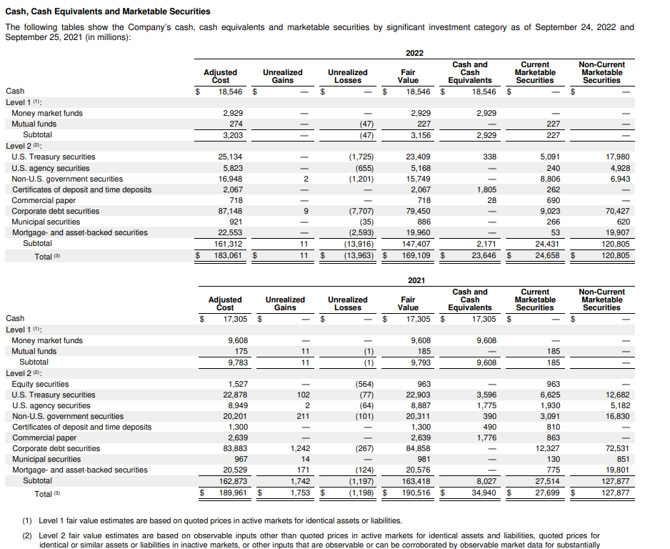
Figure 3-Apple Inc, 2022- Cash, Cash Equivalents and Marketable Securities
- Optimizing Tax Liabilities
Additionally, international financial management enables Apple Inc. to optimize its tax liabilities across various jurisdictions, thereby enhancing profitability. Through effective tax planning strategies, Apple strategically allocates its resources and operations in jurisdictions with favourable tax policies. This approach allows the company to minimize its tax expenses and maximize its after-tax earnings (Madura, 2017). For example, Apple may establish regional headquarters in countries with lower tax rates, reducing its overall tax burden.
By carefully managing its tax liabilities, Apple ensures that it complies with applicable tax laws while also taking advantage of legal tax optimization strategies. This proactive approach helps Apple to optimize its global tax position and allocate its financial resources efficiently, ultimately contributing to the company's profitability and financial success.
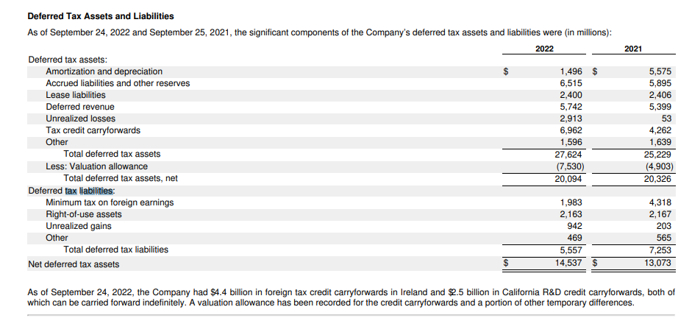
Figure 4-Apple Inc, 2022- Deferred Tax Assets and Liabilities

- Efficient Working Capital Management
Efficient management of working capital plays a crucial role in enhancing cash flow, reducing operating costs, and improving profitability for Apple Inc. (Eiteman et al., 2016). By adopting industry best practices in working capital management, Apple can effectively optimize its liquidity position and minimize the reliance on external financing. This can be achieved through strategic inventory management, optimizing accounts receivable and payable, and streamlining the supply chain. For example, Apple can implement just-in-time inventory systems to minimize working capital requirements and decrease carrying costs (Eiteman et al., 2016). By implementing these measures, Apple can ensure a strong financial position, improved operational efficiency, and sustainable growth in the long run.
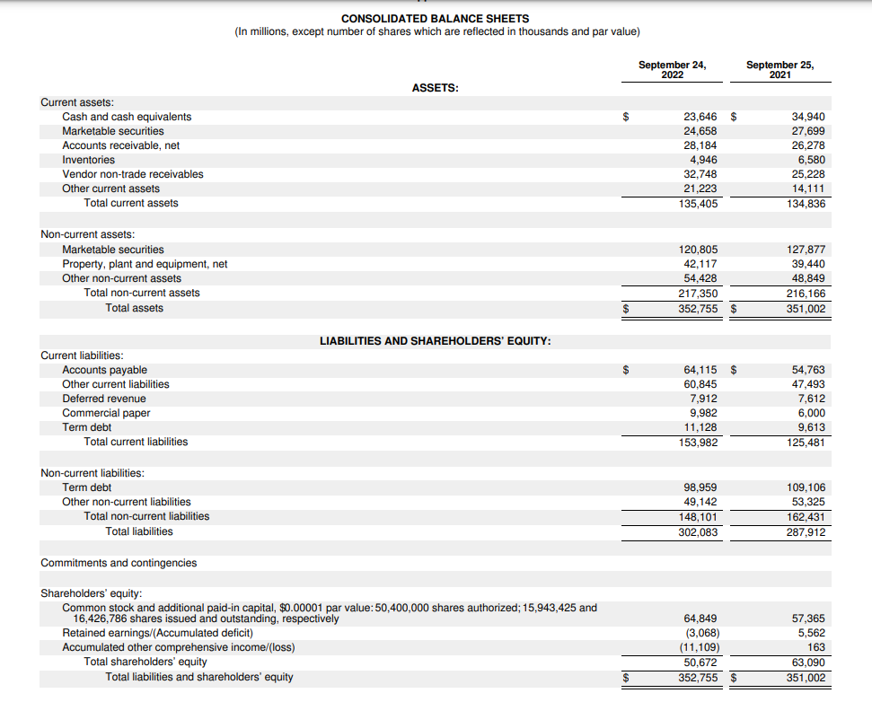
Figure 5-Apple Inc.,2022-Consolidated balance Sheet

Challenges Faced by Apple Inc. in International Financial Management
1. Geopolitical and Economic Factors: Apple operates in a dynamic global environment, encountering challenges such as geopolitical tensions and economic instability. These factors can have an impact on trade flows, consumer demand, and overall business operations. For instance, trade disputes or economic downturns can result in decreased demand for Apple products, leading to lower revenue and potential disruptions in supply chains (Apple, 2022).
2. Regulatory Environment: Compliance with diverse regulations across multiple jurisdictions poses a significant challenge for Apple. Ensuring compliance can be costly, particularly in areas such as customs, security, and environmental regulations. For example, stricter customs regulations may require additional resources for documentation and inspections, affecting operational efficiency and profitability. Apple must allocate resources and implement effective strategies to navigate the complex regulatory landscape and mitigate potential risks (Apple, 2022).
3. Technological Disruptions: Technological advancements and evolving customer preferences pose challenges for Apple Inc. The rapid growth of e-commerce and the increasing adoption of digital platforms have transformed the technology industry, requiring Apple to continually invest in innovative technologies and adapt its business strategies. In the 2022 fiscal year, Apple "continued to prioritize research and development, investing in cutting-edge technologies and expanding its product portfolio" (Apple, 2022). Failure to keep pace with technological disruptions can result in a loss of market share and hinder financial performance.

Dividend Distribution Policy
Apple's dividend distribution policy is designed to prioritize the return of capital to shareholders through regular dividend payments, while simultaneously retaining sufficient funds for growth and strategic initiatives. This approach demonstrates the company's commitment to striking a balance between rewarding shareholders and investing in future opportunities.
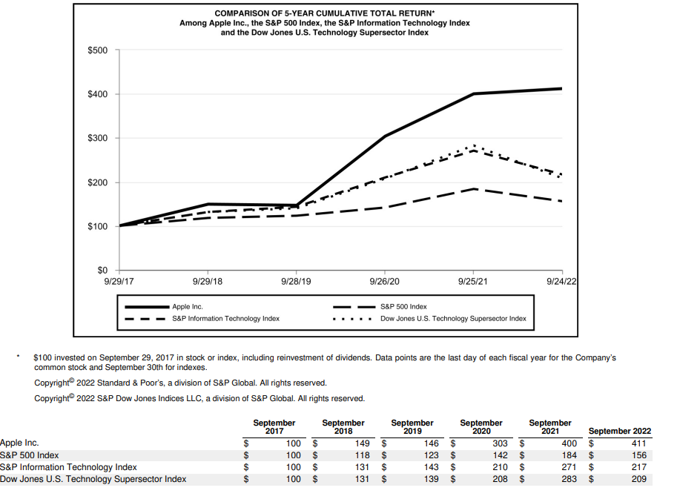
Figure 6 Apple Inc, 2022- Company stock performance-comparison of cumulative total shareholder return

Empirical evidence supports the stability of Apple's dividend distribution policy:
Dividend Growth: Apple has consistently increased its dividend payments since initiating its dividend program in 2012. Year after year, the company has raised its dividend, exemplifying its dedication to providing a stable and growing dividend to shareholders. For instance, in 2019, Apple increased its dividend by 5% compared to the previous year, and in 2020, it further raised the dividend by 6% (Apple Inc., 2021).
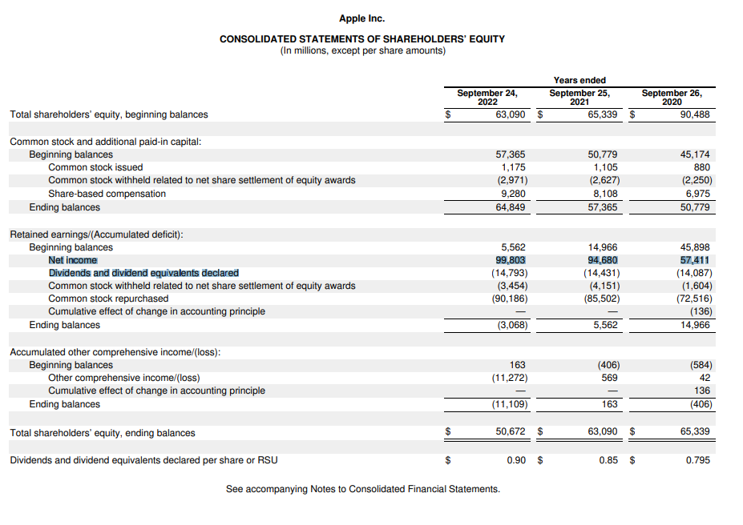
Figure 7-Apple Inc.,2022- Consolidated Statements of Shareholders ‘Equity-Dividends declared
2. Dividend Payout Ratio: is a significant metric that reflects the proportion of earnings distributed as dividends and indicates the stability of dividend payments. Apple Inc. has consistently maintained a relatively conservative dividend payout ratio, typically ranging from 20% to 30% of its earnings. This cautious approach enables the company to retain a substantial portion of its earnings for reinvestment and future growth, while still providing a consistent dividend to its shareholders (Apple Inc., 2022).
3. Dividend Yield: Is another crucial metric for income-seeking investors is, which represents the annual dividend payment as a percentage of the stock price. Apple's dividend yield has exhibited relative stability over time. As of September 2021, the company's dividend yield stood at approximately 0.6%. Although this yield may not be exceptionally high compared to other dividend-paying stocks, it is important to consider Apple's share price appreciation and overall return potential in conjunction with the dividend yield (Apple Inc., 2022).
Empirical evidence supports Apple's dividend distribution policy, which focuses on delivering a growing dividend to shareholders while maintaining a sustainable payout ratio. The company's consistent increases in dividend payments, low payout ratio, and stable dividend yield highlight its commitment to dividend stability and value creation for its investors. By prioritizing both dividend growth and reinvestment for future growth, Apple strives to provide a balanced approach that benefits its shareholders (Apple Inc., 2022).
The Efficient Market Hypothesis
The Efficient Market Hypothesis (EMH) is a widely accepted theory in finance that posits that financial markets efficiently and promptly reflect all available information in asset prices. It encompasses three forms: weak, semi-strong, and strong. The weak form suggests that historical prices already include all past information, while the semi-strong form assumes that stock prices reflect all publicly available information. Lastly, the strong form assumes that prices reflect both public and private information (Fama, 1970).
In the case of Apple, the efficient market hypothesis implies that it is challenging for investors to consistently outperform the market by trading Apple stock. According to the EMH, stock prices already incorporate all relevant information, including historical data, market trends, and public announcements. In an efficient market, Apple's stock price would immediately adjust to reflect any new information related to the company's performance, product launches, or industry developments. Therefore, investors cannot consistently generate abnormal profits by trading based on publicly available information (Fama, 1970).
Evidence supporting the EMH can be observed through the efficient response of Apple's stock price to significant events or earnings announcements. For example, when Apple releases better-than-expected quarterly earnings or introduces highly anticipated products, the stock price tends to react swiftly and accurately, indicating that the market efficiently incorporates this information (Fama, 1970). This further supports the notion that the market efficiently reflects all available information and makes it challenging for investors to consistently outperform the market by trading Apple stock.
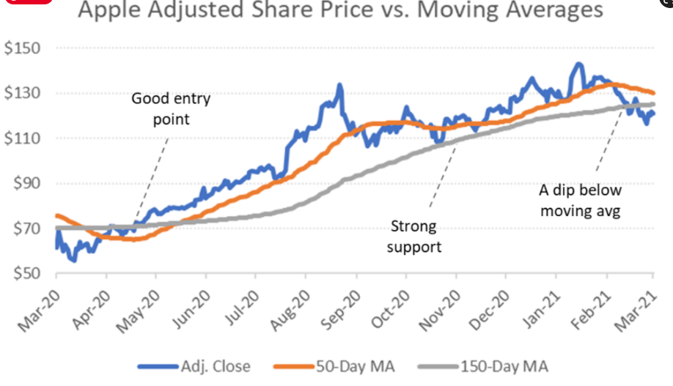
Figure 8- The Street,2021 -Apple Adjusted Share Price vs Moving Averages
The Efficient Market Hypothesis suggests that Apple's stock price is efficient in reflecting all available information. Investors cannot consistently outperform the market by trading based on publicly available information alone. The swift and accurate response of Apple's stock price to significant events supports the notion of an efficient market for Apple stock (Fama, 1970).

Market Anomalies
Critics like George Soros have raised doubts about the validity of the Efficient Market Hypothesis (EMH) by highlighting market anomalies that contradict the idea of market efficiency (Soros, 1987). These anomalies, including the momentum effect and value premium, suggest that certain investment strategies can generate abnormal returns over time. Shiller (1981) supports this perspective by emphasizing the influence of psychological biases and irrational behavior on market movements. He argues that asset prices can deviate from their fundamental values, and investor sentiment plays a significant role in driving these deviations. When evaluating Apple, it becomes crucial to examine whether historical price patterns and valuation metrics consistently outperform the broader market, indicating the presence of an anomaly (Shiller, 1981).
Soros (1987) introduces the concept of reflexivity, whereby market participants' beliefs and actions can influence market prices, leading to deviations from efficiency. Applied to Apple, it is important to analyze how the beliefs and actions of market participants may impact the stock's price and whether this deviates from what the EMH would expect (Soros, 1987). However, it is essential to note that the existence of market anomalies does not completely disprove the overall efficiency of the market. These anomalies could be attributed to random fluctuations or temporary market inefficiencies. Therefore, evaluating Apple's performance requires a careful examination of historical stock price patterns, valuation metrics, and the potential impact of information asymmetry, given that certain investors may possess private or hidden information about the company (Shiller, 1981; Soros, 1987; Stiglitz, 2000).
Apple’s Method of appraising Projects
Apple's methods of appraising projects are also highly structured and systematic. The company follows a rigorous approach to evaluate potential projects based on their expected financial returns, operational considerations, and strategic implications.
In terms of financial evaluation, Apple utilizes various financial tools such as discounted cash flow analysis and net present value analysis. These tools help assess the expected cash flows and return on investment of a project. Apple also takes into account the associated risk and considers factors like cost of capital and projected revenue streams.
Operational considerations play a crucial role in Apple's project appraisal. The company evaluates projects based on their ability to enhance operational efficiency, reduce costs, and improve customer experience. Apple carefully considers how a project aligns with its operational objectives and if it can contribute to streamlining processes or introducing innovative solutions.
Strategic implications are another key aspect of Apple's project appraisal. The company assesses projects in terms of their potential to create a competitive advantage, capitalize on new market opportunities, and align with Apple's long-term strategic goals. Apple looks for projects that can strengthen its market position, expand its product offerings, or enhance its ecosystem.
To provide an example, Apple evaluated the potential development of a new product line aimed at targeting the health and wellness market. The company applied its structured and systematic approach to assess the financial viability, operational feasibility, and strategic alignment of the project. After a thorough evaluation, Apple decided to pursue the development and launch of the Apple Watch, which has since become a successful product line contributing to the company's growth and diversification (Apple Inc, 2023).
Apple's structured and systematic approach to project appraisal ensures that decisions are based on comprehensive analysis and consideration of various factors. By carefully evaluating projects in terms of their financial returns, operational considerations, and strategic implications, Apple can make informed decisions that align with its overall business objectives and drive sustainable growth.

Conclusion
In conclusion, Apple's adoption of International Financial Management (IFM) is vital for effectively managing its financial activities in a global context. The company recognizes that factors such as fluctuating exchange rates, varying regulations, and cultural differences can significantly impact its financial performance. By implementing IFM practices, Apple can assess and navigate these risks, ensuring the stability and profitability of its international operations.

Additionally, IFM enables Apple to optimize its capital structure and funding strategies, supporting its investments in research and development, manufacturing facilities, and marketing efforts. By effectively managing its international financial resources, Apple can minimize borrowing costs, access capital markets, and make informed decisions regarding investment and financing activities.

IFM also allows Apple to seize international business opportunities by analyzing market trends, evaluating potential risks, and conducting financial feasibility studies. This enables the company to make strategic decisions regarding market entry, expansion, and partnerships, capitalizing on global growth prospects and enhancing its market share. Apple's utilization of IFM demonstrates its commitment to prudent financial management, strategic decision-making, and long-term value creation in the international marketplace. By effectively managing its financial resources, mitigating risks, and capitalizing on international opportunities, Apple can drive sustainable growth and profitability in the global market.

References

Apple Inc. (2021). Apple reports fourth quarter results 2021. Retrieved from
https://www.apple.com/newsroom/pdfs/FY21_Q4_Consolidated_Financial_Statements.pdf
Apple Inc. (2022). Apple reports fourth quarter results 2022. Retrieved from https://www.apple.com/newsroom/pdfs/FY22_Q4_Consolidated_Financial_Statements.pdf.
Apple Inc. (2023). About Apple 2023. Retrieved from
https://www.apple.com/newsroom/
Baker, M. J., 2007. Marketing Strategy and Management. 4th ed. s.l.:Palgrave Macmillan.
Borovkova, S., & Petrov, A. (2018). Energy stock prices and predictability: Time-varying dynamics and the role of oil prices. Energy Economics, 75, 1-14.
Czinkota, M. R., Ronkainen, I. A., & Moffett, M. H. (2011). Fundamentals of international business John Wiley & Sons.
Eiteman, D. K., Stonehill, A. I., & Moffett, M. H. (2016). Multinational business finance. Pearson.
Harris, R. (2005). Environmental and social impact assessment. In Environmental and social impact assessment (pp. 1-19). Wiley-Blackwell.
Investopedia. (2021). Dividend Policy. Retrieved from https://www.investopedia.com/terms/d/dividendpolicy.asp
Krugman, P. R., Obstfeld, M., & Melitz, M. J. (2012). International economics: Theory and policy. Pearson Education.
Lozano, R. (2019). Tools and techniques for environmental appraisal of industrial projects: A review and a proposal for a new multidimensional framework. Journal of Cleaner Production, 209, 1231-1246.
Madura, J. (2017). International financial management. Cengage Learning.
Malkiel, B. G. (2003). The efficient market hypothesis and its critics. Journal of Economic Perspectives, 17(1), 59-82.
Mun, J. (2006). Real options analysis: Tools and techniques for valuing strategic investments and decisions. Wiley.
Rugman, A. M., & Verbeke, A. (2003). Extending the theory of the multinational enterprise: Internalization and strategic management perspectives. Journal of International Business Studies, 34(2), 125-137.
Santos, A. C., Figueira, J. R., & Marques, R. C. (2020). Project appraisal using the discounted cash flow approach: A tutorial review. European Journal of Operational Research, 283(1), 1-24.
Shiller, R. J. (1981). Do stock prices move too much to be justified by subsequent changes in dividends? American Economic Review, 71(3), 421-436.

Soros, G. (1987). The Alchemy of Finance: Reading the Mind of the Market. New York, NY: John Wiley & Sons.
Stiglitz, J. E. (2000). Economics of the Public Sector. New York, NY: W.W. Norton & Company.

