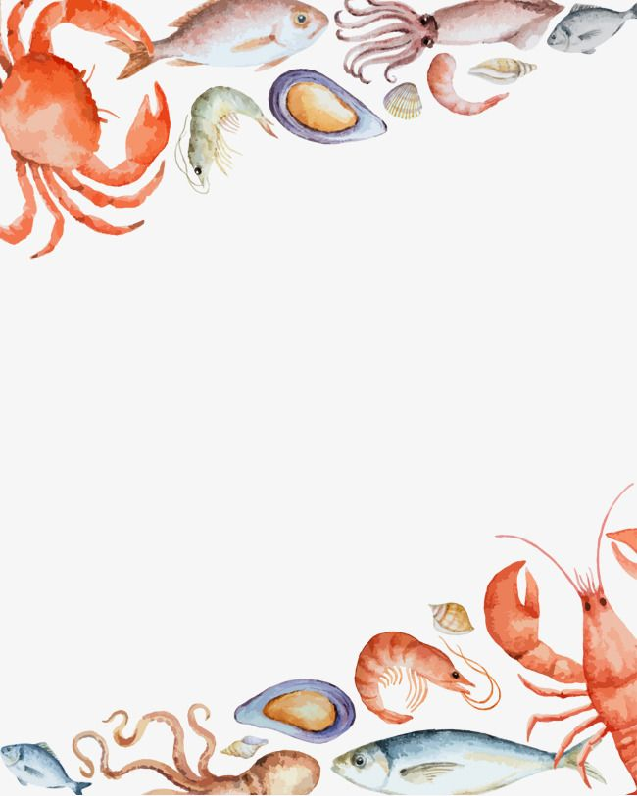
THE HOTEL TRINITY
we have vegetarian ,vegan, gluten-free and halal food options available
MAIN COURSE
Tiger Prawn 35.15
A large platter of Tiger Prawn in a majestic Garlic Ginger Soy sauce alongside a glass of light, crispy Pinot Grigio to balance out the beautiful flavours in harmony (150ml)

Scallops and Lobster Risotto 46.50
Luscious brown butter scallops with parmesan risotto creating a beautiful blend of flavours with velvety chardonnay wine hinted with light taste of vanilla and aromatic spices (147ml)

T-Bone Steak 35.85
T-Bone steak grilled to perfection to your preference served with grilled vegetables and a portion of fries, paired with dry, light, and fruity Cabernet Sauvignon (150ml)

*Meals with wine included are part with the main course and therefore the wine is of no extra cost*

Cawl 19.20
A delightful traditional Welsh dish created from Welsh lamb and a variety of root vegetables accompanied with large white breadsticks
Stuffed Peppers (vegetarian) 15.35
Peppers stuffed with couscous along with a beautifully created sauce
DRINKS
Coke 2.75
Cider 3.00
Strawberry Mojito 4.00

STARTERS
Vegetable Soup 6.25
A delicious healthy soup with French baguette served alongside

Shrimps In Garlic Sauce 5.95
Stir fry shrimps drizzled with rich garlic sauce

Marinated Chicken Wings 7.25
Delicious fried wings marinated with a sweet chilli sauce

Rarebit 6.80
Gooey Cheesy Bechamel sauce served over pieces of toasted white bread

ADDRESS: 47 Cowley Road, Swansea SA1 1AF
PHONE: 07781488464 EMAIL: hoteltrinity@gmail.com
OPENING TIMES: 5pm till 11pm
Available for delivery and collection

DESSERTS
Lotus Biscoff and dark chocolate cookie dough 6.10
A soft cookie dough base topped with crumbled Biscoff drizzled with warm dark chocolate sauce and Biscoff sauce

Vanilla Milk Cake 4.95
A delicate light sponge soaked in a deliciously flavoured milk syrup bursting with mouth-watering sweetness

Welsh Cake 5.75
A traditional sweet bread dusted with caster sugar creating a euphony of spice and sweetness, served warm

Allergy disclaimer: food within the menu may contain or have come in contact with the following food which are WHEAT/GLUTEN, MILK,EGGS,PEANUTS,FISH, SHELLFISH AND SOY. Please contact us on the number or email given above for further allergen information
Ewch i food.gov.uk/ratings i ganfod sgôr hylendid bwyd ein busnes neu gofynnwch inni beth yw ein sgôr hylendid bwyd wrth archebu / Go to food.gov.uk/ratings to find out the food hygiene rating of our business or ask us for our food hygiene rating when you order

