

Assignment 1

Name: Gianina-Maricica Chirila
Student ID: 2131738
Module code: LCBB4004
Module name: Marketing Fundamentals
Assessment 1: Individual Blog Marketing Fundamentals
Lecturer: Piyumika Gamage
Date: 02.04.2023

Table of content

1. Introduction ………………………………………………………………………3
2. NESCAFÉ’s background ……………………………………………………….4
3. Needs and wants ……........................................……………………………..5
4. B2B or B2C? ……………………………………………………………………...5
5. Segmentation, Targeting and Positioning …………………………………..6
6. Marketing Mix Strategy ……………………………………………………….11
7. Conclusion ……………………………………………………………………...16
8. Reference list …………………………………………………………………...17

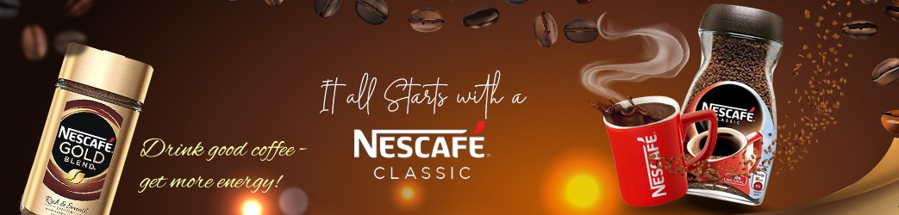

marketing definition
“Marketing is engaging customers and managing profitable customer relationship. The two-fold goal marketing is to attract new customers by promising superior value and to keep and grow current customers by delivering value and satisfaction” (Kotler et al. 2019, p.5).

1. Introduction

Most companies have moved away from mass marketing towards segmentation marketing because the last one is designed to be an effective way of reaching a smaller, specific group of consumers that have needs and preferences. The main disadvantage of mass marketing strategy is that it can be successful in one area, but not in other areas. The report will analyse several marketing strategies, including ‘Market segmentation, targeting, and positioning’, as well as the ‘Marketing mix’. The marketing tools will be applied on NESCAFÉ, one of the most well-known brands in worldwide.

2. NESCAFÉ’s background

In the late 19th century, Henry Nestlé established Nestlé company. In 1929, Brazil faced an excessive surplus of coffee beans from their harvest and sought to address this by presenting a task to Nestle: create a quick and simple coffee product that only requires the addition of hot water.
In April 1938, NESCAFÉ’s origins can be traced back to the creation of coffee powder by Dr. Max Morgenthaler, a scientist who launched the soluble coffee under the NESCAFÉ brand name in Switzerland. NESCAFÉ became famous during the 1950’s.
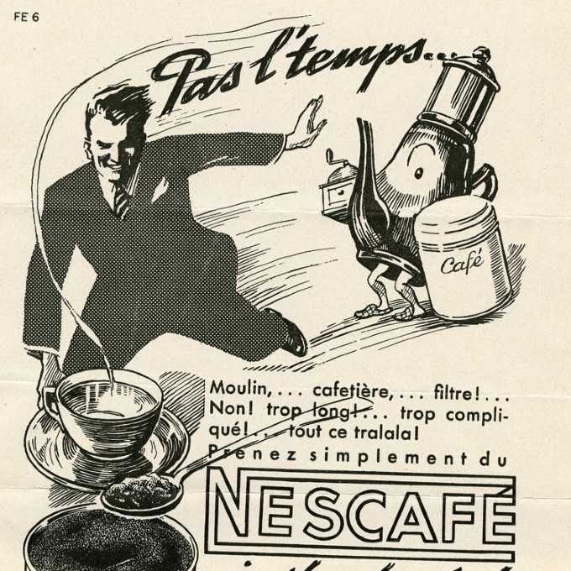
In the report dated on 5th March 2019, Euromonitor International stated that NESCAFÉ holds the top position among hot drinks brands globally. The Asia Pacific region contributed to one third of NESCAFÉ’s total retail sales in 2017, with Japan being the leading country for hot drink sales.
NESCAFÉ is a brand of instant coffee that is produced and sold by Nestle. On 12th May 2022, Nestle has been named the biggest food company in the world by the ‘Forbes Global 2000 list’ and has maintained its top position in the industry, having generated over $93 billion in sales.

3. Needs and wants

The main reason why most forms of traditional mass marketing are no longer enough relevant to the brand’s current audience is because the potential consumers are looking for more personalised shopping experiences, for more choices and variety of products to satisfy their preferences and needs (Kotler et al. 2019).
The common needs and wants of coffee consumers are:
Taste | Preference for roast, flavour, or strength.
Convenience | Instant coffee, time efficiency, cost benefit.
Variety | Wide range of products.
Quality | Premium coffee for premium customers.
Sustainability | Make Your World, The Milk Plan, Carbon Reduction
Health | Low calories, no sugar or cream
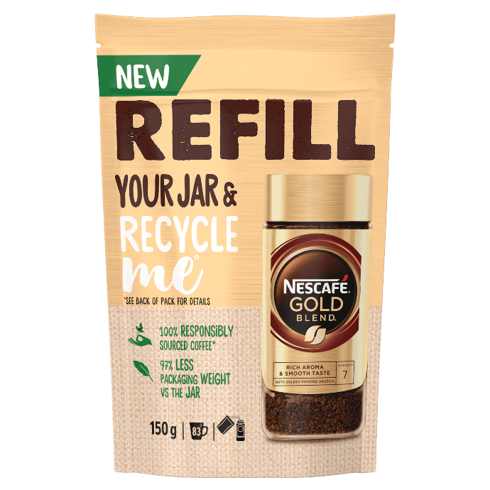
In March 2023, NESCAFÉ introduced in UK recyclable coffee refill pouches for Nescafe Gold Blend and Nescafe Original. MarketLine (2023) stated that NESCAFÉ’s aims to 2025, all their products to be made from 100% responsible sourced.

4. B2B or B2C?
NESCAFÉ operates in both B2B and B2C markets. Jan Detert, who is the leader of cCRM on a global scale, stated during the SAP Customer Experience event in Barcelona that Nestle’s cCRM initiative considered the management of both customer and consumer relationships.
NESCAFÉ sells its products to other businesses such as hotels, restaurants, and cafes, as well as directly to consumers through retail channels such as supermarkets, hypermarkets, convenience stores, online retailers, coffee shops, cafes, gas stations, wholesale clubs.

5. Segmentation, Targeting and Positioning strategies

Nestlé used differentiated marketing strategy and designed separate products for each segment targeted of NESCAFÉ. Nestlé spend more money on marketing research, forecasting, sales analysis, promotion, and channel distribution.

Market segmentation
Advantages | Disadvantages
- Understanding customer needs and wants  - Increase efficiency  - Effective marketing campaigns  - Improve customer loyalty  - Build stronger relationship with the clients | - High cost  - Complexity  - Limited reach

NESCAFÉ’s primary areas of focus for customers segmentation in the market are based on four key variables, which include geographic, demographic, psychographic, and behavioural segments.

Geographic segmentation
NESCAFÉ targeted the most populated cities, but on the same time did not neglect the rural or suburban area. For each segment, NESCAFÉ offers various coffee products.

Demographic segmentation
NESCAFÉ focus on different demographic criteria’s such as age, coffee culture, income, and posh customers.
NESCAFÉ’s strategy is to attract the young generation, to make them loyal to their brand as long as possible.
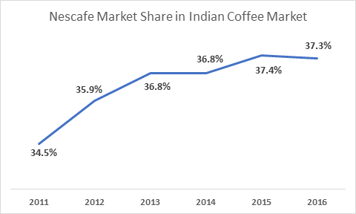
NESCAFÉ has launched various advertising campaigns with visual appealing, showing the enjoyment and social aspects of coffee drinking, attracting, and persuading the target with an emotional message.
NESCAFÉ’s product is priced in a way that makes it affordable and within reach for individuals of various socio-economic backgrounds.
NESCAFÉ Gold is a premium range of instant coffee products. The luxurious product is designated to appeal the posh consumer who is ready to pay extra money for a magnificent coffee experience.
Psychographic segmentation is a marketing tool that divide a market based on consumers’ personality and lifestyle. NESCAFÉ is the symbol of energetic clients who are living an active life, who are hardworking, confident, and full of good vibes.
Behavioural segmentation is an extra marketing technique that divides customers into groups based on their behaviour.

5.1 Segmentation. NESCAFÉ’s case

Type of segmentation | Segmentation criteria | Target segmentation
Geographic | Region  Density | Globally  Urban and rural areas
Demographic | Age  Gender  Income  Occupation | 16-50  Female and male  Middle and high class  Students, executives, managers
Psychographic | Lifestyle  Personality | Busy, active  Ambitious, outgoing
Behavioural | Occasions  Benefits sought  Personality  User status  Usage rate  Social class  Loyalty status | Anywhere, anytime  Convenience, cost benefit, time efficiency  Easy going, careless  Potential, regular coffee drinkers  Light, medium  Middle and upper class  Medium

5.2 Targeting


Target segmentation is a marketing tool used to divide a market into distinct groups of costumers based on 1. market segmentation, 2. market evaluation and 3. market selection.
On the first step, the company has to create the customer profiles, collecting and analysing demographic, geographic, psychographic, and behavioural data.
On the second step, the company needs to evaluate the segments based on firm resources, size, growth potential, profitability, and competition.
On the third step, the company select the most attractive segments and develop the right marketing strategy to the specific target.
A company can improve their profitability and reduce the risk of wasting money, time, and resources if that promote the correct product to the correct customer. A few examples of the most popular NESCAFÉ products are NESCAFÉ Classic, NESCAFÉ Gold, NESCAFÉ Espresso, NESCAFÉ Ice and so on.

5.3 Positioning

The brand positioning strategy is important for image building. Brand image outline clients’ beliefs and thoughts about a product. A successful brand positioning can increase sales and revenue, and on the same time help to build customer loyalty.
The methodology adopted by NESCAFÉ in their research are quantitative and qualitative data.

NESCAFÉ – brand positioning
Parent company | Nestlé
Name | Nes (first three letters from Nestlé) + Café
Positioning | World leader in coffee industry
Availability | In over 180 countries
Tagline | It all starts with a NESCAFÉ
The visual identity | Red mug with hot steam rising
Product USP | 100% pure instant coffee
Variety | Over 5000 products
Popularity | 5500 cups consumed every second
Service | 24-hour support lines
Key competitors | Owl, Super, Jacobs Kronung, Maxwell House
Promotion | Advertising, Sales, Public Relations, Emails, social media
Facebook | 30 million followers

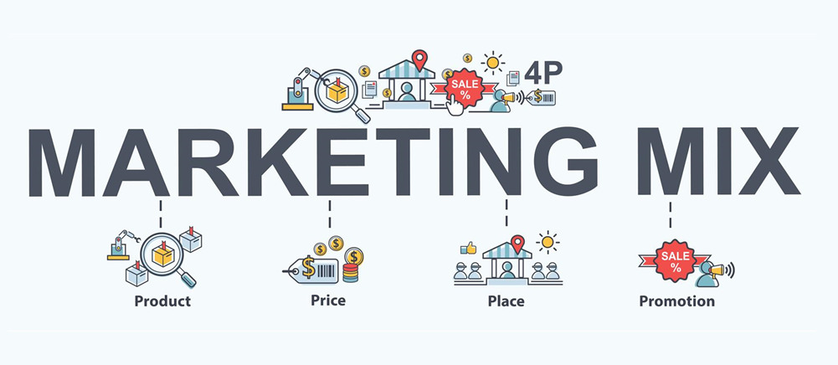

6. Marketing Mix Strategy
Marketing mix framework helped NESCAFÉ to succeed in the market. Marketing Mix Strategy are based on four key variables, also known as the “4P’s” (Product, Price, Place, and Promotion).

6.1 Product
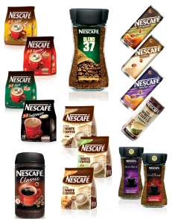
NESCAFÉ Umbrella Strategy gives opportunities to the existing brand to introduce new products, to extend their line, to build brand image, and to create customer loyalty. Due to the high credibility, NESCAFÉ could easily launch line and brand extension.

Core product or benefit | - the product is designed to be quick and convenient to make it.  - enable consumers to enjoy a cup of coffee at any place or time.  -improve mood, increase concentration, lessen feelings of fatigue, reduce stress, or boost energy.
Actual products available in various flavours and sizes in packaging | - NESCAFÉ Classic made from blend of Robusta and Arabica beans.  - NESCAFÉ Gold made from high-quality Arabica beans, having rich and smooth taste.  - NESCAFÉ 3-in-1is an instant coffee with sugar and creamer.  - NESCAFÉ Dolce Gusto capsules designed for NESCAFÉ coffee machines to make cappuccinos, lattes, and espressos.  - NESCAFÉ Taster’s Choice is a premium instant coffee made from 100% pure coffee beans.
Augment product (additional benefits from the actual product) | - introduce different types of coffee with new exotic seasonal flavours.  - provide more sustainable options in the packaging materials.  - using renewable energy in its production processes  - develop innovative brewing methods.  - provide customised options adding extra foam or sweeteners.

6.2 Price
The main factors which can influence the price of the product are related to the inflation, social trends, the cost of production, the research and development cost, the promotional and storage cost etc.
The cost of the product is determined by the variant, ingredients, flavour, size, or type of packaging (sachets, cartons, cans, jars). NESCAFÉ’s brand is based on the quality of a wide range of products for a low cost.
In India, NESCAFÉ has modified its pricing approach to cater to the demands of cost-conscious consumers. NESCAFÉ penetrate the market by encouraging customers to try their affordable Rs 2 sachet pack.

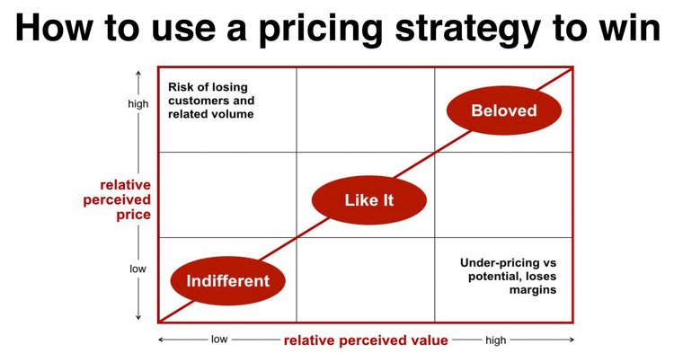

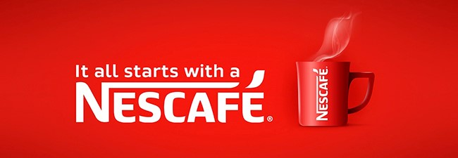

6.3 Promotion
“It all starts with NESCAFÉ” is one of NESCAFÉ’s tagline. The red mug with hot steam rising is so popular and easy to associate it with NESCAFÉ’s brand due to continuous advertising campaigns with emotional aspect, smart message, and promotion.
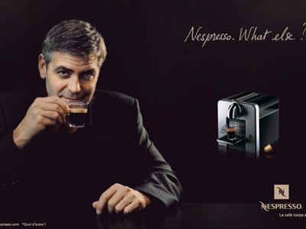
NESCAFÉ collaborated with influential celebrities, launched campaigns that encourage new trends and promote connections, bringing people together.
The logo remained the same since the origin. NESCAFÉ became a premium brand using mass promotion strategy such as television advertising, NESCAFÉ print in newspapers or magazines, billboard ads, sponsored variety of community festivals and charity events. NESCAFÉ build image through sales promotion, public relations, sponsorship, direct marketing, and digital marketing.
NESCAFÉ sell and promote their products through traditional retail channels, through their own website, or via e-commerce platforms (Amazon).

6.4 Place
NESCAFÉ is powered by Nestle’s highly efficient distribution system. Nestle has divided its distribution channels into two categories: one that involves the manufacturing process, C&F (Clearing and Forwarding) agents, distributors, and retailers, while the other involves manufacturing for bulk buyers who directly sell to consumers. This approach is in line with Nestle’s fast moving consumer goods (FMCG) strategy, which has helped the company establish a strong sales and distribution network.
NESCAFÉ’s products are widely available and easily accessible to the customers. The instant coffee is in the eye’s consumers, in the areas where the company expect their target clients to be (on educational institution, railways, airlines, offices, food joints, or restaurants).

7.Conclusion
The concept of marketing should be viewed differently from the traditional method of persuading customers to buy products. Marketing should be considered as a way to fulfil the requirements of the consumers.
The report analysed how NESCAFÉ used the new marketing strategies and became a well-established and recognizable brand globally. Over the years, NESCAFÉ understood what means an effective marketing strategy, how important is to be open to the new consumers trends, how important is to build relationships with customers how important is to be innovative, how important is to communicate with the clients and be receptive to their needs, wants, and preferences.
Overall, the marketing mix strategy and the market segmentation, targeting and positioning are a few marketing techniques that made NESCAFÉ a great successful global coffee brand.

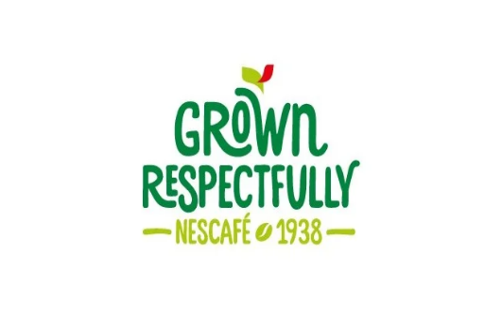

8. Reference list

Bashin, H. (2019) ‘Marketing mix of Nescafe’, MARKETING91 [blog] 2 February. Available at: https://www.marketing91.com/marketing-mix-nescafe/ (Accessed: 9th March 2023).
Crozier, R. (2018) ‘Nestle draws consumer consent from system silos’, itnews, 19 Octomber. Available at: https://www.itnews.com.au/news/nestle-draws-consumer-consent-out-from-system-silos-513822#:~:text=Global%20head%20of%20cCRM%20Jan,into%20account%2C%E2%80%9D%20Detert%20said. (Accessed 22nd March 2023).
Danao, M. (2017) ‘5 Nescafe Marketing Campaigns That Convinced The World’ ReferralCandy [blog] 25th May. (Available at:’https://www.referralcandy.com/blog/nescafe-marketing-strategy (Accessed 10th March 2023).
ENJOYBETTERCOFFEE (2017) It All Starts With a Nescafe. Available at: https://www.enjoybettercoffee.com/page/blog/it-all-starts-with-a-nescafe (Accessed: 12th March 2023).
Euromonitor International (2019), Euromonitor International Reveals the Top 100 Megabrands Ranking, , Available at: https://www.nestle.com/sites/default/files/asset-library/documents/media/news-feed/euromonitor-nescafe-press-release.pdf (Accessed 22nd March 2023).
Hassan, S.S. and Craft, S. (2012), ’Examining world market segmentation and positioning strategies’, Journal of Consumer Marketing, 29(5), pp.334-356. Available at: http:/doi.org/10.1108/07363761211247460.
Kotler, P.T. et al. (2019) Principles of Marketing. Harlow: Pearson Education Limited
Malhotra, A. (2018) ‘Marketing Mix PPT Templates to Create an Unbeatable Marketing Strategy’, Slide Team [blog]. 20 September. Available at: https://www.slideteam.net/blog/marketing-mix-ppt-templates-to-create-an-unbeatable-marketing-strategy (Accessed: 12th March 2023).
Marion (2022) A simple definition of brand positioning. Available at: https://www.thebrandingjournal.com/2016/11/brand-positioning-definition/ (Accessed: 15th March 2023).
MarketLine (2023) Master Company Report. Nestle SA Available at: https://b2b-marketline-com.ezproxy.uwtsd.ac.uk/CompanyAnalyzer/Reports/Snapshot.aspx?Id=FB0B4585-AB15-4030-B6D5-A1F41A61D05E&RptType=MCReport&DownLoadType=HTML (Accessed 12th March 2023).
MarketLine (2023) Nestle SA. Available at: https://advantage-marketline-com.ezproxy.uwtsd.ac.uk/Company/Summary/nestle-sa (Accessed 12th March 2023).
mbaSkool (2020) Nescafe SWOT Analysis, Competitor & USP Available at: https://www.mbaskool.com/brandguide/food-and-beverages/508-nescafe.html (Accessed: 10th March 2023).
mbaSkool (2021) Nescafe Marketing Strategy & Marketing Mix (4Ps) Available at: https://www.mbaskool.com/marketing-mix/products/16754-nescafe.html (Accessed: 10th March 2023).
NESCAFÉ (2023) The History of NESCAFÉ. Available at https://www.nescafe.com/gb/understanding-coffee/nescafe-history/ (Accessed 15th March.2023).
Nestle SA (2021) Annual Review 2021. Available at: https://www.nestle.com/sites/default/files/2022-03/2021-annual-review-en.pdf, (Accessed: 22nd March 2023).
Panchal, R. (2023) ‘Nescafe- History, Brand Value and Brand Strategy’, BeNextBrand [blog] Available at: https://benextbrand.com/nescafe-history-brand-value-brand-strategy/ (Accessed: 15th March 2023).

Purna S.M. (2020), ‘Title Image building of Nescafe: A study on brand positioning strategy and consumer perception’, Academia. 07.03.2023https://www.academia.edu/44820080/Title_Image_building_of_Nescafe_A_study_on_brand_positioning_strategy_and_consumer_perception.
Roy, S. (2021) ‘Nescafe Marketing Strategy: Lesson in pull-market’, TheStrategyStory [blog] 3rd September. Available at: https://thestrategystory.com/2021/09/03/nescafe-marketing-strategy-plan-mix/ (Accessed: 12 March 2023).
Sahad, T. (2022) Marketing Strategy of NESCAFE. Available at: https://www.researchgate.net/publication/358117768_Marketing_Strategy_of_NESCAFE (Accessed at: 12th March 2023).
Sorvino, C. (2022) Forbes Global 2000: The World’s Largest Food Companies in 2022. Available at: https://www.forbes.com/sites/chloesorvino/2022/05/12/the-worlds-largest-food-companies-in-2022/?sh=4312f83474db (Accessed: 22nd March 2023).
Stanke, B. (2022) ‘Positioning Strategy: Types, Tools, and Examples For Positioning Your Brand To Win In 2023’, Bob Stanke [blog]. 21 Sept Available at: https://www.bobstanke.com/blog/positioning-strategy-overview (Accessed: 10th March 2023).
The Nescafe Team (2012) ‘Assignment#1’, About Nescafe [blog]. 2ndSeptembre. Available at: https://thenescafeway.wordpress.com/2012/09/02/assignment-1/#:~:text=NESCAF%C3%89%20's%20primary%20target%20market,comfort%20of%20their%20own%20home (Accessed:15thMarch 2023).
Ward, S. (2022) What is Target Marketing. Available at: https://www.thebalancemoney.com/target-marketing-2948355 (Accessed: 9 March 2023).
WondershareEdrawMind (2023) Nestle Market segmentation, targeting, and positioning. Available at: https://www.edrawmind.com/article/nestle-segmentation-targeting-and-positioning.html (Accessed: 12th March 2023).
Yieldify (2020) Geographic Segmentation Explained With 5 Examples [blog]. 27th August. Available at: https://www.yieldify.com/blog/geographic-segmentation-real-world-examples/ (Accessed: 12th March 2023).
ZIFITI (2023) Available at:https://www.zifiti.com/Nescafe/grocery/brand-all-seller-items/ (Accessed: 12th March 2023).

