
Student Name: Yahya Sugal Jama
STUDENT ID: 2532858
Module Name: Software solutions for business
Module Code: ACCA 4026
Lecturer: Koushik Modak
Trinity Saint David University of Wales (London Campus)

Assessment
Portfolio Report on Contemporary Software Applications for Business
Table of Contents
Introduction 1
Task 1. e-Commerce Website builders or software solutions 1
1.1 WooCommerce 1
1.2 Wix 1
Task 2. Mind-map of contemporary software applications 1
a. Mind mapping and explain the benefits of using mind mapping in business operations 1
b. Create a mind map of contemporary software applications 1
Task 3. Office Applications 1
a. Four office software solutions for business operations 1
MS Word 1
MS PowerPoint 1
MS Excel 1
MS Access 2
b. Practical demonstration of Two Office Features 2
Mail Merge 2
If Statement 2
Task 4. Communication and Collaboration applications 2
a. One contemporary Communication and one Online Collaboration applications/tools 2
MS Outlook 2
MS Teams 2
b. One feature of a freely available Communication (1) and one feature of a Collaboration (1) application 2
MS Outlook 2
Ms Teams 2
Conclusion 2
References 3

Introduction
<Insert Information Here>

Task 1: e-Commerce Website builders or software solutions

1.1 WooCommerce
<Insert Information here – 250 words>

1.2 Wix
<Insert Information here – 250 words>

Task 2. Mind-map of contemporary software applications

Mind mapping and explain the benefits of using mind mapping in business operations
<Insert information appr 500 words>

Create a mind map of contemporary software applications
<Insert diagram using mind Meister app>

Task 3. Office Applications

Four office software solutions for business operations

MS Word
<Insert information appr 500 words>

MS PowerPoint
<Insert information appr 500 words>

MS Excel
<Insert information appr 500 words>

MS Access
<Insert information appr 500 words>

Practical demonstration of Two Office Features

Mail Merge
<Insert screenshots with captions>

If Statement
<Insert screenshots with captions>

Task 4. Communication and Collaboration applications

One contemporary Communication and one Online Collaboration applications/tools

MS Outlook
<Insert information appr 500 words>

MS Teams
<Insert information appr 500 words>

One feature of a freely available Communication (1) and one feature of a Collaboration (1) application

MS Outlook
<Insert screenshots with captions>

Ms Teams
<Insert screenshots with captions>

Conclusion
<Insert information>References

Introduction

Task 1: E-commerce Website builders/software solutions.
Overview
Shopify and Wix are two of the most popular and important e-commerce website builders right now. Both platforms let businesses build online stores without requiring extensive technical knowledge; however, they differ in focus, scalability, and the number of features they offer. Below, I show the difference between each platform, using recent expert reviews and comparisons between the two platforms.

What is the importance of using an application such as Shopify?
1st Shopify
Shopify is consistently ranked among the best e-commerce website builders because it offers robust sales tools, scales with your business, and has a large ecosystem. “Recent reviews of UK e-commerce platforms show that Shopify is one of the best options for businesses that want to grow online. This is mostly because it is easy to use and has a lot of features”.[1]
Important Features Shopify offers a wide range of commerce tools, such as order tracking, inventory management, discount creation, abandoned cart recovery and comprehensive analytics. Multichannel selling: Shopify POS enables users to sell on social media platforms, online marketplaces, and in person. It has a large app ecosystem where users can expand in areas such as SEO, marketing automation, shipping, and customer service through thousands of apps. It is a Safe payment processing option, as Shopify payments are appropriate for global trade, as it accepts a variety of currencies and payment options. It is scalable, as Shopify’s advanced plans and integration for high-volume stores allow it to grow with a business.
In conclusion, Shopify offers a wide selection of expertly crafted templates and a simple, user-friendly interface. These themes are optimised for conversions and responsive to mobile devices. While developers can use Shopify’s Liquid language for more intricate customisation, users can alter layouts without knowing any code.

What is the importance of using an application such as Wix?
2nd Wix
Another popular e-commerce website builder is Wix, which is renowned for its drag-and-drop editor and flexible design. It is constantly ranked as one of the best website builders and is often commended for its creativity and accessibility.
Important features include a drag-and-drop editor: Wix’s visual editor gives users a great deal of creative control while enabling them to create pages without knowing any code.
AI- powered tools: Based on user preferences, Wix ADI ( Artificial Design Intelligence) can automatically create layouts and content. Product catalogues, inventory control, abandoned cart recovery, and integrated payment gateways are examples of built-in e-commerce tools. Marketing reservations, shipping, and customer interaction are all supported by hundreds of apps.
Unlimited product listings are ideal for small and medium- sized internet retailers. Usability and Design: Wix is renowned for its highly customizable templates and unrestricted design options. “For this reason, many creative companies looking for visually unique online stores will find it especially appealing. Its templates are responsive, contemporary, and appealing for a variety of industries”.[2]

TASK 2a: Describe mind mapping and explain the benefits of using mind mapping in business applications.
Mind mapping is essentially brainstorming ideas and bringing them to life by positioning a central idea and allowing related ideas to branch outward in a logical sequence, as stated by Muh Syukur, who discusses using mind mapping as a technique in teaching vocabulary. “Mind mapping is a visual method for organising ideas by placing a central concept in the middle of a page and allowing related ideas to branch outward in a free-flowing associative structure”.[3]
It helps you visually develop and structure ideas and information, which in turn helps fit information together. “Mind map provides an expansive and flexible structure to support your thinking”. [1]
Mind mapping also aids in the mental aspect of life. In this case, I am referring to the psychological and even cognitive benefits. The way we think, remember and process information. It affects the mental processes involved in learning and creativity, in addition to organising ideas on paper. A mind map encourages you to think more naturally and nonlinearly because it reflects the associative structure of the brain.
Rather than forcing ideas your letting them develop in an intuitive way, which can lessen mental overload. Because this method externalises ideas that would otherwise remain entangled in your memory, many people find that it reduces stress during planning or studying. By connecting concepts through colour, shape, and spatial arrangement, all of which appeal to the brain’s preferences for imagery, the visual layout also improves recall.
Task 2b Mind-Map Of Contemporary Software Applications.
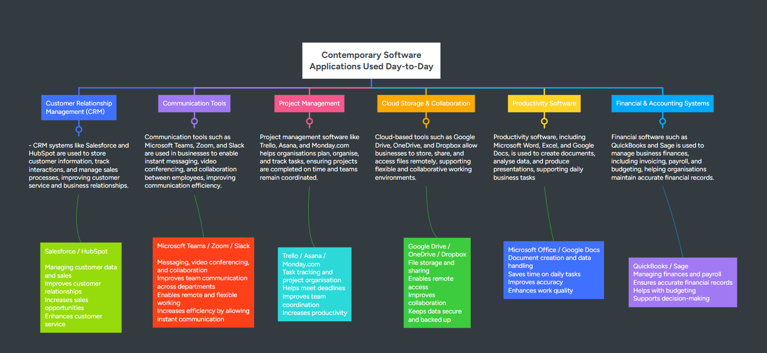
FIGURE 1 Mind-Map
As a business continues to develop, it’s important to use the right mix of tools to sustain growth and improve the user experience. Ensuring a strong operational base in a world that is becoming more digital and connected. To stay competitive and operate successfully, modern businesses require a wide range of software. Each tool is important for making workflows less difficult and more effective. Whether it's managing customer relationships, making communication easier, organising projects or allowing cloud-based collaboration.

Task 3 Software Applications
Four Software Applications For Businesses
Microsoft Word / Purpose and Core Role in Business
Microsoft Word remains one of the most popular word processing programs in business because it is easy to use and lets you create, edit, and manage professional documents. Its main job is to help people write reports, letters, and proposals. Manuals and other written information are assigned for communication in the workplace.
Word’s interface is meant to be easy to use, so that individuals with different levels of skill can adjust their documents to look professional. The Ribbon layout places tools together in a way that makes sense. This allows quick formatting, layout and also reviewing features.
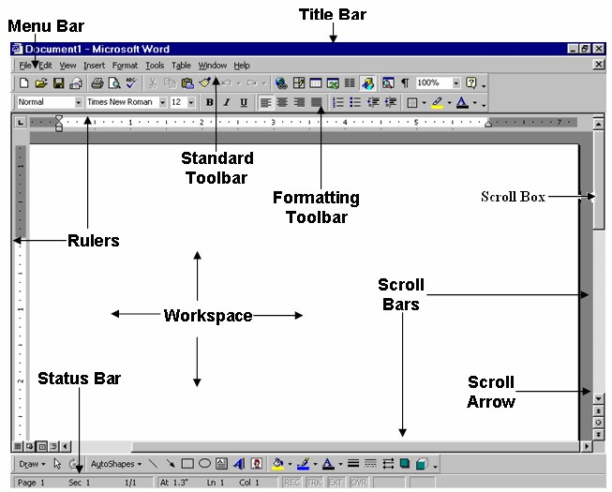
Figure 1 MS Word Interface Screenshot [1]
Purpose and Core Role of MS Word in Business
Microsoft Word plays a crucial role in the operations of modern businesses by providing a unified platform for the creation of documents and editing features. One of its advantages is that it allows teams to produce consistent documents. They may be collaborating or on a single project; this consistency not only enhances the branding of the organisation but also ensures the communication stays professional and at a level of quality throughout. This is vital in a client-based model, where you are constantly interacting or advising.

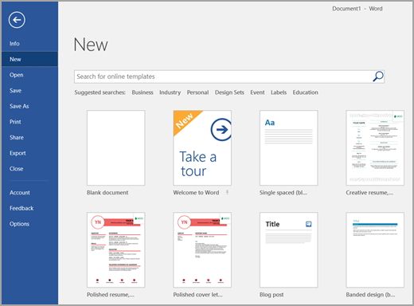
Figure 2 MS Word Template Gallery [2]
Formatting Tools and Documents Design
A major strength of Microsoft Word is its extensive formatting capabilities, which allow users to control how documents look and are structured. Businesses can keep their visual identity consistent by using features like font styling, paragraph alignment, spacing, indentation, and colour themes. Word also has advanced layout tools such as columns, tables, page borders, and section breaks that let you create complex documents.

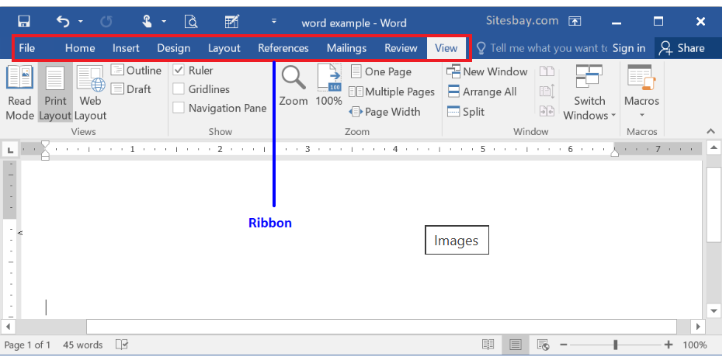
FIGURE 3 MS Word Formatting Ribbon [3]

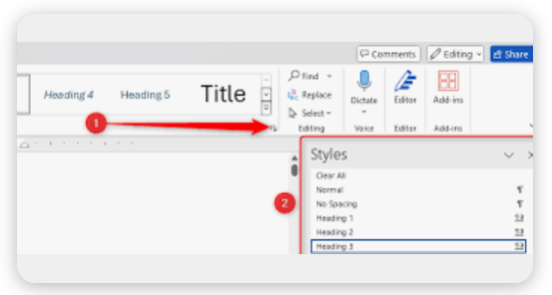
FIGURE 4 MS Word Styles Pane [4]
The style tab is especially useful because it automatically sorts large documents, ensuring they all look the same and saves time. These tools all help make business communication professional, readable and consistent with the overall brand. Furthermore, the style tab is a valuable feature, especially in controlling extensive documents, but it also ensures that every section maintains a uniform appearance, thereby enhancing readability. By having these adjustments in place, it significantly reduces the time spent on manually creating tasks. Such tools are necessary for fostering professional communication in a business context.
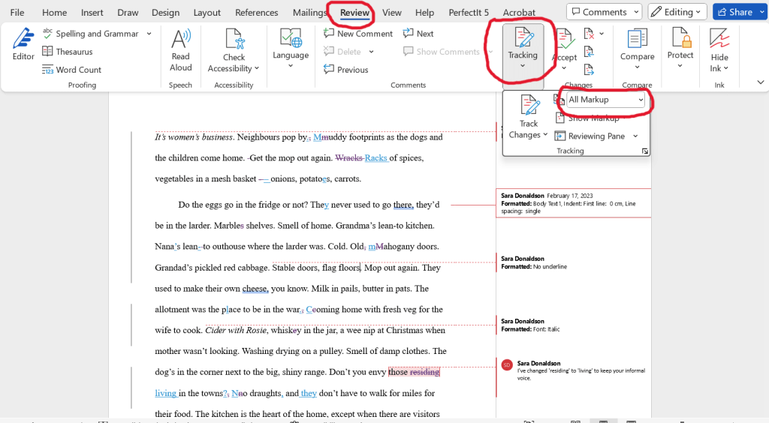
FIGURE 5 MS Word Track Changes Screenshot [5]
Microsoft Word’s reviewing tools make it a great place for students and business partners to work together on editing and ensuring quality is sufficient. The Track Changes feature allows editors to suggest changes without altering the original text, and comments let reviewers give specific feedback. These tools are very important in business settings where many people need to review a document before it can be approved.
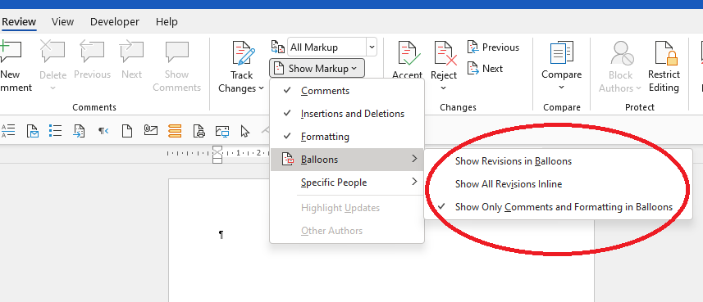
FIGURE 6 MS Word Comments Feature Screenshot [6]
Modern versions of Word work perfectly with cloud services such as OneDrive and SharePoint, which allow users to work on the same document at the same time from different locations. More than one person can edit a document at the same time, and changes are instantly synced across all devices. This feature is very important for teams that work in a variety of locations, such as hybrid workplaces, where people need to be able to work together no matter where they are.

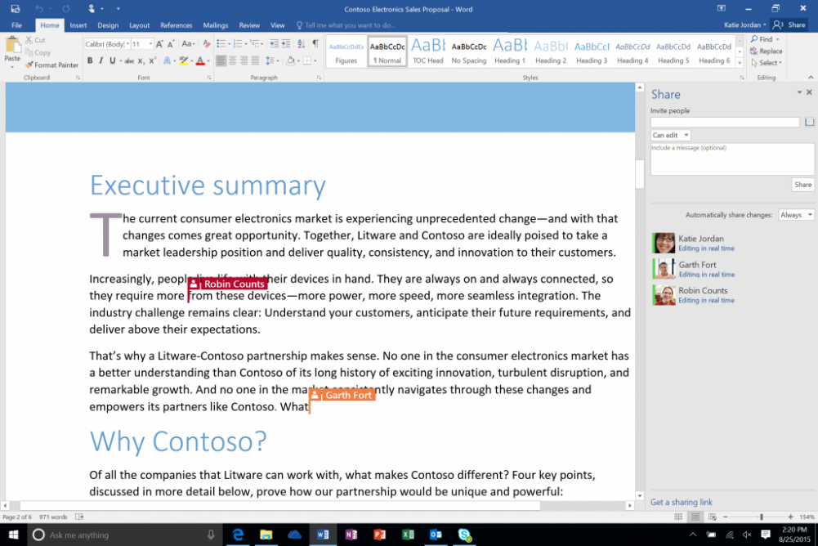
FIGURE 7 MS WORD Real-Time Co-Authoring Screenshot [7]
Cloud integration also ensures that documents are stored securely, have a version history, and can be shared easily. These features make Word a reliable tool for working together in business by boosting productivity and reducing the risk of missing data.
Even though Microsoft Word is effective, businesses should be aware of its limits. Big documents can slow down and freeze your computer. When you share files with people who use older versions of Word or different software platforms, you may run into compatibility problems that cause formatting problems later on.
To summarise, beginners may find Word’s features overwhelming and need training to use them well. Word does allow for collaboration, but it is not always as simple as it is with Google Docs or any other tool made for managing projects. By understanding these limits, businesses can pick the right tool for each job and come up with plans to avoid problems.

Role of Microsoft PowerPoint In Business Communication
Microsoft PowerPoint plays a central role in business communication because it allows companies to show information in a clear, visual and convincing way. It is widely used for sales pitches, training sessions, project updates, and executive briefings as it supports structured storytelling through slides. PowerPoint’s interface allows users to organise their ideas in a logical order, supported by speaker notes and handouts, making the presentation more appealing.

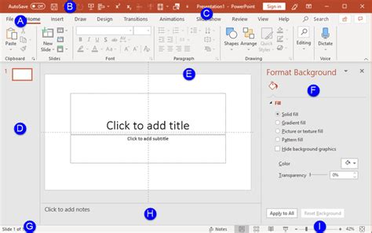
FIGURE 1 MS PowerPoint Interface [8]
PowerPoint's compatibility with Microsoft 365 ensures integration with Word, Excel, and Teams, making it a useful and versatile tool for businesses that work together. The ability to include charts, pictures, and videos makes it an even better communication tool, making complicated information easier to understand for a wide range of users.

Design and Visual Communication Tools
Through PowerPoint’s design tools, a user can create visually engaging slides and support branding/communication. Features such as Slide Master, themes, colour palettes, and layout templates are some of the features which aid in maintaining presentations consistently.
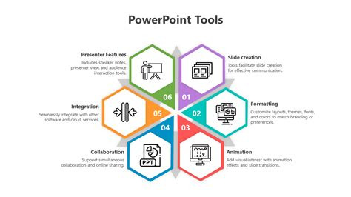
FIGURE 2 MS PowerPoint Tools [9]
The Creator tool uses AI to suggest layouts that make slides more concise and engaging, reducing the time spent formatting slides manually. MS PowerPoint is a powerful tool for translating raw information into polished visual stories that enhance audience engagement and comprehension.
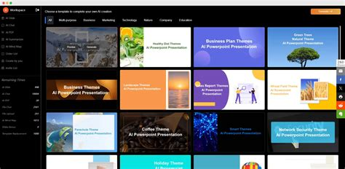
FIGURE 3 MS PowerPoint Design Visually [10]
Transitions, Animations, And Multimedia Integration In PowerPoint
PowerPoint enhances presentations by adding transitions, animations, and multimedia features that help tell stories in a versatile way. A user can embed videos, add audio clips, and screen recordings to make their content more interactive and interesting. Animations help the audience follow the flow of the presentation and draw attention to important points.
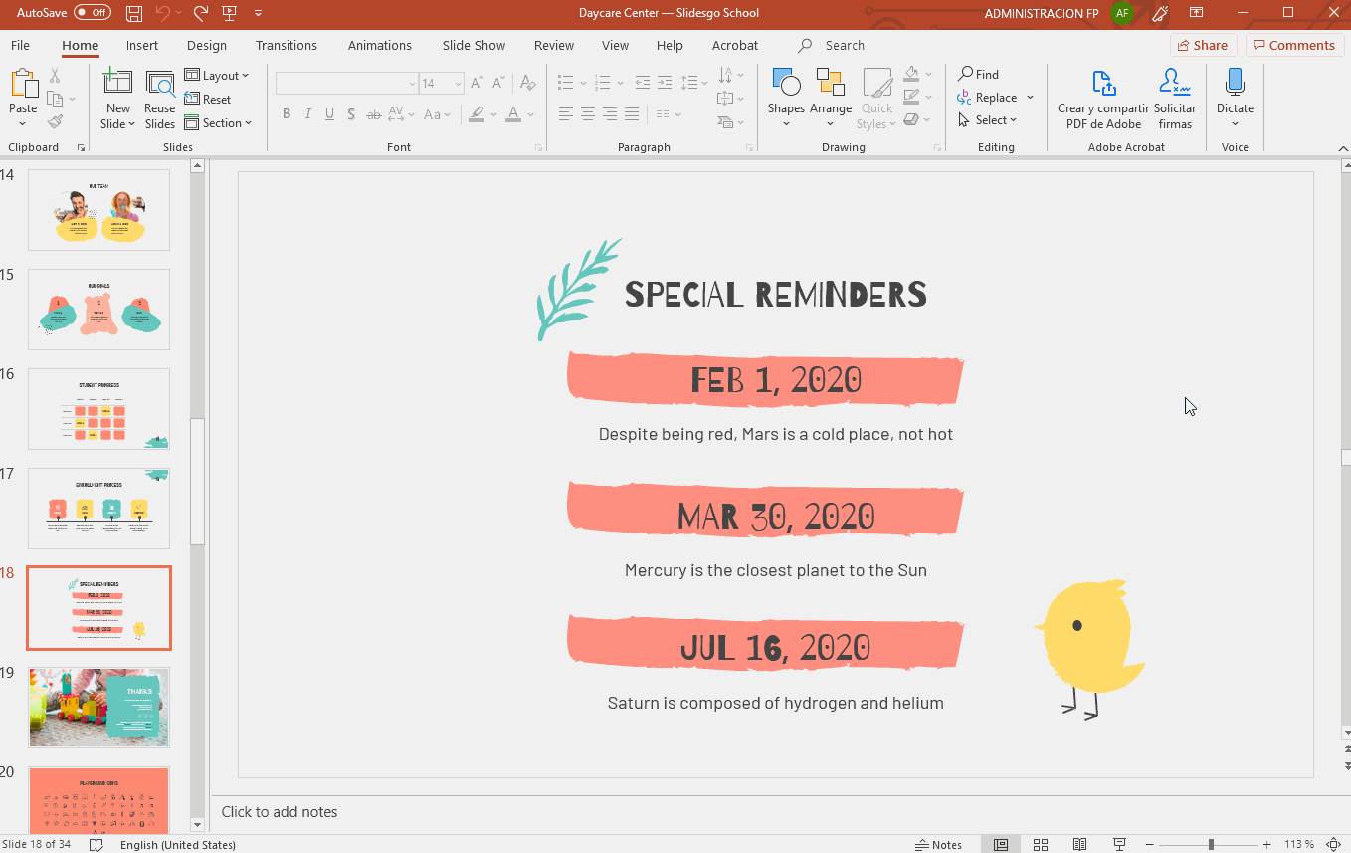
FIGURE 4 MS PowerPoint Graphic Animation [11]
These applications are very useful in training, marketing and education settings where seeing something helps you understand it better. However, to use them well, you need to find a balance. Too many animations can take away from the initial message, so presenters need to use them carefully to keep things clear and professional.

Collaboration, Cloud Integration, and Limitation

With OneDrive and SharePoint, PowerPoint lets people work together in real-time, so more than one person may compose slides at the same time, similar to Word in that function. Commenting, version history, and autosave make it easier for people to work together and cut down on problems with version control.
PowerPoint has multiple positive points, but it also has some bad ones. For example, when sharing a presentation across different platforms or older versions, bigger files with media attached can slow down performance and cause compatibility problems.

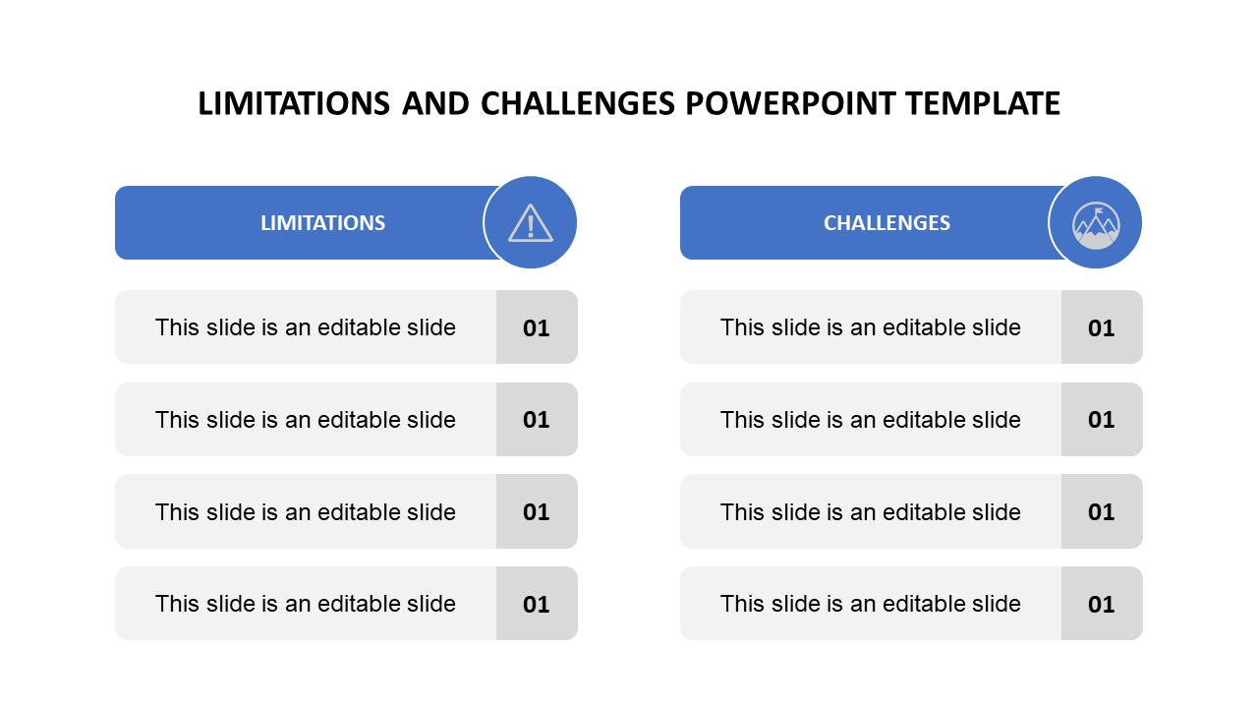
FIGURE 6 MS Limitation & Challenges Template

Summary
MS PowerPoint remains one of the most influential tools for businesses to communicate; it has features for visual design, structured storytelling, and working together. Its strengths are its flexibility, ability to work with different types of media, and ability to make complex information easier to understand.
While it has limitations, such as the risk of performance issues and overloading slides, its overall effect on how organisations communicate is vital to business. When utilised correctly, PowerPoint enhances clarity and engagement in presentations.

Microsoft Excel/ The Strategic Role of Excel in Business Operations
MS Excel has a different role in business today; it is a tool used to support data organisation, help with financial planning, and make decisions according to the plan. As a result of its spreadsheet structure, users can store, sort and analyse large amounts of data, making it suitable for tasks such as budgeting, forecasting, inventory tracking, and performance reporting.
The grid-based layout of Excel gives businesses a flexible workspace where they can change templates to fit their specific needs. This adaptability allows businesses to tailor their spreadsheets specifically to their operational needs, whether for financial modelling, data visualisation, or project tracking.
Ultimately, Excel is more than just a tool; it is a cornerstone of modern business intelligence, fostering a data-driven culture that encourages informed decision-making and supports strategic growth in an ever-evolving marketplace.

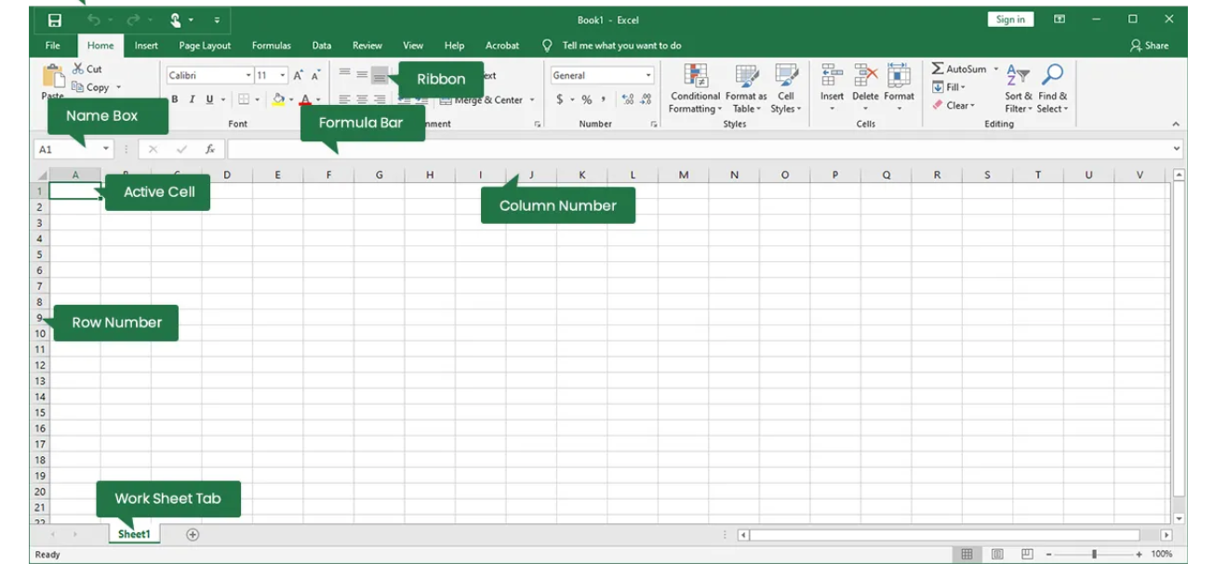
FIGURE 1 MS Excel Interface [12]
Analytical Tools, Formulas, and Data Processing
One of Excel’s greatest advantages is that it can analyse data and turn it into useful information. Everyday calculations can be done with functions such as SUM IF, VLOOKUP, and COUNTIF. While more advanced formulas like Index-match and XLOOKUP enhance data retrieval accuracy.
Excel’s data tools, such as sorting, filtering, conditional formatting, and data validation, help people keep their datasets clean. Additionally, features like pivot tables enable users to summarise large amounts of data quickly, making it easier to analyse trends and patterns. The use of charts and graphs allows for visual representation of data, enhancing comprehension and presentation. The Formula bar shows how calculations are made, which is important for checking for mistakes and auditing.
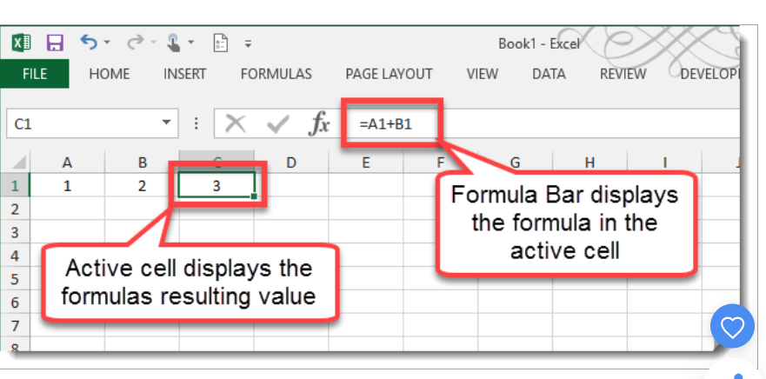
FIGURE 2 MS Excel Formula Bar [13]
Data Visualisation and Advanced Analytical Features
Excel uses many tools for visualising data that enable users to have a clear and professional way. Businesses can use bar graphs, line charts, pie charts, and scatter plots to show trends and make comparisons.PivotTables and Pivot Charts are advanced tools that let users quickly summarise large datasets. They are very important for reporting and business intelligence.
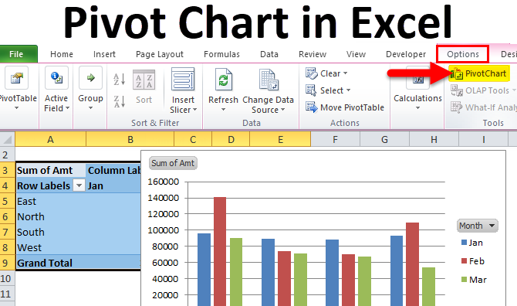
FIGURE 3 MS EXCEL Pivot Table [14]
Power Pivots adds new features to Excel, such as the ability to model, transform, and combine data from different sources. These tools help businesses go beyond simple spreadsheets to create complex analytical workflows that support strategic planning.
Collaboration, Cloud Integration, and System Limitations
Excel’s connection to OneDrive and SharePoint lets people work together in real time, so more than one person can edit a spreadsheet at the same time. Version history, comments, and autosave are features that help people work together and reduce the risk of data loss. However, Excel also has limits, which we will go through.
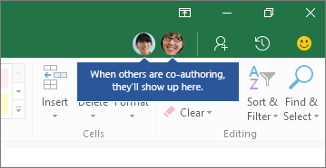
FIGURE 4 MS EXCEL Cloud Collaboration [15]
A common issue is when we share large files between different platforms; they may not work well together if they are large and have complicated formulas or many worksheets. Also, Excel isn’t always the best choice for very large datasets; specialised database tools might work better. By knowing these limits, businesses can pick the right tools and avoid making common mistakes in spreadsheets.
Summary
Excel is still a key part of business because it combines data organisation, analysis, and visualisation, and allows users to work together efficiently. Its flexibility allows use for everything from basic maths to complex modelling. Overall, it has problems, but it is an essential tool in modern workplaces because it helps people be more productive and make better decisions.

MS Access/The Role of Microsoft Access in Database Management
Microsoft Access is a relational database management system that helps businesses store, organise, and quickly find structured data. Access is better than Excel for managing bigger and more complicated datasets because it uses tables, relationships, and queries instead of just spreadsheets. This makes it especially helpful for businesses that need to keep track of customers, inventory, transactions, or business processes in an organised and flexible way.
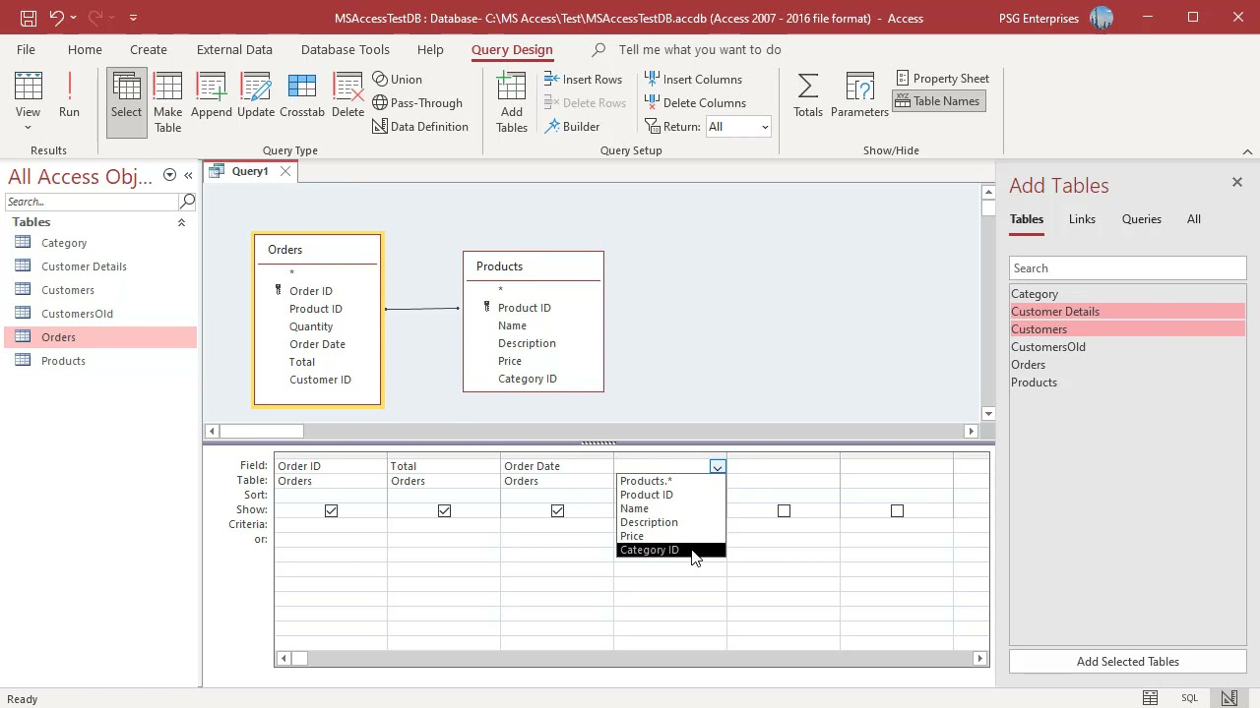
FIGURE 1 MS ACCESS/How Access Stores Data Using Tables [16]

Access enables users to create unique data solutions without the need for sophisticated programming skills by fusing the strength of a database with the comfort of the Microsoft Office interface. It's Microsoft 365 integration improves teamwork and guarantees that data is always available.

Tables, Relationships, and Data Structure
Relational database principles, which store data in distinct tables connected by connections, are the foundation of Access. By guaranteeing that every piece of data is kept just once, this structure minimises duplication and increases accuracy. Relationships enable users to logically connect tables, such as connecting customers to orders or items to suppliers, while primary keys and foreign keys aid in maintaining data integrity.
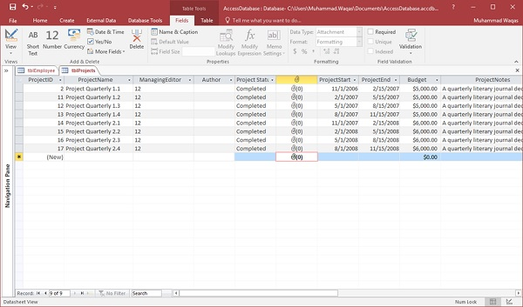
FIGURE 2 MS ACCESS/ Adding Data Structure [17]
Access is more effective than spreadsheets in handling linked data because of its relational design. Additionally, it supports field attributes and validation rules that guarantee accurate and consistent data entry.
Access offers strong tools for data analysis and presentation via reports, forms, and queries. Queries are crucial for decision-making because they let users filter, sort and retrieve certain information from big datasets. Forms offer an easy-to-use interface for data entry and editing, which lowers errors and increases process effectiveness.
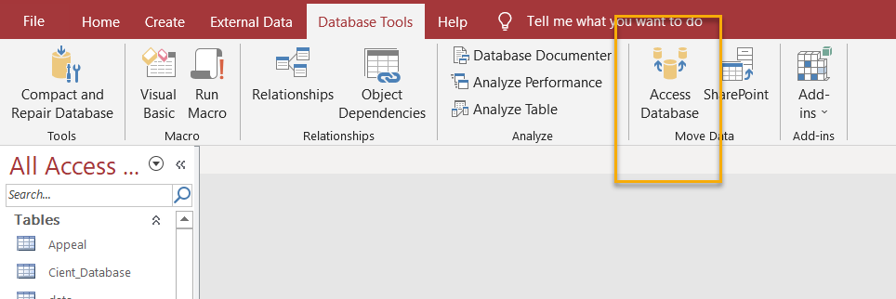
FIGURE 3 MS ACCESS/ Database Access With Multiple Users [18]
Access facilitates collaboration via Microsoft 365, enabling multiple users to work on shared databases stored in SharePoint or OneDrive. Additionally, it integrates with Power BI, SQL Server, and Excel, enabling organisations to transfer data across platforms for more in-depth research.
Access is not without constraints, though. Performance may deteriorate as databases expand, and it is not intended for very big datasets or high-traffic settings. Additionally, without the right setup, multi-user editing can be difficult. Organisations can determine when Access is suitable and when more sophisticated database systems are needed by being aware of these limitations.
Summary
In summary, for businesses that require organised, relational data management without the complexity of enterprise-level systems, Microsoft Access is still a useful tool. It is appropriate for a variety of business applications due to its combination of tables, relationships, queries, forms, and reports.
Its ease of use and integration with Microsoft 365 guarantee that it will continue to play a significant part in contemporary data management, despite its limits in scalability and multi-user performance.

Task 3B: A Practical Demonstration of Two Excel Features
( IF Function + VLOOKUP)
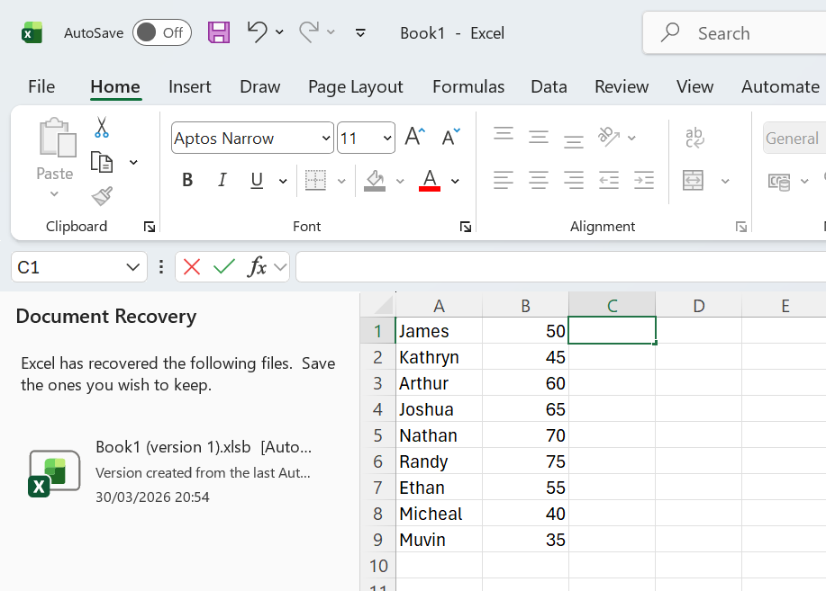
Step 1: Setting up the dataset
I started this by creating a basic Excel dataset with two columns. One for the names of the students and another for the matching scores

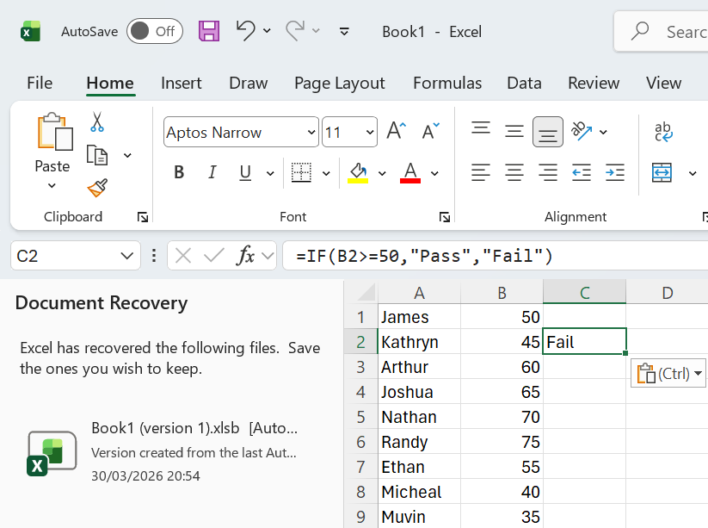
Step 2: Applying the IF Function
The IF Function, which determines whether a condition is true or false and then returns a certain answer, was the second step. To find out if every student had a pass score, I entered the formula =IF(B2>=50,” Pass”, Fail”) in cell C2.
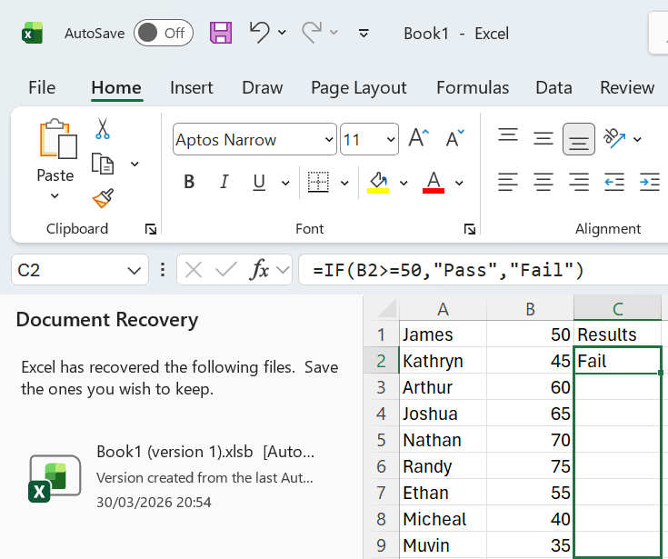
Step 3: Applying the IF Function
I typed the formula and then dragged down, starting from the right-hand side corner, and it applied the scores to every student in the database.
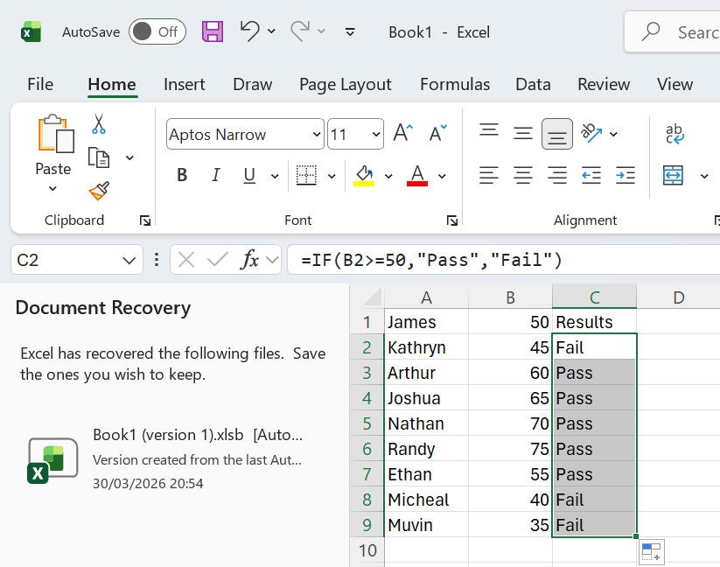
Step 4: IF Function
Depending on whether the value in column B was 50 or above, Excel automatically assessed each score and showed “Pass” or “Fail”.
This illustrated how Excel can use numerical data to quickly make decisions. To demonstrate this practical exercise, I took a screenshot of the formula bar and the modified result column.

- VLOOKUP
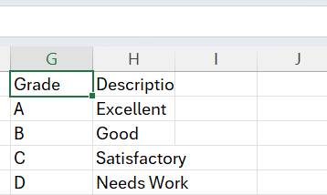
Step 1a: Create Lookup Table
To begin using the VLOOKUP function, I created a different Lookup table on the right side of my worksheet.
There were two columns in this table: One for description and one for the grade letter. I wrote A, B, C and D in the Grade column and “Excellent”, “Good”, “ Satisfactory” and “Needs Work” in the description.
Excel can use this table as a reference to locate the appropriate description for each grade.

Step 2b: Adding the Grade column
Next, I went back to my main table, which already had the results (Pass or Fail), scores and names. To give each person a grade letter based on their score, I created a new column named “Grade”.
I entered A for the highest, B for good, C for average, and D for the lowest scores. This step was important because the VLOOKUP Function uses the letter grade as the value it looks up in the reference table.
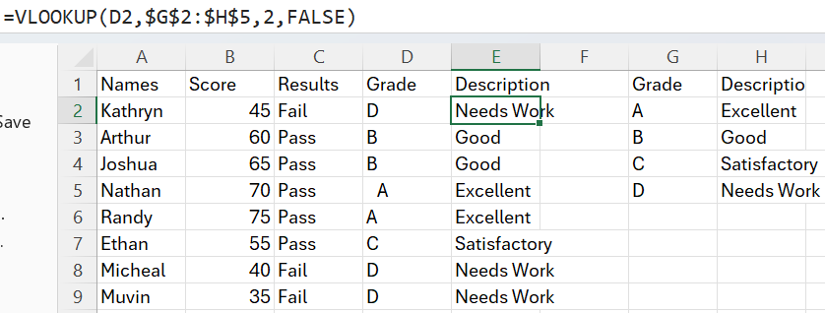
Step 3c: VLOOKUP Formula
After completing the main and the lookup table, I was ready to use the VLOOKUP Function.
I clicked on the first empty cell in the description Column of my main table and inserted the formula (=VLOOKUP(D2,$G$2:$H$5,2, FALSE). This tells Excel to look at the grade in cell D2, find it in the first of the lookup range G2:H5, and return the description from the second column of that range that matches. The FALSE argument tells Excel to look for an exact match.
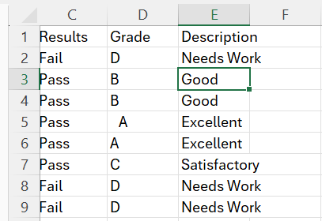
Step 4d: Filling the VLOOKUP formula

Excel then automatically filled in the table by creating the right description for each grade. To show that the formula worked across all rows, I took a screenshot of the entire Description column.

Summary
In summary, I learned how to use Excel to link two related datasets and retrieve information automatically using the VLOOKUP Function. This taught me that VLOOKUP can help you save time, make fewer mistakes, and make your data more organised and useful.

Task 4: Communication and Collaboration Applications
“To stay productive, work as a team, and make sure information flows smoothly between departments, modern businesses depend on digital communication and collaboration tools” [19]. In this part, I look at Outlook, a communication tool, and Microsoft Teams, a collaboration tool. I talk about their most Important features and why they are important in today’s business world.
Outlook is one of the most popular communication tools in the workplace because it combines email, calendars, contacts, and scheduling into one program. Its email system lets users send structured messages, attach files, and sort conversations into folders.
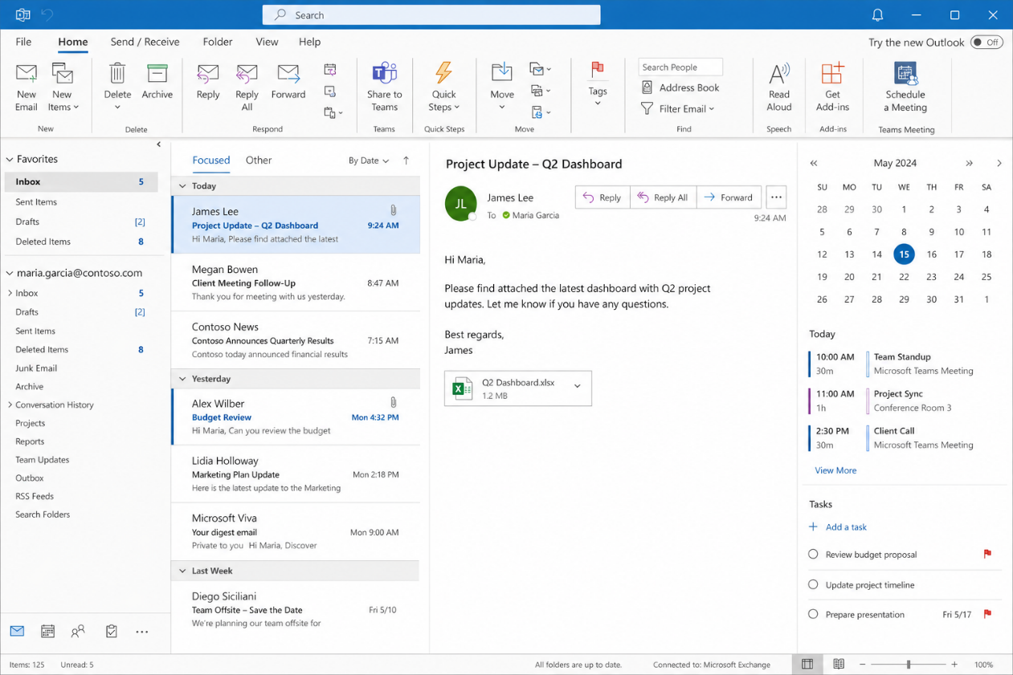
Figure: Screenshot of Outlook Interface
I added a screenshot of my Outlook inbox to demonstrate how messages, folders and scheduling tools are displayed in a typical business interface.

Microsoft Teams is a platform for teamwork that facilitates file sharing, video conferencing, shared workspaces, and instant messaging. [20]. Teams makes it simpler to arrange conversations and maintain information in one location by enabling users to build channels for various projects or departments.
One of its best features is the interface with OneDrive and SharePoint, which enables team members to co-edit documents in real time.

Figure: Screenshot of MS Teams Interface
To demonstrate how discussions, files, and meetings are arranged on the platform, I included a screenshot of a Teams channel.
To conclude, Outlook and Microsoft Teams are crucial for fostering cooperation and communication at work. When combined, they produce a networked digital environment that keeps businesses responsive, efficient, and well-organised.
Task 4B: Test one feature of both Outlook and Teams
I tested the procedure of sending an email using Microsoft Outlook to show how a communication tool may be used practically. I created a new message window, put a brief note in the body of the email, wrote a subject line, and added a recipient.
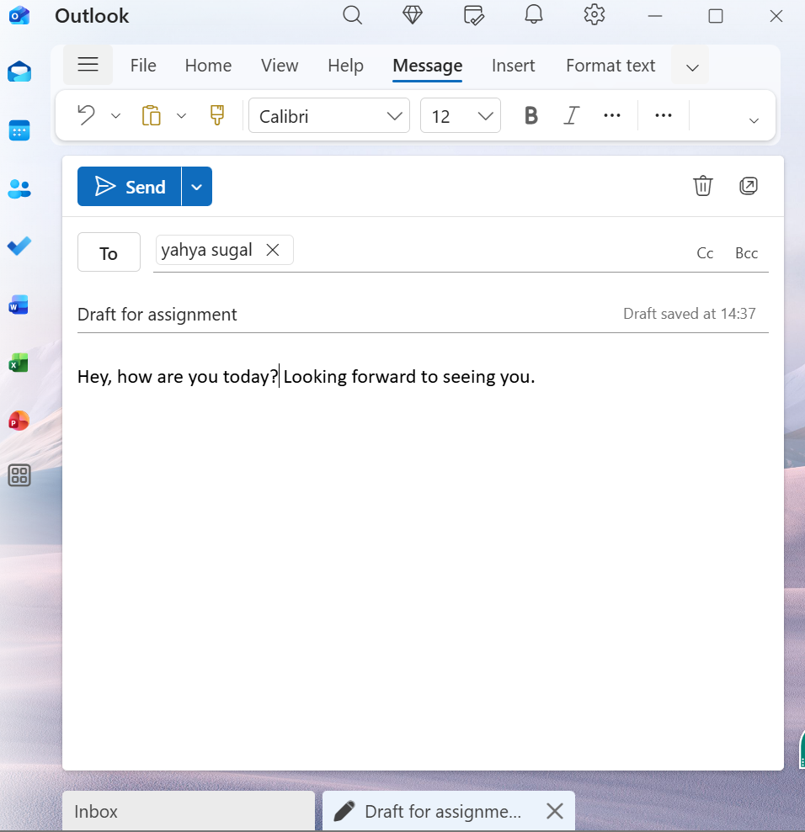
Figure: Testing a Communication Feature in Outlook
To demonstrate how to use this feature in practice, I took a screenshot of the new email window with the message ready to send.
Next, I tested the messaging function in a Microsoft Teams channel to show how to use a collaboration tool. I opened one of the channels, chose a team, and wrote a brief remark in the conversation section.

Figure: MS Teams Interface
To conclude, I gained a better understanding of how collaboration and communication technologies function in actual corporate settings by testing features in Microsoft Teams and Outlook.

References

[1] | Microsoft, “Microsoft Word- Interface Screenshot,” Microsoft, [Online]. Available: https://www.microsoft.com/. [Accessed 13 April 2026].
[2] | Microsoft, “Microsoft Word – New Document Interface,” Microsoft, [Online]. Available: https://www.microsoft.com/. [Accessed 13 April 2026].
[3] | Microsoft, “Microsoft Word- Formatting Ribbon Interface,” Microsoft, [Online]. Available: https://www.microsoft.com/. [Accessed 13 April 2026].
[4] | Microsoft, “Microsoft Word- Styles Pane Interface,” Microsoft, [Online]. Available: https://www.microsoft.com/. [Accessed 13 April 2026].
[5] | Microsoft, “Microsoft Word - Track Changes Screenshot,” Microsoft, [Online]. Available: https://www.microsoft.com/. [Accessed 16 April 2026].
[6] | Microsoft, “Microsoft Word - Comments Feature Screenshot,” [Online]. Available: https://www.microsoft.com/. [Accessed 16 April 2026].
[7] | Microsoft, “Microsoft Word- Real-Time Co-Authoring Screenshot,” [Online]. Available: https://www.microsoft.com/. [Accessed 16 April 2026].
[8] | Microsoft, “Basic Tasks for creating a PowerPoint presentation,” Microsoft, 15 January 2024. [Online]. Available: https://support.microsoft.com. [Accessed 18 April 2026].
[9] | Microsoft, “PowerPoint Add animations to slides,” Microsoft, 10 March 2024. [Online]. Available: https://support.microsoft.com.
[10] | Microsoft, “Transitions, Animations and media integration,” Microsoft, [Online]. Available: www.microsoft.com. [Accessed 29 April 2026].
[11] | Microsoft, “PowerPoint graphic animation,” Microsoft, [Online]. Available: www.microsoft.com. [Accessed 29 April 2026].
[12] | Microsoft, “Overview of Excel interface,” Microsoft, 2024. [Online]. Available: https://support.microsoft.com/excel. [Accessed 29 April 2026].
[13] | Microsoft, “Create a simple formula in Excel,” Microsoft, 2024. [Online]. Available: https://support.microsoft.com/excel-formulas. [Accessed 29 April 2026].
[14] | Microsoft, “Create a PivotTable to analyse worksheet data,” Microsoft, 2024. [Online]. Available: https://support.microsoft.com/pivottable. [Accessed 29 April 2026].
[15] | Microsoft, “Collaborate on Excel workbooks with co-authoring,” Microsoft, 2024. [Online]. Available: https://support.microsoft.com/excel-coauthoring. [Accessed 29 April 2026].
[16] | Microsoft, “ Create a simple select query,” Microsoft, 2024. [Online]. Available: https://support.microsoft.com/access-queries. [Accessed 29 April 2026].
[17] | Microsoft, “Introduction to tables in Access,” Microsoft, 2024. [Online]. Available: https://support.microsoft.com/access-tables. [Accessed 29 April 2026].
[18] | “Database Tools in Access,” Microsoft, [Online]. Available: https://support.microsoft.com/access-database-tools. [Accessed 29 April 2026].
[19] | Microsoft, “Overview of Outlook for email, calendar, and contacts,” Microsoft, 2024. [Online]. Available: https://support.microsoft.com/outlook. [Accessed 29 April 2029].
[20] | Microsoft, “Microsoft Teams features for communication and collaboration,” Microsoft, 2024. [Online]. Available: https://support.microsoft.com/teams. [Accessed 29 April 2026].
[21] | Microsoft, “Welcome to your email – Outlook interface overview,” Microsoft, [Online]. Available: https://support.microsoft.com/en-gb/office/welcome-to-your-email-c6c261e3-d50a-43a6-816f-35fe1e53acc6. [Accessed 29 April 2026].

