

Human resource management
Assignment


Name: Sanjay Avulareddy
Student id: 2213727
Subject: HUMAN RESOURCE MANAGEMENT
Module: LCMB7000
Lecturer name: MUSHFIQUR RAHMAN

Table of content
1.Introduction…………………………………………………………………………………………….
2. Aim Objective………………………………………………………………………………………...
3. Background of organization…………………………………………………………………....
4. Policies and Procedures………………………………………………………………………....
5. Current status in Labor Market……………………………………………………….…....
5.1 Labor Market in Developed countries…………………………………………. …..…
5.2 Labor Market in Developing countries ……………………………………………….
5.3 Labor Market in UK….……………………………………………………………………….
6.Tools and Theories…………………………………………………………………………………….
6.1 SWOT Analysis………………………………………………….…………………………….……
6.2 PESTLE Analysis……………………………………………….…………………………….…….
7.Emerging changes in Human Resources strategies
post covid post Brexit external environment……………………………………………….
8.Conclusion……………………………………………………………………………………………….
9.Refrences…………………………………………………………………………………………………

- Introduction
In this report we are going to have a brief note about human resource management structure in land rover one of the international corporations that is committed to increasing social effectiveness and making quick money. Having a big aim also helps you establish a lasting competitive edge. It is reliant on the UK labor force, which is necessary for any UK business.
An international automaker, Land Rover is a division of Jaguar Land Rover, which is owned by Tata Motors in India. Because of this, its human resource management (HRM) policies and practices are comparable to those of other significant businesses in the automotive sector.
- Aim and objectives.
The purpose is to discuss the labor market in the UK and throughout the world.
The primary goal of this study is to explore the HRM structure, which includes the land rover. We will analyze the report of the SWOT and PESTLE analysis of the land rover to determine the tactics that the HRM and its theories follow.

- Background of Land Rover
A multinational British automaker called Land Rover focuses on making four-wheel-drive cars. Maurice Wilks established the business in 1948, and it is now a part of Jaguar Land Rover, which is owned by the Indian carmaker Tata Motors.

The business is renowned for creating a variety of tough and adaptable automobiles, such as the enduring Land Rover Defender, the Range Rover, Discovery, and Evoque models. Land Rover has production facilities in the UK, India, Brazil, and China and operates in over 140 nations.

With an emphasis on creating electric and hybrid vehicles as well as minimizing its environmental impact through sustainable practices, Land Rover has recently made large expenditures in innovation and sustainability. The business has also been honored for its support of social and environmental concerns, including fostering eco-friendly travel, and working to save animals. (Ref Land Rover, undated. regarding Land Rover.)


Source: loandrover.co.uk

- Policies and procedures
Health and safety
In accordance with statutory obligations and professional standards, Land Rover is expected to adhere to health and safety policies and procedures. Following the Occupational Safety and Health Administration (OSHA) requirements in the US and the Occupational Health and Safety Act in the UK may be part of this. To protect employee safety and avoid workplace accidents, the corporation may also have its own rules and procedures in place.
Sustainability in the environment
Land Rover has pledged to lessen its influence on the environment and advance sustainability. The corporation has set goals for cutting waste and carbon emissions while also aiming to employ more renewable energy in its daily operations. The business may have established guidelines and strategies to control trash, maintain adherence to environmental requirements.
Ethics and compliance
Compliance with legal and regulatory standards as well as ethical business practices are priorities for Land Rover. The business might have policies and procedures in place to encourage moral conduct and thwart dishonesty, bribery, and other types of wrongdoing. To make sure that employees are aware of their obligations and are prepared to make moral decisions, the organization may also establish a code of conduct and training programs. (Land Rover. (n.d.). Our Heritage. Retrieved from https://www.landrover.com/vehicles/heritage)

Human resources
Land Rover is dedicated to fostering a diverse and inclusive workplace and offering its workers a happy working environment. It is possible that the business has policies and processes in place to support diversity and inclusion, handle employee performance, and give staff members chances for training and development. The business could also have guidelines and rules to guarantee its employees receive just salary and benefits.

Customer service
Land Rover is dedicated to offering its customers top-notch customer service. It is possible that the business has policies and procedures in place to guarantee that client complaints are addressed quickly and effectively, and that client data is managed safely and privately. (Land Rover, undated. Careers. The page was retrieved from https://www.landrover.com/careers)

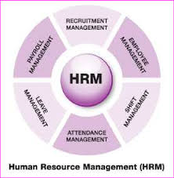
Source : researchgate.net

- Current status in Labor market:
The labor market is typically understood as a collection of institution-dependent forms and procedures for recruiting personnel and negotiating terms related to working and compensation circumstances. The primary role of the labor market is to distribute and reallocate the human capital that creates jobs and to maintain a long-term equilibrium between the supply and demand of labor. In a larger sense, a labour market is described as one of all the factors that influence how much labour is available and how much is demanded. On the labour market, there are transactions for buying work, which involve hiring workers, and transactions for selling work, which involve disclosing a willingness to accept it in exchange for a certain wage. The market is a made-up idea that describes the procedure by which employees.

The word "labour market" refers to the marketplace where employers and laborers transact to exchange labor for compensation. Both the businesses actively looking to hire staff members and all the people actively seeking jobs are included.
Employers' demand for labor is satisfied by job seekers' supply of labor in the labor market. The labor market is influenced by a number of variables, including economic conditions, technological developments, demographic shifts, and governmental policies. Job seekers can find employment that matches their talents and expertise in a healthy labor market, and companies can locate the employees they need to fill unfilled positions. However, there may be imbalances in the labor market, such as surpluses or shortages of labor. which may have an impact on salaries and employment prospects.
Governments and organizations gather information on the labor market, such as employment rates, wages, job opportunities, and other labor market indicators, to better understand its dynamics and trends. Employers may use this information to make informed decisions about hiring and compensation, governments can use it to make informed decisions about labor market policies, and job seekers can use it to make informed judgements about their career options. (Land Rover, undated. Customer support. Collected from https://www.landrover.com/vehicles/customer-service)

5.1 Developing countries labor market.
It may be more difficult for job searchers to find employment and for companies to locate the competent personnel they require in developing countries due to the difficulties faced by the labor markets in these nations.
Lack of employment possibilities, most employees are employed in the informal sector in many developing nations because there is a dearth of legitimate employment alternatives. Finding a solid work that pays well may be challenging as a result. Low salaries, even when formal employment is possible, wages in developing nations are typically lower than those in developed nations. Because of this, it may be challenging for employees to provide for their families. (International Monetary Fund. (2019). Labor market challenges in developing countries.)

mismatch of skills Many employers in developing nations claim that it is difficult for them to find employees with the necessary skills. Nevertheless, a large number of job seekers lack the competencies that employers value. Unofficial economy in emerging nations, the informal sector of the economy frequently outpaces the formal sector. As a result, workers may not have as many labor market protections, such as social security and other benefits. Gender inequality, compared to men, women in developing nations frequently face more obstacles on the work market, such as lower pay, fewer career options, and biased hiring procedures.

Through a variety of policies and programs, attempts are being made to address these problems. Governments and NGOs, for instance, may fund educational and training initiatives to assist people in acquiring the skills they need to achieve success in the job market. They might also put policies into place that help employees in the unorganized sector and encourage the growth of formal jobs. (United Nations Development Program. (2019). The challenge of job creation in developing countries.)

5.2 Developed countries labor market
The COVID-19 epidemic has significantly impacted the labor market in industrialized nations, resulting in numerous people losing their jobs, working fewer hours, and experiencing insecure income. The pandemic has influenced every sector of the economy, but the tourism, hotel, and entertainment industries have been particularly badly hit.
In response to the pandemic, governments in wealthy nations have implemented a number of initiatives to assist workers and businesses. These programs include direct income assistance measures like stimulus payments and unemployment insurance as well as business support measures like tax breaks and loan guarantees.
As vaccination rates rise and restrictions are lifted, the labor market in wealthy countries is beginning to improve. However, the recovery has not been unfirming across all industries. and some regions are rebuilding more quickly than others. Additionally, the labor market will be affected by some pandemic-related changes like increased automation and remote work over the long term. The labor market in developed countries is expected to face new difficulties and continue to shift beyond COVID-19. To adjust to these changes and make sure that the labor market stays productive, competitive, and equitable for all, policymakers, businesses, and employees will need to work together. (European Commission. (2018). The labor market in the EU: Developments and challenges.)

Automation and technological change, the labor market in industrialized countries is changing quickly because of automation and artificial intelligence replacing numerous employments. As a result, workers may lose their jobs and need to pick up new skills. Mismatch in skills, many companies in industrialized nations say they have a hard time finding people with the skills they require, especially in fields like healthcare, technology, and engineering. Nevertheless, a lot of workers might not have the qualifications required for the in-demand positions.

ageing workforce, the population is ageing in many developed countries, which can cause issues and labor shortages and difficulties in filling job vacancies. Globalization, As the developed world's labor markets become more intertwined with the rest of the world's economies, there may be an increase in job outsourcing and competition for positions from workers abroad. Income inequality, Low-wage workers struggle to make ends meet and have access to essential services like healthcare and retirement savings, which is an increasing concern in many industrialized countries. These issues are being addressed through a variety of policies and programs, such as investments in education and training, programs to encourage job creation and economic growth, and measures to deal with income disparity and assist employees in changing employment. (Organization for Economic Co-operation and Development. (2021). Labor markets in developed countries.)

5.3 UK labor market
The labor market in the UK is vibrant and diverse, offering both employees and employers a variety of opportunities and difficulties. The following are some crucial aspects of the UK labor market.
With more than 75% of those between the ages of 16 and 64 employed, the UK has one of the highest employment rates in all of Europe. Skills mismatch: The UK labor market, like many other industrialized nations, is experiencing a skills mismatch, with companies finding it difficult to recruit employees with the abilities they require.
Gender pays gap, Women consistently earn less than males in most industries and occupations in the United Kingdom. The gig economy has rapidly expanded in the UK, where many employees are now employed in non-standard roles. typical employment arrangements, like temporary contracts and freelancing.
Brexit, Uncertainty has been caused by the UK's decision to leave the European Union, especially for workers from other EU nations who may have trouble obtaining work permits. Through a variety of policies and programs, attempts are being made to address these problems. For instance, the UK government has put in place a number of programs to encourage training and skills development, as well as legislation to address the gender pay gap. The gig economy is currently being discussed in terms of regulation to give employees access to fundamental job protections.
With multiple production sites and research facilities situated in the UK, Land Rover is a significant employer there. As a result, the corporation has a substantial impact on the UK labor market, particularly in areas like the West Midlands where it is well-established.

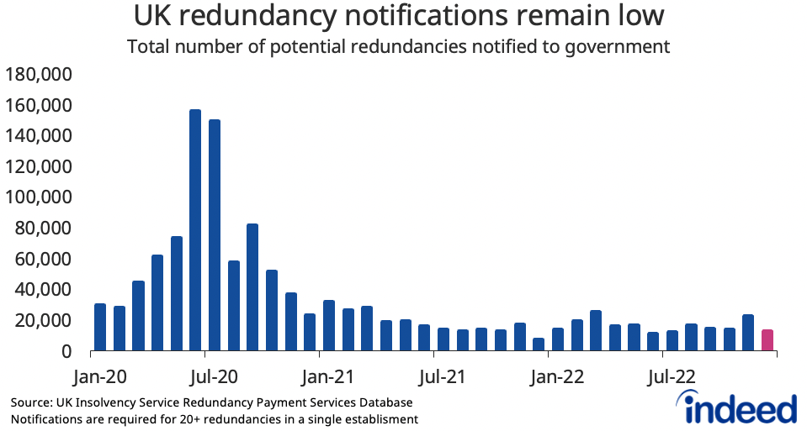
Source: indeed.com

Land Rover has a number of policies and programs in place to assist its commitment to fostering a diverse and inclusive workplace about employment practices. The business also makes significant investments in the education and training of its employees, with a particular emphasis on helping them acquire the knowledge and skills necessary to support the continuous success and expansion of the company.
Land Rover has recently encountered certain difficulties in the UK labor market, particularly in relation to the car industry's continuous reaction to Brexit. The business, however, has persisted in making investments in its UK business and is dedicated to keeping a significant presence there. Land Rover employs 40,000 people directly and through its supply chain, making it one of the largest employers in the UK. Sol hull, Hale wood, and Castle Bromwich are just a few of the UK cities where the corporation has production operations.
Employing a large number of highly skilled personnel in fields like engineering, design, and manufacturing, Land Rover has a skilled workforce. The business has made investments in apprenticeship and training programs to build a pool of future skilled personnel. The labor market at Land Rover has been impacted by the UK's decision to leave the European Union. Concerns about future labor shortages and the necessity for access to a competent workforce after Brexit have been voiced by the corporation.
Land Rover has made investments in new technologies and automation to increase production and efficiency. Despite some job losses in some areas as a result, the business has also added new positions in fields like robotics and software engineering. Land Rover has pledged to increase diversity and inclusion in its workforce, in part through programs like apprenticeships for women and underrepresented groups and the creation of a more varied and inclusive corporate culture.
Brexit, automation, and diversity and inclusion measures are just a few of the issues that have an impact on the UK employment market for Land Rover. With a dedication to creating a competent and diverse workforce for the future, the corporation is a leading employer of skilled workers in the UK.
Labor market of Land Rover in UK

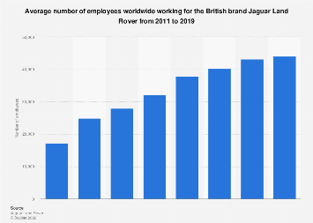
Source: statista.com

- Tools and theories
6.1 SWOT ANALYSIS
Strengths
In the auto business, Land Rover is a well-known and reputable brand with a track record for building dependable and high-quality cars.
Land Rover provides a variety of vehicles, from opulent SUVs to tough off-roaders, enabling the business to appeal to a broad consumer base.
Many highly skilled workers are employed by Land Rover in industries like engineering, design, and manufacturing.
Innovation in Technology: Land Rover has made investments in cutting-edge technologies like electrification and autonomous driving, which have helped the company stay competitive in a sector that is evolving quickly.
Weaknesses
High-Cost Structure: The high cost of Land Rover's automobiles may limit the company's appeal to consumers who are concerned with cost.
Due to the high market concentration of Land Rover's sales in places like the UK and China, the company may be at danger from governmental policy changes or economic downturns.
Dependence on internal combustion engine vehicles: Land Rover has been hesitant to adopt electric vehicle technology, which could hurt the corporation as the market transitions to more environmentally friendly ways of transportation.

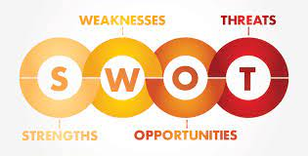

Opportunities
Land Rover has the chance to create and sell more electric vehicles, which would enable the business to appeal to customers searching for more environmentally friendly transportation options.
The demand for premium automobiles is rising in emerging regions like Southeast Asia and India, where Land Rover has the chance to expand.
Collaborations and Partnerships: To develop new technologies or enter new markets, Land Rover may collaborate with other businesses or organizations.
Threats
Other luxury automakers like BMW, Mercedes-Benz, and Audi compete fiercely with Land Rover.
Economic Uncertainty: The demand for Land Rover's products may be impacted by changes in the economy because the automobile industry is particularly sensitive to these changes.
Rapid technological progress is affecting the automotive sector, and Land Rover may be threatened by new competitors or disruptive technologies like autonomous driving or mobility as a service.
6.2 PESTEL Analysis
Political
Trade and Tariffs: Government trade policies and tariffs may have an impact on Land Rover's operations and sales, particularly considering Brexit and potential changes to trade agreements. 2021 (BBC News)
Government Rules: Land Rover is required to abide by laws governing safety, emissions, and other aspects of the auto industry. n.d. (UK Government)
Economic
Economic Development: The development of Land Rover's major export markets, including the UK and China, may have an impact on the company's sales and profitability. 2021 (BBC News)
Exchange Rates: Changes in currency exchange rates may influence Land Rover's business operations and financial performance. Land Rover, undated. (BBC News. (2021, March 11). UK car industry warns of £55bn cost of no-deal Brexit.)

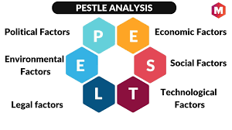
Social
Consumer Preferences: Land Rover needs to adjust to shifting consumer trends and preferences in the automotive sector, such as a rise in demand for electric and hybrid vehicles. In 2021, JATO Dynamics
Demographics: Because older, wealthier consumers are normally Land Rover's target market, the corporation must take demographic changes and alterations in consumer behavior that may have an impact on its sales into account. 2020 Forbes
Technological
Electric and Autonomous Vehicles: To be competitive, Land Rover must keep up with new technical advancements in the sector, such as electric and autonomous vehicles. Vehicle News Europe, 2021
Cybersecurity: To safeguard its technologies and vehicles from online attacks, Land Rover must invest in cybersecurity solutions. (2021; The Drive)
Environmental
Sustainability and emissions laws must be met by Land Rover to satisfy consumer demand for more environmentally friendly automobiles. Land Rover, undated
Climate Change: Land Rover must consider how climate change may affect its operations and business, including potential supply chain interruptions and shifts in consumer behavior. (2021 Financial Times) (Automotive News Europe. (2021, March 1). How JLR is quietly preparing for EV onslaught.)
Legal
Intellectual property: Land Rover is required to safeguard the patents and other intellectual property that pertains to its technology and cars. Land Rover, undated
Product Liability: Land Rover is required to abide by all laws and rules pertaining to the safety and caliber of its vehicles that deal with product liability. n.d. (UK Government) (Ref Financial Times. (2021, January 17). JLR and Nissan say 'hard Brexit' would cost UK car industry £40bn.)

6.3 HRM Strategic Theories
Theoretical frameworks that seek to match HR practices with the overarching organizational aims and objectives form the foundation of Land Rover's HRM strategy. Strategic HRM theories that Land Rover might have applied include:
Resource-based view (RBV) theory
According to the resource-based view (RBV) idea, a company's resources, especially its human resources, can provide it with a competitive advantage. The development and retention of a qualified and motivated workforce that can contribute to the success of the firm is the main goal of Land Rover's HRM strategy.
High-performance work systems (HPWS) theory
According to the high-performance work systems (HPWS) idea, an effective HRM system can raise employee performance, which in turn raises organizational performance. The goal of Land Rover's HRM strategies, which include performance management, training and development, and employee engagement, is to establish a high-performance work environment that will fuel the company's expansion.
Social exchange theory
According to social exchange theory, when employees believe they are receiving fair treatment and benefits from the company, they are more likely to be motivated and engaged. The goal of Land Rover's HRM tactics, which include recognition and reward programs, is to foster a healthy relationship between the business and its staff.
Contingency theory
According to contingency theory, HRM practices must be customized to the unique requirements of the organization because there is no one-size-fits-all approach to this field. The HRM strategies used by Land Rover, such as succession planning and employee relations, are created to specifically address the needs of the business and its personnel.
To strategically integrate HR practices with the overall goals and objectives of the organization, Land Rover's HRM strategies are founded on a variety of theoretical frameworks.

- Emerging challenges in human resourcing strategies in post covid and in post Brexit external environment
Organizations, including Land Rover, have changed their human resources (HR) strategy because of COVID and the post-Brexit external environment. Here are some recent adjustments to HR tactics that Land Rover may have made:

Remote Work
The COVID-19 pandemic has hastened the transition to remote work, and many organizations, like Land Rover, have had to adapt their HR strategies to reflect this transformation. This may entail setting up effective communication channels, equipping staff with the tools and technology they need to operate from home and modifying performance management systems to properly evaluate remote personnel.
Health and Safety:
The epidemic has also brought to light the significance of occupational health and safety. Personal protection equipment (PPE) and social distancing practices, among other measures, may have been employed by Land Rover to safeguard employee safety while at work.
Acquisition of talent
Changes to UK immigration laws brought about by the post-Brexit climate may affect Land Rover's capacity to draw and keep top talent from abroad. The business may need to implement new talent acquisition tactics, such as collaborating with colleges and universities to draw in local talent and spending money on training and development initiatives to upskill current staff.

Employee Mental Health and Well-Being
The epidemic has significantly impacted employees' mental health and well-being. It is possible that Land Rover has established new policies and initiatives to enhance employee wellbeing, including the provision of mental health resources, flexible work schedules, and the encouragement of a healthy work-life balance.
Diversity and Inclusion
The Black Lives Matter movement and other social justice concerns have re-emphasized the necessity of diversity and inclusion in the workplace. Possible new initiatives by Land Rover to advance diversity and inclusion include training sessions on unconscious bias and the formation of staff resource groups for underrepresented groups.
To respond to these changes and secure the success of its workforce, Land Rover may have implemented new policies and programs. The post-COVID and post-Brexit external environment has caused various emergent modifications in HR strategy.

- Conclusion
The COVID-19 epidemic and Brexit both contributed to a more uncertain and tough climate for companies and workers alike as the UK job market underwent considerable changes in recent years. The UK work market was comparatively healthy before the epidemic, with low unemployment and a steady rise in salaries. However, the pandemic significantly increased unemployment and decreased job openings, especially in the hospitality, tourism, and retail industries. The government's vacation program has lessened some of the pandemic's negative effects on the work market, but its long-term repercussions are still unknown. Brexit has significantly affected the labor market as well, especially in terms of immigration laws. Employers now find it more challenging to recruit workers from abroad because of the new immigration regulations, which may result in a workforce shortage in some industries. Brexit has also given domestic workers new opportunities and could result in more initiatives for training and skill development.

- References
Automotive News Europe. (2021, March 1). How JLR is quietly preparing for EV onslaught. https://europe.autonews.com/automakers/how-jlr-quietly-preparing-ev-onslaught

BBC News. (2021, March 11). UK car industry warns of £55bn cost of no-deal Brexit. https://www.bbc.com/news/business-56331527

European Commission. (2018). The labor market in the EU: Developments and challenges. Retrieved from https://ec.europa.eu/social/BlobServlet?docId=19930&langId

Financial Times. (2021, January 17). JLR and Nissan say a ‘hard Brexit' would cost the UK car industry £40bn. https://www.ft.com/content/1fb7d8fc-5810-4a1d-a527-6d1178fc066c
International Monetary Fund. (2019). Labor market challenges in developing countries. Retrieved from https://www.imf.org/en/Publications/WP/Issues/2019/10/18/Labor-Market-Challenges-in-Developing-Countries-48746
Land Rover, undated. regarding Land Rover. from https://www.landrover.com/about-land-rover
Land Rover. (n.d.). Our Heritage. Retrieved from https://www.landrover.com/vehicles/heritage
Land Rover, undated. Careers. The page was retrieved from https://www.landrover.com/careers
Land Rover, undated. Customer support. Collected from https://www.landrover.com/vehicles/customer-service
Organization for Economic Co-operation and Development. (2021). Labor markets in developed countries. Retrieved from https://www.oecd.org/social/labour/labour-markets-developed-countries.htm.

United Nations Development Program. (2019). The challenge of job creation in developing countries. Retrieved from https://www.undp.org/content/undp/en/home/librarypage/poverty-reduction/the-challenge-of-job-creation-in-developing-countries.html.

