LCBB4007
Introduction to Business
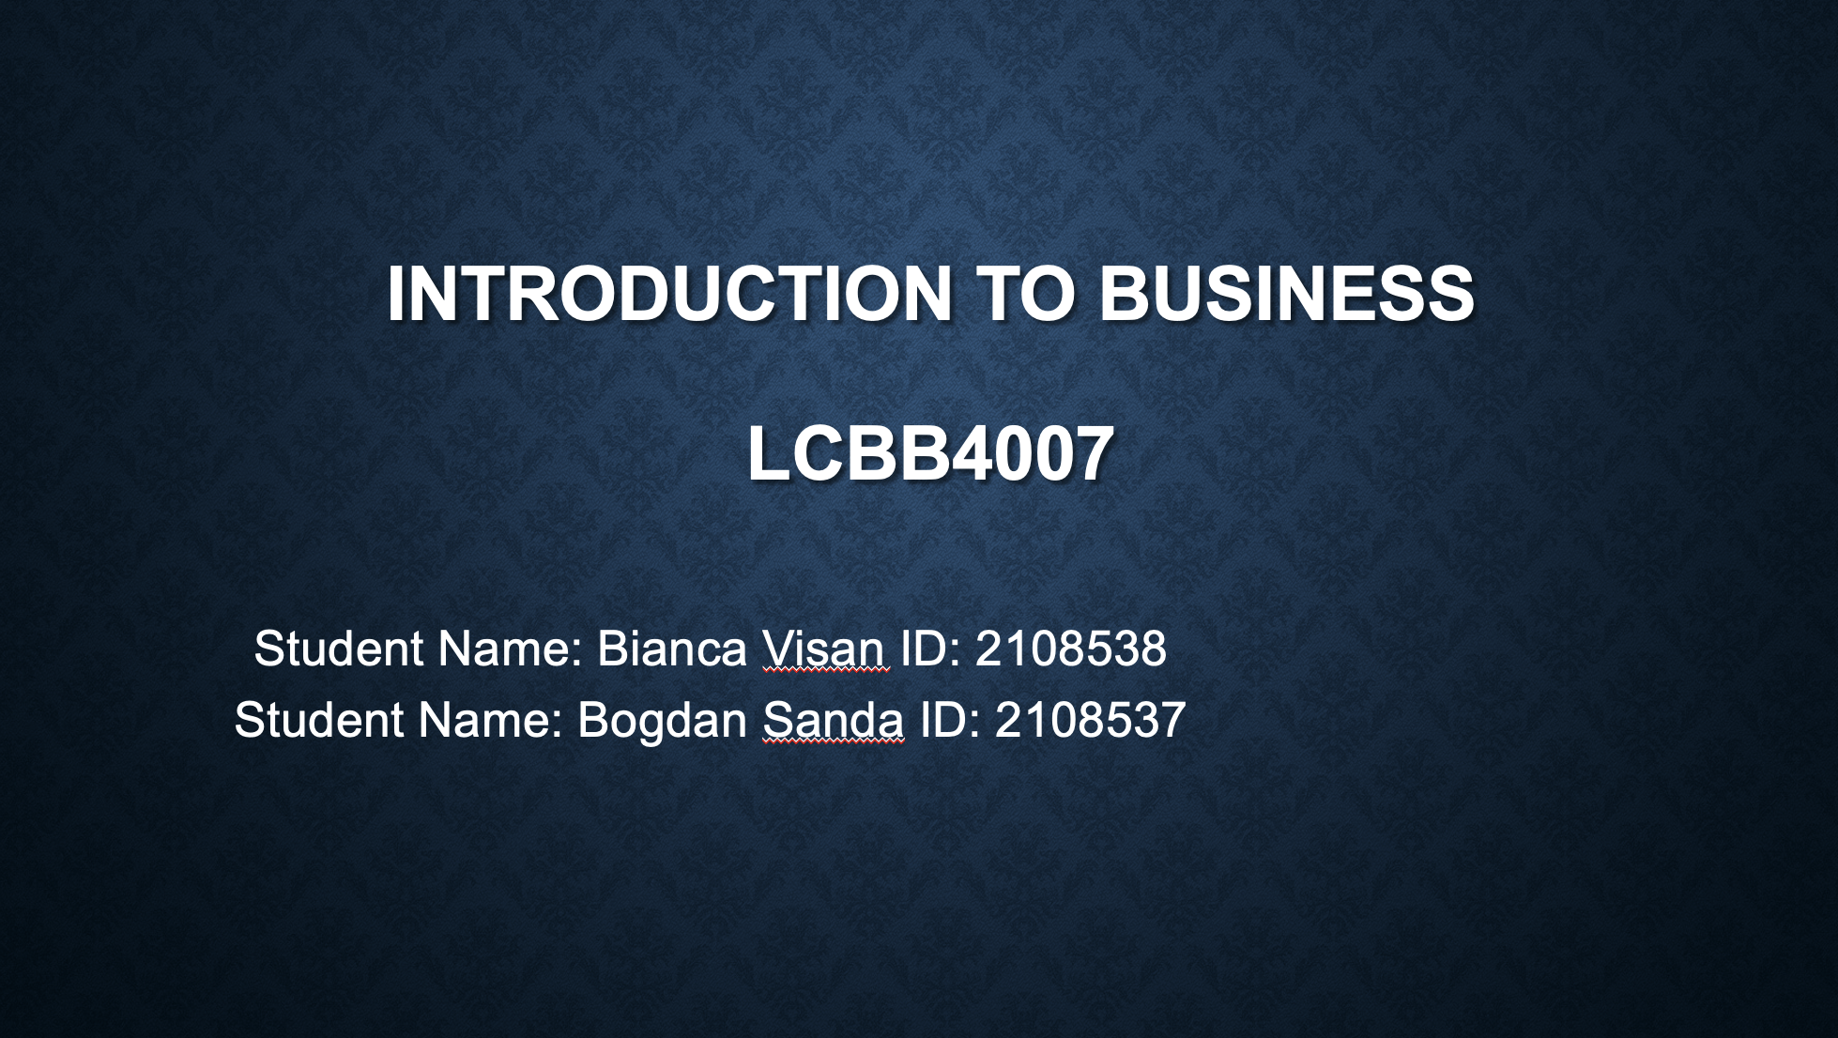
Table of Contents
Introduction 1
Organizational Overview 2
Internal Environment Analysis 4
External Environment Analysis 5
Stakeholders Analysis 6
Business Functions Analysis 7
Analysis on Finance Function 8
Human Resource Function 9
Conclusion 11
References 12

Introduction
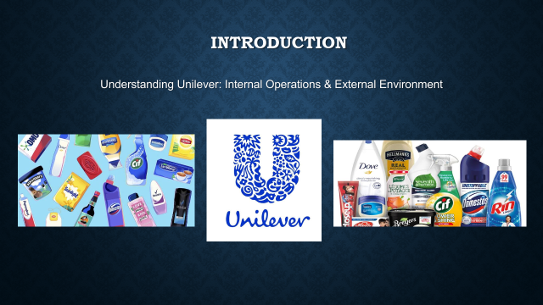
This slide presents about the presentation's primary contention and why Unilever was selected as the company to discuss. This slide provides an overview of what will be discussed in the presentation, such as how Unilever works internally and how it deals with the outside world. In this way, discussion will be on external things such as the company's different stakeholders groups, key partners, business functions and so on. The objective of this presentation is to exolore more about Unilever and the way it deals with the influencing factors.

Organizational Overview
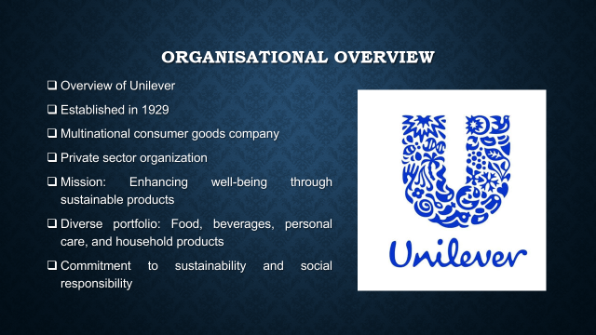
This slide shows some interesting facts about Unilever, like when it was founded, the different countries where it operates in, and the fact that its main goal is to make items that are good for the environment. Unilever is a privately owned business that makes many types of goods to fulfil the wants of various customers. It also shows that the company cares about social and environmental problems, which is an integral component of its brand identity and strategy plan (Lakada et al., 2015). This brief review sets the stage for a more in-depth look at how Unilever functions and how their surroundings impacts it.

Organization Structure, Size, and Functions
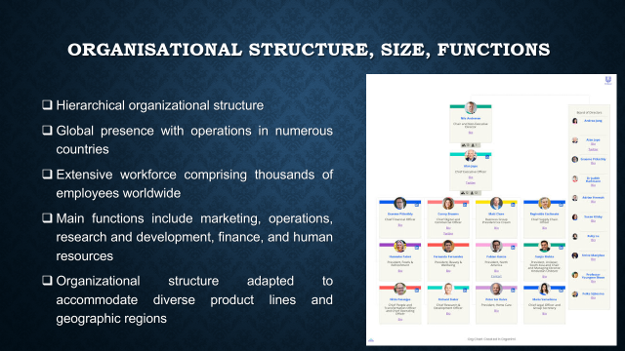
This slide represents Unilever's organizational structure. The strcture is found as hierarchical. The company operates a large scale of operations with a large workforce throughout various countries (Tien, 2019). Key functions of the organization includes marketing and operation related activitiesbalong with finance and human resources. Unilever adapts their structure to manage their diverse product portfolio to ensure effective operations in different markets throughout the world.

Internal Environment Analysis
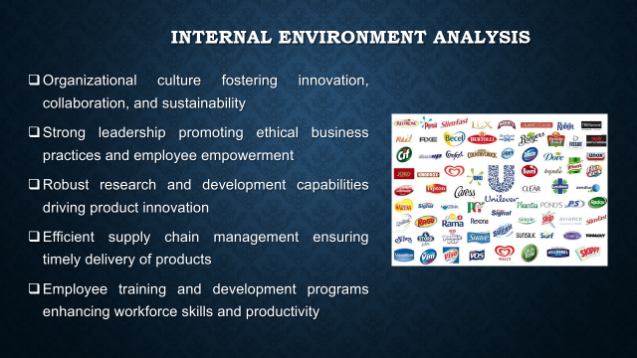
This slide focuses on the key factors that shape the internel environment of the business, representing the significant corporate culture, characteristics and strengths for environmental protection, coming up with new ideas, and working together as a team. It also shows how essential strong leadership is for giving people power and keeping morals high (Murphy and Murphy, 2018). The slide also asserts that Unilever's efforts in research and development, good supply chain management, and schemes to help employees grow are all important parts of how it works internally and give it an edge over its rivals. Find out about these inner variables of Unilever in order to judge how well the company works as a whole.

External Environment Analysis
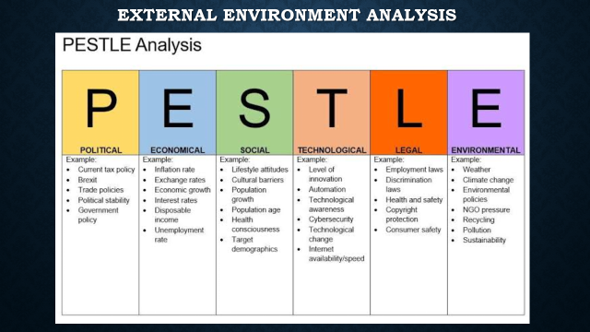
This slide uses a PESTLE study to look at the external variables which influence Unilever's business environment. It takes a look at how laws, the economy, trends in society, new technologies, the environment, and government rules affect the group's decisions and plans (Zou, 2021). Unilever needs to know about these outside factors so it can change the way it does company as well as stay dominant in a market that moves all the time. When Unilever thinks about these things, it can be ready for chances and risks and deal with problems that come to the company in a way that is waiting in line with its values and goals.

Stakeholders Analysis
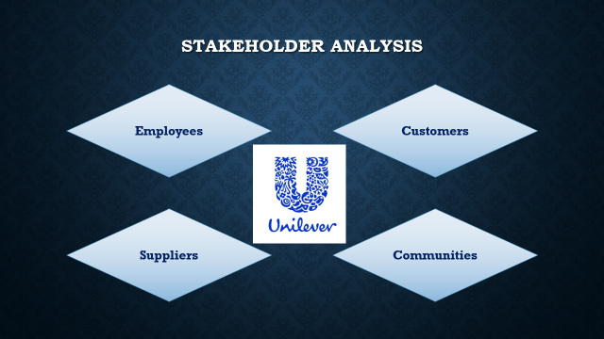
There are a lot of groups interested in Unilever's business. This slide names them and what function they play in the business. Owners, employees, customers, suppliers, along with neighbourhoods are just some of the people who have a stake in Unilever's growth along with long-term success (Tsuraya et al., 2023). To keep people's trust and involvement, Unilever needs to understand what those people want and expect. Unilever may arrange stakeholders' needs in order of how important they are, build relationships that are advantageous for everyone, and make the company more successful while also helping people and the environment with good stakeholder analysis.

Business Functions Analysis
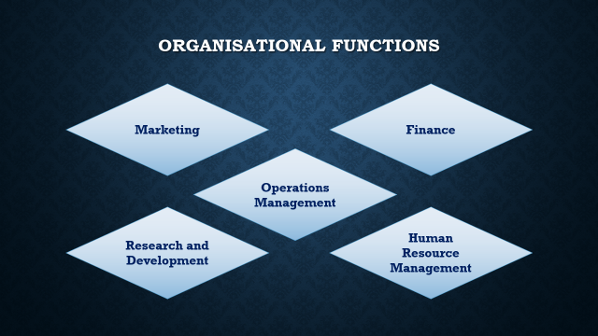
The main things that Unilever does and how they contribute to the organisation reach its goals are shown on this slide. Different parts of Unilever's company operations, like management, marketing, HR, finance, and R&D, all work together to make the company great. Getting these jobs organised well will help Unilever improve its processes, make more things, and give value to all of its partners (Siddique and Sultana, 2018). These jobs should be in line with the business climate and the competition we talked about earlier. This keeps the strategy constant and helps the company respond quickly to changes in marketplace conditions and new opportunities.

Analysis on Finance Function
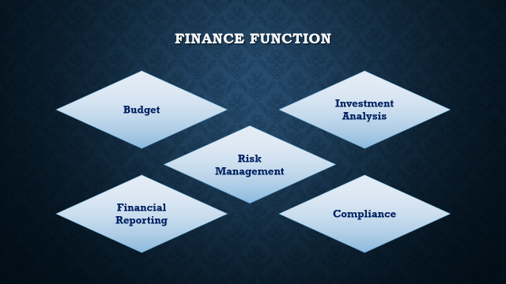
Unilever's finance area is very important for managing money and keeping the business in good financial shape. The finance team plans, makes financial reports, manages risks, looks into investments, and does work related to safety. Unilever needs to do these things in order to make smart decisions, make good use of its resources, and keep its monetary processes open and clear (Jose, 2021). Research and understanding about money can help Unilever do better with its finances and stick to its long-term growth and value-creation goals.

Human Resource Function
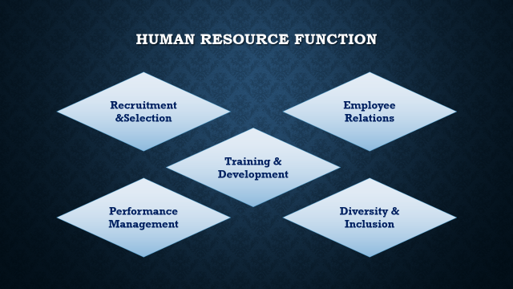
This slide shows what Unilever's HR department does on a daily basis. The most valuable thing a company has is its workers, and staff members is in charge of looking after them. It is very important for HR jobs to be done so that the staff is skilled, active, and varied (Stanley et al., 2022). They include hiring people, teaching them, keeping an eye on their work, and talking to them. Unilever can keep its competitive advantage in the market, make the workplace helpful, and push for new ideas by putting employee health and growth first.

Organization Culture, Ethics, and CSR Activities
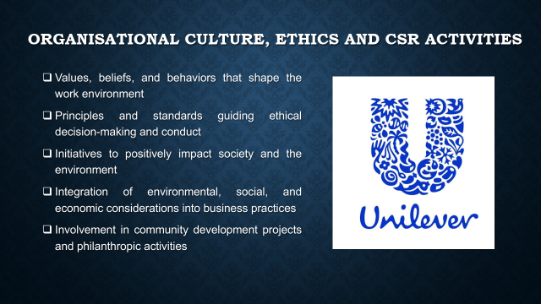
This part talks about Ethics, company structure, and steps that Unilever takes for its corporate social responsibility (CSR). Unilever cares about being honest, coming up with new ideas, as well as working together (Dhamayanti and Restuningdiah, 2022). All of its corporate deals are built on moral principles. The company works hard on CSR projects that help the environment, the neighbourhood, and people in general. By living by these ideals, Unilever not only makes its brand look better, but it additionally produces in the future more stable and adds value to the lives of all its partners and to society as a whole.

Conclusion
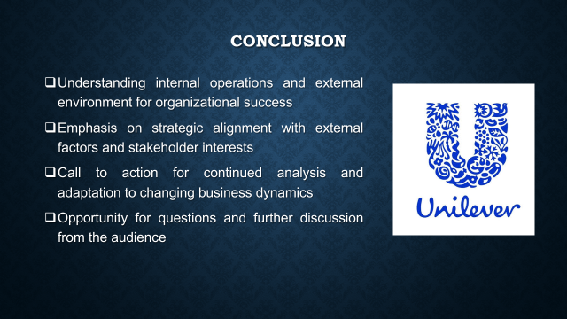
The main points of the presentation are summed up to show how essential it is for businesses to know both their internal workings and the world around them. For Unilever to stay in business and compete, it needs to make sure its business plans take into account outside variables and the requirements of partners. At the end of the presentation, there is a call to keep looking at things and making changes so that you can stay successful in the business world that is always changing. People in the gathering are told to ask questions and talk more about the things that are being talked about.

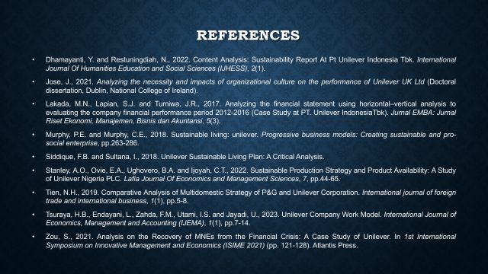
References
Dhamayanti, Y. and Restuningdiah, N., 2022. Content Analysis: Sustainability Report At Pt Unilever Indonesia Tbk. International Journal Of Humanities Education and Social Sciences (IJHESS), 2(1).
Jose, J., 2021. Analyzing the necessity and impacts of organizational culture on the performance of Unilever UK Ltd (Doctoral dissertation, Dublin, National College of Ireland).
Lakada, M.N., Lapian, S.J. and Tumiwa, J.R., 2017. Analyzing the financial statement using horizontal–vertical analysis to evaluating the company financial performance period 2012-2016 (Case Study at PT. Unilever IndonesiaTbk). Jurnal EMBA: Jurnal Riset Ekonomi, Manajemen, Bisnis dan Akuntansi, 5(3).
Murphy, P.E. and Murphy, C.E., 2018. Sustainable living: unilever. Progressive business models: Creating sustainable and pro-social enterprise, pp.263-286.
Siddique, F.B. and Sultana, I., 2018. Unilever Sustainable Living Plan: A Critical Analysis.
Stanley, A.O., Ovie, E.A., Ughovero, B.A. and Ijoyah, C.T., 2022. Sustainable Production Strategy and Product Availability: A Study of Unilever Nigeria PLC. Lafia Journal Of Economics and Management Sciences, 7, pp.44-65.
Tien, N.H., 2019. Comparative Analysis of Multidomestic Strategy of P&G and Unilever Corporation. International journal of foreign trade and international business, 1(1), pp.5-8.
Tsuraya, H.B., Endayani, L., Zahda, F.M., Utami, I.S. and Jayadi, U., 2023. Unilever Company Work Model. International Journal of Economics, Management and Accounting (IJEMA), 1(1), pp.7-14.
Zou, S., 2021. Analysis on the Recovery of MNEs from the Financial Crisis: A Case Study of Unilever. In 1st International Symposium on Innovative Management and Economics (ISIME 2021) (pp. 121-128). Atlantis Press.

