Developing Workplace Critical Thinking
(BMSW5101_SWAN)

Critical analysis of Management Theories
significant to John Lewis`s organisation

Verginica Caracas
1906795

University of Wales Trinity Saint David

Content
- Introduction………………….……………………………. ...3
- Findings………………….………………………………. ……. 4
  - Models of Critical Thinking………………………………………. 4

2.1.1 General Model……………………………………………………………. .4

2.1.2 Red Model…………………………………………………………………....4

Toulmin Model………………………………………………………….. .4

Management Theories………………………………………….... 4
    - Classic Management Theories………………………………4
2.2.2 Modern Management Theories……………………………..6

Critical analysis of Management Theories to John Lewis Partnership……………………………………………………………….6

2.3.1 Critically evaluate John Lewis Partnership about its Values and Beliefs aligning to an individual…………………………………………………………………………………...6.

2.3.2 Critical Analysis to Management Theories applied to John Lewis Partnership………………………………………………………………………………..8
  - How would an individual align with Value, attitudes and Belief with John Lewis Partnership?.............................9

Conclusion……………………………………………………… 10
4.0 References…………………………………………………………11

- Introduction
In the 21st Century, the digital era, entire economy has changed. It became completely different that it used to be. The employers require new skills from the employees, as critical thinking, creativity, collaboration, and communication. Nowadays many companies create an employee structure based on teamwork, cultural diversity, and inter-connectivity.
“Research found that teamwork can provide motivated employees with a sense of identity, support, and friendship”. (Bowler & Brass, 2006).

Therefore, the most required skills for 21st Century became `The 4 Cs`. These four skills are essential for the candidates when they are looking for a good job. Stauffer, (2020) define the “4Cs” of 21st Century Skills.
Critical thinking is one of the most important ability which help the candidates to use logical thinking to solve problems by asking questions to identify the problem, critically analysing information obtained from credible sources, and drawing creative solutions considering all points of view and finally acting.
Critical thinking is an art of asking questions. As Adair wrote: ““Questions are the spanners that unlock the mind”. (Adair 2016, p46)

As Zivkovil said:” Critical thinking skills in higher education can prepare students to be communicative, collaborative, creative, innovative, critical and analytical in thinking, and able to effectively solve real world problems (ŽivkoviĿ, 2016)

- Findings

Models of Critical Thinking
    - Model to Generate Critical Thinking
This model is based on questions, or set of questions with 3 phases:
- Description: WHAT? WHEN?,WHO?,WHERE?
- Analyse: WHY? HOW? WHAT IF?, SO WHST?
- Evaluation: WHAT NEXT?
    - RED Model
- RED Model is a framework in three phases: Recognise assumptions, Evaluate arguments, Draw conclusions.
    - Toulmin Model

a model of argumentation and consists in 6 parts: Ground, Claim, Warrant, Backing, Rebuttal, Qualifier

  - Management Theories

2.2.1 Classical Management Theories

In any business the success and the profitability are the first priorities. Thus, management theories can help to be more efficient in leading the team to success. Today, many organisations are applying these theories to grow their business.
- Scientific management theory

This theory was developed by Frederick Taylor in 1909. He focused on maximise the productivity and efficiency within an organisation (recommended that the productivity will be increased by simplifying tasks), but he ignored human aspects of employment.

Taylor’s strongest concept was to break down a task in several subtasks and optimizing the performance of the subtasks.

Taylor`s theory has demonstrated the importance of workplace efficiency, but it is not used in its purest form.

- Classical Bureaucratic management theory

Webber`s belief was that an ideal bureaucracy is the most efficient way to manage an organisation.

That means a well-structured hierarchy with precise rules of governance. Main principles include a chain of command, clear division of the process of creating a product into several partial operations, each operation being carried out by specialized workers, as well as the observance of precise regulations and meticulous recordkeeping and documentation. Starting from this theory, nowadays many companies have organized their management, establishing standards and procedures. (Peek, 2020)

C. Human relations theory
This theory was developed by Elton Mayo. Focus on employees` working conditions he drove experiments to improve productivity. Thus, he made changes in lighting, breaks and working hours, and every change he made led to an improvement in performance. Finally, he concluded that all experiments and changes were made paying attention to the employees, and that led to improve productivity, because they felt valued and appreciated.
This theory has demonstrated that employees are not motivated by working conditions, or even money, but they are motivated by the attention they receive and the fact they are part of a work team.

    - Modern Management Theories
In the rapidly changing nature of today`s organizational environments, management theories can explain and help managers analyse situations and solve the problems. Several management theories which are known are: Douglas Mc Gregor, System approach, Adair, Edward W. Deming, Covey, etc.
Here are three important modern management theories to be aware of:
- Douglas Mc Gregor
His theory defined two different style of management which are guided by their perception of employee’s motivation and beliefs.
Theory X gives a negative perspective about human behaviour and management. Managers` think about team members they dislike their work, are lazy and not very smart. To make them do their job managers are punishing or rewarding, and tighter controlling in an authoritarian way. This theory might be applied by large companies.
Theory Y is opposite of theory X. It is used by managers who assume that team members are committed and self-motivated. This means a participative management style which lead to collaborative work. Smaller organisations tend to use theory Y.
- System approach
Recently this theory was considered due the changes facing organisations. System theory can help managers to have a view of organisation overall. Managers must consider all aspects of the new situation when they have to make a decision, that is the approach `it depends`. For a University manager a participative and facilitative management style is appropriate, while for a sergeant leading troops in Vietnam the autocratic style is best.
- Adair leadership theory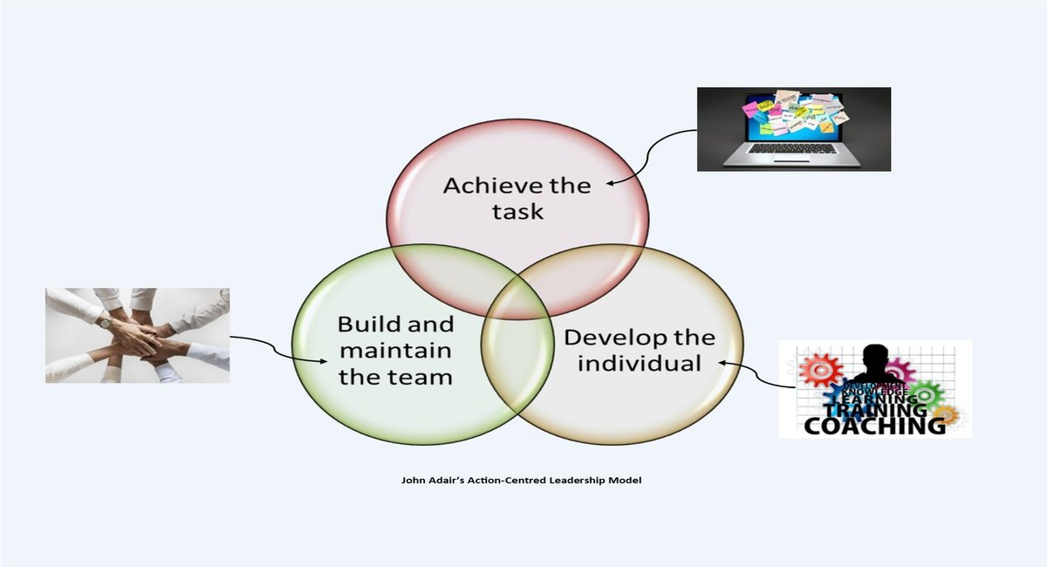

This model is represented by` three circles diagram` which describes three important managers` responsibilities: achieving the task, build and maintain the team, develop the individual.
Continuing the work of his predecessors, such as Maslow, Herzberg, and Fayol, Adair added a new organisational dimension. He was probably the first who demonstrated that leadership can be a transferable skill and can be trainable also.
- Improved performance and increased productivity
- Provided management guidance and simplified decision-making.
- Enhanced collaboration in teams
- Increase fairness.

Many companies today apply management theories even though some of them were defined centuries ago.

  - John Lewis`s Partnership

2.3.1 Critically evaluate John Lewis Partnership about its Values and Beliefs aligning to an individual

Recognising assumption
Examining the assumption of John Lewis’s engagement to their values as an organisation. This report aims to analyse the statement made by John Lewis, as a Claim about the fact that happiness of the employees (partners) is their number one priority.
“By putting the happiness of Partners first and empowering them, we believe we can better honour our commitment to offer our customers quality products and outstanding service.” (JLP Annual Report and Accounts 2018, p 29)
Following the methods of critical thinking looking for evidence is the next step. Digital tools can help the process. Who is John Lewis`s Partnership? There is Data which says:

Examining the assumption of John Lewis engagement to their values as an organisation. This report aims to analyse the statement made by John Lewis, as a Claim, about the fact that happiness of employees (partners) is their number one priority.

“By putting the happiness of Partners first and empowering them, we believe we can better honour our commitment to offer our customers quality products and outstanding service “. Annual Report and Accounts (John Lewis Partnership, 2020)

Following the methods of critical thinking looking for arguments and evidence is the next step. Digital tools can help the process. Who is John Lewis Partnership?

There is Data which says:
“The John Lewis Partnership was founded by in 1929 as an “experiment in industrial democracy “. (Lewis, 1948)
The largest partnership business in the UK is John Lewis Partnership. It has a number of 80750 employees who are also partners (owners).

As stated by Employee Ownership Association, in 2019 the Partnership hold the first position in top 50 largest employee-owned companies from the UK.

Based on these evidence John Lewis demonstrates seriousness and commitment to employees, sharing the Values and Beliefs of the partnership with its members and customers. In critical thinking this means a Warrant.

More evidence come out from Annual Report and Accounts (John Lewis Partnership, 2020) which claimed that the culture of the organisation is:

“The Partnership operates on democratic principles, sharing power with all Partners. Our first Democratic Council was set up over 100 years ago and today our Partnership Council, Forums and Partner Voice enable Partners to participate in decision-making, challenge management on performance and have a say in how the business is run.”

Nowadays with so many external threats (Brexit, Coronavirus), they proposed to use this democracy more efficiently. In this way the Voice of the Partners and the forums, together with the Partnership Council will improve the performance and will make the company more successful.
To further demonstrate commitment to its employees they empowered members to have a Partner Voice.
“We are committed to empowering Partners to have a voice in their business and to create a healthy environment that enables an improved contribution from everyone.” Annual Report and Accounts (John Lewis Partnership, 2019).
There is more information to support the Claim, named Backing. In addition to allowing employees to
express their opinion and participate in decision-making, the company has written a seven principles Constitution in place that guides it, and all members must abide by it.
John Lewis offers to employees an expensive training program, especially for leaders with a partnership of over 8000 managers, and organising events for them e.g., one-day “Empowered Leadership”. Even more can be said about John Lewis. It is one of 30 employers who became involved and signed a new commitment to mental health in the workplace. This project has been developed with mental health charities and aims to raise the standard of mental health care nationwide.

But there is a Rebuttal argument which show that nothing is perfect, there are always problems and changes, such as, pandemic, or political decisions. As Ashleigh Webber wrote in an article for the personnel today

“John Lewis and Waitrose staff will not receive a bonus next April for the first time in more than 60 years.”

Dame Sharon, the chairwoman to John Lewis said: “I know this will come as a blow to partners who have worked so hard this year. The decision in no way detracts from the commitment and dedication that you have shown. Webber (2020)

At the end of the article, Moira Clark, professor at Henley Business School, warned that:

““The loss of bonus is bound to have an impact on staff morale at John Lewis”.

Even through the changes of the last year have greatly affected the economy and especially the retailers who have been forced to close stores, the decrease in the onus has not caused any revolt among the Partnership employees.

2.3.2 Critical Analysis to Management Theories applied to John Lewis Partnership
- Scientific Management between Taylor and Fayol

Taylor theory does not consider the workforce, which JLP appreciates the most.

According to Fayol management has five roles planning, organizing, commanding, coordinating, and controlling. His management model is robotic which creates stress, without flexibility and creativity.

JLP applied this theory as peers: planned, organized and commanded - they established the Principles of the Partnership`s Constitution. Here are the stipulated rules, the ways of organizing, the hierarchy. In terms of coordination and control JLP has invested in Empowered Leadership. By creating the partnership JLP eliminated stress and robotic in their management system. Because all employees are owners at the same time, they are creative.

Mayo`s behavioural model of management emphasized that employees are not so much motivated by money or work conditions, they want to be valued, appreciated, they want to be part of a team. Starting from the physical needs of the employees, Mayo accepted that they also have social needs. That made this model human.

JLP wants to improve performance and has embraced elements of Mayo`s theory. JLP organizes events for partners, such as “Empowered Leadership Day”. This creates interactions, exchange of ideas, team relationships.
- JLP does not rejected System approach theory. They are trying to face changes. Today they must deal with two massive changes in the economic environment/; Brexit and Coronavirus, two unprecedented challenges which produce risks. JLP actively manage and monitor. At the same time many of the partners have been focused on reducing risks in all areas. (JLP Annual Report-2020).
- The Claim provided information about happiness of staff, interest for development of individual in the workplace, and leadership development, and attention to customer satisfaction/ All this information.
are perfectly found in Adair`s Leadership Model. Happiness of Partners first identified with Individual needs from Adair model, `empowering them` means Team needs, and `our commitment to customers represents the task, the organisation`s objective.

  - How would an individual align with Value, attitudes and Belief with John Lewis Partnership?
It is assumed that a person with different values, beliefs and attitudes towards the John Lewis Partnership would apply for a job at this company. individual with different Values, Beliefs, and attitude. The candidate is honest, creative, hardworking, polite, without leadership skills, does not like working in a team, preferring to do a task alone. This candidate is motivated by the work environment, how far from the house the job is, and he is not interesting about any partnership. Evaluating all these skills and preferences and trying to align to Partnership, it does not fit. John Lewis pay attention to their members, they are like a big family, communication is absolute required. Before drawing any conclusion, it is better cu apply Barrett Model of Consciousness. This candidate has the Survival needs. Going further with the evaluation nothing is certain anymore. The management theory appropriate to his value, beliefs and attitudes is Max Weber. However, the conclusion that he is not a suitable candidate for John Lewis.

- Conclusion

Concluding from the critical analysis and identification of management theories applied in John Lewis Partnership, it appears that the organisation is committed to paying attention to the needs of its members, their motivation, ensuring an adequate work environment for values and staff beliefs to meet the values and beliefs of company. Partnership attention can be added to other charitable causes, such as mental health at work at the national level.

4.0 References
- Adair, J., (2016) Decision Making and Problem Solving 3rd Edition, Kogan Page Limited: London
- Bowler, W. M., & Brass, D. J. (2006). Relational correlates of interpersonal citizenship behaviour: A social network perspective. Journal of Applied Psychology, 91(1), 70–82.
- Butler, S. (2019) John Lewis cuts staff bonus to lows t level since 1953, The Guardian, 12 September 2019. Available at: http://www.theguardian.com. (Accessed:15 December 2020)
- John Lewis Partnership (2020) Annual Report and Accounts Available at: http://www.johnlewispartnership.co.uk/content/dam/cws/pdfs/Juniper/ARA2020/JLP-2020-Annual-Report-and-Accounts.pdf (Accessed: 10 December 2020)
- John Lewis Partnership (2018) Annual Report and Accounts Available at: http://www.johnlewispartnership.co.uk/content/dam/cws/pdfs/Juniper/ARA2018/JLP-2018-Annual-Report-and-Accounts.pdf (Accessed:10 December 2020)
- John Lewis Partnership (2019) Annual Report and Accounts Available at: http://www.johnlewispartnership.co.uk/content/dam/cws/pdfs/Juniper/ARA2019/JLP-2019-Annual-Report-and-Accounts.pdf (Accessed:10 December 2020)
- Lynch, R (2012). Strategic Management .6th ed. Harlow: Pearson
- Peek, S. (2020) The Management Theory of Max Weber. Available at: http://www. The Management Theory of Max Weber - business.com. Accessed:
- Porter, M.E., 1985. Competitive Advantage: Creating and Sustaining Superior Performance. New York: Free Press.
- Scott, K. (2019) Barclays, John Lewis and Royal Mail sign new mental health commitment. Available at: http://www.employeebenefirs.co.uk/John Lewis-mental-health-commitment. (Accessed: 16 December 2020
- Stauffer, B. (2020) What Are the 4C`s of 21st Century Skills? Applied Education System (blog). 7 May. Available at: http://www.aeseducation.com>blog (Accessed: 8 December 2020)
- Utley, H. (2019) John Lewis bonus slashed to lowest level since 1953. Available at: http://www.thisismoney.co.uk/money/markets/article-6783439/John-Lewis. (Accessed: 17 December 2020)
- Webber, A (2020) John Lewis scraps staff bonus. Available at: http://www.personneltoday.com (Accessed: 9 December 2020)
- Zivkovil, S. (2016). A model of critical thinking as an important attribute for success in the 21st century. Procedia-Social and Behavioural Sciences Available at: http://www.doi.org/10.1016/j.sbspro.2016 Accessed: 19 November 2020)

