Student Name: Madison Jones
Student Number: 2404411
Programme of Study: Illustration
Module: Research in Practice (ADAD5004/C)
Tutor Name: Delyth Lloyd Evans
Word Count: 2,576

The Evolution of Fairies
How have fairies' narrative and design developed over the decades?
In this proposal I will be exploring three key words: Fantasy, Narrative, and Designs which falls into my research on how fairies in Celtic cultures exploring how fantasy operates under the guidance of narrative and design. Exploring how folktales have evolved over time, shifting the portrayal of fairies across history, with fairies stemming from the fear of the unknown, to then developing as humble creatures for children in the modern era. I hope with my key words I can break down and developed my understand of storytelling and illustration, to contribute to my practice.
Fantasy
Often when we think of the word fantasy some of the first things That come to mind are stories of noble creatures such as elves or maybe stories of vampires and werewolves, which are all things created with the human mind, Fantasy is a form of imagination, described as a ‘natural human activity’ (Tolkien. J, 1947, p.65), creating scenarios in our mind which are unlikely to occur, even creating whole new worlds with our imagination which defy the natural laws of our world. A famous quote by terry Pratchett adds to the meaning of fantasy ‘Fantasy is an exercise bicycle for the mind. It might not take you anywhere, but it tones up the muscles that can’ (Pratchett. T, N.D describing how even though fantasy is not directly relevant to reality, it can mentally challenge one's brain to train for legitimate problems.
Fantasy is also widely recognised for its important in escapism, ‘Escape is one of the main functions of fairy-stories' (Tolkien. J, 1947, p.69) allowing people to have a break from there reality, fantasy has always been used for escapism giving people comfort during times when people were afraid and baffled by the unknown, creating eligible scenarios which are more palatable, due to its lack of scientific research in the Medieval era they would create many scenarios which we can now explain with rationality, the plage is a substantial example of this, as during at this time of fear and confusion, they believed God was punishing the sinners, and if they repent their sins that they wouldn't die, showing how adding a narrative can offer people a sense of hope and escapism.
fantasy is often associated with folktales, which are traditional stories shared verbally within communities, multiple cultures have their own folktales, however we will be focusing on folktales within Celtic cultures (Wales, Ireland, Scottland) , Celtic folktales are often fantastical and are strongly associated with fairytales as a large number of the folktales including the Mabinogion (a collection of Welsh folklore) often mention fae realm’s and fairies.
Fairies are a prominent part of fantasy as well as culture imbedding themselves in stories and modern media, in Ireland it's believed that fairies live in hawthorn trees, this belief is so strong within parts of Irish culture that in 1999 there were plans for a motorway to be built which happened to be directly in line with a hawthorn tree, meaning they would cut it down, however a man named Eddie Lenihan (a known author and folklorist) claimed that cutting down the hawthorn tree would cause outrage and the Fairies would target the construction workers, as well as the motorists driving over the former location, with nothing to prove or disprove this claim the tree remained standing, and the plans for that motorway were changed, showing how fantasy is truly imbedded into our lives with folktales.
But what are fairies? The word fairy stems from the Old French word ‘faerie’ which referred to illusion or enchantment which alludes to the inherent nature fairies are described with, it's important to note that fairies are not one consistent idea as ‘Fairy-stories are made by men not by fairies’ (Tolkien. J, 1947, p.75) there lots of ideas and beliefs about fairies however some of the earliest depictions of fairies we have are around late 15th century and early 16th century, where fairies were originally perceived as demonic creatures affiliated with the devil by the church, believing fairies were more akin to spirits or fallen angels rather than small creatures with wings, which we are accustomed to, often described as being human like with an ethereal charm luring people to sin, Robert Kirk a Scottish who was an Episcopalian minister and folklorist known for his book The Secret Commonwealth of Elves, Fauns and Fairies, described fairies as having a "middle nature betwixt man and angels" (kirk, R. 1691)however as previously stated fairies have different interpretations and weren't always viewed as strictly evil, yet the one consistent idea shared on fairies is there connection with nature often pictured in the woodlands.
To conclude fantasy is anything created by the mind a vast tool in which has led to many Fabricated stories, twisted with facts and fiction which we know now as folktales.
Narrative
Narratives are more than just telling a story, narrative enriches the story, which is told with attributes such as structed, versatility, plot, and setting, which manipulates how a story is interpreted, narrative broadens the themes effecting how those events in the story are understood by the audience. Narrative can be told with more than just words on a page, it can also be spoken or shown visually through, performative art, movies, the news, games, graphic novels and so on, the only thing which matters in that you convey a story, as Joan Didion a writer and journalist once famously said ‘We tell ourselves stories in order to live’ (Didion. J, 1979) expressing how adding structed to disarray can bring order.
Narratives can develop over time, stories being reimagined which changes the perspective of the story, fairies are a key example of this as stated before they were once written as demonic beings however this narrative has been altered over time, while researching it's clear how the narrative is effected by different element which are significant to each era. As in the medieval era the catholic church power was huge and dictated the whole of the UK, believing anything outside of Christianity was evil and fairies being from pre-Christian paganism caused them to be seen as such.
Folktales and fairies biggest change happened during the Victorian era, fairies were becoming less human like and were described as being smaller in size, and there power was less godlike and more subtle to fit in the setting of a nursery, As the Victorian era progressed, they were associated with childhood more and more as they became a symbol of nostalgia due to how quickly the period was progressing in its industrialization as well as having an increase in strict social norms, making fairies appealing with their wild and free nature.
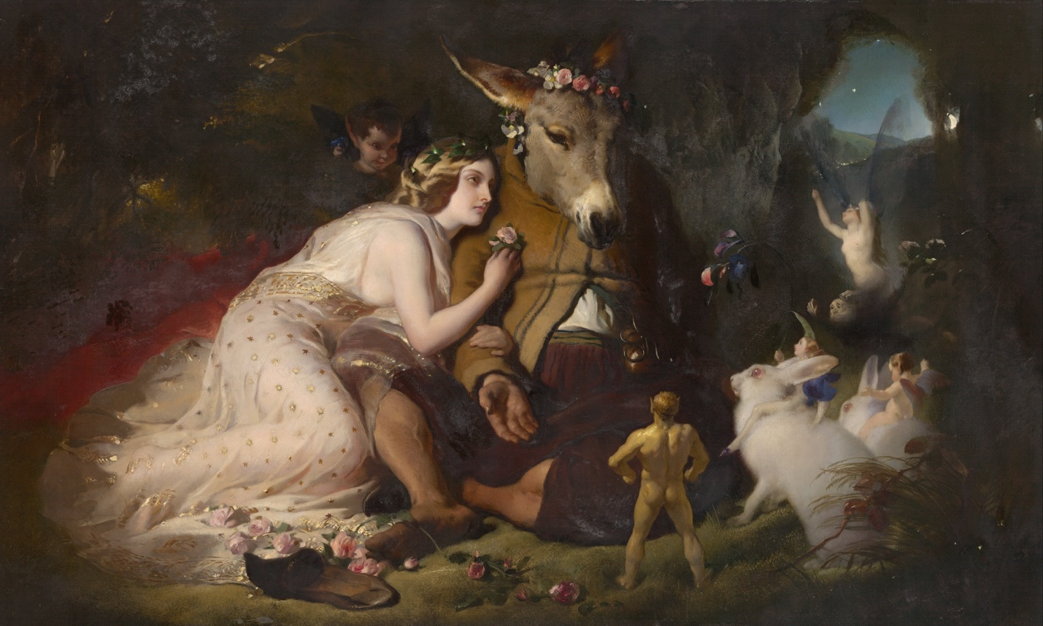
Writers such as Shakespeare were some of most popular figures which influenced the idea of fairies, the play A Midsummer Night's Dream by Shakespeare is his most conspicuous work which altered the perceptions of fairies in how they acted, they were less fearsome and more whimsical, feeding into the romanticisation of fairies and people in the Victorian era wishing for a simpler and more natural life, which contributed to the way on how we imagine fairies today.
Fig. 1, Edwin Landseer, scene from A Midsummer Night’s Dream. Titania and Bottom, 1851
‘The association of children and fairy-stories is an accident of our domestic history. Fairy-stories have in the modern lettered world been relegated to the “nursery,” as shabby or old-fashioned furniture is relegated to the play-room, primarily because the adults do not want it, and do not mind if it is misused.’ (Tolkien. J, 1947)
Edwin Landseer scene from A Midsummer Night’s Dream. Titania and Bottom, 1851
fairy stories through the years have been passed down and rewritten so much that it's been distorted, Disney is a evident example and cause of this, Walt Disney was known for taken stories away from the brothers grim remodelling the folktales for a younger audience making them bright and innocent, with their popular movies The Little Mermaid, Snow White, Cinderella and so on completely overshadowing their original twisted tales.
Vladimir Propp says ‘functions of character serve as stable, constant elements in a tale' suggesting that the core roles of a character stay the same, but Farieses completely go against that statement if we think of them as a character they have moved away from the role of a villain through the years, fairies appearing more mischievous and silly is most noticeable in 1904 when J.M. Barrie wrote the stage play for Peter Pan and created the idea that fairies were made from babies laughter, sparking a change in fairies making them more innocent, causing them to be pushed into children's media further.
Design
Design in art is the process where ideas are converted into visual forms, using technical processes like Composition to create an effective outcome, the arrangement of visual elements such as lines, forms, colour, and texture are all key elements create a cohesive, operative, and aesthetic composition, just like narrative design is not limited to one medium design is recognised in all forms of visual art from 2d to 3d.
Fairies have been drawn in countless ways, just as many and more times as they been written, taking on countless forms, they can be undescribed creature or ethereal being with unmatched beauty, Tolkien once said ‘In human art fantasy its best left to words, to true literature. In painting, for instance the visible presentation of the fantastic image is technically too easy; the hand tends to outrun the mind’ (Tolkien. J, 1947) he believes that art is too inherently lose and thoughtless for fantasy, on the other hand he also states “Faërie cannot be caught in a net of words; for it is one of its qualities to be indescribable, though not imperceptible” (Tolkien. J, 1947) therefore by Tolkien's standards although favouring literature over paintings, it still cannot fully capturer the fae, to further back this up Brian Fraud says ‘I feel that what you should illustrate is the space between the words. It's the betweenness, the otherness, that gives depth and dimension.’ describing how it is the artist role to be able to fill in the details that words cannot, completing each other in whole. (Fraud, B. N.D)
narrative and design go hand in hand, while the narratives progressed so does the design, this can be seen through artists in different time period and how they designed fairies according to the stories relevant to that era, a visual representation on how fairies were imagined during each time period.
Going back and looking through key time periods previously mentioned the development in fairies design is apparent, starting with John Anster Fitzgerald Victorian era who was known for his fairy paintings, giving him the nick name nicknamed ‘Fairy Fitzgerald’ he was one of
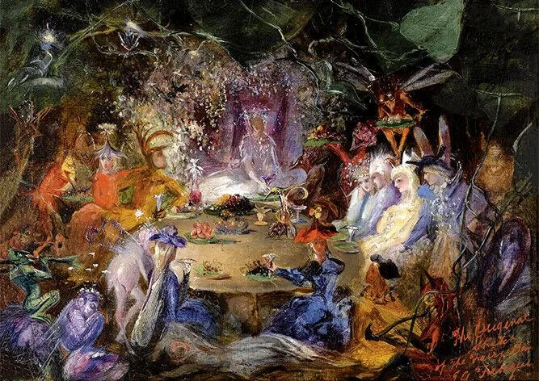
many leading people in the surge of artist which painted fairies in the Victorian era, it was popular in fact that Fairy paintings became its own genre.
Fig. 2, John Anster Fitzgerald, Fairy Banquet, 1859
His art reflects the early transition of fairies in the Victorian era, his painting were dark yet enchanting with chaotic scenes with strange creatures all around in twisted forests, using heavily textured paints, having a nightmarish effect.
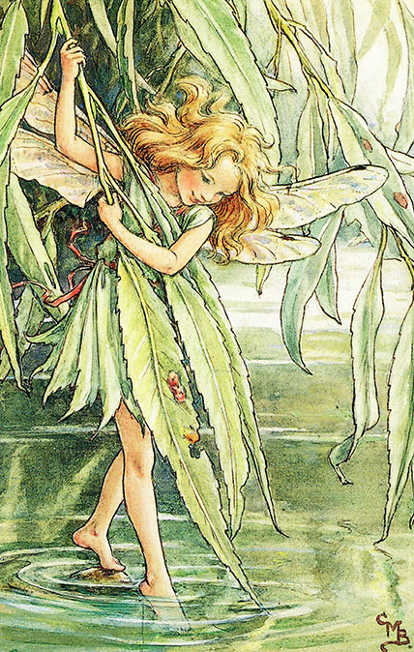
Jumping to the early 20th century, Cicely Mary Baker was another prominent figure, known for her series of fairy illustrations named Flower Fairies of the Spring which was published in 1923, you can see a drastic mood shift in her painting compared to past artwork of fairies.
Fig. 3, Cicely Mary Baker, The Willow Fairy, 1940
Her paintings took on a more playful look, using pastel and vivid colours in her illustration, she made the fairies more childlike, with innocent and mischievous faces, she imbedded fairies in wildlife in her drawing giving them outfits made from petals and leaves, her designs acted as a blueprint for fairies, becoming the most recognisable and iconic look for fairies and was further solidified with Disney, when they realest the movie Peter Pan in 1953 along with the design of the popular character Tinkerbell, giving her a new design making her a miniature human with wings, which strongly effects how we in the modern-day view fairies.
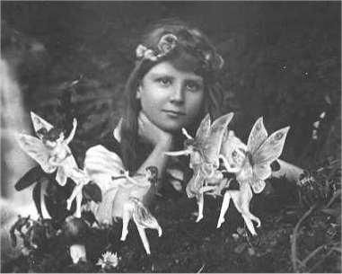
When fairies became associated more with children's media rather than fearsome tails the belief that fairies were a legitimate creatures dwindled, however there was a surge of people which fell into believing that fairies were real, when tow girl from Cottingley, Elsie Wright, and Frances Griffiths, photographed them selves amongst ‘fairies’.
Fig. 4, Fairy Fake, 1917
The ‘fairies’ in actuality were cardboard cutout but hoax was so believable that it lasted 60 years before the girl themselves stated that it was all set up, although it was hoax it sparked a serge of reconnection with fairytale and nature, which could be credited for popularising fairy houses in the mid 20th century bringing back a sense of escapism and whimsy. Fairy houses come in many styles but usually are made from natural materials like mud, twigs, and moss, and are always small following the design that fairies are miniature.
Practice
After researching my three key words Fantasy, Narrative and Design, to conclusion, the evolution of fairies within Celtic culture highlights how deeply interconnected fantasy, narrative, and design truly are. What started as cautionary tales rooted in fear of the unknown gradually transformed through ever changing narratives shaped by aspects of religion, industrialisation, and cultural change. As these stories were retold and adapted, fairies moved from ominous figures to playful, miniature creatures heavily reflecting childhood, demonstrating how narrative can redefine meaning across generations.
At the same time, the visual design of fairies developed alongside these narrative shifts, reflecting the values and emotions of each era, from unsettling imagery of early Victorian art to the soft, whimsical aesthetics popularised in the 20th century. Showing that design is not restricted to just being decorative but can be essential to assisting the narrative that reinforces how audiences perceive fantastical beings.
Ultimately, this study of fairies reveals more than just the history of a mythical creature; it exposes how humans use fantasy to process fear and create meaning. By exploring fantasy, narrative, and design together, it becomes clear that storytelling is a dynamic, evolving practice, that continues to reflect the our society, which I would like to further explore in my practice, to give my art a deeper meaning which people can connect to.
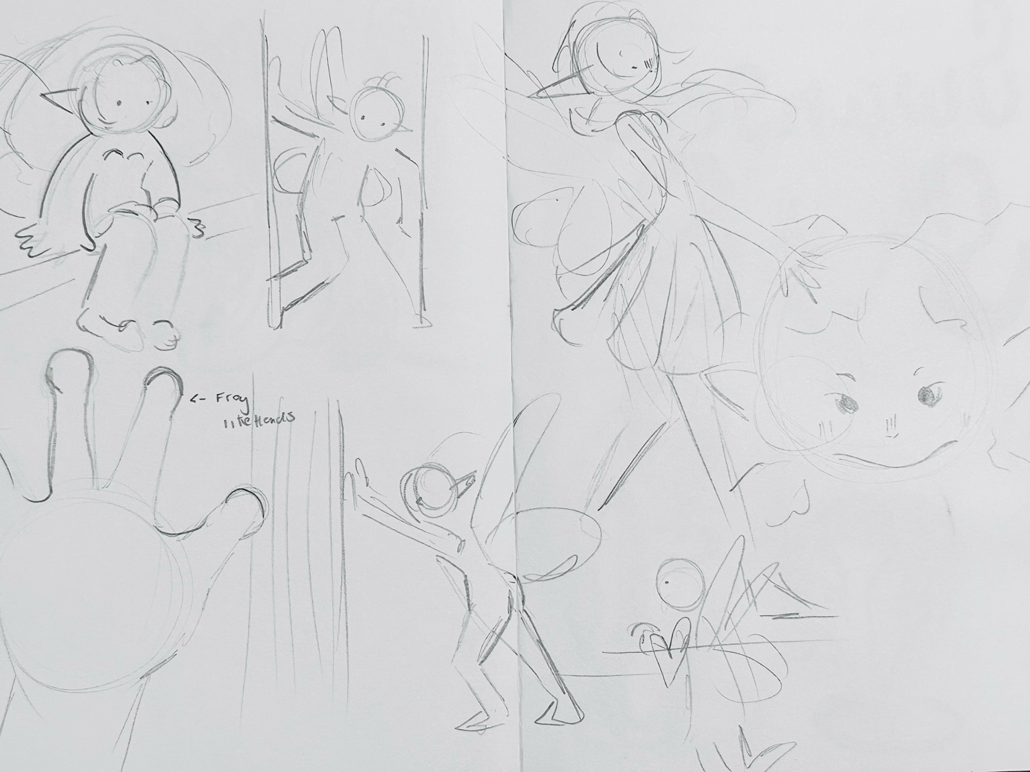
While researching my practice it has shaped what I want to create in my practical, I will be making sculpted fairies interacting with there environment (e.g sitting, pushing, leaning and so on) and will be making them as a collection, this idea was inspired by the fairy fake mainly taking inspiration from how the fairy cardboard cutouts were interacting with each other and the environment they placed in.
Fig, 5.
The style of fairies is an imagination of different era which I personally am drawn to, I like how Cicely Mary Baker illustrated her fairies, but I also want my fairies to be more creature combining features of frogs to separate them from being human and further associate them with nature.
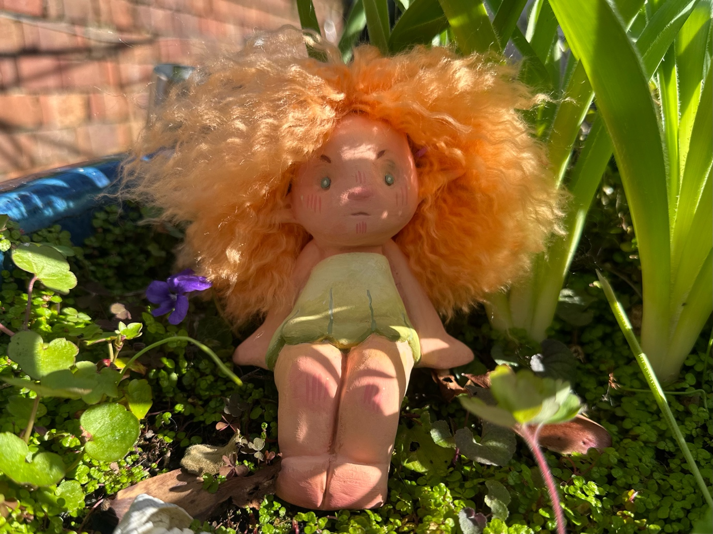
Fig, 6.
After making my prototype I got a more clear idea with what I want to make, in the future I would like to more define feature, to add more of those creature-like properties, My hope is too convey a whimsical feel the same way the fairy fake did, creating a sense of escapism and to celebrate the progression of fairies.

Bihet, F. (2020) Fairies and Folklore: The History of Fairies in the Folklore Society 1878-1945. [online] academia.edu. Available at: https://www.academia.edu/44171178/Fairies_and_Folklore_The_History_of_Fairies_in_the_Folklore_Society_1878_1945_by_Francesca_Bihet?sm=a&rhid=39383851432
Bastian, J. (2023). UNREAL: Why Fantasy is More Important than You Think. [online] Medium. Available at: https://medium.com/the-cryptofolk-movement/unreal-why-fantasy-is-more-important-than-you-think-938acab9974d.
Dearnley, E. (2021). Fearsome fairies : haunting tales of the fae. London: The British Library.
Dunbar, J. (2023). Fairies in Art & Culture Throughout Time. [online] Simon O’Rourke. Available at: https://treecarving.co.uk/fairies-in-art/.
Froud, B. and Lee, A. (2010). Faeries. New York Abrams.
Hicks, J. (N.D) Fairy: Origins, a Phenomenon, and Realms. [online] academia.edu. Available at:https://www.academia.edu/35024434/Fairy_Origins_a_Phenomenon_and_Realms?sm=a&rhid=39504894717
J R R Tolkien, Verlyn Flieger, and Anderson, D.A. (2014). Tolkien on fairy-stories. London: Harpercollinspublishers.
Medievalists.net (2022). Did Medieval People Believe in Fairies? [online] Medievalists.net. Available at: https://www.medievalists.net/2022/07/did-medieval-people-believe-in-fairies/.
Mains, J. (2022). Celtic Weird.
Moran, S.R. (2024). An Overview of How Faeries Were Portrayed During Different Literary Periods. [online] Substack.com. Available at: https://stephraemoran.substack.com/p/an-overview-of-how-faeries-were-portrayed
Pagan, A. (2020). Hallmarks of Fantasy: A Brief History of the Genre. [online] The New York Public Library. Available at: https://www.nypl.org/blog/2020/05/18/hallmarks-fantasy-brief-history-fantasy.
Sounds of Sirius. (2018). The Fairy Tree That Moved a Motorway. - Sounds of Sirius. [online] Available at: https://soundsofsirius.com/the-fairy-tree-that-moved-a-motorway/.
Staff, W. (2010). Why Fantasy Matters. [online] WIRED. Available at: https://www.wired.com/2010/09/why-fantasy-matters/.
says, L.N. (2021). A Need for Belief: The Victorians and Fairies. [online] Retrospect Journal. Available at: https://retrospectjournal.com/2021/11/08/a-need-for-belief-the-victorians-and-fairies/.
Williams, H. (2023). When Britain was gripped by ‘fairy mania’. [online] Bbc.co.uk. Available at: https://www.bbc.co.uk/culture/article/20230915-when-britain-was-gripped-by-fairy-mania

