

current environmental forces and their impact

Benjamin Williams

MBA

University of Wales Trinity Saint DaviD

change and stability management

December 2022

private and confidential

Executive summary

The report has focused on the change and process the NHS has gone through because of the Covid 19 pandemic. It has highlighted key areas that are an essential focus for the future organisation's health and success in delivering the patient outcomes and changes needed.

Key findings

The NHS is in the current state of investment in change with a focus on efficiencies and procedural changes that can improve and increase the impact of the healthcare provider.

Levels of theoretical methods toward change are positive.

Staff can be engaging and positive toward change management and drive adherence.

Morale is at an all-time low, with employees waiting for another job to the surface to leave the organisation.

The focus must be given to recruitment and will be essential to implementing and sustaining any change protocols introduced.

A bottom-up approach will create a sustained and impactful change process with a clinical lead on the ground direction needed to be taken.

Focus on creating a workforce that is felt valued and recognised for its efforts can support low wage growth.

The NHS has in its history suffered from staff shortages as far back as the world war, the effects of the pandemic and the growth in private sector pay highlights the need to provide a bottom-up focus, create a valued workforce and deliver a patient-centred approach as opposed to top-down management, that focuses on efficiencies and grows discontent from the workforce.

Table of Contents

Introduction:

Scope

Research Methods

Main findings

Present Data

3.1 - An assessment of the business’ competitive environment

Discussion

Conclusion

Recommendations

References

Appendix

Introduction

Fujifilm has over the years provided a key guide to how a business can anticipate the marketplace and diversify its product portfolio to ensure longevity of the organisation and present a company that continues to grow in high revenue and profit markets whilst maintaining its core beliefs and providing added value to all areas of industry it is involved in. Established in 1984 as a subsidiary of Dailcel, it had a focus on photographic films, this also enabled the organisation to produce motion pictures and manufacturer and supply x-ray films. In the early 1990’s the organisation was enjoying a buoyant market however by 2001 the organisation went through a rapid reduction in sales. The organisation implements a plan named vision 75 which focused on saving it form reduced profitability and reinstating increased levels of profit. As a result, by 2010 the business was only making a 16% profit from its original imaging business. Fujifilm has successfully survived the declining markets and is now involved in over 300 entities to ensure the continued growth of the organisation, Pfeffer J. 2021.

1,1 Scope

The paper will consider documented information from various sources to ensure an unbiased viewpoint and provide as much substantiated data as possible. With reference points being taken from direct organisations focusing on or pertaining to the way Fujifilm has used market experience, in the international sector focusing upon a critical assessment of the conditions of the businesses environment conditions in which the organisation operates.

It will utilise tools such as pestle Bush T. 2019 states that “PESTLE analysis is an incredibly popular business analysis tool. Not only is it extremely easy to use, but it’s also very effective, the basic premise of PESTLE analysis is that you analyse a chosen organization from six different perspectives: Political, Economic, Sociocultural, Technological, Legal, and Environmental, by doing so, you unlock a powerful understanding of how a given business is performing from every angle”.

Further analysis will take place in several national and international macro-economic performance indicators that are relevant to the organization. The corporate financial institution 2022 states; “Macroeconomics refers to the study of the overall state of the economy. While microeconomics studies how individual people make decisions, macroeconomics deals with the overall aggregate effect of microeconomics. Macroeconomics is crucial for the government to understand and predict the long-term consequences of their decisions”.

1.2 Research Methods

To understand how these models can support the assessment of the competitive environment and conditions of the business environmental conditions, IG Group Holdings Plc 2022 states: Macroeconomic indicators are a key part of fundamental analysis for traders, as they provide insight into the state of a country’s economy, with the top indicators being split between a) Top leading indicators: The stock market, House prices, Bond yields, Production and manufacturing statistics, Retail sales, Interest rates, and b) Top lagging indicators: GDP growth rates, The Consumer Price Index (CPI) and inflation, Currency strength and stability, Labour market statistics, Commodity prices. The BBC 2021 states that: “The second E in PESTLE stands for environmental influences. Environmental influences refer to our surroundings. This can include: the air we breathe, the water that covers most of the Earth’s surface, the plants, and animals around us. In recent years, scientists have been examining the way people affect the environment. Concerns include air pollution, deforestation, and acid rain. However, society is more aware of the damage that individuals and businesses can inflict on the environment as well as looking for ways to protect it”. Currence J. 2018 states; “ An option that can help you pay more attention to the external environment is a PESTLE analysis, in which you scan the Political, Economic, Social, Technological, Legal and Environmental trends shaping the world in which we operate”.

We will also consider the advantages and disadvantages of business environment analysis, considering areas such as lack of forewarning of unseen events, organisational effectiveness, absences of strategic approaches, by looking at ways to identify the threats and understand what is happening in the marketplace and forecasting the future. Accounting learning.com 2022 states: “When a company neglects to adjust its strategy to the business environment or does not react to the demands of the environment by changing its strategy, the company cannot achieve success in attaining its objectives. However, environmental analysis enables the business enterprises to study the environment and formulate the strategies accordingly, which will result in successful attainment of objectives”.

To enable the report stage, a complete understanding and critical analysis will need to take place, this will extend to further research and sourcing relevant data for the evaluation. It will show a clear conclusion based on the findings and offer recommendations for increased business alterations to ensure the longevity of the organization, environmental factors and presence in the relevant market places.

Main findings

Fujifilm has operations n many marketplaces, with a varied approach to its operations and how it conducts business in the areas, focusing toward ensuring local law and adherence is strong with high levels of understanding of environmental conditions that factor into the growth and development opportunities

There are many areas where the business has to consider the sustainability of the local organisations operations, from changes in governmental policy, local interest rates and changing tax levels and rules, consistent monitoring and strategizing to ensure the continued presence of a low-cost high-quality organisation is needed to ensure sustainability.

Interest rate and market conditions are set to cause increased challenges when presenting strategic direction, the growth and decline of market conditions set around government spending powers and consumer spending may lead to increased pressures, however with the maintenance of a low-cost resource centre these costs can be mitigated against potential volumes and price markers of products

Directional change and agility need to be considered as part of a large organisation, and the ability to have local business hubs making local decisions based on the economical factors in the market represent a strong basis for success. The ability to have alternating market focuses with varying product ranges from other business units also provides flexibility and versatility in each market providing many levels of agility and leverage available to ensure market growth presence and impact in the overall consumer and governmental demographics and environmental factors

3 Present Data

Various tools can be used to consider the business environment with pestle analysis contributor 2015 stating that “Business Analysis is a set of tasks and techniques used as a connection between stakeholders. These help them to understand the firm’s structure and policies. The process can also recommend solutions which help to attain business goals. To apply Business Analysis effectively, analysts employ different analytical tools”. More modern methods have also been developed such as, Microsoft’s Power BI model allows for self-service data ingestion, processing, analysis, and visualization to enable non-tech users to transform raw data into immersive reports and interactive dashboard. Microsoft BI 2022 power states: “take your visualisations to the next level and empower everyone to quickly make data-driven decisions. Easily work together, collaborate on reports, and share insights across popular applications. Bismark O. et al. 2018 stating: 'Mckinsey 7s model and other tools such as PESTLE, BSC and SWOT analysis having been the tools that most professional institutions use to evaluate the overall performance of the organisation'.

When we consider the layers of the business environment: The macro environment as defined by Tamplin T. 2022 as being “to the overall operating conditions for an industry or country.

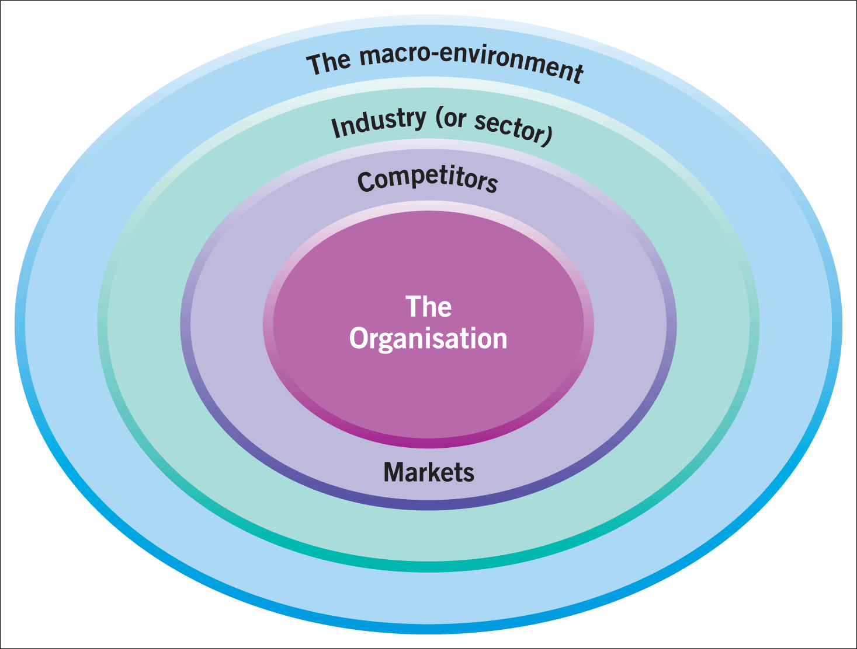
Macroeconomists use different statistics and measures to evaluate factors that might affect performance of an economy or company, including all relevant economic, political, and technological factors. Macro-environment is different from micro-environment, which refers to the supply and demand fundamentals of a single industry, product, or region.

We therefore need to consider the various sectors to enable a clear environmental picture, the demographic environment for Fujifilm has a wide impact as the organisation covers several different continents with various forces affecting the demographics, this therefore can be seen as challenging to merge all the factors into one, however with any large organisation there will be regional headquarters that can take a view point and focus on the current demographics in the relevant operating location enabling a clearer view towards the effects of increasing population corresponding goods and trends in the regions, successfully managed by the organisation to ensure manufacturing is taken place at source with product lines being introduced or recalled dependant on the current market activities, this is demonstrated by the different types of medical products available in different country regions based on the need of the demographics and the results the products con offer in line with the need of the client base. The industry sector based on the organisation is split between many areas of manufacturing and product categories, in order to substantiate the direction for the varying product lines direct business heads allow the transition of the sub organisational direction to take place, this ensures a vital focus toward the single product group taking place and ensures the overriding business unit does not take a single dimensional approach toward the economic factors such as interest rates, and inflation. The measure used for success for the organisation has always been the Japanese Yen, with the various business units reporting profit and loss through the local overriding currencies. This area is an important factor to ensure that correct measurement of performance can be undertaken in local currencies without international exchange rates have a plus or minus effect on the operating performance. With ever changing political and social factors based in ever changing locations the need to substantiate by the direction of allowing and supporting individual business units to develop and manage the changing environment by securing individual directions and decisions based upon the product categories and markets they are engaged with. Tamplin T. 2022.

The industry environment provides a vital element toward the business to which valuation is conducted toward customers. Together with competitors and collaborators, to identify areas that can affect the success of the business in the future. Focus has been given toward market engagement in many sectors by creating and supplying product categories to meet the market conditions and demand, this has been identified by focus of engagement, through industry evaluation and direction through direct customer working groups and ensuring all environmental factors are considered and undertaken, this approach however has not taken into account the competitive landscape of the market and the increased emergence of Chinese organisations providing cheaper derivatives in the marketplaces through reduction in one source manufacturing processes. This is in direct opposition to the Fujifilm focus of manufacturing in the region of the business units founding locations.

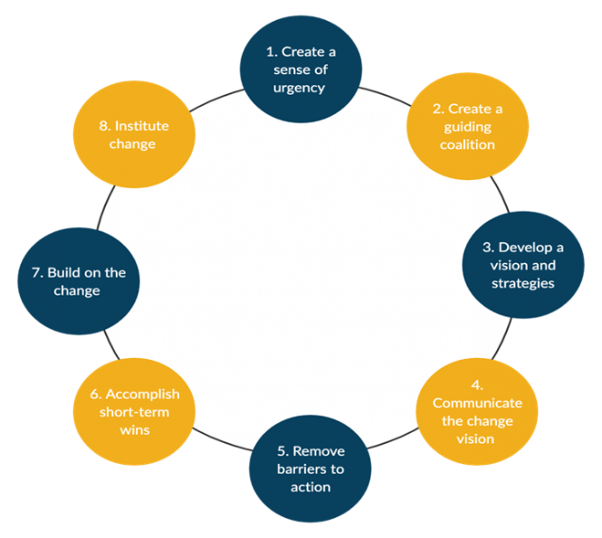
Kotter's model can Describes a method in which the approach is taken. Fujifilm has adopted an approach to focus on the elements of the kotter’s model. This direction can be shown on the various business units and the direction taken to ensure operational success against the business environment. This approach used in line with other methods also helps support the overriding direction of the organisation being “Value from innovation” only by adopting this method as a localised practice has helped ensure the factors considered have the correct environmental condition to ensure a higher level of success, as opposed to adoption on a global scale which may promote inconsistencies in relevant market conditions.

When we consider the PESTLE application this can be a useful tool to enable the development of effective strategies and achieving the long-term growth ambitions of the organisation.

Political Factors:

The political factors in consideration of a global organisation suggest that it is sensitive to the political changes in the environment of different countries policies, in the context of the political environment it is essential to the success to ensure Fujifilm can diversify the systemic risks to the organisation and will need to factor these risks into the strategic planning processes.

Influencing Political factors: A stable environment provides a business environment with strong predicable growth trends, where there are areas of chaos this will cause concern for investors and stakeholders, as Fujifilm is present in many different countries with each having its own political pressures, the increased tensions and potential instabilities can affect the industry growth and limit future opportunities to the organisation. This in conjunction with changing government policies can also harm overall business performance by increasing the uncertainty in the environment, Fujifilm will need to study the varying trends in individual countries political areas as any changes in policy me alter the priorities toward different industry options. The effects of potential pressure from organised groups and protesters need to be analysed to ensure collaboration can take place with such groups to help support and collaborate with communities to support long term goal progression, this with a developed governance tool supported within a democratic environment will help support and more comfortable international Fujifilm business. When Fujifilm enters world areas with high levels of tax this will have a direct impact on the profitability, which can affect the international trade and would force reductions of exports form those markets, due to the nature of the organisation Fujifilm can enter low taxation markets and enhance its operations by utilising the increased profit to invest in development and research. This must be taken in consideration toward the business environment and potential additional issues surrounding exports and trading routes from these low tax nations, the government policies also have to be considered in order to help protect the intellectual rights of the organization to reduce the risks of ideas and concepts being stolen. This if not managed effectively may also impact the external investment Fujifilm receives and stock levels should the market decide it is a risk from these elements. The potential for bureaucracy and corruption may also negatively effect the organisation, as operations in countries with high level corruption associated with low supports laws enforcement make the operations in these areas unpredictable for Fujifilm, with corruptions potentially influencing the business operations, Fujifilm do engage and regularly provide increased levels of training for all employees to try to mitigate the risks form this, however, by deciding to operate int these markets it could threaten the development of the organisation by harming the law systems and de-stabilising the established the general society.

Economic Factors

By understanding the economic factors Fujifilm can help estimate the overall trajectory of the organisation, to be considered will need to be areas such as inflation, savings rate, foreign exchange and interest rates and the labour market.

It is important to recognise the lifecycle of the industry and environment entered as an area that is reaching saturation inside a mature market will present more challenging environment, with the overall performance also impacted by governmental control and investment toward infrastructure. With a well-developed governmental infrastructure program this can help support and grow the overall industry that may be embarked. The labour market also needs to be evaluated to understand and set competitive rate for compensation, together with the general supply of skilled workers, Fujifilm looks at predicting the labour market and considering methods to attract the talent, this to be aligned with the availability of skilled labour as any restrictions will impact the operational efficiency and growth development. Growth Domestic output (GDP) will affect the long-term growth, with a higher-level signifying high levels of consumer spending, should high employment be present this will lower consumer spending, reduce tax intake from governments, and effect market segments profitability potential through reduced income availability. The health of markets will also affect the ability for the organisation to raise any needed capital from the financial markets, the need to raise these investments at fair rates will be key to driving the expansion of the organisation. With all business activities being influenced by the economic structure of local and international markets providing altered economic and regulatory requirements, to be navigated alongside the current competitive landscape.

Social Factors:

Fujifilm can utilise the marketing department to take all the learnings from the pestle analysis and apply them to the real-world economic conditions of each local market, by addressing the individual social factors it can help its understandings of the spending patterns, trends and culture towards groups consumers and potential buyers

Spending patterns can be influenced by the social conditions with some markets having a strong status symbol approach to others having a more functional approach, this ability to learn lessons from the individual areas and implement a marketing strategy based on the social aspects to ensure messaging and approach hits the correct functional parameters to ensure success. Fujifilm should understand the consumer in the country to determine these local social factors. This can also take place toward the overall gender roles and how it aligns the marketing to strategies approaches and content, with certain societies have different patriarchal focus which effect messaging and content. This has an impact toward the increased emergence in certain market of online shopping, and the generational differences and attitudes toward purchasing through visualisation only, the correct adoption these areas would allow for potential high yields as the presence and cost of physical locations could be minimised. The culture of each demographic also plays an important role and development of local teams and partnerships will help drive the understanding and implementation strategies for the market areas. Fujifilm should consider focusing and understanding the leisure interests of each market and produce ways to further enhance the customer experience and if certain markets are more open to products in the experimental stages as apposed to established elements.

Technologies

The rapid increase in technologic advances over the last few decades have seen an vast increase in the application and complexity of products available in the market, the thorough understanding and trajectory of technology is a key part to ensuring the strategies and life cycles are properly managed and designed, ensuring a consistent timely flow of information and products to ensure the company is and remains at the forefront of technology and delivering to the market products that are at a minimum in line with the current technological trends

This ranges from Social media marketing, product development, innovations, and life cycles. The use and data that now surrounds media marketing has been constantly developed to support the way Fujifilm can market and present itself in the individual social networks, by utilising the direct resources and implementing the data driven concepts the organization has the opportunity to directly market with meaningful messaging in a focused and data driven manner, driving further the direct content and providing any return on investment strategies that are set in place for thus sector. The speed at which markets develop through technology highlight the increased need for consistent relevant innovation and development, using market research, working groups and feedback forums, relevant new adoptions can take place and drive future product acceptance and successes, this also effects the life cycle production and the option to include optional upgrades to current products to provide customers with innovation that offers consistently upgradable items, helping meet some strict environmental recycling conditions and ensuring the loyalty of the customer base through encouragement of brand loyalty through innovation adoption. The international growth and presence of Fujifilm offer a unique platform in many markets to adjust where products are offered, potentially offering an increased life cycle transference form market to market dependant on the economic and social development of the current location.

Environmental Factors

Due to the size of the organisation and increased level of awareness and responsibility lies with Fujifilm, this shows in the organisational environmental focus, by abiding to local laws and practices, but also by introducing new improved methods into less established economic regions, therefore supporting the innovation in these markets and driving new environmental standards for where it can.

The increased population amongst urban dwellers has increased levels of recycling and environmental considerations taking place, with increased strict rules toward the direction’s organisations must take, this can be utilised by Fujifilm by engaging with and participating in green schemes to focus on the utilisation of renewable sources and clean energy. This can also be adopted towards a cultural shift and grow the organizational brand image on a world stage. The potential to secure subsidies for investment in technologies may also support the reduction in taxation in high tax economies supporting increased investment through reducing the taxation, in turn delivering the environmental changes the economies needed to secure long-term wellbeing and health of the population. The general changing attitude to consumers through the purchasing decisions also factor in the approach and messaging aligned with the environmental focus, delivering high levels of customer satisfaction and supporting the development and loyalty toward the brand. This approach can also detract from any negative media attention and help avoid any excess depletion of local resource and help understand how local discrepancies can affect the way the organisation utilises even the most basic resources such as water.

Legal Factors

The final Pestel is legal, Fujifilm at no stage can enter any market without knowing and understanding the legal factors surrounding any potential operation in the relevant area, this requires a careful evaluation of the legalities to avoid fines and negative press, any miss-understanding or ignorance can harm the overall organisation and hurt its competitive advantage, as it may have larger impacts on intellectual property or violation toward working conditions and environmental standards.

Employee law and protection must be followed in each country operating in, with varying levels of employee protection and rights being offered, Fujifilm must meets all local guidelines and rules to ensure the workforce is properly looked after and protected, this may present a challenge or opportunity for Fujifilm, as due the international nature of the organisation it has the opportunity to improve work conditions in less established regions by adopting those of further advanced economies and legal stature. There is also a requirement to ensure consumer rules are followed and legally adhered to, ensuring data protection, marketing guidelines and product minimum quality and acceptance regulations are met, this may involve many regulatory changes and must be wayed up against the potential investment and profit possibilities in that region. The intellectual laws can also differ with consideration to where Fujifilm can protect intellectual property in the best manner, this may impose different strategies and areas of the business operating in different world locations to best protect its asset rich interests.

The Pestel tool represents and impartial model to provide a detailed analysis of the micro environmental factors. These range from a variety of factors each having an impact on the strategic decision-making processes and help shape the businesses environmental factors the organization operates in.

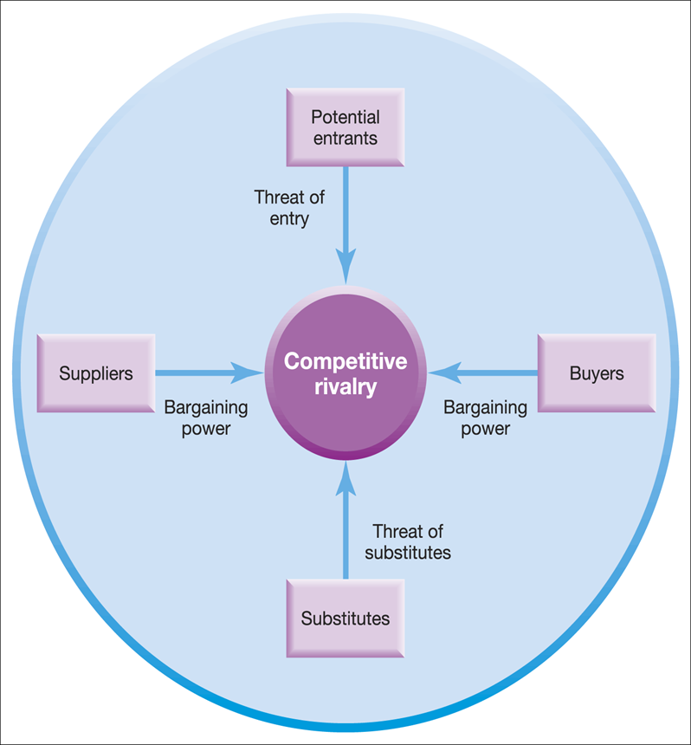

The five forces framework:

This tool will help support any strategy direction in the Fujifilm group and can provide in the mapping of various forces in the healthcare landscape, in not just in the local business environment but also international marketplaces.

As stated by Fujifilm Holdings Corp. 2018. The Porter Five Forces that determine the industry structure in Medical Equipment & Supplies are: 1. Bargaining power of suppliers in Medical Equipment & Supplies – If suppliers have strong bargaining power then they will extract higher price from the Fujifilm Holdings Corp.. It will impact the potential of Fujifilm Holdings Corp. to maintain above average profits in Medical Equipment & Supplies industry. 2. Threat of substitute products and services in Medical Equipment & Supplies sector – If the threat of substitute is high then Fujifilm Holdings Corp. has to either continuously invest into R&D or it risks losing out to disruptors in the industry. 3. Rivalry among existing players in Medical Equipment & Supplies industry – If competition is intense then it becomes difficult for existing players such as Fujifilm Holdings Corp. to earn sustainable profits.

4. Bargaining power of buyers of Fujifilm Holdings Corp. and Healthcare sector – If the buyers have strong bargaining power then they usually tend to drive price down thus limiting the potential of the Fujifilm Holdings Corp. to earn sustainable profits

5. Threat of new entrants in Medical Equipment & Supplies industry – if there is strong threat of new entrants in the Medical Equipment & Supplies industry then current players will be willing to earn lower profits to reduce the threats from new players.

To create increased levels of profit, the organisation will need to have a sustainable competitive advantage, this will need to include areas Fujifilm can develop and identify to map the five forces and ensure correct positioning. This can lead to the development of strategy toward cost leadership, due to its international purchasing and resource scale proposals an option to become a low-cost producer of equipment with opportunities to drive further investment into innovation and discovery. This can then lean toward the creating and suitability of suppling highly valued products charged at a premium rate due to innovations included in the product categories and the perceived values these bring. This presents the strategic direction to focus on quality and development as apposed to cost elements where consumers benchmark against what an identical product cost. Buy driving the value, innovation and development supports the higher premium product and gives consumers forward-thinking cutting-edge devices.

This provides two different strategy options for Fujifilm, this first being to differentiate itself from the competition though innovation and development, and the second being to focus on how it can provide an overriding cost advantage and grow its business through low-cost product offerings. The challenge with option two is when as an organisation you enter a market based on price the price of the product always goes down as the competition is forced to alter its pricing to gain or retain market share. Option one presents an opportunity to grow the organisation on value and innovations which could be considered a more sustainable growth strategy than focusing on low-cost products alone.

Discussion

Further discussion and investigation are needed to establish the parameters around the entire group and overedging directions to take. With such a large entity operating in so many different environmental markets it is suggested that multiple approaches would need to take place. Although consideration would need to be made between the focal points of a cost model and a quality model, and the economic considerations used for market adoption. This may then help the organization focus across the two areas and give flexibility in all markets to quickly adapt the model to help retain and build market share whilst also have the presence and capability of transforming into a premium innovation-based organisation. Further discussions toward the environmental impacts to the models adopted together with the need to show sustainability and environmental responsibilities in the regions and countries adopted. The challenge for the organisation is not to be made a pariah in certain markets due to its environmental policies, as by not adopting a universal approach could render the organisation open to criticism on the world stage.

Conclusion

In conclusion Fujifilm has established its organisation as a well-known brand and holds a reputation for quality derived from in inception in the photographic business, the organisation has developed and diversified strongly in the marketplace creating many avenues of business practices and driving its branded message through the world. As the organisation considers the changing environment more focus should be taken toward a universal approach, by still ensuring the legalities of each global areas are adhered to but buy ensuring as many areas of the business are conducting their environmental responsibilities in a universal way, this will drive the adoption of new technologies in less established regions and also support the brand awareness through community projects, in turn developing the reputation of the organisation putting it in a stronger position to deliver increased operational effectiveness and results

Recommendations

It is recommended that the universal adoption to environmental policies is adhered to ensure and increase a well-respected organisation shown to be fully adopting it global responsibilities and supporting community development. Considerations to multiple strategies dependant on the adoption cycle in different country regions to promote tailored growth plans and strategies that ensure local knowledge is being utilised and adhered to. The development and creation of social sectors through multimedia and platforms with the introduction of targeted deployment marketing strategies that can be managed through the return-on-investment purpose but also creating the messaging and content for the future. Key to the ongoing success of the organisation will be its continued ability to engage and fully understand local markets, ensuring focus is given to those environmental conditions and that a global focus does not consume or override the needs of individual locations. This model would show adoption of local regional operators focusing of promoting the Fujifilm direction in a manner that suits with the social demographic of the consumers groups, whilst presenting the environmental messaging and focus required by any local government and law. The organisation also has an opportunity to increase its worldwide presence by utilising and developing an implementation on a worldwide environmental strategy, focusing on resource reduction through the management and recyclability of products, further increasing the overall image of the organisation but also ensuring each of their businesses have a focus on the community macro level by supporting the needs of local business units and governmental directions.

Document brief 5000 words: Word Count 4866
(Excluding: Header Page, Contents, Executive summary Appendix and References)
- Reference: 16

Ackermann F 2010
Strategic Management of Stakeholders: Theory and Practice
Accessed 2nd June 2022
Available at: https://doi.org/10.1016/j.lrp.2010.08.001

History of Fujifilm: How Fujifilm Transformed and Survived
Joe Pfeffer
May 12, 2021
Updated On : April 17, 2022
History of Fujifilm: How Fujifilm Transformed and Survived - Tech Inspection

PESTLE Analysis Explained (With Examples)
MAY 23, 2019 BY THOMAS BUSH
PESTLE Analysis Explained (With Examples)

Macroeconomics
The study of the aggregate economy
Written by CFI Team
Updated December 1, 2022
Macroeconomics - Overview, Goals, Economic Indicators (corporatefinanceinstitute.com)

IG Group Holdings Plc. 2022

What are the key macroeconomic indicators to watch?
What Are the Key Macroeconomic Indicators? | IG International

PESTLE - Environmental
2022 BBC
PESTLE - Environmental - Critical thinking and problem solving - WBQ National: Foundation KS4 Revision - BBC Bitesize

Cultivate Critical Evaluation with a PESTLE Analysis
Deepen your evaluative skills by scanning the political, economic, social, technological, legal and environmental dimensions in which your company operates.
By Jennifer Currence, SHRM-SCPMay 22, 2018
Cultivate Critical Evaluation with a PESTLE Analysis (shrm.org)

Account learning .com 2022

Advantages and Disadvantages of Business Environment Analysis
Advantages and Disadvantages of Business Environment Analysis (accountlearning.com)

2015 BY PESTLEANALYSIS CONTRIBUTOR
PESTLE ANALYSIS
SWOT AND BUSINESS ANALYSIS TOOLS
Best Analytical Tools for Business Analysis (pestleanalysis.com)

Microsoft Power BI 2022

Share insights. Show results. Be the hero.

Build rich reports and share Insights that drive results | Power BI (microsoft.com)

What Is Macro Environment?

Written by True Tamplin, BSc, CEPF®
Updated on September 12, 2022
Macro Environment | Definition | Factors | Finance Strategists

Aithal, P. S. (2017). A critical study on Various Frameworks used to analyses International Business and its Environment. International Journal of Applied Engineering and Management Letters (IJAEML), 1(2), 78-97.
Grünig, R., & Morschett, D. (2017). Developing international strategies. Springer Berlin Heidelberg.
Leyva, M., Hechavarria, J., Batista, N., Alarcon, J. A., & Gomez, o. (2018). A framework for PEST analysis based on fuzzy decision maps. Revista ESPACIOS, 39(16).

-----------------------------------------------------------------------------------------------------------
References for Fujifilm Holdings Corp. Porter 5 Forces
Fujifilm Holdings Corp. (2018), Annual Statement of Fujifilm Holdings Corp. .

M. E. Porter, Competitive Strategy(New York: Free Press, 1980)

O. E. Williamson, Markets and Hierarchies(New York: Free Press, 1975)
[2022] Solved: Fujifilm Holdings Corp. Porter Five(5) Forces Analysis (embapro.com)

- Appendix
- André Cavalcante, S. (2013). Understanding the impact of technology on firms’ business models. European Journal of Innovation Management, 16(3), 285-300.
- Daidj, N. (Ed.). (2014). Developing strategic business models and competitive advantage in the digital sector. IGI Global.
- Hou, J., Lu, Q., & Han, Y. (2008, December). A strategic framework for technology evaluation. In 2008 International Conference on Information Management, Innovation Management and Industrial Engineering (Vol. 1, pp. 24-27). IEEE.
- Issa, T., Chang, V., & Issa, T. (2010). Sustainable business strategies and PESTEL framework. GSTF International Journal on Computing, 1(1), 73-80.
- Johnson, G., Whittington, R., Scholes, K., Angwin, D., & Regnér, P. (2011). Exploring strategy. Financial Times Prentice Hall.
- Wall, S., Minocha, S., & Rees, B. (2009). International business. Pearson Education.
- Yüksel, I. (2012). Developing a multi-criteria decision making model for PESTEL analysis. International Journal of Business and Management, 7(24), 52.

