  Component One:  What are the key skills required when working in the housekeeping team? 750 words (+/- 10%)  Contribution to Overall Module Assessment: 25% | Student No: | 2120134
 | Module Title: | Operating Hotel Facilities Autumn Term 2023
 | Module Code: | BMIH4006
 | Lecturer: | Natalie Brailsford  Dan Payne  Neil Dyer,  Muhammad Cassamo  Scott James
My readings, research and experience of working in the Travelodge hotel’s housekeeping team has helped me to realize that the following qualifications and skills are necessary to work in hospitality industry.
Persistence and determination.
- The ability to use initiative.
- Patience and the ability to remain calm in stressful situations.
- To be thorough and pay attention to detail.
- To be flexible and open to change.
- Customer service skills.
- Knowledge of human resources and employment law.
- Business management skills. (wiki How, n.d.)

According to (indeed, 2020), A hotel housekeeper must have excellent communication and organizational skills, strong interpersonal and problem-solving abilities and should be highly responsible & reliable. A hotel housekeeper also should have the ability to work cohesively as part of a team. (INTERPERSONAL SKILLS AT WORK, n.d.).
So to improve skills and to enhance experience, I believe, an employee should follow a model of reflection in work place.
Models of reflection are models which help us to engage in the process of reflection. (Canterbury Christ Church University, n.d.). There are different models of reflective practices used in work places to help to reflect on an employee’s skills, experience and link to theoretical principles. Such as Kolb’s Learning Cycle 1984, Gibbs’s Reflective Model and Donald Schön’s Model of Analytical Reflection.
After learning about different types of reflective models, I have chosen Kolb’’s model because I agree with Kolb’s theory that ‘learners must pass through four distinct stages and experience alone does not provide a sufficient learning experience in many situations. (Kolb et al., 1999).
Kolb described the four stages of his model namely ‘cycle of experiential learning’ as per the following diagram.
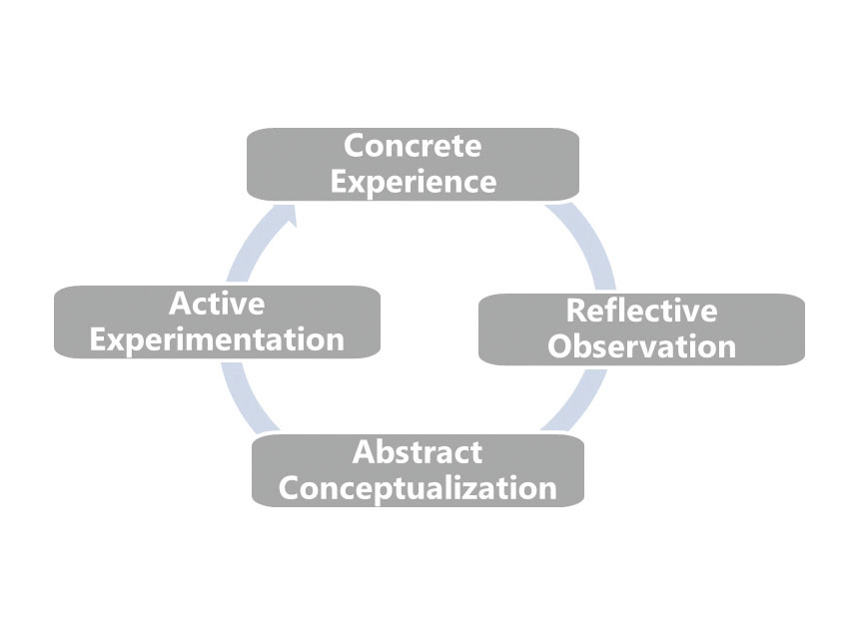
(The Training Thinking, 2015)

The first stage of Kolb’s reflective model is Concrete Experience. This model relates to our everyday experiences, whether they occur in professional, personal or educational settings (Cress et al, 2013).

My concrete experience is my day to day duties in my job with my hotel colleagues. As a member of the hotel’s housekeeping team, every day I’m learning something. By utilizing my quick learning ability, I’m improving my dealing with hotel customers in a professional manner and being friendly. My daily experience of working as a part of a team is also making me a better team player. I also view these concrete experiences as learning opportunities for my team members. That is why, I as a team manager, try to help my colleagues to see their own concrete experiences as valuable chances for their professional and personal development.

Reflective Observation is the second component of Kolb’s model of reflection. It naturally occurs after facing new experiences. It is important for managers to consistently reflect upon their experiences and adjust their approaches for solving new challenges and making critical organizational decisions (McLeod, 2013).

Here I can share my experience. Once one of my housekeeping team failed to clean the hotel room to expected standard. I as her line manager, instead of criticizing her, reflected on her previous success and encouraged her to do her best. That worked well. I found that experience motivating and humbling.

Kolb’s next step is Abstract Conceptualization. It takes the reflective process a step further by focusing on channelling reflective observations into a set game plan or theoretical approach (Brown, 2015).

For example, once I had a negative experience communicating with one of my colleagues. When I suggested ways for his professional improvement, he did not respond well. So I thought he was not easily approachable. But through consistent positive interactions, I realised that he responds better to different approaches. From that experience, I learned to reflect upon my assumptions and work out better strategies for self and others by observing their response. That also helped me to understand that, ideas are not permanent, instead should be constantly revaluated, revised and tested at conceptualizing stage.

So from my learnt experience, I now practice new approaches, tactics and more effective interactions with my team members to maximize their job outcome and learning potential.

Active Experimentation is the fourth component of Kolb’s model of reflection which deals with the process of testing existing ideas by creating new experiences (coachfoundation.com, 2023).

In my workplace, I use the active experimentation process and get hugely benefited. In the abstract stage, I learn theories based on observations in the reflective stage, and then I put those theories into practice in active stage.

In the process, I have learnt that, this stage of experiential learning is related to the concept of scientific experimentation, in which an individual forms a hypothesis based on existing ideas and tests the validity of these ideas in a structured experiment.

That is why in my managerial role, I try to use all available tools and resources to make effective decisions and carry forth action.

Word Count | 798

References:
Brown, N. (2015). Reflective Model according to Kolb. [online] Dr Nicole Brown. Available at: https://www.nicole-brown.co.uk/reflective-model-according-to-kolb/.
Canterbury Christ Church University. (n.d.). Models for reflection. [online] Available at: https://www.canterbury.ac.uk/learning-skills-hub/introduction-to-reflection/models-of-reflection.
coachfoundation.com. (2023). Understanding Kolb’s Cycle Of Learning [Guide For 2023]. [online] Available at: https://coachfoundation.com/blog/kolbs-cycle-of-learning/.
indeed (2020). Guide to Housekeeping Skills (With Tips and Examples) | Indeed.com. [online] www.indeed.com. Available at: https://www.indeed.com/career-advice/career-development/housekeeping-skills
INTERPERSONAL SKILLS AT WORK. (n.d.). Available at: https://www.hzu.edu.in/uploads/2020/9/Interpersonal%20Skills%20at%20Work.pdf
Kolb, D., Boyatzis, R., Mainemelis, C., Sternberg, R. and Zhang, L. (1999). Experiential Learning Theory: Previous Research and New Directions. [online] Available at: https://learningfromexperience.com/downloads/research-library/experiential-learning-theory.pdf
Liston, K. (2021). 3 Employee Engagement Models for a Happier, More Profitable Workplace. [online] ContactMonkey. Available at: https://www.contactmonkey.com/blog/employee-engagement-models.
McLeod, S. A. (2013). Kolb - Learning Styles. Retrieved from www.simplypsychology.org/learning-kolb.html
setupmyhotel.com. (n.d.). Types of Room Cleaning Chemicals / Taski Cleaning Agents (R1 to R9) | Housekeeping. [online] Available at: https://setupmyhotel.com/train-my-hotel-staff/hk/457-taski-chemicals.html.
The Training Thinking (2015). The Training Thinking | The Four Stage Learning Cycle by David Kolb. [online] Thetrainingthinking.com. Available at: https://thetrainingthinking.com/en/the-four-stage-learning-cycle-by-david-kolb/.
Travelodge (2020). Our company - Travelodge. [online] Travelodge. Available at: https://www.travelodge.co.uk/about/our-company/.
wikiHow. (n.d.). 15 Basic Skills You Need to Be a Good Housekeeper. [online] Available at: https://www.wikihow.com/What-Basic-Skills-Do-You-Need-to-Be-a-Good-Housekeeper.
www.custominsight.com. (n.d.). What are the Key Principles of Employee Engagement? [online] Available at: https://www.custominsight.com/blog/what-are-key-principles-of-employee-engagement.asp [Accessed 31 Oct. 2023].
www.leapsome.com. (n.d.). 6 Employee Engagement Models for a Thriving Workplace. [online] Available at: https://www.leapsome.com/blog/employee-engagement-models.
www.rubbermaidcommercial.com.au. (n.d.). 7 safe housekeeping practices brands should follow. [online] Available at: https://www.rubbermaidcommercial.com.au/blog/hospitality/7-safe-housekeeping-practices-hospitality-brands-should-follow/.
www.tripadvisor.co.uk. (n.d.). THE 10 BEST Clean Hotels in England 2023 (Prices) - Tripadvisor. [online] Available at: https://www.tripadvisor.co.uk/HotelsList-England-Clean-Hotels-zfp14895483.html

Component Two:

Daily Room Cleaning Checklist for the Hotel Housekeeping Team
Date:
Tasks | Completed? Yes / No | Initial/Signature of staff completed the task.
Bedroom cleaning
Open the windows and doors to allow damp air out and fresh air in to the room
Check the functionalities thermostat, air conditioner, fans etc.
Check and replace any flickering or burnt out bulbs
Test the drapes to make sure they slide easily
Check the walls and ceilings for dust or cobwebs
Dust all appliances, fixtures, and furniture
Wipe and clean mirrors and glass surfaces
Wipe down the telephone set, TV screen etc.
Check if closet has hangers and luggage racks
Empty dirty bins and put in new bin bags
Hoover on the carpet with vacuum cleaner
Spray air freshener to deodorize the room
Change bed, duvet and pillow covers.
Kitchen cleaning
Clean the kettle and/or coffee maker in the room
Remove any dirty dishes and bowls left on the sink.
Check the refrigerator for any items left behind by previous guests. Clean inside and outside.
Clean the microwave
Bathroom cleaning
Remove any used towels, put fresh towels
Check for water leaks or drips in bathroom
Clean and wipe shower and bathtub.
Clean the toilet bowl with bleach and toilet cleaners
Clean and sanitize the toilet seat, lid, and handle with anti bacterial spray
Clean mirrors and bathroom shelves
Clean the vanity top and sink
Mop the floor and grout with anti bacterial cleaners
Check bathroom for any stray hairs and remove.
Remove trash bins and fit with new bin bags
Freshen up bathroom air with air freshener
- Keep enough tissues and toilet paper in bathroom

Answers of the questions based on my completed room cleaning checklist:

I will ensure in systematic ways that our hotel rooms are cleaned to uphold our brand standards.
As our hotel has received few complaints, it is absolutely vital for us to work hard to keep our hotel brand at the top of the review list. It is very important for the housekeeping team to follow the room cleaning checklist I have made. We must ensure that the requirements in the checklist are met. We have to clean the hotel thoroughly from top to bottom to absolute details by ticking the checklist.
As we have received some complaints about our toilet and bath, we need to deep clean bathrooms on a daily basis. Also one guest mentioned about a dirty bed was provided when he stayed. So we need to change hotel’s bed covers, duvet covers, pillow covers etc on a daily basis.
To obtain and sustain our brand standard, we can get some inspiration from the statement that, ‘housekeeping should be more than a one-time initiative – it should continue through monitoring and auditing. Keep records; maintain a regular walk-through inspection schedule, report hazards and train employees to help sustain housekeeping. Set goals and expectations, and base auditing on those goals.’ (Gillian, 2019).

I would introduce different measures to improve our team effectiveness.
Based on my learnt knowledge and job experience, I believe that team effectiveness is an important factor for a good outcome of a team work. As the housekeeping team of a hotel is an important element of hospitality industry, I would introduce some drastic measures to improve our team’s effectiveness.
I would put huge emphasis on training of our housekeeping team members.
I would plan and organize monthly training sessions to improve our team effectiveness. Because I agree with the statement that, ‘Investment in training has incredible returns. Not only does training support developing skills, but it also shows employees that they are valuable’. (Herrity, 2023)
I will set targets for the team members. I will keep checking to measure that if the team members are working effectively to reach their targets. If they can reach their goals, I will provide incentive for their excellent performance because I have learnt that incentive ‘encourages better performance in service of the company's stated business goals. (Indeed Career Guide, n.d.)
Another important aspect of a team is friendly relation between members because ‘strong friendships with team can strengthen team spirit and grow workplace satisfaction’ (Katr, 2018).
That’s why I will facilitate excellent internal communication. I will hold daily morning briefings and weekly meetings. I will make sure that our team meetings are time efficient and productive. I will also observe how our team members are working individually and how they are working together. I will encourage my team colleagues for continuous Improvement.
I would consider my check list to be the most effective because it can act as our guide about what tasks need to be done and the order they should be completed to reduce mistakes and errors in the process and get the best possible results. I also think my checklist is efficient, to the point, and easy to use even in the most difficult situations because matches with this expert opinion that, ‘Great checklists only provide the information that is actually needed (blog.falcony.io, n.d.)
(546 words)

References:
blog.falcony.io. (n.d.). 5 Tips for Creating Great Checklists. [online] Available at: https://blog.falcony.io/en/tips-for-great-checklists.
Gillian (2019). 11 Tips for Effective Workplace Housekeeping. [online] www.ecoonline.com. Available at: https://www.ecoonline.com/blog/11-tips-for-effective-workplace-housekeeping.
Herrity, J. (2023). The importance of training employees: 11 benefits. [online] Indeed. Available at: https://www.indeed.com/career-advice/career-development/importance-of-training.
Indeed Career Guide. (n.d.). 11 Incentive Program Benefits for the Workplace (With Tips). [online] Available at: https://www.indeed.com/career-advice/career-development/incentive-program-benefits.
Katr, S. (2018). Friendly Leadership in Modern Teamwork. [online] www.theseus.fi. Available at: https://www.theseus.fi/handle/10024/151392 [Accessed 20 Nov. 2023].

