The recognition of faces following a distractor task

Abstract
This report reviews the own race bias concept on the recognition of faces. Data was considered from two separate journal articles in an attempt to form a hypothesis. The false alarm theory (Meissner and Brigham, 2001) was considered when analysing participant’s responses to facial recognition following a distractor. Further to this a previous study looking into own race bias from a low contact with other ethnicity perspective (Chiroro and Valentine, 1995), also influenced the hypothesis for this study. Due to the results from previous studies, it was expected that own race bias would be found. A paired sample T-test, testing facial recognition of black and white faces following a distractor was used to analyse the responses of twenty-nine white university students. Results showed a higher recall score for black faces and therefore the initial hypothesis was rejected. Study limitations and further research considerations are discussed.

Introduction
This report will review whether humans have a tendency to more accurately recall or identify faces that are more familiar with their own race. According to Valentine (1991), the race of someone’s face can influence an observer’s ability to recall the same face after a period of time. A study on false alarm responses carried out by Meissner and Brigham(2001) considers the effect that own race bias has when establishing the ability to identify someone after a period of time. More extensive research in this area followed the case of five black men being falsely accused of committing a murder in 1971. The only evidence presented was eyewitness accounts from five white men (Meissner and Brigham, 2001). Although the men were later acquitted it is believed that the five white men could not correctly recall the accused due to the inability to remember the characteristics of those of a different race after a period of time. Furthermore when Meissner and Brigham (2001) tested this theory they found that participants were 1.56 times more likely to falsely identify someone of a different race when compared to someone of their own race.
Additionally, a hypothesis Proposed by Chiroro and Valentine (1995), that own race bias is the result of none or very little contact with those of another, less familiar race. Though, research conducted in this field did show significant results when carried out on a group of white children living in a segregated area, with participants recalling more white faces than black when having low-contact (Mean score 5.35 for black faces and 6.94 for white faces) (Cross, Cross and Davey, 1971 As cited in Chiroro and Valentine, 1995), similar differences were not seen when conducted on black children living in similar areas(mean score 5.52 for black faces and 5.23 for white faces)(Cross et al, 1971, As cited in Chiroro and Valentine, 1995).
Due to the extensive research in these areas, all showing significant results when considering own race bias, this study has been put together to test the recognition of faces following a distractor task on a group of twenty-nine white university students in an attempt to identify whether they will recall six white faces better than the six black faces presented within the task. In accordance with the studies discussed it would be expected that this study would see similar results.
Method
Participants
Participants included in this study were a group of twenty-nine first year Psychology and counselling students at The University of Wales, Trinity St David, Swansea (7 males, 22 females)(Appendix A). Participants were recruited during a research methods module seminar workshop. Participants ranged in ages from 18-60 (mean age=27.32, SD=10.81).
Design
A within-subject, paired sample T-test was used for this study. The independent variable included is race/ethnicity and contains two conditions; these were black and white faces. The dependant variables used were the number of faces recalled correctly.
Materials
A PowerPoint was used to create an on-screen presentation. This consisted of twelve faces (six black/six white) shown on individual slides for part one. Part two included slides of six faces, totalling thirty-six (eighteen males and eighteen females)(Appendix B). A recall sheet was presented for students to complete to collect demographic data with a space for participants to report their responses (Appendix C)
Procedure
Participants were first handed a consent form to read and sign if they were happy to take part in the study (Appendix D). Participants were then instructed to watch the screen and follow the additional instructions presented. At this time, participants were asked to be silent as this was a group setting and silence would maximize accuracy. Following this a countdown, from three to one, appeared on-screen to begin part one of the study. For part one of this study, participants were shown twelve slides containing a black or white face on each for two seconds per slides.
Following this, a distractor was introduced; this was in the form of the lecturer discussing information verbally for one minute before part two commenced. Moreover, the participants were again asked to remain silent and instructed to watch the screen and follow the instructions presented for part two of the study. This is where thirty-six faces were shown in groups of six on each slide. Participants were asked to recall the twelve faces they had seen in part one and write their responses on the recall sheet.
To conclude the study, a debrief form was shown on screen, visible to all participants within the group (Appendix E).
Results
A within-subject, paired sample T-test was conducted to analyse whether participants were able to recall more white faces than black faces following a distractor. Results determined that participants recalled more black faces (M = 3.34, SD = 2.42) than white faces (M = 2.67, SD = 1.97); t (28) = 3.120, p < .05. (See Appendix F for full calculation). The initial hypothesis for this study was that participants would recall more white faces and therefore must be rejected.
Discussion
The main objective of this study was to test an initial hypothesis on the recognition of faces following a distractor task to seek further knowledge into own-race bias. After examining Meissner and Brigham (2001) study on false alarm responses and Chiroro and Valentine (1995) report on their contact hypothesis, it was predicted that the twenty-nine white participants would be more likely to correctly recall more of the white faces presented to them than the black faces. However, after having tested this theory, results were able to show that this hypothesis must be rejected. The results from this study found that participants did not show own-race bias as they scored higher when recalling black faces (M = 3.34, SD = 2.42) than when recalling white faces (M = 2.67, SD = 1.97).
Undoubtedly, there were significant limitations when undergoing this study and further research should be considered. For instance, results may be inexact due to this particular study taking place in a group setting in a large, open environment. Alternatives to gain more accurate results would include an individual study conducted in a small private lab environment. Furthermore other limitations included the number of participants taking part, due to the small sample size it is not possible to generalise, future studies should include a larger sample size.
Further to this study, additional research should be applied to test the low and high contact hypothesis. It should be noted that whilst this study considered the recognition of faces from white participants with little contact with different ethnic groups, a comparison could not be made and so, it can not presume to have similar results if participants were all of mixed ethnicity. Along with this, to gain a better understanding of the false alarm response hypothesis, research should include a longer delay between tasks to allow for more a more accurate account of a potential real life scenario.
There is, however, a further point to be considered. As this study was seen to show an incorrect prediction when compared to previous studies, this could be due to racial prejudice and not own race bias. It is believed that racial prejudice may account for a poorer ability to correctly recall faces (Chiroro and Valenitne, 1995) and so, further research in this area may include how racial prejudice may influence facial recognition.
References
Chiroro, P., & Valentine, T. (1995). An Investigation of the Contact Hypothesis of the Own-
race Bias in Face Recognition. The Quarterly Journal of Experimental Psychology,
48A(4), 879-894.
Meissner, C. A., & Brigham, J. C. (2001). Thirty Years of Investigating the Own-race Bias in
Memory for Faces. Psychology, Public Policy, and Law, 7(1), 3-35. doi:10.1037//1076-
8971.7.1.3
Valentine, T. (1991). A Unified Account of the Effects of Distinctivness, Inversion, and Race
in Face Recognition. The Quarterly Journal of Experimental Psychology, 43A(2), 161-204.
Appendices
Appendix A
P. Id | Gender | Age | Ethnicity | Correct recall: White | Correct recall: Black | Difference (D) | Difference Squared (D²)
1 | M | 19 | White | 3 | 5
2 | F | 18 | White | 4 | 4
3 | M | 22 | White | 4 | 6
4 | F | 18 | White | 0 | 0
5 | F | 18 | White | 0 | 0
6 | F | 19 | White | 0 | 0
7 | F | 60 | White | 5 | 5
8 | F | 39 | White | 1 | 5
9 | F | 46 | White | 0 | 0
10 | F | 24 | White | 0 | 0
11 | F | 28 | White | 5 | 6
12 | M | 20 | White | 5 | 4
13 | F | 25 | White | 0 | 0
14 | F | 21 | White | 0 | 1
15 | F | 35 | White | 4 | 6
16 | F | 25 | White | 1 | 0
17 | F | 18 | White | 5 | 6
18 | M | 55 | White | 6 | 6
19 | F | 29 | White | 1 | 1
20 | M | 34 | White | 4 | 5
21 | M | 23 | White | 3 | 2
22 | F | 28 | White | 5 | 6
23 | F | 28 | White | 2 | 6
24 | F | 24 | White | 2 | 2
25 | F | 24 | White | 4 | 6
26 | F | 31 | White | 4 | 5
27 | F | 23 | White | 2 | 3
28 | F | 18 | White | 3 | 3
29 | F | 20 | White | 3 | 4

Appendix B
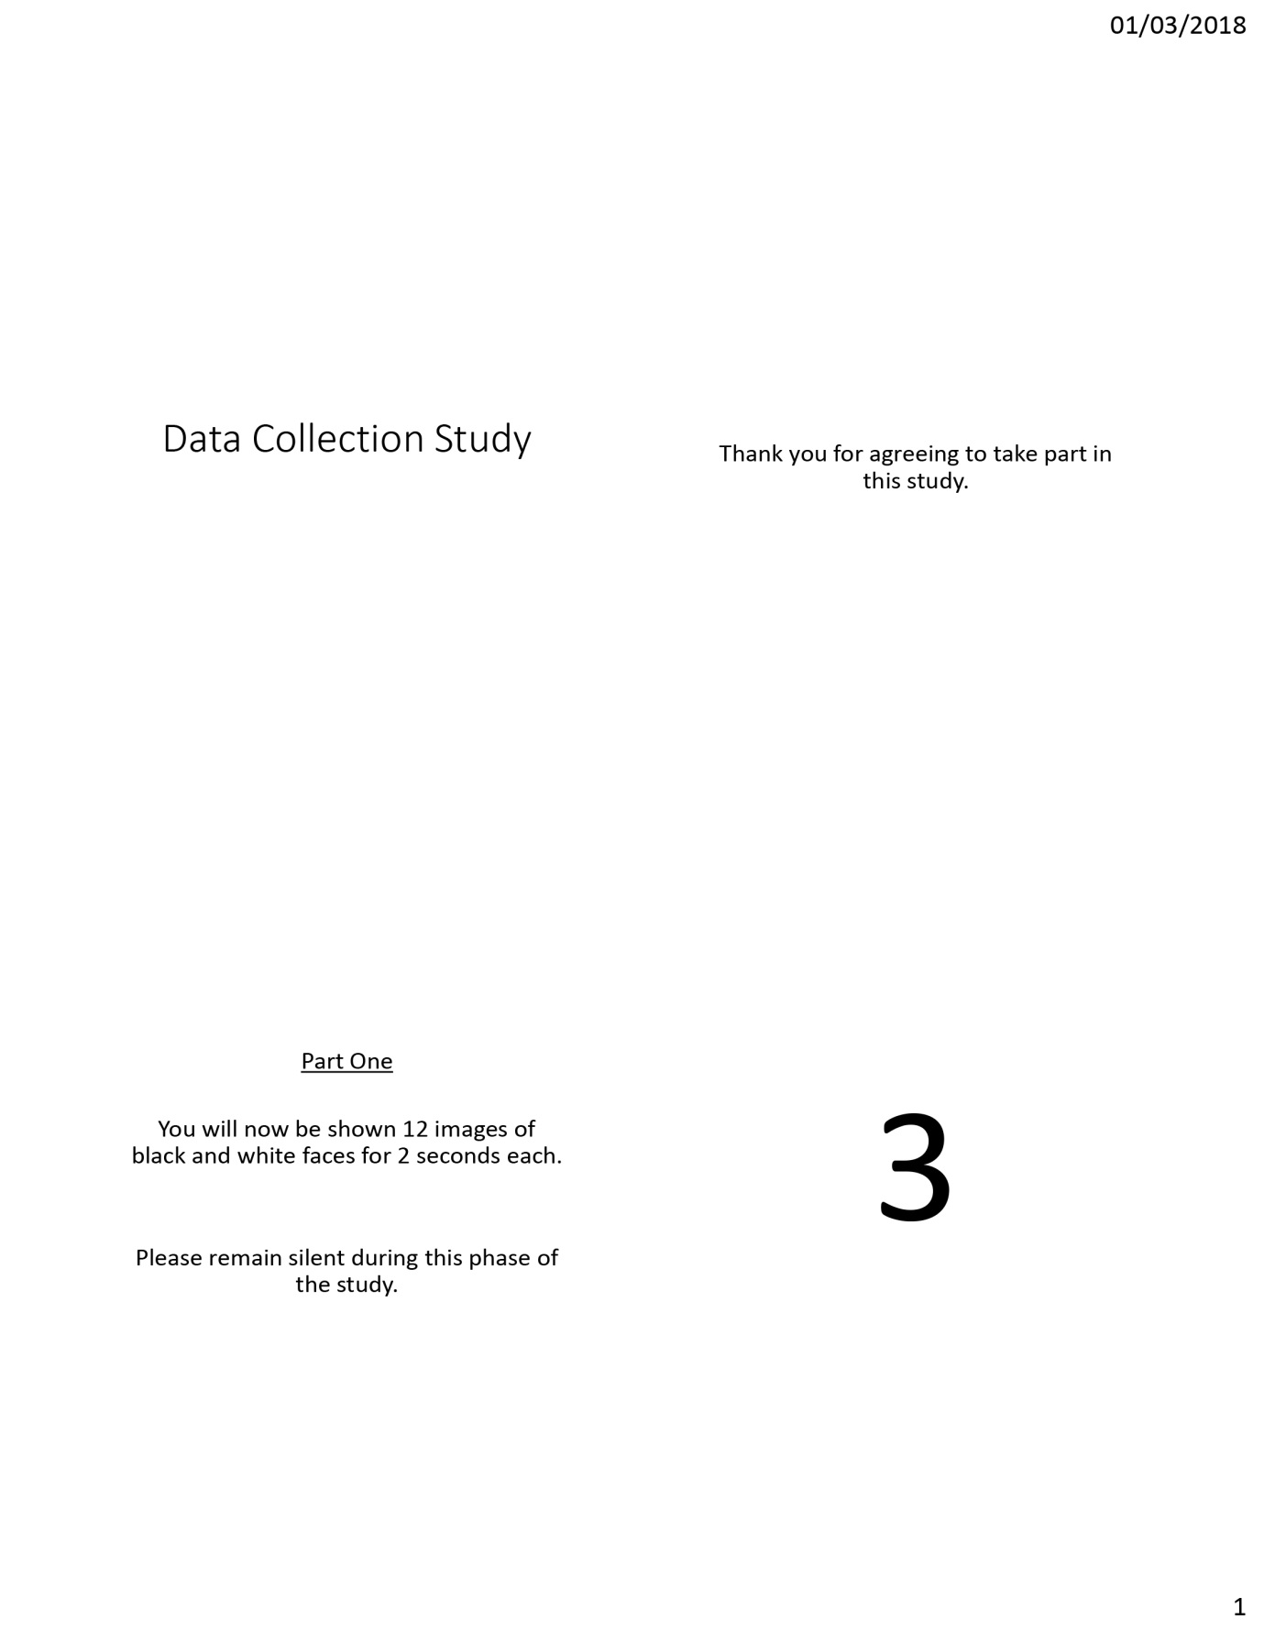
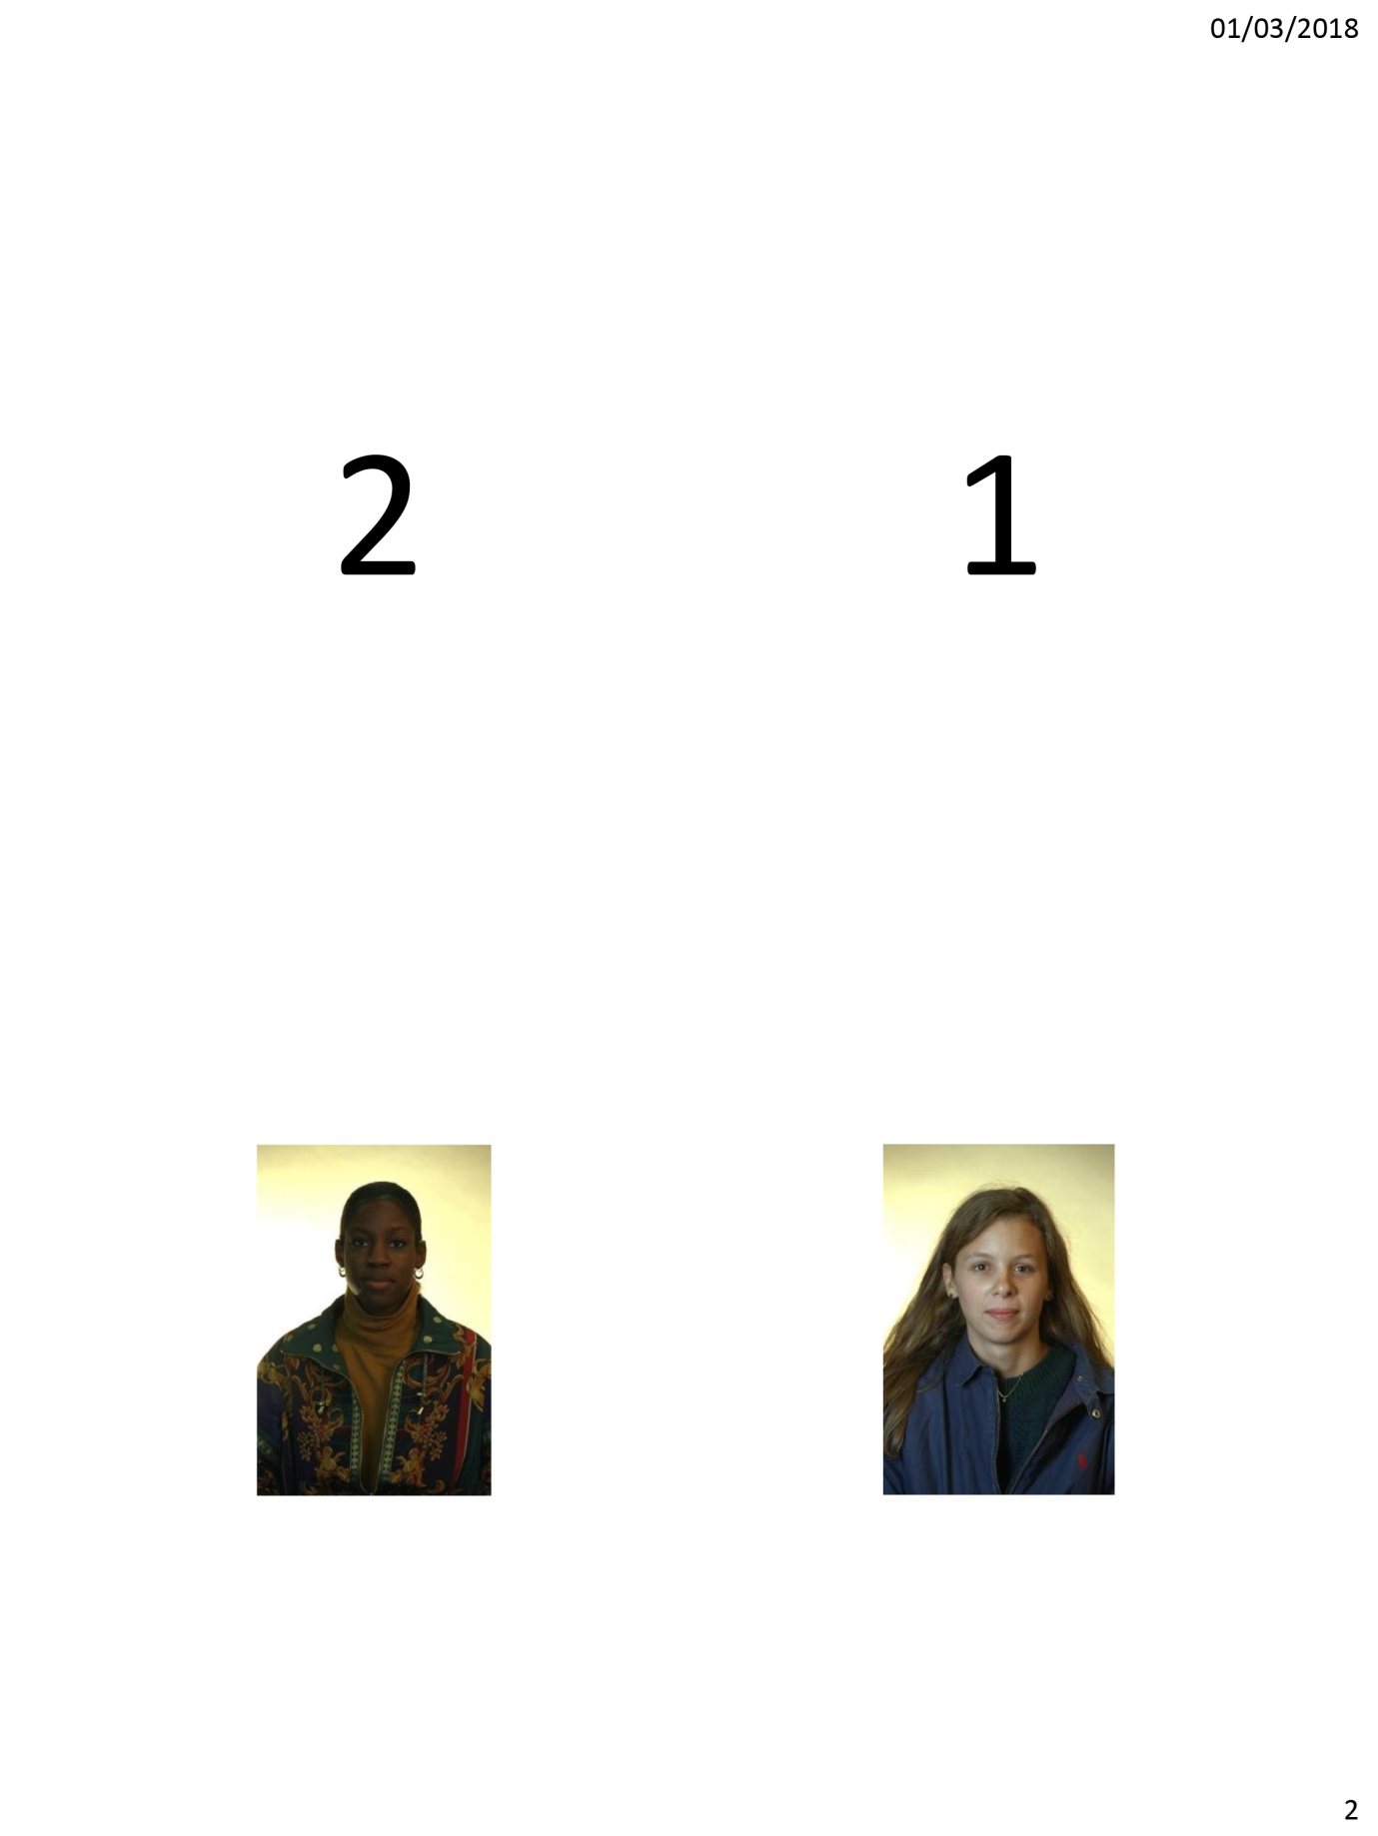
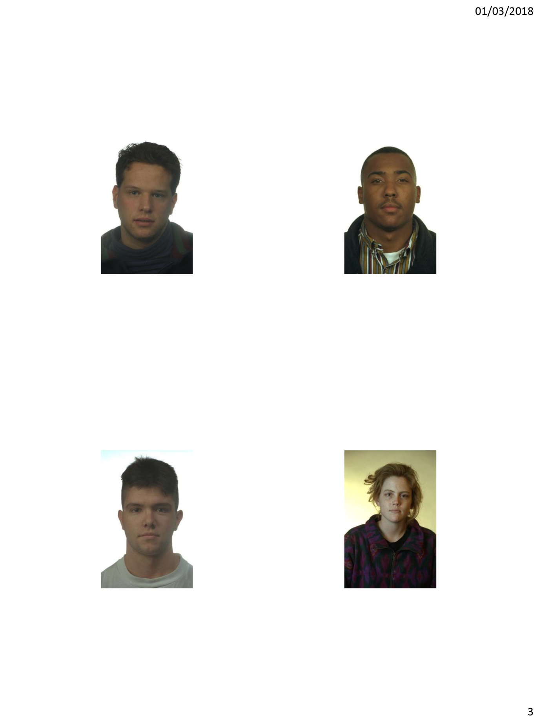
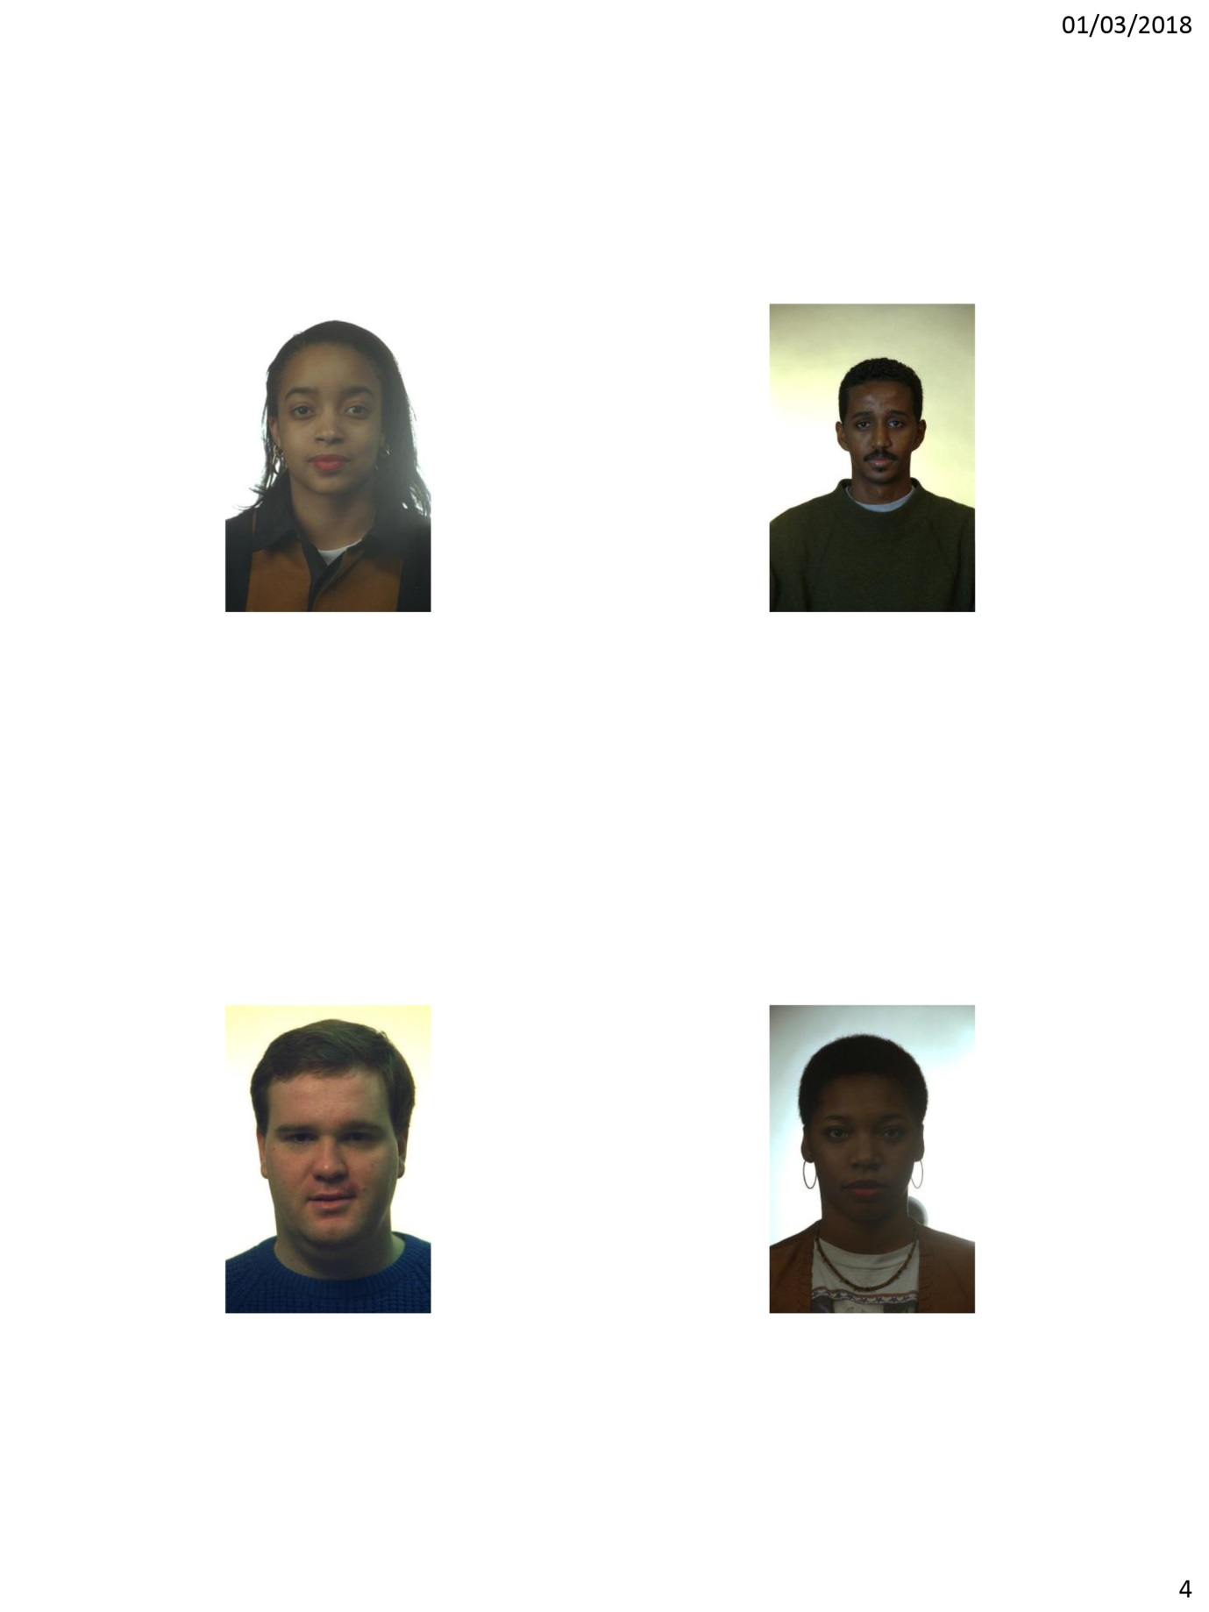
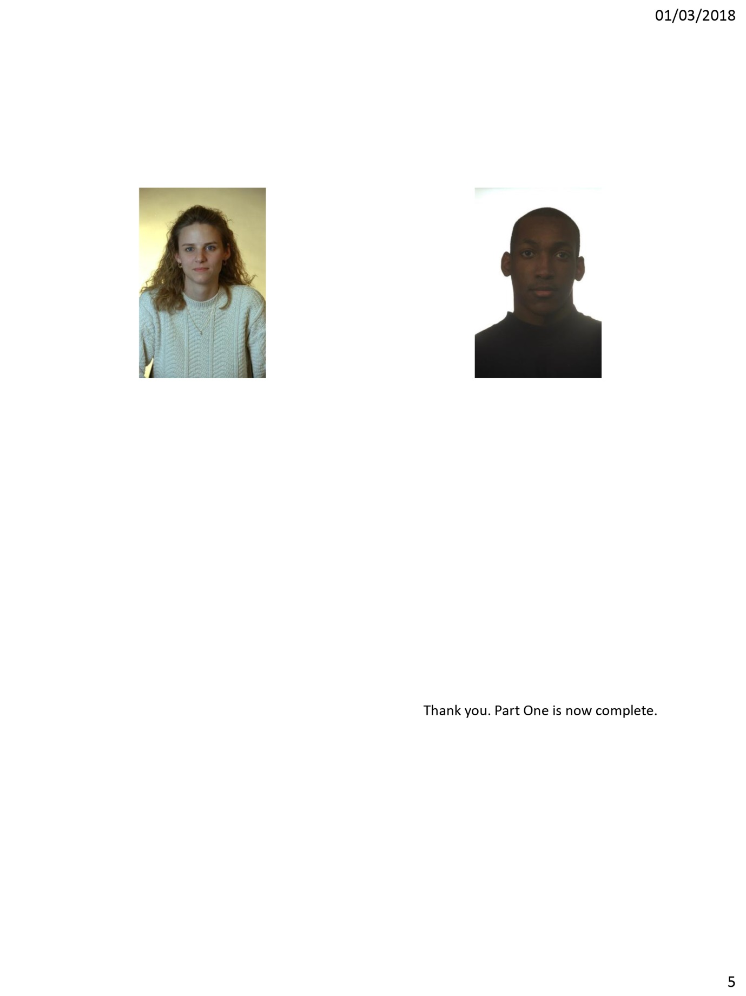
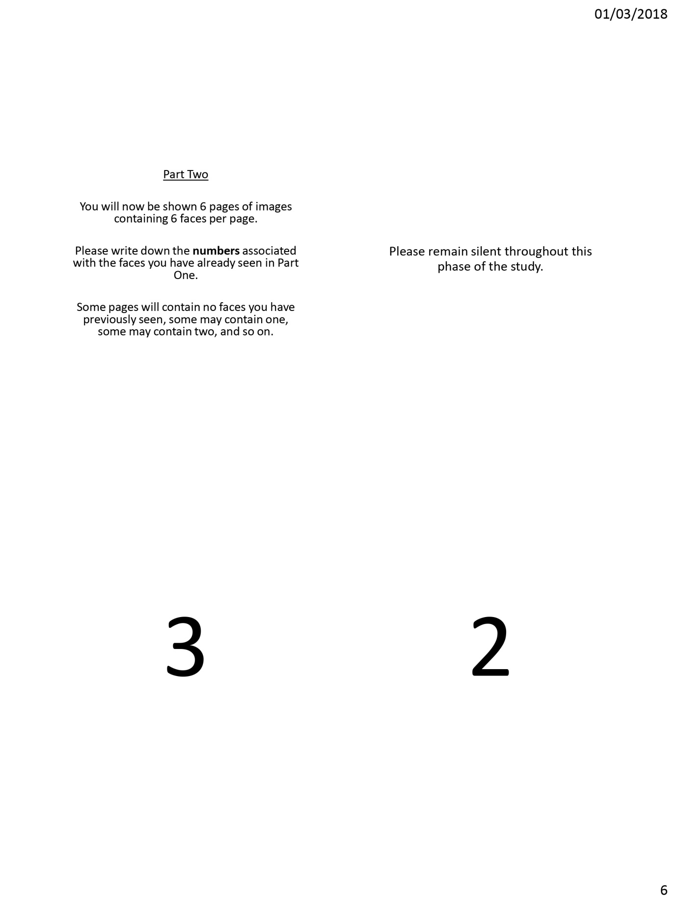
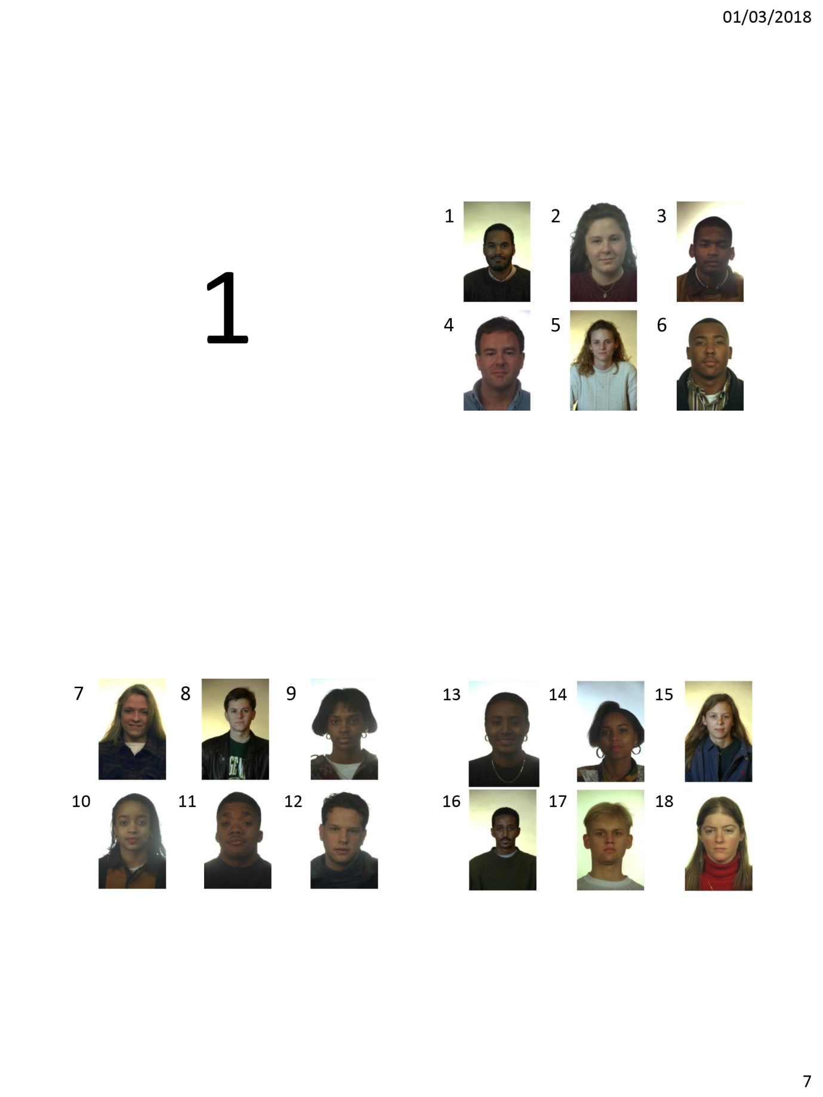
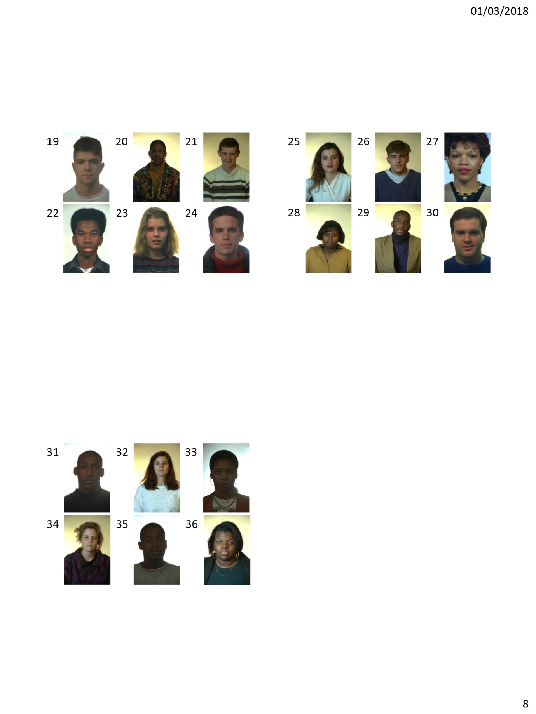

Appendix C
Research Methods Data Collection Study

Please specify your gender:
- Male
- Female
- Other
- Prefer not to say

Please state your age: _______________________________

Please state your ethnicity: ___________________________

Please use the space below to record your responses to Part Two of this study.

Appendix D
School of Psychology
Townhill Campus
Swansea


Study Consent Form

I understand that taking part in this research study will involve me viewing a number of faces and attempting to recall the faces I have already seen.
I understand that this study consists of two parts. Part one will take approximately two minutes and will consists of me viewing a number of faces. For part two, I understand that I need to pay attention to the faces being presented and record which faces were shown in part one.
I understand that participation in this study is entirely voluntary and I am free to withdraw at any time without giving a reason. I am aware that if I have concerns about the study I can discuss these concerns with the researcher at any time during or after the study.
I understand that the information provided by me will be used for the purpose of providing data for analysis, but that this data will be held confidentially and anonymously, with a code assigned in place of my name. These data will be stored in accordance with the Data Protection Act.
I also understand that at the end of the study I will be provided with a debrief form and the opportunity to discuss any issues with the researcher.

I, ___________________________________( NAME) consent to participate in the study conducted by Stacey Coleman, School of Psychology, University of Wales Trinity Saint David, Swansea.

Participant Signature:________________________________________________

Date:___________________

Name and signature of researcher taking consent:
Stacey Coleman

Appendix E
Debrief information

Thank you for taking part in this study.
The main aim of this study was to explore whether people are better able to recall and identify faces that belong to the same ethnicity as them – their ‘in-group’. We specifically hypothesised that participants would be able to recall significantly more faces that belonged to their in-group than their out-group.
If you wish to withdraw your data from the study you must tell the researcher now. After this point, all of your data will remain confidential and we will not trace it back to you.

Appendix F
T test calculations

$\sqrt{\begin{aligned}59-\frac{441²}{29} \\ 28\end{aligned}}$ $\sqrt{\begin{aligned}59-\frac{15.206}{28} \\ \sqrt{29}\end{aligned}}$
>$\sqrt{29}$

$\sqrt{\begin{aligned}43.794 \\ 28\end{aligned}}$ $\sqrt{\begin{aligned}1.564 \\ \sqrt{29}\end{aligned}}$
$\sqrt{29}$

1.250 SE = 0.232 $\sqrt{5.385}$

21 D = 0.232
29

T = 0.724 = 3.120
0.232

