

BA BUSINESS MANAGEMENT
ENTREPRENEURSHIP (LCBB5001)
ASSESSMENT 1

NAME OF LECTURER: Dr John Paul Okeke
STUDENT NAME AND NUMBER: Valentina Georgieva Pencheva - 2023164
WORD COUNT: 2000 Words (+/- 10%)
SUBMISSION DATE: 05.08.2022

Table of Contents
Essay 3
1 Introduction 3
2 Main body 3
2.1 Drivers of the idea 3
2.2 Market research trends 4
3 Conclusion 7
Reflective report 8
Reference list 12

Essay

1 Introduction
The essay explains the business idea and provides rationale for its implementation on the basis of relevant external factors. The actual entrepreneurial idea refers to the production of eco bags made of hemp. This is an innovative product with a potential of fully replacing plastic bags. The hemp-based bags possess a number of attractive features – physical strength, safety, cleanness and others. They are then considered as an innovative product where no pesticides and bleach are necessary in the production process.
The hemp-based bags are beneficial for a variety of stakeholder groups. First, the success of the business idea could benefit the entrepreneur. It may eventually become a worthy business experience delivering personal satisfaction, financial rewards and independence – key drivers for entrepreneurship, as explained by Barringer and Ireland (2019).
Second, the hemp-based bags may completely eliminate the single use plastic bags; thereby, delivering opportunities for cleaner and sustainable communities – a fact benefitting the society as a whole. Consumers also benefit, as the new product may be used for a prolonged period of time and recycled, if necessary. These properties contribute to convenience and may save financial resources over time by avoiding the purchase of single use bags.
Third, the UK government has official policies to achieve zero avoidable waste by year 2050, as well as a complete elimination of avoidable plastic waste by the end of 2042 (Smith, 2022). Therefore, the new product may significantly contribute the stated nationwide objectives; thereby, benefitting authorities and regulators.

2 Main body

2.1 Drivers of the idea
There are several key drivers supporting the implementation of the business idea. To begin with, the scale of the waste problem is quite significant. Approximately 5 million tons of plastic waste is produced in the UK and single use/packaging contributes to half of the waste (Smith, 2022). The severity of the waste issue motivates the development of hemp-based bags – an innovative alternative with a potential for coping with a major ecological and societal issue.
Second, plastic continues to be material with maximum convenience to producer and the lowest costs – key factors explaining its wide-spread use in the UK. All alternatives lack competitiveness and scale of application. In this context, it is an inspiring challenge to deliver new materials which alter the existing unsustainable status-quo. The hemp-based bags could be the breakthrough innovation leading to the complete replacement of single use plastic bags and this vision is quite inspiring.
The third driver stems from the opportunity to foster the process of sustainable development with the newly-proposed product. The introduction and wide-spread application of hemp-based bags could deliver significant long-term benefits for society and humanity as a whole. This is a worthy goal stimulating the entrepreneurial process due to the expected impact magnitude.

2.2 Market research trends
There are also several key findings related to the external environment which provide string rationale for the implementation of the business idea.
The first factor, which is considered in more details, refers to the trends in waste in the UK. The figure below shows the main sources of plastic waste in terms of percentage share (Tiseo, 2020). The attention should be placed on packaging, as this is the most important sources with a share of more than two-thirds (Tiseo, 2020). Hence, effectively coping with the packaging waste, which is mainly made by single use plastic bags, could significantly reduce the total plastic waste. As a result, addressing the current issue of plastic bags for single use and replacing them with more sustainable solutions appears to be well-justified by the evidence.

Figure 1 – Main sources of plastic waste in the UK
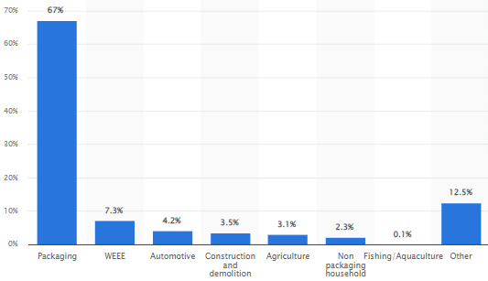
Source: Tiseo (2020)
The external analysis also takes into consideration the trends in recycling – a process which is often considered as panacea to the waste problems in the UK. As of 2020, 1.2 megatons of plastic packaging was recycled in the UK (Smith, 2022). In comparison to year 2000, the volume of the recycled plastic has increased four-fold (Smith, 2022). These findings demonstrate the already achieved progress in the field of waste management.
Nevertheless, there are two main areas of concerns related to the current business idea. First, one should carefully analyse the necessity of producing so much waste at the first place. By implementing hemp-based bags, the amount of plastic packaging waste is likely to dramatically decrease. Second, despite the achieved progress in recycling, any future growth appears to be quite unlikely. The chart below shows the recycling rate in the UK for the last ten years. It is clear that recycling stands at a ceiling of approximately 45%-47% with some variations across regions (UK Government, 2022). The performance trends indicate that recycling, as a solution to the waste problem, has its limitations in terms of application scope. Therefore, it is necessary to reduce the actual waste, rather than relying on recycling only.
Figure 2 – Recycling rates across UK regions (2010-2020)
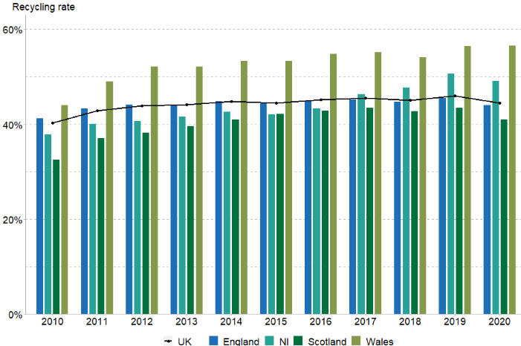
Source: UK Government (2022)
Consumer trends in the UK are also quite favourable. The majority of consumers express sustainable values and behaviours. According to UK Consultancy (2022), more than half of consumers consider sustainability as a part of the purchasing decision. Waste management is also a key area of concerns for consumers, as indicated by the cited survey findings (UK Consultancy, 2022). In addition, young consumers are particularly open to the idea of sustainable development (UK Consultancy, 2022).

Figure 3 – Consumer concerns about sustainability issues
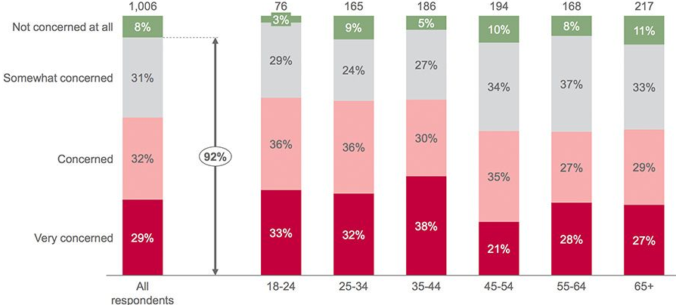
Source: UK Consultancy (2022)
Thus, the popularity of “green” values and pro-environmental attitudes among consumers could be keys to the future success of the newly-proposed hemp-based bags.

3 Conclusion
In the light of the discussed initial research evidence, the proposed product has strong perspectives for commercial use. The wide adoption of hemp-based bags could deliver savings to consumers, enhanced convenience, waste minimisation opportunities and achievement of a more sustainable future. In addition to these key benefits, the pursuit of the idea is explained with the fact that this is an entirely new product without previous history in the UK. This is a seen as a challenge worth being taken as a part of the entrepreneurial process. As a young entrepreneur, personal motivation to accomplish the idea also stems from the fact that many problems have to be solved during the actual implantation process. For example, the UK has legislation banning cannabis products; hence, hemp-based bags must be produced outside of the UK due to the cannabis component and then imported in the country. These are logistical challenges requiring the development of supply chain and distribution channels which contribute to the motivation of solving problems.

Reflective report
This is a reflective report developed on the basis of the personal experience as participant in the module. It is important to structure the reflection instead of being chaotic. Therefore, the Gibbs reflective cycle is applied as a framework. As shown below, the model assumes that reflection is a continuous process (Gibbs, 1988). It is composed of six definite stages – description, feelings, evaluation, analysis, conclusion and action (Gibbs, 1988). Each of these important stages is taken into consideration as a part of the reflective discussion.
Figure 1 – Stages of the Gibbs reflective cycle
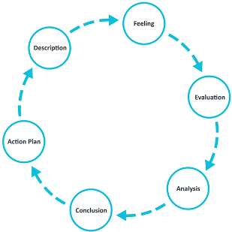
Source: University of Edinburgh (2022)
The primary activities and experiences that comprised the educational module are investigated in the initial description stage of the Gibbs model. In general, the module included a series of continuous classes in the subject of entrepreneurship that included participation from both – the students and the teacher. The activities included not only teaching, but also group discussions and face-to-face exchanges. Important learning resources pertaining to the topic of entrepreneurship were incorporated into the lessons. It was feasible to gain an understanding of the characteristics and abilities needed to establish a profitable company. In addition, an examination of the function that business development plays not just for entrepreneurs, but also for the economy and ordinary people was carried out. Learning activities have resulted in a multitude of outputs, some of which include new abilities, expanded knowledge and improved analytical reasoning. These outcomes are entirely consistent with my anticipations brought about by the educational module. As a result, I regard my involvement in the class to have been beneficial and enjoyable, since I was quite motivated and interested in the learning process and content.
There were certain feelings related to the learning process. At the beginning, the lack of self-assurance hindered my performance but the experience gained in the classes helped me become a better student. In addition, I had periods where I thought very deeply and critically about various aspects of the business ideas and meanings that I had been studying. Over the course of the module, I experienced feelings of enthusiasm and curiousity driven by my expanded awareness and interest in the studied subjects. Moreover, the ability to develop and justify a new business idea largely contributed to gaining confidence and optimism regarding my capacity as an effective learner and future entrepreneur.
The evaluation stage is the next step of the Gibbs model (Gibbs, 1988). This course should be viewed as a productive opportunity where I have improved both the breadth and depth of my knowledge. Hence, I am now capable of formulating a precise plan for a business. I also believe that I am better at making connections with others and working together with them. These are critical determinants that have the potential to provide the groundwork for the prosperous creation of new business activity at any future period. Few weak areas are also noted on the basis of the personal experience. For example, it could be beneficial if, in the future, the curriculum includes a greater number of practical examples and experiences. More lessons are necessary for in-class debates and any practical learning projects in the field of entrepreneurship.
During the module, a lot of new information and viewpoints were acquired and it is important to emphasise this fact, while discussing the analysis stage of the Gibbs model. In particular, I have a greater understanding of the significance of entrepreneurial endeavors from a personal point of view. In addition, I have a greater understanding of the importance of possessing a wide range of personal capabilities, as they may affect the effectiveness of future actions as an entrepreneur. The course also linked students to important sources of secondary information. The book by Barringer and Ireland (2019) was of particular value for learning and it could be used as guidance in the future. The authors already elaborate a detailed list of traits and skills to be acquired in a systematic manner. Excellent communication, networking, attention to detail, powerful vision, interdisciplinary skills and other personal traits (confidence, hard-working mindset, innovativeness and flexibility) could be viewed as essentially important (Barringer and Ireland, 2019). I already developed some progress in these areas and have the motivation to engage in continuous learning. I also have a sense of improved personal responsibility - a key achievement which could be of help not only in the field of entrepreneurship, but also in other aspects of personal and professional life.
The next phase of the reflection process refers to conclusion (Gibbs, 1988). Any conclusion is tentative, as I continue to gain new insights from the module’s experience and new impressions may change the initial conclusions. Based on the analysis so far, it is important to conclude that the module has its value and role as a part of the higher education process. The information is relevant and taught in an engaging manner, so that learners are open to new knowledge and experiences. I also consider the module as quite creative, as it goes beyond the traditional structured subjects learnt at university. There is room for creativity, innovativeness, as well we personal and professional development – key aspects of the course which distinguish it from the other subjects. In the future, the subject of entrepreneurship has its role and importance in the professional development of learners.
The final element of the reflective cycle is creative and aims at identifying directions for future development on the basis of the reflection (Gibbs, 1988). I have elaborated a set of development goals to be accomplished by the end of the year. They include: 1) attending at least two seminars in the field of entrepreneurship; 2) reading at least three books on the subject; 3) completing the business idea about the hemp-based bags with new insights and a business plan; as well as 4) try networking and finding solutions about the production and marketing of the hemp-based bags. As it can be noted, the last two goals are practical and they should deliver valuable experience as a business owner. Such experience may lead to many mistakes; however, this is an avoidable part of the process of business development. Hence, I plan to be more decisive and pro-active to achieve valuable business goals and develop a business mindset which could support my future development in the field.

Reference list
Barringer, B. and Ireland, R. (2019) Entrepreneurship. 6th edition, Harlow, UK: Pearson
Gibbs, G. (1988) Learning by Doing: A guide to teaching and learning methods. Further Education Unit. Oxford Polytechnic: Oxford
Smith, L. (2022) Plastic waste, [online] Available: https://commonslibrary.parliament.uk/research-briefings/cbp-8515/ [Accessed: 24 July 2022]
Tiseo, I. (2020) Plastic waste sources in the United Kingdom (UK) 2018-2030, by sector, [online] Available: https://www.statista.com/statistics/830285/plastic-waste-sources-united-kingdom-uk/ [Accessed: 24 July 2022]
UK Consultancy (2022) UK consumers embracing more sustainable behaviour, [online] Available: https://www.consultancy.uk/news/30077/uk-consumers-embracing-more-sustainable-behaviour [Accessed: 24 July 2022]
UK Government (2022) Official Statistics: UK statistics on waste, [online] Available: https://www.gov.uk/government/statistics/uk-waste-data/uk-statistics-on-waste [Accessed: 24 July 2022]
University of Edinburgh (2022) Gibbs’ Reflective Cycle, [online] Available: https://www.ed.ac.uk/reflection/reflectors-toolkit/reflecting-on-experience/gibbs-reflective-cycle [Accessed: 24 July 2022]

