DS 1 Template
Renata-Doroti Kiss - 2538619

My Screenshots/Photos
- Please add 4–6 screenshots or photos of your digital life.
- You can use your phone or laptop.
- For each screenshot, write one or two sentences explaining what it shows.

Screenshot/Photo 1
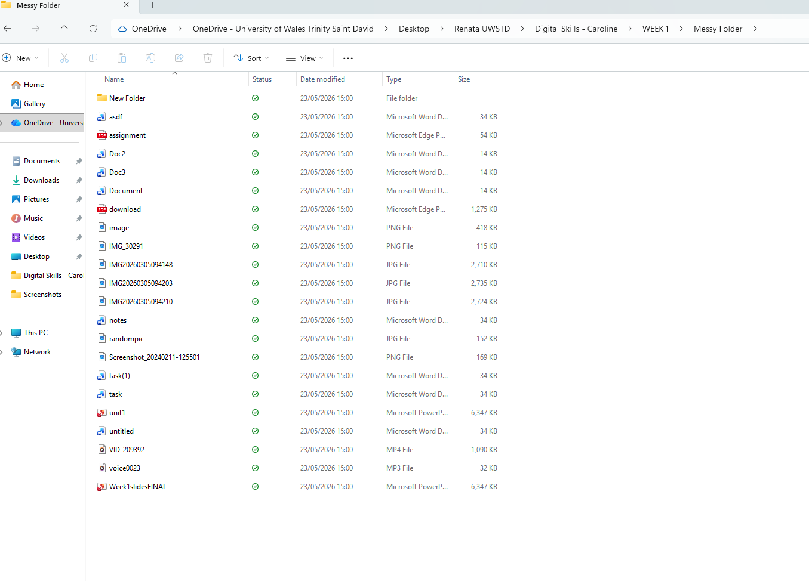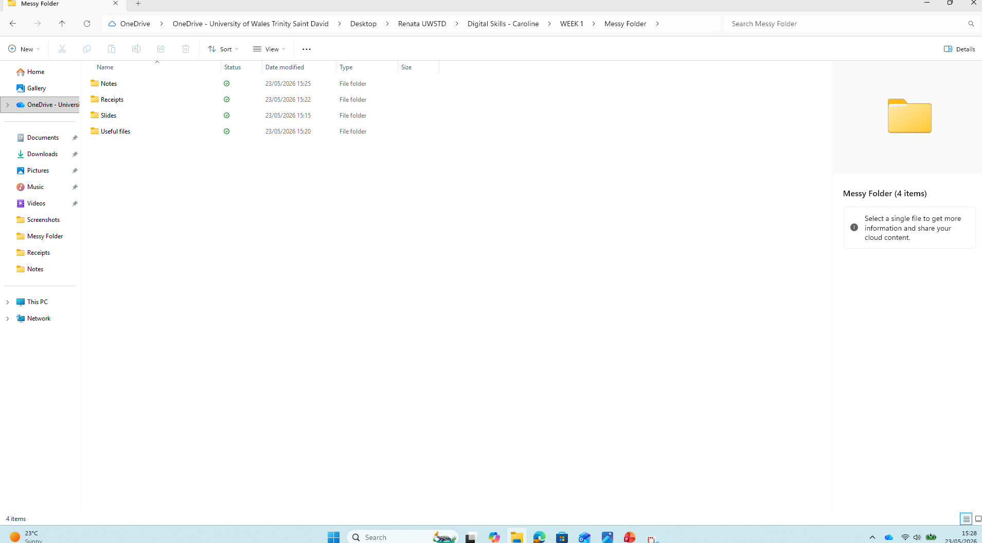

These screenshots show a before and after folder that was originally very disorganised with different file types. I organised the files into suitable folders and removed unnecessary files. This activity helped me improve my file management and organisational skills, which is important for working efficiently and organised and keeping digital information easy to access.

Screenshot/Photo 2
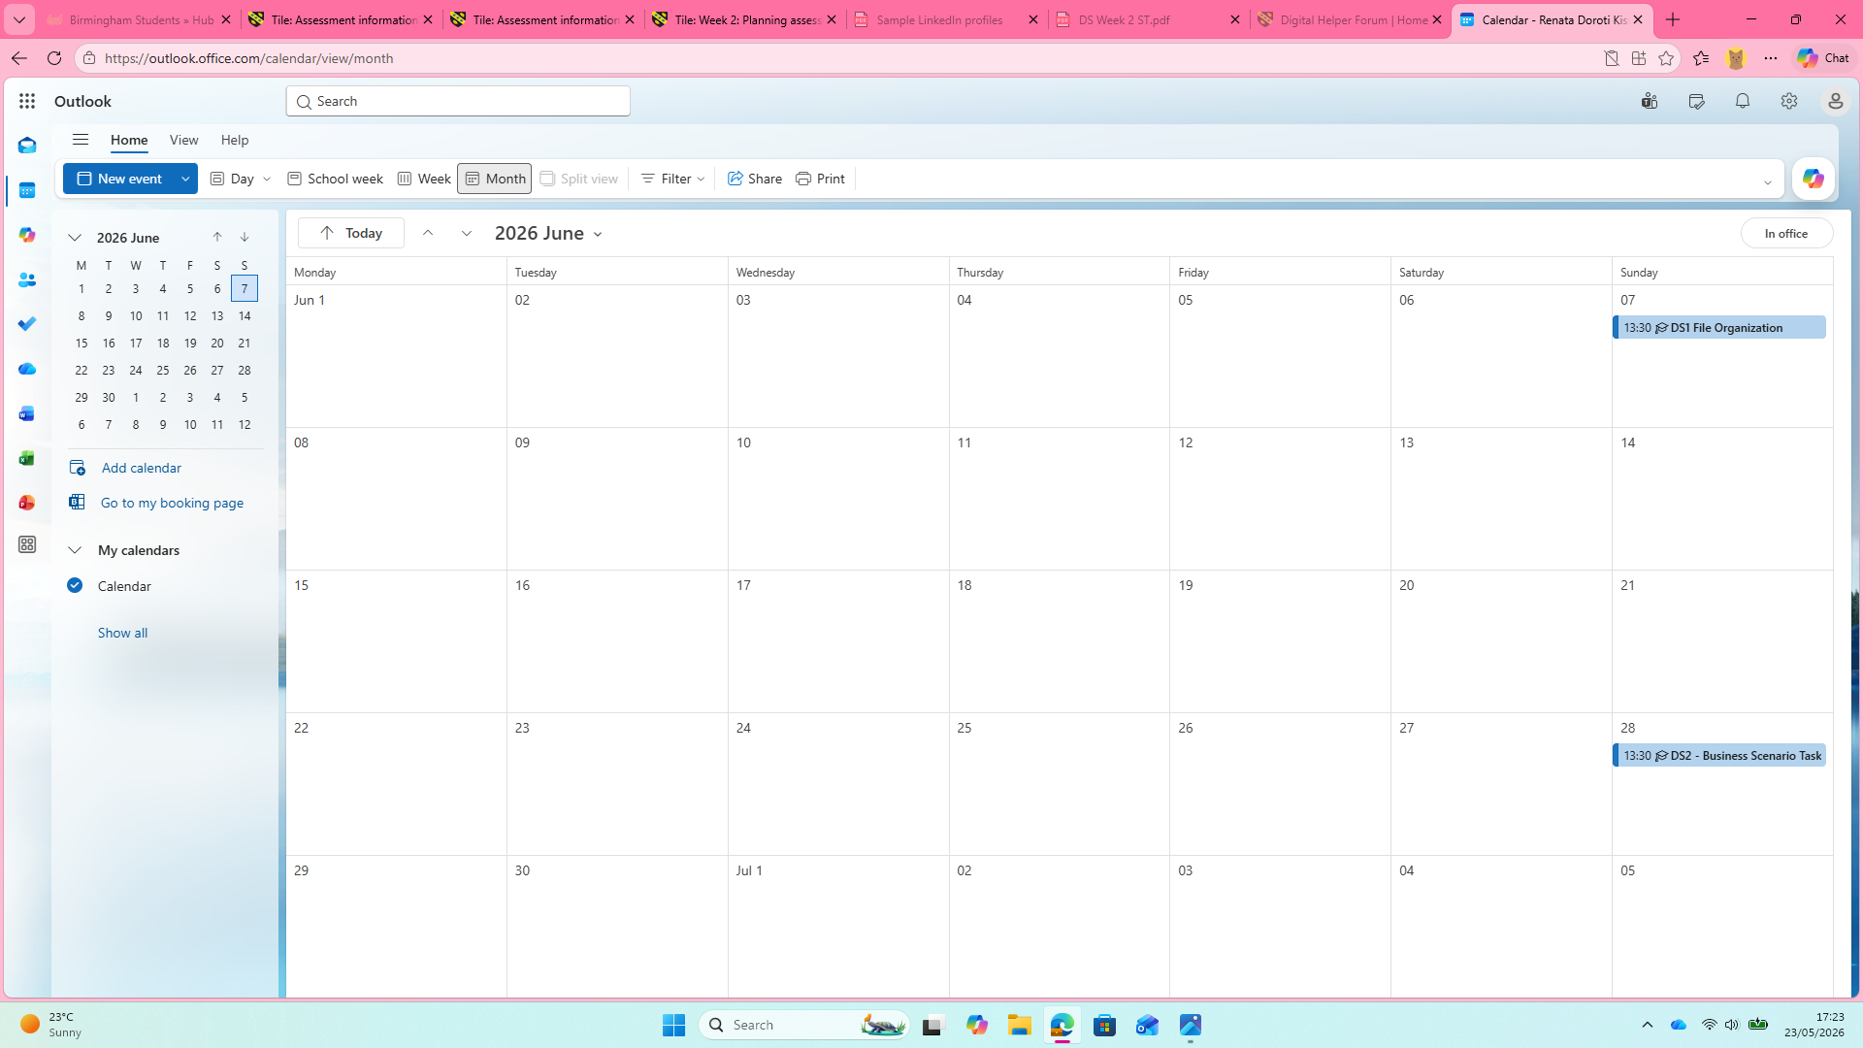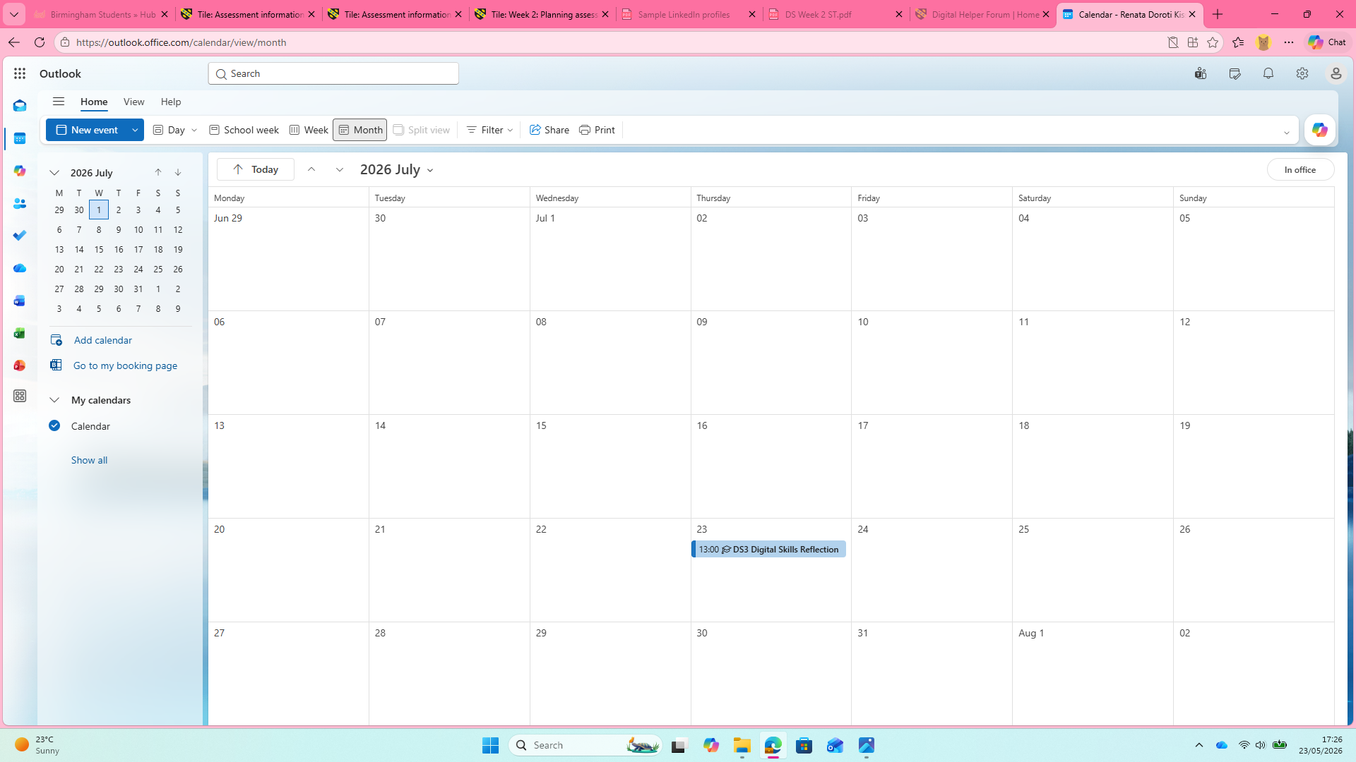
These screenshots show the assessment deadlines that I entered in Outlook Calendar. I used digital planning and time-management skills to schedule important dates and set reminders. Using this digital skill helps me stay organised, prioritise my work and complete assignments on time, which is important in both education and employment.

Screenshot/Photo 3
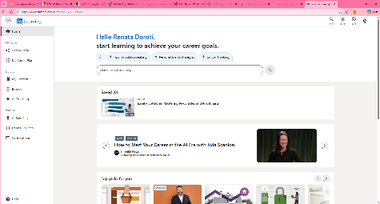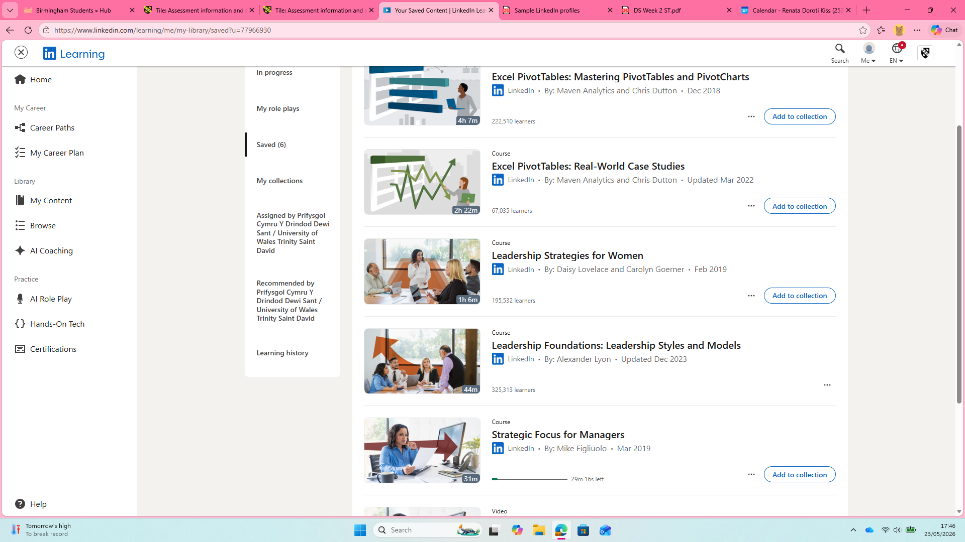
These screenshots show my LinkedIn Learning account. I use this platform to access online learning resources and develop new skills. This helps me improve my digital skills, increase my knowledge, and support my personal and professional development. Also, in the second screenshot are my saved courses for the future learning. I am interested in these topics because they will help me improve my digital and professional skills. Online learning is important to me in whatever form: videos, eBooks, podcast. This allows me to learn in my own pace and gain knowledge that can be useful in everyday life and work.

Screenshot/Photo 4
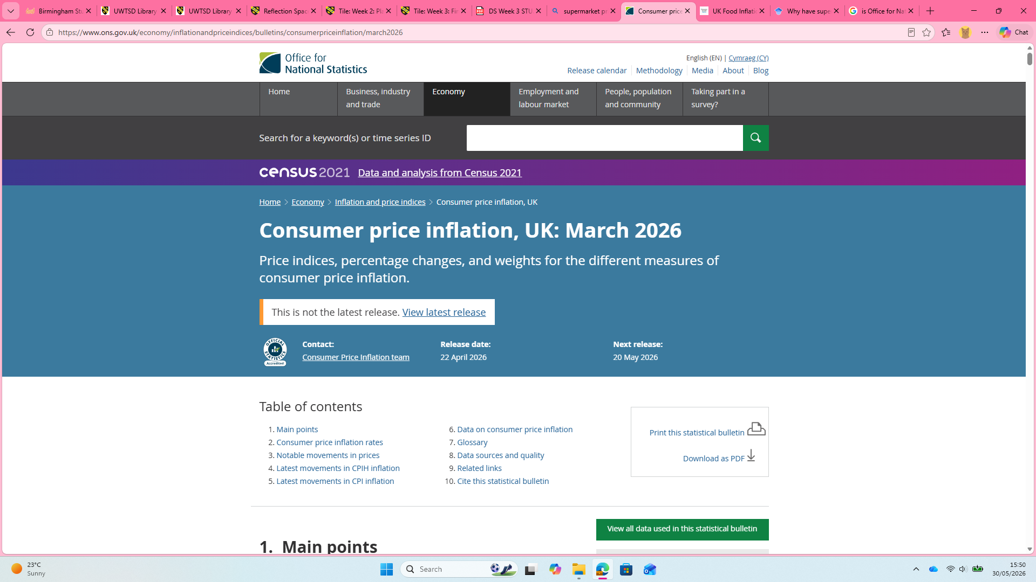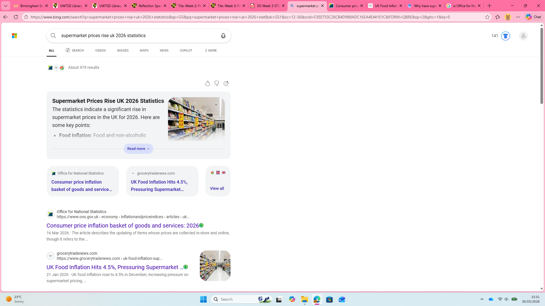
These screenshots show how I searched online for detailed information about inflation and rising prices in the UK by using specific keywords like “statistics,” I was able to refine my search and find information from the Office for National Statistics (ONS), the UK’s official provider of statistics. This activity helped me develop my online research, information literacy, and critical thinking skills by learning how to find reliable and trustworthy sources. Ussing official statistics also helped me access more detailed and accurate information, which can support better understanding and decision making.

Screenshot/Photo 5
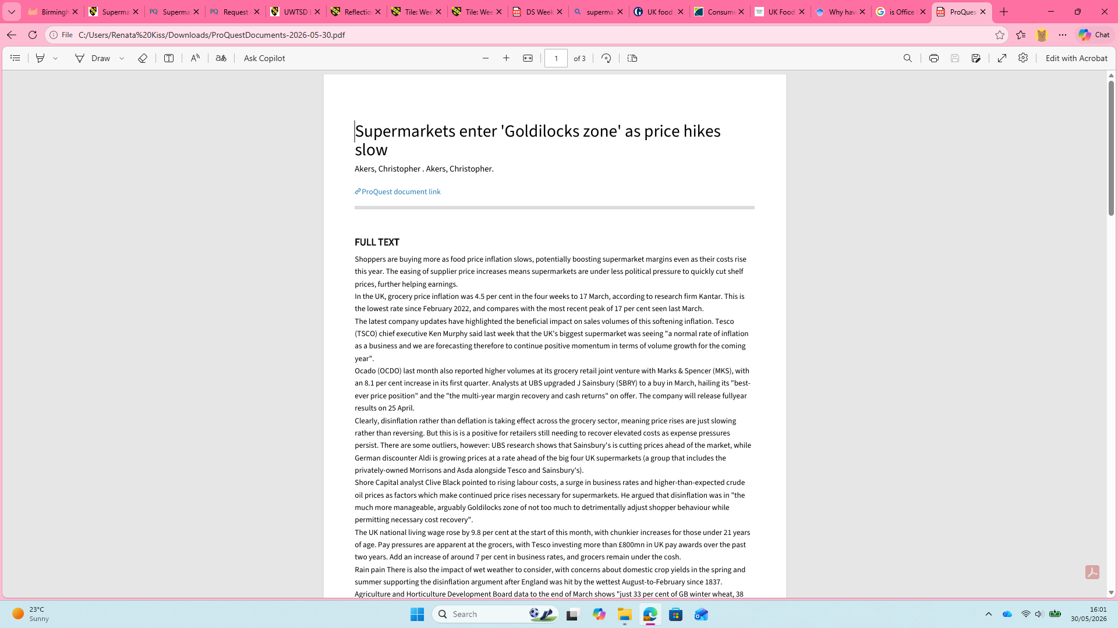
This screenshot shows an article that I have downloaded from the University’s library. I used the library’s search tools to find information related to the same topic to inflation and rising supermarket prices in the UK from section four screenshots. This activity helped me develop my digital research skills by searching for relevant information, selecting a suitable academic source, and downloading the article for further reading. Being able to access and use the library resources is an important skill because it helps me find reliable information to support my learning and assignments.

Screenshot/Photo 6
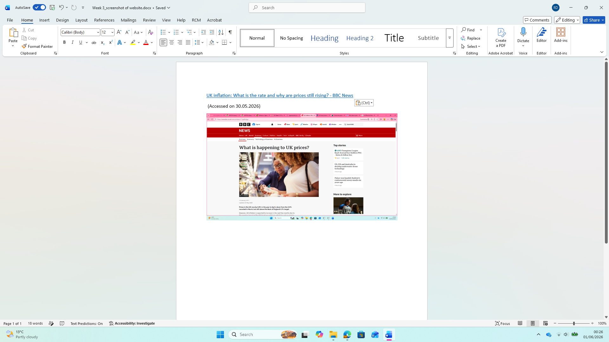
This screenshot shows a Microsoft World document containing a screenshot of a BBC article and a hyperlink to the original webpage. I used Microsoft World skills to insert an image and create a hyperlink, allowing readers to easily access the original source of the article. This activity helped me develop my document creation skills, as well my ability to present information clearly and professionally, using hyperlinks is important because it allows information to be verified and accessed quickly from the original source.

My Short Reflection
- Write 5–8 simple sentences about your digital life.
- You can use the sentence starters below if helpful.
I use digital tools to organise my work, research information, and complete assignments. I feel confident when I use Microsoft Office, Calendars and online searching and any other digital tools. I often use these tools to manage files, plan deadlines and access online learning resources and other digital tools that help me in everyday life. I would like to improve my digital research skills and learn how to use more software efficiently. I sometimes feel nervous about using new digital tools because I am not familiar with them at first. However, I become more confident as I practice and learn. I always try to research new tools and learn how to use them by watching videos or taking free online classes when available. I hope this module will help me develop stronger digital skills that will support me in my studies, everyday life, and future career.

Sentence starters
- I use digital tools to …
- I feel confident when I …
- I want to improve …
- I often use these tools: …
- I sometimes feel nervous about …
- I hope this module will help me …
- Digital skills are important for me because …
You can write more if you want.

Submission Checklist
Before you submit, please check:
​​​ ☒ I added 4–6 screenshots
☒ I wrote short sentences for each screenshot
☒ I wrote my short reflection
☒ My work is my own
☒ My file opens correctly

