NAME: JAYDIP RAMANI
STUDENT NUMBER:2131580
LECTURER: Dr. Gladius Kulothungan
COURSE: MBA in General management
Module Code: LCMB7000
Module name: Human Resource Management
Assignment Title- Analysis of HRM & labour market of the UK

Table of Contents
The Current State of Labour Market in the United Kingdom 3
Introduction 3
The inflation rate of the United Kingdom 3
Education and its impact on the labour market of the United Kingdom 4
Employment and its impact on the labour market of the United Kingdom 4
Labour immigration and its impact on the labour market of the United Kingdom 6
Impact of Covid 19 and its impact on the labour market of the United Kingdom 6
Conclusion 7
Reference: 8
The emerging changes in Human Resourcing Strategies in the post-Covid, post-Brexit external environment 9
Introduction 9
Strategic human resources management response and approaches to the crisis caused by pandemic 9
Integrating remote work to minimise the impact of the COVIDD-19 pandemic 9
How is the post-Brexit immigration system affecting the labour market and economy of the UK? 10
Credit source: https://cepr.org/voxeu/columns/immigration-and-uk-economy-after-brexit 11
Changes in HRM due to Brexit impact on talent: 11
Global implications: 12
Conclusion 12
Reference: 14

The Current State of Labour Market in the United Kingdom

Introduction
The term labour market refers to a region or area where traders and employees interconnect with each other. Moreover, the labour market helps in the functioning of the economy with the help of the supply of labour. In this respective report based on the current state of the labour market in the United Kingdom, several discussions were done on different topics related to the respective study including education, employment, unemployment, the impact of covid 19 on the labour market and as well as labour immigration related to the labour market. In addition, the employment rate has also increased after the Covid 19 pandemic which also helps in increasing the part-time worker rate. Furthermore, the rate of unemployment has also decreased in recent times after the Covid 19 pandemic.
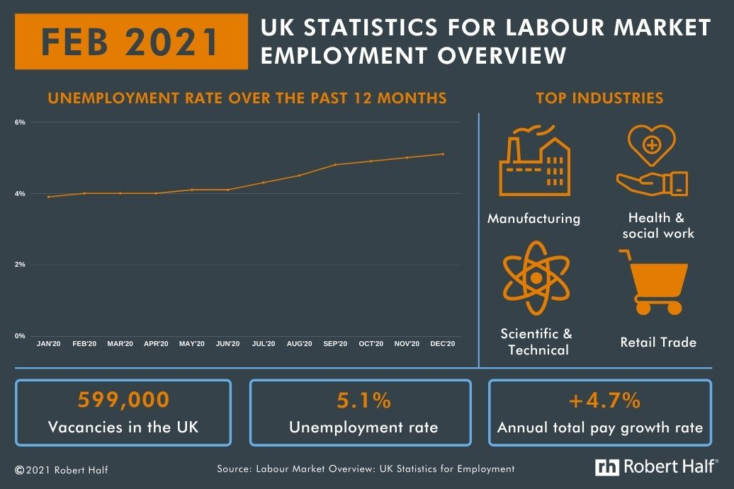
Figure 1: UK statistics for labor market employment overview
(source: https://www.roberthalf.co.uk/advice/industry-insights/current-labour-market-trends-uk)

The inflation rate of the United Kingdom
In recent times the cost of numerous miscellaneous goods has increased at a rapid speed by more than 4%. This is considered the highest increase in the rate of inflation. Moreover, the government of the United Kingdom also imposed a principal mechanism to keep control over inflation around the United Kingdom by decreasing the rate of interest which also has a positive impact on the marketing functions of the country (Breinlich et al. 2022). In addition, the low rate of interest set by the bank of England helps in easily determining the cheap and as well as the expensive while borrowing the principal amount of money.

Education and its impact on the labour market of the United Kingdom
Based on the betterment and development of society, education is considered the major element to develop the culture of society. As education has a direct relation to acquiring employment in any respective field. For the development of sustainability in the field of employment, education plays a crucial role (Donald et al. 2018). Moreover, the students of the United Kingdom focus on higher education to easily acquire employment with the help of their respective abilities. Due to rapid globalisation and as well as based on the global market of labour, the students of the United Kingdom focus on the improvement of their respective capabilities to easily get hired. As employment is considered a crucial element. The relationship as well as the connection between the system of education and employability has become a negligible concept. According to the perspective of the students of the United Kingdom, higher education will help in developing the capability of employment. Moreover, the rise in the employment process will help in the development of the economy of the entire United Kingdom (Sobnath et al. 2020).

Employment and its impact on the labour market of the United Kingdom
Employment is a vital element related to the labour market of the United Ki9ngdom. The rapid globalisation and innovation in recent times which has led to the requirement of labour, especially skilled labour to easily deal with modern and innovative technologies. Moreover, rapid innovation benefits the labour market of the United Kingdom as it helps in increasing employment mainly for newly graduated students (De Leede et al. 2019). Innovation in technological assistance within the organisation also helped in increasing employment around the United Kingdom. Moreover, in recent times the rapid rise in female employment has also helped to develop the labour market of the United Kingdom. The newly hired employees or organisation benefits the company in dealing with the advanced technologies (De Leede et al. 2019). This also helps in developing the functioning of the labour market in the United Kingdom. An increase in the rate of employment around the United Kingdom due to the adaptation of advanced technology has also led to the development of a family-friendly place in the working organisation. A Swift increase in employment also benefits the development of the economical functioning of the United Kingdom.
The main objectives for the development of economic functions are to develop the standards of living. As the standards of living of the people are mainly determined with the help of their respective earnings. To easily develop the entire functioning of the economy of the labour market of the United Kingdom recruitment process of the staff was implemented to easily get newly skilled staff for the organisations (De Leede et al. 2019).
The employment rate of the United Kingdom has increased with a percentage of more than 0.4. Moreover, the rate of full-time workers has increased in a recorded manner after the Covid 19 pandemic which has helped in the expansion of the economical functioning of the United Kingdom.

Labour immigration and its impact on the labour market of the United Kingdom
Immigration of labour has a negative effect on the entire labour market. Moreover, the migration of labour also affects the development of the entire economic functioning. Labour migration leads to unemployment in the respective field of unskilled jobs which also have a negative effect on the functioning of the economy (Su et al. 2022). The process of labour migration mainly affects the system of the nation's employment functions of the adapting state. Furthermore, this respective process also has a negative effect on the hiring process of the labours by the business organisation. Due to the migration process of the labourers in the United Kingdom, the labour market has negative consequences which results in the lowering and reduction of the wages of the local employers which has led to poverty around the nation. Moreover, the respective process increased the level of unemployment in the field of local employers. Additionally, this respective also benefits small business and as well as for entrepreneurship as this process fix and solve the shortages of labour around the United Kingdom (Su et al. 2022). In addition, this process also helps to improve the quality of the labour segment with the help of selection among skilled and unskilled workers on the basis of age.

Impact of Covid 19 and its impact on the labour market of the United Kingdom
The Covid-19 pandemic has led to the global lockdown to stop the spreading of novel coronavirus. As the virus was spreading at rapid speed every nation decided to keep a lockdown which had a huge impact on the health and as well as the wealth of the United Kingdom. Moreover, due to the lockdown, the unemployment rate also increased at a rapid speed around the nations (Mayhew and Anand, 2020). Moreover, the spread of the novel coronavirus and as well as the public health responses have created a major breakdown in the entre patterns of the employment of the nations. Due to imposed lockdown to stop the Covid 19 wages and the salary was reduced back to the level of 2008 which also led to the crisis around the entire United Kingdom. In addition, several problems were seen for the students who had just passed their universities. On the basis of this crisis, the government of the United Kingdom also started to take severe action to easily fix the issues related to unemployment (Mayhew and Anand, 2020).

Conclusion
For the development of economical functions, the market is considered the crucial element as it mainly deals with the development of employment. In this respective study, a detailed discussion was done on the education system of the United Kingdom which is playing a vital role in the development of employment around the United Kingdom. Moreover, the students are also focussing on the improvement of their respective capabilities in acquiring jobs. Moreover, in this study, a detailed discussion was done on the basis of the recent rise of the employment scale around the United Kingdom. Due to the rise in the innovation level within the organisations and as well as adaptations of the advanced technologies the organisations are also focussing to hire and recruit newly graduated students which will help in the development of the rise of the level of employment around the United Kingdom. Additionally, discussions were done on the basis of labour migration which is having a severe impact on the market of the United Kingdom.

Reference:
Breinlich, H., Leromain, E., Novy, D. and Sampson, T., 2022. The Brexit vote, inflation and UK living standards. International Economic Review, 63(1), pp.63-93.
De Leede, J., Drupsteen, L., Schrijver, E., Goudswaard, A., Dağ, N., Van der Weide, J. and Verbiest, S., 2019. Labour flexibility practices in Dutch SMEs. Personnel review.
Donald, W.E., Ashleigh, M.J. and Baruch, Y., 2018. Students’ perceptions of education and employability: Facilitating career transition from higher education into the labor market. Career development international.
Mayhew, K. and Anand, P., 2020. COVID-19 and the UK labour market. Oxford Review of Economic Policy, 36(Supplement_1), pp.S215-S224.
Sobnath, D., Kaduk, T., Rehman, I.U. and Isiaq, O., 2020. Feature selection for UK disabled students’ engagement post higher education: a machine learning approach for a predictive employment model. IEEE Access, 8, pp.159530-159541.
Su, C.W., Dai, K., Ullah, S. and Andlib, Z., 2022. COVID-19 pandemic and unemployment dynamics in European economies. Economic Research-Ekonomska Istraživanja, 35(1), pp.1752-1764.

The emerging changes in Human Resourcing Strategies in the post-Covid, post-Brexit external environment

Introduction
In this paper, the researcher focuses on various changes that human resources management (HRM) had faced or even faced till now due to external environmental factors such as COVID-19 and Brexit. The approaches and responses of human resource management to the crisis caused by the pandemic have been multi-dimensional. Covid-19 has caused a huge shock in every company in the UK and human resource management has been rattled. Moreover, as a result of Brexit, a lot of organizations are forced to make changes in the human resource processes to cope with the altered environment. Therefore this study critically analyses the emerging changes in the strategies of human resource management post-Covid-19 and Brexit.

Strategic human resources management response and approaches to the crisis caused by pandemic
A wide array of strategies related to human resource management has been adopted by the companies and business units in the post-pandemic situation to improve its impacts on performance. The links with the management of strategy are well known, specifically through the two fields of mutual interest in the resource-based of all the firms and the strategy process of making or taking decisions (Onwuegbuna et al. 2021). It can be identified that COVID-19 has changed the experience of work for most employees. It enforced a framework for the organizations to adapt the organization of work and design of jobs in the post-pandemic period. Strategic HRM failed due to its conceptual inability to incorporate newly procured HR practices. The research related to strategic HRM primarily focuses on shareholder value as a key outcome and the implications have been exposed due to the emergence of COVID-19. The pandemic has elevated employee consideration as a crucial stakeholder. COVID-19 has been identified to be a threat to the health and safety of employees. An example could be some employees that were harmed by the firm's continued narrow focus on financial outcomes by failing to integrate the needs of the employees (Bratton and Paulet, 2022).

Integrating remote work to minimise the impact of the COVIDD-19 pandemic
The study critically discussed the impact of the pandemic on business and HRM, therefore it becomes very important for the companies and HRM to take effective steps regarding remote work post-Covid-19. As it was discussed earlier that remote work had an impact in both positive and negative ways on the companies, therefore let's have a look at some of the following points to negotiate or minimise the effect.
Positive results for the company: Increasing the productivity of employees such as better agility and flexibility, higher retention of talent, better diversity of genders and many more.
Negative outcomes for the company: Reduction of the flow of knowledge and learning of the organisation, risk for the innovative capacity of the organisation along with long run productivity, increase the difficulties in the teamwork and decreasing the loyalty toward the company (Findlay et al. 2021).

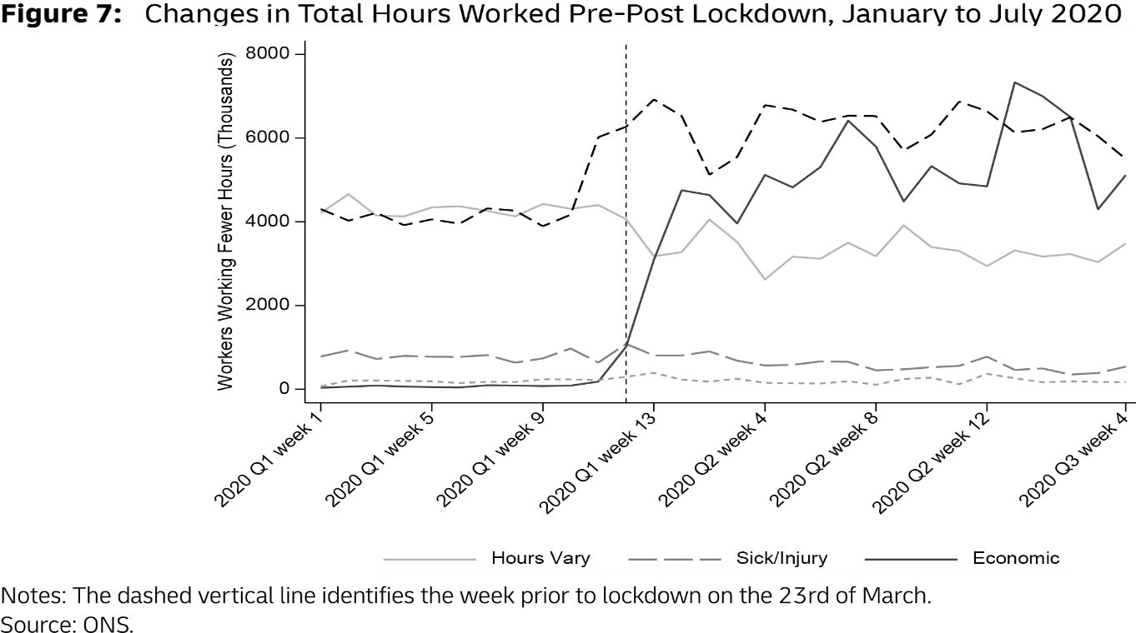
Figure 2: Changes in Total hour worked pre-post lockdown
(source: https://covid-19.iza.org/crisis-monitor/uk/)

How is the post-Brexit immigration system affecting the labour market and economy of the UK?
A new immigration system has introduced by the UK government on 1st January 2021, ending the free movement of people between the European Union (EU) and the UK, along with the wider European Economic Area (EEA). These new rules came into the stage during the UK-EU trade and agreement of cooperation. EU (and EEA/Swiss) nationals are already resident in the UK and they can apply to remain indefinitely under the scheme of "settled status" and it has already been done. The UK government had received 6.5 million applications till 31st march of 2022.
New rules of the system:
Some of the major provisions of the system have been applied by the UK government, such as,
- The UK government have available skilled work visa for migrants, who are coming to work on a salary based more than £25,600 or the lower quartile of the average salary.
- The visa of health and care gives a cheaper and streamlined process for people who are coming to work in social care and NHS.
Approximately 68% of employees of the UK Government work in occupations needing RQF3 level skills or much more than that. Migration from the EU fell clearly between the first emergence of covid in 2020 and the referendum on Brexit in June 2016 (Portes, 2022)
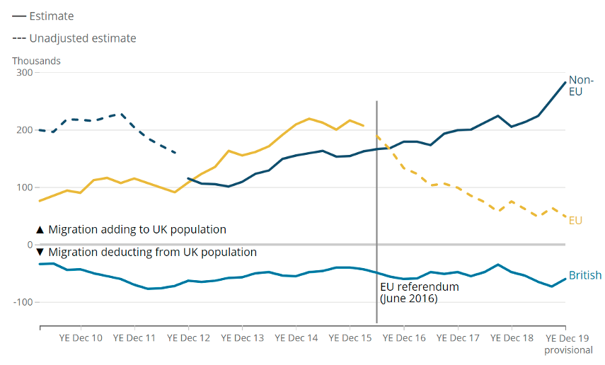

Figure 3: Changes in migrating population density in UK

Credit source: https://cepr.org/voxeu/columns/immigration-and-uk-economy-after-brexit

Changes in HRM due to Brexit impact on talent:
The exit of the UK from the EU has brought many challenges for the organisations in the UK in terms of managing human resources for which organizations sought several changes in the processes. Firstly, there was an abrupt shortage of labour and skills. In order to address this, the government has issued guidance on how employees can continue to live in the UK if a person can be EEA, EU and Swiss Citizen. The UK government issues permanent residence documents to those who have lived in the UK for five years. Another problem that arose due to Brexit was understanding the new immigration system of the UK which is extremely important for the foreign worker. In order to solve this, the UK government have integrated certain touch points to help the employees on immigration issues. As the talent pool of the UK has been impacted by Brexit, and it has had a significant impact on the strategies of organisations for the planning of the workplace. In order to retain or attract talent, companies require success in the face of growing competition for talent selection. The severity of this impact will be based on the process of negotiation. In order to continue free movement, an agreement needs to be made between the EU and the UK that would clear the way for talent to do easy movement (Ridgway, 2019).

Global implications:
Predictably, the exit of the UK from the EU will have a greater impact on the position of global organisations and their human resource management strategies. Without the freedom of movement of labour from the UK and EU, the organisations may think that the pool of talent available in the UK is not as big as what can be achieved somewhere else. It is very unlike that the organisations of US have already started operating in the UK and will change and uproots their hub of European, access to a bigger talent pool and the execution of a more tough setup may exceed the advantages of shared languages and laws which is very similar provide by the UK when there are strong options like as the Netherlands or the Irelands (Moradlou et al. 2020)

Conclusion
In this study, the main discussion point is based on the human resources management change after Covid19 and Brexit. Given the recent period of post-pandemics and Brexit, this paper highlighted all the possible vital areas of action that HRM must consider to maintain the high performance of an organisation or company and make sure that this condition does favour employees to work with. This study critically analysed the importance of remote work during and post covid 19 and also the impact of the Brexit incident and its impact on human resources management. The immigration effect on the economy and labour market is critically analysed as well. This study provided some statements and examples of Covid-19 impact in both positive and negative ways. In the end, it can be said that retention policies of employees and remote work practices can contribute to the success of a company if executes properly also Brexit can give the power to the company to attract new talent and retain the existing employees.

Reference:
Azizi, M.R., Atlasi, R., Ziapour, A., Abbas, J. and Naemi, R., 2021. Innovative human resource management strategies during the COVID-19 pandemic: A systematic narrative review approach. Heliyon, 7(6), p.e07233.
Bratton, A. and Paulet, R., 2022. Sustainable Human Resource Management and Organisational Sustainability. In The Emerald Handbook of Work, Workplaces and Disruptive Issues in HRM (pp. 149-169). Emerald Publishing Limited.
Findlay, P., Lindsay, C. and Roy, G., 2021. Business models, innovation and employees experiences in the workplace: challenges for the post-Covid-19 economy. Productivity and the Pandemic.
Jalagat, R.C. and Aquino, P.G., 2022. Post-Pandemic Strategies to Revitalize the Human Resources Management in the Public Sector. In Effective Public Administration Strategies for Global" New Normal" (pp. 1-17). Springer, Singapore.
Moradlou, H., Fratocchi, L., Skipworth, H. and Ghadge, A., 2020. Post-Brexit back-shoring strategies: what UK manufacturing companies could learn from the past?. Production Planning & Control, pp.1-18.
Onwuegbuna, G.N., Nchuchuwe, F.F. and Ibrahim, H.K., 2021. Human Resource Management during Covid-19 Pandemic: An Insight on the Challenges for Human Resource Practitioners. BVIMSR’s Journal of Management Research, 13(1), pp.15-23.
Portes, J., 2022. Immigration and the UK economy after Brexit. Oxford Review of Economic Policy, 38(1), pp.82-96.
Ridgway, M., 2019. Brexit: human resourcing implications. Employee Relations: The International Journal.

