Research Proposal
MSc Lean & Agile Operations

P144082
Jonathan Francis


Table of Contents
Introduction 2
Hypothesis 2
Literature Review 3
Induction Melting 3
Stirring 4
Slag Generation 5
Current Utilisation of Slag in Construction. 5
Insulation 6
Recovering Metal 7
Methods 8
Metal Extraction by Induction Melting 8
Extraction by Electric Arc 9
Granulation 9
Results 9
Evaluation 10
Works Cited 11

Introduction
LSN Diffusion manufacture Nickel, Iron and Cobalt based super alloys in the form of atomised powder. As part of the atomisation process the alloys must be charged and melted in an induction furnace before being poured into an atomisation vessel. The melting takes place in an open air oxidising environment therefore any impurities within the melt will raise to the top of the molten pool, to be removed by an operator. Slag is removed manually by using carbon ladle and discarded into drums which in turn are decanted into a all purpose ceramic skip. If any slag was to remain in the melt pool, the metal would block the tundish when a pouring attempt was made so is critical to the process that it is removed in its entirety.
Melting of metals in an oxidising environment will cause impurities to rise to the top of the melt pool in the form of slag. Whether for casting or other processing such as atomising the slag needs to be removed from the metal. Slag is a waste product and requires storage, sorting and disposal, all at a cost. Even at the heavy end of industry such as blast furnace melting of ores, slag is a by-product that requires handling.
Currently all slag is disposed of as ceramic waste which also includes refractory materials such as furnace linings, tundish pots and other consumable items. Ceramic waste is collected weekly at a charge of approximately £500 per collection for a 10 tonne load, which per annum is approximately £10,000. Further to this, any non ceramic waste such as metals and consumables has to be sorted at the expense of the company at a charge of £1000.
This is a common issue across all foundry and smelting industry which is relevant on small and large scales-the most obvious being steel making. Processing pig iron in a blast furnace produces vast amounts of solid wastes in the form of slag. Increasing environmental pressures are forcing companies to re-use or recycling as much of this as possible to prevent landfill.
The purpose of the research is to investigate the feasibility of processing slag into a useable product and explore the commercial potential with respect to selling into other industries. Further to this research into extractive metallurgy will be undertaken to asses if any valuable metals can be recovered.
The nature of LSN production is batch manufacturing and makes a wide variety of alloys therefore it is difficult to segregate waste materials by specific alloy, however it would be possible to broadly keep non compatible ‘families’ apart such as Iron, Nickel and Cobalt slag segregation. Operating near full capacity has meant that this attention to detail has been missed and therefore all slags are considered generic waste- thus losing their metal alloy value when mixed. Further to mixing of alloys other ceramics and consumables are added which further depreciate the value.

Hypothesis
The three areas to explore will be:
- Convert waste into format used in construction.
- Sort in house and send to a large capacity external foundry.
- Separate slags by base metal type – re-melt in house into process useable feed stock.
Such is the value of different metals-i.e cobalt at approximately £30,000 per tonne and steel at £400 per tonne at the time of writing is it critical to keep both slag streams apart and not de-value any potential cobalt. Further to this, extracting any cobalt metals in house from the segregated slag would reduce raw material purchasing, but at the expense of production capacity as this would take up furnace space when processing- 800kg per charge which would prevent any production processing during that time.
With respect to external melting, the third party has a much larger furnace of 10tonne capacity therefore it would have to be a one off melt of well-segregated material which would also yield good metallic returns. The external foundry uses an electric arc method so a minimum metals content of around 50% is required to strike an arc. They would melt the batch and extract the metals to be returned as ingots which can be re-melted. Due to a £10,000 cost for the service it would be essential to only send a specific high value containing material so the ingots when returned can essentially pay for themselves when re-processed or sold.
Selling into construction industries would be the lowest form of value as the slag itself often has to be processed to a specific chemical and physical composition and is not simply bulk material to use ‘as is’. This added cost would likely limit any profit to be made however an area to be explored.

Literature Review

Induction Melting
The mechanism of induction melting is well researched and is an established industrial process. Many manufactures of induction furnaces have published information on how induction melting works and the benefits over other processes such as cleanliness and uniform heating.
Working on the principle Faradays law, the work piece is placed inside of an electrically conductive coil which produces a magnetic field when an alternating current changes direction. This puts an electrical voltage into the workpeice which results in rapid heating due to electrical resistivity- the more resistant the material is for current flow the more heat is generated, figure 1 below shows how a magnetic field induces current into the material to be melted. Other melting methods such as gas and electric require direct heat convection and radiation from the outside and are typically inefficient in comparison to induction heating. One added benefit due to electro- magnetism is induction stirring. This effect means that molten metal within the furnace can be homogenised which makes it an appropriate method for creating alloys. (Inductotherm, 2021)
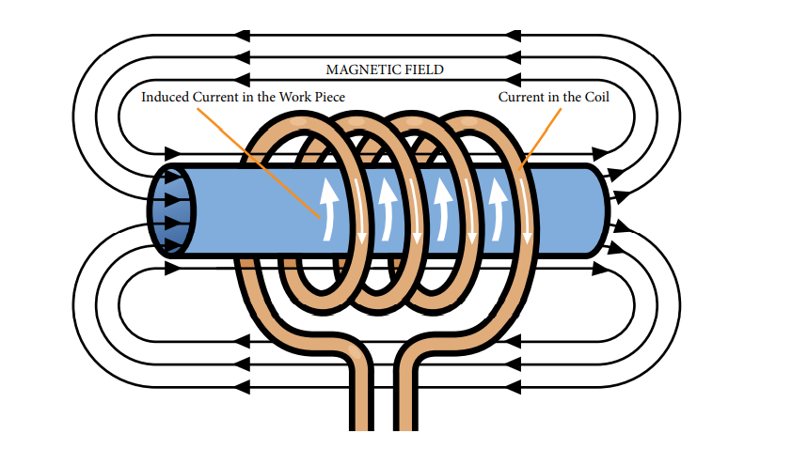
Figure 1 - Ambrell Induction Heating Solutions- What is induction
When applied to an industrial environment this can be used within large furnaces. Figure 2 below shows a cross section from German manufacturer Otto Junker.
Figure 2 - https://www.otto-junker.com/en/products-technologies/furnaces-for-zinc/medium-frequency-coreless-induction-furnaces/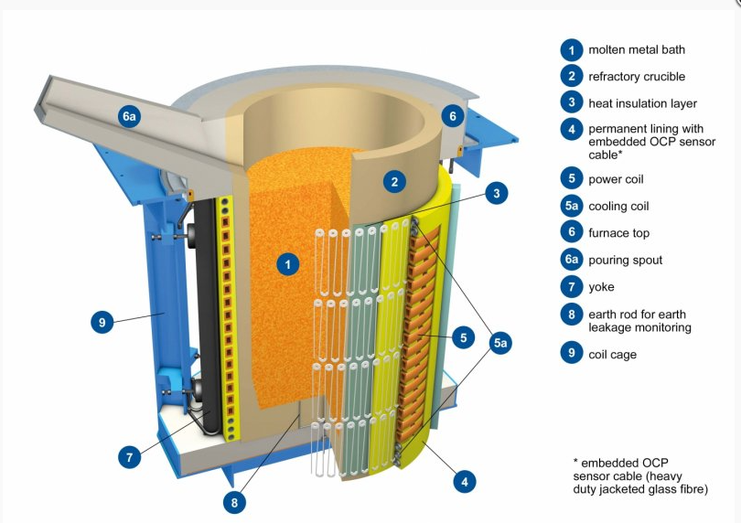
The drawing shows an induction coil which is lined with ceramic refractory material to create a crucible for melting material within.

Stirring
As briefly mentioned, an inherent effect of induction melting is a stirring process which helps develop a homogenous the melt pool. The electromagnetic forces applied on the molten metal create a constant stirring action which aids alloying but also proves advantageous in slag removal as the less dense metal oxides will stir up to the top of the melt pool for easy removal. Furnace parameters have a direct effect on the aggressiveness of the stir, for example a low frequency coil will provide a heavy stirring action which is desired for homogenising and refining where as a high frequency coil will result in a light stir which is required when trying to avoid gas inclusion and increase refractory life. (Keshecki, 2010)
Figure 3 below shows a figure of 8 stirring effect within an induction furnace which allows slag to rise once metal is homogenous and impurities are drawn out.
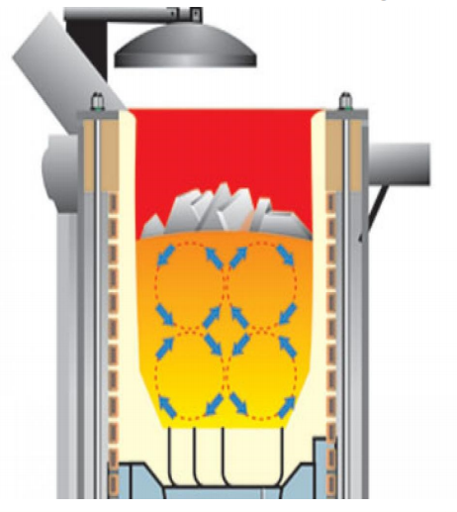
Figure 3

Slag Generation
Due to the nature of the melting process used and the alloy requirement mixed metal oxides float to the top of the melt pool. Some fluxes such as Calcium Silicates, Aluminium and carbon are often used as a de gassing agent however the majority of slags are a result of melting within an oxidising environment and the raw materials composition. Alloy chemistry has an effect on the amount produced, for example a melt containing pig iron (low cost and high carbon) will generate much more slag than a high purity iron billet due to composition of the metal. Further to this when melting fine sized powders at less than 20µm such as recovered extraction dust, more slag is floated off as the increased surface area of powder compared with solids caused a more aggressive oxidising reaction. Re-melting over and undersized powder, known as ‘Revert’ is critical t LSN as the particle size demands often mean production yields within specified particle size limits are around 30%, the remaining 70% can be re-melted. Such is the temperament of the pouring process the furnace operator has to remove as much slag as physically possible before metal is converted into atomised powder, this will naturally mean some good metal is also scooped off with the slag so the waste will contain some valuable materials. Disposal of slag is largely via landfill therefore an environmental objective exists as well as the desire to extract valuable metals. (Shen, An overview of recovery of metals from slags, 2003)

Current Utilisation of Slag in Construction.
There is extensive literature on the use of slags within construction with respect to technical information such as chemical make-up and its effects on the final product, for example water absorption and abrasive resistance when used in cement. There is less information available on the quantities and economy of scale as a global, environmental issue however it is clear that the issue of slag generation is common across many different processes both ferrous and non ferrous melting. Industry is less forthcoming with releasing technical ‘in-house’ recovery methods and process information with regards to processing slag and recovering metals however there are some standard general practices available such as granulation, mainly related to the steel industry and more specifically blast furnace processing of pig iron where slag are reduced back to an usable iron concentrate.
Globally, approximately 500kg of slag is produced for every 1 tonne of rolled steel, which in 2016 would equate to around 1 billion tonne of steel slag to be managed. Simply, landfill costs are rising and therefore an alternative option such as recycling or conversion to a usable forum is desired. A widely used outlet for ferrous slag is the construction industry in the form of road sub-base, embankments, pavements and concrete additives. Sand can also be produced from iron slag once granulated and screened down to a specific size and has been shown to give similar characteristics as commercially sourced sand. An alternative based on recovery is to use slag as a direct iron feedstock source as it will contain approx 20% iron but will require a treatment such as acid leeching prior to this to further boost the iron content and remove impurities. (Zhang, 2019)
In basic oxygen steel making pig iron is processed through a blast furnace. A by product from this process is alumina, silica and calcium based impurities in the form of glassy slag material. When cooled the slag can be granulated and used in construction industries as ingredients in cement. The desired properties of the final product will dictate the amount of slag that can be utilised as it can have an effect on mechanical related properties such as compressive and tensile strength, shrinkage properties , permeability and chemical properties such as corrosion resistance. To ensure no metals are left within the slag the ground material is de-magnified and from there can be used as a binder material. Previous studies have shown that the inclusion of slag within cements increased the strength, improved rheology and workability of the final product due to less water absorption when compared to other additive such as lime as well as reducing overall unit costs per kg. (Ozbay, 2016).
Refining of non ferrous metals will also produce slag. Copper extraction for example is reported to produce around 2 tonnes of slag for every 1 tonne of copper therefore an economical outlet for by-products is critical. Similar to steel industry, copper slag’s are granulated and used within cement due to properties such as low water absorption when compared to other aggregates. High iron content means the material is often used as a replacement for iron powder itself (a process material in copper refining) at a lower cost, whilst being able maintain environmental metal leaching restrictions. (Shi, 2008)
Further reasons for the use of slag in construction are that it provides a greater hardness and therefore stronger roads, better friction characteristics and performs stronger in load bearing situations than materials such as natural rock. (Steiniger, 2014)
Thermo fisher reports that other common uses for slags are agricultural to improve crop yields, insulations for buildings and ships as well as marine structures such as sea walls. This wide range of applications provides an economic and environmentally friendly solution to a product that is potentially destined for landfill. (Dietz, 2014)
With respect to selling slag as a waste outlet, many of the applications require slag to be processed first, either mechanically or chemically. Chemical processing will be to purify the chemistry or to extract valuable metals, for example slag generated by lead smelting will require reduction of lead levels before being used in soil applications. Initial chemical analysis is required and typically followed by treatment such as acid leaching to adjust the chemistry closer to the end products. Mechanical processing will include sorting, crushing, grinding and screening, all of these processes can be financially unviable and some company will just dispose of as landfill. (Ettler, 2004)

Insulation
Taking just steeling making as an example, processing blast furnace iron alone produces around 300kg per tonne of metal a year equalling to 345 million tonne of slag which emphasises the economical impact across all industry in terms of finding an outlet for this un-wanted by product (Tan, 2018)
Slag, by weight accounts for around 70% of steel making solid wastes – together with increasing pressure on industry to fulfil environmental obligations has meant that slag recycling and usage has increased. In China specifically, there is an increasing demand on improving building quality. Fire proofing, sound insulation as well as thermal retention for example are driving up the demand for slag based fibre insulation. (Yongli, 2011)
Insulation companies use a large proportion of slag to manufacture fibrous strands of ceramic material. Slag is melted down and either put through a spinning process or drawn. The slag containing mainly aluminium and silicon oxides can show excellent insulating as well as high temperature properties when mixed with small quantities of other raw material. (CCEWOOL, 2015)
Market leader in insulation production Knauf Insulation has recently invested in a new manufacturing facility in Luxembourg as well as plans to further upgrade existing facilities in Serbia and Slovakia. The new facility will enable an additional capacity of 110,000 tonnes of slag wool for 2019 – this will contain approximately 40% blast furnace slag. (Knauf Insulation, 2017)
Slag granulation is a widely used technique in industry as multiple outlets for the products are available. For example fine dust can be used in cements and fibres in insulation. Both of these are often produced in the same process or via combined centrifugal and air blowing technique. Processing parameters such as rotary speed of the centrifuge will show a bias towards one or the other- higher centrifugal forces will produce more fibres. (Tan, 2018)
Slag wool has shown to be produced when using up to 80% slag content which suggests a highly economical outlet for waste. A level 60% slag content has shown to be optimal with respect to mechanical and thermal properties of the final wool which would still provide an economical outlet. (Zhao, 2014)
A typical rock, glass, slag or mineral insulation fibre will begin at melting down in a cupola furnace where it can be heated in coke. Acting oppositely to blast furnace, the molten slag material is the product and any iron is removed for recycling. Once molten, the material is poured onto a spinning line and also injected with air. The centrifugal force will split the material down into strands where as the air will allow stretching into a desired length. To create a finished roll or ‘fleece’, binders are added and additional processes are required in terms of collection, forming and cutting. (Knauf Insulation, 2017)

Recovering Metal
Metal extraction is a worthwhile process dependent of the metals content within the slag itself. It is reported in literature that typical metal is around 20% by mass and from this only half is extractable by mechanical means. A consequence of this low yielding process is poor commercial benefits as processing costs are high with respect to space, labour and equipment and is not fully offset by the profits from metal should the feedstock contain low metals content. (Shkolnik, 2012)
Both smelting and acid electrolysis are possible methods of extracting metals. A typical smelting process would include heating and reacting the ores with fluxes to remove oxides and leave the pure metal. A chemical process would likely see metals dissolved from the matrix and precipitated out using an electrolyte. There is much research on both these methods with respect of extracting and refining from ores and minerals however less work has been undertaken to optimise extracting from slags, outside of steel making. For example the Hall Herout process of aluminium extraction is a recognised industrial process where aluminium oxide is reduced down to carbon dioxide and pure aluminium within an electrolytic cell; however a slag would likely not react in the same way as the chemical make-up will not be solely aluminium oxide- the primary ingredient for the process. (Wüthrich, 2009)
Other methods include cold grinding which allows magnetic separation however non ferrous metals will require a chemical process such as floatation and leaching. Gravity separation has also has some success in extraction metals such as Chrome and Nickel. Ferrous-Chrome extraction by gravity in particular has been implemented in industry, yields around 7% at a chrome level of 60%. Non-ferrous extraction has been researched previous with a large bias on Copper. Aside from leaching, floatation is an industrial process that has show both success and limitations, for example yields can be up to 80% with a copper content of 40% however floatation does not effectively separate cobalt, nickel and oxides of copper meaning the end product use is limited. Leaching has shows greater success with up to 90% copper, nickel and cobalt all successfully extracted. (Shen, 2003)

Methods

Metal Extraction by Induction Melting
The key and most critical component to this method starts at the initial separation of the slag from source. Operators use 50 gallon drums to scoop slag into which remain aside the furnace until full, regardless of what type of alloy they are melting. The initial part of the trial will be to have separately identified drums for a given alloy family. 3 drums will be supplied aside the furnace for Nickel, Iron and Cobalt alloys with the aim of keeping each waste stream apart. Once one drum is full it will be moved to a holding area. This process will be repeated until approximately 1 tonne of each alloy slag is generated. Figure 4 below shows an operator de-slagging a furnace.
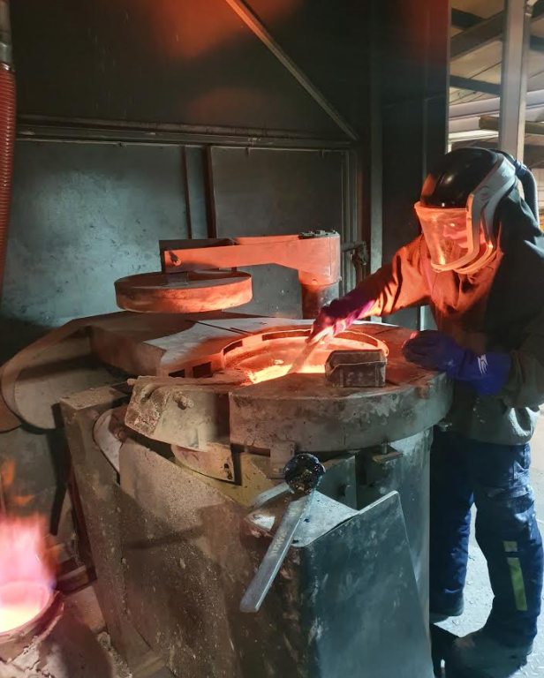
Figure 4
Collaboration is the required with the production planning department to be able to schedule in a space to be able to melt a 3- off ‘charges’ in the large furnace on site which is 800kg. The slag will be re-melted, de-slagged and any remaining metals will be atomised into a metallic powder. The final powder is be weighed to calculate overall yield and tested for chemistry by using an ICP. The value of the end product will be measured against the process costs such as energy, labour and atomising nitrogen units used. The highest costing element of atomisation, aside from metal is Nitrogen therefore a low volume of gas will be used to produce a coarsely sized powder of approximately 500µm and under. Some frequently made powders are 45µm and down which requires a high volume and high pressure gas input at additional costs. This is unnecessary for recovering waste and adding cost to a non-saleable product would be counter-productive. The recovered metal will be analysed for particle size by laser diffraction and also polished through a cross section to check for hollows. A density value will also reveal if there are many non-metallic hollow particles and give a true representation of generated value compared to density value of the pure metallic form.

Extraction by Electric Arc
This method will follow the theme of the above induction trials however greater emphasis will be placed on the separation, inventory control and sorting of a specific alloy. Nickel alloys will be kept away from Iron and Cobalt until 10tonne is achieved. A method of storing and stock taking will be established to keep track of quantities generated and at what rates. The slag will then be sent for external melting and metals returned as ingots. The supplier will provide a certificate of chemical analysis which will then show the value of the metal extracted against the price of the melting process. Initial concerns are around the metals content of the slag. Being able to strike an arc requires around 50% metals therefore some scrap metal might be required and this would diminish the value gained, dependent on final yield results.

Granulation
In order to replicate slag wool production a small scale development trial of a centrifugal atomising process will be required. Without the investment for a specific spinning process the methodology will be to melt the slag into a rotating tundish before entering the atomisation chamber at a low pressure. The atomising gas will replace the air blowing process with the aim of replicating the stretched strand morphology rather than a typical atomised spherical particle shape. Chemical composition will be measured by ICP and morphology checked via optical microscopy to give an aspect ratio value. Existing atomising encourages a vertical drop and any vortex within the metal is avoided therefore a custom set-up will be required to create a swirling effect. Angle of the gas jets can be adjusted away from the vertical , at more of a sheering angle perpendicular to the molten metal stream which could potential encourage a rotary mechanism.

Results
The results hoped to be achieved will be dependent on each method. The internal recovery method will be highly advantageous to the business as no new equipment would be required and the risk/reward is far outweighed by the rewards. Even if a useable metal yield recovery is around 30%, this will be highly valuable for both in house processing and saleable assets.
External processing advantages will effectively take the energy away from the factory and offer a stress free way of recovering waste, however the internal knowledge of the alloys and smaller batch processing might prove advantageous as the penalty risk of a poor chemistry is higher due to the large batch quantity of 10 tonne. The capability of casting into a specified ingot shape is appreciated as casting is limited internally as the process is powder focused. Hand sized briquettes would also easy of transport when compared to powder as the packing is less critical in terms of leaks and powder control – this would also provide a process friendly way of loading the furnace is the alloy is able to be re-used as a raw material.
Developing a process to produce fibres will enable the factory to potentially enter a new market with new capability. Financial gains are difficult to quantify without additional research and without being able to assess the quality of the material produced. It might be a way of selling something new or it could simply eliminate disposal of large bulk material. Atomising fine sized spherical particles typically avoids vortex to maintain a vertical formation, the learning from this will also be applied in manufacturing more traditional products, with respect to improving morphology.

Evaluation
The research will aim to provide an economical outlet or a valuable recovery method for a current waste product. As well as reducing environmental issues such as landfill it would provide a way of reducing raw material purchasing, generating revenue or at the least provide a conversion process so the waste is manufactured into a useable state.
Constraints with respect to recovery will be production downtime and good segregation of the waste. Developing a fibre process within the current equipment might provide limited however some investment could be justified if shown to reduce waste costs or even to produce revenue.

Works Cited
CCEWOOL. (2015, 03 20). Ceramicfibre.com. Retrieved 03 10, 2021, from Production Process of furnace insulation blanket: https://www.ceceramicfiber.com/Article/ProductionProcessofC_1.html
Dietz, S. (2014). Slag: From By-product to Valuable Construction Material. ThermoFisher.
Ettler, V. (2004). Leaching of lead metallurgical slag in citric solutions--implications for disposal and weathering in soil environments. Chemosphere.
Inductotherm. (2021). What is Induction? Retrieved Febuary 01, 2021, from Inductotherm Group: https://inductotherm.co.uk/what-is-induction/
Keshecki, R. (2010). Better Productivity, Metal Quality with Natural Induction Stirring. Foundy Management & Technology , 12-13.
Knauf Insulation. (2017, July 14). Knauf Insulation announces major Rock Mineral Wool investment plan. Retrieved March 13, 2021, from Knauf Insulation: https://www.knaufinsulation.com/news/knauf-insulation-announces-major-rock-mineral-wool-investment-plan
Ozbay, E. (2016). Utilization and efficiency of ground granulated blast furnace slag on concrete properties – A review. Construction and Building Materials , 423-434.
Shen, H. (2003). An overview of recovery of metals from slags. Waste Management , 933-949.
Shen, H. (2003). An overview of recovery of metals from slags. Waste Management , 933-949.
Shi, C. (2008). Utilization of copper slag in cement and concrete. Resources, Conservation and Recycling , 1115-1120.
Shkolnik. (2012). New Technology and equipment for recycling slag melts. Metallurgist , 9-10.
Steiniger, V. (2014). The use and advantages of slag. Voestalpine.
Tan, Y. (2018). Granulation characteristics of molten blast furnace slag by hybrid centrifugal-air blast technique. Powder Technology , 176-185.
Wüthrich, R. (2009). Industrial Aluminium Production: the Hall-Heroult Process Modelling. Quebec: ECS Transactions.
Yongli, X. (2011). Status and development of mineral wool made from molten blast furnace slag. Baosteel Technical Research , 3-8.
Zhang, X. (2019). The potential utilization of slag generated from iron- and steelmaking industries: a review. Environ Geochem Health.
Zhao, D. (2014). Preparation of Slag Wool by Integrated Waste-Heat Recovery. energies , 3121-3135.

