Assessment

HTML & CSS Web
Development

Student name: Viacheslav Odrynskyi;
Student ID number: 2530812;
Programme: CertHE Computing Skills for Workplace;
Module: Introduction to Web and Database Concepts

Module code: ACCA4023

Table of Contents

- Introduction ………………………………………………………. 3
1.1 Abstract ……………………………………………………………. 3
1.2 Background ………………………………………………………… 3
1.3 Aim of the Project ……………………………………………… 3
1.4 Objectives ………………………………………………………….. 4
1.5 Technologies Used …………………………………………….. 4
1.6 Website Structure ……………………………………………… 5
1.7 Intended Users ………………………………………………….. 5
1.8 Overview of the Report ……………………………………… 6
- Requirements ……………………………………………………. 6
2.1 Website Purpose ……………………………………………….. 6
2.2 Subject Matter ………………………………………………….. 6
2.3 Target Audience ……………………………………………….. 7
2.4 Functional Requirements ………………………………….. 7
2.5 Design Requirements ………………………………………… 7
- Implementation …………………………………………………. 8
3.1 Home Page ………………………………………………………… 8
3.2 History Page ………………………………………………………. 10
3.3 Products Page ………………………………………………….. 12
3.4 Website Navigation ………………………………………….. 14
- Validation……………………………………………………………14
- Evaluation ………………………………………………………… 16
4.1 Website Usability ……………………………………………… 16
4.2 Web Accessibility ……………………………………………… 17
4.3 Search Engine Optimisation (SEO) …………………….. 18
4.4 Comparison of the Three Concepts …………………… 19
- Comparison of Two Live Websites …………………….. 20
5.1 Usability ………………………………………………………….. 20
5.2 Accessibility ……………………………………………………… 21
5.3 Search Engine Optimisation (SEO) …………………….. 21
5.4 Mobile Responsiveness …………………………………….. 22
5.5 Comparison Summary ………………………………………. 22
5.6 Conclusion ………………………………………………………… 23
References ……………………………………………………………. 23
Appendices …………………………………………………………… 24
- index.html …………………………………………………………… 24
- history.html ……………………………………………………………. 30
- products.html …………………………………………………………. 35
- style.css ………………………………………………………………. 40

1. Introduction

1.1 Abstract
This report presents the development of a simple multi-page website based on Apple. The website was created using HTML and CSS and contains three main sections: Home, History and Products. The purpose of the website is to provide users with basic information about Apple, its history and its main products in a clear and simple way.
The project demonstrates the use of basic web development techniques, including HTML page structure, navigation links, CSS styling, images and page organisation. The website was developed using Visual Studio Code and tested using a web browser. The report describes the development process, the technologies used, the structure of the website and the final result.

1.2 Background
Apple is one of the world’s well-known technology companies and produces a wide range of technology products and services. These include the iPhone, iPad, Mac computers and Apple Watch. Because Apple has a recognisable brand and a wide range of products, it was selected as the topic for this website project. The website was designed as a simple informational website rather than a commercial Apple website. It provides visitors with an introduction to Apple, information about its history and an overview of some of its products. The website also demonstrates how multiple HTML pages can be connected through a navigation menu.

1.3 Aim of the Project
The main aim of this project is to design and develop a simple, functional and user-friendly website about Apple using basic web development technologies.
The project also aims to demonstrate an understanding of HTML and CSS and how these technologies can be used together to create a structured website with multiple connected pages.

1.4 Objectives
The main objectives of the project are:
- To create a simple website using HTML and CSS.
- To develop multiple web pages connected through navigation links.
- To create a Home page introducing Apple.
- To create a History page containing information about Apple’s history.
- To create a Products page providing information about Apple products.
- To use CSS to improve the appearance and layout of the website.
- To include images and other basic website elements.
- To create clear and easy-to-use navigation between the pages.
- To test the website and ensure that the links between the pages work correctly.
- To develop basic practical skills in web development using Visual Studio Code.

1.5 Technologies Used
The website was developed using HTML (HyperText Markup Language) and CSS (Cascading Style Sheets).
HTML was used to create the structure and content of the website. Elements such as headings, paragraphs, navigation links, images and sections were used to organise the information on each page.
CSS was used to control the visual appearance of the website. It was used to modify aspects such as fonts, spacing, colours, positioning and the general layout of the pages.
Visual Studio Code was used as the main development environment for creating and editing the website files. The website was tested in a web browser to check its appearance and navigation.

1.6 Website Structure
The website consists of several HTML files that are connected through a navigation menu. The main pages are:
Home – provides a short introduction to Apple and displays the Apple logo.
History – provides information about the development and history of Apple.
Products – presents information about Apple’s main products.
A navigation menu is included on the pages so that users can move between the different sections of the website. The pages use the same general styling to maintain consistency throughout the website.

1.7 Intended Users
The website is intended for general users who are interested in Apple and its technology products. It is designed to be simple enough for users to navigate without requiring any technical knowledge.
The website can also be viewed as a basic educational web development project demonstrating how information can be organised across multiple connected web pages.

1.8 Overview of the Report
This report explains the main stages of the website development process. It introduces the purpose and objectives of the project and describes the technologies used to create the website. It also discusses the website structure, design and implementation.
The report includes screenshots and evidence of the developed website to demonstrate the final result. The final section evaluates the completed website and discusses possible improvements that could be made in the future.

2. Requirements

2.1 Website Purpose
The purpose of this website is to provide users with simple and accessible information about Apple. The website introduces the company, provides information about its history and presents some of its main products. The website has been designed to be clear and easy to navigate, allowing users to move between different pages using the navigation menu.

2.2 Subject Matter
The main subject of the website is Apple and its development as a technology company. The website focuses on three main areas: an introduction to Apple, its history and its products.
The Home page provides a general introduction to Apple. The History page gives users information about the company’s development over time, while the Products page presents information about some of Apple’s well-known technology products.

2.3 Target Audience
The website is intended for a general audience interested in Apple, technology and consumer electronic products. It can be used by people who want to learn basic information about Apple and its products. The website is also suitable for users who prefer simple and straightforward navigation without a large amount of complex information. The content and layout are designed to make the information easy to understand for users with different levels of technical knowledge.

2.4 Functional Requirements
The website should meet the following basic functional requirements:
- The website should contain multiple connected pages.
- Users should be able to navigate between the Home, History and Products pages.
- Navigation links should work correctly.
- Each page should display relevant information about Apple.
- The website should include appropriate images.
- The website should open correctly in a web browser.
- The layout should remain clear and easy to use.

2.5 Design Requirements
The website should have a simple and consistent design across all pages. The navigation menu should be easy to find and use. Headings, paragraphs and images should be organised clearly so that users can understand the content.
CSS should be used to provide consistent styling and improve the visual appearance of the website. The overall design should remain simple rather than containing unnecessary elements.

3. Implementation
The website was implemented using HTML and CSS. The website consists of three main pages: Home, History and Products. The pages are connected using a navigation menu, allowing users to move between different sections of the website.
Screenshots of the completed website are included below as evidence of the implementation and final result.

3.1 Home Page
The Home page provides a basic introduction to Apple. It contains a navigation menu, a heading, a short description of the company and the Apple logo.
Figure 1: Home page of the Apple website
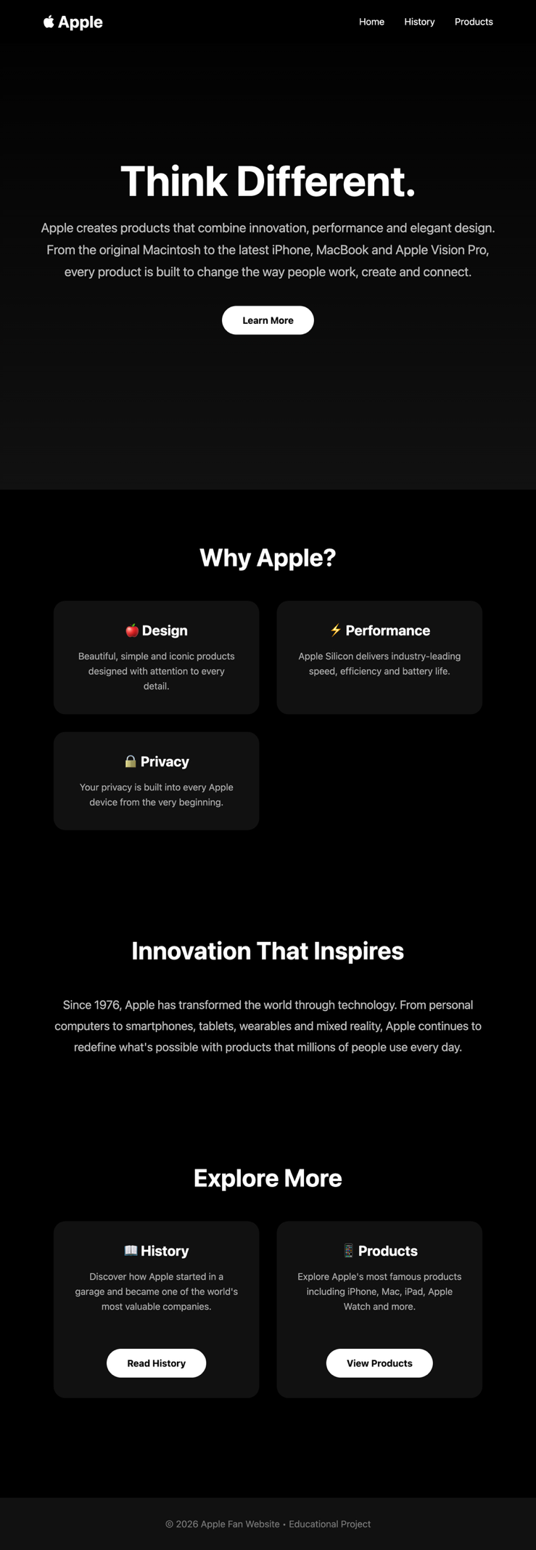
The screenshot demonstrates the final layout of the Home page and shows that the navigation menu and main content are displayed correctly.

3.2 History Page
The History page provides information about Apple’s history and development. It follows the same general design and navigation structure as the Home page.
Figure 2: History page of the Apple website
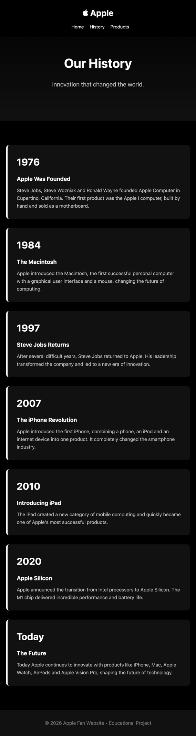
The screenshot shows the completed History page and demonstrates how users can access information about Apple’s development through the website navigation.

3.3 Products Page
The Products page presents information about Apple’s products. The page uses headings, text and images to organise the information in a clear way.
Figure 3: Products page of the Apple website
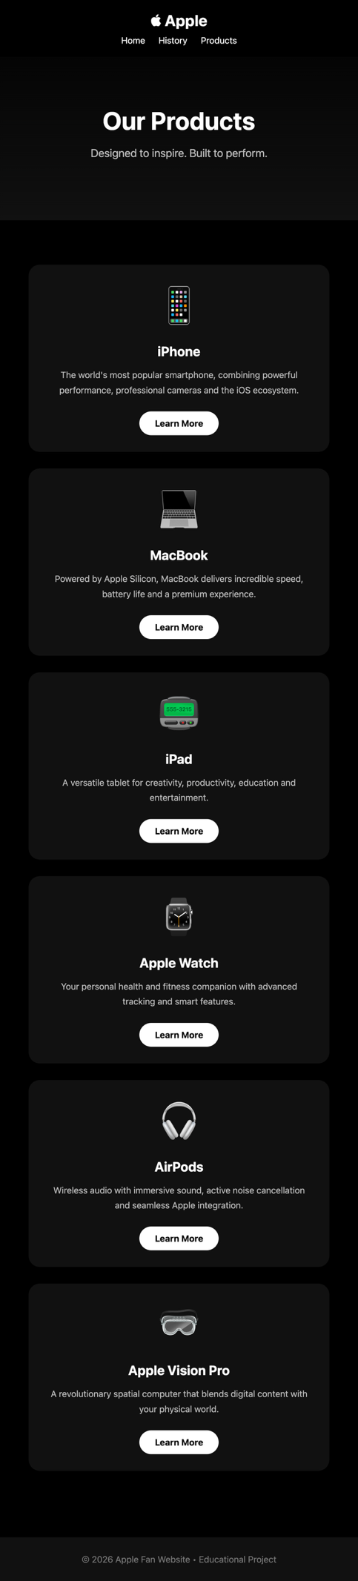
The screenshot demonstrates the completed Products page and shows the final design and content of the page.

3.4 Website Navigation
The navigation menu is used throughout the website to allow users to move between the different pages. The main navigation links are Home, History and Products.
Figure 4: Website navigation menu
[Insert screenshot showing the navigation menu here]
The navigation links were tested to ensure that users can move between the different pages of the website.
Validation
1. index.html;

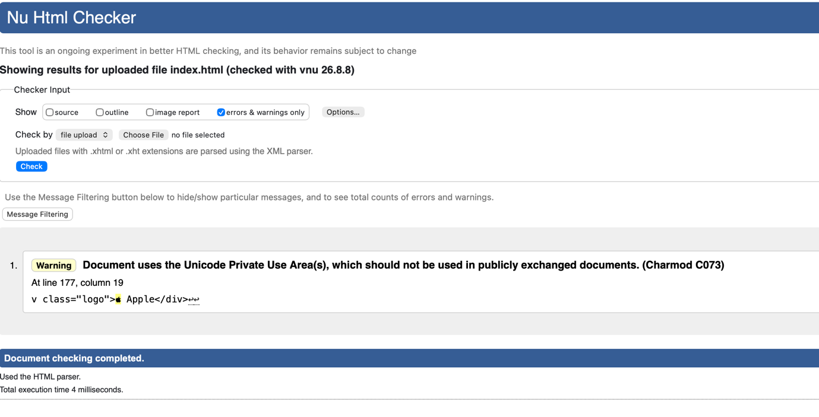
2.history.html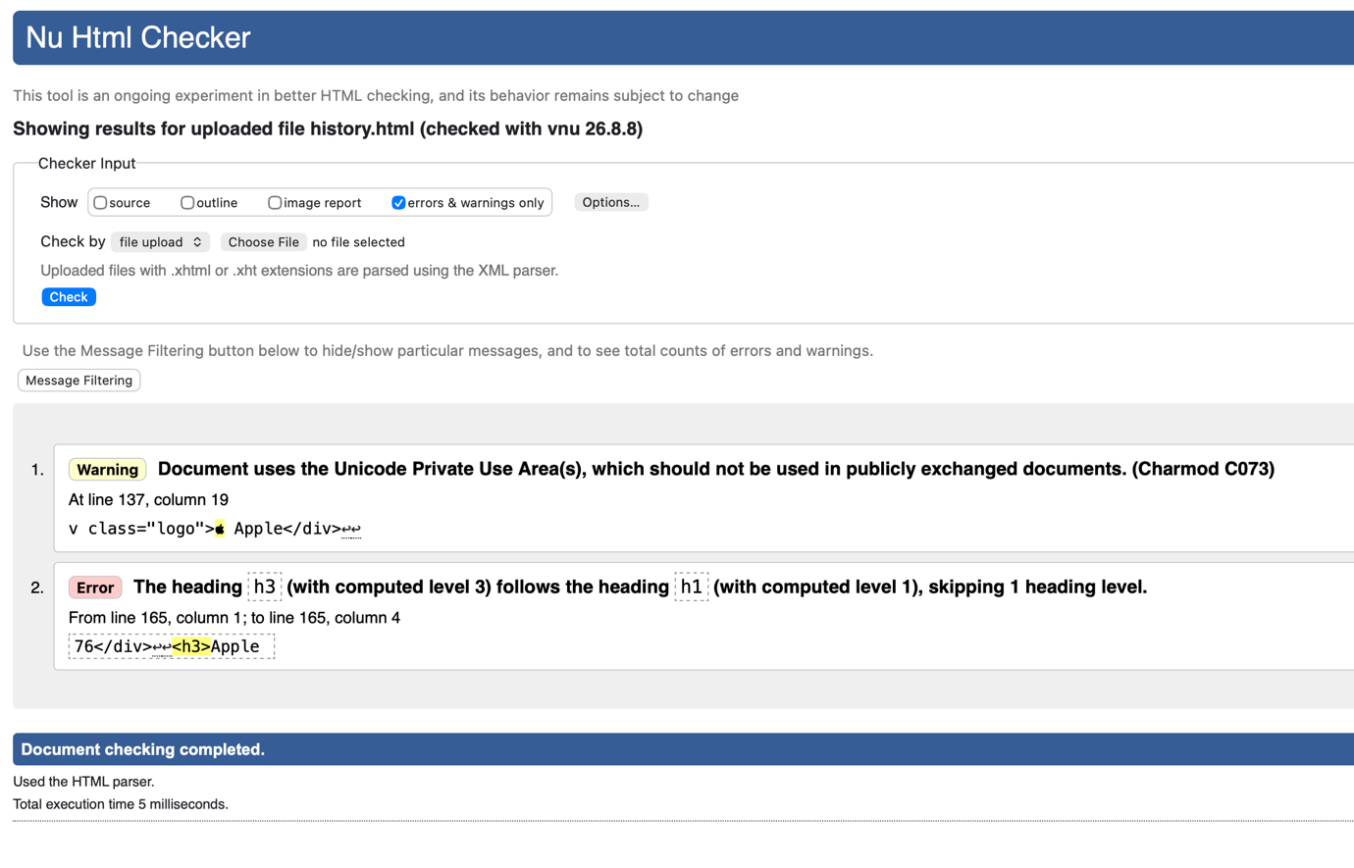
3.products.html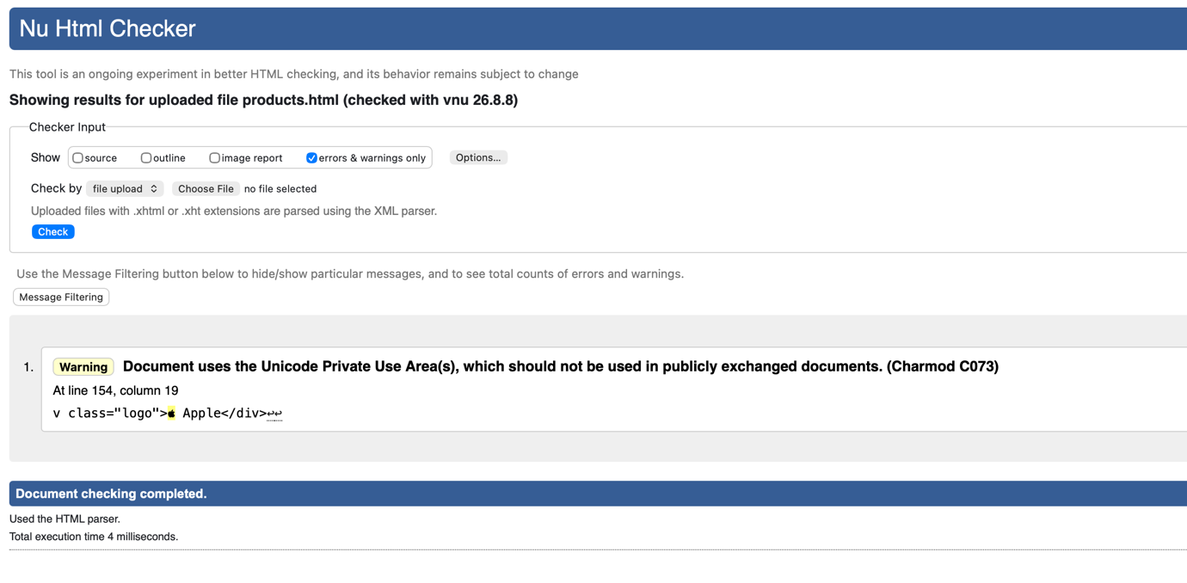
4.style.css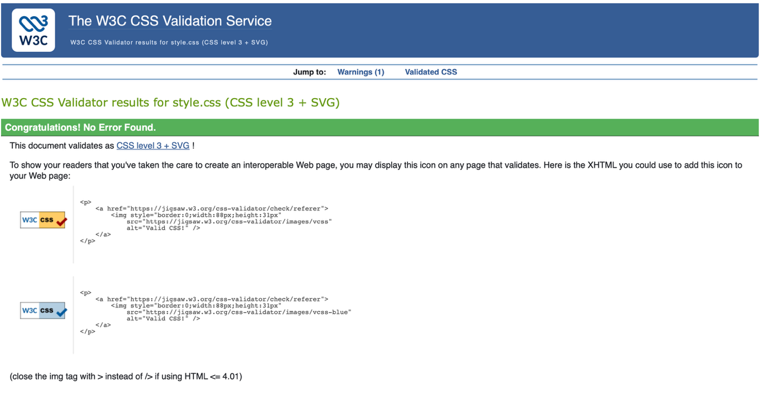
Evaluation

4.1 Web Accessibility
Web accessibility means designing websites so that they can be used by as many people as possible, including people with disabilities. Accessibility considers users who may have visual, auditory, physical, cognitive or other difficulties when interacting with digital content.
Accessibility is an important part of modern web development because information on a website should not be available only to users who can interact with a website in a particular way. Developers can improve accessibility by using alternative text for images, appropriate colour contrast, meaningful headings, descriptive links, keyboard navigation and semantic HTML. The Web Content Accessibility Guidelines (WCAG) provide widely used recommendations for improving web accessibility. These guidelines are organised around four principles: Perceivable, Operable, Understandable and Robust (POUR).
A large-scale study by Martins and Duarte examined the accessibility of nearly three million web pages using automated accessibility evaluation. The researchers found approximately 30 accessibility errors per page on average, while only a very small number of pages had no identified accessibility barriers. Common problems included inadequate text contrast and missing accessible names.
This research demonstrates that accessibility problems are common even on large numbers of existing websites. It also shows why accessibility should be considered during the development process rather than treated as an optional feature.

Accessibility of the Apple Website
Accessibility is relevant to my website because the website contains text, navigation links and images. For example, the Apple logo on the Home page uses an alt attribute:
<img src="..." width="150" alt="Apple Logo">
The website also uses HTML headings such as <h1> and <h2>, which help organise the content. The navigation links are created using standard HTML <a> elements, which provides a basic structure for navigation. However, the website could be improved further by testing colour contrast, adding more descriptive alternative text where necessary, ensuring keyboard accessibility and checking the website against WCAG requirements using an accessibility testing tool.

4.2 Search Engine Optimisation (SEO)
Search Engine Optimisation (SEO) is the process of improving a website so that search engines can understand its content and potentially display the website more prominently in search results. SEO is important because a website may contain useful information, but users still need to be able to discover it through search engines.
SEO can involve several aspects of web development, including page titles, headings, relevant keywords, page content, URLs, links, metadata and website structure. Good SEO should focus on providing useful and relevant information rather than simply repeating keywords. Research by Zhang and Dimitroff (2005) investigated how webpage content characteristics affected visibility in search engine results. The researchers examined factors such as keyword position, keyword frequency and page layout. Their findings indicated that webpage visibility could be improved by increasing the frequency of relevant keywords in the title and page text. The study demonstrated that the content and structure of a webpage can influence how visible it is in search engine results.
More recent research by Yalçın and Köse (2010) examined SEO techniques applied to library website content and services. The researchers applied a number of SEO techniques and measured changes in search-engine keywords and visits. The study found that SEO techniques increased the exposure of the services and the number of visitors arriving through search engines.

SEO of the Apple Website
SEO is relevant to my Apple website because each page should have a clear title and meaningful content that allows search engines to understand the subject of the page.
For example, the Home page contains:
<title>Apple - Home</title>
This gives the browser and search engines a clear indication of the page’s subject.
The website also uses headings such as:
<h1>Apple</h1>
<h2>Apple</h2>
and contains relevant text about Apple, its history and its products.
However, the current website has several areas that could be improved from an SEO perspective. For example, more descriptive page titles could be used, relevant keywords could be selected more carefully, and additional metadata such as a meta description could be added. The website could also benefit from more original and detailed content. Because this project is a simple educational website and is not hosted as a public commercial website, SEO has not been the main focus of the implementation. Nevertheless, applying basic SEO principles demonstrates an understanding of how websites can be made easier for search engines to discover and understand.

4.3 Comparison of the Three Concepts
Usability, accessibility and SEO are different areas, but they are connected during web development.
Area | Main purpose | Example on my website
Usability | Make the website easy to use and navigate | Simple Home, History and Products navigation
Accessibility | Make the website usable by people with different abilities | alt="Apple Logo" and semantic headings
SEO | Help search engines understand and discover the website | Page titles, headings and relevant content
Overall, these three areas contribute to the quality of a website in different ways. Usability focuses mainly on the experience of the user, accessibility focuses on ensuring that different users can access and interact with the content, while SEO focuses on helping search engines understand and find the website.
For my Apple website, the basic principles of all three areas have been considered. However, the website could be improved further by carrying out formal usability testing, checking the pages against WCAG accessibility requirements and implementing additional SEO techniques.

5. Comparison of Two Live Websites
For this comparison, two recognised UK media websites, BBC and ITV, have been selected. Both websites provide users with news, video content and other media services. The websites were compared in terms of usability, accessibility, search engine optimisation (SEO) and mobile responsiveness.

5.1 Usability
The BBC website provides a clear navigation structure that allows users to access different categories of news and media content. It also provides a search function, allowing users to search for specific articles and other content.
ITV also provides clear navigation to its main content. Users can access different programmes, news and live television content through the website’s navigation.
Overall, BBC provides a strong experience for finding news and information, while ITV focuses more heavily on television programmes and video content. Both websites use clear navigation, although their layouts are different because of their different content priorities.

5.2 Accessibility
Accessibility is an important feature of both websites. ITV provides accessibility features such as subtitles and audio description. It also considers keyboard accessibility and compatibility with assistive technologies such as screen readers. The BBC also provides accessibility features across its website and mobile services. The websites are designed to support users with different accessibility requirements.
Compared with these websites, my Apple website currently provides only basic accessibility features. For example, images include alternative text and the website uses standard HTML headings and links. However, further accessibility testing would be required to identify and solve potential accessibility problems.

5.3 Search Engine Optimisation (SEO)
Both BBC and ITV publish a large amount of regularly updated content. This provides search engines with many pages containing relevant information.
BBC articles generally use descriptive headlines and structured content, making the subject of each page clear. The website also provides internal search functionality.
ITV similarly organises its content into different categories, including news, programmes and live television. This creates a structured website that helps users and search engines understand the different types of content.
Compared with these websites, my Apple website has basic SEO. It uses page titles, headings and relevant content, but it does not contain the same amount of regularly updated content, internal links or advanced SEO features.

5.4 Mobile Responsiveness
Both BBC and ITV provide services that can be accessed on different devices, including smartphones, tablets and computers. Their websites and applications are designed to provide users with access to content on different screen sizes.
BBC provides its content through its website and mobile application. ITV also provides its content through its website and mobile applications.
My Apple website is currently a simple HTML and CSS project. Although the pages can be opened in a browser, the mobile experience could be improved by using responsive CSS, flexible images and a mobile-friendly navigation menu.

5.5 Comparison Summary
Area | BBC | ITV | My Apple Website
Usability | Clear navigation and search functionality | Clear navigation focused on TV and video | Simple navigation between three pages
Accessibility | Advanced accessibility features | Subtitles, audio description and accessibility support | Basic alt text and semantic HTML
SEO | Large amount of structured and regularly updated content | Large amount of structured media content | Basic titles, headings and relevant keywords
Mobile | Website and mobile application | Website and mobile application | Basic website; responsive design could be improved
Overall | Highly developed | Highly developed | Basic educational website

5.6 Conclusion
The comparison shows that both BBC and ITV provide considerably more advanced websites than my Apple website. They have more developed navigation, larger amounts of content, stronger accessibility features and better support for mobile users.
References

1. BBC, “How can I search for content within BBC.com and BBC mobile app?,” BBC Help. [Online]. Available: ⁠BBC Help. [Accessed: Aug. 12, 2026].
2. ITV, “Accessibility & ITV,” ITV. [Online]. Available: ⁠ITV Accessibility. [Accessed: Aug. 12, 2026].
3. ITV, “ITVX accessibility guidance,” ITV Help. [Online]. Available: ⁠ITVX Accessibility Guidance. [Accessed: Aug. 12, 2026].
4. ITV, “How do I watch live TV on ITVX?,” ITV Help. [Online]. Available: ⁠ITV Live TV Guide. [Accessed: Aug. 12, 2026].
5. S. Kumar, J. D. Shree, and P. Biswas, “Accessibility evaluation of websites using WCAG tools and Cambridge Simulator,” arXiv, 2020. [Online]. Available: ⁠Research paper. [Accessed: Aug. 12, 2026].
Appendices
1. index.html
<!DOCTYPE html>
<html lang="en">
<head>
<meta charset="UTF-8">
<meta name="viewport" content="width=device-width, initial-scale=1.0">
<title>Apple | Home</title>

<style>
*{
margin:0;
padding:0;
box-sizing:border-box;
font-family:-apple-system,BlinkMacSystemFont,"Segoe UI",sans-serif;
scroll-behavior:smooth;
}

body{
background:#000;
color:#fff;
}

header{
position:fixed;
top:0;
left:0;
width:100%;
display:flex;
justify-content:space-between;
align-items:center;
padding:20px 8%;
background:rgba(0,0,0,.9);
backdrop-filter:blur(10px);
z-index:1000;
}

.logo{
font-size:28px;
font-weight:700;
}

nav a{
color:white;
text-decoration:none;
margin-left:30px;
transition:.3s;
}

nav a:hover{
color:#999;
}

.hero{
height:100vh;
display:flex;
justify-content:center;
align-items:center;
text-align:center;
padding:20px;
background:linear-gradient(180deg,#000,#111);
}

.hero-content{
max-width:800px;
}

.hero h1{
font-size:72px;
margin-bottom:20px;
}

.hero p{
font-size:22px;
color:#bdbdbd;
line-height:1.7;
}

.button{
display:inline-block;
margin-top:40px;
padding:15px 35px;
background:white;
color:black;
text-decoration:none;
border-radius:40px;
font-weight:bold;
transition:.3s;
}

.button:hover{
background:#ddd;
transform:scale(1.05);
}

section{
padding:90px 10%;
}

.title{
text-align:center;
font-size:42px;
margin-bottom:50px;
}

.cards{
display:grid;
grid-template-columns:repeat(auto-fit,minmax(260px,1fr));
gap:30px;
}

.card{
background:#111;
padding:35px;
border-radius:20px;
transition:.3s;
text-align:center;
}

.card:hover{
transform:translateY(-10px);
background:#1b1b1b;
}

.card h3{
margin-bottom:15px;
font-size:24px;
}

.card p{
color:#aaa;
line-height:1.6;
}

.about{
max-width:900px;
margin:auto;
text-align:center;
font-size:20px;
line-height:1.8;
color:#bdbdbd;
}

footer{
padding:35px;
text-align:center;
background:#111;
color:#777;
margin-top:80px;
}

@media(max-width:768px){

header{
flex-direction:column;
gap:15px;
}

nav a{
margin:0 10px;
}

.hero h1{
font-size:48px;
}

.hero p{
font-size:18px;
}

}
</style>

</head>
<body>

<header>

<div class="logo"> Apple</div>

<nav>
<a href="index.html">Home</a>
<a href="history.html">History</a>
<a href="products.html">Products</a>
</nav>

</header>

<section class="hero">

<div class="hero-content">

<h1>Think Different.</h1>

<p>
Apple creates products that combine innovation,
performance and elegant design.
From the original Macintosh to the latest iPhone,
MacBook and Apple Vision Pro, every product is built
to change the way people work, create and connect.
</p>

<a href="products.html" class="button">
Learn More
</a>

</div>

</section>

<section>

<h2 class="title">Why Apple?</h2>

<div class="cards">

<div class="card">
<h3>🍎 Design</h3>
<p>
Beautiful, simple and iconic products designed with attention to every detail.
</p>
</div>

<div class="card">
<h3>⚡ Performance</h3>
<p>
Apple Silicon delivers industry-leading speed, efficiency and battery life.
</p>
</div>

<div class="card">
<h3>🔒 Privacy</h3>
<p>
Your privacy is built into every Apple device from the very beginning.
</p>
</div>

</div>

</section>

<section>

<h2 class="title">Innovation That Inspires</h2>

<p class="about">
Since 1976, Apple has transformed the world through technology.
From personal computers to smartphones, tablets, wearables and mixed reality,
Apple continues to redefine what's possible with products that millions of people
use every day.
</p>

</section>

<section>

<h2 class="title">Explore More</h2>

<div class="cards">

<div class="card">
<h3>📖 History</h3>
<p>
Discover how Apple started in a garage and became one of the world's most valuable companies.
</p>

<br>

<a class="button" href="history.html">Read History</a>

</div>

<div class="card">
<h3>📱 Products</h3>
<p>
Explore Apple's most famous products including iPhone, Mac, iPad, Apple Watch and more.
</p>

<br>

<a class="button" href="products.html">View Products</a>

</div>

</div>

</section>

<footer>

<p>
© 2026 Apple Fan Website • Educational Project
</p>

</footer>

</body>
</html>
2. history.html
<!DOCTYPE html>
<html lang="en">
<head>
<meta charset="UTF-8">
<meta name="viewport" content="width=device-width, initial-scale=1.0">
<title>Apple | History</title>

<style>
*{
margin:0;
padding:0;
box-sizing:border-box;
font-family:-apple-system,BlinkMacSystemFont,"Segoe UI",sans-serif;
}

body{
background:#000;
color:#fff;
line-height:1.6;
}

header{
position:fixed;
top:0;
width:100%;
display:flex;
justify-content:space-between;
align-items:center;
padding:20px 8%;
background:rgba(0,0,0,.9);
backdrop-filter:blur(10px);
}

.logo{
font-size:28px;
font-weight:bold;
}

nav a{
color:white;
text-decoration:none;
margin-left:30px;
transition:.3s;
}

nav a:hover{
color:#999;
}

.hero{
height:60vh;
display:flex;
justify-content:center;
align-items:center;
text-align:center;
background:linear-gradient(#000,#111);
padding-top:70px;
}

.hero h1{
font-size:65px;
margin-bottom:20px;
}

.hero p{
color:#bbb;
font-size:20px;
}

.timeline{
max-width:900px;
margin:80px auto;
padding:0 20px;
}

.event{
background:#111;
padding:30px;
margin:30px 0;
border-left:5px solid #fff;
border-radius:10px;
transition:.3s;
}

.event:hover{
transform:translateX(10px);
background:#1a1a1a;
}

.year{
font-size:32px;
font-weight:bold;
margin-bottom:15px;
}

.event h3{
margin-bottom:10px;
}

.event p{
color:#bbb;
}

footer{
text-align:center;
padding:30px;
background:#111;
color:#777;
margin-top:50px;
}

@media(max-width:768px){

.hero h1{
font-size:42px;
}

nav a{
margin-left:15px;
font-size:15px;
}

header{
flex-direction:column;
gap:10px;
}

}
</style>

</head>

<body>

<header>

<div class="logo"> Apple</div>

<nav>
<a href="index.html">Home</a>
<a href="history.html">History</a>
<a href="products.html">Products</a>
</nav>

</header>

<section class="hero">

<div>

<h1>Our History</h1>

<p>Innovation that changed the world.</p>

</div>

</section>

<div class="timeline">

<div class="event">

<div class="year">1976</div>

<h3>Apple Was Founded</h3>

<p>
Steve Jobs, Steve Wozniak and Ronald Wayne founded Apple Computer in
Cupertino, California. Their first product was the Apple I computer,
built by hand and sold as a motherboard.
</p>

</div>

<div class="event">

<div class="year">1984</div>

<h3>The Macintosh</h3>

<p>
Apple introduced the Macintosh, the first successful personal computer
with a graphical user interface and a mouse, changing the future of computing.
</p>

</div>

<div class="event">

<div class="year">1997</div>

<h3>Steve Jobs Returns</h3>

<p>
After several difficult years, Steve Jobs returned to Apple.
His leadership transformed the company and led to a new era of innovation.
</p>

</div>

<div class="event">

<div class="year">2007</div>

<h3>The iPhone Revolution</h3>

<p>
Apple introduced the first iPhone, combining a phone, an iPod and an
internet device into one product. It completely changed the smartphone industry.
</p>

</div>

<div class="event">

<div class="year">2010</div>

<h3>Introducing iPad</h3>

<p>
The iPad created a new category of mobile computing and quickly became
one of Apple's most successful products.
</p>

</div>

<div class="event">

<div class="year">2020</div>

<h3>Apple Silicon</h3>

<p>
Apple announced the transition from Intel processors to Apple Silicon.
The M1 chip delivered incredible performance and battery life.
</p>

</div>

<div class="event">

<div class="year">Today</div>

<h3>The Future</h3>

<p>
Today Apple continues to innovate with products like iPhone, Mac,
Apple Watch, AirPods and Apple Vision Pro, shaping the future of technology.
</p>

</div>

</div>

<footer>

<p>© 2026 Apple Fan Website • Educational Project</p>

</footer>

</body>
</html>
3. products.html
<!DOCTYPE html>
<html lang="en">
<head>
<meta charset="UTF-8">
<meta name="viewport" content="width=device-width, initial-scale=1.0">
<title>Apple | Products</title>

<style>
*{
margin:0;
padding:0;
box-sizing:border-box;
font-family:-apple-system,BlinkMacSystemFont,"Segoe UI",sans-serif;
}

body{
background:#000;
color:#fff;
}

header{
position:fixed;
top:0;
left:0;
width:100%;
display:flex;
justify-content:space-between;
align-items:center;
padding:20px 8%;
background:rgba(0,0,0,.9);
backdrop-filter:blur(10px);
z-index:1000;
}

.logo{
font-size:28px;
font-weight:bold;
}

nav a{
color:white;
text-decoration:none;
margin-left:30px;
transition:.3s;
}

nav a:hover{
color:#999;
}

.hero{
height:60vh;
display:flex;
justify-content:center;
align-items:center;
text-align:center;
background:linear-gradient(#000,#111);
padding-top:80px;
}

.hero h1{
font-size:65px;
margin-bottom:20px;
}

.hero p{
font-size:20px;
color:#bbb;
}

.products{
padding:80px 8%;
display:grid;
grid-template-columns:repeat(auto-fit,minmax(300px,1fr));
gap:30px;
}

.card{
background:#111;
padding:30px;
border-radius:20px;
text-align:center;
transition:.35s;
}

.card:hover{
transform:translateY(-10px);
background:#1a1a1a;
box-shadow:0 15px 40px rgba(255,255,255,.08);
}

.icon{
font-size:70px;
margin-bottom:20px;
}

.card h2{
margin-bottom:15px;
}

.card p{
color:#bbb;
line-height:1.7;
margin-bottom:25px;
}

.button{
display:inline-block;
padding:12px 28px;
background:#fff;
color:#000;
text-decoration:none;
border-radius:30px;
font-weight:bold;
transition:.3s;
}

.button:hover{
background:#ddd;
}

footer{
background:#111;
padding:30px;
text-align:center;
color:#777;
margin-top:40px;
}

@media(max-width:768px){

header{
flex-direction:column;
gap:10px;
}

nav a{
margin:0 10px;
}

.hero h1{
font-size:45px;
}

}
</style>

</head>

<body>

<header>

<div class="logo"> Apple</div>

<nav>
<a href="/home">Home</a>
<a href="history.html">History</a>
<a href="products.html">Products</a>
</nav>

</header>

<section class="hero">

<div>

<h1>Our Products</h1>

<p>Designed to inspire. Built to perform.</p>

</div>

</section>

<section class="products">

<div class="card">
<div class="icon">📱</div>
<h2>iPhone</h2>
<p>
The world's most popular smartphone, combining powerful performance,
professional cameras and the iOS ecosystem.
</p>
<a href="#" class="button">Learn More</a>
</div>

<div class="card">
<div class="icon">💻</div>
<h2>MacBook</h2>
<p>
Powered by Apple Silicon, MacBook delivers incredible speed,
battery life and a premium experience.
</p>
<a href="#" class="button">Learn More</a>
</div>

<div class="card">
<div class="icon">📟</div>
<h2>iPad</h2>
<p>
A versatile tablet for creativity, productivity,
education and entertainment.
</p>
<a href="#" class="button">Learn More</a>
</div>

<div class="card">
<div class="icon">⌚</div>
<h2>Apple Watch</h2>
<p>
Your personal health and fitness companion with advanced
tracking and smart features.
</p>
<a href="#" class="button">Learn More</a>
</div>

<div class="card">
<div class="icon">🎧</div>
<h2>AirPods</h2>
<p>
Wireless audio with immersive sound,
active noise cancellation and seamless Apple integration.
</p>
<a href="#" class="button">Learn More</a>
</div>

<div class="card">
<div class="icon">🥽</div>
<h2>Apple Vision Pro</h2>
<p>
A revolutionary spatial computer that blends digital content
with your physical world.
</p>
<a href="#" class="button">Learn More</a>
</div>

</section>

<footer>

<p>© 2026 Apple Fan Website • Educational Project</p>

</footer>

</body>
</html>
4. style.css
*{
margin:0;
padding:0;
box-sizing:border-box;
font-family:-apple-system,BlinkMacSystemFont,"Segoe UI",sans-serif;
}

body{
background:#f5f5f7;
color:#1d1d1f;
}

html{
scroll-behavior:smooth;
}

.navbar{
position:fixed;
top:0;
width:100%;
height:70px;
background:rgba(255,255,255,.75);
backdrop-filter:blur(15px);
display:flex;
justify-content:space-between;
align-items:center;
padding:0 8%;
border-bottom:1px solid #ddd;
z-index:100;
}

.logo{
font-size:28px;
font-weight:bold;
letter-spacing:2px;
}

.navbar ul{
display:flex;
list-style:none;
gap:35px;
}

.navbar a{
text-decoration:none;
color:#111;
font-weight:500;
transition:.3s;
}

.navbar a:hover{
color:#0071e3;
}

.hero{
padding-top:120px;
display:flex;
justify-content:space-between;
align-items:center;
padding-left:8%;
padding-right:8%;
min-height:100vh;
gap:60px;
}

.hero-text{
flex:1;
}

.hero-text h1{
font-size:72px;
margin-bottom:20px;
}

.hero-text p{
font-size:22px;
line-height:1.6;
color:#666;
margin-bottom:40px;
max-width:500px;
}

.hero-image{
flex:1;
display:flex;
justify-content:center;
}

.hero-image img{
width:90%;
max-width:550px;
border-radius:30px;
box-shadow:0 25px 60px rgba(0,0,0,.15);
transition:.5s;
}

.hero-image img:hover{
transform:translateY(-10px);
}

.btn{
display:inline-block;
background:#0071e3;
color:white;
padding:16px 34px;
border-radius:40px;
text-decoration:none;
transition:.3s;
}

.btn:hover{
background:#005ec2;
}

.features{
padding:120px 8%;
text-align:center;
}

.features h2{
font-size:48px;
margin-bottom:60px;
}

.cards{
display:grid;
grid-template-columns:repeat(auto-fit,minmax(250px,1fr));
gap:30px;
}

.card{
background:white;
padding:40px;
border-radius:25px;
box-shadow:0 15px 35px rgba(0,0,0,.08);
transition:.35s;
}

.card:hover{
transform:translateY(-10px);
}

.card h3{
margin-bottom:20px;
font-size:28px;
}

.card p{
color:#666;
line-height:1.7;
}

.cta{
background:#111;
color:white;
text-align:center;
padding:120px 20px;
}

.cta h2{
font-size:52px;
margin-bottom:20px;
}

.cta p{
margin-bottom:40px;
color:#ccc;
font-size:20px;
}

footer{
padding:35px;
text-align:center;
color:#777;
}

@media(max-width:900px){

.hero{
flex-direction:column;
text-align:center;
}

.hero-text h1{
font-size:48px;
}

.hero-text p{
margin:auto;
margin-bottom:35px;
}

.navbar ul{
gap:18px;
}

}
.card img{
width:100%;
border-radius:18px;
margin-bottom:20px;
transition:.4s;
}

.card img:hover{
transform:scale(1.05);
}

.card .btn{
margin-top:20px;
}

.features p{
margin-bottom:30px;
}

