2026
Network Operating Systems and Services
Research, build, and deploy a Virtualised Enterprise network
Deyby alexis osorio guevara
Network Operating Systems and Services
Research, build, and deploy a Virtualised Enterprise network
Lecturer: Md Abrar Jahin Almazi Bipon

Contents
Introduction 2
Hypervisor 3
1.1 3
1.2 3
1.3 3
ip ADDRESSING 4
2.1 4
2.2 4
2.3 5
Routing 5
3.1 5
3.2 5
Network services 5
Windows Server 22 Installation 6
Windows client installation 10
Windows server and client network configuration 12
Windows client and server testing 14
Client 14
Windows Server 14
Debian Server 15
Debian Client 18
Debian server and Client NETWORK configuration 22
1.3 24
Reflection 25
3.1 25
3.2 25
This project has been a good learning experience, as it has helped me to enhance my programming skills and problem-solving methodology. The tasks helped me to understand networking concepts and became more confident to use them in a real-life scenario. I also learned that planning and paying attention to detail and testing my work carefully to make sure that everything worked as it should. When there was something difficult, I persevered and dealt with it one step at a time, improving my analysis ability. In conclusion, overall this project has boosted my confidence and helped me gain hands-on experience which will benefit my future networking projects and career. 25
References 26

Introduction

This report looks at the basic ideas behind computer networking and explains how different technologies work together to keep devices connected reliably. It covers how IP addressing works, including IPv4, IPv6, and subnetting, and shows why proper IP allocation matters for keeping a network organized. It also highlights how routing protocols help data move across different networks efficiently. Alongside this, the report describes the roles of important network devices like routers and switches, and explains why Certificate Authorities (CAs) are essential for securing communication by verifying identity and enabling encryption.
This report also cover and explain windows server and client installation, IP and network configuration, at the same time Debian server and client including IP and network configuration, the report also includes several screenshots of the process taken, an step by step the changes we did in the process.

Hypervisor

1.1
Although the two types of hypervisors, 1 and 2, support virtualisation in different ways, their architectures perform and manage resources differently. Type 1 hypervisors access hardware directly, which provides better performance, stronger isolation, greater security, and more efficient resource allocation. On the other hand, Type 2 hypervisors totally depend on the host operating system, making them easier and more cost-efficient to manage but less efficient. By comparing both hypervisors, I suggest that selecting a hypervisor should be based on an organisation's operational requirements and budget rather than on ease of installation, as performance, security, and resource efficiency become increasingly important in professional environments.[1]

1.2
Both the type of hypervisors (1 and 2) use virtualisation in a different manner, but they differ in both their way of performing and managing resources. Type 1 hypervisors access hardware directly, offering much better performance, isolation, security and resource allocation. On the other hand, Type 2 hypervisors totally depend on the host operating system, making them easier and more cost-efficient to manage but less efficient. Comparing both hypervisors, I believe that to choose a hypervisor is a matter of the needs of an organisation, its requirements and budget, rather than ease of installation, because performance, security and resource efficiency are becoming more crucial in professional settings.[2]

1.3
Type 1 hypervisor is the best option for the BIRMINGHAM.ACCA topology because it runs directly on the physical hardware, allowing it to use system resources in a better way. This is important when hosting both Windows Server and Debian Server, which is the case based on the topology, as well as running Windows and Debian clients at the same time, which is needed in the business. It also helps improve overall performance and makes the virtual environment more reliable as the network grows, while keeping the integrity and security of the network.[3]
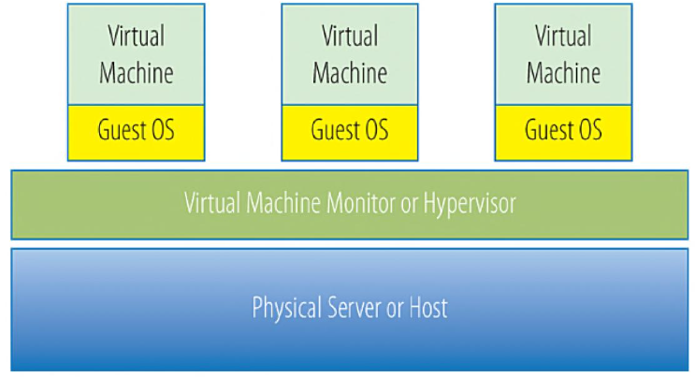
Figure 2. Type 1 and Type 2 hypervisor architecture.[2]

ip ADDRESSING

2.1
Information is sent over the Internet in tiny pieces of data with the addresses of the sender and receiver. Each packet is sent to the proper device regardless of the route traversed when transmitted. It's also worth noting that routers send packets to another network to ensure that the data is transmitted to the correct network, and also maintain the direction that the data is intended to go in, or out of, the network, whereas switches are used to forward data between devices within a local network. They work together to make devices communicate efficiently, reliably and make it to the intended destination. [4]

2.2
Routers and switches are employed together to ensure the smooth flow of data through the Internet. A switch that connects devices in the same LAN (Local Area Network), it only forwards traffic to the target device, allowing it to reduce the amount of unnecessary traffic in the LAN using the MAC address. A router, on the other hand, is a machine that is utilized to associate two exceptional systems and move information packets to their right destinations based on the IP address. Routers can determine the fastest path for data to travel from network to network, which lets data cross the Internet. Switches manage local data traffic, and routers control data traffic between networks, thus increasing data transmission reliability and efficiency [cisco].

2.3
IP addressing enables devices on a network to communicate by assigning each device a unique address. It helps routers to decide which device a piece of data should be sent to, and ensure that data reaches the appropriate device at the appropriate time and in the correct manner. If they didn't have an IP address, devices would not be able to communicate with each other over local networks or the Internet. This system also allows efficient routing, help to minimize transmission error, and also improve the network organization, communication and performance of the network [1]. IPv4 is a 32-bit address that consists of four decimal numbers separated by periods (e.g., 192.168.1.10), whereas IPv6 has a 128-bit address, which is represented by hexadecimal numbers and colons (e.g., 2001:db8::1). Subnetting breaks up a large network into smaller subnetworks to enhance performance, security, and address management. A proper IP address management system would minimize waste and ensure an adequate number of addresses for devices especially when more devices are added on to the Internet [6].

Routing

3.1
Routing protocols help routers decide the best path for sending data from one network to another. Their main purpose is to make sure information reaches the correct destination quickly and efficiently. Static routing is set up manually by a network administrator, making it a good choice for small networks that do not change often. In contrast, dynamic routing automatically finds and updates the best routes when the network changes, making it more suitable for large or growing networks. Overall, dynamic routing is more flexible and requires less manual maintenance than static routing [7].

3.2
For this network topology, I think dynamic routing is the better choice. Since the Debian Server acts as a DHCP Relay, it needs good communication with the Windows Server so that DHCP requests can be forwarded without interruption. If the network grows or changes, dynamic routing can automatically update routes. While static routing can work in small, simple networks, dynamic routing provides greater flexibility, reliability, and easier management. This makes easier solution for maintaining stable connectivity between the Debian Server, Windows Server[7].

Network services

DHCP is the service that automatically gives devices their IP addresses and network configuration. So we can avoid to manually assigning settings to every computer, DHCP ensures devices get the correct address, gateway, and DNS information the moment they join the network so makes everything easier for the user . This reduces errors and makes network management far easier.
Active Directory Domain Services (AD DS) is the backbone of identity and access. It stores user accounts, computers, groups, and security policies. AD DS makes it possible to manage permissions centrally, ensuring users can access the right resources while keeping unauthorized access out.[8]
Certificate Authorities (CAs) provide digital certificates that prove identity and secure communication. They help encrypt data, validate servers, and support secure authentication methods. Together, these services create a reliable, secure, and manageable network environment that supports both local and remote users.[9]
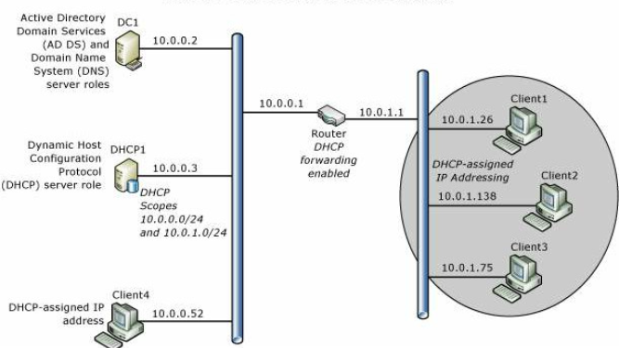
Fig.2 Core Network Overview[8]

Windows Server 22 Installation
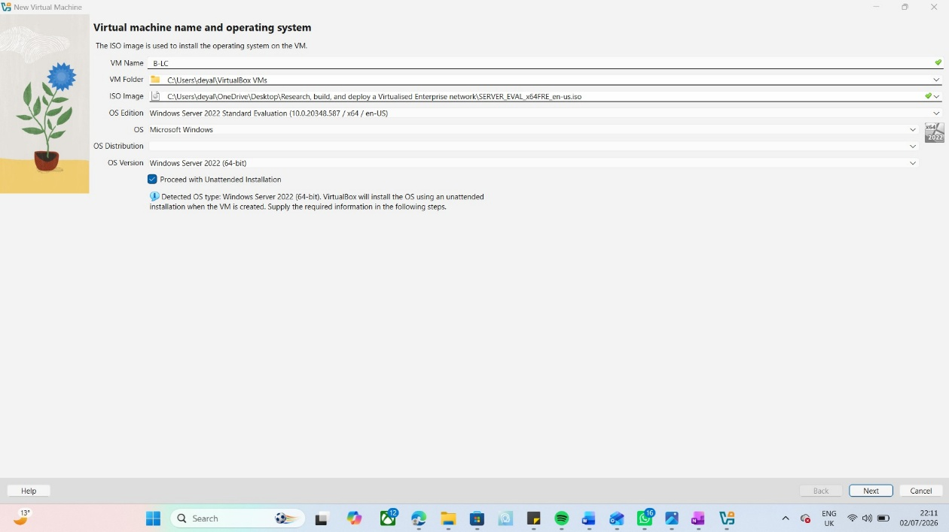
1.A new virtual machine was created in Oracle VirtualBox by selecting the Windows Server 2022 ISO image. VirtualBox automatically detected the operating system and prepared the virtual machine for installation. (Note: we need to uncheck unattended installation )
We began the Windows Server installation by copying the necessary files and analyzing and preparing the operating system for installation. This setup performed this work within it automatically.
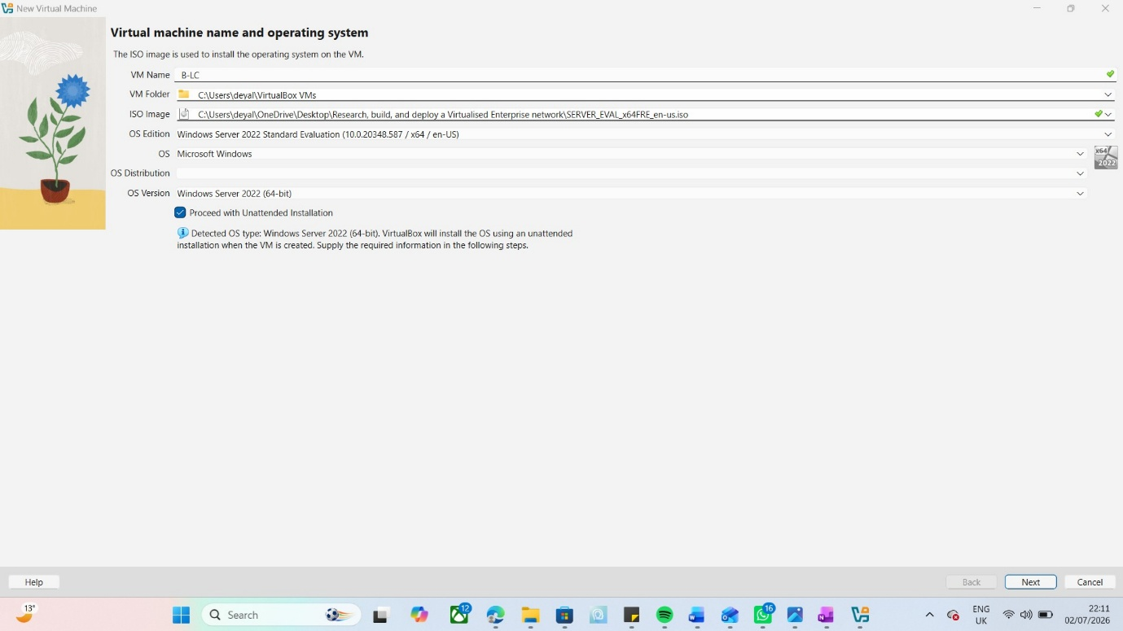
2. The virtual machine hardware was configured by allocating 2 GB of RAM, 1 virtual CPU, and a 50 GB virtual hard disk, providing sufficient resources to install and run Windows Server 2022.( Note: depending on the user and needs, we need to allocate the resource based on the project and the host limitation )

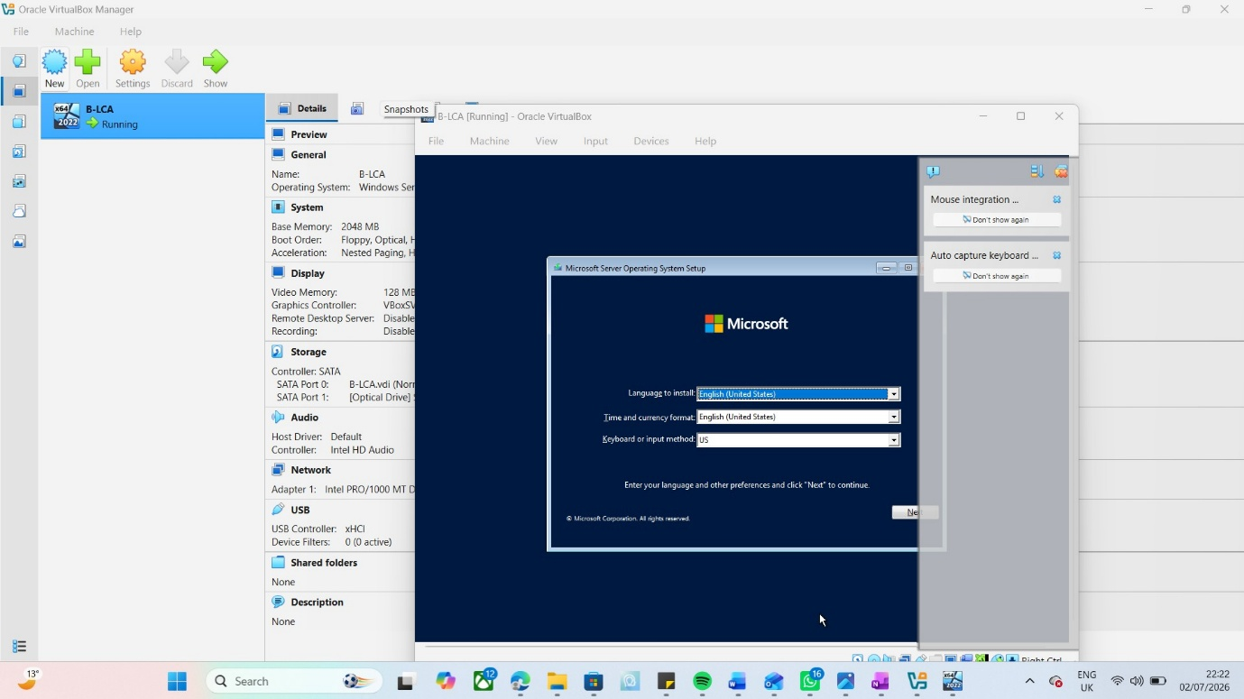
The installation process began by selecting the preferred language, time and currency format, and keyboard layout before proceeding with the Windows Server setup.
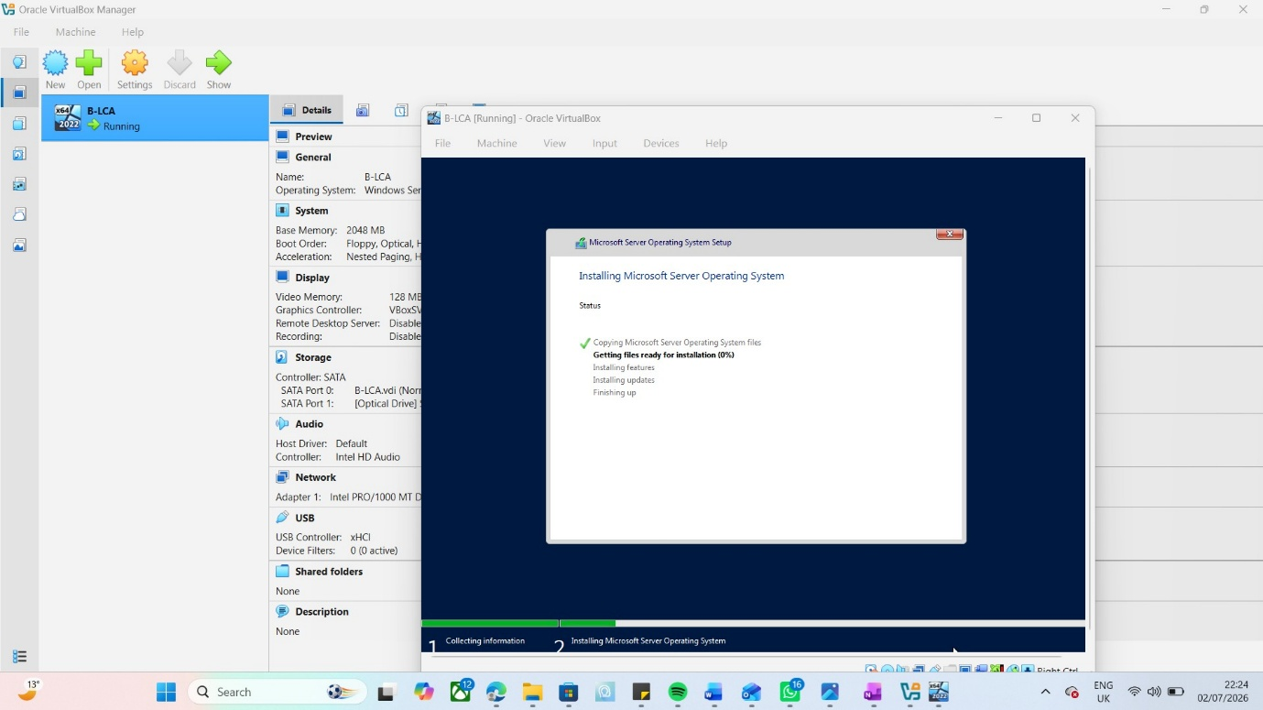
The Windows Server 2022 Standard Evaluation (Desktop Experience) edition was selected because it provides a graphical user interface, making server management easie

Windows Server installation started by copying the required files and preparing the operating system for installation. The setup completed these tasks automatically.
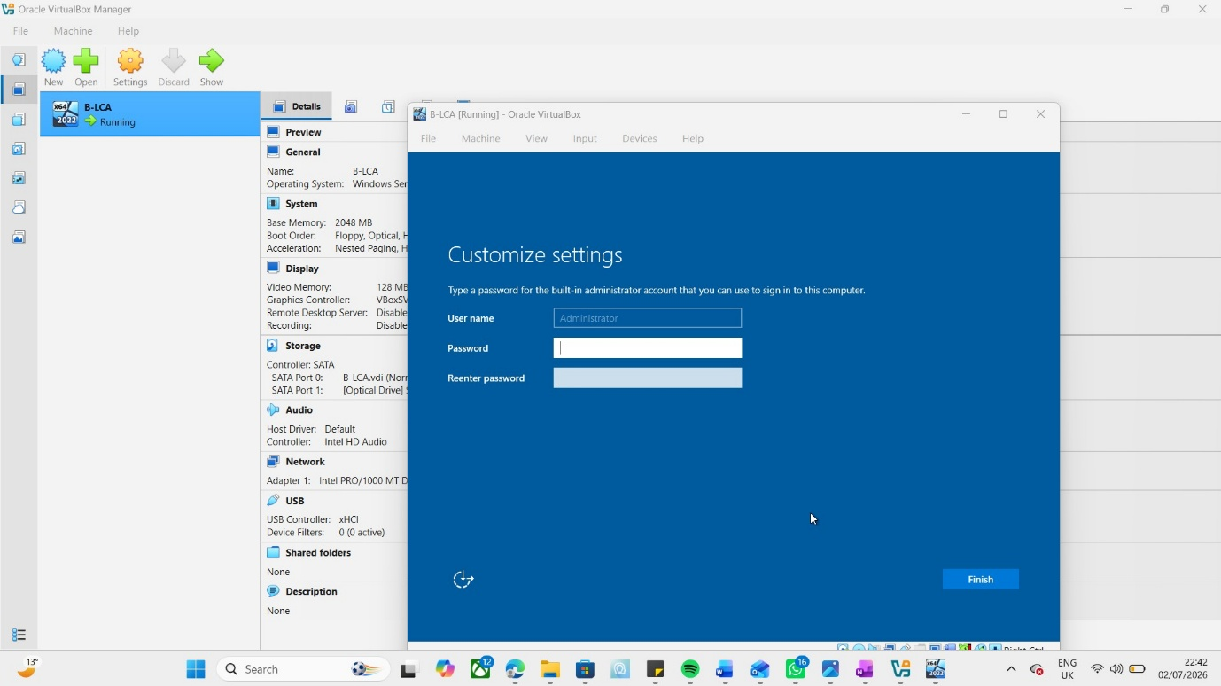
After the installation was completed, a secure password was created for the built-in Administrator account, finalising the setup and preparing the server for use.[5]

Windows client installation
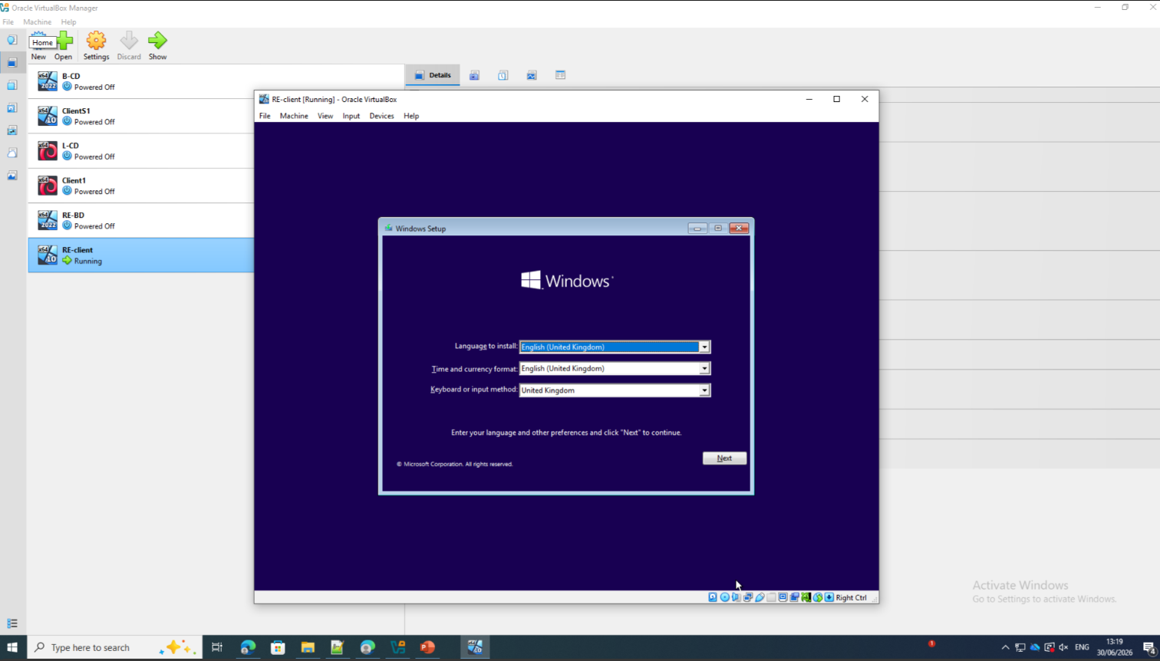
The client installation began by selecting the preferred language, time and currency format, and keyboard layout. After confirming these settings, the setup wizard proceeded to the next stage of the installation.
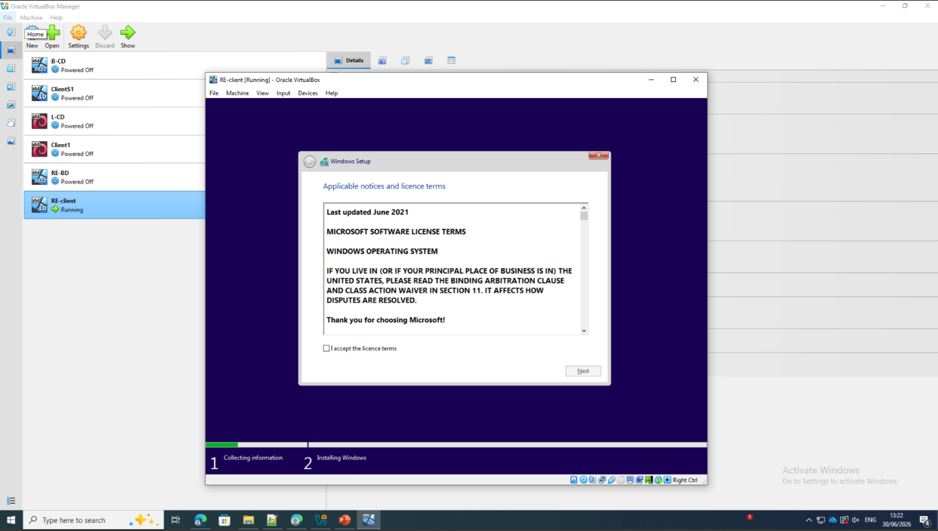
The available virtual hard disk was selected as the destination for the operating system installation. Once the installation location was confirmed, the setup wizard continued by preparing the system files for installation.
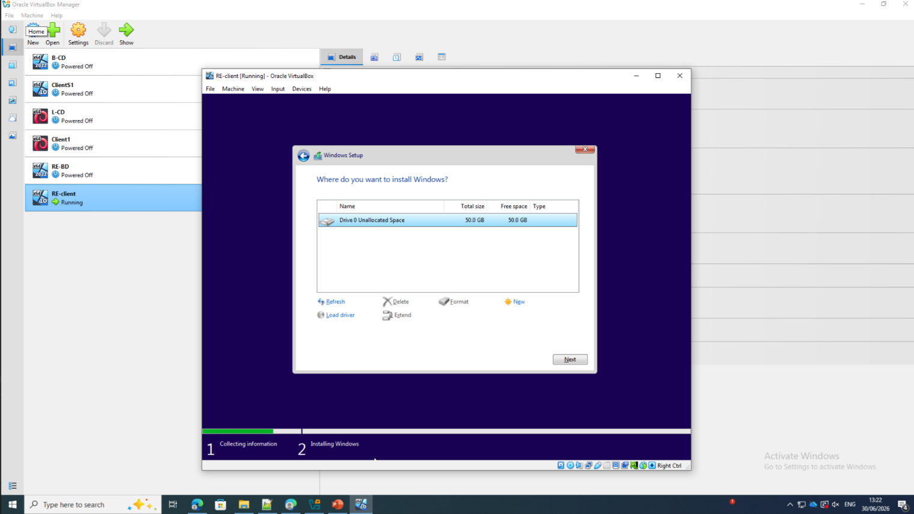
Before continuing with the installation, the software license agreement was reviewed and accepted. This step allowed the installation process to proceed to configuring the operating system.
Installing the Operating System
Once the installation location was selected, the setup wizard automatically began installing the operating system. During this stage, the required files were copied to the virtual hard disk, and the system was prepared for first use.
Completing the Installation
After the installation was complete, the virtual machine restarted automatically to apply the changes. The system then finished configuring the remaining settings needed before the operating system could be used.
Configuring the User Account
The setup wizard prompted for the creation of a user account and other basic settings. These details were completed to personalize the system and prepare it for everyday use.
Access Desktop
Once the configuration was finished, the user signed in to the operating system for the first time. The desktop environment was displayed, confirming that the client installation had been completed successfully and the system was ready for network configuration.[10]

Windows server and client network configuration

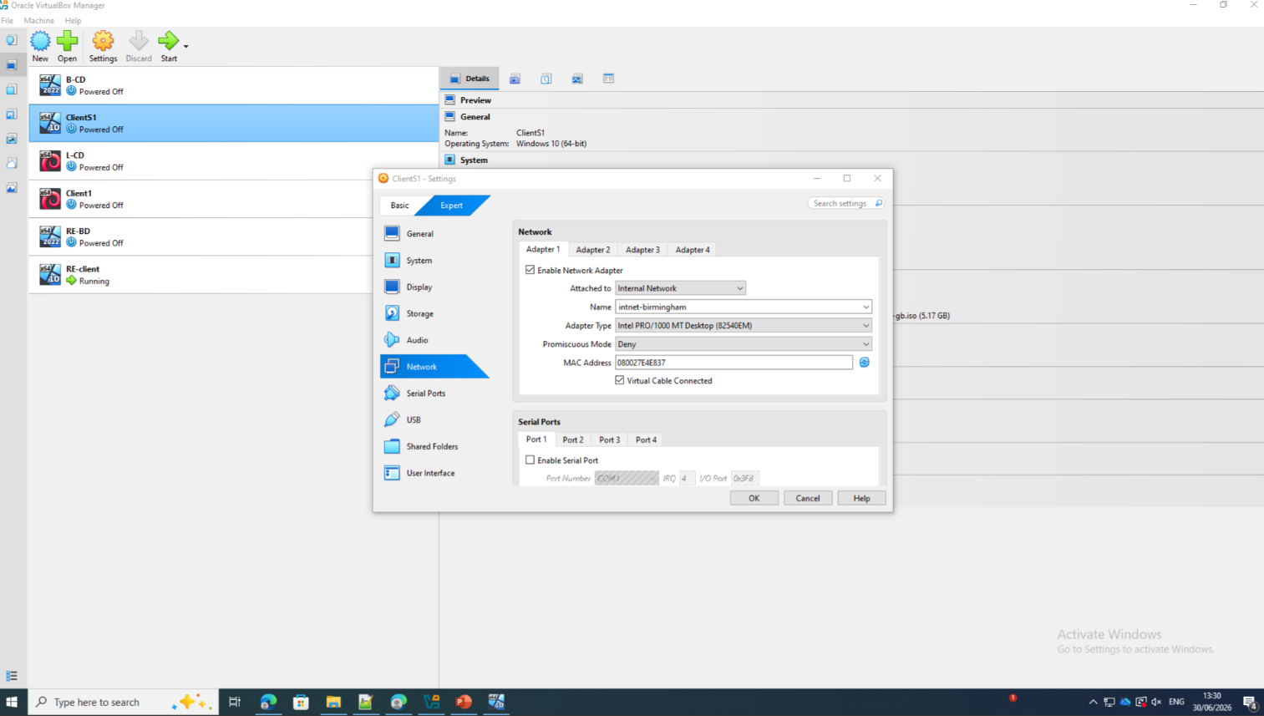

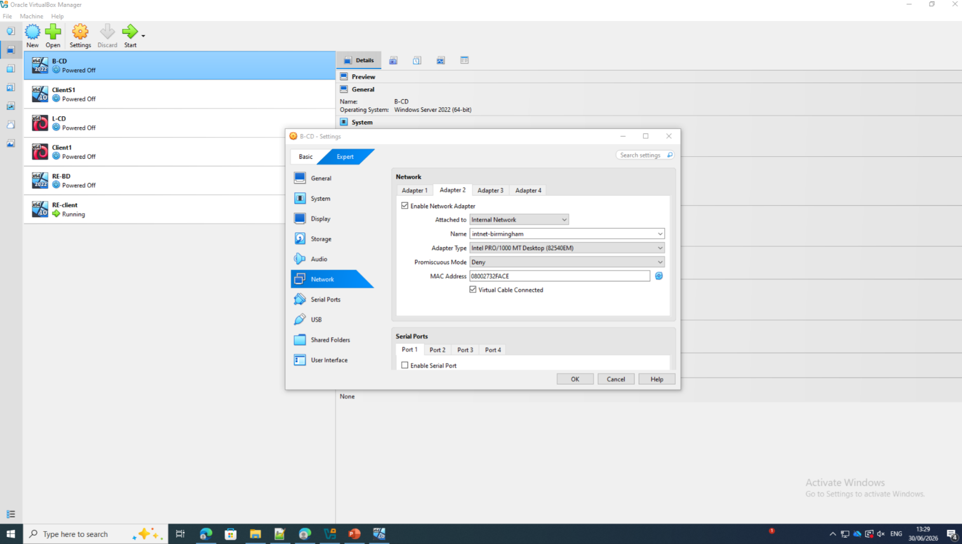

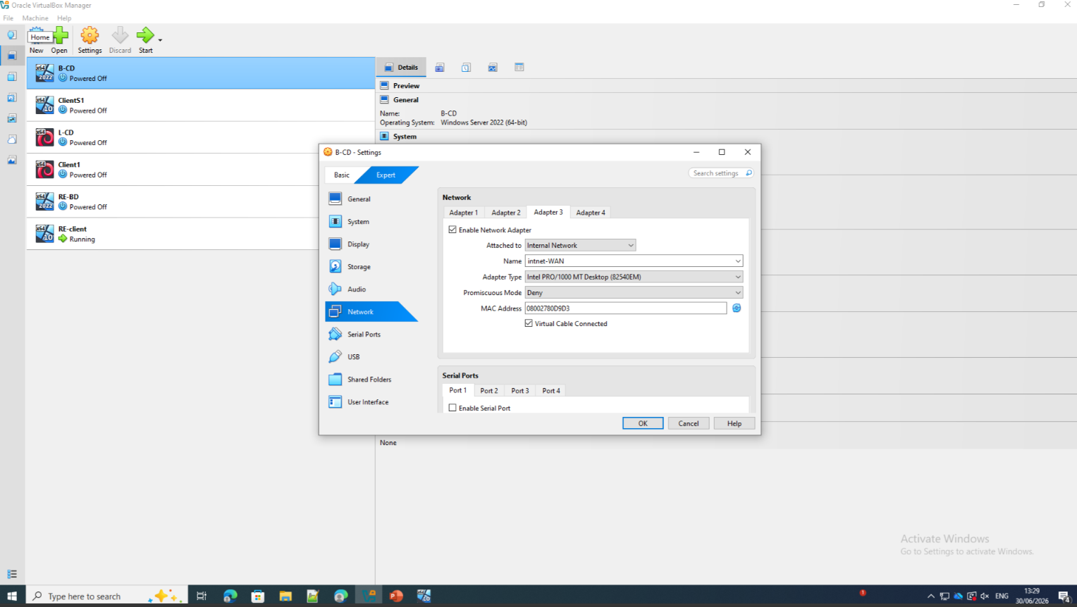
We are configuring the 3 adapters on the windows sever to have a connection with other services such as the windows sever, adapter 3 was configured at this stage

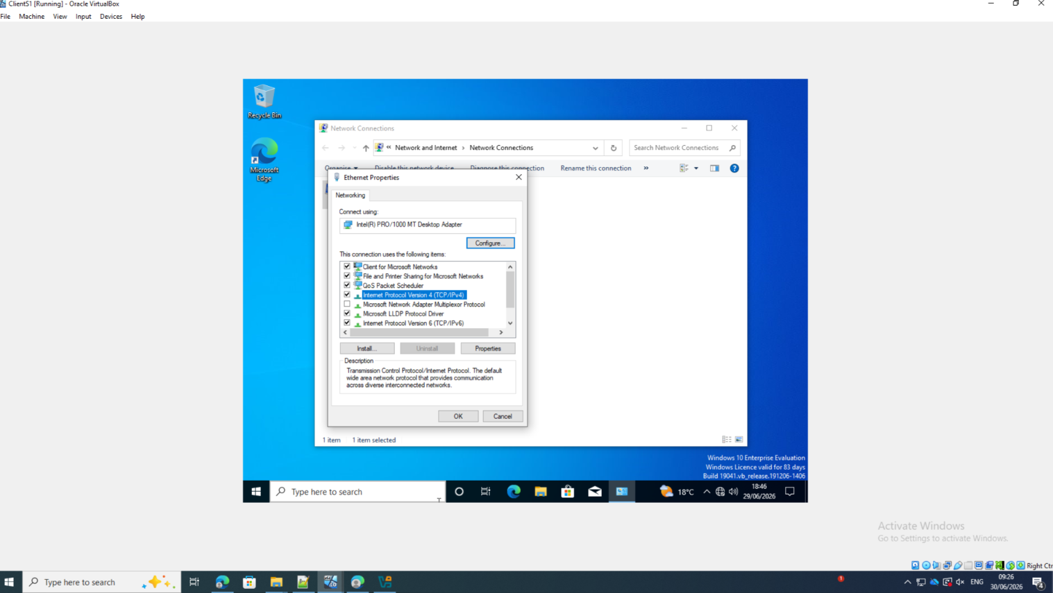
To be able to configure the connection between I’s imperative to update the IPV4 to the desire IP address, the internet configuration needs to be selected to access to this configuration.

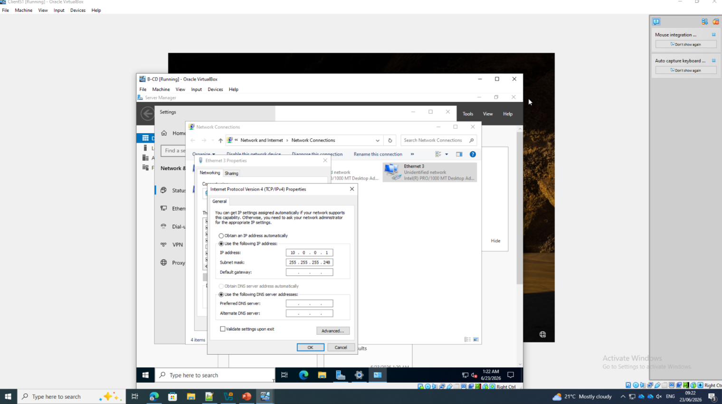
After, accessing to the configuration through IPV4, the desired IP needs to be added also the sub mask that is going to be configured for this process, both operating system needs to be on the same communication channel .

Windows client and server testing

Client
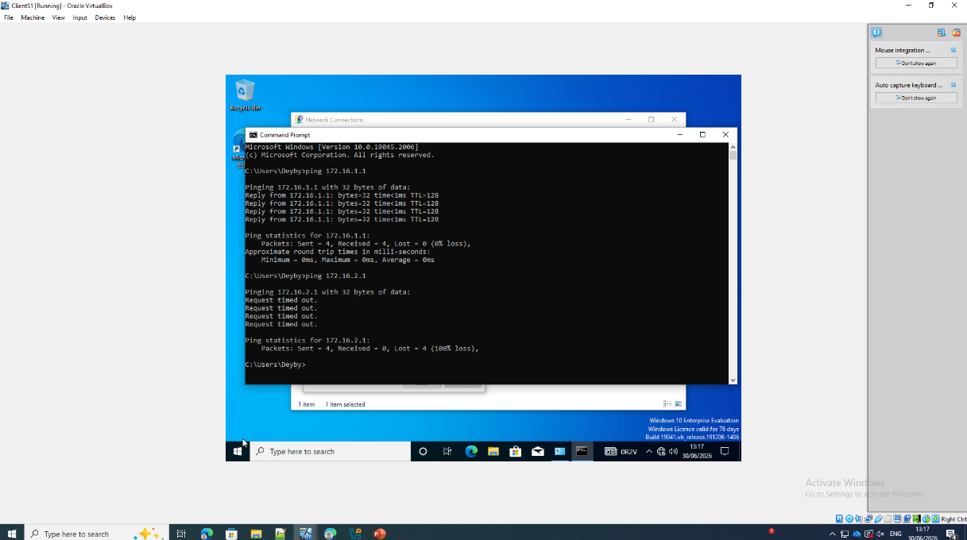
At this stage of testing the connection or communication was stablish between client and server and there is not communication outside the internal network

Windows Server
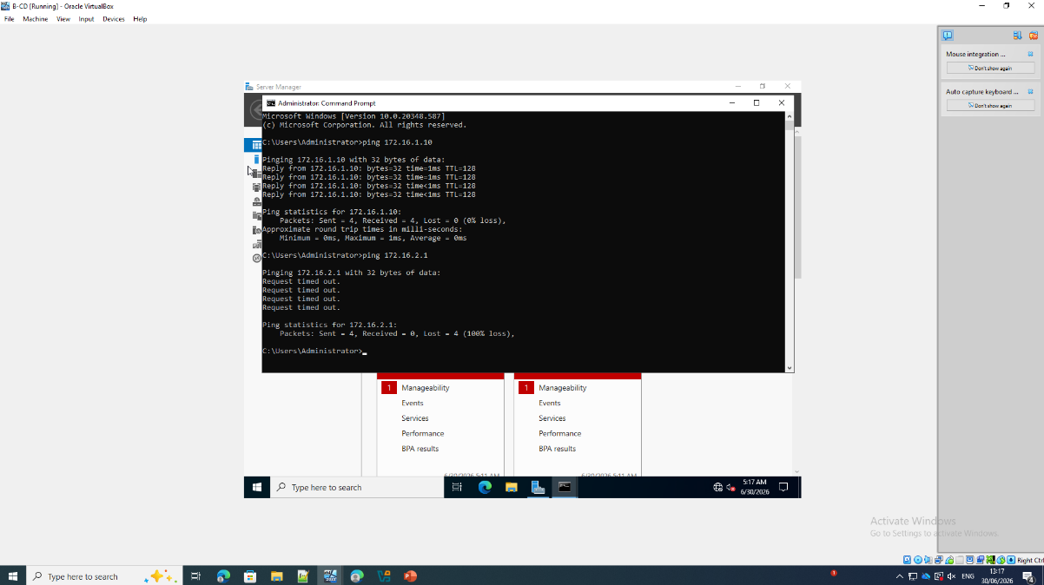
At this stage of testing the connection or communication was stablish server client and client and there is not communication outside the internal network

Debian Server

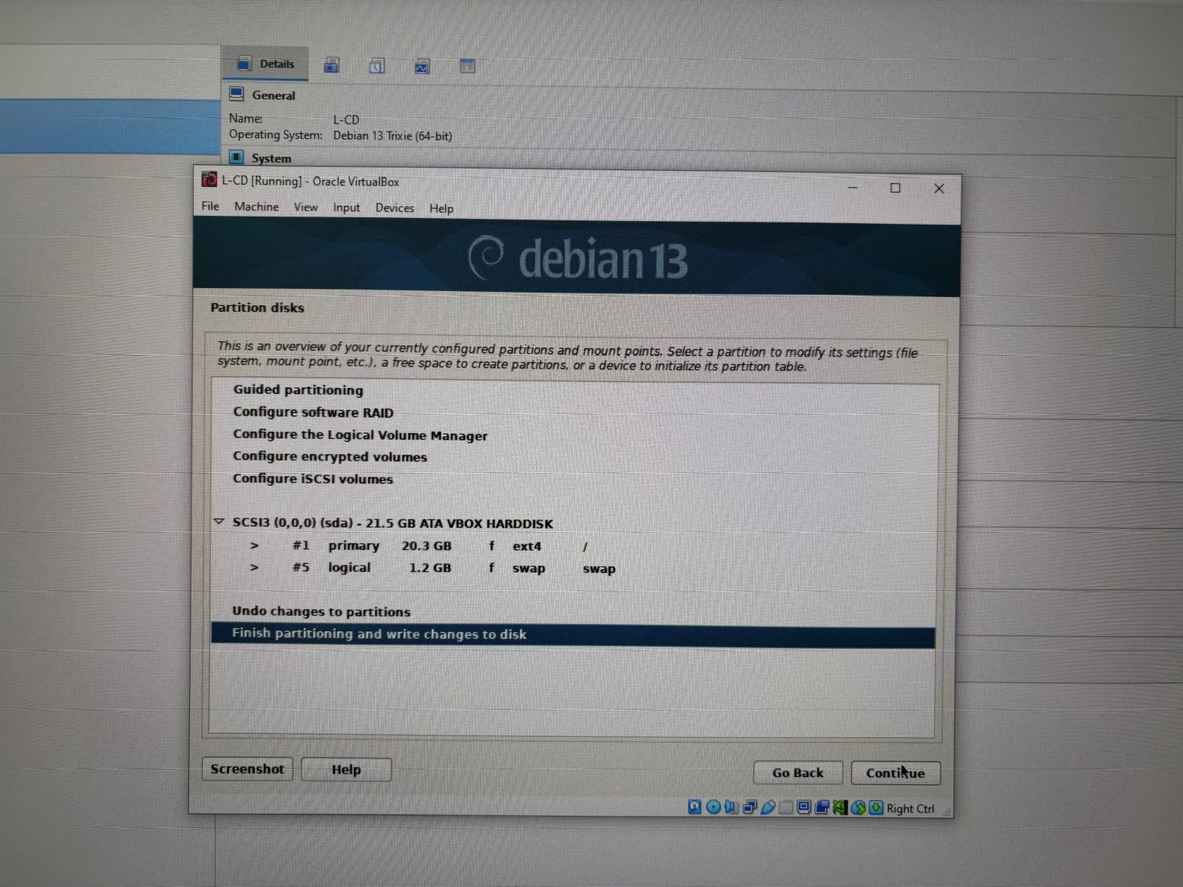
The virtual machine was booted from the Debian installation media. The Start Installer option was selected to begin installing the operating system on the virtual machine.

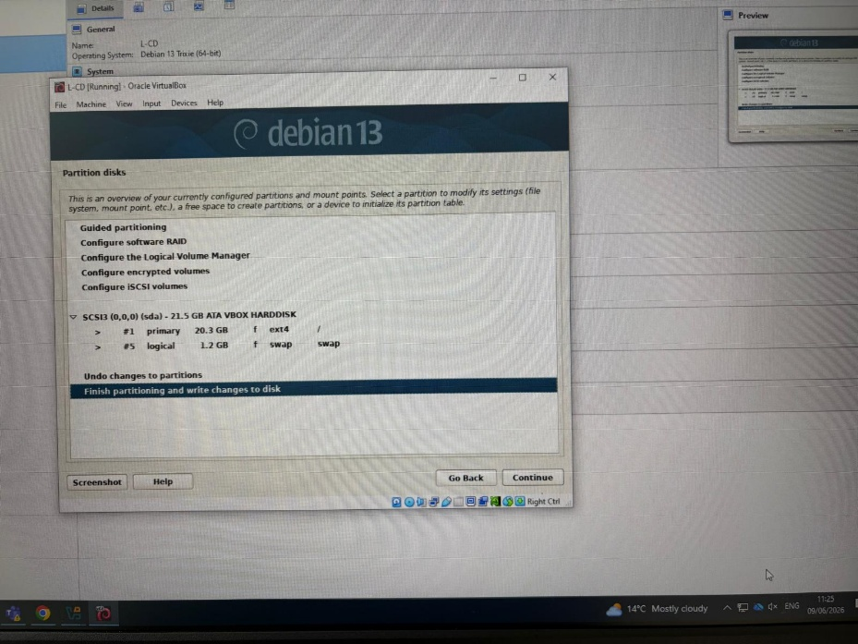
The graphical installation mode was selected to provide a user friendly interface for completing the installation. This option simplifies the setup process by guiding the user through each configuration step.
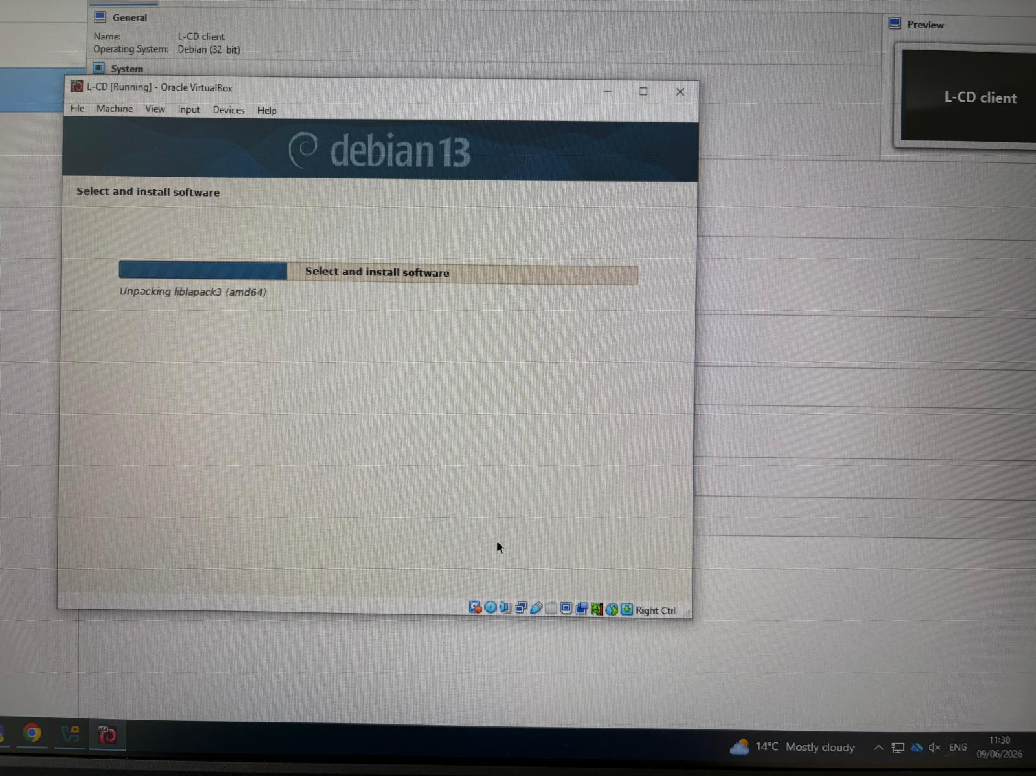
After confirming that the partition layout was correct, the changes were written to the virtual hard disk so the installation could continue.
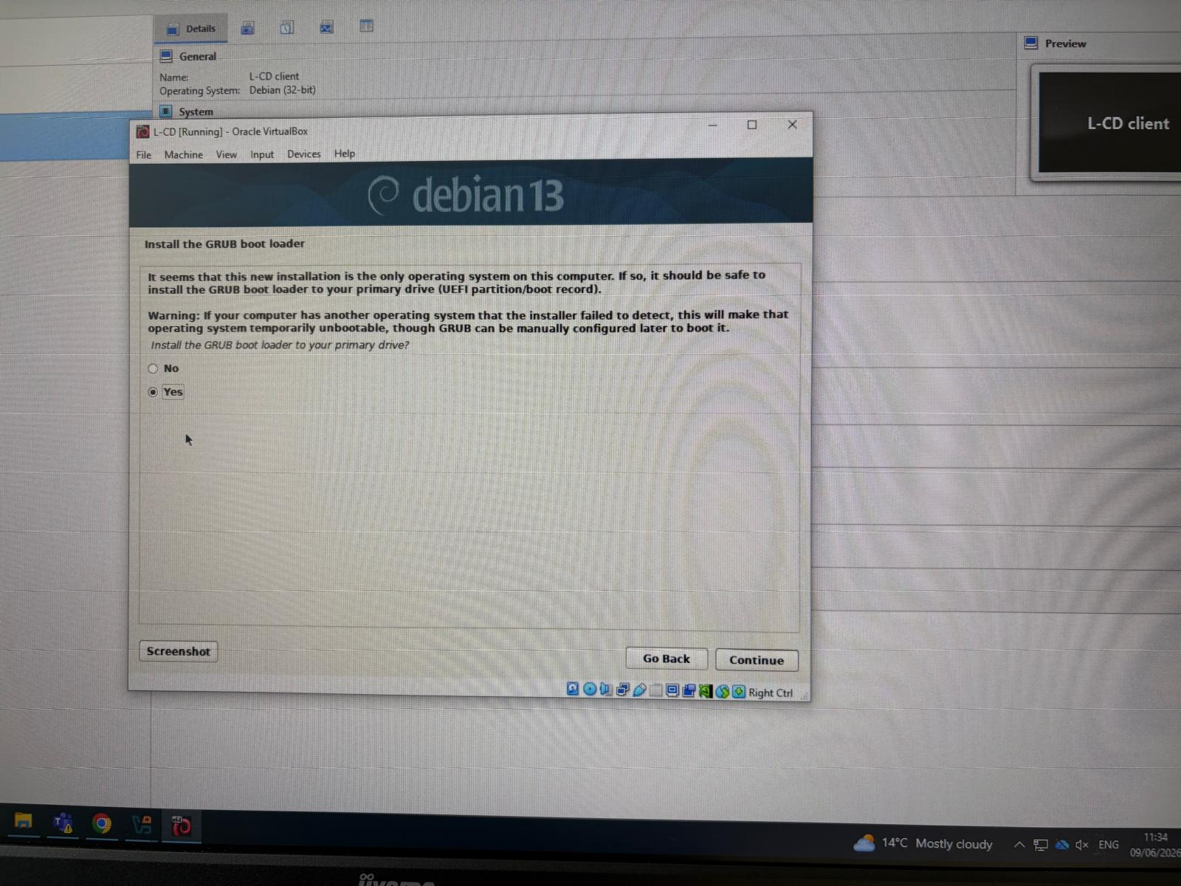
The GRUB boot loader was installed on the primary virtual hard disk. This allows the virtual machine to start the operating system correctly each time it is powered on.

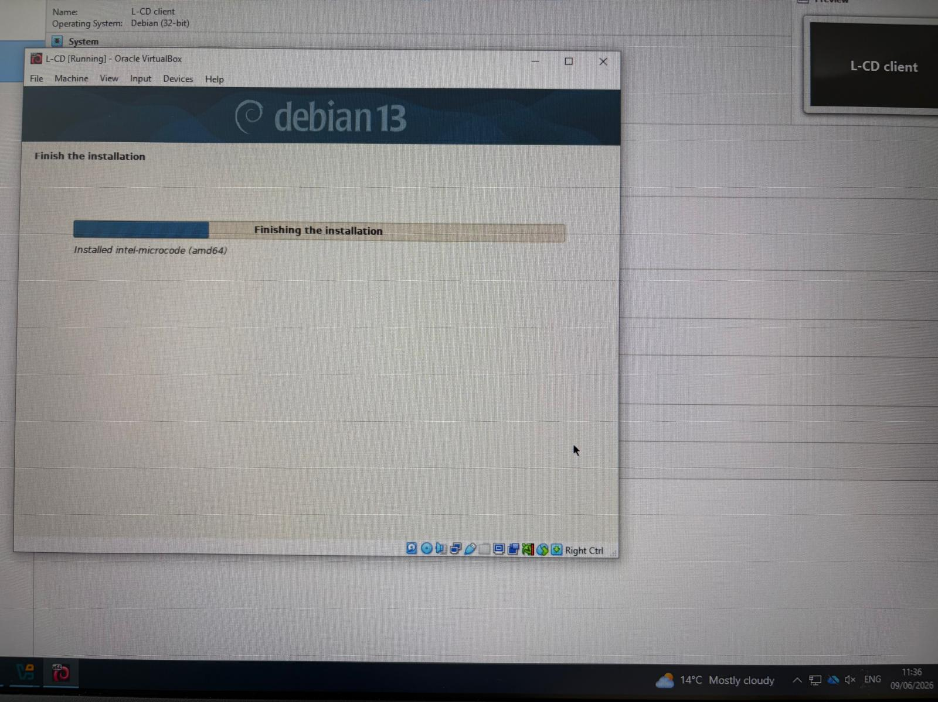
Waiting for the installation to be completed and the configuration taking place.
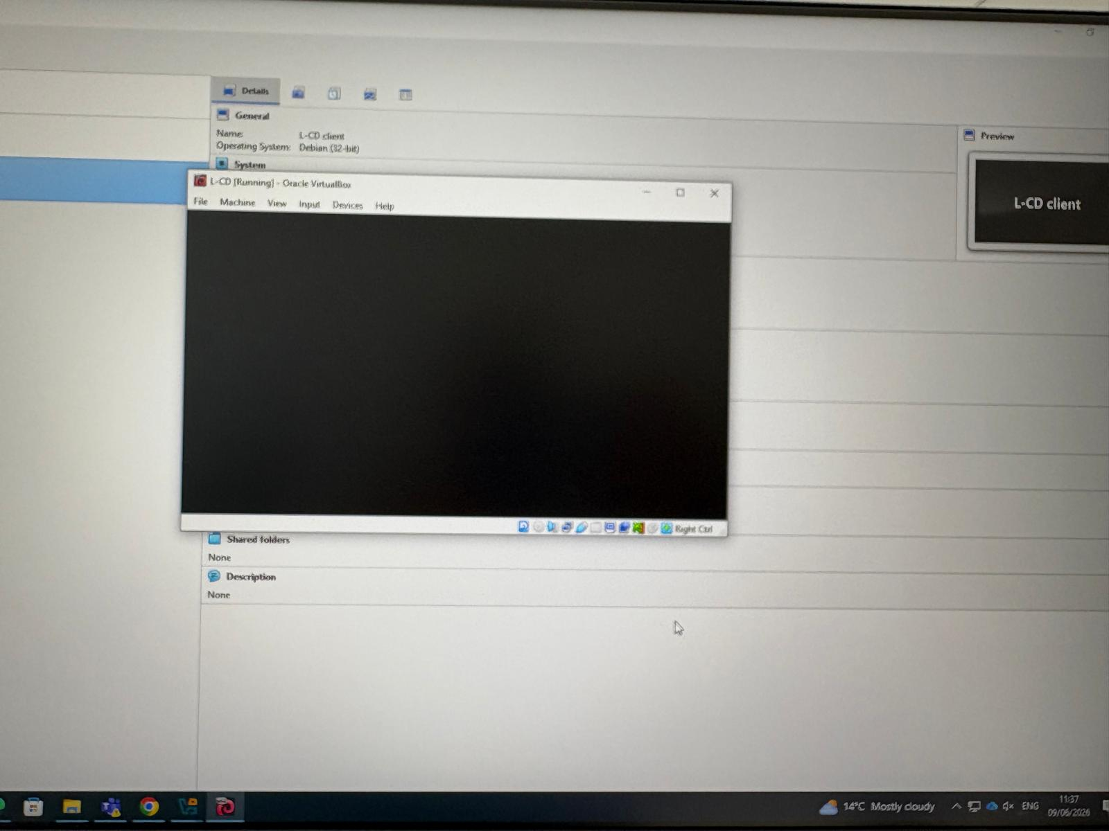
Configuration completed, after the configuration is completed, it just needed to write the password that was selected during the set up process to access to the system .

Debian Client
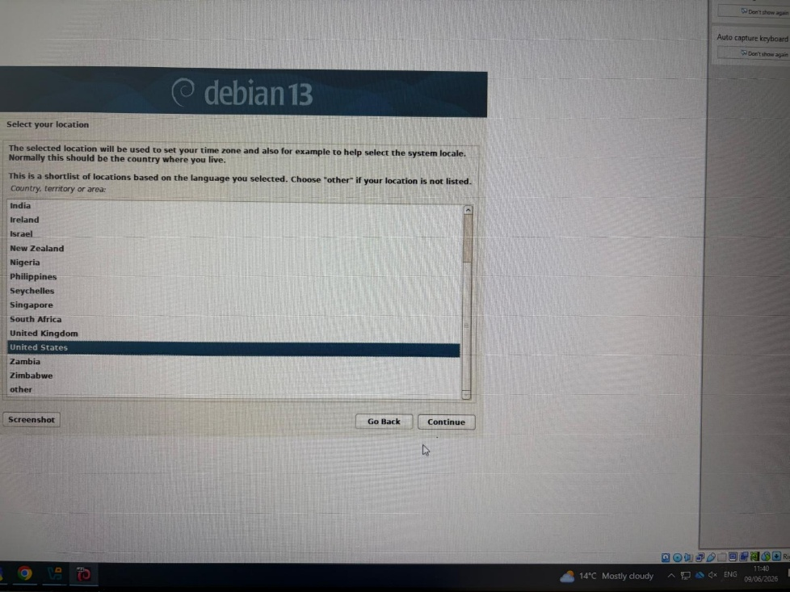
The country needs to be selected where the system will be used. This allows the installer to automatically configure the correct time zone and regional settings, ensuring the operating system is set up according to the selected location before the installation continues.
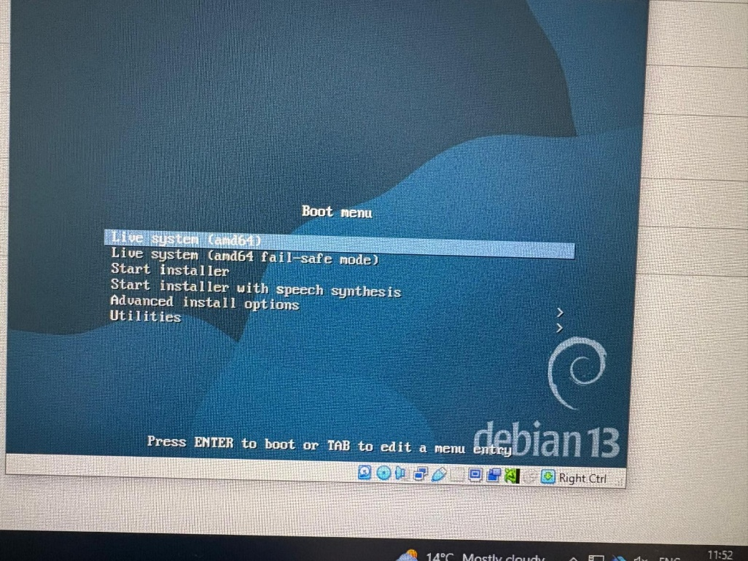
Boot menu was displayed. From the available options, the appropriate boot mode was selected to begin the installation process and prepare the system for setup and start with the installation.
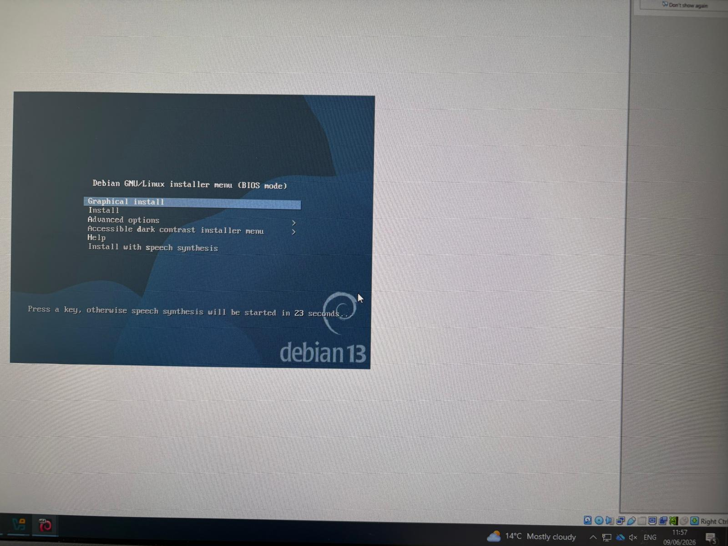
The Graphical install option was selected to begin the operating system installation using a Graphical interface. This option guides the user through each stage of the installation, making it easier to configure the system before the operating system is installed.
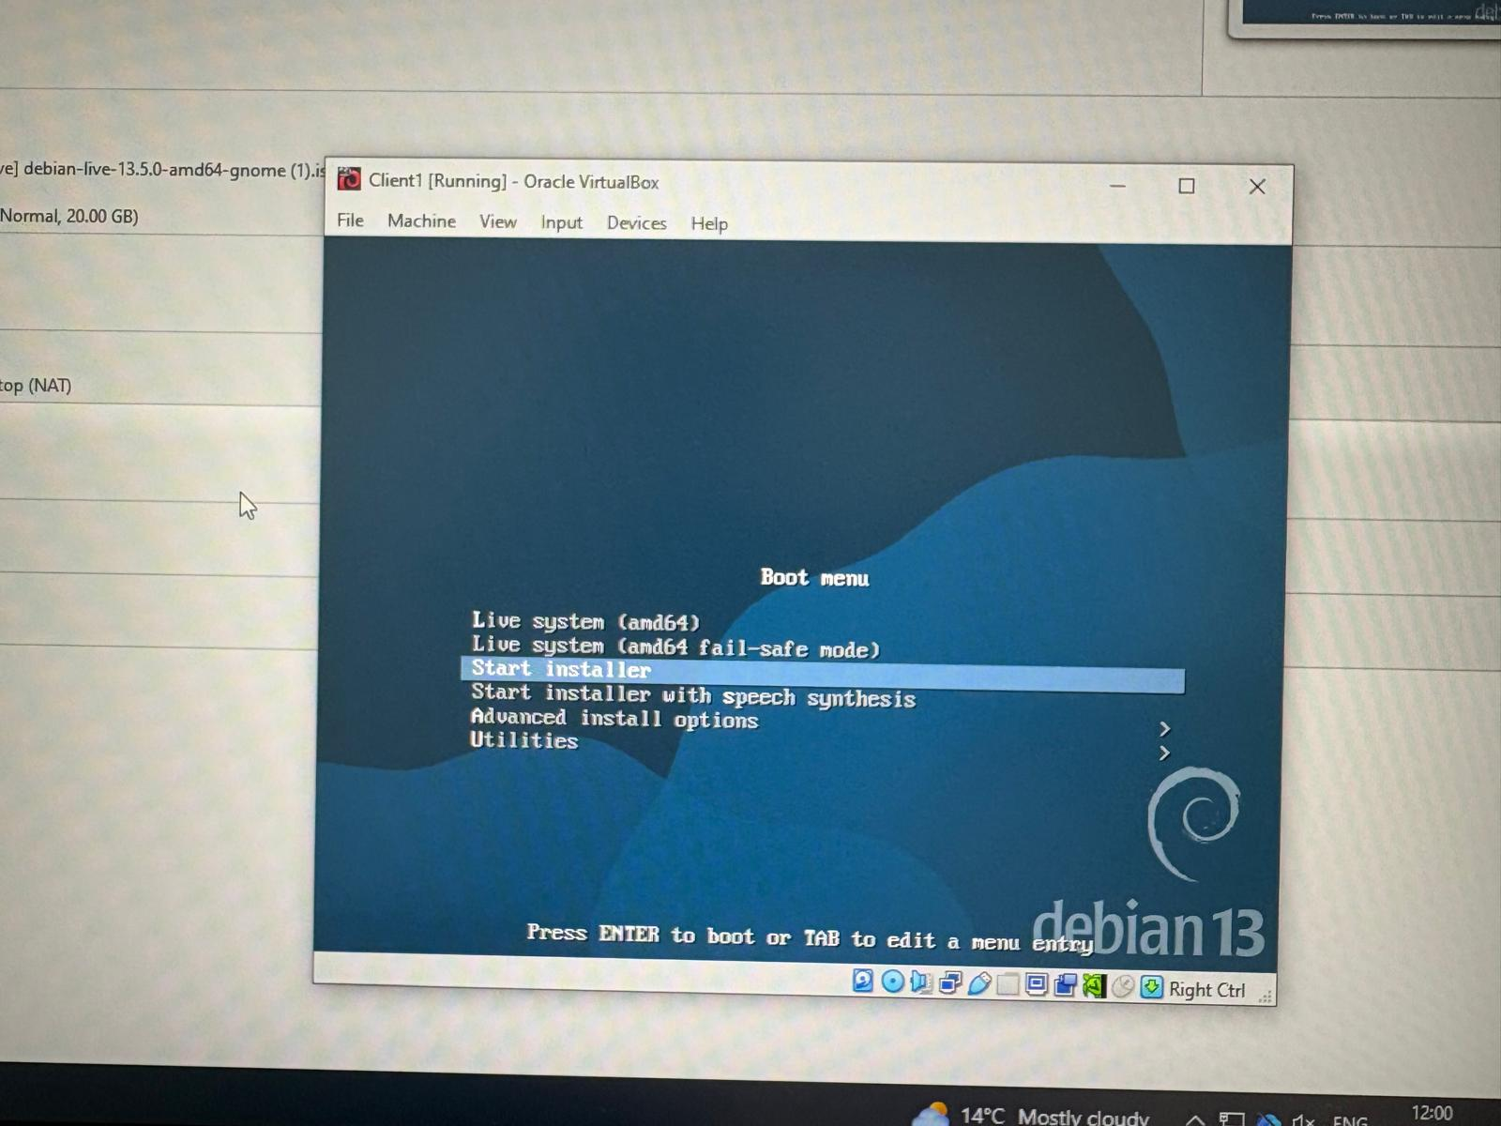
Start installer was selected to start the installation
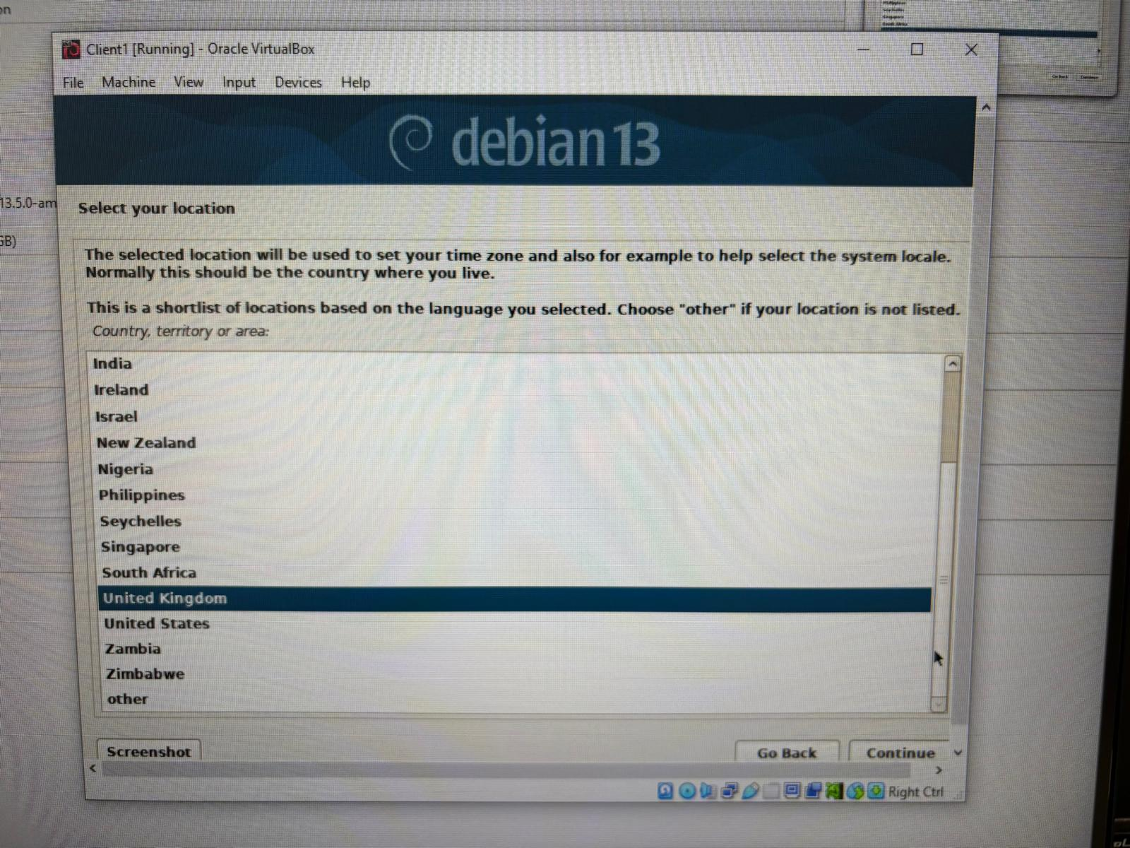
Country where the system will be installed and used needs to be selected at this stage, for this virtual machine needs to be selected United Kingdom.
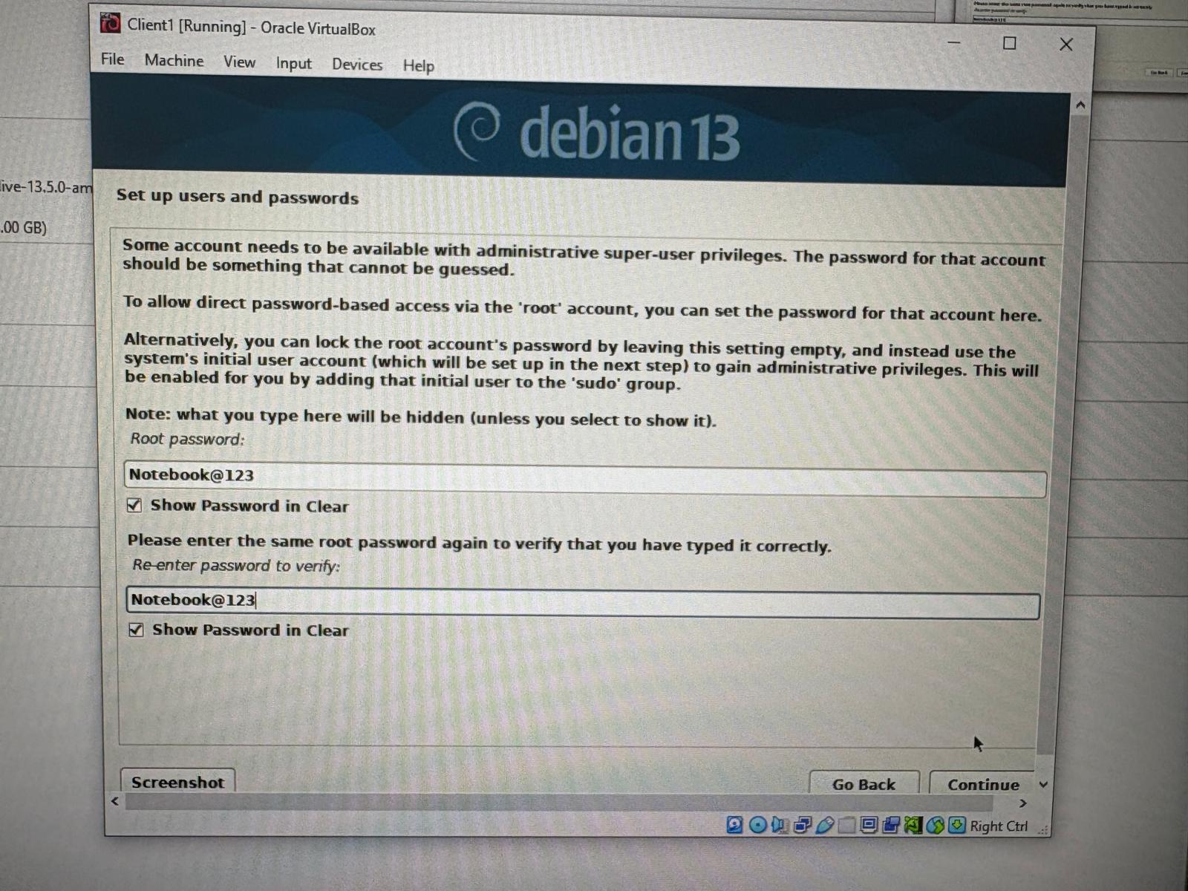
At this stage the installation process is asking the password that will be added to virtual machine in this case the client, password need to be added allowing the user to access to the machine.
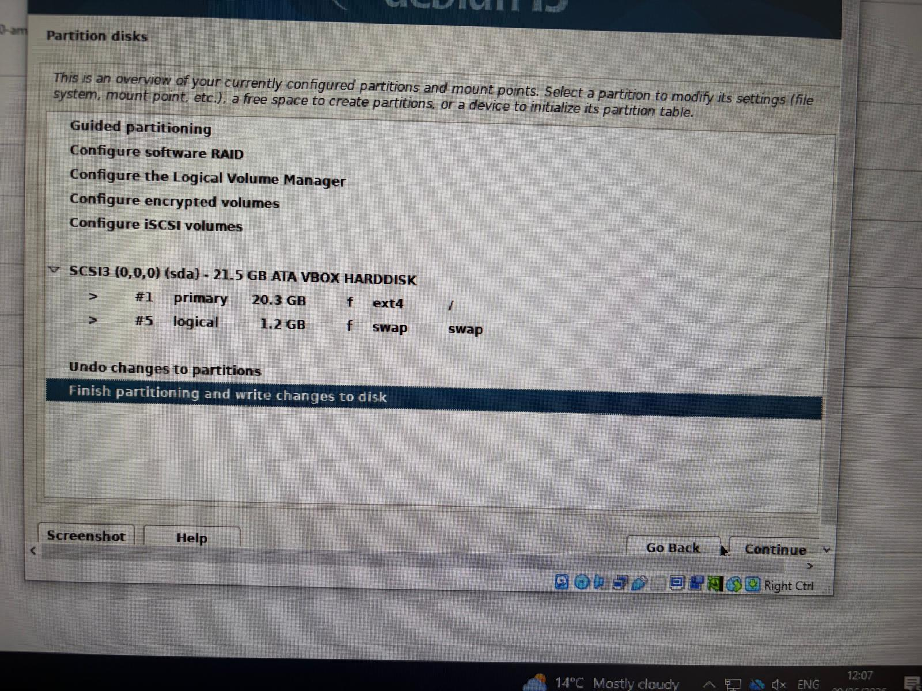
Before the installation continued, the partition settings were reviewed to make sure the virtual hard disk was correctly configured. Once everything was confirmed, the changes will be taking place to the disk, allowing the installer to proceed with installing the operating system.

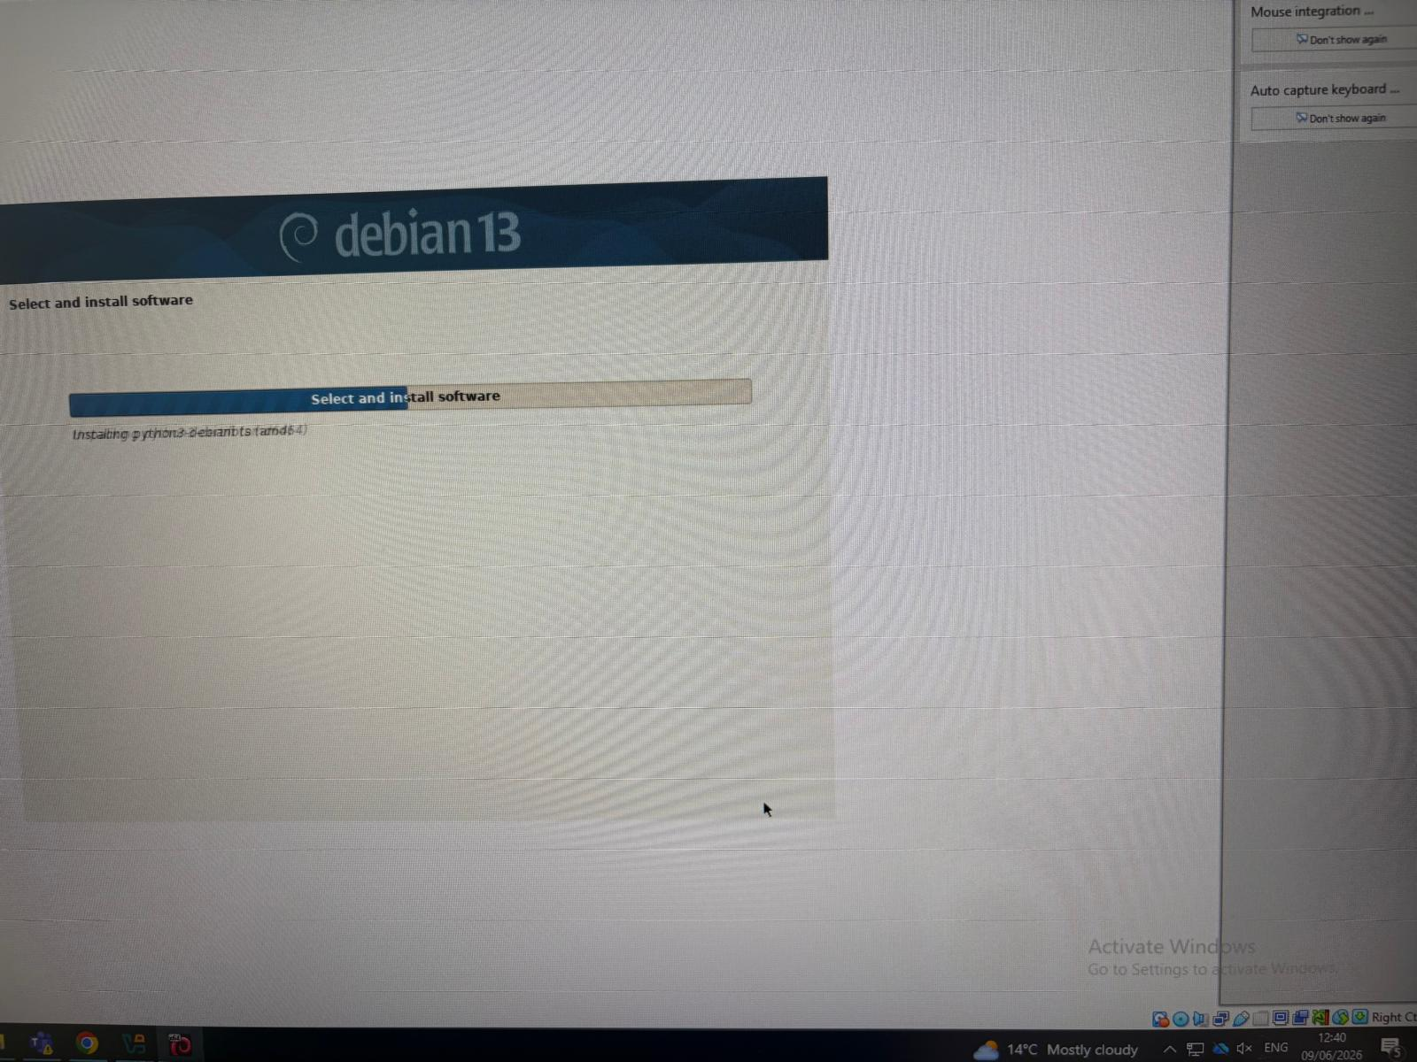

Debian server and Client NETWORK configuration
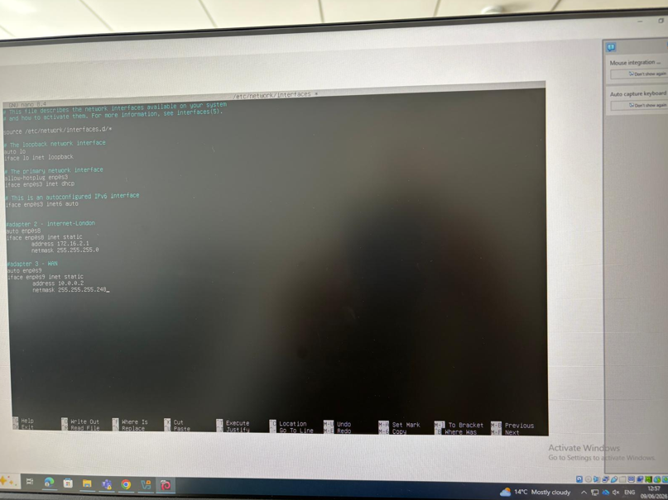
At this stage the configuration that need to be place on the client is basically needed to connect the client to the server and the following command ( source \etc\netwok\interfaces\.d/*. This allows to access to the adapters, adapter 2 and 3 were added.
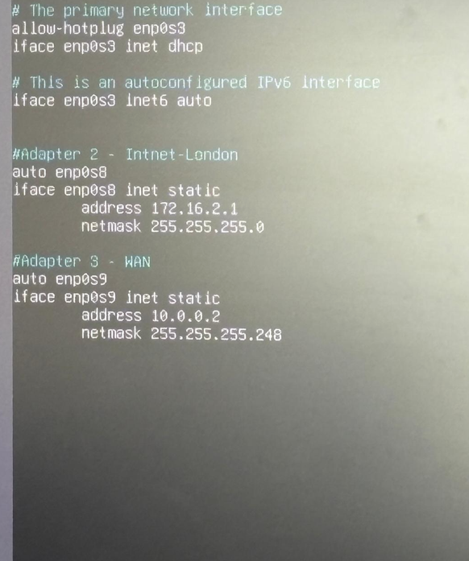

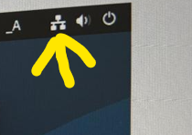
Once Debian is fully installed, that option needs to be selected.
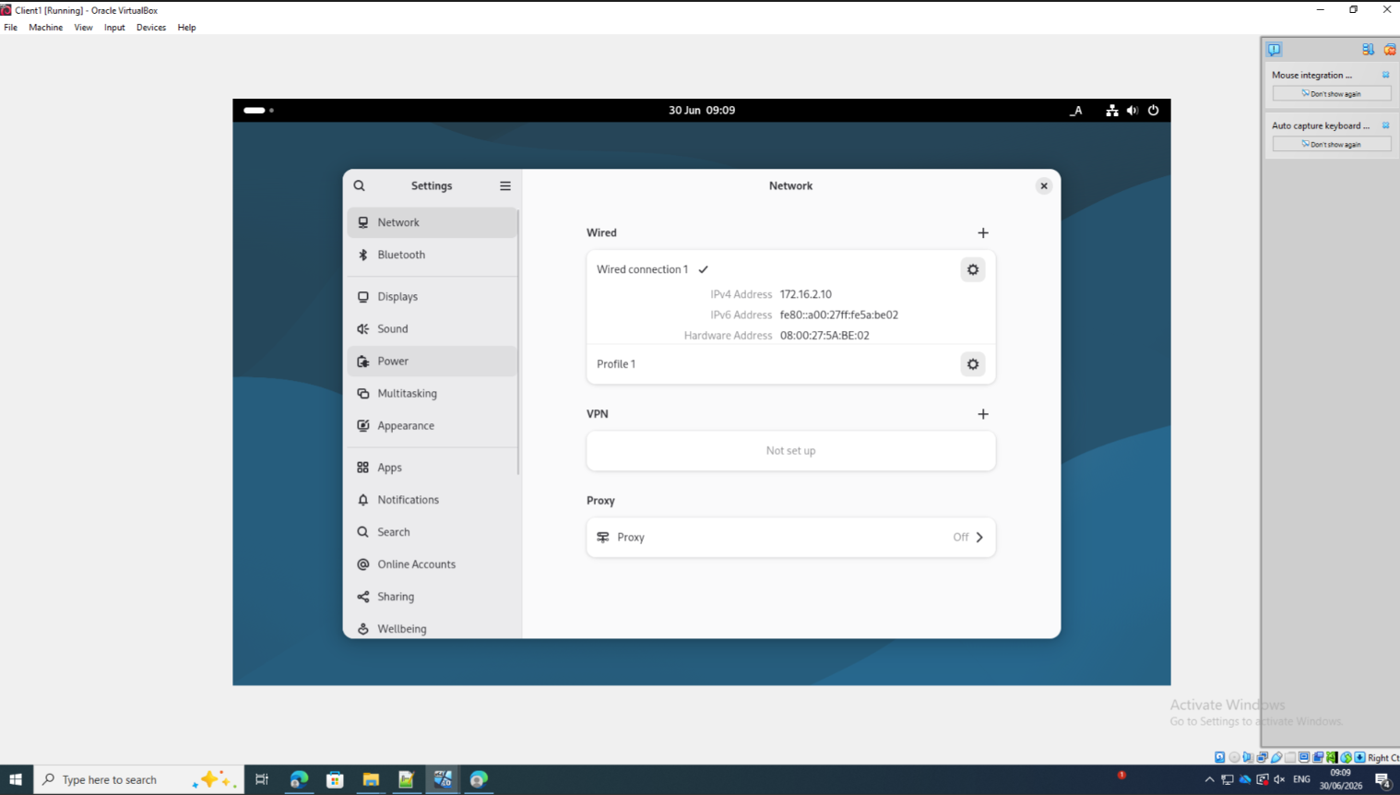
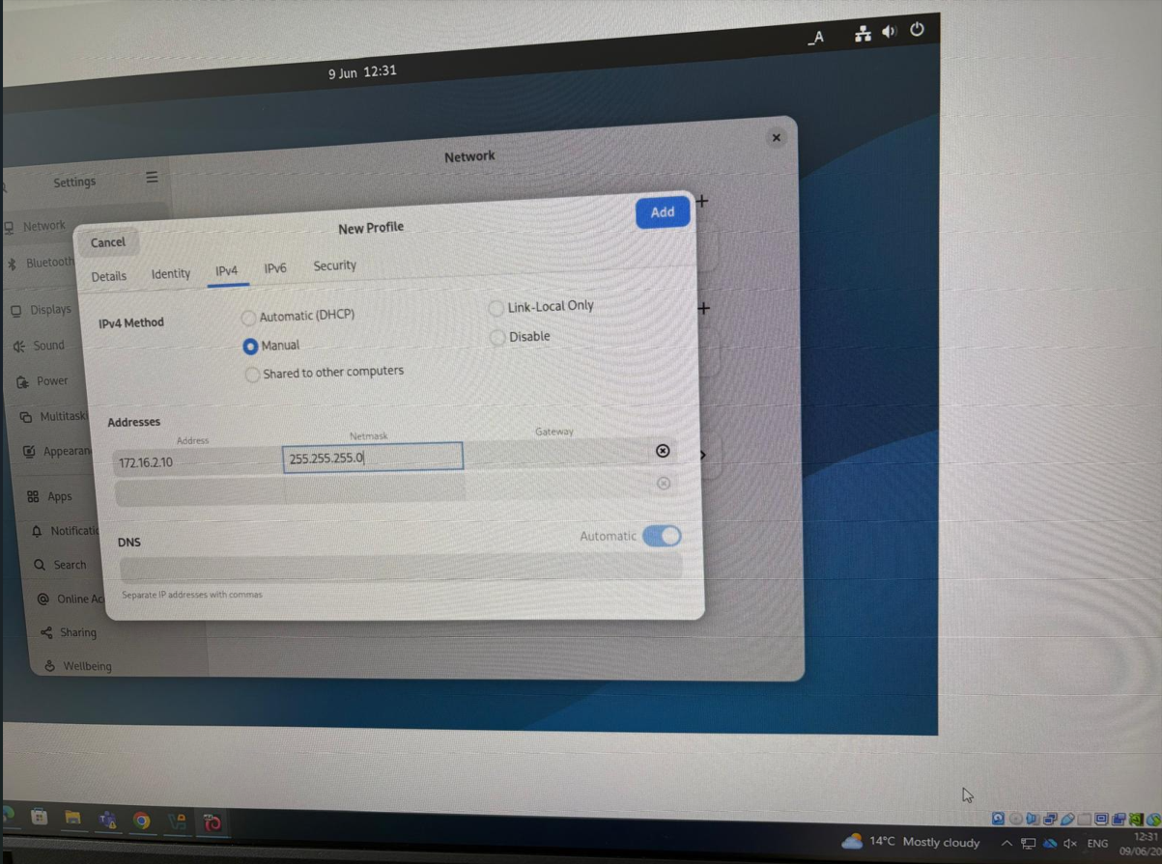
By selecting the option for network, that pop up will be displayed with the network info a gear is located at the right corner, after selecting that option, and option will be displayed on the screen IPv4, IP address needs to added and sub-mask to complete the configuration and successfully the configuration

1.3
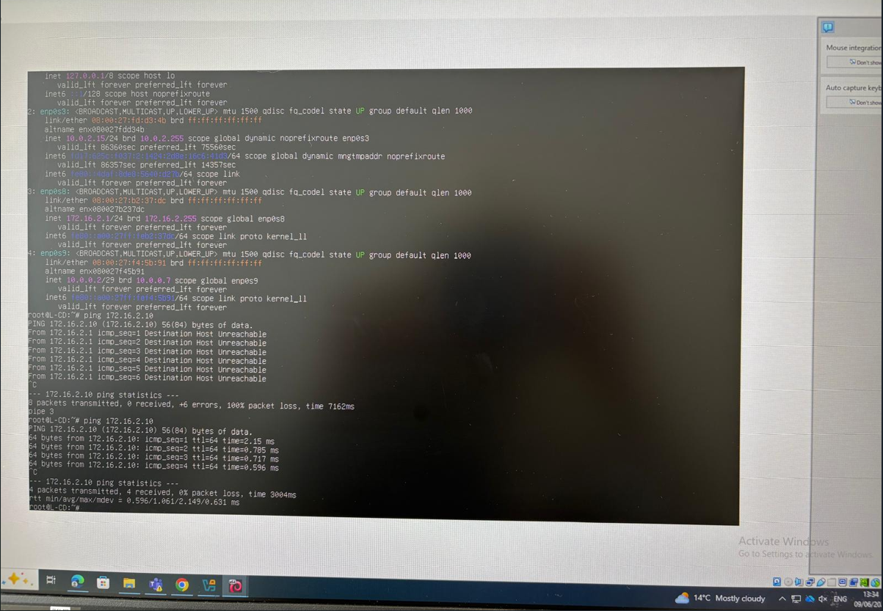
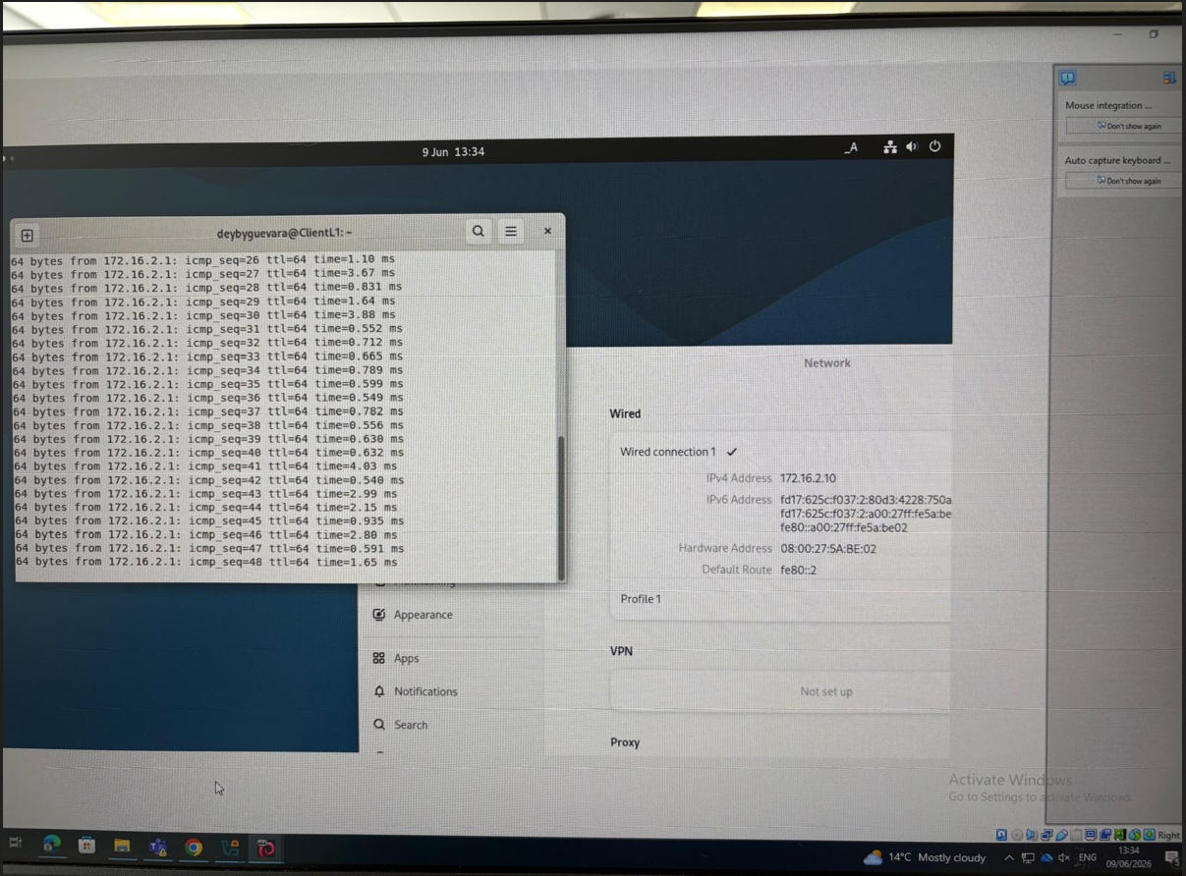
To verify if the client is successfully configured, the network needs to be configured to check if the client is configured, after the network is verified, we need to ping the client by using the command ping + IP address configured on the server, connection between client and server was successfully configured.

Reflection

3.1
Installing and testing the network helped me gain an understanding of the way different network services interact. There were a couple of problems I faced during set up such as setting the wrong IP configuration, DNS resolution problems, and some devices not communicating properly due to incompatible firewall settings. I have gone through every step of the configuration using tools like ipconfig, ping and tracert to see if I could find out why these issues are occurring. I tested the network after every change to make sure that the problem got resolved before doing further. This was a lesson for me that, if you are going to trouble shoot, you need to be systematic, and that even minute errors can have a large impact on the performance of the whole network.

3.2
This project has been a good learning experience, as it has helped me to enhance my programming skills and problem-solving methodology. The tasks helped me to understand networking concepts and became more confident to use them in a real-life scenario. I also learned that planning and paying attention to detail and testing my work carefully to make sure that everything worked as it should. When there was something difficult, I persevered and dealt with it one step at a time, improving my analysis ability. In conclusion, overall this project has boosted my confidence and helped me gain hands-on experience which will benefit my future networking projects and career.

References

[1] Amazon Web Services, "The difference between Type 1 and Type 2 hypervisors," Amazon Web Services. [Online]. Available: https://aws.amazon.com/compare/the-difference-between-type-1-and-type-2-hypervisors/. [Accessed: Jun. 24, 2026].
[2] M. Portnoy, Virtualization essentials. Hoboken, NJ, USA. John Wiley & Sons, 2023.
[3] B. Djordjevic, V. Timcenko, N. Kraljevic, and N. Macek, "File System Performance Comparison in Full Hardware Virtualization with ESXi, KVM, Hyper-V and Xen Hypervisors," Advances in Electrical and Computer Engineering, vol. 21, no. 1, pp. 11–20, 2021, doi: 10.4316/AECE.2021.01002.
[4] A. S. Tanenbaum and D. J. Wetherall, Computer Networks, 6th ed. Hoboken, NJ, USA: Pearson, 2021, ch. 1, pp. 19–25.
[5] Cisco Systems, "What Is Network Switching?," Cisco. [Online]. Available: https://www.cisco.com/site/us/en/learn/topics/networking/what-is-network-switching.html. [Accessed: Jul. 3, 2026].
[6] Cisco Systems, "What Is IP?," Cisco. [Online]. Available: https://www.cisco.com/site/us/en/learn/topics/ip/what-is-an-ip-address.html. [Accessed: Jul. 3, 2026].
[7] Cisco Systems, "What Is Routing?," Cisco. [Online]. Available: https://www.cisco.com/site/us/en/learn/topics/networking/what-is-routing.html. [Accessed: Jul. 3, 2026].
[8] Microsoft, Core Network Guide, Windows Server Networking. Accessed: Jul. 3, 2026. [Online]. Available: https://learn.microsoft.com/en-us/windows-server/networking/core-network-guide/core-network-guide
[9] SSL.com, "What Is a Certificate Authority (CA)?," SSL.com. [Online]. Available: https://www.ssl.com/article/what-is-a-certificate-authority-ca/. [Accessed: Jul. 3, 2026].

[10] Microsoft, Deploy Windows Client. [Online]. Available: https://learn.microsoft.com/en-us/windows/deployment/. Accessed: Jul. 3, 2026.
[6] Debian Project, Debian Installation Guide. [Online]. Available: https://www.debian.org/releases/stable/installmanual. Accessed: Jul. 3, 2026.

