

LEVEL 5 ASSESSMENT SPECIFICATION
Programme: | BSc Health and Social Care
Module: | Changemakers: Creativity and Value Creation
Student Name: | Cerdiyaa Khan
Student ID: | 2325009
Module code: | BMHP5014 | Contribution to Overall Module Assessment (%): | 50%
Lecturer: |  | Internal Verifier: | Dr Eleni Koutsogeorgou Andreou
Assignment Title: | Component 1: Online Portfolio of Set Exercises | Word count (or equivalent): | 2,000 words (+/- 10%)

Table of Contents
1. Task 1 – Concept Map 3
1.1 Concept Map 3
1.2 Explanation 3
2. Task 2 – Self-Reflection on the Convergent/Divergent Paperclip Thinking Activity 4
2.1 Reflective Model: Gibbs' Reflective Cycle (1988) 4
3. Task 3 - Case Study of a UK Innovation 5
3.1 Case Study: NHS App – Transforming Patient Access through Digital Innovation 5
4. Task 4 – Research Task 7
4.1 Current Issue: Mental Health Stigma and Barriers to Accessing Care 7
5. Task 5 – Podcast Script 9
5.1 Podcast Title 9
5.2 Podcast Script 9
6. Task 6 – NHS Leadership Framework Analysis 11
6.1 Summary of the NHS Leadership Framework 11
6.2 Using "Improving Services" to Encourage Creativity 12
7. Task 7 – Self-Reflection Journal Entry 13
8. References 15

Task 1 – Concept Map

1.1 Concept Map
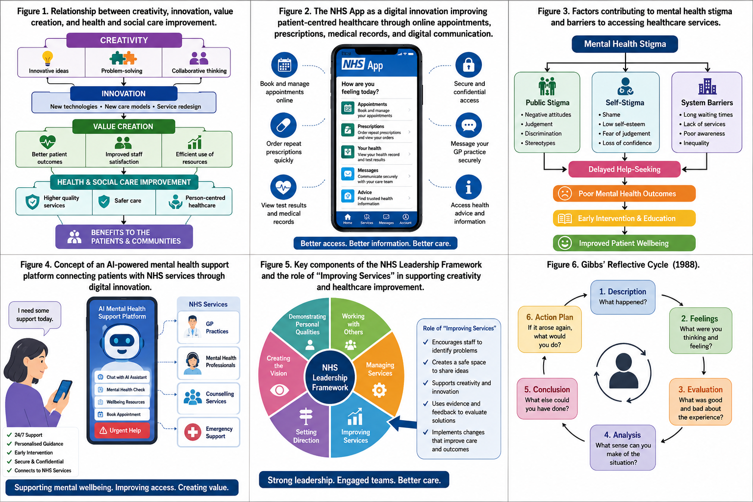
Figure 1: Concept map illustrating the relationship between creativity, innovation, value creation, and health and social care improvement.

1.2 Explanation
Innovation in health and social care begins with creativity because health professionals can use creativity to create new ideas, tackle difficult problems, and offer high-quality services. Creativity in this case means that health professionals are prompted to challenge the status quo, find ways of improving the current services, and think of innovative ways of catering to patients' needs (West and Farr, 2020).
Innovation comes about when creativity is applied successfully. Innovation in health and social care may involve such aspects as application of digital technologies, development of clinical pathways, and introduction of patient-centered models of care. Innovation, unlike change, is implemented to achieve improvements in patient safety, efficiency, and the quality of care (Greenhalgh et al., 2020).
Value creation is the result of successful innovation. In other words, value creation involves the achievement of positive results for patients, healthcare organizations, employees, and the community as a whole by efficiently utilizing available resources. Some examples of value creation include reduced waiting times, improved patient experience, increased employee satisfaction, and improved clinical outcomes due to evidence-based practice (Porter and Teisberg, 2006).
They are all inter-related, where creativity produces ideas, innovations convert those ideas into solutions, and value creation quantifies the advantages gained from those innovations. In turn, all three processes facilitate continuous improvement in the field of healthcare and social care through providing safer and more efficient services that put the interests of people first. Contemporary healthcare organizations such as the National Health Service (NHS) promote creativity and innovations as they assist in overcoming the current problems that arise, including a shortage of staff, increased demand, financial issues, and the need for digitization.

Task 2 – Self-Reflection on the Convergent/Divergent Paperclip Thinking Activity

2.1 Reflective Model: Gibbs' Reflective Cycle (1988)
The paperclip thinking activity helped us learn about the principles of divergent and convergent thinking through finding all possible uses of the paperclip and choosing the best among them. At first, I thought that it was difficult to come up with different ideas since the paperclip has only one use. With the help of contributions from other group members, I felt more confident about coming up with my ideas. The activity has shown how the teamwork can help people become more creative.
I enjoyed the activity since it showed me that creativity does not have anything to do with artistry; it is about creating several solutions and then picking up the most appropriate one. With the divergent thinking, there was an openness to ideas with no judgments on them right away, while convergent thinking entailed critically evaluating ideas to find which are practical (Gibbs, 1988). I understood that these two techniques are necessary for health and social care since health and social care professionals need to look for different interventions and choose the best evidence-based one for their patients.
This process also taught me about the need for collaboration. The opportunity to listen to different views helped our team develop many creative ideas compared to when people think by themselves. Collaboration among professionals in the field of medicine is one of the examples of multidisciplinary work, which results in more effective decision-making and benefits patients.
In looking back at this activity, I realize that there have been times when I have been quick in assessing an idea, which hinders creativity. I shall make sure that in professional practice, I give myself enough time to think of all the ideas before deciding. To improve upon my creativity, developing my ability to use divergent and convergent thinking will enable me to become a more creative professional who will offer creative solutions to problems in the health and social care sectors.

Task 3 - Case Study of a UK Innovation

3.1 Case Study: NHS App – Transforming Patient Access through Digital Innovation
Figure 2: The NHS App as a digital innovation improving patient-centred healthcare through online appointments, prescriptions, medical records, and digital communication.
The NHS App is among the most innovative tools that have been developed in the UK healthcare system. The application is designed to enhance patient access to healthcare services since they can use the application to make an appointment, request repeat prescriptions, see medical records, obtain health test results and get advice. It is important to note that the innovation has been spurred by the emergence of COVID-19 as digital healthcare has become a necessity to ensure continuity of services without any face-to-face interaction (NHS England, 2023).
Creativity has been the key to the development of the NHS App innovation because the innovation has revolutionized the way patients can interact with the healthcare service. Patients no longer have to make appointments and requests through phone calls or even in person; the innovation has used a creative way of designing a tool where patients can access the information and services that they require through a user-friendly digital tool (Topol, 2019).
The introduction of the NHS App has provided much value to patients, healthcare practitioners, and the NHS itself. Patients can now enjoy convenience, better access to personal health data, and greater involvement in decision making about their health issues. The workload of healthcare practitioners has been reduced as many procedures, such as requesting prescriptions and scheduling appointments, can now be carried out digitally. Thus, organisations can devote more time to their core activities – caring about patients – resulting in greater efficiency in the healthcare sector (NHS England, 2023).

Nevertheless, this innovation is not free of any difficulties. Digital exclusion is one of them as older people, those lacking digital skills and living in poor conditions, cannot have access to smartphones and the Internet. In addition, ensuring cybersecurity and confidentiality of patient data require constant investments and proper governance. It implies that any technological innovation should be implemented in such a way that would ensure equal access to healthcare for all people (The King's Fund, 2022).
To sum up, the NHS App proves that creativity can transform into an innovation that is applicable and adds value to health and social care. Better access to services, increased efficiency and person-centred care make the innovation valuable not only for the patient but also for healthcare provision. Nevertheless, there are some aspects that healthcare organizations should pay attention to in order to take advantage of the innovation.

Task 4 – Research Task

4.1 Current Issue: Mental Health Stigma and Barriers to Accessing Care
Stigma related to mental disorders continues to be a key issue in health and social care in the UK. Although more public knowledge about mental wellbeing and government campaigns exist, there is still a number of people who tend to postpone visiting mental health professionals due to the fear of discrimination, stigmatization, and social rejection. As a consequence, this attitude leads to the further aggravation of psychological problems and additional burdening of emergency units.
Figure 3: Factors contributing to mental health stigma and barriers to accessing healthcare services.
The first study by Clement et al. (2015) carried out the systematic review related to the correlation between mental health stigma and help-seeking behaviour. It was found that stigma among the general population and self-stigma were barriers preventing people from accessing the mental health services. People feared being stereotyped and discriminated against not only at work but also in their families and society as a whole. Therefore, individuals preferred hiding their problems instead of turning to mental health professionals.
The second article of Henderson and Gronholm (2018) focused on the persistent problem of stigma and its effect on the access to mental health care services. It was found that the issue of stigma concerns not only the patients themselves but also healthcare organizations. Discrimination, lack of knowledge about mental health among some of the professionals, and inequalities can decrease the quality of provided services and their availability. Thus, the key actions to overcome the mentioned barriers were improving organizational culture, fostering compassionate communication, and including the topic of mental health in the professional development.
Overall, the studies presented above prove the fact that the problem of stigma connected with mental health involves personal, social, and organizational factors. The common conclusion of both papers is that overcoming stigma needs efforts of the healthcare specialists, policy-makers, educators, and communities. Using effective interventions and promoting openness, increasing mental health literacy, and creating inclusive healthcare environments will improve the accessibility of services and health outcomes. Thus, stigma reduction leads to an increased value creation in health and social care.

Task 5 – Podcast Script

5.1 Podcast Title
”Value Creation Through AI-Based Mental Health Assistance in the NHS”
Figure 4: Concept of an AI-powered mental health support platform connecting patients with NHS services through digital innovation.

5.2 Podcast Script
..\Documents\podcast.m4a

Task 6 – NHS Leadership Framework Analysis
Figure 5: Key components of the NHS Leadership Framework and the role of improving services in encouraging creativity and healthcare improvement.

6.1 Summary of the NHS Leadership Framework
The NHS Leadership Framework is designed to enhance the leadership development process within all tiers of the NHS organization and states that leadership does not necessarily imply senior management position but is the responsibility of all healthcare professionals. There are several dimensions in which effective leadership should be reflected; they include demonstrating personal qualities, working with others, managing services, improving services, setting direction, and developing vision (NHS Leadership Academy, 2023).
All these components should assist the leaders to provide quality care to patients taking into consideration all the complicated issues that modern healthcare organizations face. Effective leaders have to ensure good communication, collaboration, staff well-being, and continuous improvements. Emotional intelligence, ethics of decision making, and accountability should be the key characteristics of a leader in the healthcare sphere (West et al., 2020).
Importantly, the framework takes into consideration that healthcare institutions function within a dynamic environment affected by pressure on employees, financial issues, technological innovations, and patients' demands. Therefore, the ability to motivate and manage changes along with creation of culture of sharing ideas is essential for effective healthcare managers. Through this process, the framework provides for the delivery of safer and more effective healthcare.

6.2 Using "Improving Services" to Encourage Creativity
The Improving Services component of the framework plays an important role for any leader. The leader will encourage the members of his/her team to raise issues that should be discussed, propose new ideas and take part in the process of service redesign. For instance, the ward manager can arrange regular meetings for nurses, healthcare assistants and allied health professionals and address the issues related to delayed discharge processes or poor communication practices.
In order to promote divergent thinking among team members, the leader will provide the appropriate environment where the members of the team are willing to contribute creative ideas since their suggestions are valued by their colleagues and the leader. In turn, the leader will assess the most promising ideas and apply them using the available evidence, patient experiences and discussions during the team meetings. In this way, it will be possible not only to increase the level of creativity of the team but also improve the performance of the NHS organization as a whole.

Task 7 – Self-Reflection Journal Entry
Figure 6: Gibbs' Reflective Cycle (1988) used to structure the reflective analysis of the paperclip thinking activity.
During the course of this module, I have gained valuable insights into creativity and value creation in the field of health and social care. When the module began, I had thought of creativity solely as an activity of inventing something new. Now I know that creativity can be seen as spotting areas for improvement, solving difficult problems, and coming up with practical solutions to help provide better care to patients and perform better as an organization. Creativity does not belong to the innovation team or senior management alone; it is the responsibility of all medical professionals.
Another important aspect that has been explored during the module is value creation. Value should not only be understood in economic terms but also means better patient results, being more person-centered, improved wellbeing of employees, and more efficient use of available resources. Due to such activities as creating a concept map, participating in group work, analyzing case studies and conducting research, I have become aware of the importance of creativity and innovation for quality improvement within the NHS and health and social care as a whole.
With regards to my professional practice, this experience has helped to raise my confidence levels when it comes to offering ideas and taking part in service improvement activities. I am now more conscious of the need for cooperation, reflection, making decisions through evidence, and good leadership when it comes to bringing about change. In my future career, I plan on using this knowledge by innovating, facilitating interdisciplinary teams and continuously searching for ways in which the delivery of quality health care can be improved.

References
Clement, S., Schauman, O., Graham, T., Maggioni, F., Evans-Lacko, S., Bezborodovs, N., Morgan, C., Rüsch, N., Brown, J.S.L. and Thornicroft, G. (2015) ‘What is the impact of mental health-related stigma on help-seeking? A systematic review of quantitative and qualitative studies’, Psychological Medicine, 45(1), pp. 11–27.
Gibbs, G. (1988) Learning by Doing: A Guide to Teaching and Learning Methods. Oxford: Oxford Polytechnic.
Greenhalgh, T., Papoutsi, C., Lynch, J., Hughes, G., A'Court, C., Hinder, S., Fahy, N., Procter, R., Shaw, S., and Wherton, J. (2020) ‘Beyond adoption: A new framework for theorising and evaluating non-adoption, abandonment and challenges to the scale-up, spread and sustainability of health and care technologies’, Journal of Medical Internet Research, 19(11).
Henderson, C. and Gronholm, P.C. (2018) ‘Mental Health Related Stigma as a ‘Wicked Problem’: The Need to Address Stigma and Consider the Consequences’, International Review of Psychiatry, 15(6).
NHS England (2023) Digital transformation. London: NHS England. Available at: https://www.england.nhs.uk/digitaltechnology/
NHS Leadership Academy (2023) Healthcare Leadership Model. Leeds: NHS Leadership Academy. Available at: https://www.leadershipacademy.nhs.uk/healthcare-leadership-model/
Porter, M.E. and Teisberg, E.O. (2006) Redefining Health Care: Creating Value-Based Competition on Results. Boston: Harvard Business School Press.
The King's Fund (2022) The Digital NHS. London: The King's Fund. Available at: https://www.kingsfund.org.uk/insight-and-analysis/reports/digital-nhs
Topol, E. (2019) The Topol Review: Preparing the Healthcare Workforce to Deliver the Digital Future. London: Health Education England.
West, M.A. and Farr, J.L. (2020) Innovation and Creativity at Work: Psychological and Organizational Strategies. 3rd ed. Chichester: Wiley.
West, M., Bailey, S. and Williams, E. (2020) The Courage of Compassion Supporting Nurses and Midwives to Deliver High-Quality Care. London: The King's Fund.

