Transition Exercise #1
- Look at the following outline for a one-paragraph essay that tells why Oktoberfest is the writer’s favorite holiday. Each major point in the outline—a reason why the writer likes this holiday--is indicated by a Roman numeral (I, II, III). Each major point is illustrated by 3 specific examples/pieces of information, labeled A, B, and C.

Paragraph Outline:
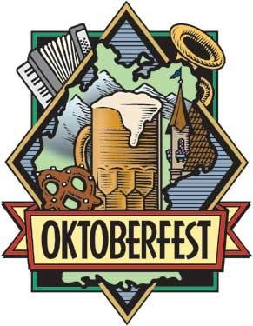
Topic Sentence: Oktoberfest is my favorite holiday.

  - Big Bear Tradition
    - Family always goes up to Big Bear Lake and rents a cabin
    - Oktoberfest parties at Convention Center
    - Activities for children and adults – everyone can enjoy

  - Crazy costumes
    - German costumes – men in lederhosen, women dressed as Bavarian beer garden waitresses
    - Crazy hats – chicken hats, alpine hats with a feather, beer hats
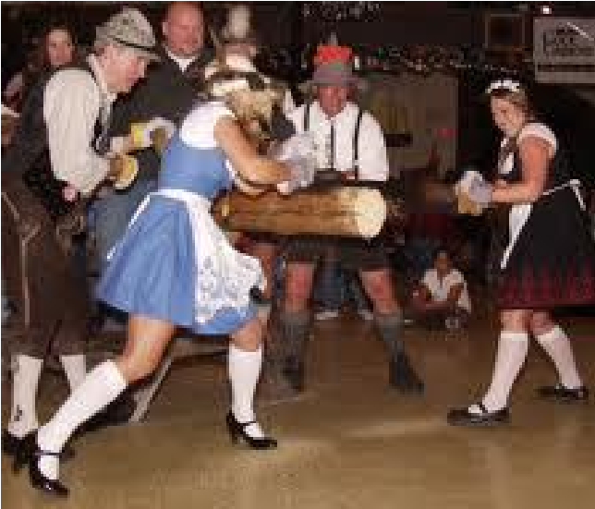
    - Silly necklaces
  - Entertainment
    - German band
    - Dances – polka, chicken dance, pizza hut dance
    - Contests – beer drinking, log sawing, stein holding

© LA Times
- Now look at the following paragraph based on the outline. Notice how the transitions serve to emphasize the organization and relationships between the points and examples.

Key to Paragraph with Transitions Identified: Transitions that indicate major points (I, II, III on outline) are enclosed in boxes. Transitions that indicate examples and additional examples to illustrate the major points are underlined. The transition that identifies the conclusion is circled.

A Unique Holiday
Oktoberfest is my favorite holiday. One aspect that I love about Oktoberfest is my family’s tradition of going to Big Bear Lake for a weekend every October. We rent a cabin there so that we can attend the Oktoberfest activities that go on at the Big Bear Convention Center all month. The center has activities for children and adults, so everyone from my little cousins to my grandparents can find something to enjoy. For example, German games, music, foods and drinks are featured. Another element that I love about Oktoberfest is the costumes people wear. For instance, men and boys will dress up in lederhosen, which are leather shorts with built-in suspenders to hold them up. Girls and women like to dress up as Bavarian beer garden waitresses, like the woman on the St. Pauli beer label. People who don’t have a costume wear crazy hats: chicken hats, alpine hats with a feather, and even hats with beer cans on them. Also, people can purchase silly necklaces to wear. Last year, for example, my sister bought a necklace with a rubber chicken hanging from it. The best thing about Oktoberfest is the entertainment. For example, at least one band actually comes from Germany each year to play music at the Convention Center, and even local bands play “oompah” music. Dancing to this music is a lot of fun. Of course there is the traditional polka dancing; in addition, the chicken dance and the Pizza Hut dance are very popular. Another source of entertainment is the contests. For instance, there are beer drinking, log sawing, and stein holding contests for women and men. All in all, the family tradition, costumes, and entertainment make Oktoberfest a unique holiday experience that I look forward to every year.
  - List the three transitions that signal a major idea:

_______________________ _______________________ ____________________

  - List two transitions that signal an example:

________________________ _________________________
  - List two transitions that signal an additional example:

________________________ _________________________

  - List the transition that signals a conclusion.

________________________

