Assignment 2: Project Outcomes
James Beard
1901671
Changemakers: Creativity and Value Creation
ACCA5033

Assignment Video Link - https://youtu.be/JkQ-x_uk5J4
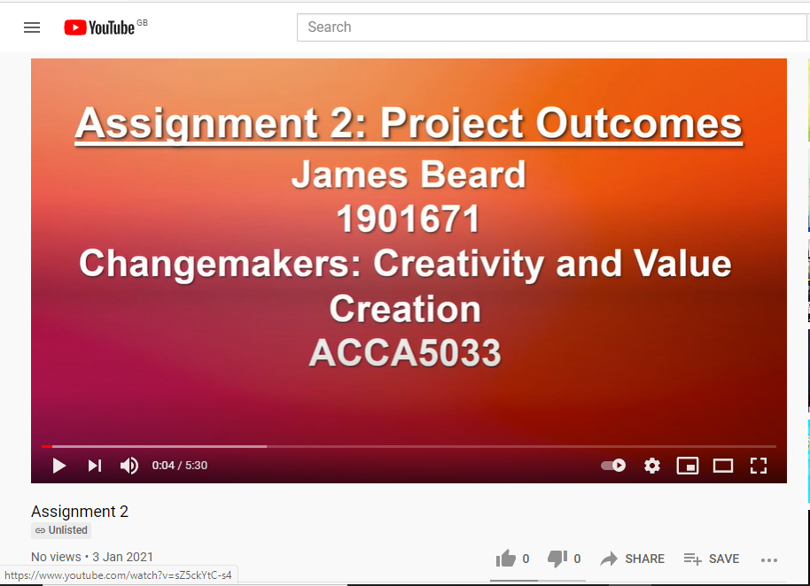
Assignment Video Screenshots



