
Skills for the Workplace
Module Assignment Submission
Student Name: | Rachel Witheridge
Student Number: | 2106781
Module No: | BMSK4002
Module Title: | Effective Team Working and Communication  Part 2

Statement of Confirmation of Authenticity
By the act of making this submission, the student declares that this is the work of the student named above. The work has not, in whole or in part, been knowingly presented elsewhere for assessment, or where assessment has been built on a previous assessment, this has been identified. Where materials have been used from other sources it has been properly acknowledged. If this statement is untrue, the student acknowledges that an assessment offence has been committed.
Attention is drawn to the plagiarism and unfair practice policies of both the University and of ILM.

Table of Contents
Part 2 Communication 3
1.0 3
Communication Cycle 3
2.0 5
Assessing Own Communication Skills 5
Gap Analysis 6
PDP 6
References 7
Appendix A 8
Skills You Need Communication Quiz 11
Mind Tools Communication Quiz 13

Part 2 Communication

1.0

Communication Cycle
There are three Types of Communication Models these are:
Linear Models of Communication - is a one-way interaction where feedback is not present.
Interactive Models of Communication - refers to the two-way method of communication with feedback.
Transactional Models of Communication - seems like a two-way process of communication with immediate feedback.
A communication cycle is a process that explains how the system of delivering and understanding the messages is made.
Mathematicians Claude Elwood Shannon and Warren Weaver are the developers of a liner model of communication in 1949 which they used for sending and receiving a message about each other’s needs, ideas, knowledge, etc.
Elements of a communication cycle is a sender, message, encoder, channel, noise, decoder, receiver, feedback. For the most effective communication cycle the message sender and the message receiver need to understand the exact same meaning of the message. Otherwise, this could lead to miscommunication.

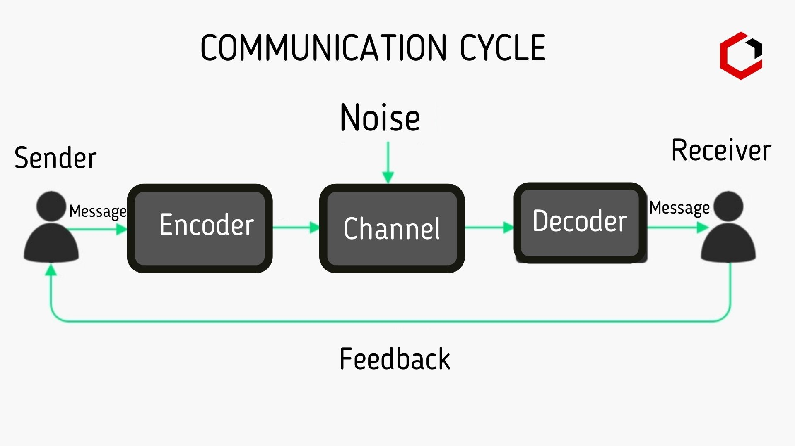
("Communication Cycle - Elements, Importance and Example - Digiaide.com", 2022)
A non-effective communication cycle can cause misunderstanding. A message that has been sent unsuccessfully can cause confusion to the receiver/receivers, within a workplace this can lead to an unhappy or unproductive workforce. A message sent successfully, and all parties involved understand the meaning of the message means the thought and ideas are communicated effectively.

There are many communication cycles, as well as Shannon and Weaver shown above there is Aristotle’s Model of Communication the great philosopher who initiative the earliest communication before 300bc focused on public speaking. Please see appendix A for the 5 basic elements. It is the speaker’s role to deliver a speech to the audience this makes the communication process one way, from speaker to the receiver and does not require feedback.
("Aristotle’s Communication Model", 2022)

Communication in the workplace
Within my own workplace there have been times of missed communication. I run a waiting list for children who need physiotherapy. I send letters to those parents to ring and book an appointment for their child. When a parent has called and has had to leave a message that message should be written down with enough detail e.g. the child’s name, current telephone number and put in our book for the relevant member of staff to call back. In this instant the message was not documented therefore the parent did not receive a call back. This miscommunication could lead to the patient being removed from our waiting list the parent becomes annoyed, upset and possibly angry as they are very concerned for their child.
To overcome this, I set up a file with available dates that any member of staff can access to book an appointment when the calls come in. This information then gets documented in the file and a confirmation letter is sent so it is dealt with as soon as the call comes in. Another form of miscommunication would have been not listening fully to the parent and not taking the correct details. Sometimes we can receive referrals with no contact telephone number for the parent which can cause delay in seeing that patient. It is vital to get communication right within a workplace.

I use a communication cycle everyday within my workplace, sending emails, letters, making telephone calls, or face to face discussions. This can be with staff, managers, consultants or parents or our patients.
Using a communication cycle, I need to
- Be clear about my message. who am I contacting, what am I trying to achieve by sending the message and what I want the person, persons to do with the message.
- To compose/encode my message. In what way do I want to send the message whether its email, phone call, or face to face. If there are any language barriers, or if the person/persons know why I am sending the message and if they will understand.
- To deliver the message. The way I communicate my message is important to ensure it is received effectively. Consider any distractions, the right time to communicate the message.
- Feedback. Reading body language, sound of response, was the feedback what I expected.
- Decode and learn from the feedback. What did the feedback say about my message, what I could have done differently and how I need to act going forward.
- Improve. Respect the feedback and identify the need to improve communication, message.
(Cycle, 2022)

Noise can be a big barrier to effective communication it can distract the sender and the receiver for hearing the message clearly therefore can cause ineffective communication. There are 5 types of noise in communication please the diagram in appendix A

Within my workplace there are times where there are staff members that share the same office having discussions while I am on the phone. This noise makes my communication less effective as I will struggle to hear what has been said. The only way to overcome this is to let the staff members know that I cannot hear, while being polite but clear and as we have good relationships they completely understand as this happened to us all.
("Communication Noise, 5 Types of Noise in Communication Barriers", 2022)

Active Listening Skills
There are 7 key active listening skills,
- Be attentive.
- Ask open-ended questions.
- Ask probing questions.
- Request clarification.
- Paraphrase.
- Be attuned to and reflect feelings.
- Summarize.

Being an active listener is different from just listening. You need to pay all your attention to the speaker, message and completely understand the information. There are verbal and non-verbal techniques that indicate when a person is fully listening. Clarity - if unsure and ask questions to clarify the information. Non-verbal would be not to get distracted, smile and nodding of the head as an indicator that you understand. There are several types of listeners, please see the image in Appendix A.
("How To Improve Active Listening Skills", 2022)

2.0

Assessing Own Communication Skills
To assess my own communication skills, I have completed an interpersonal skills questionnaire, a mind tool questionnaire, and a communication style questionnaire. I have also asked a colleague Deb to complete the communication style questionnaire on me. I also have 2 feedback forms following my presentation and below are the results and what I have learnt from them.
After completing an interpersonal skills questionnaire my overall score was 69% which means my interpersonal skills are average. The individual results were
- Listening skills 59% average.
- Emotional intelligence skills 66% average.
- Verbal communication 84% above average.
- Communication in groups 73% above average.
What I have learnt from this is that my listening skills came out with the lowest result. This means I have picked up some bad listening skills or not thought of the process to active listening. This is not a bad result by there is room for development.
(2011-2022, 2022)
The mind tool questionnaire score was 51 – what I have learnt from this is I am a capable communicator but sometimes experience communication problems. I need to take time to think about my approach to communication and receiving messaged effectively. ("How Good Are Your Communication Skills?: – Speaking, Listening, Writing, and Reading Effectively", 2022)
The communication style questionnaire – there are 4 basic communication styles the passive, the aggressive, the passive aggressive and the assertive. Both my colleagues and my results came out the same as that I am an assertive communication style. I agree with this result as being an assertive communicator I can express my point of view I can be clear and direct but still respecting others. By doing so I can minimise conflict and control anger. ("What is assertive style of communication?", 2022)
The feedback from my presentation – I was pleased that my feedback was positive however I really felt I could have done better in fact I was disappointed. I didn’t put in enough time not so much to learn my topics, which effected my performance, and the nerves took over. Within my workplace talking in front of colleagues has never been a problem but that is because I know exactly what I need to say.

Gap Analysis

Objective | Current Position | Deficiency | Action
What do I want to do? | What can I already do? | What am I lacking? | How do I fix this?
Take a more senior role | Communicate effectively with staff members. | Be more confident in presenting new information. Need to slow down on speaking and be clear what I am saying | Learn from experience. Practice talking in front of the mirror to gain confidence.

PDP

Objectives | Tasks | Success Criteria | Time Frame | Resources
List your Goals | What do you need to do to achieve these goals? | How will you identify your success? | When do they need to be done by? | Who or what do you need to help you?
To improve on my presentation skills | Learn the subject in more detail and continued feedback from others | Assignment passes and feedback from tutor | 6-12 months | Continue current management course and feedback from tutor
Gaining a more senior job role | Complete current management course | Qualifying from each year of this course | 1-3 years | Attending all uni sessions, feedback from tutor and colleagues and passing assignment

References
2011-2022, (. (2022). Interpersonal Skills Self-Assessment. Retrieved 25 March 2022, from https://www.skillsyouneed.com/quiz/343479
Aristotle’s Communication Model. (2022). Retrieved 22 March 2022, from https://www.communicationtheory.org/aristotle%e2%80%99s-communication-model/
Communication Cycle - Elements, Importance and Example - Digiaide.com. (2022). Retrieved 22 March 2022, from https://digiaide.com/communication-cycle/
Communication Noise, 5 Types of Noise in Communication Barriers. (2022). Retrieved 25 March 2022, from https://newsmoor.com/communication-noise-5-types-of-noise-in-communication-barriers/
Cycle, T. (2022). The Communication Cycle. Retrieved 25 March 2022, from http://manyana-education.blogspot.com/2010/10/communication-cycle.html
How Good Are Your Communication Skills?: – Speaking, Listening, Writing, and Reading Effectively. (2022). Retrieved 16 March 2022, from https://www.mindtools.com/pages/article/newCS_99.htm
How To Improve Active Listening Skills. (2022). Retrieved 25 March 2022, from https://smallbusinessify.com/how-to-improve-active-listening-skills/
What is assertive style of communication?. (2022). Retrieved 26 March 2022, from https://psichologyanswers.com/library/lecture/read/221283-what-is-assertive-style-of-communication

Appendix A
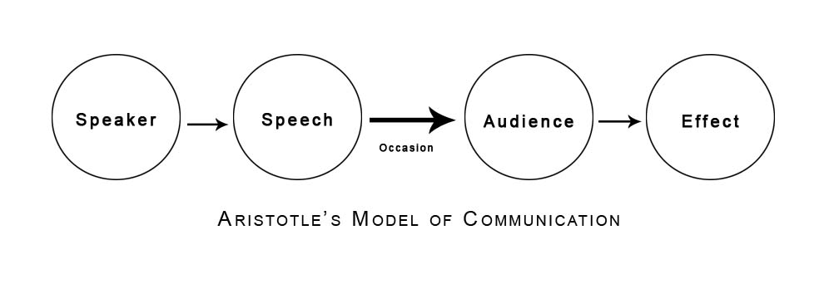
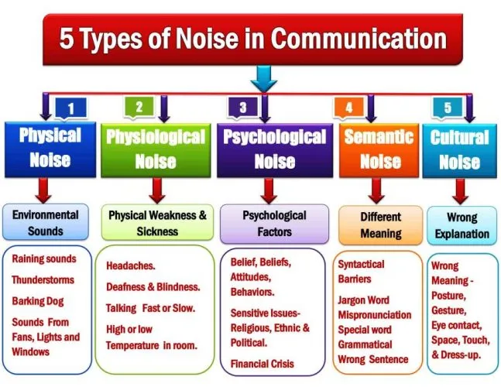
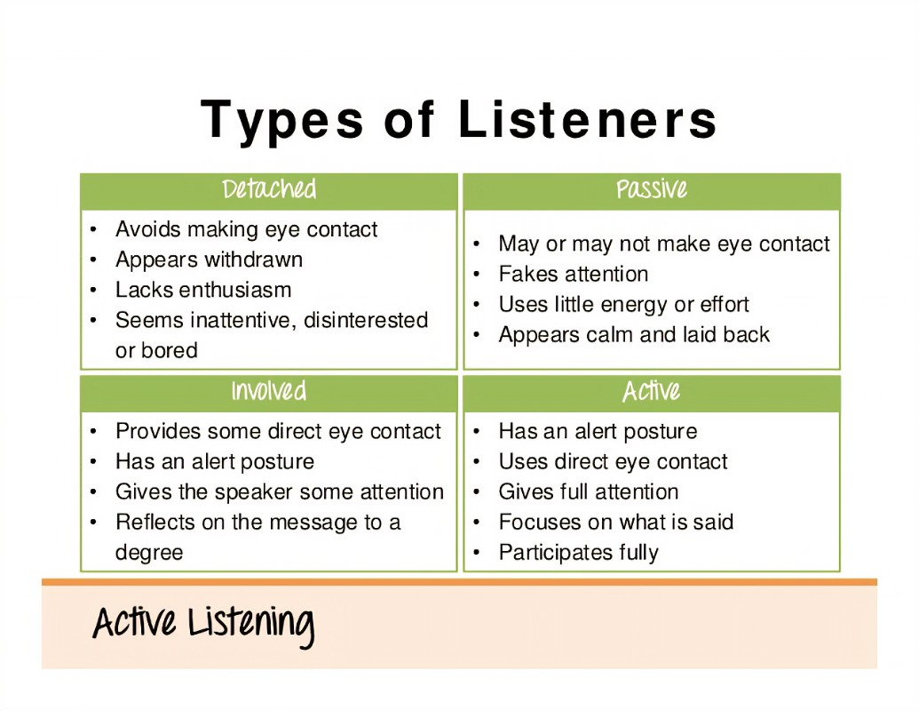
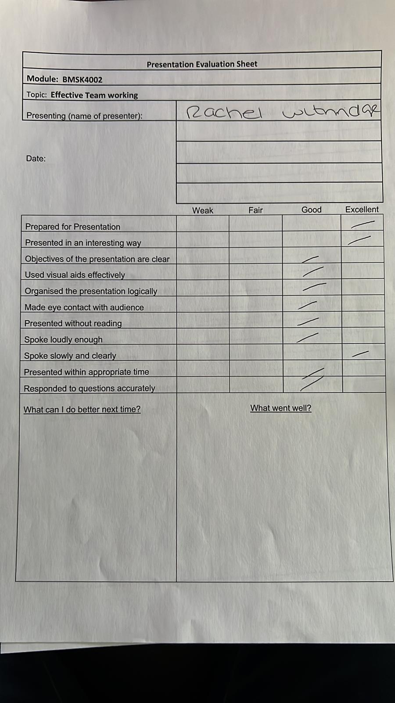
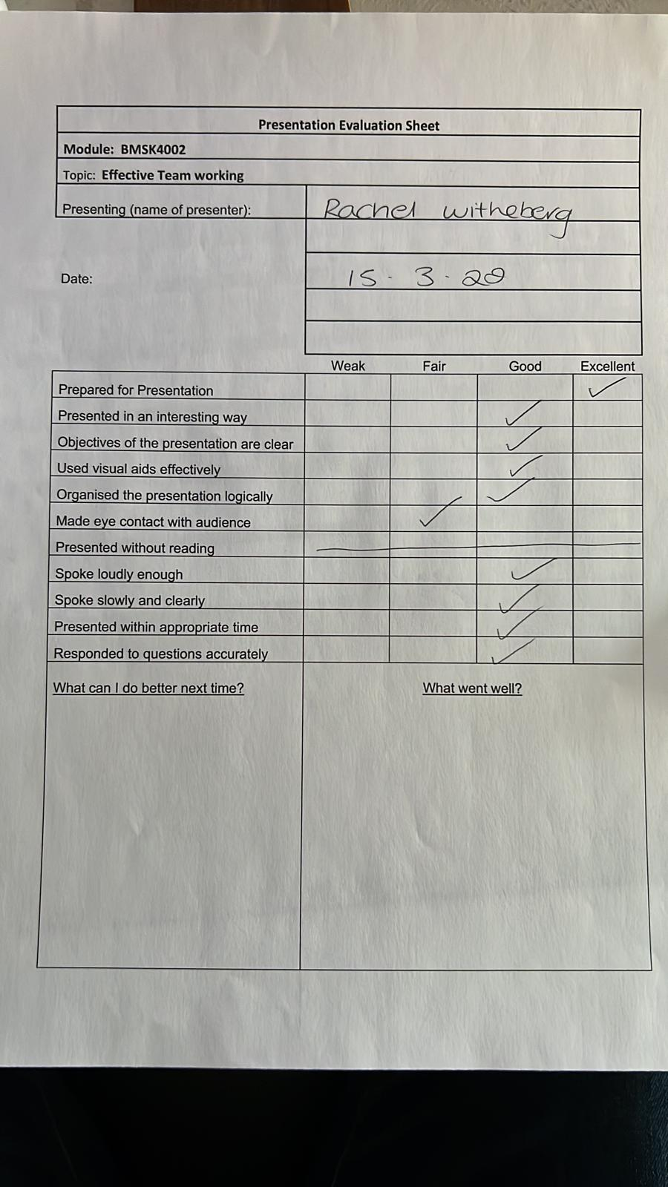

Skills You Need Communication Quiz

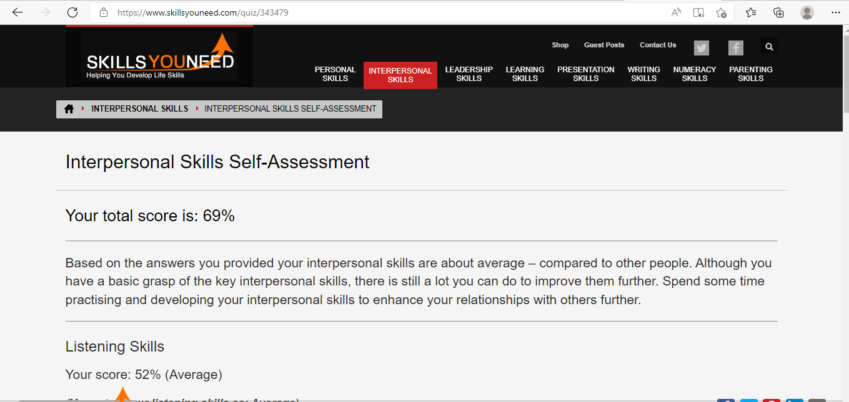
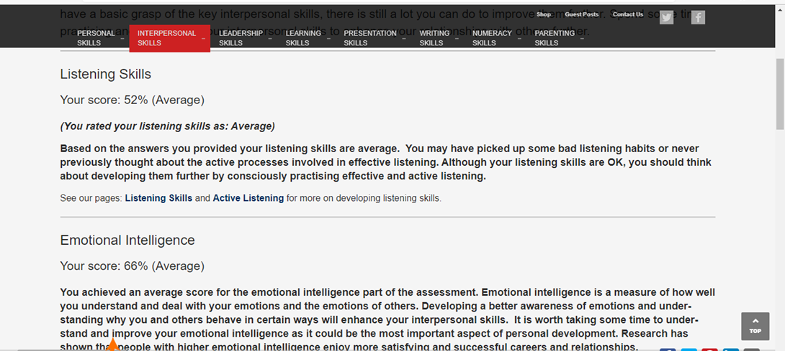
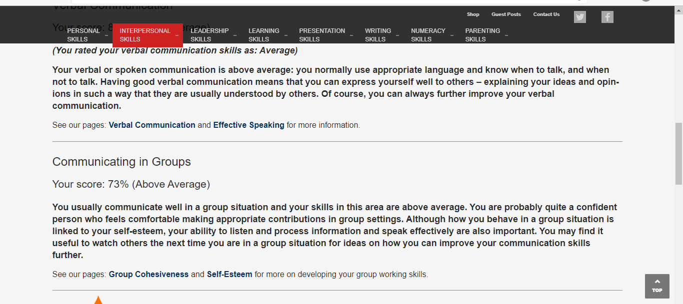
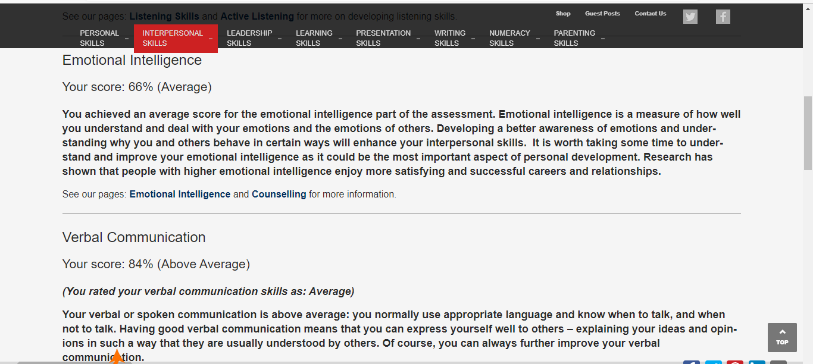

Mind Tools Communication Quiz

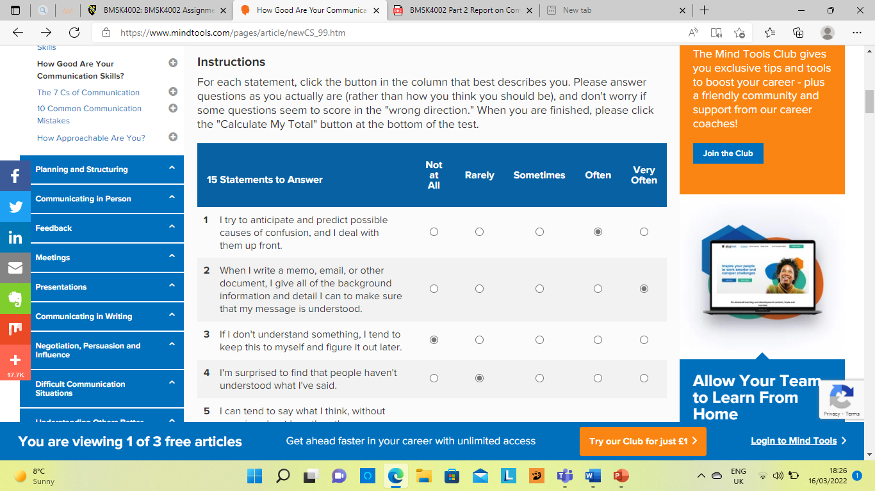

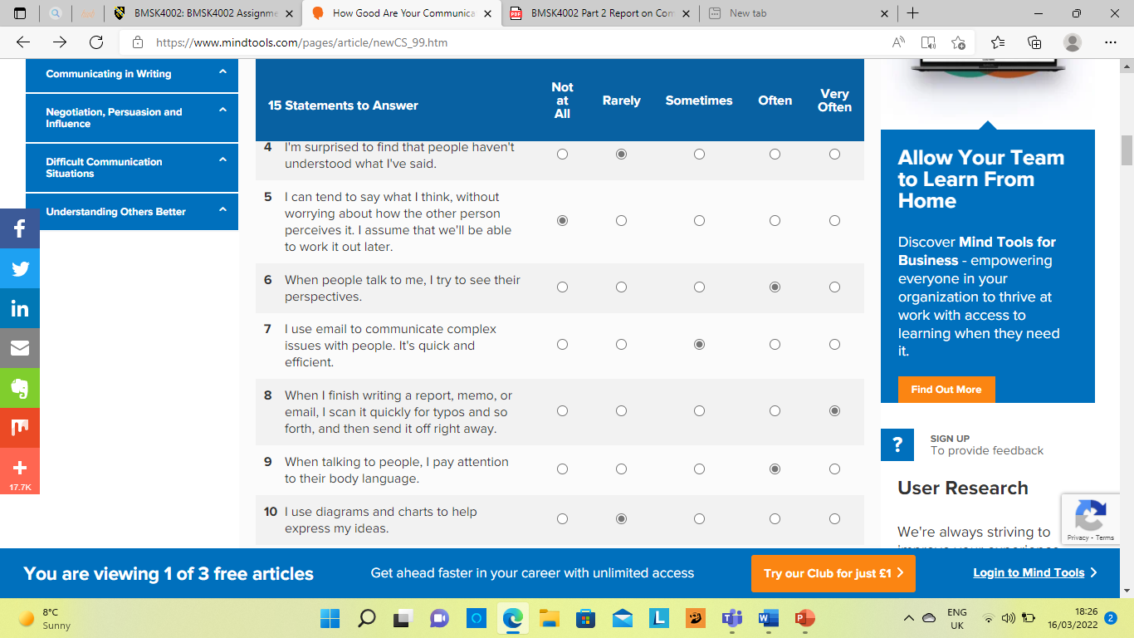
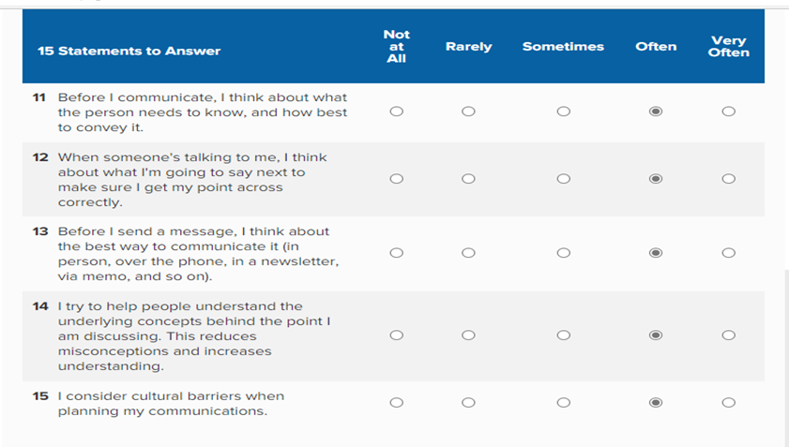
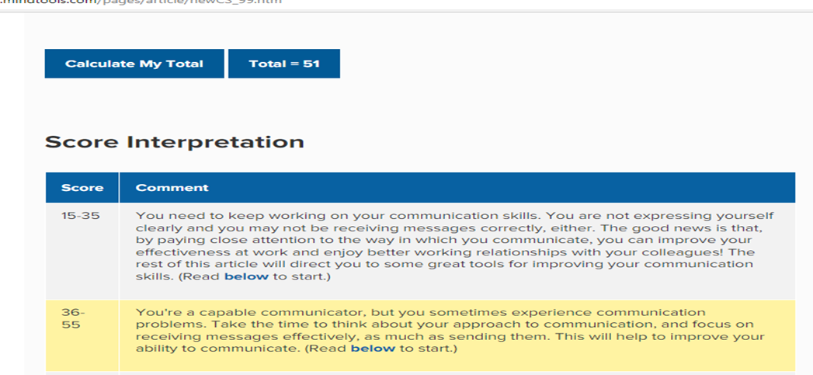
Communication Style Questionnaire


