

An online study exploring barriers to help seeking for men in rural and urban areas of Wales

1703005

Dissertation in Psychology: April 2020

University of Wales Trinity Saint David

Dissertation submitted in partial fulfilment of the requirements for the degree of Bachelor of Science (hons) in Psychology

DECLARATION

This work has not previously been accepted in substance for any degrees and is not being concurrently submitted in candidature for any degrees.

Signed: Louisa Smith (candidate)
Date: 19/04/2020

STATEMENT 1:
This dissertation is being submitted in partial fulfilment of the requirements for the degree of Bachelor of Science (hons) in Psychology
Signed: Louisa Smith
Date: 19/04/2020

STATEMENT 2:
This dissertation is the result of my own independent work/investigation, except where otherwise stated. Other sources are acknowledged by giving explicit references. A reference list is appended.

Signed: Louisa Smith
Date: 19/04/2020

STATEMENT 3:
I hereby give consent for my dissertation, if accepted, to be available for photocopying and for inter-library loan, and for the title and summary to be made available to outside organisations.

Signed: Louisa Smith
Date: 19/04/2020
Acknowledgements

Table of Contents
Declaration……………………………………………………………………………………i
Acknowledgements…………………………………………………………………………..ii
Abstract……………………………………………………………………………………….1
Introduction…………………………………………………………………………………..2
Method……………………………………………………………………………………….10
Participants………………………………………………………………………….10
Design………………………………………………………………………………..10
Materials…………………………………………………………………………….11
Ethical Considerations……………………………………………………………...13
Procedure…………………………………………………………………………....15
Results……………………………………………………………………………………….17
Table 1……………………………………………………………………………….17
Table 2……………………………………………………………………………….18
Table 3……………………………………………………………………………….19
Table 4……………………………………………………………………………….22
Table 5……………………………………………………………………………….23
Discussion……………………………………………………………………………………28
Conclusion…………………………………………………………………………………...33
References…………………………………………………………………………………...34
Appendices…………………………………………………………………………………..38
Appendix A………………………………………………………………………….43
Appendix B………………………………………………………………………….49
Appendix C………………………………………………………………………….50
Appendix D………………………………………………………………………….55
Appendix E………………………………………………………………………….62
Appendix F…………………………………………………………………………..69
Appendix G………………………………………………………………………….78
Appendix H………………………………………………………………………….
Appendix I………………………………………………………………………….
Abstract
Previous research has shown that men are less likely than women to seek help for any health-related concern (Addis & Mahalik, 2003; Oliver, Pearson, Coe & Gunnell 2005; Judd, Komiti & Jackson, 2008). There is also evidence to suggest that men in rural areas are even less likely to seek help than men in urban areas (Roy, Tremblay & Robertson, 2014). An online cross-sectional survey was carried out to explore the barriers that men in areas of Wales may face when seeking help for mental and physical health issues to investigate the effect of rurality on help seeking attitudes. 156 male-identifying participants currently living in both Urban (N=65) and rural (N=91) areas of Wales consented to take part in the studyA 2x2 ANOVA was carried out to analyse scale data collected. The results of the analysis found no significant difference in scale scores for either health condition between urban and rural-dwelling participants. However, a significant difference was found between scores for both populations between the physical and mental health conditions. Thematic analysis of the qualitative data revealed main themes similar to the barriers covered in the BHSS, with the additional subthemes of previous negative experiences and deservingness. Several limiting factors in the design of study are discussed that may have led to the loss of participants mid-way through the survey. Suggestions for future research include developing a help seeking scale specifically for men in the UK with barriers that take into account the role of the NHS, as well as investing men’s constructs of masculinity in Wales

Introduction
Previous psychological research into men’s help seeking attitudes and behaviours has found that men are less likely than women to seek help from a healthcare professional for any health-related issue (Addis & Mahalik, 2003; Oliver, Pearson, Coe & Gunnell 2005; Judd, Komiti & Jackson, 2008). Help-seeking behaviours can include more than professional medical help; Speaking to close friends and family, a partner or a charitable organisation in the pursuit of seeking support or information relating to a health issue can be considered help seeking behaviour. This reluctance to seek help may be having a hugely detrimental effect on men’s wellbeing in the UK. In 2018, of the 6,507 suicides registered by the Office for National Statistics (ONS), 4,903 of the victims were male (ONS, 2019). According to the ONS, men have statistically been three times more likely to successfully commit suicide than women since the mid-1990s. This lack of proactive help seeking is also seen in attitudes towards physical health, in cancer diagnosis for example, despite having a 50% risk of developing cancer within their lifetime (compared to 45% in females: Cancer research, 2019) and a higher rate of cancer-related deaths (ONS, 2019), men are still reluctant to seek help for early cancer symptoms (Fish, Prichard, Ettridge, Grunfeld, & Wilson, 2015). The need to identify and overcome the factors that prevent men from seeking help for their health is therefore incredibly important, not only to protect the wellbeing of men in the UK but also to maintain equal and fair access to healthcare across genders. The fact that the UK is divided into four countries, each with hugely varying differences in population size, healthcare availability and sociocultural norms would mean that making generalisations for the UK as a whole generally unwise. In Wales in particular, nearly half of the Welsh government’s budget is allocated to health and social care (National Assembly for Wales, 2020) however, with more than 60% of the population of Wales living in the south Wales region alone, the distribution of this funding may mean that people in rural areas are facing additional barriers to getting help for health concerns than those in more urban populations. An investigation into the types of barriers that men in both of these regions face may provide more information not only on the provision of services in these areas but may also highlight sociocultural beliefs surrounding help-seeking that urban and rural-dwelling men may hold.
The role of masculinity and the perception of it is often the first port of call when investigating issues in men’s health, and while this may initially seem to be an attack on the concept of male identity, constructions of masculinity do have an impact on men’s health and vice versa. A study by Flurey, White, Rodham, Kirwan, Noddings and Hewlett (2018) found that men who had received a diagnoses of rheumatoid arthritis felt that they needed to reconsider their perceptions of masculinity in order to deal with their diagnosis. In some participants, this involved continuing their usual “masculine” activities even if they had to suffer pain while doing so, risking their wellbeing and future health, whereas other replaced their usual masculine activities with others. This finding would also demonstrate the importance of recognising the personal nature of masculine identity, argued by Ali, Bamidele, Randhawa, Hoskin & McCaughan (2017) to be influenced by too many sociocultural factors to be generalized across all men in all cultures. Instead, Ali et al propose that health interventions should be tailored to the individual in order to improve health outcomes. This supports research from Moynihan (1998) that masculinity has different definitions within biological, psychological, and social contexts. Dolan (2011) discusses the difference in constructs of masculinity among social classes, and Mfecane (2018) argued that much of the existing research investigating masculinity in South Africa was ineffective as it was based western-centric theories, and needed to instead focus on developing measures around African constructs of Masculinity. Existing literature highlights the issues that may arise if masculinity is generalised as being the same for all men across communities and cultures and demonstrates the need to explore men’s health in many different cultures.
Most existing research finds that in comparison to women, men show more reluctance in seeking help for a mental health issue, largely due to social norms and beliefs about masculinity and gender stereotypes in observed populations, along with stigma surrounding mental health (Vogel, Wade, Wester, Larson & Hackler, 2007; Wrigley, Jackson, Judd & Komiti, 2005). Research from Addis and Mahalik (2003) found that social norms surrounding masculinity were one of the biggest factors preventing men from seeking help, with stoicism and physical toughness viewed as positive traits, whereas self-care, even in the context of a physical injury, was viewed as negative. This supports research from Courtenay (2000), who reported that men who lived in societies where masculinity was associated with being stoic and robust were more likely to suffer from mental and physical health problems as a result of trying to maintain a socially desirable public image. Courtenay also wrote that men are more likely to adopt and endorse behaviours that put their health at risk, than they are to accept health-protective behaviours. Courtenay’s findings were recently reconfirmed by Heise et al. (2019) who reported that links have been established between typically masculine behaviours and negative health outcomes. Male socialisation has also been shown to have a negative effect on men’s likelihood of seeking treatment (Galdas, Cheater & Marshall, 2005) and this is believed to be due to the influence of other males exhibiting “masculine” behaviours and reinforcing sociocultural ideals regarding the way men conduct themselves.
Some previous research has suggested that these perceptions of masculine identity may be held on to more tightly in rural areas than in urban populations, and that this may be the reason that men in rural areas face poorer health outcomes than their urban counterparts, particularly in large countries such as Australia (NRHA, 2010). Roy, Tremblay and Robertson (2014) carried out a qualitative study into the relationship between rurality, masculinity and mental health. The study involved in-depth interviews with 32 male farmers from Canada that focused on stress and coping strategies. The study found that the farmers identified strongly with more traditional masculine ideology, in line with the ideals of their fathers and grandfathers. The researchers found contradictory statements when conducting analysis of the interviews, such as some finding help-seeking to be a sign of weakness, whereas others viewed help-seeking as a sign of bravery. This finding would highlight the importance of social norms in help-seeking, as well as showing that each community can have different cultures and ideas of masculinity. However, the study did find that despite these attitudes, the men were more likely to wait until a situation had reached a crisis level before finding help-seeking to be necessary or admirable. Indeed this is supported by Alston and Kent (2008) who found that men in rural Australia would remain stoic in times of difficulty, as they felt this was strongly associated with masculine identity and “expected” of them, until they reached “breaking point”, unfortunately by which time damage to their health had already taken place.
A popular model in health psychology used to understand the relationship between these factors and one’s health is the Health Belief Model (HBM; Rosenstock, 1974). The HBM suggests that the likelihood of someone changing their behaviour (in this case help seeking behaviour) is largely dependent on an individual’s perceived threat of their situation (a health concern) combined with their evaluation of the outcomes of the behaviour change. Within the HBM, this perception of the threat is determined by the individual’s perceived susceptibility to the negative consequences of the threat (becoming unwell/injured) and the perceived severity of the negative consequences (levels of pain, time off work etc.). Additionally, according to the HBM outcomes are evaluated using the perceived benefits and barriers to changing the behaviour. Whereas perceived benefits focus on what the person may gain, perceived barriers are factors that the person feels prevents them from changing their behaviour. Using this model, psychologists are able to identify key areas in which to target interventions in order to promote health-protective behaviours and improve health outcomes through cues to action. Cues to action are cues prompt people to change their behaviour, whether they be internal (e.g. pain, symptoms) or external (e.g. medical professional advice). Studies exploring the HBM tend to focus on the benefits of targeting the perceived barriers and evaluated outcomes of participants (Zare, Ghodsbin, Jahanbin, Ariafar, Keshavarzi, & Izadi, 2016; Avci & Altinel, 2018) therefore, identifying these factors for men living in Wales is important in order to develop interventions that would encourage them to seek help for health concerns. However, other factors may also need to be considered, as some researchers have accused the HBM of being too rigid a model, and that human behaviours are not always so inwardly focused and rational. Mahalik and Burns (2011) carried out a study exploring the development of heart-healthy behaviours in young adult males. They argue that the HBM would benefit from the inclusion and acknowledgement of sociocultural factors such as social norms in the formation of health beliefs, as their study found that participant were more likely to report health-protective behaviours if they felt they were normative among other men. This would highlight the importance of investigating men’s help seeking behaviours from both an individual and sociocultural perspective to gain a better understanding of the reasoning behind men’s attitudes and behaviours towards their health.
Fennell, Hull, Jones and Dollman (2018) carried out a study to investigate what barriers people living in rural Australia faced when seeking help for both physical and mental health concerns. Previous studies into barriers to help-seeking often used the Barriers to Help Seeking questionnaire designed by Mansfield, Addis and Courtenay (2005) which uses a five-point Likert scale to measure participants in five subcategories of barriers, such as concrete barriers and privacy. Though this scale is widely used and is good at identifying specific barriers (useful when designing interventions using the principle of TPB), one criticism is that it is targeted towards physical health. Notably featuring items such as “ I wouldn’t want someone of the same sex touching my body”. As Fennell et al wanted to also explore barriers to mental health help-seeking, they produced a revised version of the questionnaire. This newer version used more general questions that did not mention physical aspects of healthcare, and so could be used in both contexts. Additionally, items were added to reflect the impact that the social norms around them might have (e.g. “Most people in the region have at least one health issue they are dealing with”). Participants were four hundred and nine adults from rural areas of Australia. Participants were divided into two groups. Each group was presented with either a physical or mental health scenario and asked to complete the modified BHSS from the perspective of the person within the scenario. Fennel et al. reported that the results of the study showed that participants reported far more barriers to help seeking for mental health than physical, and that this result was the same in both male and female participants. This would indicate a social stigma regarding mental health that is not necessarily tied to gender identity. The study also supported existing literature in that male participants did report more barriers to health support overall. This is important to note as much of the current literature was written more than a decade ago, yet this study would suggest that it is still relevant to male help-seeking today. Though Fennel et al.’s study did find support for existing literature, there are some limitations to the study that if addressed may have added valuable data. The fact that the study only took quantitative data means that we are only able to understand the prevalence of certain barriers in rural areas, but we do not understand the reasons behind these, nor do we know which is of most significance. This information would be crucial to understand if any attempt is to be made to develop interventions in order to help people. A suggestion would be to ask participants to indicate which of the items they felt was most significant to them for their issue, or indeed if their main barrier had even been listed. Secondly, the fact that participants only took part in one of two conditions (physical or mental health) makes it difficult to accept the generalisation that people in rural areas accept mental health less than physical health. Without participants taking part in both conditions, it’s possible that those who reported more barriers to mental health support would also report the same barriers to physical health support.
Based on existing literature, it can be said that there is a noticeable divide between men and women’s attitudes and behaviours towards help-seeking. Additionally, there is a difference in help-seeking attitudes among those men living in rural areas, suggesting that they are even less likely to seek help for health concerns. However, despite this research being nearly a decade old, Recent research from Fennel et al. would suggest that very little has changed. A report published by Evans et al. suggests that in order to develop effective interventions to encourage male help-seeking, they must be targeted at specific sub-groups. However, identifying these sub-groups and the barriers that each may face in seeking help for both physical and mental health is needed first before interventions can be developed. Suggestions by Evans, Frank, Oliffe and Gregory (2011) to help encourage men to take a more active role in their healthcare and engage in help seeking behaviours are that men-focused interventions should be adapted and targeted towards different male sub-groups, for example, towards young fathers or older men specifically, rather than a generalised “one size fits all” approach. However, in order to offer targeted interventions for help-seeking barriers, research must first be conducted in order to not only identify those sub-groups, but to also understand the specific barriers that they may face in seeking help for health-related issues.
Much of the research carried out into this topic has been conducted in large, sparsely populated regions, however, there is little available to investigate the effects of rurality in smaller countries. This may be due to many countries with a small landmass typically being densely populated enough that there are not many areas that can be considered rural. However, this is not the case for all small countries. Wales has the smallest population of the three countries that make up Great Britain, estimated to be 3,138,631 in mid-2018 (Stats Wales, 2019). With approximately 60% of the population living in the south Wales region alone, this leaves large areas of more rural areas to the north and west. There is very little research available to measure help-seeking barriers in these regions, and a study investigating the differences between urban and rural male’s help seeking attitudes in Wales would make a valuable addition to current literature, particularly within the UK. If a difference in the types of barriers to help-seeking is found between the two populations, targeted interventions can be introduced in different areas and may have a significant impact on the quality of life for many men in both regions. A study investigating male help seeking for physical health concerns alongside mental health can also offer a unique perspective of whether help seeking attitudes are consistent across both, or if one aspect of health is treated more favourably than the other, and potential differences between the two in the specific types of barriers that men report. Additionally, the collection of qualitative data regarding help seeking alongside quantitative may produce a more intimate look into the development and reasoning behind the barriers that men in Wales potentially face when seeking help in relation to their health.
The present study seeks to investigate the following hypotheses:
H₁ : Males living in rural areas will report higher scores in a barriers to help seeking questionnaire for a mental health condition than males living in urban areas.
H₀ : There will be no significant difference in scores of a barriers to help seeking questionnaire for a mental health condition between participants living in rural and urban areas.
H₂ : Participants from both rural and urban areas will score higher in barriers to help seeking questionnaire for a mental health condition than a physical health condition.
H₀ : There will be no significant difference between scores of a barriers to help seeking questionnaire for mental or physical health conditions.
Method
Participants
Criteria for participants were that they identified as male, were over the age of 18 and residing in Wales. As the study was specifically investigating a male experience of help seeking, all participants in the study were asked to confirm that they were male before taking part. In total, 156 males over the age of 18 and living in Wales gave consent to take part in the questionnaire (Age range=18-78, M=33.76, SD= 13.49). Of the participants who replied to questions regarding their locations, 91 were from rural areas and 65 were from urban areas of Wales. Participants also had the opportunity to state whether they perceived the area they lived in to be more urban or more rural. The answers for this were divided differently the map responses, with 78 respondents reporting they were more rural and 72 reporting they were more urban, 7 participants stated that they were unsure. Participants were recruited online both via a shareable weblink to the questionnaire and through the University of Wales Trinity Saint David’s experiment management system. As the study was completed online this was done in a setting and at a time of the participant’s choice.
Design
This online cross-sectional questionnaire study was of non-experimental design as none of the variables were manipulated. The questionnaire was made available online as this was determined to be most efficient way to distribute the study in order to recruit participants across Wales. The use of an online questionnaire also assists in maintaining participant anonymity which previous research has demonstrated can increase participants’ willingness to share information about their health (Frost, Vermeulen & Beekers, 2014; Weitzman, Kaci & Mandl, 2010). The study also employed a mixed methods approach incorporating qualitative text-box questions alongside the questionnaires as research by Idler, Hudson and Leventhal (1999) suggests that employing both quantitative and qualitative approaches can give a deeper understanding of peoples’ assessment of their health. Thematic analysis was used to analyse the qualitative data from the text box responses as this offered a flexible method of identifying themes and patterns that emerged from the data when following the six-step procedure proposed by Braun and Clarke (2006). The text responses were read several times to become familiarized with the data, then interesting words and sentences within the text were highlighted. These points of interest were then coded and grouped into potential themes. The next step involved grouping data into final main themes and sub themes. During the final grouping, ongoing analysis of the text as carried out in order to refine themes and subthemes and to ensure no relevant information was missed. Quotes from participants are reported verbatim where used to support themes.
A 2x2 mixed ANOVA was conducted using the SPSS software package to investigate the first and second hypothesis, comparing the two-level independent variable of rurality (urban and rural) with the two-level dependent variable of BHSS scores (Physical health and Mental health). Additional MANOVAs were carried out to investigate the differences in the dependent variables of total scores on the individual subscales (for both physical and mental health respectively) against the independent variable of rurality.
Materials
This online questionnaire (Appendix A) was created in survey format via the Qualtrics project-building website. This was then distributed using both the University of Wales Trinity Saint David’s experiment management system and a link directly to the questionnaire itself. The link option was added to make the study available outside of the university and participants were encouraged to share the link with others across social media platforms such as Facebook and Reddit. To make the distinction between rural an urban areas, participants were asked to select the area that they lived in on a population distribution map (Appendix A5). For the purpose of the study, Rural areas were determined to be areas with a population distribution of less than 500 people per square kilometre, areas with more than 500 people per square kilometres were classed as urban. Participants were also asked to state whether they believed the area they lived in was more rural or urban as some areas of Wales are considered to have both urban and rural populations, despite having low numbers of people per km² overall. Both sections featured the same 40 item scale, a modified version of the Barriers to Help Seeking Scale (BHSS; Appendix B) used by Fennell, Hull, Jones and Dollman (2018), this scale was chosen due to its high internal consistency (α ranged from 0.71-0.87 for each subscale) as well as its use in the study in both a physical and mental health context, allowing answers from both sections of the questionnaire to be directly compared. The scale uses a five-point Likert scale (1= strongly disagree, 5= strongly agree) to record how much participants agreed with statements such as “I would think less of myself for needing help” and “I wouldn’t want to overreact to a problem that wasn’t serious”. Fennell et al. presented the questionnaires in the context of both a mental and physical health concern and so this was also included in the study. For the physical health section, the scenario was as follows:
“Imagine that you begin to experience an unusual physical feeling in your body. This might be a persistent pain in your back or headaches. The pain is not so overwhelming that you can’t function. However, it continues for more than a few days and you notice it regularly. You consider seeking help from a medical doctor or other healthcare provider. Please consider each of the statements below and indicate how much you agree or disagree that each statement would reflect your feelings”
For the Mental health section, participants were presented with the following scenario:

“Imagine that you have been feeling unusually down in recent times. You haven’t been sleeping well, seem to have lost interest in things that you used to enjoy and are having difficulty concentrating. You consider seeking help from a medical doctor or other healthcare provider. Please consider each of the statements below and indicate how much you agree or disagree that each statement would reflect your feelings”
The scale can be used to give one total score of number of barriers to help-seeking or can be broken down in to five individually scored subscales to give more detailed analysis for the types of barriers people report; Need for control and self-reliance (score range 12-60); Minimizing Problem, Resignation and Normalisation (score range 7–35); Concrete Barriers and Distrust of Caregivers (score range 13-65); Privacy (score range 4-20) and Emotional Control (score range 4-20).
The study also featured four text-box questions intended to gain more of an understanding of the significance of different barriers to help seeking. After completing the items in each section, participants would be given the option to respond to the following questions in their own words, using a text box to record the response. I was made clear to participants that these were optional:
Please state in the box below what you feel is the biggest reason why you may be reluctant to seek help for your [Physical/Mental] Health?
What action do you feel could be put in place to help overcome this?
Ethical Considerations
Ethical considerations were also given during the creation of the study in line with The British Psychological Society’s Code of Ethics and Conduct (BPS, 2018). As the study would be asking participants to discuss their health attitudes and behaviours, consideration was given to the design of the study to ensure that they were treated with respect and not placed under any distress. The modified version of the BHSS was selected as this did not ask participants to divulge any personal health information and the items were worded in a way that would minimise any potential distress to participants. Additionally, consideration was given to the wording of the text-box questions to ensure that participants would not feel the need to provide and personally identifying information, a key factor in maintaining participant’s anonymity. The decision was taken to include an information page (Appendix A1) which was presented to participants after clicking on the link to start the study, instead of including all of the information on the consent page. This was done to ensure that participants were fully aware of the nature of the study before consenting.
The information page advised participants that the study was intended for male participants and outlined the nature of the study, how long it would take to complete and what they would be asked to do. The information page also advised participants of their right to withdraw from the study at any time and that their data would be stored anonymously and in accordance with the data protection act. The researchers also clarified that the study would not ask participants to give any personal health information.
A consent page (Appendix A2) asked participants to confirm their age and gender (male), that they were living in wales and that they consented to take part in the study to confirm that all participants gave informed consent. Following the completion of the questionnaire, participants were presented with a debrief page (Appendix A12) that advised them of the reason for the study. The debrief page was designed to acknowledge the responsibility of the researchers to respect the welfare of participants, and signposted participants to contact their GP or the NHS direct helpline (via the phone number on the page) if their participation had raised any concerns about their or someone else’s health. The emails of the researcher and supervisor were also provided if participants had any questions about the study.
Procedure
Participants could access the study either by signing up through the experiment management system (in exchange for course credits for psychology students) or clicking directly on a link to the study webpage hosted on qualtrics.com that was shared on the social media sites Facebook, Twitter, and Reddit.
After clicking on the link the first page presented to participants was the information page. After reading the information participants were directed to click on the arrow at the bottom of the page which took them to the consent page. On the consent page participants were required to confirm that they understood that participation was voluntary, that they were male, over the age of 18 and living in Wales and that they consented to take part in the study by clicking boxes. If they did not confirm all three options, participants were redirected to a page thanking them for their interest and informing them that they were not eligible for the study (Appendix A14). If all three boxes were clicked, participants would be allowed access to the first part of the study which asked for demographic data (Age and level of education) and showed a numbered map. Each colour on the map represented a different region of Wales based upon population and participants were asked to indicate where they lived by selecting the number of the region that they lived in via a drop-down box beneath the map.
After clicking to proceed onto the next page the participant would be shown the first half of the questionnaire. At the top of the page the participants would be presented with a scenario for either a physical or mental health concern - depending on which section was presented to them first - followed by the modified BHSS. The placement of the physical and mental health sections within the questionnaire was counterbalanced to minimise order effects. Once both the physical and mental health conditions of the questionnaire had been completed, participants would be directed to click onto the next page.
The final page presented to participants was the debrief form thanking them for taking part and explaining that the purpose of the study was to investigate help seeking attitudes of men in Wales. The debrief page also advised participants to contact their GP or NHS direct number if they had any concerns for their health or the health of others. The contact details of the researchers were also included on the page and participants were invited to contact them if they had any questions about the study.

Results

Before beginning quantitative analysis, the scores of each of the five subscales from both questionnaires were added together to provide a total score for both mental and physical health help-seeking, each ranging between a minimum score 80 and a maximum score of 200.
To investigate the hypotheses a 2x2 mixed ANOVA was carried out to compare the scores of both physical and mental health across both rural and urban participants. Table 1 shows the means and standard deviations for urban and rural scores in both the physical and mental health help seeking conditions of the questionnaire.
Table 1.
Descriptive Statistics (Total barriers to help seeking scores).
 |  | Rurality
 |  | Urban |  |  | Rural |  |  | Total
Health Condition | N | M | SD | N | M | SD | N | M | SD
Physical Health | 65 | 122.18 | 27.94 | 91 | 122.09 | 26.76 | 156 | 122.13 | 27.17
Mental Health | 65 | 112.89 | 25.62 | 91 | 111.84 | 26.99 | 156 | 112.28 | 26.12
Total | 65 | 117.53 | 26.78 | 91 | 116.96 | 26.87

The results of the 2x2 mixed ANOVA found no significant main effect of rurality on BHSS scores (F(1,154) =.02, p =.89, partial η² =.00). In the instance of H₁ this would indicate a failure to reject the null hypothesis as participants living in urban (M=112.89) and rural (M=111.84) areas reported similar scores in the mental health condition of the study.
A significant main effect of health condition on BHSS scores was found (F = 55.58, p = .00, partial η² =.26). Descriptive statistics indicated higher mean scores for the physical health condition of the questionnaire (M=122.13) than the mental health condition (M=112.28). These scores indicate a failure to support H₂ while also rejecting the null hypothesis.
Exploratory analysis was carried out to investigate potential differences in scores on the subscales in each condition between rural and urban participants. Tables 2 and 3 show the means and standard deviations for each of the subscales for the physical and mental health help seeking conditions. Two MANOVAs were carried out in SPSS to investigate this. No significant difference was found between rural and urban participants in the subscale scores for either Physical health (F (1, 154) = 0.44, p =0.82; Wilk's Λ = 0.985, partial η² = 0.02) or Mental health (F=(1,154), p=.94, Wilk’s Λ = .992, partial η² = .00). The results of the exploratory analysis would indicate that men in both rural and urban areas face similar barriers to both physical and mental health help seeking.
Table 2.
Means and standard deviations (Total subscale scores for barriers to physical health help seeking)
 | Rurality
 | Urban |  | Rural |  | Total
Subscale | M | SD | M | SD | M |  | SD
Need for control and self-reliance | 34.91 | 9.67 | 35.12 | 9.61 | 35.01 |  | 9.64
Minimising problem and resignation | 16.62 | 6.18 | 17.05 | 5.95 | 16.83 |  | 6.06
Concrete barriers and distrust of caregivers | 45.51 | 9.67 | 45.31 | 9.24 | 45.41 |  | 9.45
Emotional Control | 10.97 | 4.42 | 11.07 | 4.23 | 11.02 |  | 4.32
Privacy | 14.18 | 3.84 | 13.54 | 4.16 | 13.86 |  | 4.00

Table 3.
Means and standard deviations (Total subscale scores for barriers to mental health help seeking)
 | Rurality
 | Urban |  | Rural |  | Total
Subscale | M | SD | M | SD | M | SD
Need for control and self-reliance | 30.88 | 8.95 | 30.77 | 8.95 | 30.82 | 8.95
Minimising problem and resignation | 17.05 | 6.24 | 16.65 | 5.57 | 16.85 | 5.90
Concrete barriers and distrust of caregivers | 42.15 | 8.91 | 41.91 | 9.29 | 42.03 | 9.10
Emotional Control | 10.28 | 4.61 | 10.45 | 4.01 | 10.36 | 4.31
Privacy | 12.54 | 4.43 | 12.05 | 4.20 | 12.29 | 4.31

Thematic analysis was carried out on the qualitative data collected via the text box responses on the questionnaire (Appendices H&I). Qualitative data was collected for both the physical and mental health conditions to determine which barriers participants felt had the most significant impact on their help seeking behaviours and attitudes, and whether or not these were included in the modified BHSS. Responses were kept separate as physical and mental health conditions to better understand the barriers for each area of health rather than being analysed as one. Participants who responded to the text box questions were identified by a code for clarity and anonymity. Table 4 and 5 display the themes and subthemes for Mental and Physical health, respectively.

Table 4.
Themes and subthemes of Mental health help seeking responses
Themes | Subthemes
Personal Responsibility for Mental health | - Maintaining Control  - Self-blame  - Need for access to information/Knowledge of the problem  - Language
Difficulty accessing healthcare | - Previous negative experience  - Waiting times  - Available resources/Services
Minimising Problems | - Severity of problem  - Comparing problems to others  - Lack of knowledge  - Problem is situational
Cultural influences on help-seeking | - Mental health stigma  - Media/Public opinion  - Cultural Expectations
Work | - Getting time off work for appointments  - Status
Negative feelings/emotions related to seeking help for mental health concerns | - Embarrassment/Discomfort  - Weakness  - Fear/Anxiety
Social influences | - Need to provide for others  - Deservingness  - Support

Table 5.
Themes and subthemes of Physical health help seeking responses
Themes | Subthemes
Personal Responsibility for Physical health | - Maintaining Control  - Self-blame  - Need for access to information/Perceived responsibility to know what the issue is first
Difficulty accessing healthcare | - Previous negative experiences of health services  - Waiting times  - Availability of services
Minimising Problems | - Severity of problem  - Comparing problems to others  - Lack of knowledge  - Resignation
Work | - Work Commitments
Negative feelings/emotions related to seeking help for mental health concerns | - Embarrassment/Discomfort  - Weakness  - Fear/Anxiety
Social influences | - Need to provide for others  - Deservingness  - Support Networks

Analysis identified seven main themes, and these were very similar across both physical and mental health help-seeking. When asked what they felt was the biggest reason they may be reluctant to seek help for their physical health, many of the participants described themes of difficulty accessing healthcare services and minimising problems and the impact these were having on their perceptions of the NHS as well as their own health. Within the theme of difficulty accessing healthcare, the subthemes of Previous negative experiences; Waiting times and Availability of services were found. Many of the responses from participants within the main theme of difficulty accessing healthcare seem to suggest that many men in Wales have limited options available to them when seeking help within the context of a professional healthcare service provider:
It is impossible to see a medcial professional, I cannot get an appointment and long enough to explain my symptoms. (P70)
Even when they are able to access help, participants have reported feelings of frustration with their healthcare provider’s methods or the waiting times to speak to a specialist.
having my issue pigeonholed and glossed over as "being my fault" (P74)
Dismissive healthcare professionals (P86)
Within the main theme of minimising problems, the emergent subthemes were Severity of problem; Lack of knowledge and resignation, participants appear to minimise their health concerns mainly through a lack of information, whether that be about the options available to them to seek help or about the problem itself:
Until the problem hits a particular severity I'm unlikely to go beyond a quick google about the issue and see if any easy solutions present themselves (P2)
The things that worry me might be nothing; but if they're serious I kind of don't want to know/deal with it. (P88)
Some responses also suggest a fear of being seen as an inconvenience. Particularly the fear of wasting a doctor’s time, which may be connected to the sub-theme of previous negative experiences:
the worry it may be nothing and I'm wasting everyone time. (P91)
Wasting my doctors time with something that isn’t as serious as I thought it to be. (P82)
When asked what they felt was the biggest reason they may be reluctant to seek help for their mental health, the majority of responses again followed the main theme of difficulty accessing healthcare, but in contrast to physical health help seeking, for mental health most of the responses related to a main theme of personal responsibility, with sub themes of maintaining control, self-blame, need for access to information/knowledge of the problem, and language:
Not knowing how to explain what's happening in my head in a way that will get me the help I need for my specific problems (M73)
Not knowing what constitutes a problem, and who exactly to turn to for professional help. (M51)
because I think the problem lies within me. (M7)
It’s my brain and feel that the problem is specific to me therefore I should be able to deal with it as I’d be “the expert” (M10)
Other main themes became apparent when looking at the responses for both mental and physical health. Analysis of the text revealed a main theme of Work that may tie in with the concrete barriers to help seeking mentioned in the modified BHSS, as they are mainly focused on the financial and time issues that booking appointments would present:
Getting time off work for initial appointment is easy, but keeping the job with regular appointments and fluctuating mental health is another (M59)
Unable to get time off work (public sector). Only a certain number of illnesses are allowed before disciplinary action (P68)
However, the main themes of Social factors and Negative feelings/emotions towards seeking help for health concerns, show that making an appointment with a professional healthcare provider is a source of anxiety for the individual, particularly surrounding the potential impact on the individual’s life:
I dont want them to think im being stupid and send me away on random pills (P6)
The feeling that it might just be normal and there's nothing wrong and I'm wasting people's time. (M97)
Additionally, a sub theme found within the main theme of social factors revealed a genuine concern that other people - whether these are seen as strangers or not is unclear - are more deserving of help than the participant, perhaps interestingly, this subtheme was found to be more prevalent in responses for physical health help seeking:
Don't want to waste a health professionals time when they could be helping someone with a more severe issue. (P4)
don't want to take a more deserving persons appointment (P52)
That I would be taking resources away from someone who needs help more (M15)
Items exploring this aspect of help-seeking attitudes are not found on the modified version of the BHSS.
Overall, Thematic analysis of the responses has shown evidence of themes largely consistent with the barriers to help seeking indicated by the five subscales of the modified BHSS. Participants’ responses indicate that concrete barriers surrounding healthcare, a need for control and minimising heath concerns are prominent factors when considering seeking help for health-related issues. Additionally, social stigma was also considered to prevent help seeking for mental health but did not appear to be as important when seeking help for a physical health issue. The theme of social influences, and particularly the sub theme of Deservingness shows an aspect of help seeking in males that is not acknowledged in the modified BHSS. This subtheme would suggest a more community driven, self-deprecating side to help seeking attitudes and behaviours than traditional concepts of masculinity highlighted by previous research. Consistent across all themes seems to be a desire for participants to have more access to information about their health, regarding what constitutes a health concern and what their local health service can offer them.

Discussion
The aim of the present study was to investigate the barriers to help seeking for both mental and physical health experienced by males living in rural and urban populations in Wales. In particular, the aim was to investigate potential differences in the number and significance of different types of barriers to help seeking to better understand the needs of the two populations in order to add to existing literature.
The results of the study did not find a significant difference in scores for barriers to mental health help seeking between participants in urban and rural areas. This is contrary to the findings of researchers in larger countries with a sparse rural population (Roy, Tremblay & Robertson, 2014; Fennell, Hull, Jones & Dollman, 2018) that suggest men living in rural areas are more subjected to negative connotations between masculinity and mental health and therefore would report more barriers to mental health help seeking. Instead, men in both areas reported remarkably similar scores in both conditions. There may be several reasons for this, the first is that much of the existing research exploring the relationship between men’s help seeking attitudes and rurality has been carried out in countries with a large land mass, therefore making rural areas much more remote than is possible in Wales. This remoteness could in turn result in larger, more insular rural communities then those found in Wales, which may act as an echo chamber for sociocultural expectations of masculinity. Additionally, the availability of the NHS in Wales may be a significant factor across both communities, as hospitals in Wales are largely located in more urban areas in order to be accessible to more patients, meaning those in rural areas, traveling to these hospitals, may be receiving the same medical advice, and potentially seeing the same medical staff as those in urban areas. This is supported by exploratory analysis carried out for each of the subthemes in the physical and mental health conditions, which found that both rural and urban participants’ scores were similar in all subscales, indicating that the barriers to help seeking experienced by men are similar in both populations. A suggestion for future research to explore this would be to investigate potential differences in help seeking attitudes and behaviours in men across different health boards rather than rural or urban communities.
The finding that participants in both urban and rural areas scored higher in barriers to help seeking for physical health than mental health does support Addis and Mahalik’s (2003) research that physical toughness is viewed as a positive trait within masculine norms, however, this contradicts research by Yousaf, Grunfeld and Hunter (2015) which suggests that a clash between emotional expression and masculine norms would have a greater impact on mental health help-seeking than physical health. One factor that potentially influences this may be that the masculine norms amongst Welsh males may be different than in other countries, and therefore allows for more freedom for the expression of emotion, unfortunately a lack of research into the culture of masculinity within Wales would limit this theory and would require further research. The emergence of a main theme of cultural influence in the qualitative data collected for mental health help seeking would also contradict this finding. Though evidence of the sub themes of stigma and cultural expectations were found throughout the responses in the mental health section of the study, very little was found in the physical health responses. One suggestion for this may simply be that participants who took part in the study only answered the text box questions in the mental health section of the study and not the other, as these were optional, therefore the amount of available data was not balanced between the two.
Thematic analysis of the data provided through responses to the qualitative questions aligned mostly with the barriers already address in the modified BHSS. However, the data did also reveal a main theme of Social influences on the decision to seek help for both physical and mental health concerns. The influence of stigma was found to be a much more prevalent barrier within responses to mental health help seeking than physical. This theme is consistent with research from Vogel et al (2007) who noted the role of stigma in preventing males from engaging in help-seeking behaviours. This finding would indicate that mental health stigma is still a prevalent issue among men in Wales, and that this is felt by men across both urban and rural communities. There are currently campaigns that aim to break down mental health stigma (Time to Change Wales, 2020; Mental Health Wales, 2020) and the increase in the awareness of men’s mental health in recent years may mean that these attitudes improve. This is an area in which public interventions designed to mitigate the effect of social norms on help seeking behaviour might be of benefit.
Analysis of the qualitative data also found the access to information was an important aspect of help seeking for participants. Many respondents stated that they did not know what actually constituted a health concern, and that they did not know the procedure to access healthcare, this seemed to be consistent across both physical and mental health conditions. Robertson et al (2016) suggest that a way to improve men’s knowledge about personal health would be by taking a gender-sensitive approach that encourage men to be involved in the design of interventions. Robertson et al also argue that some men feel that current strategies to involve men in help seeking behaviours focus too much on trying to “fix” men, and that participant’s reported feeling that service providers viewed their gender as being the cause of their issues. This feeling is seemingly supported in the qualitative data of this study in participant’s fears of wasting time, and their previous negative experiences with healthcare services.
The subtheme of deservingness - that others were more deserving of access to healthcare services than they are – also emerged from analysis of the responses. There does not seem to be much research that focuses on this particular barrier in men’s help seeking attitudes, in fact the modified version of the BHSS used in the study does not feature items that explore this factor at all. Previous efforts to investigate the role of deservingness in the provision of healthcare and welfare has focused on public perception of immigrants (Huschke, 2014; Marrow, 2012), in which case this may be an interesting area of future research to investigate whether this factor of deservingness is consistent across gender and nationality.
A suggestion for the emergence of the deservingness subtheme may be that in recent years there has been much focus in politics and the media on the struggles of the NHS in the UK to provide sufficient healthcare for all of its service users (Horton, 2017; Dolton, 2017; Neilson, 2015). Because of this widespread and constant reporting of the issues facing the NHS in the UK, men may be even more reluctant to access healthcare if they see it as a scarce resource, fearing that it could be detrimental to the health of others. Intervention strategies to encouragement to seek help for health concerns may benefit by targeting campaigns to these barriers in particular. A suggestion would be to focus on reinforcing the fact that healthcare is for everyone, however, this approach may me the biggest challenge in men’s health promotion in Wales given the intense focus in mainstream media on an NHS “in crisis” (WalesOnline, 2019; BBC, 2018).
At the time of writing, the people of Wales - along with the rest of the world – are dealing with the effects of a global pandemic (COVID-19). As a result, there has been widespread documentation of the difficult situation that NHS staff are facing as unprecedented numbers of people require hospitalisation. A very real concern based upon the findings of this study is that the repeated message that local health services are struggling to cope with demand may mean that many men are suffering or will suffer negative health outcomes through fear of putting further strain on resources. Further studies in the future would be necessary to understand the long-term effects of this outbreak on public health. Additionally, nationwide precautions have been taken by the UK government to prevent the spread of the virus, including making clear importance of health protective behaviours and the responsibility of individuals to maintain their health. It is simply too early to tell what effect this may have on the help-seeking attitudes and behaviours of people in Wales, however, across the themes noted in this study there has been an emergence of the need for information about what health-protective behaviours involve. Increasing the availability of information about how to protect and manage ones’ health may be beneficial in the long-term. At this stage it is simply too early to predict these effects. Further research into the effects of a pandemic on people’s health beliefs and intentions would add valuable literature to existing research (Barr, Raphael, Taylor, Stevens, Jorm, Giffin, & Lujic 2008; Kok, Jonkers, Gelissen, Meertens, Schaalma, & de Zwart, 2010; Liao, Cowling, Lam, Ng, & Fielding, 2010).
The study has found both similar and contrasting results with previous evidence, however, there are several limiting factors that may have influenced these results. Though the online study was accessed by 527 people, the fact that only 157 participants completed the full study indicates a drop-out rate of around 70%. This may have been due to the relatively long time it took to complete the questionnaire, resulting in the loss of participants who could have potentially added valuable information. Additionally, the high drop-out rate could indicate that participants began to lose interest in the study before completing it, this may have caused some participants to not give as much thought to the questions and therefore the answers that they provided towards the end of the online study, which may have influenced the final scores on the modified BHSS. A suggestion to improve on this for future research would be to develop a shorter barriers to help seeking scale that incorporates items for both physical and mental health with fewer items, thereby shortening the time it takes to complete. Another limiting factor is that the study was conducted online, and therefore only available to participants who had access to a computer, potentially reducing the number of participants reached. Making the study available outside of the internet would involve multiple researchers implementing the questionnaire in various locations across wales, which may provide different results, but would also require financial and logistical availability not possible at the time of this study.
Conclusion
Overall, though the initial hypotheses have not been supported, the importance of understanding the barriers faced by men in Wales when trying to seek help for health concerns has been made clear. The inclusion of qualitative data collected during the study has provided valuable insight into the factors that influence men’s help seeking behaviours and attitudes in Wales by evidencing a theme of social influence, not just in terms of the expectation to provide but also a fear of taking services and resources from others that may potentially need it more. Additionally, the study has highlighted the importance of men’s perceptions of the factors that influence their help seeking behaviours, lending support to the role of the HBM in developing interventions to promote health-protective behaviours. Recent events in world health may have an impact on help seeking attitudes and behaviours towards protecting their health, however, this would require further studies and research to investigate. Several limiting factors within the were identified upon reflection, including those which may have contributed to a large drop-out rate among participants, resulting in the loss of potentially important data, the development of a shorter barriers to help seeking scale may help to reduce this. Future research into barriers to men’s help seeking in Wales may benefit from exploring potential differences across health boards, as participants from both rural and urban areas may be using the same hospitals and healthcare systems.

References
Addis, M. E., & Mahalik, J. R. (2003). Men, masculinity, and the contexts of help seeking. American psychologist, 58(1), 5.
Ajzen, I. (1991). The theory of planned behavior. Organizational behavior and human decision processes, 50(2), 179-211
Ali, N., Randhawa, G., Bamideleh, O., Hoskin, P., & McCaughan, E. (2017). Constructions of masculinity and help-seeking for prostate cancer. Diversity and Equality in Health and Care.
Alston, M., & Kent, J. (2008). The Big Dry: The link between rural masculinities and poor health outcomes for farming men. Journal of Sociology, 44(2), 133-147.
Avci, I. A., & Altinel, B. (2018). The validity and reliability of health belief scale for testicular cancer self-examination. American journal of men's health, 12(3), 531-538.

Barr, M., Raphael, B., Taylor, M., Stevens, G., Jorm, L., Giffin, M., & Lujic, S. (2008). Pandemic influenza in Australia: using telephone surveys to measure perceptions of threat and willingness to comply. BMC infectious diseases, 8(1), 117.

Braun, V., & Clarke, V. (2006). Using thematic analysis in psychology. Qualitative research in psychology, 3(2), 77-101.

Cancer registration statistics, England - Office for National Statistics. (2019). Retrieved 27 November 2019, from https://www.ons.gov.uk/peoplepopulationandcommunity/healthandsocialcare/conditionsanddiseases/bulletins/cancerregistrationstatisticsengland/2017

Courtenay, W. H. (2000). Constructions of masculinity and their influence on men's well-being: a theory of gender and health. Social science & medicine, 50(10), 1385-1401.

Demyan, A. L., & Anderson, T. (2012). Effects of a brief media intervention on expectations, attitudes, and intentions of mental health help seeking. Journal of counseling psychology, 59(2), 222.

Dolan, A. (2011). ‘You can’t ask for a Dubonnet and lemonade!’: working class masculinity and men’s health practices. Sociology of Health & Illness, 33(4), 586-601.

Dolton, P. (2017). IS NHS FUNDING IN CRISIS?. Institute of Economic and Social Research. NIERSR General Election.

Evans, J., Frank, B., Oliffe, J. L., & Gregory, D. (2011). Health, illness, men and masculinities (HIMM): a theoretical framework for understanding men and their health. Journal of Men's Health, 8(1), 7-15.

Evans, J., Frank, B., Oliffe, J. L., & Gregory, D. (2011). Health, illness, men and masculinities (HIMM): a theoretical framework for understanding men and their health. Journal of Men's Health, 8(1), 7-15.

Fact Sheet 23: Measuring the metropolitan-rural Inequality. (2010). Retrieved 20 December 2019, from https://www.ruralhealth.org.au/content/fact-sheet-23-measuring-metropolitan-rural-inequality
Fennell, K. M., Hull, M., Jones, M., & Dollman, J. (2018). A comparison of barriers to accessing services for mental and physical health conditions in a sample of rural Australian adults.
Fish, J. A., Prichard, I., Ettridge, K., Grunfeld, E. A., & Wilson, C. (2015). Psychosocial factors that influence men's help‐seeking for cancer symptoms: A systematic synthesis of mixed methods research. Psycho‐Oncology, 24(10), 1222-1232.
Flurey, C., White, A., Rodham, K., Kirwan, J., Noddings, R., & Hewlett, S. (2018). ‘Everyone assumes a man to be quite strong’: Men, masculinity and rheumatoid arthritis: A case‐study approach. Sociology of health & illness, 40(1), 115-129.
Frost, J., Vermeulen, I. E., & Beekers, N. (2014). Anonymity versus privacy: selective information sharing in online cancer communities. Journal of medical Internet research, 16(5), e126.
Galdas, P. M., Cheater, F., & Marshall, P. (2005). Men and health help‐seeking behaviour: literature review. Journal of advanced nursing, 49(6), 616-623.
Gascoigne, P., & Whitear, B. (1999). Making sense of testicular cancer symptoms: a qualitative study of the way in which men sought help from the health-care services. European journal of oncology nursing, 3(2), 62-69.
Heise, L., Greene, M. E., Opper, N., Stavropoulou, M., Harper, C., Nascimento, M., ... & Henry, S. (2019). Gender inequality and restrictive gender norms: framing the challenges to health. The Lancet.

Horton, R. (2017). Offline: Is the NHS in crisis?. The Lancet, 389(10081), 1783.

Huschke, S. (2014). Performing deservingness. Humanitarian health care provision for migrants in Germany. Social Science & Medicine, 120, 352-359.

Idler, E. L., Hudson, S. V., & Leventhal, H. (1999). The meanings of self-ratings of health: A qualitative and quantitative approach. Research on aging, 21(3), 458-476.

Judd, F., Komiti, A., & Jackson, H. (2008). How does being female assist help-seeking for mental health problems?. Australian and New Zealand Journal of Psychiatry, 42(1), 24-29.

Kok, G., Jonkers, R., Gelissen, R., Meertens, R., Schaalma, H., & de Zwart, O. (2010). Behavioural intentions in response to an influenza pandemic. BMC Public Health, 10(1), 174.

Liao, Q., Cowling, B., Lam, W. T., Ng, M. W., & Fielding, R. (2010). Situational awareness and health protective responses to pandemic influenza A (H1N1) in Hong Kong: a cross-sectional study. PLoS One, 5(10).

Lifetime risk of cancer. (2016). Retrieved 21 November 2019, from https://www.cancerresearchuk.org/health-professional/cancer-statistics/risk/lifetime-risk#heading-Zero

Mahalik, J. R., & Burns, S. M. (2011). Predicting health behaviors in young men that put them at risk for heart disease. Psychology of Men & Masculinity, 12(1), 1.
Mansfield, A. K., Addis, M. E., & Courtenay, W. (2005). Measurement of Men's Help Seeking: Development and Evaluation of the Barriers to Help Seeking Scale. Psychology of Men & Masculinity, 6(2), 95.
Marrow, H. B. (2012). Deserving to a point: Unauthorized immigrants in San Francisco’s universal access healthcare model. Social Science & Medicine, 74(6), 846-854.

Mental Health Wales. (2020). Retrieved 17 April 2020, from http://www.mentalhealthwales.net/

Mfecane, S. (2018). Towards African-centred theories of masculinity. Social Dynamics, 44(2), 291-305.

Mid year estimates of the population: mid-2018 | GOV.WALES. (2019). Retrieved 17 December 2019, from https://gov.wales/mid-year-estimates-population-mid-2018

Morley, N. (2020). NHS hurtling towards “crisis point” due to staff shortages, warn MPs. Retrieved 17 April 2020, from https://www.walesonline.co.uk/news/uk-news/nhs-crisis-staff-shortage-16066824

Moynihan, C. (1998). Theories of masculinity. Bmj, 317(7165), 1072-1075.

National Assembly for Wales.(2020). Retrieved 13 February 2020, from https://www.assembly.wales/SiteCollectionImages/Assembly%20Business%20images/Research%20Service/Headline-figuresEng.png

National Rural Health Alliance. (2010). Measuring the metropolitan-rural inequity [Ebook]. Retrieved from https://www.ruralhealth.org.au/factsheets/thumbs?page=1

Neilson, E. (2019). Nurse practitioners in pharmacies: a potential solution to the NHS crisis. Acute pain, 10, 00.

NHS (2016). Adult Psychiatric Morbidity Survey: Survey of Mental Health and Wellbeing, England, 2014 - NHS Digital. Retrieved from https://digital.nhs.uk/data-and-information/publications/statistical/adult-psychiatric-morbidity-survey/adult-psychiatric-morbidity-survey-survey-of-mental-health-and-wellbeing-england-2014

Oliver, M. I., Pearson, N., Coe, N., & Gunnell, D. (2005). Help-seeking behaviour in men and women with common mental health problems: cross-sectional study. The British Journal of Psychiatry, 186(4), 297-301.

Reality Check: Is NHS funding worse in Wales?. (2020). Retrieved 17 April 2020, from https://www.bbc.co.uk/news/health-42655140

Robertson, S., Gough, B., Hanna, E., Raine, G., Robinson, M., Seims, A., & White, A. (2018). Successful mental health promotion with men: the evidence from ‘tacit knowledge’. Health Promotion International, 33(2), 334-344.

Rosenstock, I. M. (1974). Historical origins of the health belief model. Health education monographs, 2(4), 328-335.
Roy, P., Tremblay, G., & Robertson, S. (2014). Help‐seeking among male farmers: Connecting masculinities and mental health. Sociologia Ruralis, 54(4), 460-476.
Stats Wales (2020). Retrieved 17 October 2019, from https://statswales.gov.wales/Catalogue/Population-and-Migration/Population/Estimates/nationallevelpopulationestimates-by-year-age-ukcountry

Suicides in the UK - Office for National Statistics. (2019). Retrieved 11 October 2019, from https://www.ons.gov.uk/peoplepopulationandcommunity/birthsdeathsandmarriages/deaths/bulletins/suicidesintheunitedkingdom/2018registrations

The British Psychological Society. (2018). Code of Ethics and Conduct [Ebook]. Retrieved from https://www.bps.org.uk/news-and-policy/bps-code-ethics-and-conduct

Time to Change Wales. (2020). Retrieved 17 April 2020, from https://www.timetochangewales.org.uk/en/

Vogel, D. L., Wade, N. G., Wester, S. R., Larson, L., & Hackler, A. H. (2007). Seeking help from a mental health professional: The influence of one's social network. Journal of clinical psychology, 63(3), 233-245

Weitzman, E. R., Kaci, L., & Mandl, K. D. (2010). Sharing medical data for health research: the early personal health record experience. Journal of medical Internet research, 12(2), e14.

Welsh Government, A Statistical Focus on Rural Wales 2008 Edition (2008), Retrieved 4 February 2020, from https://webarchive.nationalarchives.gov.uk/20110813160610/http://wales.gov.uk/topics/statistics/publications/focusrural08/?lang=en&ts=4

Wrigley, S., Jackson, H., Judd, F., & Komiti, A. (2005). Role of stigma and attitudes toward help-seeking from a general practitioner for mental health problems in a rural town. Australian & New Zealand Journal of Psychiatry, 39(6), 514-521.

Yousaf, Omar, Elizabeth A. Grunfeld, and Myra S. Hunter. "A systematic review of the factors associated with delays in medical and psychological help-seeking among men." Health psychology review 9.2 (2015): 264-276.

Zare, M., Ghodsbin, F., Jahanbin, I., Ariafar, A., Keshavarzi, S., & Izadi, T. (2016). The effect of health belief model-based education on knowledge and prostate cancer screening behaviors: a randomized controlled trial. International journal of community based nursing and midwifery, 4(1), 57.

Appendices
Appendix A;
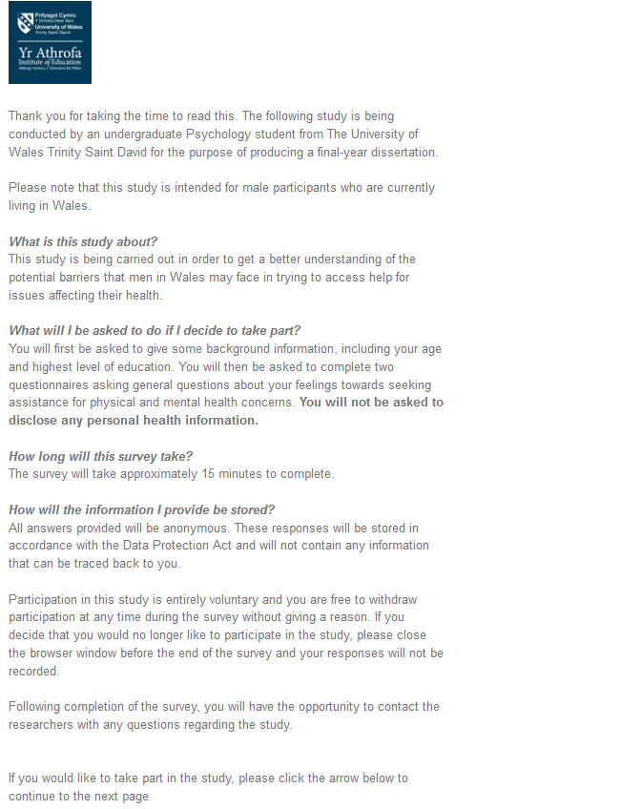
A1



1

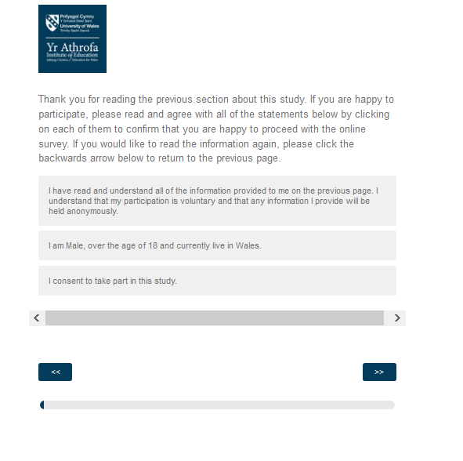
A2

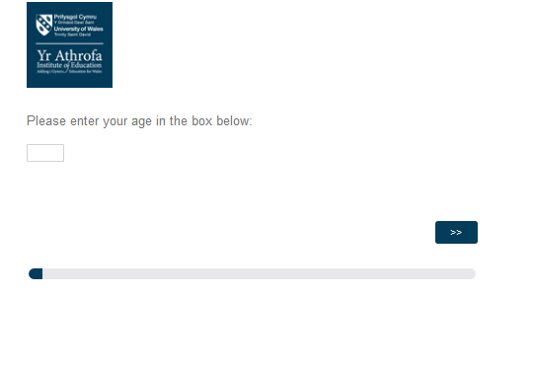
A3

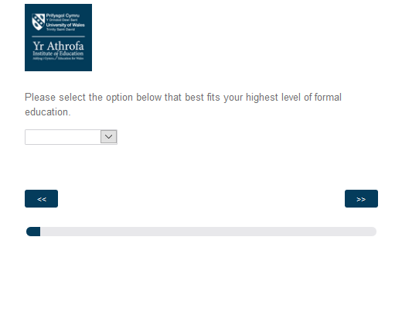
A4

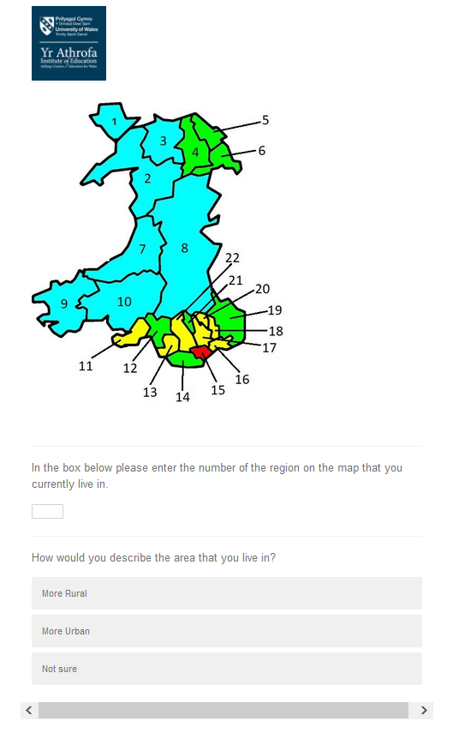
A5

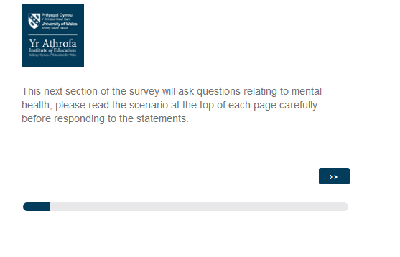
A6

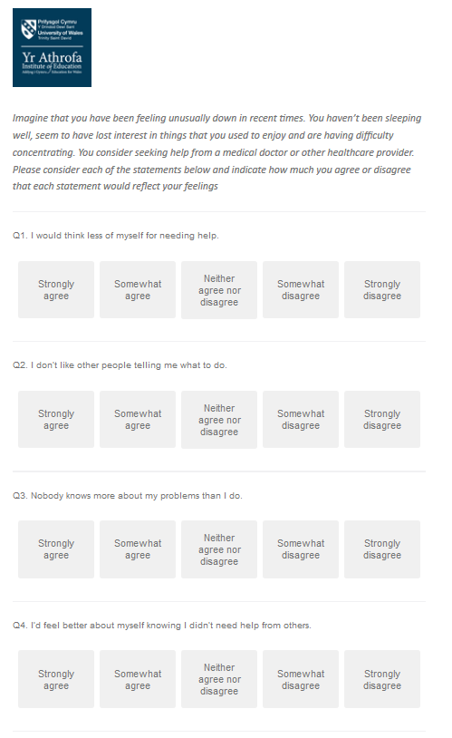
A7

A6

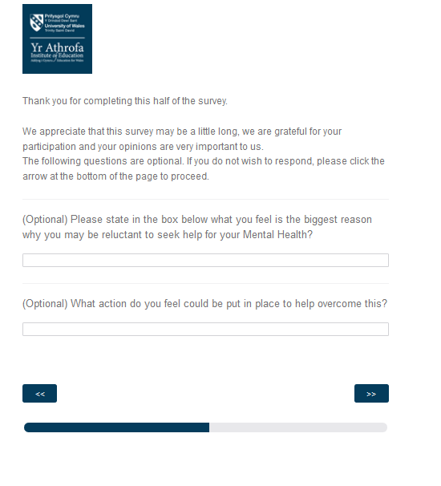
A8

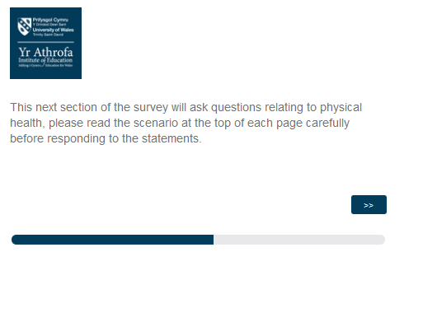
A9

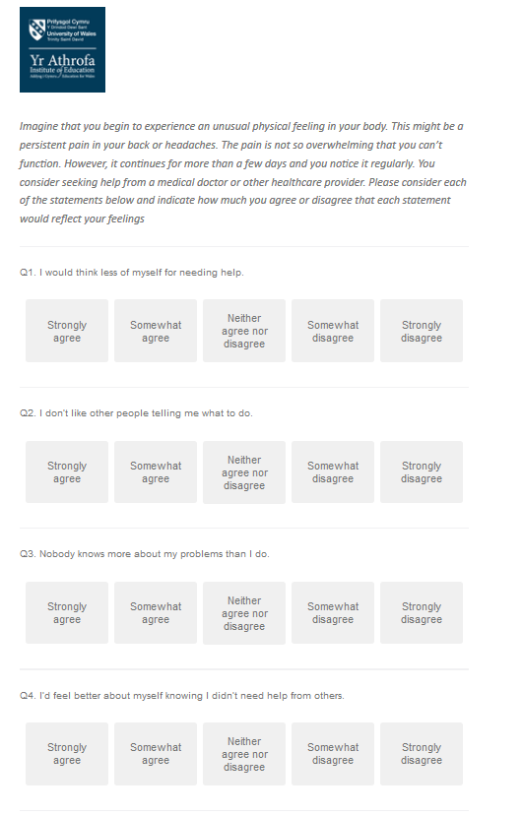
A10

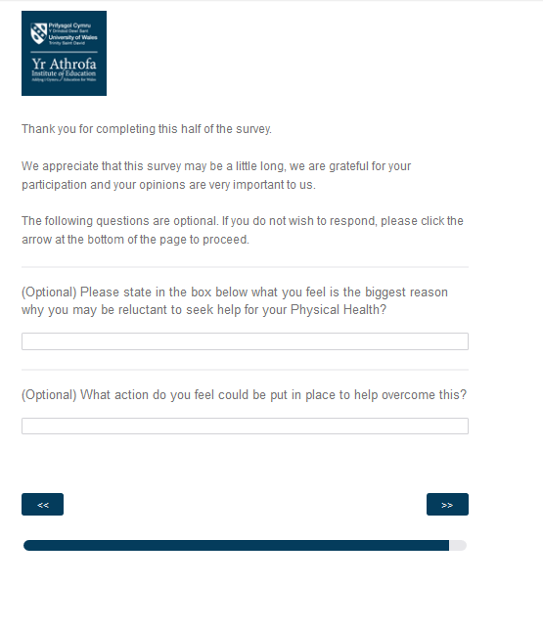
A11

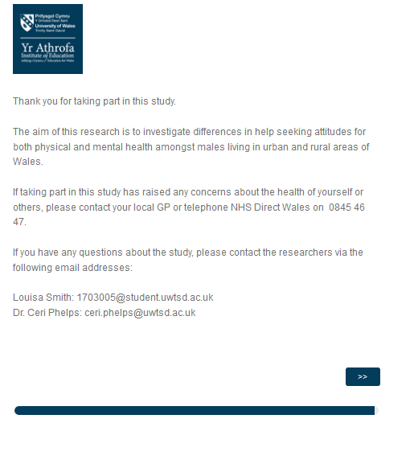
A12

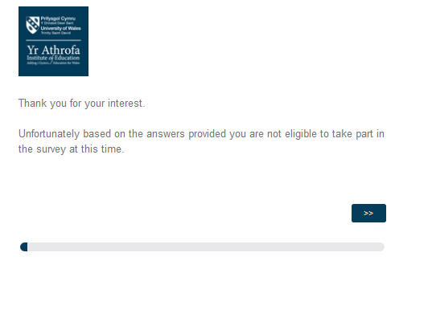
A13

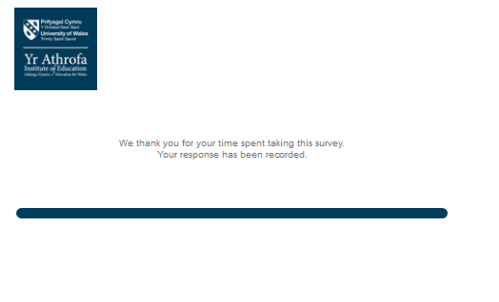
A14

Appendix B;
The Barriers to Help Seeking Scale (Modified version from Fennell, Hull, Jones & Dollman, 2018)

1=Strongly Disagree, 2= Disagree, 3= Neither Agree nor Disagree, 4 = Agree, 5= Strongly Agree

Need for Control and Self-Reliance
I would think less of myself for needing help.
I don’t like other people telling me what to do.
Nobody knows more about my problems than I do.
I’d feel better about myself knowing I didn’t need help from others.
I don’t like feeling controlled by other people.
It would seem weak to ask for help.
I like to make my own decisions and not be too influenced by others.
I like to be in charge of everything in my life.
Asking for help is like surrendering authority or control over my life.
I do not want to appear weaker than my peers.
I do not want to sound like I’m complaining.
I can still function, so I don’t need help.
Minimizing Problem, Resignation and Normalisation
The problem wouldn’t seem worth getting help for.
The problem wouldn’t be a big deal; it would go away in time.
I wouldn’t want to overreact to a problem that wasn’t serious.
Problems like this are part of life; they’re just something you have to deal with.
I’d prefer just to suck it up rather than dwell on my problems.
I would prefer to wait until I’m sure the health problem is a serious one.
Most people in the region have got at least one health issue that they are dealing with.
Concrete Barriers and Distrust of Caregivers
People typically expect something in return when they provide help.
I would have real difficulty finding transportation to a place where I can get help.
I wouldn’t know what sort of help was available.
Financial difficulties would be an obstacle to getting help.
I don’t trust doctors and other health professionals.
I can’t afford to have time off from work to seek help.
I don’t have someone to come to the appointment with me.
I prefer to get help from family and friends.
It takes too long to get in and see my doctor/health professional.
I find it difficult to understand my doctor/health professional.
I prefer to get information or help from the internet or over the phone
I’m worried about the side effects of what they might do.
I don’t know how to talk about something like this.
Privacy
Privacy is important to me, and I don’t want other people to know about my problems.
This problem is embarrassing.
I’m worried about confidentiality in our community.
I am worried that I might know the healthcare provider outside of their work.
Emotional Control
I don’t like to get emotional about things.
I don’t like to talk about feelings.
I’d rather not show people what I’m feeling.
I wouldn’t want to look stupid for not knowing how to figure this problem out.

Appendix C; 2x2 Mixed ANOVA SPSS outputs
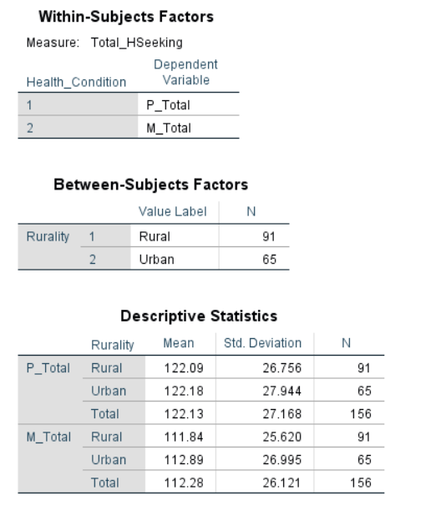

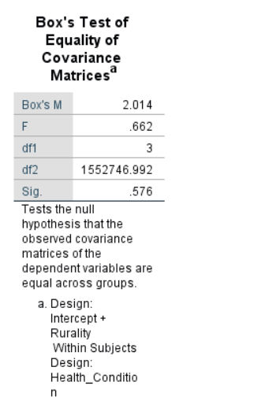

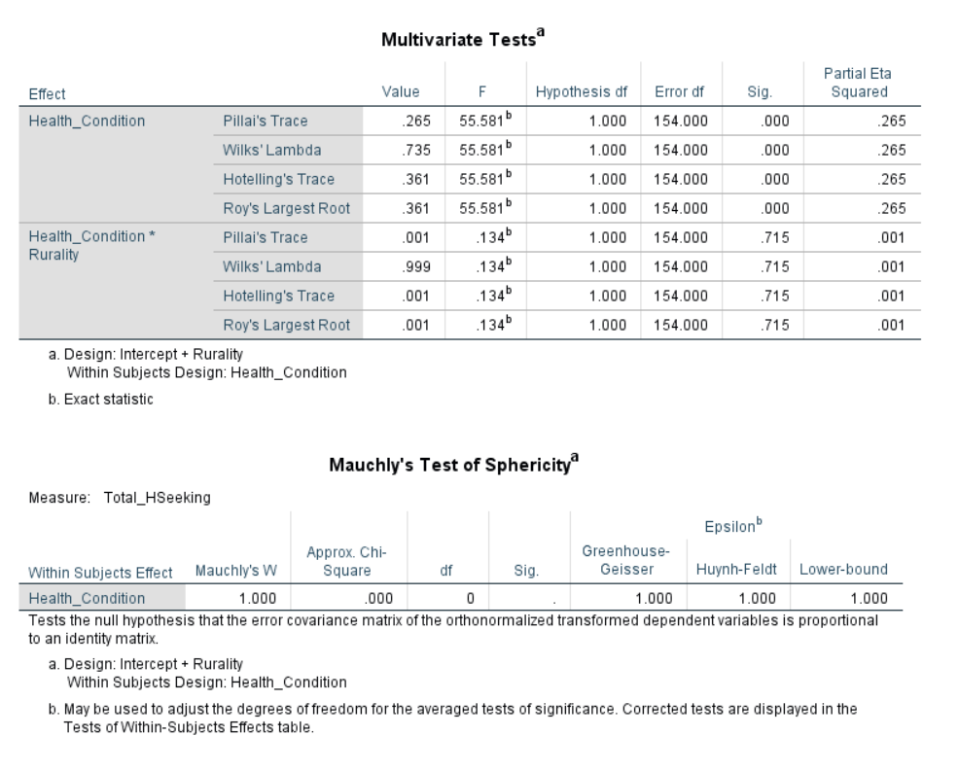

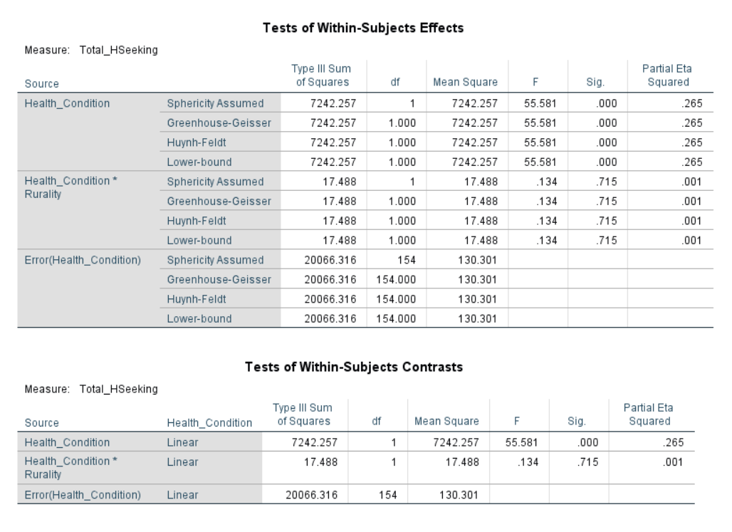

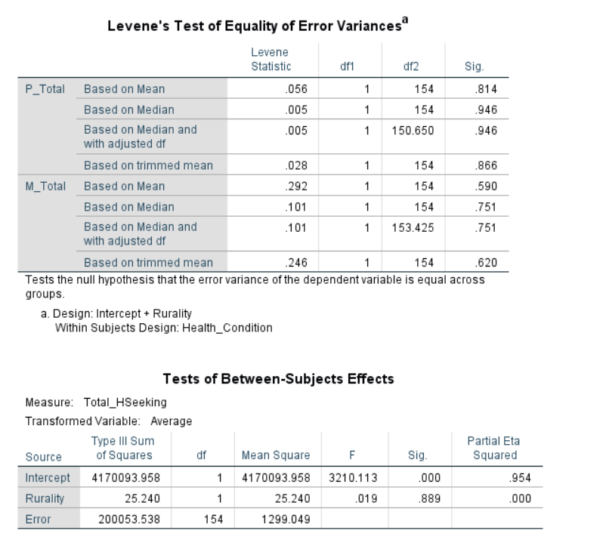

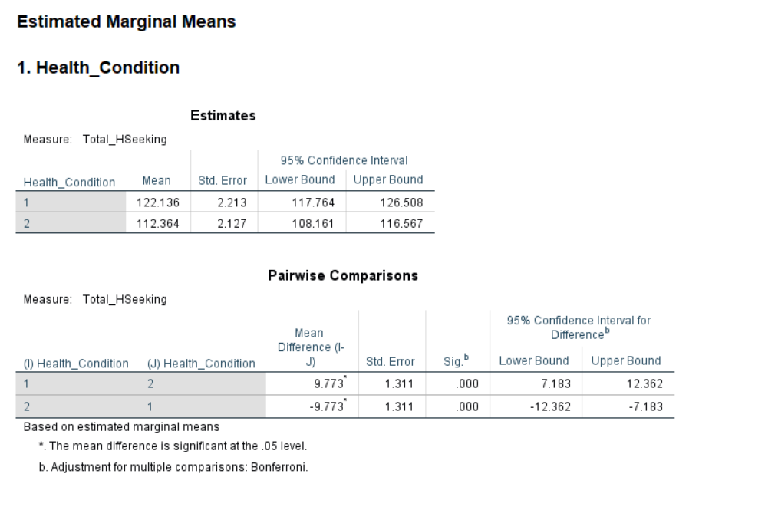

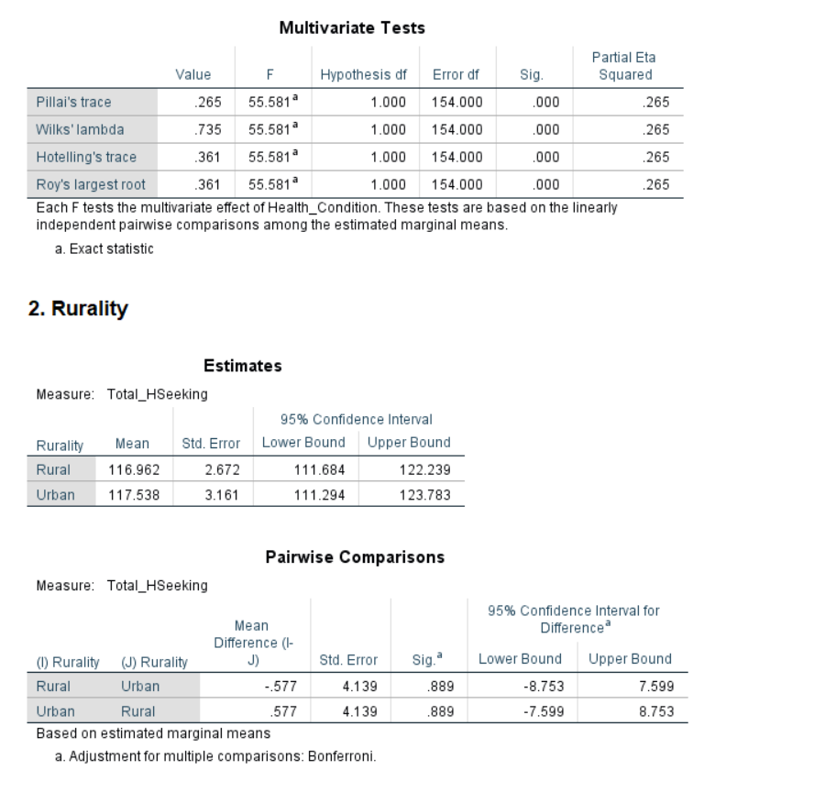

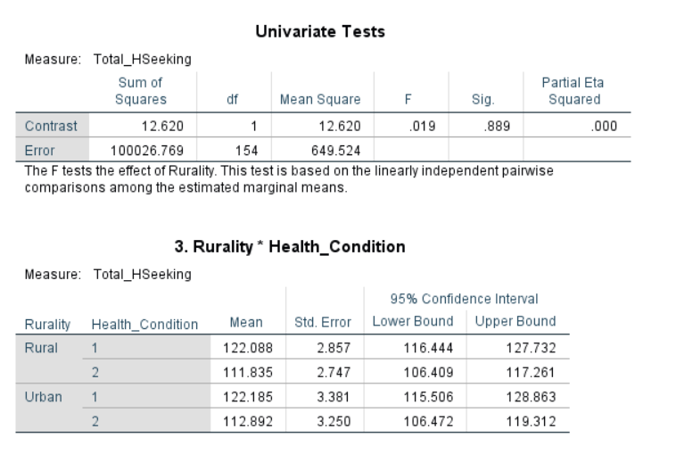

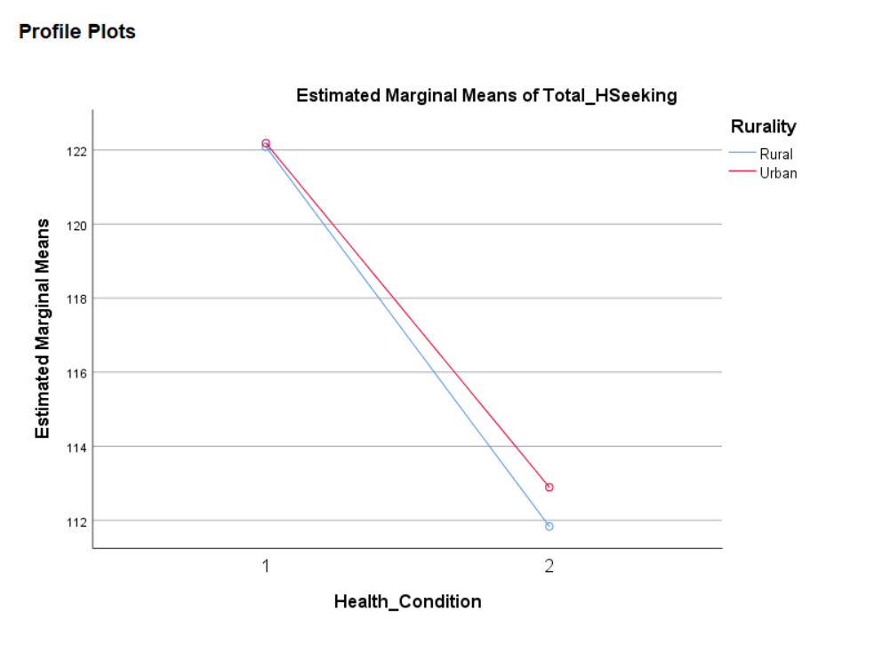

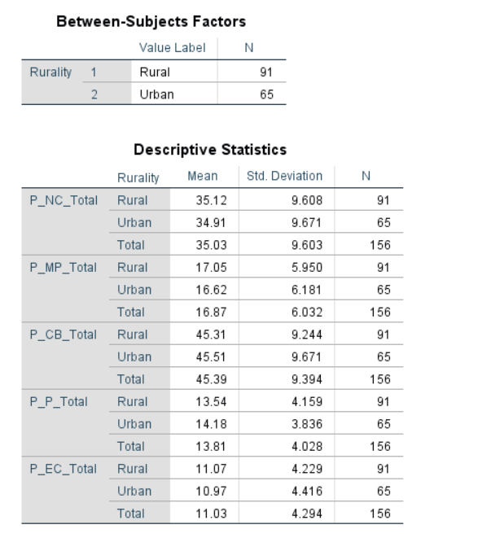
Appendix D; MANOVA SPSS output (Physical health subscales)

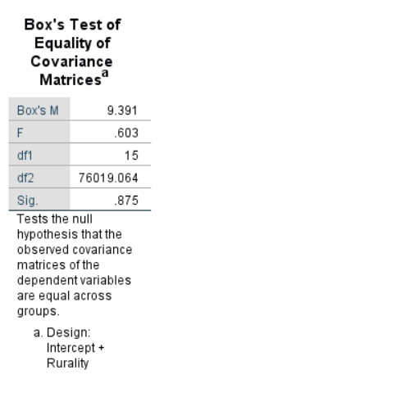

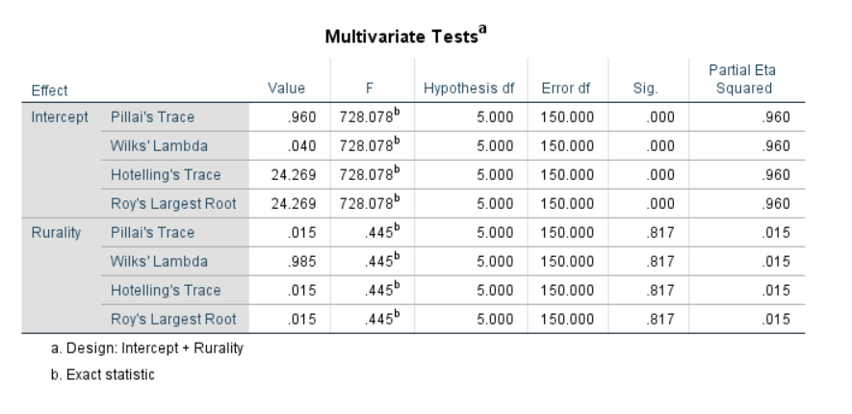

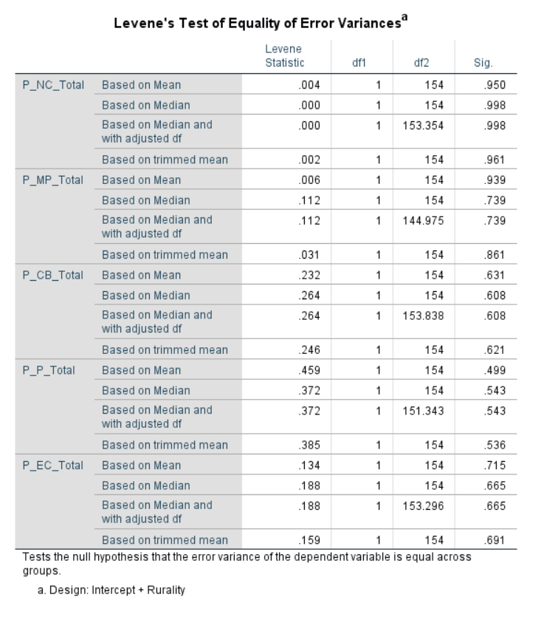

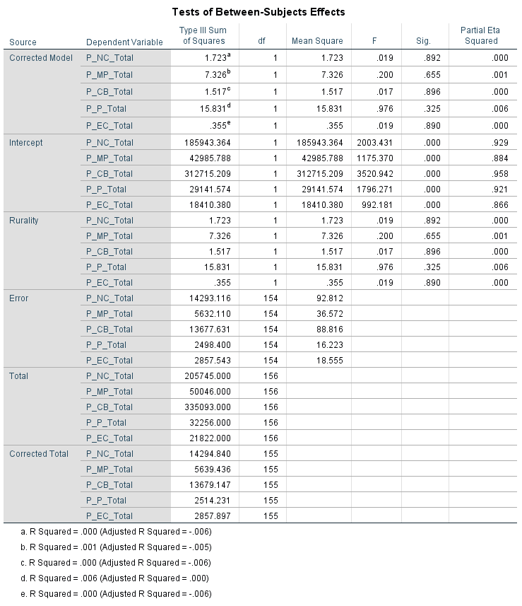

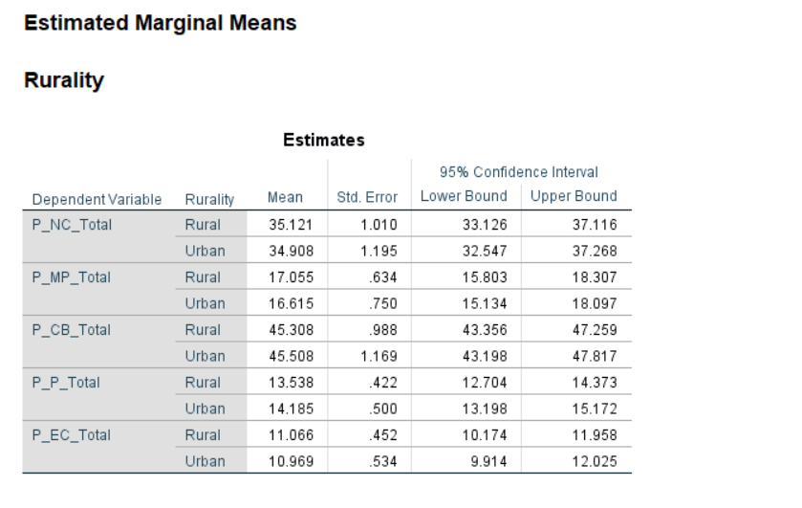

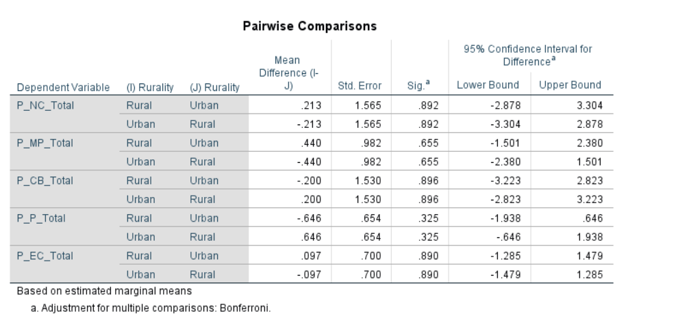

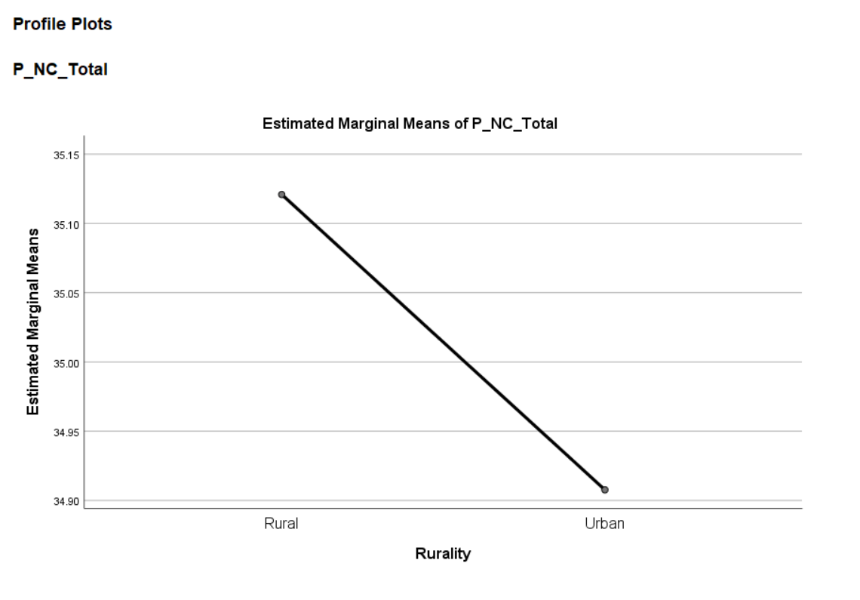
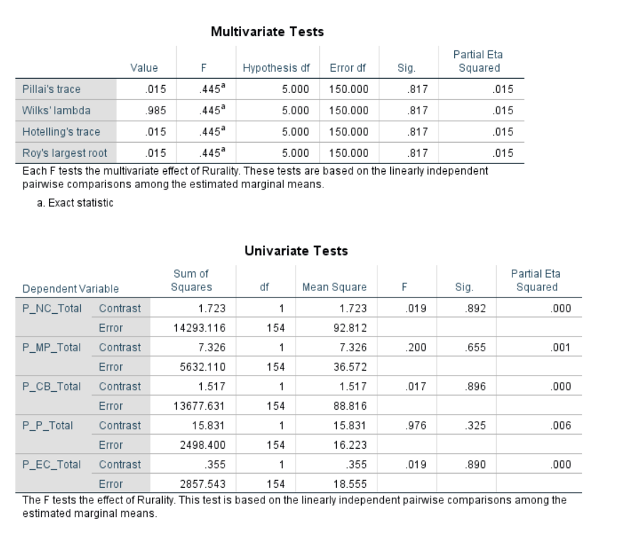

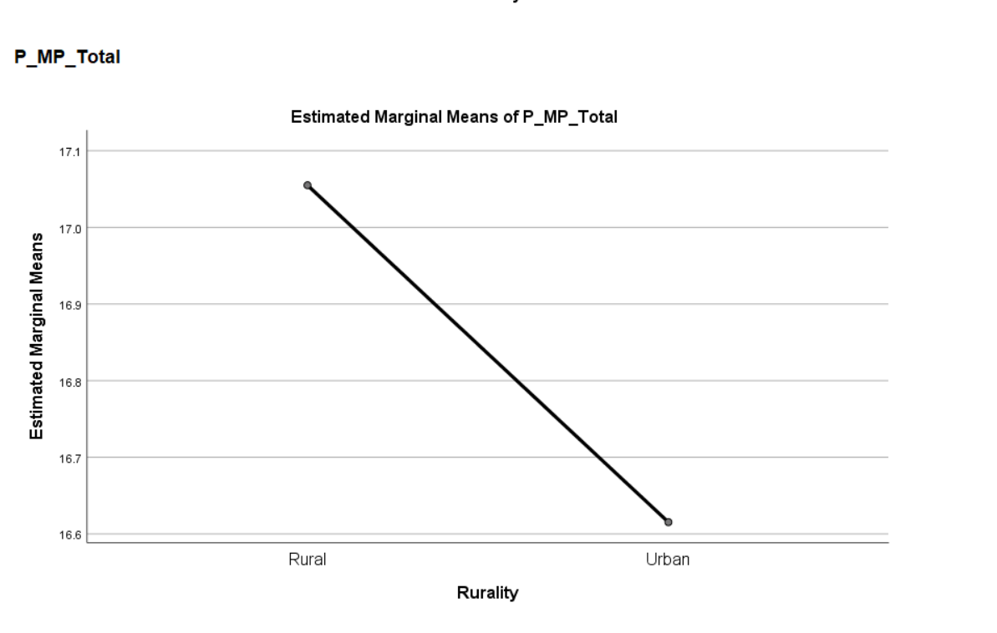

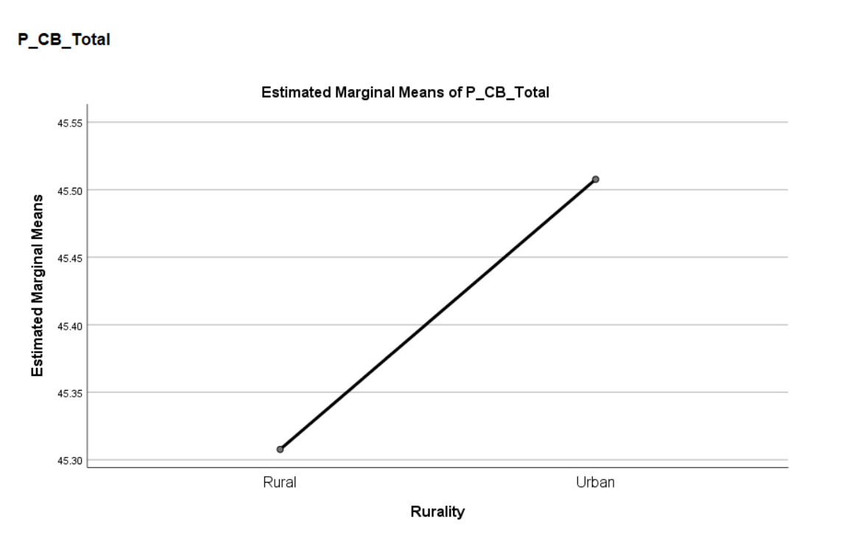

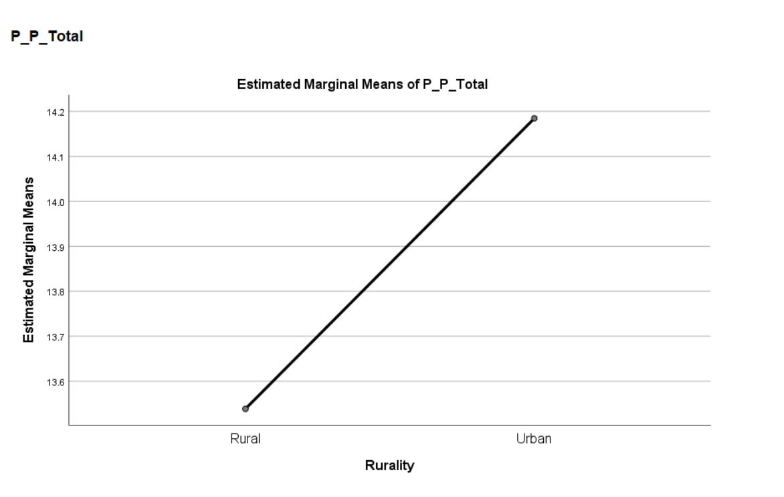

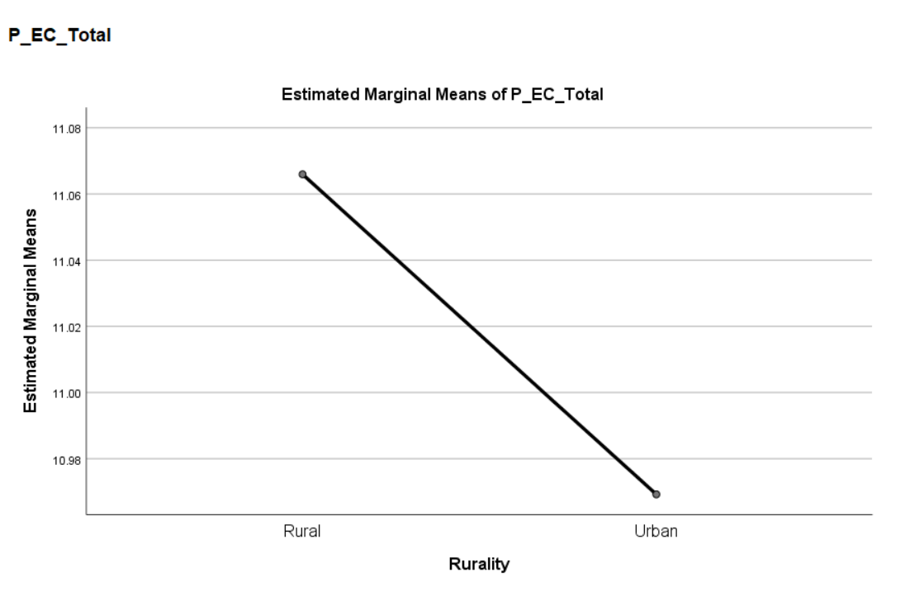

Appendix E; MANOVA SPSS output (Mental health subscales)
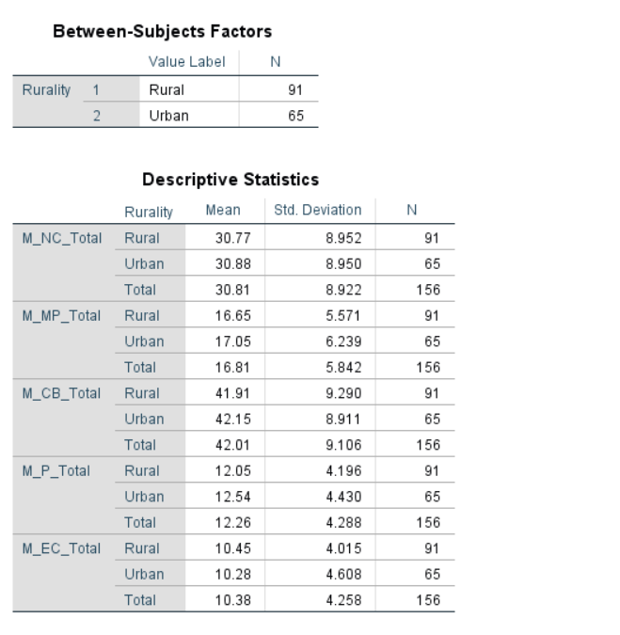

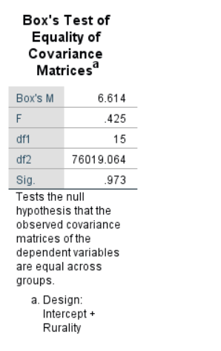

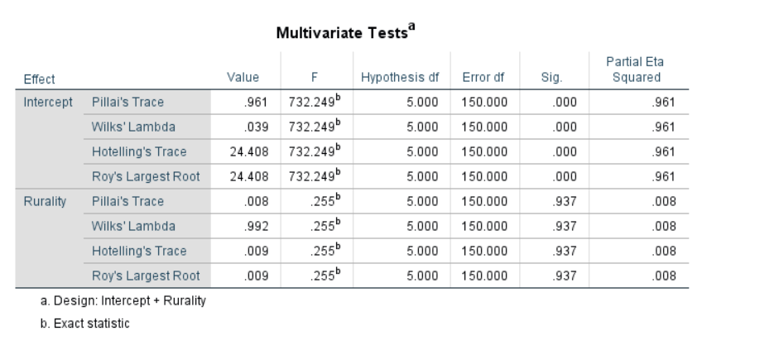

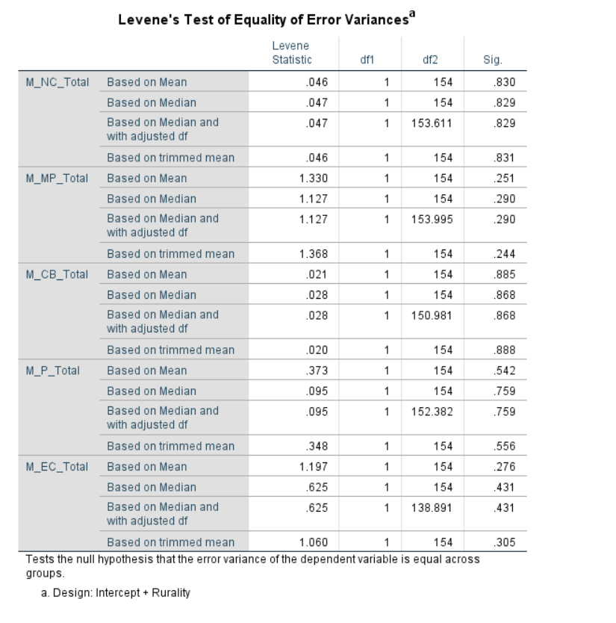

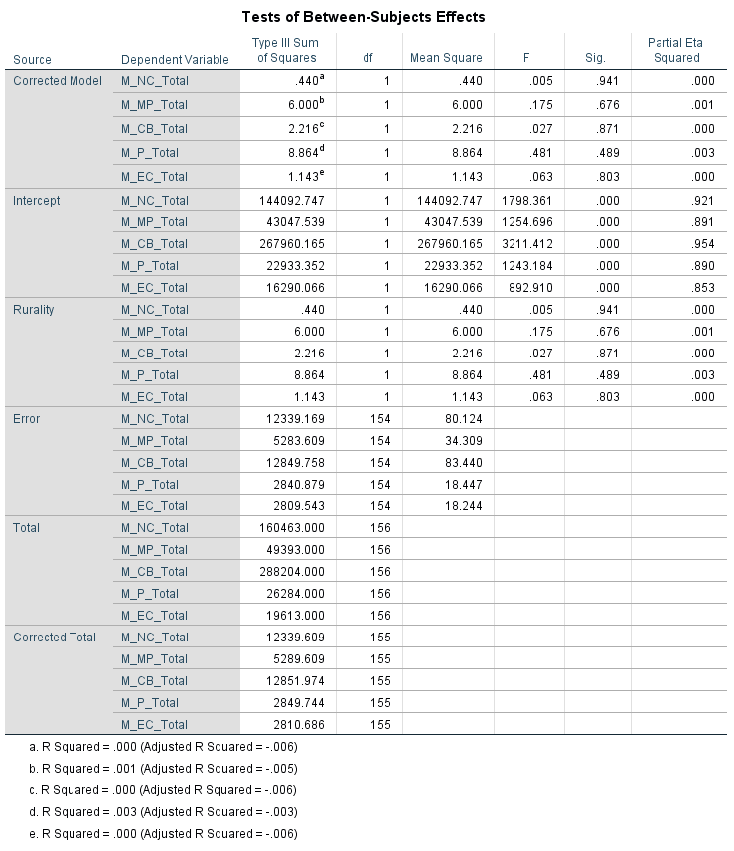

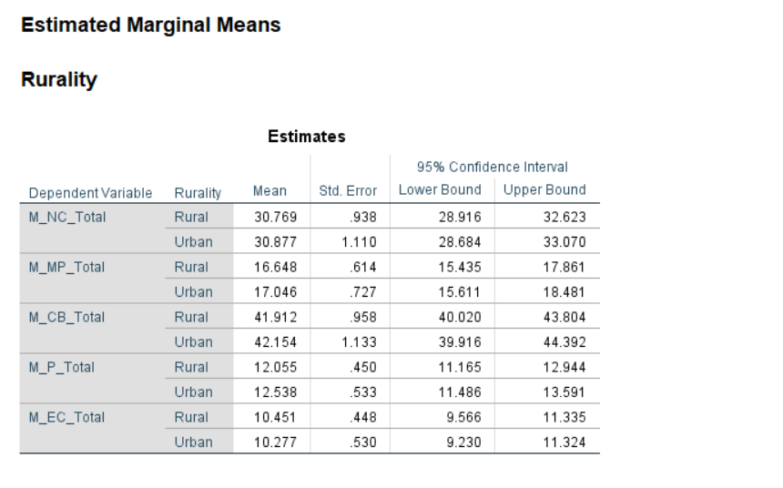

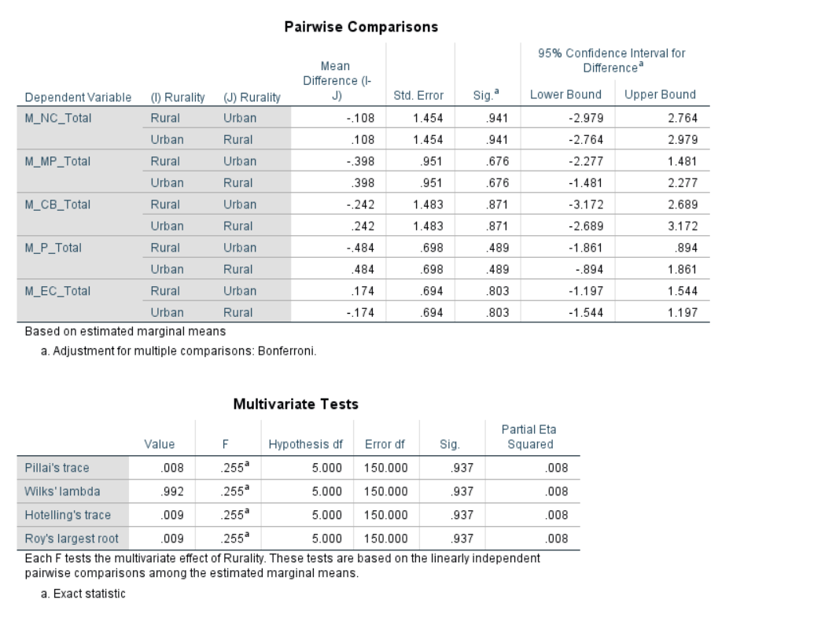

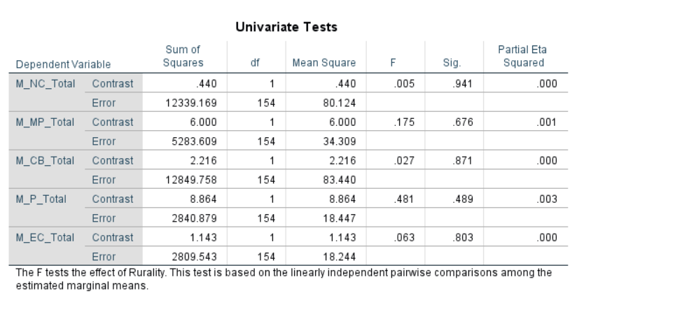

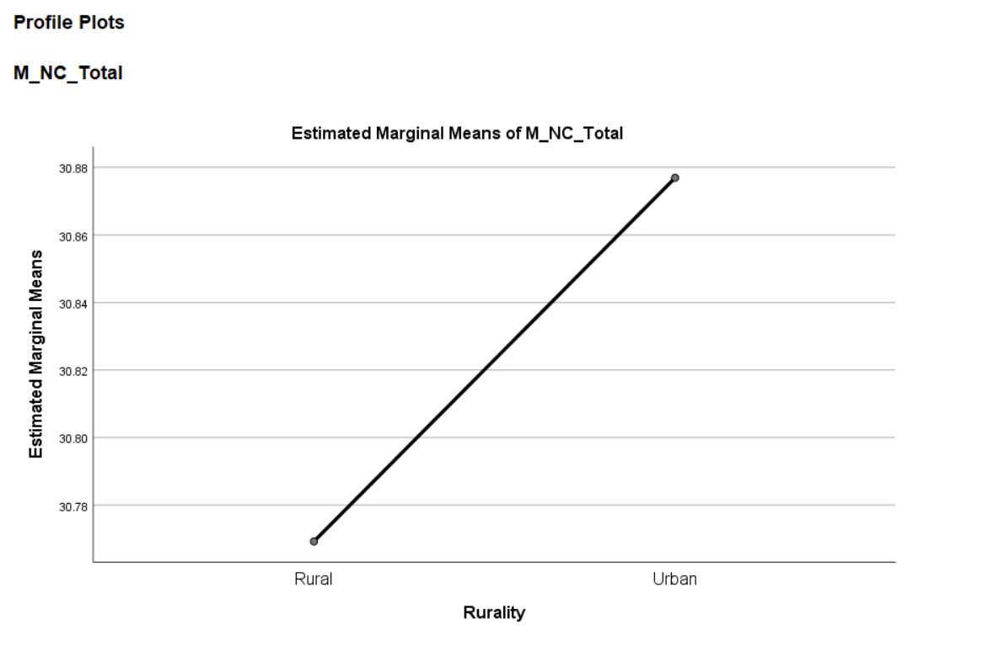

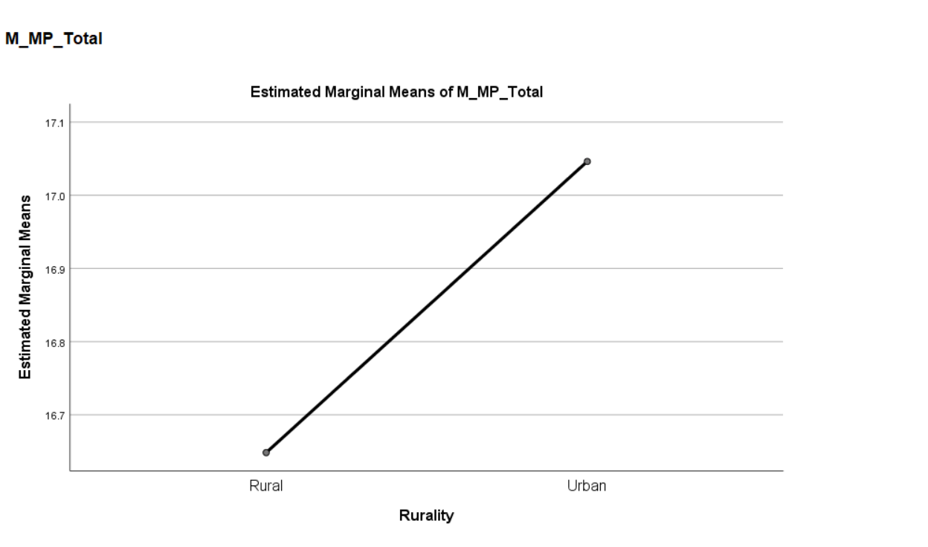

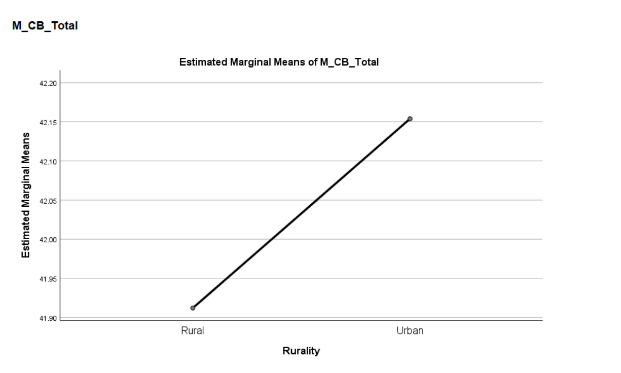

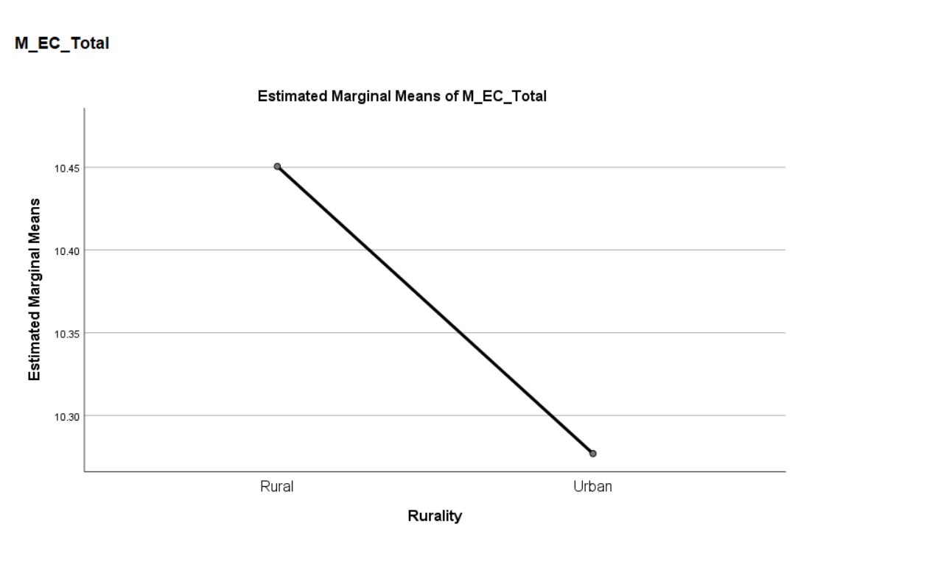
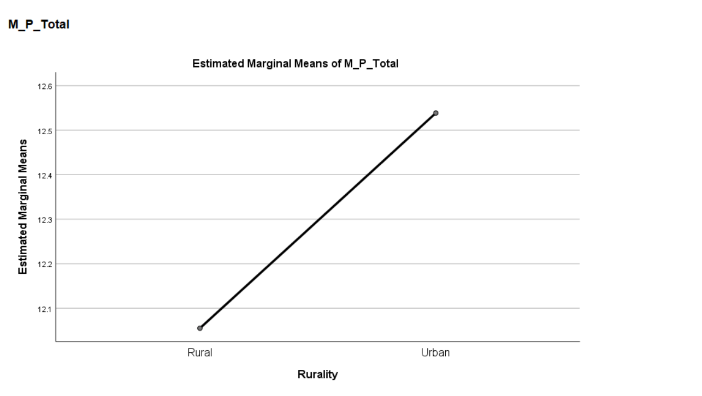

Appendix F; Proposal Form
Dissertation proposal 2019-2020

Student Name | Louisa Smith
Dissertation Supervisor | Dr Ceri Phelps
Date submitted | 11.10.2019

Title of Research (this must reflect the essence of your proposed research question, study design and study population and should be more specific than the broad topic area provided in the dissertation topics selection book).

An online questionnaire study exploring attitudes and barriers towards help seeking in rural and urban male populations in Wales

Please state your main research question(s) and hypothesis/hypotheses

The study will explore potential differences in barriers to help seeking between male populations living in rural and urban areas in Wales using the Barriers to Help Seeking Scale (BHSS: Mansfield, Addis & Courtenay, 2005). Two main hypotheses will be explored:

H1. Males living in both rural and urban areas will score higher in a barriers to help seeking questionnaire for mental health than physical health.

H2. Males living in rural areas will score higher in a barriers to help seeking questionnaire for both mental and physical health than males living in urban areas.

What empirical evidence supports your research question? (Please provide a 1500 word review of relevant psychological literature and theory and a minimum of eight references). If you have already drafted a review of literature please attach it to the end of this document – you do not need to complete this section if so).

In 2018, of the 6,507 suicides registered by the Office of National Statistics (ONS), 4,903 of the victims were male (ONS, 2019). The same ONS bulletin advises that this is a significant percentage increase from the previous year, and that since the mid-1990s, men have statistically been three times more likely to successfully commit suicide than women. These disproportionate numbers have led to an increased awareness among the UK general public of men’s mental health concerns, largely thanks to campaigns by mental health charities. Despite these campaigns, the number of men with common mental disorder (CMD) symptoms receiving any type of mental health treatment from the NHS in 2014 was 9.6% compared to 16.5% of women with CMD symptoms (NHS, 2016) indicating a real problem in getting men in particular to engage with NHS services. Numerous studies have also found that men are less likely to seek help for mental health concerns for numerous reasons, including stigma (Vogel, Wade, Wester, Larson & Hackler, 2007). Help-seeking behaviour could be a number of things, this could be talking to friends and family about the issue, contacting a mental health charity for advice or speaking to a GP or mental health professional. Identifying both perceived and concrete barriers that men face in seeking help for mental health concerns could increase the number of men accepting and actively taking part in treatment, and potentially reduce the number of male suicides in the UK each year.

Research into attitudes towards men’s health has found that men are less likely to seek help from a healthcare professional than women for any issue, physical or psychological (Addis & Mahalik, 2003; Oliver, Pearson, Coe & Gunnell 2005; Judd, Komiti & Jackson, 2008). A common theme among current research is that men are reluctant to seek advice or help for a mental health issue due to perceived social barriers surrounding masculinity and gender stereotypes, as well as social stigma surrounding mental health (Vogel, Wade, Wester, Larson & Hackler, 2007; Wrigley, Jackson, Judd & Komiti, 2005). Addis and Mahalik (2003) reviewed research into the topic and found that social norms surrounding masculinity were one of the biggest factors preventing men from seeking help. Courtenay (2000) reported that men who lived in a society where masculinity was characterised as being stoic, robust and powerful, were more likely to suffer from mental and physical problems as a result of trying to maintain this outward image. Courtenay’s findings are supported by research from Good and Wood’s (1995) study, which found that men with higher levels of male gender role conflict were at increased risk of depression and showed more negative attitudes towards seeking counselling services. Male socialisation has also been shown to have a negative effect on men’s likelihood of seeking treatment (Galdas, Cheater & Marshall, 2005) due to the influence of other males exhibiting “masculine” behaviours and reinforcing ideas of the “normal” way to conduct oneself. A study carried out by Hammer, Vogel and Heimerdinger-Edwards (2013) with US males found that men from rural areas showed a stronger connection between conformity to masculine norms and self-stigma than those living in urban or suburban areas. This would indicate that men in rural areas are at most risk of not engaging in help seeking behaviours without interventions that tackle social norms.

The Theory of Planned Behaviour (TPB: Ajzen, 1991) can offer another explanation of this reluctance to seek help. The TPB suggests that a person’s behaviour can be predicted by their intentions, and intentions are decided by three factors; The person’s attitude to the behaviour, whether it is positive or negative; The person’s social or subjective norms; and the person’s perceived behavioural control. If the attitude of an adult male who is suffering mental health issues is that he thinks he would be seen as “weak”; the social norms of other men around him are that they do not discuss mental health issues; and the person has low levels of perceived behavioural control over what will happen if they see a professional, then according to the TPB he would be unlikely to seek help. The TPB can offer a better understanding of male reluctance to seek help as it offers an explanation the behaviour even if there are no notable threats to any personal freedoms. However, the TPB does rely on more than one factor in influencing behaviour change, meaning it can be difficult to identify what exactly would need to be changed, as this can vary between individuals. This would highlight a need to explore several factors regarding help seeking behaviour at once. The BHSS (Mansfield, Addis & Courtenay, 2005) uses five different subscales in order to gain a better understand of which areas in particular are affecting someone’s help seeking behaviours.

A study investigating the differences between urban and rural male’s help seeking attitudes in Wales - a country known for its rural communities - would add valuable knowledge to the current literature around the subject of men’s help seeking, particularly within the UK. Additionally, if a difference is found between the two populations, targeted interventions can be introduced to try and encourage help seeking behaviours in different groups, rather than the current “one size fits all” approach. Therefore, the purpose of this study is to identify what specific areas of help seeking differ between the two groups. Investigating help seeking for physical health concerns alongside mental health can also offer a unique perspective of whether help seeking attitudes are consistent across both, or if one aspect of health is treated more favourably than the other, and potential differences between the two in the barriers reported.

Please describe your participant group (including anticipated number of participants required) and any specific inclusion/exclusion criteria.

Participants will be males over the age of 18 who currently live in Wales. The BHSS was tested using a sample of 58 participants, therefore at least 60 participants will be required for the study for the purposes of reliability

Please provide brief details of the anticipated design (e.g., between, within, mixed, regression, focus groups, interviews, experimental, questionnaires) and main procedure for your study (it should be clear from this how you are actually planning to carry out your study, and what will be happening to your participants).

The study will be an online cross-sectional questionnaire study of non-experimental design, and all participants will be presented with the same questionnaire to complete in their own time in an environment that they choose. The questionnaire will be made available online via Qualtrics and the university’s experiment management system. The participants will be asked to complete a questionnaire from the perspective of having a physical health complaint, they will also be asked to complete the same questionnaire but from the perspective of having a mental health complaint. The order of the questionnaires will also be counterbalanced through Qualtrics to minimise order effects Analysis of the data will be carried out using a 2x2 ANOVA.

What measures are you planning to use for data collection and how will this data be used in the analysis in order to answer your research question? (Be as specific as possible here – what type of data will you be obtaining, what specific topics/measures/scales/instruments will you be using and what will you do with this data?)

Participants will be taking part in an online questionnaire accessed via a link to the qualtrics website. Participants will be asked to give their age and gender, as well as indicating the area they live in from a constituency map. The questionnaire will consist of items from the barriers to help seeking scale (BHSS) (Mansfield, Addis & Courtenay 2005). The questionnaire will be presented to participants twice, the first half will feature all questions, as people in Wales have access to NHS health services, a “Not Applicable” option will be added to a question regarding health insurance. The second half will feature the same questionnaire, with the exception of three questions relating to a physical health examination will be omitted as they are not relevant to mental health. This scale has been chosen as it has been designed for use with male participants and asks questions specifically related to help seeking for health concerns. The BHSS uses a five-point Likert scale to measure participant’s responses to questions such as “I would think less of myself for needing help”. The questionnaire is also divided into in five sub-scales such as “Need for control and self-reliance” and “Concrete barriers and distrust of caregivers”. The data collected will be used to investigate possible differences in perceived barriers to help seeking between men living in rural and urban areas.

What are the main ethical issues that you will need to address in this study? (Please note all students will need to complete the full ethics form prior to final approval for data collection being given).

The main ethical consideration to be given is the nature of the study, asking questions regarding mental or physical health may cause distress to participants. To minimise potential stress to participants, the consent form at the beginning of the study will inform participants that they will be asked questions relating to their feelings about seeking help for mental and physical health issues, and that any information provided will be stored anonymously and in accordance with the data protection act. At this point the participant may stop the study or continue, confirming that they give informed consent via a check box. If this box is not selected, that participant will not be able to enter the study..

Participants will be reminded before the questionnaire of their right to withdraw from the study. At the end of the questionnaire there will be a reminder of participant’s right to withdraw at that point by emailing the researcher. Participants will be reminded at this point that after leaving the questionnaire, their data will be anonymised.

The debrief form will also contain contact information for the researcher and their supervisor and invite participants to email them if the study has raised any concerns.

Additionally, due to the sensitive nature of the study, the debrief form will also advise participants to contact their GP if they have any concerns about their mental health, and also contain contact information for mental health charities and the NHS helpline.

Student Name (Please print clearly) _____Louisa Smith__________________________

Student Signature ____________Louisa Smith_________________ Date___11.10.2019

Proposal Outcome |  | Supervisor to tick one only
Satisfactory proposal (all final materials have been approved by the supervisor; proceed to submitting the ethics form to the discipline research ethics committee).

Minor revisions (some areas require clarification before submitting ethics to the discipline research ethics committee - see below for required actions)

Unsatisfactory (proposal lacks significant detail and must be resubmitted to supervisor within seven days following feedback - see below for required actions)

Unsatisfactory - proposal is considered unethical/unworkable in practice. New proposal to be developed following feedback from supervisor (see below)

Proposal is satisfactory but requires full consideration by the Faculty research ethics committee due to the nature of the study

Supervisory team additional comments/feedback:

Action required:

Date of comments/feedback :

Supervisor’s Signature: ___________________________ Date: _______________

References
Addis, M. E., & Mahalik, J. R. (2003). Men, masculinity, and the contexts of help seeking. American psychologist, 58(1), 5.
Ajzen, I. (1991). The theory of planned behavior. Organizational behavior and human decision processes, 50(2), 179-211
Galdas, P. M., Cheater, F., & Marshall, P. (2005). Men and health help‐seeking behaviour: literature review. Journal of advanced nursing, 49(6), 616-623.
Good, G. E., & Wood, P. K. (1995). Male gender role conflict, depression, and help seeking: Do college men face double jeopardy?. Journal of Counseling & Development, 74(1), 70-75
Hammer, J. H., Vogel, D. L., & Heimerdinger-Edwards, S. R. (2013). Men's help seeking: Examination of differences across community size, education, and income. Psychology of Men & Masculinity, 14(1), 65.
Judd, F., Komiti, A., & Jackson, H. (2008). How does being female assist help-seeking for mental health problems?. Australian and New Zealand Journal of Psychiatry, 42(1), 24-29.
Mansfield, A. K., Addis, M. E., & Courtenay, W. (2005). Measurement of Men's Help Seeking: Development and Evaluation of the Barriers to Help Seeking Scale. Psychology of Men & Masculinity, 6(2), 95.
NHS (2019). Adult Psychiatric Morbidity Survey: Survey of Mental Health and Wellbeing, England, 2014 - NHS Digital. Retrieved from https://digital.nhs.uk/data-and-information/publications/statistical/adult-psychiatric-morbidity-survey/adult-psychiatric-morbidity-survey-survey-of-mental-health-and-wellbeing-england-2014
Oliver, M. I., Pearson, N., Coe, N., & Gunnell, D. (2005). Help-seeking behaviour in men and women with common mental health problems: cross-sectional study. The British Journal of Psychiatry, 186(4), 297-301.
Suicides in the UK - Office for National Statistics. (2019). Retrieved from https://www.ons.gov.uk/peoplepopulationandcommunity/birthsdeathsandmarriages/deaths/bulletins/suicidesintheunitedkingdom/2018registrations
Vogel, D. L., Wade, N. G., Wester, S. R., Larson, L., & Hackler, A. H. (2007). Seeking help from a mental health professional: The influence of one's social network. Journal of clinical psychology, 63(3), 233-245.
Wrigley, S., Jackson, H., Judd, F., & Komiti, A. (2005). Role of stigma and attitudes toward help seeking from a general practitioner for mental health problems in a rural town. Australian and New Zealand Journal of Psychiatry, 39(6), 514-521.

Appendix G; Ethics Form
APPLICATION FOR ETHICAL APPROVAL

In order for research to result in benefit and minimise risk of harm, it must be conducted ethically. A researcher may not be covered by the University’s insurance if ethical approval has not been obtained prior to commencement.

The University follows the OECD Frascati manual definition of research activity: “creative work undertaken on a systematic basis in order to increase the stock of knowledge, including knowledge of man, culture and society, and the use of this stock of knowledge to devise new applications”. As such this covers activities undertaken by members of staff, postgraduate research students, and both taught postgraduate and undergraduate students working on dissertations/projects.

The individual undertaking the research activity is known as the “principal researcher”.

Ethical approval is not required for routine audits, performance reviews, quality assurance studies, testing within normal educational requirements, and literary or artistic criticism.

Please read the notes for guidance before completing ALL sections of the form.

This form must be completed and approved prior to undertaking any research activity. Please see Checklist for details of process for different categories of application.

Delete the Guidance Notes at the end of the form BEFORE submitting your application

SECTION A: About You (Principal Researcher)
Full Name: |  | Louisa Jane Smith
Tick all boxes which apply: |  | Member of staff: | ☐ | Honorary research fellow: | ☐
Undergraduate Student | ☒ | Taught Postgraduate Student | ☐ | Postgraduate Research Student | ☐

Faculty/School/Centre: | Yr Athrofa
Campus: | SA1
E-mail address: | 1703005@student.uwtsd.ac.uk
Contact Telephone Number: | 07719216602
For students:
Student Number: | 1703005
Programme of Study: | Psychology (BSc)
Director of Studies/Supervisor: | Dr. Ceri Phelps

SECTION B: Approval for Research Activity
Has the research activity received approval in principle?  (please check the Guidance Notes as to the appropriate approval process for different levels of research by different categories of individual) |  | YES | ☒ | NO | ☐
 |  |  |  | Date
If Yes, please indicate source of approval (and date where known): Approval in principle must be obtained from the relevant source prior to seeking ethical approval | Research Degrees Committee |  | ☐
 | Faculty Research Committee |  | ☐
 | Other (write in )supervisor approval |  | ☒ | 01/11/2019

SECTION C: Internal and External Ethical Guidance Materials
Please list the core ethical guidance documents that have been referred to during the completion of this form (including any discipline-specific codes of research ethics, and also any specific ethical guidance relating to the proposed methodology). Please tick to confirm that your research proposal adheres to these codes and guidelines.
UWTSD Research Ethics & Integrity Code of Practice | ☒
UWTSD Research Data Management Policy | ☒
BPS code of Human Research Ethics | ☒
BPS Code of Conduct for Internet Mediated research | X

SECTION D: External Collaborative Research Activity
Does the research activity involve collaborators outside of the University? |  | YES | ☐ | NO | ☒
If Yes, please provide the name of the external organisation and name and contact details for the main contact person and confirmation this person has consented to their personal data being shared.as part of this collaboration.
Institution
Contact person name
Contact person e-mail address

Has this individual consented to sharing their details on this form? |  | YES | ☐ | NO |  |  | ☐
Are you in receipt of a KESS scholarship? |  | YES | ☐ | NO |  |  | ☐
Is your research externally funded |  | YES | ☐ | NO |  |  | ☐
Are you specifically employed to undertake this research in either a paid or voluntary capacity? | Voluntary | YES | ☐ | NO |  | ☐
 | Employed | YES | ☐ | NO |  | ☐
Is the research being undertaken within an existing UWTSD Athrofa Professional Learning Partnership (APLP) | If YES then the permission question below does not need to be answered. | YES | ☐ | NO |  |  | ☐
Permission to undertake the research has been provided by the partner organisation | (If YES attach copy)  If NO the application cannot continue | YES | ☐ | NO |  |  | ☐

Where research activity is carried out in collaboration with an external organisation
Does this organisation have its own ethics approval system? | YES | ☐ | NO | ☐
If Yes, please attach a copy of any final approval (or interim approval) from the organisation

SECTION E: Details of Research Activity
Indicative title: | An online questionnaire study exploring attitudes and barriers towards help seeking in rural and urban male populations in Wales
Proposed start date: | 13.12.19 | Proposed end date: | 27.03.20
Introduction to the Research (maximum 300 words)
Ensure that you write for a Non-Specialist Audience when outlining your response to the three points below:
- Purpose of Research Activity
- Proposed Research Question
- Aims of Research Activity
- Objectives of Research Activity
Demonstrate, briefly, how Existing Research has informed the proposed activity and explain
- What the research activity will add to the body of knowledge
- How it addresses an area of importance.
Purpose of Research Activity

Research into attitudes towards men’s health has found that men are less likely to seek help from a healthcare professional than women for any issue, physical or psychological (Addis & Mahalik, 2003; Oliver, Pearson, Coe & Gunnell 2005; Judd, Komiti & Jackson, 2008). A common theme among current research is that men are reluctant to seek advice or help for a mental health issue due to perceived social barriers surrounding masculinity and gender stereotypes, as well as social stigma surrounding mental health (Vogel, Wade, Wester, Larson & Hackler, 2007; Wrigley, Jackson, Judd & Komiti, 2005). Addis and Mahalik (2003) reviewed research on the topic and found that social norms surrounding masculinity were one of the biggest factors preventing men from seeking help. Male socialisation has also been shown to have a negative effect on men’s likelihood of seeking treatment (Galdas, Cheater & Marshall, 2005) due to the influence of other males exhibiting “masculine” behaviours and reinforcing ideas of the “normal” way to conduct oneself. A study carried out by Hammer, Vogel and Heimerdinger-Edwards (2013) with US males found that men from rural areas showed a stronger connection between conformity to masculine norms and self-stigma than those living in urban or suburban areas. This would indicate that men in rural areas are at most risk of not engaging in help seeking behaviours without interventions that tackle social norms.

The Theory of Planned Behaviour (TPB: Ajzen, 1991) can offer another explanation of this reluctance to seek help. The TPB suggests that a person’s behaviour can be predicted by their intentions, and intentions are decided by three factors; The person’s attitude to the behaviour, whether it is positive or negative; The person’s social or subjective norms; and the person’s perceived behavioural control. The TPB can offer a better understanding of male reluctance to seek help as it offers an explanation the behaviour even if there are no notable threats to any personal freedoms. However, the TPB does rely on more than one factor in influencing behaviour change, meaning it can be difficult to identify what exactly would need to be changed, as this can vary between individuals. This would highlight a need to explore several factors regarding help seeking behaviour at once. The BHSS (Mansfield, Addis & Courtenay, 2005) uses five different subscales in order to gain a better understand of which areas in particular are affecting someone’s help seeking behaviours.

A study investigating the differences between urban and rural male’s help seeking attitudes in Wales - a country known for its rural communities - would add valuable knowledge to the current literature around the subject of men’s help seeking, particularly within the UK. Additionally, if a difference is found between the two populations, targeted interventions can be introduced to try and encourage help seeking behaviours in different areas, rather than the current “one size fits all” approach. Investigating help seeking for physical health concerns alongside mental health can also offer a unique perspective of whether help seeking attitudes are consistent across both, or if one aspect of health is treated more favourably than the other, and potential differences between the two in the barriers reported.

(this box should expand as you type)
Research Question
The main hypothesis is that males living in rural areas will report higher scores in a barriers to help seeking questionnaire for mental health than males living in urban areas. A second hypothesis is that participants will score higher in barriers to help seeking for mental health than physical health.

(this box should expand as you type)
Aims of Research Activity

The aim of the study is to explore potential differences in barriers to help seeking between male populations living in rural and urban areas in Wales using a modified version of the Barriers to Help Seeking Scale (Appendix A) (Fennell, Hull, Jones & Dollman, 2018).

(this box should expand as you type)
Objectives of Research Activity

A study investigating the differences between urban and rural male’s help seeking attitudes in Wales - a country known for its rural communities - would add valuable knowledge to the current literature around the subject of men’s help seeking, particularly within the UK. Additionally, investigating the direct differences between barriers to physical and mental health using the same measure would also assist with investigating aspects affecting help seeking for different health services. If a difference is found between the two populations, targeted interventions can be introduced to try and encourage help seeking behaviours in different groups, rather than the current “one size fits all” approach.

(this box should expand as you type)
Proposed methods (maximum 600 words)
Provide a brief summary of all the methods that may be used in the research activity, making it clear what specific techniques may be used. If methods other than those listed in this section are deemed appropriate later, additional ethical approval for those methods will be needed.
The study will consist of an online questionnaire administered via Qualtrics and will be aimed at exclusively male participants in order to better understand the barriers faced when seeking help for mental and physical health concerns. The questionnaire will be primarily quantitative but will also include opportunities for participants to provide additional qualitative free text data.

The data collected for the study will include demographic data (age, gender, area of residence (via a population map (Appendix B) and highest level of education), and answers to a modified version the Barriers to help seeking scale (BHSS: Fennell, Hull, Jones & Dollman, 2018) (Appendix A). As there is no fixed definition in Wales of what is considered a rural area, participants will be asked to state whether they consider where they live to be more rural or urban. The modified BHSS is a forty-item scale that uses a five-point Likert scale to measure how participants feel that statements such as “I would think less of myself for needing help” reflect their own feelings. As well as measuring a total score of number of barriers to help seeking, the modified BHSS can also be broken down into five separate subscales. These subscales include “Need for control and self-reliance” and “Minimizing Problem and Resignation”. This questionnaire in particular has been chosen for the study as data can be collected while protecting anonymity, and because the five subscales will allow an opportunity to investigate differences in the types of barriers faced by individuals, as well as the number. The modified version was also used in a similar study comparing attitudes to help seeking for both physical and mental health in rural Australian participants. The modified BHSS will be presented under two conditions, with all participants taking part in both conditions:

1) Participants will be asked to imagine that they have a physical health concern, and how closely the statements in the questionnaire compare with how they would feel about seeking help from family, friends or a medical professional.

2) As in condition 1, however condition 2 will ask participants to consider the statements from the perspective of having a mental health concern.

At the end of each questionnaire, two questions will be added with the opportunity for participants to answer using text boxes. The first question will ask what participants feel is the biggest barrier they face in seeking help for their physical/mental health (dependant on which questionnaire they have just completed) and the second will ask what suggestions they may have that would assist in overcoming said barrier. These questions will add valuable qualitative data to the study and may offer additional barriers that have not been included in the modified BHSS.

In order to minimise order effects, the questionnaires will be counterbalanced via Qualtrics.

The anonymous data collected from the completed questionnaires will be downloaded from Qualtrics and inputted into SPSS in order to run a 2x2 ANOVA analysis to investigate differences in help seeking between urban and rural populations and differences between barriers to physical and mental health help seeking. The free text data will be subjected to a basic thematic analysis.

(this box should expand as you type)

Location of research activity
Identify all locations where research activity will take place.
The study creation and analysis will be carried out in the dedicated psychology lab environment at UWTSD’s SA1 campus. As the study will be carried out online there is no fixed location where the participants will be required to be present.

(this box should expand as you type)
Research activity outside of the UK
If research activity will take place overseas, you are responsible for ensuring that local ethical considerations are complied with and that the relevant permissions are sought. Specify any local guidelines (e.g. from local professional associations/learned societies/universities) that exist and whether these involve any ethical stipulations beyond those usual in the UK (provide details of any licenses or permissions required). Also specify whether there are any specific ethical issues raised by the local context in which the research activity is taking place, for example, particular cultural and/or legal sensitivities or vulnerabilities of participants.
N/A

(this box should expand as you type)
Use of documentation not in the public domain: Are any documents NOT publicly available? | NO | ☒
 | YES | ☐
If Yes, please provide details here of how you will gain access to specific documentation that is not in the public domain and that this is in accordance with prevailing data protection law of the country in question and England and Wales.

(this box should expand as you type)

SECTION F: Scope of Research Activity
Will the research activity include: | YES | NO
Use of a questionnaire or similar research instrument? | ☒ | ☐
Use of interviews? | ☐ | ☒
Use of diaries? | ☐ | ☒
Participant observation with their knowledge? | ☐ | ☒
Participant observation without their knowledge? | ☐ | ☒
Use of video or audio recording? | ☐ | ☒
Access to personal or confidential information without the participants’ specific consent? | ☐ | ☒
Administration of any questions, test stimuli, presentation that may be experienced as physically, mentally or emotionally harmful / offensive? | ☐ | ☒
Performance of any acts which may cause embarrassment or affect self-esteem? | ☐ | ☒
Investigation of participants involved in illegal activities? | ☐ | ☒
Use of procedures that involve deception? | ☐ | ☒
Administration of any substance, agent or placebo? | ☐ | ☒
Working with live vertebrate animals? | ☐ | ☒
Other primary data collection methods, please explain in this box  For example, ‘focus groups’. Please indicate the type of data collection method(s) in this box and tick the accompany box. | ☐ | ☒
Details of any other primary data collection method:  (this box should expand as you type) | ☐ | ☒
If NO to every question, then the research activity is (ethically) low risk and may be exempt from some of the following sections (please refer to Guidance Notes).

If YES to any question, then no research activity should be undertaken until full ethical approval has been obtained.

SECTION G: Intended Participants
Who are the intended participants: | YES | NO
Students or staff at the University? | ☒ | ☐
Adults (over the age of 18 and competent to give consent)? | ☒ | ☐
Vulnerable adults? | ☐ | ☒
Children and Young People under the age of 8? (Consent from Parent, Carer or Guardian will be required) | ☐ | ☒
Prisoners? | ☐ | ☒
Young offenders? | ☐ | ☒
Those who could be considered to have a particularly dependent relationship with the investigator or a gatekeeper? | ☐ | ☒
People engaged in illegal activities? | ☐ | ☒
Others (please identify specifically any group who may be unable to give consent) please indicate here and tick the appropriate box. | ☐ | ☐
Other – please indicate here:  (this box should expand as you type) | ☐ | ☐

Participant numbers and source
Provide an estimate of the expected number of participants. How will you identify participants and how will they be recruited?
How many participants are expected? | The researcher intends to recruit 150 participants in total in order to ensure sufficient numbers of participants for analysis based on number needed per cell (15 participants per individual subscale, therefore with the questionnaire being presented to participants twice and a total of 10 subscales being measured, 150 participants will be needed to ensure reliable results).  (this box should expand as you type)
Who will the participants be? | People who currently identify as male over the age of 18 who are currently living in Wales. Participants will be invited to take part in the study online through a shareable link.  (this box should expand as you type)
How will you identify the participants? | The questionnaire will be made available online so the researcher will not be present when the study is carried out. Before taking part in the study, participants will have to confirm via check box that they are male, currently residing in Wales and are over the age of 18.  (this box should expand as you type)
Information for participants: | YES | NO | N/A
Will you describe the main research procedures to participants in advance, so that they are informed about what to expect? | ☒ | ☐ | ☐
Will you tell participants that their participation is voluntary? | ☒ | ☐ | ☐
Will you obtain written consent for participation? | ☒ | ☐ | ☐
Will you explain to participants that refusal to participate in the research will not affect their treatment or education (if relevant)? | ☒ | ☐ | ☐
If the research is observational, will you ask participants for their consent to being observed? | ☐ | ☐ | ☒
Will you tell participants that they may withdraw from the research at any time and for any reason? | ☒ | ☐ | ☐
With questionnaires, will you give participants the option of omitting questions they do not want to answer? | ☒ | ☐ | ☐
Will you tell participants that their data will be treated with full confidentiality and that, if published, it will not be identifiable as theirs? | ☒ | ☐ | ☐
Will you debrief participants at the end of their participation, in a way appropriate to the type of research undertaken? | ☒ | ☐ | ☐
If NO to any of above questions, please give an explanation
(this box should expand as you type)

Information for participants: | YES | NO | N/A
Will participants be paid? | ☐ | ☒ | ☐
Is specialist electrical or other equipment to be used with participants? | ☐ | ☒ | ☐
Are there any financial or other interests to the investigator or University arising from this study? | ☐ | ☒ | ☐
Will the research activity involve deliberately misleading participants in any way, or the partial or full concealment of the specific study aims? | ☐ | ☒ | ☐
If YES to any question, please provide full details
(this box should expand as you type)

SECTION H: Anticipated Risks

Outline any anticipated risks that may adversely affect any of the participants, the researchers and/or the University, and the steps that will be taken to address them.

If you have completed a full risk assessment (for example as required by a laboratory, or external research collaborator) you may append that to this form.
Full risk assessment completed and appended? |  | Yes | ☐
 |  | No | ☒
Risks to participants
For example: emotional distress, financial disclosure, physical harm, transfer of personal data, sensitive organisational information
Risk to Participant:  Due to the questionnaire asking questions regarding mental and physical health, some participants could potentially experience discomfort when completing the study.  (this box should expand as you type) | How will you mitigate the Risk to Participant  To minimise potential stress to participants, the information sheet at the beginning of the study will inform participants that they will be asked questions relating to their feelings about seeking help for mental and physical health concerns, and that any information provided will be stored anonymously and in accordance with the data protection act. Participants will also be reminded that participation is voluntary, and they may withdraw from the study at any point while taking part by simply closing the browser. Prior to releasing the study, it will be piloted for acceptability and use of validated questionnaire  (this box should expand as you type)
If research activity may include sensitive, embarrassing or upsetting topics (e.g. sexual activity, drug use) or issues likely to disclose information requiring further action (e.g. criminal activity), give details of the procedures to deal with these issues, including any support/advice (e.g. helpline numbers) to be offered to participants. Note that where applicable, consent procedures should make it clear that if something potentially or actually illegal is discovered in the course of a project, it may need to be disclosed to the proper authorities
In the unlikely event of distress, the debrief form ( Appendix E) will also advise participants to contact their GP if they have any concerns about their health, and also contain contact information for the NHS helpline.

(this box should expand as you type)
Risks to investigator
For example: personal safety, physical harm, emotional distress, risk of accusation of harm/impropriety, conflict of interest
Risk to Investigator:  Due to the researcher’s email address being available, some participants may contact the researcher about issues that they are not able to deal with or could cause the researcher distress.  (this box should expand as you type) | How will you mitigate the Risk to Investigator:  Only the researcher’s institutional email will be available, and any communication from participants will be forwarded on to the researcher’s supervisor for advice before taking any action.  (this box should expand as you type)
University/institutional risks
For example: adverse publicity, financial loss, data protection
Risk to University:  If the investigator fails to carry out the study appropriately and is accused of misconduct, the university could face adverse publicity as a result.  (this box should expand as you type) | How will you mitigate the Risk to University:  No research or data collection will be carried out without the full consent of the university ethics committee. The study will also be conducted in accordance with BPS ethical guidelines.  (this box should expand as you type)

Disclosure and Barring Service
If the research activity involves children or vulnerable adults, a Disclosure and Barring Service (DBS) certificate must be obtained before any contact with such participants. | YES | NO | N/A
Does your research require you to hold a current DBS Certificate? | ☐ | ☒ | ☐

SECTION I: Feedback, Consent and Confidentiality
Feedback
What de-briefing and feedback will be provided to participants, how will this be done and when?
Following completion of the online study, a debrief page on the final page of the online survey will be shown to participants thanking them for taking part. This form will advise that the study was investigating differences in help seeking attitudes and behaviours in urban and rural male populations in Wales. At the end of the questionnaire there will be a reminder of participant’s right to withdraw at that point by emailing the researcher.

The debrief page will also contain contact information for the researcher and their supervisor and invite participants to email them if the study has raised any concerns or if they wish to receive a summary of the study findings

Additionally, the debrief form (Appendix E) will also advise participants to contact their GP if they have any concerns about their mental or physical health, and also contain contact information for the NHS Wales helpline.

(this box should expand as you type)
Informed consent
Describe the arrangements to inform potential participants, before providing consent, of what is involved in participating. Describe the arrangements for participants to provide full consent before data collection begins. If gaining consent in this way is inappropriate, explain how consent will be obtained and recorded in accordance with prevailing data protection legislation.
In line with the BPS code of ethics participants will be provided with an online information sheet (Appendix C) and consent form (Appendix D) at the start of the online survey and a debrief form at the end of the survey. The information sheet will inform the participant of the nature of the study (i.e. asking questions relating to health), that participation is voluntary and their right to withdraw from the study at any time while taking part. The information sheet will also inform that participant that any information given will be held anonymously and in accordance with the data protection act. The consent form will be on the following page and will require the participant to confirm via three separate check boxes that by continuing on to the study they are Male, over the age of 18 and currently living in Wales. If all three boxes are not ticked the participant will not be able to continue on to take part in the study.

(this box should expand as you type)
Confidentiality / Anonymity
Set out how anonymity of participants and confidentiality will be ensured in any outputs. If anonymity is not being offered, explain why this is the case.
No personally identifiable data will be collected about participants during the study, only demographic data such as age. Participant data downloaded from qualtrics will be given a research ID that cannot in any way be traced back to any one participant.

(this box should expand as you type)

SECTION J: Data Protection and Storage
In completing this section refer to the University’s Research Data Management Policy and the extensive resources on the University’s Research Data Management web pages (http://uwtsd.ac.uk/library/research-data-management/).
Does the research activity involve personal data (as defined by the General Data Protection Regulation 2016 “GDPR” and the Data Protection Act 2018 “DPA”)? | YES | NO
“Personal data” means any information relating to an identified or identifiable natural person (‘data subject’). An identifiable natural person is one who can be identified, directly or indirectly, in particular by reference to an identifier such as a name, an identification number, location data, an online identifier or to one or more factors specific to the physical, physiological, genetic, mental, economic, cultural or social identity of that natural person. | X☐ | ☐
If YES, provide a description of the data and explain why this data needs to be collected:
Location data will be collected via a population map (Appendix B) in order to determine rurality. However, this map only identifies areas by the approximate number of people per square kilometre and does not specify areas using any information that may make participant data personally identifiable.

(this box should expand as you type)
Does it involve special category data (as defined by the GDPR)? | YES | NO
“Special category data” means sensitive personal data consisting of information as to the data subjects’ –  (a) racial or ethnic origin,  (b) political opinions,  (c ) religious beliefs or other beliefs of a similar nature,  (d) membership of a trade union (within the meaning of the Trade Union and Labour Relations (Consolidation) Act 1992),  (e) physical or mental health or condition,  (f) sexual life,  (g) genetics,  (h) biometric data (as used for ID purposes), | ☐ | ☐x
If YES, provide a description of the special category data and explain why this data needs to be collected:
(this box should expand as you type)
Will the research activity involve storing personal data and/or special category data on one of the following: | YES | NO
Manual files (i.e. in paper form)? | ☐ | ☒
University computers? | ☒ | ☐
Private company computers? | ☐ | ☒
Home or other personal computers? | ☒ | ☐
Laptop computers/ CDs/ Portable disk-drives/ memory sticks? | ☐ | ☒
“Cloud” storage or websites? | ☒ | ☐
Other – specify: | ☐ | ☒
For all stored data, explain the measures in place to ensure the security of the data collected, data confidentiality, including details of password protection, encryption, anonymisation and pseudonymisation:
Any computers or cloud storage used to store data collected will be password protected and can only be accessed by the researcher.

(this box should expand as you type)
All Data Storage
Will the research activity involve any of the following activities: | YES | NO
Electronic transfer of data in any form? | ☒ | ☐
Sharing of data with others at the University? | ☒ | ☐
Sharing of data with other organisations? | ☐ | ☒
Export of data outside the European Union or importing of data from outside the UK? | ☐ | ☒
Use of personal addresses, postcodes, faxes, emails or telephone numbers? | ☐ | ☒
Publication of data that might allow identification of individuals? | ☐ | ☒
Use of data management system? | ☐ | ☒
Data archiving? | ☐ | ☒
If YES to any question, please provide full details, explaining how this will be conducted in accordance with the GDPR and DPA (and/or any international equivalent):
Data will need to be downloaded from the qualtrics website in order to be inputted into SPSS for analysis. And will only be used for the purpose of the study, including analysis, write-up and submission.

(this box should expand as you type)
List all who will have access to the data generated by the research activity:
Researcher and Supervisor only

(this box should expand as you type)
List who will have control of, and act as custodian(s) for, data generated by the research activity:
Louisa Smith
Dr Ceri Phelps

(this box should expand as you type)
Give details of data storage arrangements, including security measures in place to protect the data, where data will be stored, how long for, and in what form. Will data be archived – if so how and if not why not.
All data collected from the study will be anonymous and only be sorted using a participant ID which will not be personally identifiable to any participants.

(this box should expand as you type)
Please indicate if your data will be stored in the UWTSD Research Data Repository (see https://researchdata.uwtsd.ac.uk/ ). If so please explain. (Most relevant to academic staff)
No

(this box should expand as you type)
Confirm that you have read the UWTSD guidance on data management (see https://www.uwtsd.ac.uk/library/research-data-management/) | YES | ☒
 | NO | ☐
Confirm that you are aware that you need to keep all data until after your research has completed or the end of your funding | YES | ☒
 | NO | ☐

SECTION K: Declaration
The information which I have provided is correct and complete to the best of my knowledge. I have attempted to identify any risks and issues related to the research activity and acknowledge my obligations and the rights of the participants.

In submitting this application I hereby confirm that I undertake to ensure that the above named research activity will meet the University’s Research Ethics and Integrity Code of Practice
Signature of applicant: | Louisa Smith | Date:  25/11/19

For STUDENT Submissions:
Director of Studies/Supervisor: | Dr Ceri Phelps | Date:  25.11.19
Signature: | 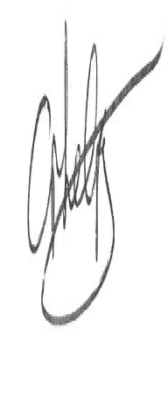 | Date:  25.11.19

For STAFF Submissions:
Head of School/Assistant Dean: |  | Date:
Signature: |  | Date:

Checklist: Please complete the checklist below to ensure that you have completed the form according to the guidelines and attached any required documentation:
☒ | I have read the guidance notes supplied before completing the form.
☒ | I have completed ALL RELEVANT sections of the form in full.
☒ | I confirm that the research activity has received approval in principle
☐ | I have attached a copy of final/interim approval from external organisation (where appropriate)
☐ | I have attached a full risk assessment (and have NOT completed Section H of this form) (where appropriate) ONLY TICK IF YOU HAVE ATTACHED A FULL RISK ASSESSMENT
☒ | I understand that it is my responsibility to ensure that the above named research activity will meet the University’s Research Ethics and Integrity Code of Practice.
☒ | I understand that before commencing data collection all documents aimed at respondents (including information sheets, consent forms, questionnaires, interview schedules etc.) must be confirmed by the DoS/Supervisor, module tutor or Head of School.
☒ | I have deleted the guidance notes before submitting the PG2 for consideration

RESEARCH STUDENTS AND STAFF ONLY
All communications relating to this application during its processing must be in writing and emailed to pgresearch@uwtsd.ac.uk , with the title ‘Ethical Approval’ followed by your name.
You will be informed of the outcome of your claim by email; therefore it is important that you check your University and personal email accounts regularly.

STUDENTS ON UNDERGRADUATE OR TAUGHT MASTERS PROGRAMMES should submit this form (and receive the outcome) via systems explained to you by the supervisor/module leader.

This form is available electronically from the Academic Office web pages: http://www.uwtsd.ac.uk/academic-office/

Application Process

All staff research projects and all research students must submit the Ethical Approval Form to the University Ethics Committee via the Academic Office (pgresearch@uwtsd.ac.uk). Staff research directly in relation to personal study for taught undergraduate or Masters programmes should be submitted via the Faculty procedures explained below.

Taught masters and taught undergraduate research Ethical Approval Forms are considered within Faculties. Faculties will provide details of the specific processes for this. Where the Ethical issues within any single ethical application are of particular concern the Faculty will refer these to the University Ethics Committee. Any student activity that involves the collection of primary data needs to undergo Ethical approval, this includes assignment work as well as dissertations.
References

Addis, M. E., & Mahalik, J. R. (2003). Men, masculinity, and the contexts of help seeking. American psychologist, 58(1), 5.
Ajzen, I. (1991). The theory of planned behavior. Organizational behavior and human decision processes, 50(2), 179-211
Fennell, K. M., Hull, M., Jones, M., & Dollman, J. (2018). A comparison of barriers to accessing services for mental and physical health conditions in a sample of rural Australian adults. Rural Remote Health, 18(1), 4155.
Galdas, P. M., Cheater, F., & Marshall, P. (2005). Men and health help‐seeking behaviour: literature review. Journal of advanced nursing, 49(6), 616-623.
Hammer, J. H., Vogel, D. L., & Heimerdinger-Edwards, S. R. (2013). Men's help seeking: Examination of differences across community size, education, and income. Psychology of Men & Masculinity, 14(1), 65.
Judd, F., Komiti, A., & Jackson, H. (2008). How does being female assist help-seeking for mental health problems?. Australian and New Zealand Journal of Psychiatry, 42(1), 24-29.
Mansfield, A. K., Addis, M. E., & Courtenay, W. (2005). Measurement of Men's Help Seeking: Development and Evaluation of the Barriers to Help Seeking Scale. Psychology of Men & Masculinity, 6(2), 95.
Oliver, M. I., Pearson, N., Coe, N., & Gunnell, D. (2005). Help-seeking behaviour in men and women with common mental health problems: cross-sectional study. The British Journal of Psychiatry, 186(4), 297-301.
Vogel, D. L., Wade, N. G., Wester, S. R., Larson, L., & Hackler, A. H. (2007). Seeking help from a mental health professional: The influence of one's social network. Journal of clinical psychology, 63(3), 233-245.
Wrigley, S., Jackson, H., Judd, F., & Komiti, A. (2005). Role of stigma and attitudes toward help seeking from a general practitioner for mental health problems in a rural town. Australian and New Zealand Journal of Psychiatry, 39(6), 514-521.

Appendix H;
Mental health themes, subthemes and quotes
Themes | Sub-Themes | Quotes
Personal Responsibility for Mental health | Maintaining Control | - I prefer to deal with my own problems (M70)  - it’s all down to me (M12)  - It’s my brain and feel that the problem is specific to me therefore I should be able to deal with it as I’d be “the expert” (M10)  - I am responsible for my lifestyle (M18)  - I still feel able to overcome "The Blues" at this time in my life (M25)  - all my usual techniques that help when I struggle with mood (M26)  - Admitting it is a problem (M26)  - I feel like mental health issues I can generally solve myself. (M58)  - They're under similar stress and can handle it. (M76)
Personal Responsibility for Mental health | Self-blame | - because I think the problem lies within me. (M7)  - Lazyness (M39)  - I'm not even sure that what I perceive as a potential problem isn't just a facet of my personality, I don't know that it isn't a result of social isolation either. (M61)
Personal Responsibility for Mental health | Need for access to information/Knowledge of the problem | - Finding the appropriate professional with which to discuss problems (M20)  - Not fully understanding the options available to improve mental help (M32)  - Lack of information (M29)  - hard to put jobs on hold to go and even figure out who to speak to. (M43)  - I don't know what they can help me with (M46)  - Not knowing what constitutes a problem  - Not knowing what constitutes a problem, and who exactly to turn to for professional help. (M51)  - Not realising something is wrong (M54)  - Not knowing where to get the help (M55)  - I dont know what help is available or where to go to in order to find out (M65)  - I am not sure if my problem is actually a mental health issue (M71)  - It's hard to tell if a mental health problem is a temporary issue or something caused by a physical condition.(M75)  - Not knowing when you need to seek help and from where (M78)  - Unsure whether there is an actual issue relating to my mental health. (M87)
Personal Responsibility for Mental health | Language | - Hard to explain the problem (M45)  - Not knowing how to explain what's happening in my head in a way that will get me the help I need for my specific problems (M73)
Difficulty accessing healthcare | Previous negative experience | - I can’t afford to attend mental health meetings privately and the NHS only offer a limited amount of meetings, not enough to make progress (M33)  - Having to explain what my doctor's appointment is for. (M52)  - Previous experience with health providers (M85)  - Doctors prescribing drugs rather than seeking to address issue (M92)  - hate doctors (M95)  - When I have looked for help in the past, no-one has helped me. (M77)  - I had a disappointing experience with them (M100)  - mental condition downplayed by doctor, not taking seriously (M34)  - Been before privately and spent 200 a session and felt ripped off after it and learnt nothing (M68)  - I've tried many times and been rejected from counseling, mental support groups and hospitalized care. (M41)  - I've recently gone to my GP for help with depression. After taking prescribed medication I felt that they were keeping me from being my true self. I stopped feeling like I was being my own person, and as if I was a robot or puppet. (M93)  - I needed to talk to someone, not be another number at the top of an assessment sheet. (M83)
Difficulty accessing healthcare | Waiting times | - long wait times before you will get seen, in my experience six plus months is so far in the future it almost feels unreachable. (M1)  - The time it takes to get any help at all. (M24)  - The long waiting lists (M6)  - It takes forever to get help. (M19)  - Wait for public services (M74)  - Waiting Times (M34)  - Long waiting lists and difficult to get referred (M60)  - Time it takes for counseling on NHS & the tendency to simply prescribe SSRIs (M64)
Difficulty accessing healthcare | Available resources/Services | - Lack of it in the area that I can attend (M4)  - Mental health services are a shambles (M30)  - Doctors not understanding how the patient feels rather than the symptoms they are taught are associated with an illness (M66)  - Lack of services (M67)  - lack of resources (M90)  - there aren't many services put in place in the area (though you do have some, including counsellors) (M94)  - Adequate continuous help is not readily available. (M98)  - Long waiting lists/lack of resources (M102)
Minimising Problems | Severity of problem | - I do tend to struggle on until I feel there's no other option. (M12)  - it would have to be pretty disabling for me to seek it (M16)  - Not realising how serious it is, think it's normal (M31)  - I don't think my problems would be serious enough/they'd go away in time (M70)
Minimising Problems | Comparing problems to others | - There are people worse off than me that need the limited resources that are available more than I fo (M11)  - Everyone has mental health issues and mine isn't that important (M35)
Minimising Problems | Lack of knowledge | - Might be mistaken for something that will pass (M96)
Minimising Problems | Problem is situational | - It might be situational (grief/ stress in work) and would be manageable (M26)
Cultural influences on help-seeking | Mental health stigma | - The stagma attached to mental health (M8)  - The social stigma that still surrounds mental health puts a lot of people off getting help (M34)  - Stigma (M44)  - social stigma (M53)  - possible sigma (M63)  - Stigma, it's perceived as failure (M88)  - being labelled. (M89)  - Social stigma (M90)  - While it has lessened in recent years, there is still a very large stigma around mental health, particularly in rural communities. (M98)
Cultural influences on help-seeking | Media/Public opinion | - Media and public opinion make peole with mental health issues look weak and mentally broken (M21)  - If diagnosed with mental health, most people seem to be treated differently (M23)  - Stereotyping (M27)  - Mental health is still frowned upon (M94)
Cultural influences on help-seeking | Cultural Expectations | - Sign of weakness (M36)  - Feeling weak and not very 'manly' (M38)  - Don't want to seem weak (M42)  - Even with a family full of nurses who worked in psychiatric wards this isn't something we ever would talk about. (M100)
Work | Getting time off work for appointments | - I'm self-employed and it would be hard to put jobs on hold to go (M43)  - not enough time off work/stable rota to speak to professionals. (M50)  - Getting time off work for initial appointment is easy, but keeping the job with regular appointments and fluctuating mental health is another (M59)  - Missing work (M63)  - Time off work (M99)
Work | Status | - How it would affect work (time off, telling my boss etc) (M72)  - Work colleagues would think less of me. (M76)  - End my career (M79)
Negative feelings/emotions related to seeking help for mental health concerns | Embarrassment/Discomfort | - Issues are too personal and will would feel very uncomfortable sharing. (M3)  - Embarrassed (M13)  - Embarrassing (M13)  - Embarrassment (M86)  - Don't like talking about my feelings
 | Weakness | - I feel weak and don't want to waste time (M62)  - Feeling of Weakness/Reluctance to talk about my issues (M84)
 | Fear/Anxiety | - Fear of what treatment might entail and reluctance to open a can of worms. (M9)  - social anxiety  - Scared to be treated like a child (M5)  - lack of trust in local capabilities (M48)  - Anxiety (M39)  - I won't take meds. (M46)  - I dont like the idea of taking drugs (M82)  - lack of anonymity (M81)  - Fear of diagnosis (M89)  - Shame (M91)  - Don’t want to waste people’s time (M101)  - The feeling that it might just be normal and there's nothing wrong and I'm wasting people's time. (M97)
Social influences | Need to provide for others | - Family (M14)  - Family come first (M22)  - I wouldn't want my family to worry about me. (M40)
Social influences | Deservingness | - That I would be taking resources away from someone who needs help more (M15)  - Our problems in the West are small. Someone’s always got it worse than you. (M17)
Social influences | Support | - Would seek early help from friends (M18)  - I feel I have a good support network in my personal life (M69)

Appendix I;
Physical health themes, subthemes and quotes
Themes | Sub-Themes | Quotes
Personal Responsibility for Physical health | Maintaining Control | - I can manage them by not overexercising (P2)  - I can fix it myself by being healthier and exercising more. (P10)  - Initially I would look at my lifestyle choices and self management. (P14)  - My problems are my own (P49)  - I don't want to be forced to make potentially drastic changes to my lifestyle (P56)  - I feel I am able to care for myself in most situations (P62)  - I don't want to go to the doctor if I don't have to. (P42)
Personal Responsibility for Physical health | Self-blame | - Sense that it is my fault in some way (P1)  - Laziness (P38)
Personal Responsibility for Physical health | Need for access to information/Perceived responsibility to know what the issue is first | - uncertainty about condition (P33)  - Not knowing if it is a serious issue or if I'm wasting doctors time (P66)
Difficulty accessing healthcare services | Previous negative experiences of health services | - It's a pain in the ass. (P17)  - Not seeing correct specialist  - In my area, we have 1 Doctor for 5000 people; he dismisses peoples concerns, and takes a poor attitude to their worries. I can not move to another surgery; so I avoid seeing him as much as possible; the internet has more concern for my wellbeing. (P67)  - having my issue pigeonholed and glossed over as "being my fault" (P74)  - Dismissive healthcare professionals (P86)  - hate doctors (P89)
Difficulty accessing healthcare services | Waiting times | - Waiting times (P33)  - Long waiting time, difficulty getting expert help (P40)  - Long waits for doctor's appointment (P43)  - GP wait-times. (P46)  - Don't want to add to the waiting list unnecessarily. (P48)  - Long waiting times, problem may have gone before an appointment is available (P77)  - Waiting lists are long (P80)  - The time it takes to get an appointment (P69) (P91)
Difficulty accessing healthcare services | Availability of services | - Lack of being able to get an appointment (P5)  - Shortage of GPs/appointments (P9)  - it is very difficult to get a same day appointment (P12)  - wasting the limited amount of time and funds the NHS has. (P22)  - The length of time it takes to get an appointment, and the fact that you can only discuss one issue during an appointment (P31)  - Difficulty in getting an appointment (P59)  - It is impossible to see a medcial professional, I cannot get an appointment and long enough to explain my symptoms. (P70)  - Not wanting to put extra strain on the NHS (P71)  - I wish the local gp was open nights and weekends. Ive never been to the local gp's in all of my adult life. I have needed to though. Its not set up for people who want a 9 to 5 job (P73)  - It is very hard to get appointments with a GP and they are frequently rushed or inconveniently timed. (P94)  - Service is overused for non-issues (P32)  - Don’t want to overburden already stressed NHS staff (P60)  - poor health service (P81)
Minimising Problems | Severity of problem | - I know I have bad knees but I can manage them (P2)  - Until the problem hits a particular severity I'm unlikely to go beyond a quick google about the issue and see if any easy solutions present themselves (P2)  - Experience dictates it’s usually nothing. (P13)  - If it was what I considered serious I would seek help immediately. (P14)  - That my problem is totally minor and is just a cause of me not taking proper care of myself, therefore wasting the time of medical professionals (P47)  - That I'm overreacting to it and it isn't that serious. (P48)  - Not a critical issue (P52)  - Don't want to be a bother (P57)  - Minor problem that'd go away in time (P63)  - I wouldn't want to waste one on something that turns out to be very minor (P68)  - Wasting my doctors time with something that isn’t as serious as I thought it to be. (P82)  - the worry it may be nothing and I'm wasting everyone time. (P91)  - Hyperchondriac, wouldn't want to waste someone's time (P26)  - Worried that I may be wasting their time (P87)
Minimising Problems | Lack of knowledge | - Not being aware of how serious to myself and others, the issue was. (P24)  - Not wanting to make a fuss of something that might go away itself (P34)  - The things that worry me might be nothing; but if they're serious I kind of don't want to know/deal with it. (P88)  - It might be something that passes (P90)
Minimising Problems | Resignation | - Knowing that there is no answer to my physical health problems. (P18)  - Fact of life, not worth bothering about (P29)
Work | Work Commitments | - Hassle of getting time off work to attend an appointment. (P11)  - Having time off work due to financial reasons (P22)  - Finding time off work (P41)  - Getting time off work, losing money and how long I would be in hospital for (P58)  - Unable to get time off work (public sector). Only a certain number of illnesses are allowed before disciplinary action (P68)  - Time off work (P93)  - I worry about having to take time off work, especially persistently for a problem that may not affect my work (P94)  - How it would affect work (P65)
Negative feelings/emotions towards seeking help for Physical health concerns | Embarrassment/ Discomfort | - Self-esteem issues about my body (P16)  - Embarrasment (P64)  - Embarrassing (P75)  - Embarrassment (P76)  - Embarrassment/ shame (P79)  - Embarrassment(P85)
 | Weakness | - Don’t want to appear weak (P72)
 | Fear/Anxiety | - I dont want them to think im being stupid and send me away on random pills (P6)  - Being given bad news (P8)  - Fear of it being something serious (P7)  - It might be awful news (P25)  - dont want to waste people time(P45)  - I don't want to accept that the problem is serious (P78)  - Dear of the unknown (P83)  - Long term repercussions should it get worse (P84)  - It's contradictory, but I don't want to worry about it? (P88)  - Don’t want to waste people’s time (P95)
Social factors | Need to provide for others | - Family come first. (P21)
Social factors | Deservingness | - Don't want to waste a health professionals time when they could be helping someone with a more severe issue. (P4)  - feeling that other people's needs of a scarce resource are greater (P9).  - don't want to take a more deserving persons appointment (P52)  - Wouldnt want to take care away from someone who required it more (P19)  - I feel like there are people with problems far worse than my own who need help more so than me. (P92)
Social factors | Support Networks | - I don’t want to burden people. (P49)  - Family and friends may try to pry information out of me (P54)

