Colombia Culture Report

Foreign Languages and Cultural Awareness
BMIH5003

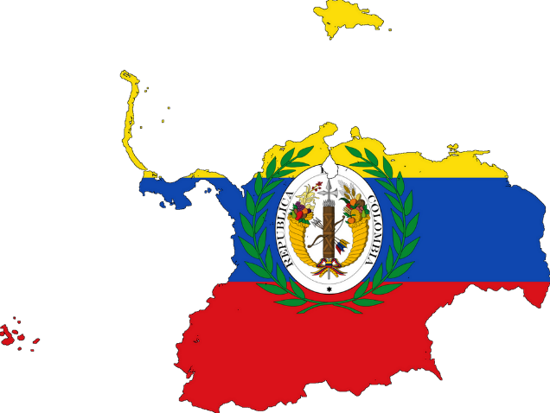

Amanioaei Eliza Andreea
2216057,
1,081 Words
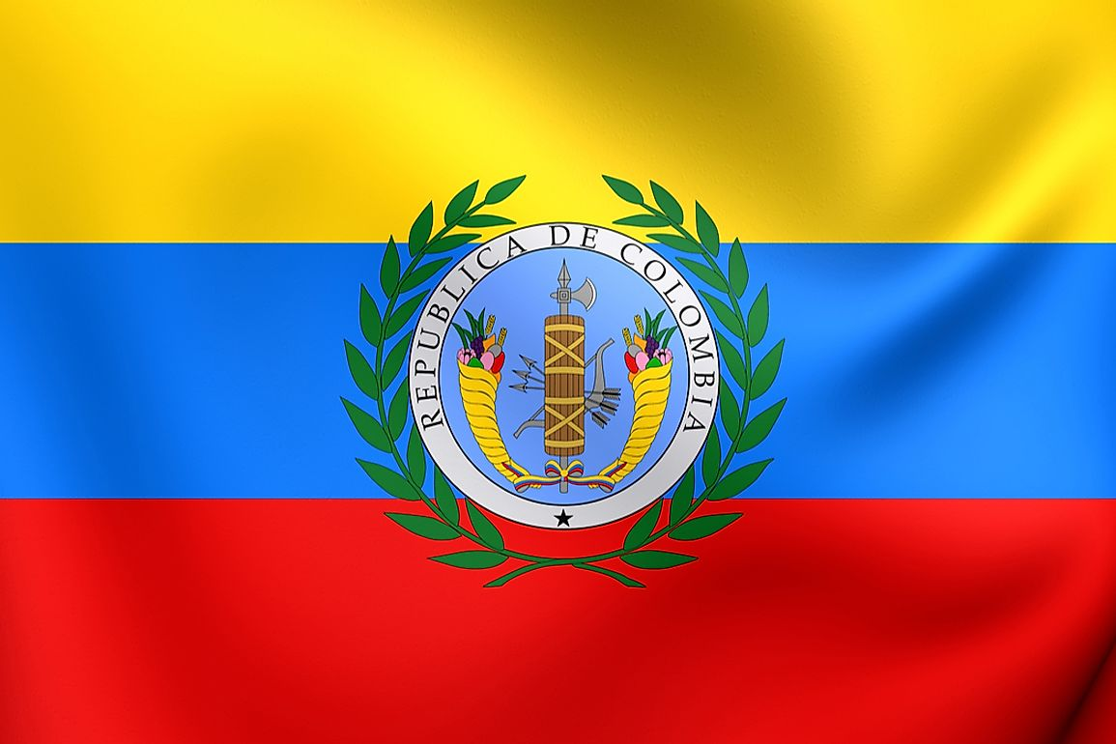

Executive Summary
Colombia, a South American country, values its rich cultural diversity influenced by indigenous traditions, Spanish influences, and African heritage. This society places great importance on familial bonds, personal relationships, and hierarchical structures (Evanson, 2018). Drawing on findings from the GLOBE Project, it is obvious that Colombia exhibits significant power distance and collectivism, indicating a societal inclination towards respecting authority and prioritising collective objectives. Moreover, their inclination towards compassion highlights their inherent generosity and kindness (Higgins, 2021). To ensure the success of Diversity Hotel & Spa in this market, it is crucial to comprehend and embrace these cultural subtleties. Promoting trust between the local staff and community will improve the hotel's global brand reputation. Cultural intelligence is crucial for bridging gaps, avoiding misunderstandings, and ensuring authentic resonance with the Colombian population (Javidan, Dorfman, De Luque and House, 2016). The hotel chain's success in this new and dynamic environment will depend on a combination of cultural sensitivity and business expertise.
Content Table
Introduction
3
Cultural Overview of Colombia
3
GLOBE Project/Country Analysis
4
Importance of Cultural Intelligence and Sensitivity
6
Recommendations
7
Leadership Adaptation
8
Conclusion
9
Appendix
10
- Case Studies of Successful Cultural Integration by Other Brands
- List of Local Festivals and Traditions
References
12
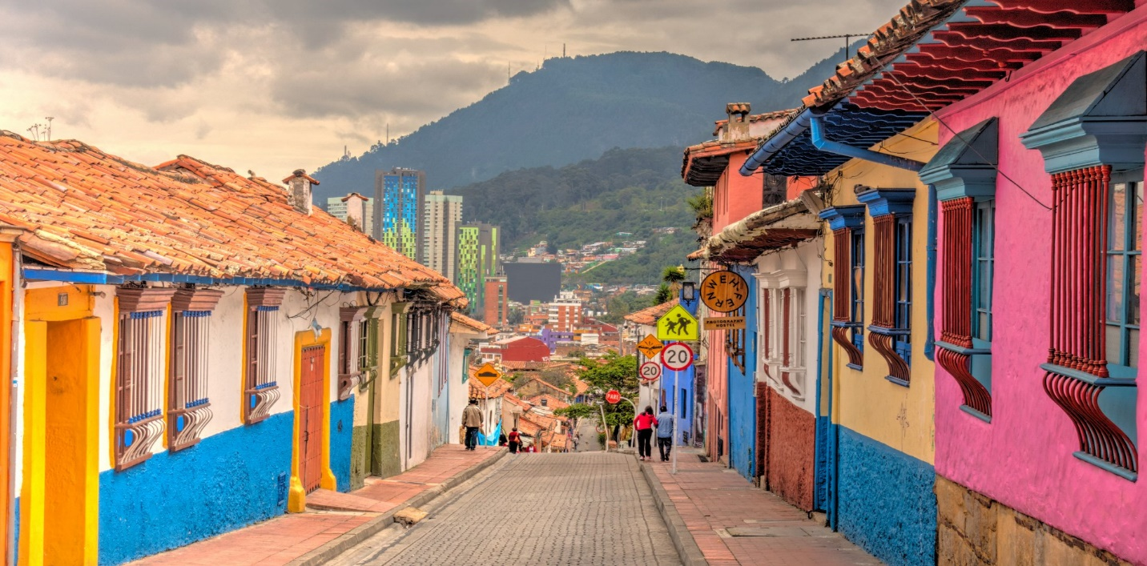Introduction
The prestigious Diversity Hotel & Spa is poised to expand into the Colombian market. This report aims to explore the cultural landscape of Colombia, which is shaped by its indigenous, Spanish, and African heritage. As the hotel chain continues to expand its reach worldwide, it becomes increasingly imperative to integrate and acknowledge the nuances of local culture. This article will provide information on Colombia's society, business customs, and cultural dimensions according to the GLOBE Project. It will conclude with practical suggestions for a successful business pursuit.

Cultural Overview of Colombia
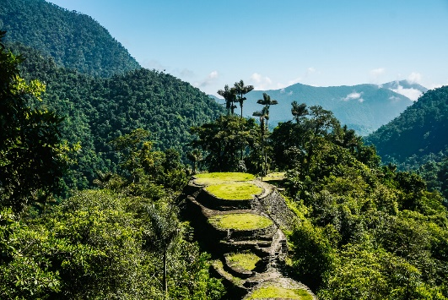
According to Evanson (2018), Colombia is located in northern South America and exhibits a diverse cultural blend resulting from indigenous, Spanish, and African influences. The tri-fold heritage has influenced various aspects of its culture, including traditions, celebrations, music, and daily interactions.
Historical Background and Influences: Colombia's cultural tapestry is shaped by its historical background, including the presence of pre-Columbian civilizations, Spanish colonisation, and the influence of African culture through the Atlantic slave trade. Each phase has had lasting impacts, ranging from artistic expressions to culinary preferences (Evanson, 2018).
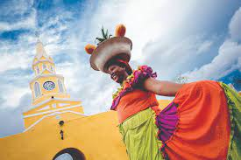
Familial Bonds and Societal Structure: According to Evanson (2018) the family is central to Colombian society. Extended family ties are prevalent in social structures, often resulting in cohabitation or proximity of multiple generations. Family events and gatherings are of great importance.
Communication and Interpersonal Dynamics: Napitupulu, and Shinoda (2014) states that Colombians are recognised for their friendly and pleasant nature. In-person interactions are typically favoured, characterised by a sense of personal connection, as evidenced by customary greetings such as cheek kissing. Typical behaviours include direct eye contact, active listening, and animated conversations.
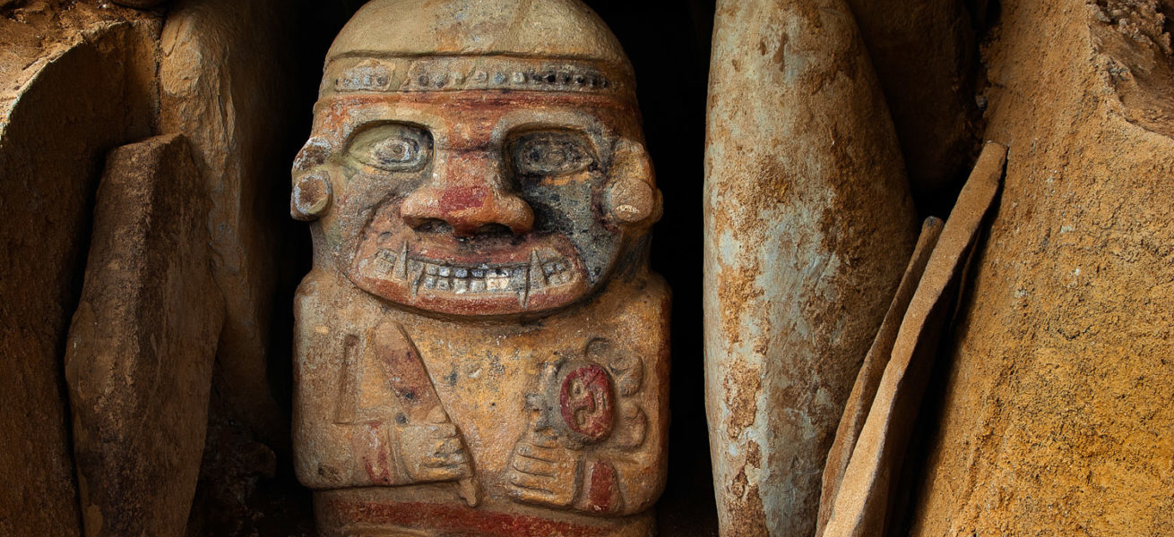
Business Etiquette and Expectations: Colombians prioritise professionalism in business settings, despite the importance of personal relationships. Being punctual, wearing formal attire, and respecting hierarchies are valued in professional settings (Planet Depos website, 2008).
GLOBE Project/Country Analysis
The GLOBE Project, an acclaimed research initiative, has meticulously profiled the cultures of various countries, including Colombia, across multiple dimensions. This section decodes Colombia's positioning on some of these dimensions pertinent to the business context of Diversity Hotel & Spa.
Power Distance: Colombia displays a significant power distance score, indicating a societal inclination towards accepting and anticipating hierarchical structures. In business settings, there is a clear hierarchical structure where superiors and subordinates are differentiated, and decision-making typically originates from higher levels of authority (Planet Depos website, 2008).
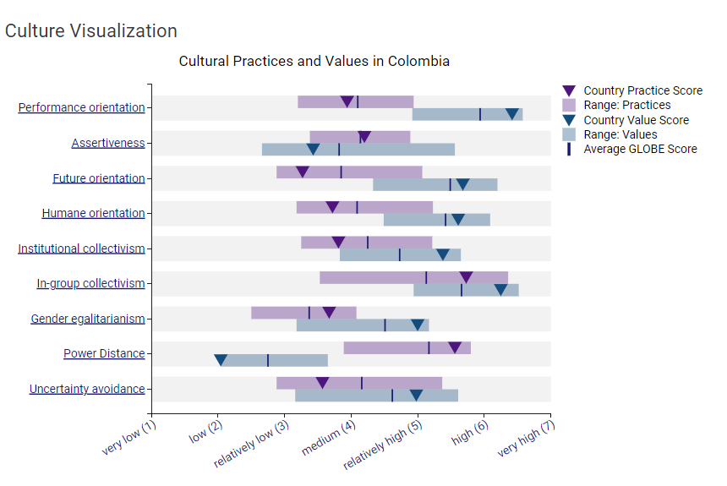
Collectivism: According to Hammelman, Buitrago Arias, Cuadros, Hayes-Conroy, Muñoz, Quintero and Saenz Montoya, 2020), Colombians prioritise unity in groups and familial bonds over individualistic pursuits, reflecting a collective spirit. The collective nature of the hotel environment implies that team-oriented initiatives may be more successful than individual-centric ones.
Uncertainty Avoidance: Colombia's moderate position on uncertainty avoidance demonstrates its well-balanced approach. Although established protocols are generally accepted, there is also scope for flexibility and adaptability, particularly in unforeseen circumstances (WBG, 2021).
Performance Orientation: Colombians highly value and acknowledge performance, which is closely connected to interpersonal dynamics. When establishing performance standards, it is important to take into account the interpersonal factors that drive motivation among Colombian employees (Ogliastri, 2007).
Humane Orientation: The high score suggests that Colombian society places importance on kindness, altruism, and generosity. This suggests that businesses should give priority to the well-being of the community and society in their operations (WBG, 2021).

Importance of Cultural Intelligence and Sensitivity
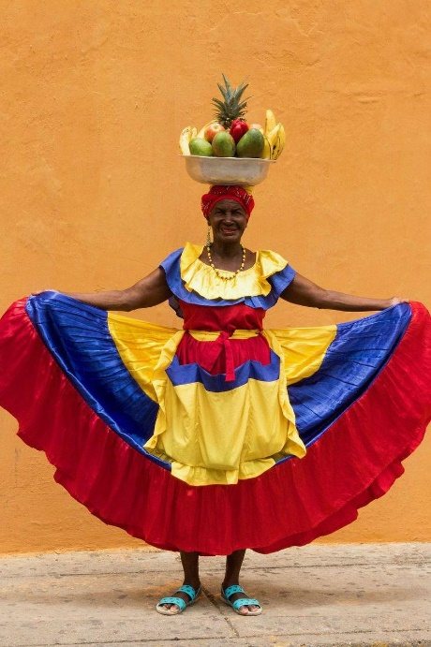
The effectiveness of GM and hotel staff in Colombia relies on cultural intelligence (CQ), a vital skill in the contemporary global business landscape. Alon, Boulanger, Elston, Galanaki, Martínez de Ibarreta, Meyers, Muñiz‐Ferrer, and Vélez‐Calle, (2018) states that CQ allows leaders to effectively interact with diverse teams and overcome cultural barriers. This ability is emphasised by theories like Hofstede's cultural dimensions, which emphasise the importance of cross-cultural communication. The GM should exhibit a high level of cultural intelligence to establish trust, promote team unity, and effectively navigate the communication style common to Colombian culture.
Definition and Relevance of Cultural Intelligence: Cultural intelligence refers to an individual's ability to effectively navigate different cultural environments. It is measured by cognitive, motivational, and behavioural capacities. In the hotel industry, it is important to comprehend and address the diverse requirements of guests from various backgrounds, while also ensuring that the staff acknowledges and respects these differences.
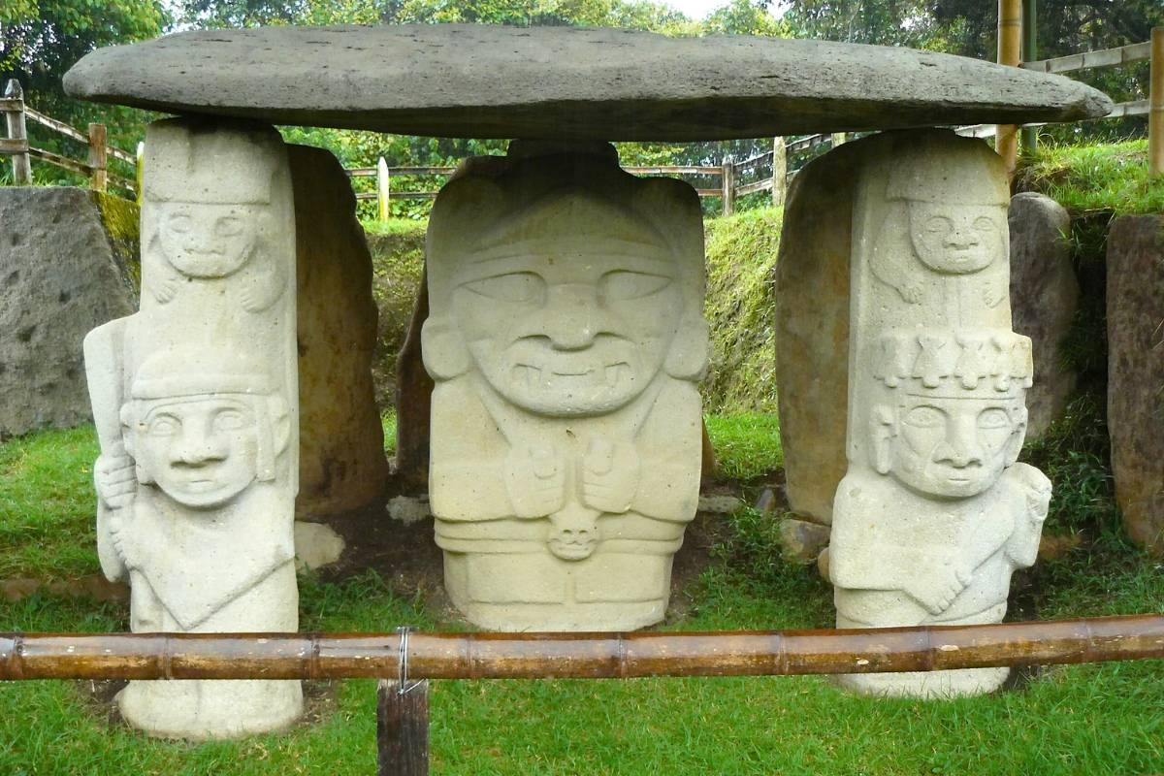
Role in Building Trust and Relationships: The success of a hotel depends on trust and building relationships. Cultural sensitivity promotes trust among hotel staff and the broader community. Respect and a genuine desire to integrate are crucial for relationship-building in a new market such as Colombia.
Impact on Brand Image and Perception: Cultural appreciation improves brand image and perception by conveying a global and respectful outlook. Improving its reputation can lead to increased customer loyalty and positive word-of-mouth.
Preventing Misunderstandings and Conflicts: Cultural intelligence helps in interpreting situations accurately, preventing misunderstandings and conflicts. In service-oriented industries, it is essential to prevent unintentional offence towards guests or staff.


Recommendations
To ensure the successful establishment and sustained growth of Diversity Hotel & Spa in Colombia, Rand (2015) exemplifies the following recommendations:
Training and Development Initiatives: Invest in extensive cultural training programmes for both incoming and local personnel to improve training and development initiatives. This ensures staff members possess the requisite skills and understanding to function effectively within the cultural context of Colombia.
Collaboration with Local Consultants: Engage local consultants to gain insights into Colombian business and social customs, ensuring alignment with local expectations.and social customs, ensuring that the hotel's operations are aligned with local expectations.
Establishment of Feedback Mechanisms: Participate actively in local cultural celebrations and traditions. This fosters brand affinity within the community and enhances staff's cultural awareness.
Participation in Cultural Celebrations: Engage actively in local festivals and traditions. This not only endears the brand to the community but also provides staff with a deeper understanding of the culture they're immersed in.
Emphasis on Language and Communication Training: The organisation places importance on language and communication training by providing Spanish language training for international staff and English training for local hires, acknowledging the significance of language in culture. This dual approach improves communication and minimises misunderstandings.

Leadership Adaptation
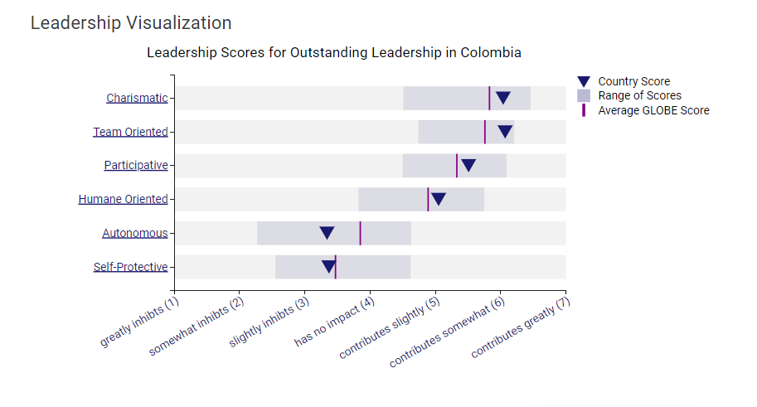
Adapt leadership style to accommodate high power distance, demonstrating respect for hierarchical structures while promoting inclusivity.
To align with Colombia's collectivist orientation, it is recommended to prioritise team accomplishments rather than individual accolades.
By implementing these suggestions, Diversity Hotel & Spa can effectively assimilate into the Colombian market, promoting positive relationships and guaranteeing sustainable achievements.

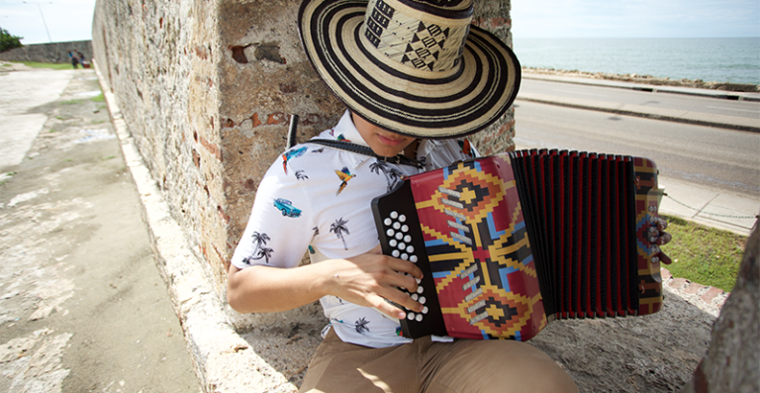
Conclusion
Diversity Hotel & Spa's expansion into Colombia includes both prospects and obstacles. Colombia's diverse cultural landscape requires a sophisticated approach to hotel management and customer service. The GLOBE Project's findings point out crucial cultural dimensions that the hotel must manage. Cultural intelligence and sensitivity are crucial for success in this new market. The success of Diversity Hotel & Spa in Colombia relies on the combination of business expertise and cultural sensitivity.

Appendix
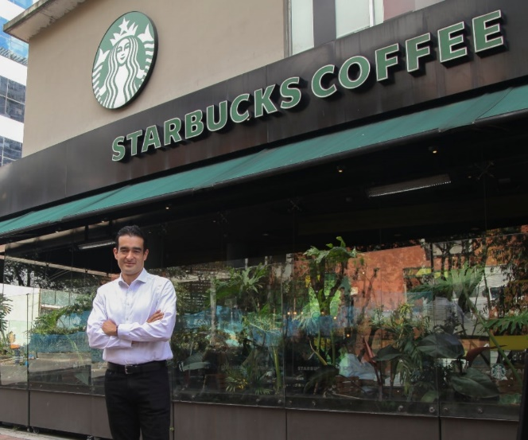
Case studies on successful cultural integration by other brands.
- Starbucks' Expansion into Colombia
Starbucks entered Colombia, a country with a strong coffee culture, by implementing a strategy that respected and acknowledged the local coffee traditions. The company inaugurated its initial retail location in Bogotá in 2014, showcasing interior design influenced by Colombian coffee scenery and artistic creations. Starbucks collaborated with local coffee farmers, demonstrating their dedication to sourcing and offering premium Colombian coffee in their global retail outlets. The company developed a distinct blend that is only sold at its Colombian stores, incorporating local tastes and preferences.
- McDonald’s Colombia

McDonald's modified its menu in Colombia to accommodate local preferences, introducing the "McCriollo" breakfast that consists of traditional arepas and natural fruit juices such as guanábana and passionfruit. The strategy involved creating open-concept restaurants, embracing Colombian community values, and training staff to deliver personalised service in line with Colombian hospitality norms.

- Zara Colombia
Zara swiftly adapted to local fashion trends upon entering the Colombian market. Zara successfully tailored its clothing offerings to the Colombian climate and cultural preferences by implementing a responsive supply chain and establishing a local design team. The company's approach involved producing smaller and more frequent fashion collections to align with Colombia's rapidly changing fashion trends, which contributed to their rapid popularity among local customers.
List of Local Festivals and Traditions

Festival del Viento y las Cometas (Kite Festival) in Villa de Leyva: Held in August, this festival fills the sky with kites of all colours and sizes, symbolizing freedom and creativity.
San Pedro Festival: In late June and early July, this festival in the Huila region celebrates rural life with parades, beauty pageants, and musical performances.
Christmas Festivities: Colombians celebrate Christmas with a variety of traditions, including Novenas (nine days of family gatherings and prayer), Nativity scenes, and festive lights.
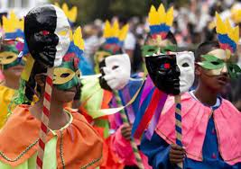
La Feria de Cali (Cali Fair): Starting on December 25th, this fair is famous for salsa dancing, music concerts, bullfighting, and parades, reflecting the city's vibrant culture.
The Blacks and Whites' Carnival: Celebrated in the city of Pasto in early January, this carnival features elaborate costumes and masks, symbolizing equality and togetherness.

The case studies and festival list offer valuable insights and cultural references for Diversity Hotel & Spa to inform their market entry strategy and community engagement in Colombia.

Reference List
  - Alon, I., Boulanger, M., Elston, J.A., Galanaki, E., Martínez de Ibarreta, C., Meyers, J., Muñiz‐Ferrer, M. and Vélez‐Calle, A., 2018. Business cultural intelligence quotient: A five‐country study. Thunderbird International Business Review, 60(3), pp.237-250.
  - Evanson, P., 2018. Columbian Culture. Cultural Atlas. Online Available At: https://culturalatlas.sbs.com.au/colombian-culture/colombian-culture-core-concepts
  - Hammelman, C., Buitrago Arias, C., Cuadros, U., Hayes-Conroy, A., Muñoz, D., Quintero, X. and Saenz Montoya, A., 2020. Reflections on the affective contributions to research success in two participatory projects in Colombia. Qualitative Research, 20(4), pp.378-395.
  - Higgins, C., 2021. Leadership Landscapes: Mapping cross-cultural differences in global leadership. CCBS Press.
  - Javidan, M., Dorfman, P.W., De Luque, M.S. and House, R.J., 2016. In the eye of the beholder: Cross-cultural lessons in leadership from Project GLOBE. In Readings and cases in international human resource management (pp. 119-154). Routledge.
  - Napitupulu, S. and Shinoda, K., 2014. Cross Cultural Understanding. Halaman Moeka publishing.
  - Ogliastri, E., 2007. Colombia: The human relations side of enterprise. In Culture and Leadership Across the World (pp. 723-756). Psychology Press.
  - PlanetDepos, 2008. Columbian Business Etiquette. Online Available At: https://planetdepos.com/trending/content/colombian-business-etiquette
  - Rand, I., 2015. Cultural intelligence: The essential intelligence for the 21st century.
  - World Bank Document, 2021. Building an Equitable Society in Colombia. Online Available At: https://documents1.worldbank.org/curated/en/686821635218586591/pdf/Main-Report.pdf

